

**CSE311 Project**

**Airline Reservation System**

**Submitted by:**

1)Mohammed Nahid Hossain iD: 2011964042

2) Md. Asif Iqbal Id: 2011964042

**Why should you use our Airlines Reservation System?**

Booking airline tickets is a very big hassle in our daily lives as a person has to move out and travel through the traffic and go to travel agencies to book and buy tickets. Even after all these hassles, the price of an air ticket gets so expensive because of the commission and hidden charges kept by the agency owners. However, we have brought a ***solution*** to this problem. With the use of our Airline Reservation System, Life will become much easier. We bring to you all the services you need to buy a ticket at a single place which you can access easily right away using your smart devices.

**About our Airline Reservation System**

Our ***Airlines Reservation System*** is a web-based technology which will be managing international flights and offer service to the Users. All the necessary features and functions required to ***Book & Confirm*** your ticket are available in our website. Our service is available for non-stop 24/7 to improve the local ticketing system of our country.

**User Features:**

* Create user accounts or login to previously created accounts
* Check travel history
* Check when tickets are available from a huge range of flights
* Book tickets
* Make safe payments

**Admin Features:**

* Admin login features
* Make new schedules
* Update old schedules if required
* Check user payments
* Add new flights

**Front-end Features:**

* Main Page
* Login/ Create Account Page
* Flight Schedule Check
* Seat Availability
* Baggage Charges
* Ticket Payments
* History Check
* Print Tickets

**Back-end Features:**

* Account Creation
  + Signup
  + Login
  + Password Reset/Change
* Update Schedule
  + Change arrival/departure time of flights
* Booked Seats
  + Check number of reserved seats
* Add Flights
* Cancel Flights
* Add New Destinations
* Check User History

**Snapshots of our Features**

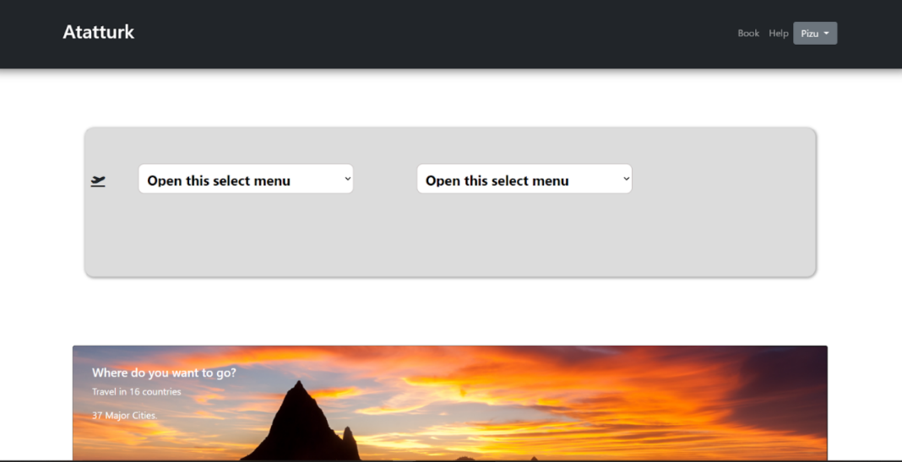

**Search Flights**

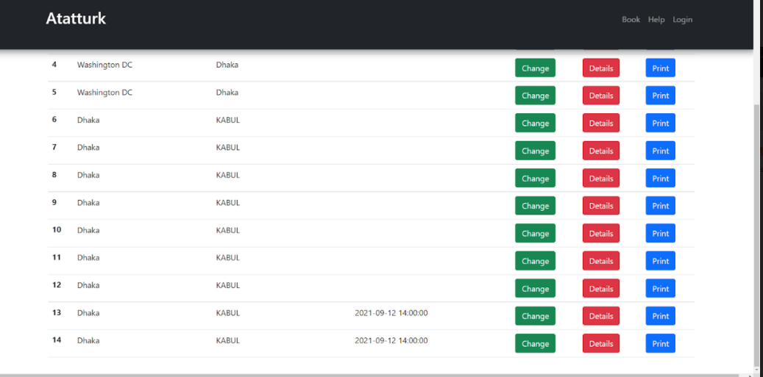

**Print Tickets**

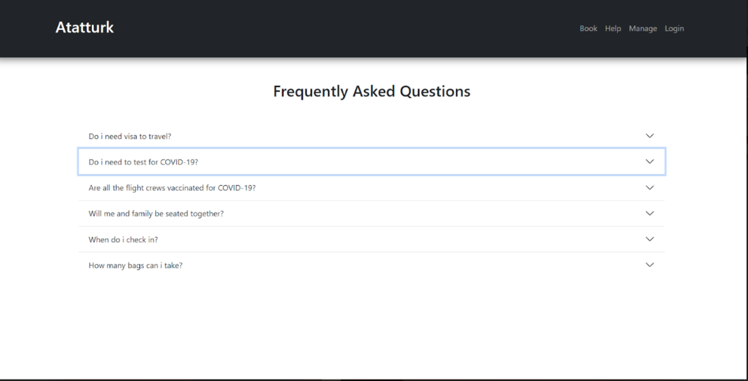

**Help Page**

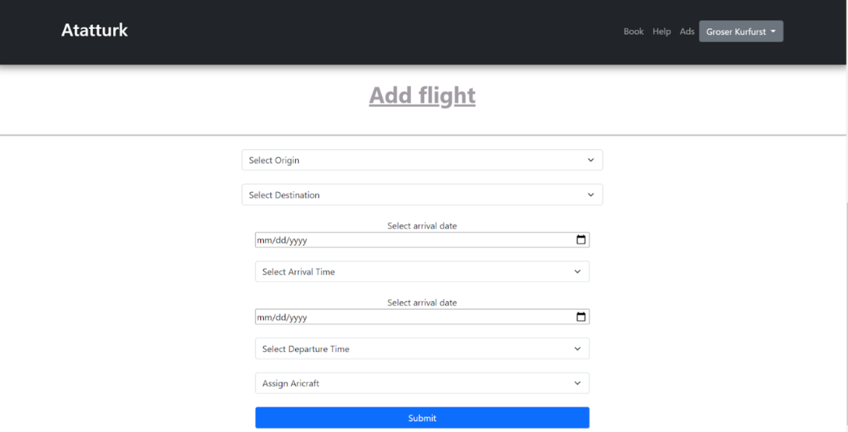

**Add New Flights**

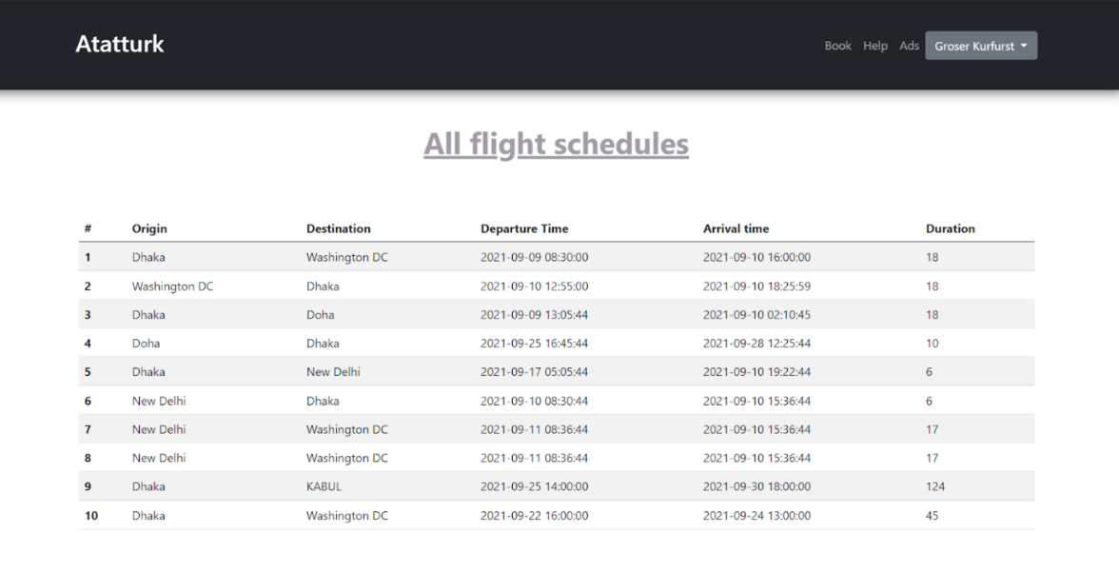

**Schedules**

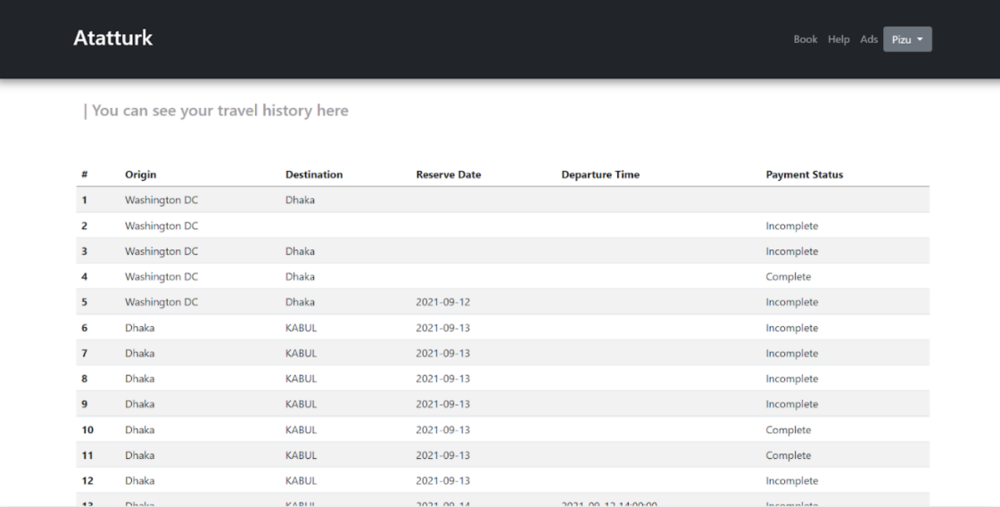

**Payment Status**

**Conclusion:**

* **Booking tickets made easier**
* **Just search, book and pay**
* **Business, first & Economy seats in each plane**
* **Make payments using Credit card**
* **Future of Buying Tickets**

**Limitations:**

* Admin is not able to delete schedule
* User can only pay during reserving tickets

**Tools & Technologies Used:**

* **Database**: MySQL
* **Frontend**: Bootstrap, HTML, Java, CSS
* **Database** **Interaction**: Ajax(jQuery)

**Appendix**

**Contact:**

**Md. Asif Iqbal, Chief Executive Officer (CEO), Airline Reservation System**

**Mohammed Nahid Hossain, Managing Director (MD), Airline Reservation System**

**Head Office, Gulshan, Dhaka.**