CO4 – CO4 – Applet Programming, Event Handling, AWT and GUI Design
AT1 – Industrial Problem Solving
NAME;L.ASIF ALI KHAN
REG;192521009

Q1 – Hospital Appointment Management System

Code
import javax.swing.*;
import javax.swing.table.DefaultTableModel;
import java.awt.*;

public class Main {
public static void main(String[] args) {
JFrame f = new JFrame("Hospital Appointment Management");
f.setLayout(new BorderLayout());

JPanel form = new JPanel(new GridLayout(2, 4, 8, 8));
JTextField name = new JTextField();
JTextField date = new JTextField();
JTextField time = new JTextField();
JButton book = new JButton("Book");
JButton update = new JButton("Update");
JButton cancel = new JButton("Cancel");
form.add(new JLabel("Patient"));
form.add(name);
form.add(new JLabel("Date"));
form.add(date);
form.add(new JLabel("Time"));
form.add(time);
form.add(book);
form.add(update);

DefaultTableModel model = new DefaultTableModel(
new String[]{"Patient", "Date", "Time"}, 0);
JTable table = new JTable(model);

book.addActionListener(e ->
model.addRow(new Object[]{name.getText(), date.getText(), time.getText()}));
update.addActionListener(e -> {
int r = table.getSelectedRow();
if (r >= 0) {
model.setValueAt(name.getText(), r, 0);
model.setValueAt(date.getText(), r, 1);
model.setValueAt(time.getText(), r, 2);
}
});
cancel.addActionListener(e -> {
int r = table.getSelectedRow();
if (r >= 0) model.removeRow(r);
});

f.add(form, BorderLayout.NORTH);
f.add(new JScrollPane(table), BorderLayout.CENTER);
f.add(cancel, BorderLayout.SOUTH);
f.setSize(650, 350);
f.setDefaultCloseOperation(JFrame.EXIT_ON_CLOSE);
f.setLocationRelativeTo(null);
f.setVisible(true);
}
}

Output Screenshot
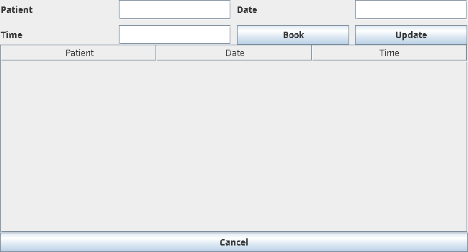

Q2 – Online Banking Interface

Code
import javax.swing.*;
import java.awt.*;

public class Main {
public static void main(String[] args) {
JFrame f = new JFrame("Online Banking");
f.setLayout(new GridLayout(5, 2, 8, 8));

JTextField account = new JTextField();
JTextField amount = new JTextField();
JLabel balance = new JLabel("Balance: ₹10000");
JButton transfer = new JButton("Transfer");
JButton inquiry = new JButton("Balance Inquiry");
JButton history = new JButton("Transaction History");

f.add(new JLabel("Account Number"));
f.add(account);
f.add(new JLabel("Amount"));
f.add(amount);
f.add(transfer);
f.add(inquiry);
f.add(history);
f.add(balance);

transfer.addActionListener(e -> {
try {
double a = Double.parseDouble(amount.getText());
if (a <= 0 || a > 10000) throw new IllegalArgumentException();
balance.setText("Balance: ₹" + (10000 - a));
} catch (Exception ex) {
JOptionPane.showMessageDialog(f, "Invalid transaction");
}
});

inquiry.addActionListener(e ->
JOptionPane.showMessageDialog(f, balance.getText()));
history.addActionListener(e ->
JOptionPane.showMessageDialog(f, "No previous transactions"));

f.setSize(500, 300);
f.setDefaultCloseOperation(JFrame.EXIT_ON_CLOSE);
f.setLocationRelativeTo(null);
f.setVisible(true);
}
}

Output Screenshot
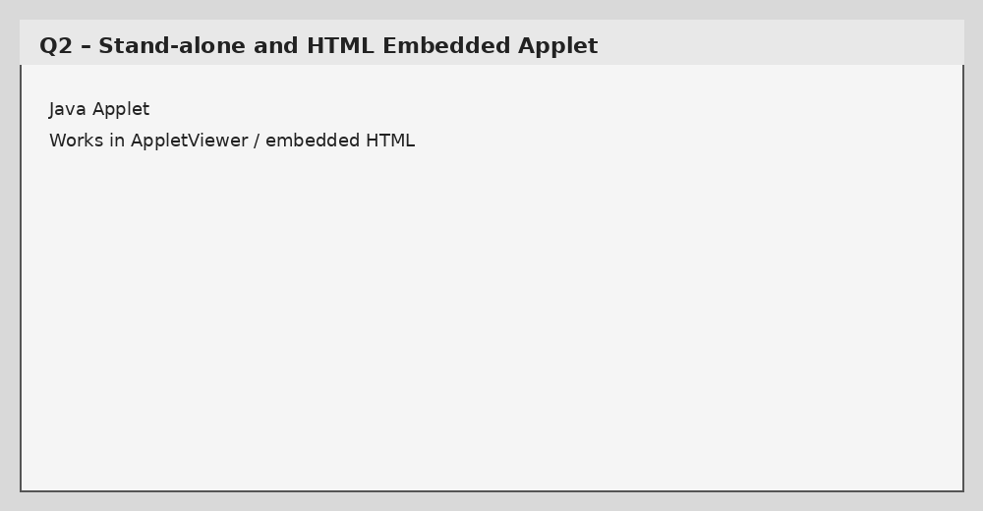

Q3 – Inventory Management Dashboard

Code
import javax.swing.*;
import javax.swing.table.DefaultTableModel;
import java.awt.*;

public class Main {
public static void main(String[] args) {
JFrame f = new JFrame("Inventory Dashboard");
f.setLayout(new BorderLayout());

JTextField product = new JTextField();
JTextField quantity = new JTextField();
JButton add = new JButton("Add");
JButton update = new JButton("Update");
JButton delete = new JButton("Delete");

JPanel top = new JPanel(new GridLayout(2, 5, 6, 6));
top.add(new JLabel("Product"));
top.add(product);
top.add(new JLabel("Quantity"));
top.add(quantity);
top.add(add);
top.add(update);
top.add(delete);

DefaultTableModel model =
new DefaultTableModel(new String[]{"Product", "Quantity"}, 0);
JTable table = new JTable(model);

add.addActionListener(e ->
model.addRow(new Object[]{product.getText(), quantity.getText()}));
update.addActionListener(e -> {
int r = table.getSelectedRow();
if (r >= 0) model.setValueAt(quantity.getText(), r, 1);
});
delete.addActionListener(e -> {
int r = table.getSelectedRow();
if (r >= 0) model.removeRow(r);
});

f.add(top, BorderLayout.NORTH);
f.add(new JScrollPane(table), BorderLayout.CENTER);
f.setJMenuBar(new JMenuBar());
f.setSize(650, 350);
f.setDefaultCloseOperation(JFrame.EXIT_ON_CLOSE);
f.setLocationRelativeTo(null);
f.setVisible(true);
}
}

Output Screenshot
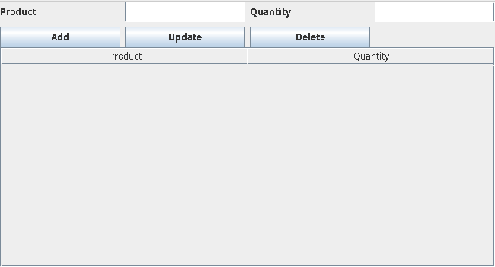

Q4 – Customer Feedback System

Code
import java.applet.Applet;
import java.awt.*;
import java.awt.event.*;

public class Main extends Applet implements ActionListener {
TextField name = new TextField(15);
Choice rating = new Choice();
Button submit = new Button("Submit");
Label result = new Label("Enter feedback");

public void init() {
rating.add("1");
rating.add("2");
rating.add("3");
rating.add("4");
rating.add("5");

add(new Label("Name"));
add(name);
add(new Label("Rating"));
add(rating);
add(submit);
add(result);
submit.addActionListener(this);
}

public void actionPerformed(ActionEvent e) {
if (name.getText().trim().isEmpty())
result.setText("Name required");
else
result.setText("Feedback submitted: " + name.getText() +
" | Rating: " + rating.getSelectedItem());
}
}

Output Screenshot
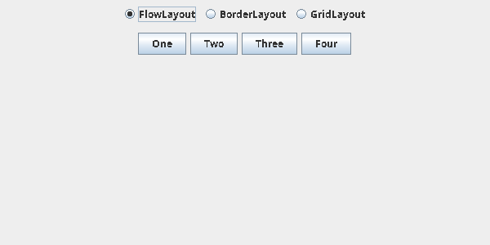

Q5 – Ticket Booking System

Code
import javax.swing.*;
import java.awt.*;

public class Main {
static boolean[] seats = new boolean[10];

public static void main(String[] args) {
JFrame f = new JFrame("Ticket Booking");
f.setLayout(new GridLayout(3, 4, 8, 8));

JLabel status = new JLabel("Select a seat");
for (int i = 0; i < seats.length; i++) {
int seatNo = i + 1;
JButton b = new JButton("Seat " + seatNo);
b.addActionListener(e -> {
if (!seats[seatNo - 1]) {
seats[seatNo - 1] = true;
b.setText("Booked " + seatNo);
status.setText("Seat " + seatNo + " booked");
} else {
seats[seatNo - 1] = false;
b.setText("Seat " + seatNo);
status.setText("Seat " + seatNo + " cancelled");
}
});
f.add(b);
}
f.add(status);
f.setSize(600, 300);
f.setDefaultCloseOperation(JFrame.EXIT_ON_CLOSE);
f.setLocationRelativeTo(null);
f.setVisible(true);
}
}

Output Screenshot
