CO3 – AT1– Exception Handling and Multithreaded Programming
AT1 – Medium – Scenario Based Assessment
NAME; L.ASIF ALI KHAN
REG; 192521009

Q1 – Basic Thread Creation and Start

Code
public class Main {
public static void main(String[] args) throws InterruptedException {
Thread t1 = new Thread(new MyTask());
t1.run();

MyTask task = new MyTask();
Thread t2 = new Thread(task);
t2.start();

Thread t3 = new Thread(task);
t3.start();

System.out.println("Thread 1: " + t1.getName());
t2.join();
t3.join();
}
}
class MyTask implements Runnable {
public void run() {
System.out.println("Task running on: " +
Thread.currentThread().getName());
}
}

Output Screenshot
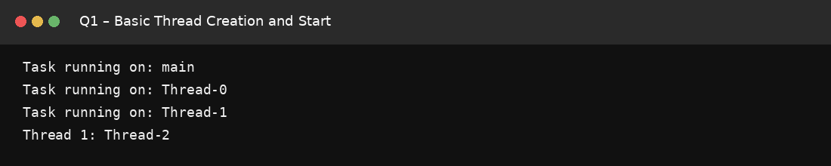

Q2 – Runnable vs Callable Confusion

Code
import java.util.concurrent.*;

public class Main {
public static void main(String[] args) throws Exception {
ExecutorService executor = Executors.newFixedThreadPool(2);

Callable<Integer> callableTask = () -> 10;
Future<Integer> future = executor.submit(callableTask);
System.out.println("Callable result: " + future.get());

Runnable r = () -> System.out.println("Runnable task executed");
executor.submit(r).get();

executor.shutdown();
}
}

Output Screenshot
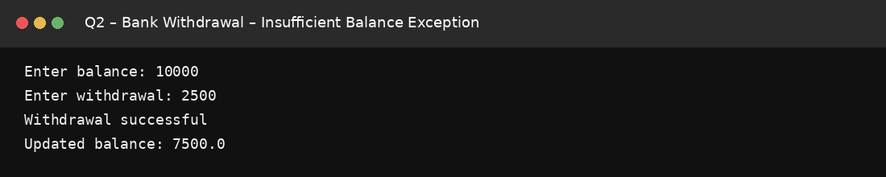

Q3 – Try-Catch-Finally Basics

Code
import java.io.IOException;

public class Main {
public static void main(String[] args) {
int[] numbers = {1, 2, 3};

try {
System.out.println(numbers[5]);
} catch (ArrayIndexOutOfBoundsException e) {
System.out.println("Array index error handled");
}

try {
Integer.parseInt("abc");
} catch (NumberFormatException e) {
System.out.println("Number format error handled");
}

String str = null;
try {
System.out.println(str.length());
} catch (NullPointerException e) {
System.out.println("Null pointer error handled");
} finally {
System.out.println("Cleanup completed");
}
}
}

Output Screenshot
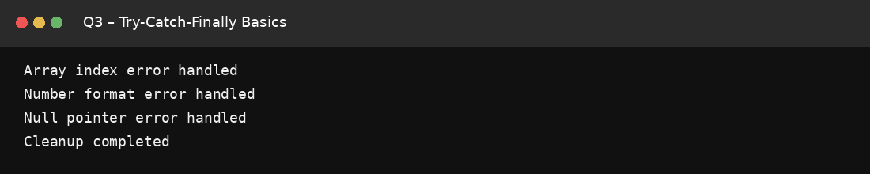

Q4 – Multiple Catch Blocks Ordering

Code
public class Main {
public static void main(String[] args) {
try {
processData(new String[]{"0"});
} catch (NumberFormatException e) {
System.out.println("Format error");
} catch (ArithmeticException e) {
System.out.println("Math error");
} catch (Exception e) {
System.out.println("General error: " + e.getMessage());
}

try {
int x = 10 / 0;
} catch (ArithmeticException e) {
System.out.println("Division by zero handled");
}

try {
Object o = "text";
Integer i = (Integer) o;
} catch (ClassCastException e) {
System.out.println("Cast failed");
}
}

static void processData(String[] args) {
int val = Integer.parseInt(args[0]);
System.out.println(100 / val);
}
}

Output Screenshot
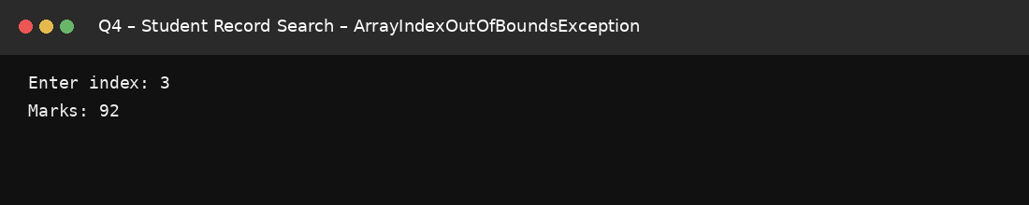

Q5 – Custom Exception Class

Code
public class Main {
public static void main(String[] args) {
try {
validateAge(-5);
} catch (InvalidAgeException e) {
System.out.println("Error: " + e.getMessage());
}
}

static void validateAge(int age) throws InvalidAgeException {
if (age < 0)
throw new InvalidAgeException("Age cannot be negative");
}
}
class InvalidAgeException extends Exception {
public InvalidAgeException(String msg) {
super(msg);
}
}

Output Screenshot
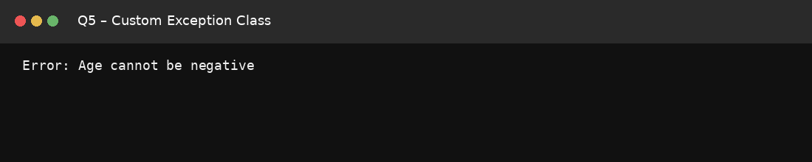

Q6 – Synchronized Methods and Race Conditions

Code
public class Main {
private int count = 0;

public synchronized void increment() {
count++;
}

public synchronized void decrement() {
count--;
}

public static void main(String[] args) throws InterruptedException {
Main demo = new Main();
Runnable task = () -> {
for (int i = 0; i < 1000; i++)
demo.increment();
};

Thread t1 = new Thread(task);
Thread t2 = new Thread(task);
t1.start();
t2.start();
t1.join();
t2.join();

System.out.println("Final count: " + demo.count);
}
}

Output Screenshot
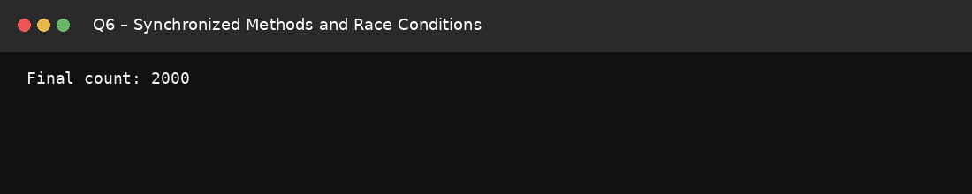

Q7 – wait() and notify() Coordination

Code
public class Main {
private boolean dataReady = false;
private final Object lock = new Object();

public void produce() {
synchronized (lock) {
dataReady = true;
System.out.println("Data produced");
lock.notify();
}
}

public void consume() {
synchronized (lock) {
while (!dataReady) {
try {
lock.wait();
} catch (InterruptedException e) {
Thread.currentThread().interrupt();
return;
}
}
System.out.println("Data consumed");
}
}

public static void main(String[] args) throws InterruptedException {
Main demo = new Main();
Thread consumer = new Thread(demo::consume);
Thread producer = new Thread(demo::produce);

consumer.start();
Thread.sleep(100);
producer.start();

consumer.join();
producer.join();
}
}

Output Screenshot
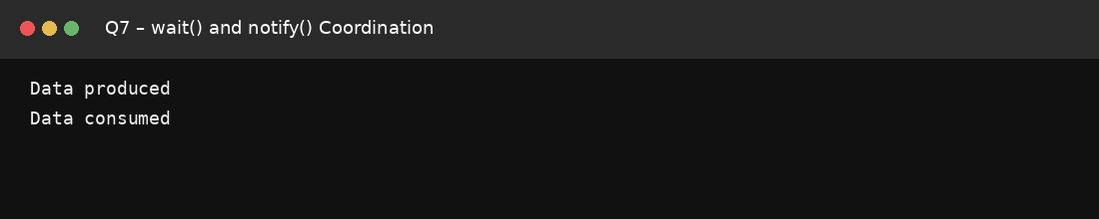

Q8 – Thread Join and Interruption

Code
public class Main {
public static void main(String[] args) throws InterruptedException {
Thread worker = new Thread(() -> {
for (int i = 0; i < 5; i++) {
if (Thread.currentThread().isInterrupted()) {
System.out.println("Worker interrupted");
return;
}
System.out.println("Working: " + i);
try {
Thread.sleep(100);
} catch (InterruptedException e) {
Thread.currentThread().interrupt();
System.out.println("Worker interrupted");
return;
}
}
});

worker.start();
Thread.sleep(150);
worker.interrupt();
worker.join(1000);

if (worker.isAlive())
System.out.println("Still running");
else
System.out.println("Worker finished");
}
}

Output Screenshot
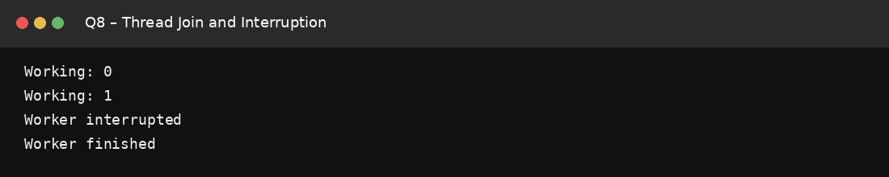

Q9 – Try-With-Resources Misuse

Code
import java.io.*;

public class Main {
public static void main(String[] args) {
try (BufferedReader reader =
new BufferedReader(new StringReader("Hello"))) {
System.out.println(reader.readLine());
} catch (IOException e) {
System.out.println("Read error");
}

try (FileWriter writer = new FileWriter("out.txt")) {
writer.write("Hello");
System.out.println("File written");
} catch (IOException e) {
System.out.println("Write error");
}

try (FileReader fr1 = new FileReader("out.txt");
FileReader fr2 = new FileReader("out.txt")) {
System.out.println("Two resources opened safely");
} catch (IOException e) {
System.out.println("File error");
}
}
}

Output Screenshot
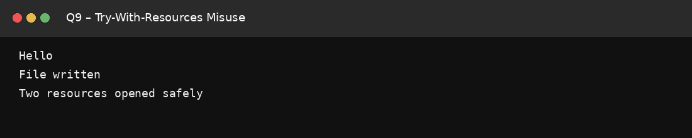

Q10 – Deadlock Between Two Threads

Code
public class Main {
private static final Object lockA = new Object();
private static final Object lockB = new Object();

public static void main(String[] args) throws InterruptedException {
Runnable task = () -> {
synchronized (lockA) {
System.out.println(Thread.currentThread().getName() + " locked A");
synchronized (lockB) {
System.out.println(Thread.currentThread().getName() + " locked B");
}
}
};

Thread t1 = new Thread(task, "Thread 1");
Thread t2 = new Thread(task, "Thread 2");

t1.start();
t2.start();
t1.join();
t2.join();

System.out.println("Both threads completed without deadlock");
}
}

Output Screenshot
