1. Write a program to print numbers from 1 to 100.

#include <stdio.h>

void main()

{

for (int i = 1; i <= 100; i++) {

printf("%d ", i);

}

return ;

}

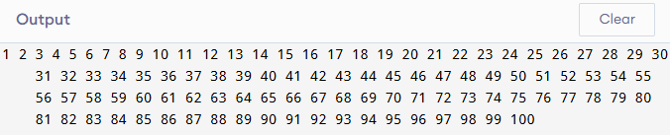

2. Write a program to print even numbers from 1 to 50.

#include <stdio.h>

void main()

{

for (int i = 2; i <= 50; i += 2) {

printf("%d ", i);

}

return ;

}

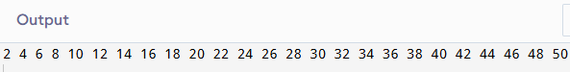

3. Write a program to find the factorial of a number.

#include <stdio.h>

void main()

{

int n;

long long fact = 1;

printf("Enter a number: ");

scanf("%d", &n);

for (int i = 1; i <= n; i++) {

fact \*= i;

}

printf("Factorial: %lld\n", fact);

return ;

}

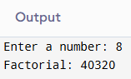

4. Write a program to calculate the sum of digits of a number.

#include <stdio.h>

void main()

{

int num, sum = 0;

printf("Enter a number: ");

scanf("%d", &num);

while (num != 0) {

sum += num % 10;

num /= 10;

}

printf("Sum of digits: %d\n", sum);

return ;

}

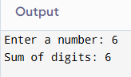

5. Write a program to reverse a number.

#include <stdio.h>

void main()

{

int num, rev = 0;

printf("Enter a number: ");

scanf("%d", &num);

while (num != 0) {

rev = rev \* 10 + num % 10;

num /= 10;

}

printf("Reversed number: %d\n", rev);

return ;

}

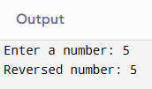

6. Write a program to check whether a number is a palindrome.

#include <stdio.h>

void main()

{

int num, original, rev = 0;

printf("Enter a number: ");

scanf("%d", &num);

original = num;

while (num != 0) {

rev = rev \* 10 + num % 10;

num /= 10;

}

if (original == rev)

printf("Palindrome\n");

else

printf("Not a palindrome\n");

return ;

}

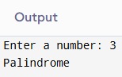

7. Write a program to print multiplication table of a number.

#include <stdio.h>

void main()

{

int num;

printf("Enter a number: ");

scanf("%d", &num);

for (int i = 1; i <= 10; i++) {

printf("%d x %d = %d\n", num, i, num \* i);

}

return ;

}

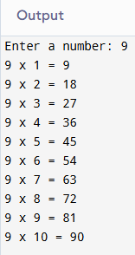

8. Write a program to count the number of digits in a number.

#include <stdio.h>

void main()

{

int num, count = 0;

printf("Enter a number: ");

scanf("%d", &num);

if (num == 0) count = 1;

while (num != 0) {

count++;

num /= 10;

}

printf("Number of digits: %d\n", count);

return ;

}

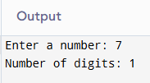

9. Write a program to print the Fibonacci series up to n terms.

#include <stdio.h>

void main()

{

int n, a = 0, b = 1, next;

printf("Enter number of terms: ");

scanf("%d", &n);

for (int i = 0; i < n; i++) {

printf("%d ", a);

next = a + b;

a = b;

b = next;

}

return ;

}

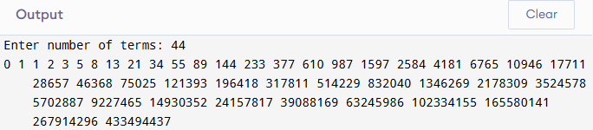

10. Write a program to calculate the sum of the first n natural number.

#include <stdio.h>

void main()

{

int n, sum = 0;

printf("Enter n: ");

scanf("%d", &n);

for (int i = 1; i <= n; i++) {

sum += i;

}

printf("Sum of first %d natural numbers: %d\n", n, sum);

return ;

}

