SOFTWARE REQUIREMENT SPECIFICATION (SRS)

Project Title: Smart Complaint & Issue Tracking System

Prepared by

Student ID | Name
24341132 | Saikat Rahman Asif
20101047 | Ifaz Ahanaf Zaman
23101205 | Mohammed Tashfiqul Islam
24101302 | Yasin Musa Saad

1. Introduction

1.1 Type of Project
The Smart Complaint & Issue Tracking System is a web-based management system designed to handle internal complaints within an organization.

1.2 Purpose of the Project
The purpose of this system is to:
- Provide a structured platform for submitting complaints.
- Ensure complaints are assigned to appropriate departments.
- Track complaint progress from submission to resolution.
- Maintain transparency through action history logging.
- Generate analytics and reports for administrative monitoring.

1.3 Target Users
The system is designed for:
- Admin: Manages users, assigns complaints, and monitors system performance.
- Employee: Submits complaints and tracks their status.
- Staff: Resolves complaints within assigned departments.

2. Functional Requirements
The system shall provide the following functionalities:

2.1 User Management
- The system shall support role-based access (Admin, Employee, Staff).
- The Admin shall create user accounts.
- The Admin shall update user accounts.
- The Admin shall deactivate user accounts.
- Users shall log in and log out securely.

2.2 Complaint Management
- Employees shall submit complaints with a title, description, category, and priority.
- Employees shall edit complaints before assignment.
- Employees shall view their submitted complaints.
- Admin shall assign complaints to departments (HR, IT, Finance, Marketing & Sales, Software & Product Development).
- Staff shall view department-specific complaints.
- Staff shall update the complaint status (Pending, In Progress, Resolved).
- Staff shall add resolution notes.

2.3 Tracking & Logging
- The system shall maintain a complaint action history.
- The system shall calculate the resolution time.
- The system shall support priority escalation.

2.4 Attachments
- Users shall upload complaint attachments.
- Users shall delete uploaded attachments.

2.5 Notifications
- The system shall send automated notifications when:
- The complaint is assigned
- Status is updated
- The complaint is resolved

2.6 Reports & Analytics
- Admin shall view the dashboard summary.
- System shall generate:
- Department-wise reports
- Priority-wise reports
- Average resolution time report

2.7 Search & Filter
- The system shall allow searching for complaints by:
- Keyword
- Category
- Status
- Priority

3. Non-Functional Requirements
- Passwords must be encrypted.
- Role-based access must restrict unauthorized actions.
- Only Admin can manage users.

- The system should respond within 2–3 seconds.
- Reports should be generated within 5 seconds.

- The interface should be simple and user-friendly.
- Dashboard should display clear statistics.

- Complaint data must not be lost.
- Action history must remain consistent.

- The system should handle an increasing number of users and complaints.

- Strictly follows MVC Architecture

4. Class Diagram

CSE470_Project_Group_8

5. Tools and Technologies

5.1 Frontend
The frontend of the system is developed using:
- JavaScript – Core programming language for client-side logic.
- React.js – A JavaScript library used to build interactive and dynamic user interfaces.

5.2 Backend
The backend of the system is developed using:
- Node.js – JavaScript runtime environment used to execute server-side code.
- Express.js – A lightweight web framework for Node.js.

5.3 Database
- MongoDB – A NoSQL document-based database.

5.4 Other Tools
- VS Code – Code editor
- draw.io – Class Diagram
- Git & GitHub – Version control

6. Compatibility with System Environment / OS
The system is web-based and compatible with:
- Windows 10 / 11
- Linux
- macOS
Supported Browsers:
- Google Chrome
- Mozilla Firefox
- Microsoft Edge
Since it runs on a browser, it does not depend heavily on OS, only requires:
- Web browser
- Internet or local server environment

7. Implementation

To be updated with each Sprint.

20 Features:

- Role-based access control (Admin, Staff, Employee)

- Admin-managed user account creation

- User account update and deactivation

- Complaint submission with title, description, category, and priority

- Attachment upload for complaint evidence

- Complaint status tracking (Pending, In Progress, Resolved)

- Complaint editing before assignment

- View personal complaint history

- Assign complaints to departments (IT, HR, Facilities, etc.)

- Department-specific complaint inbox

- Update complaint status during resolution

- Add resolution comments and notes

- Maintain a complaint action history log

- Admin dashboard showing overall complaint summary

- Department-wise complaint report

- Priority-wise complaint statistics

- Average resolution time analytics

- Complaint search and filter functionality

- Automated notifications

- Priority escalation system

8. Challenges
- Designing proper role-based access control.
- Maintaining a complaint history without redundancy.
- Implementing automated notifications.
- Designing clean UML relationships.
- Maintaining MVC Structure.

9. Conclusion
The Smart Complaint & Issue Tracking System successfully provides a structured and transparent method to manage internal organizational complaints. It improves accountability, efficiency, and tracking of issues while generating meaningful analytics for management.
The system fulfills all 20 required features and demonstrates practical implementation of object-oriented design and database management concepts.

10. References
- Software Engineering Lecture Slides (CSE470)
- UML Documentation – draw.io
- W3Schools

SPRINT 1

(User Creation + complaint submission)
1: Admin-managed user account creation
2. Role-based access control
3. User account update and deactivation
4. Complaint submission
5. Complaint status tracking

Feature 1: Admin-managed user account creation

- user created role wise (Staff & Employee)
- user (admin) created by developer

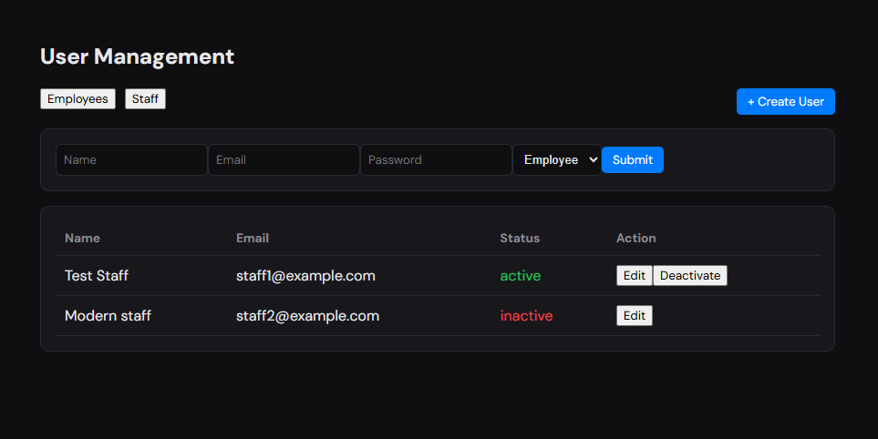

Feature 2: Role-based access control

Admin:
- can manage and see users
- manage complaints
- see report and analytics
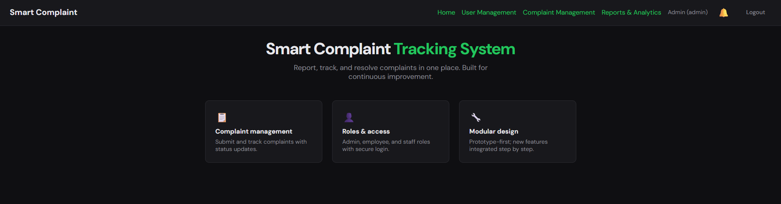

Staff:
- can see complaints assigned to them
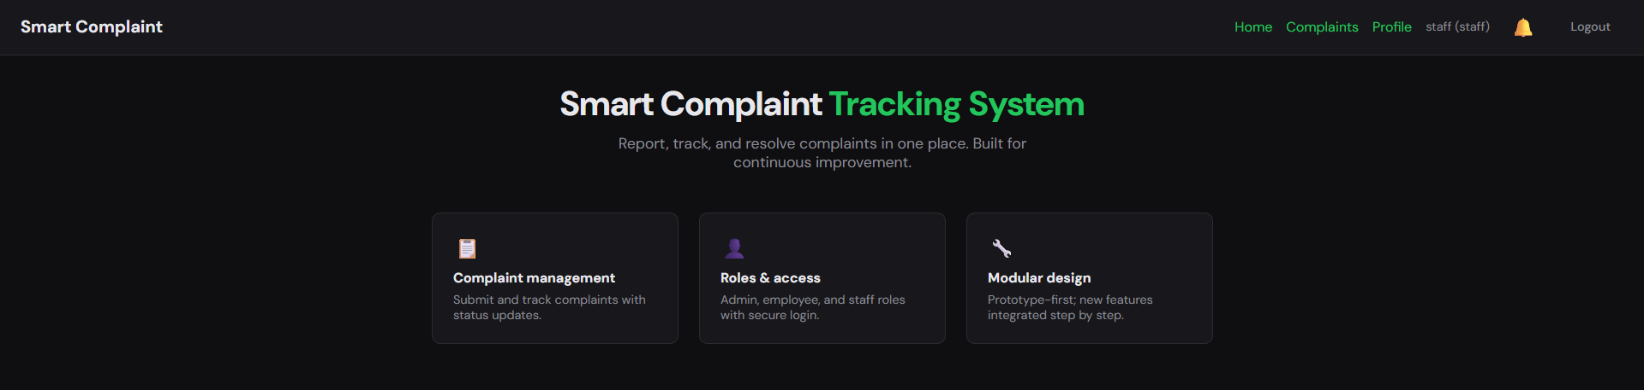

Employee:
- can register complaint
- track his registered complaints
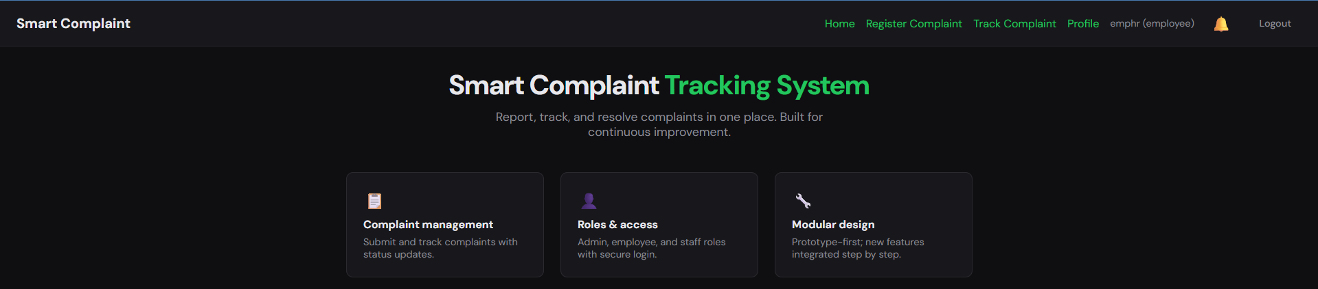

Feature 3: User account update and deactivation

- change user name, email, department
- deactivate user (user status changes to inactive with red mark)
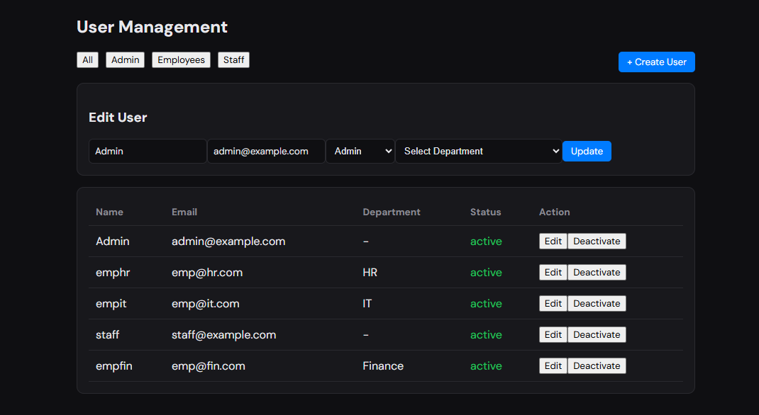

Feature 4: Complaint submission

- only employee can submit complaints

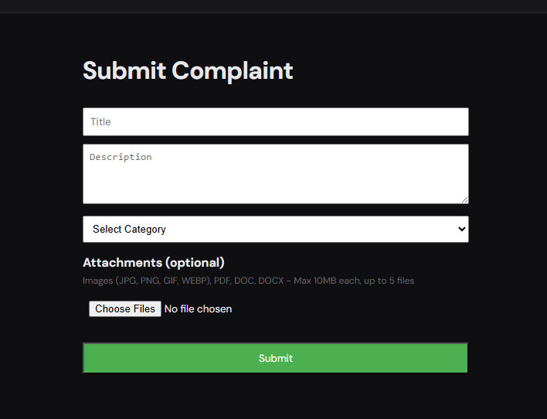
Feature 5: Complaint status tracking

- employee can track his own complaints
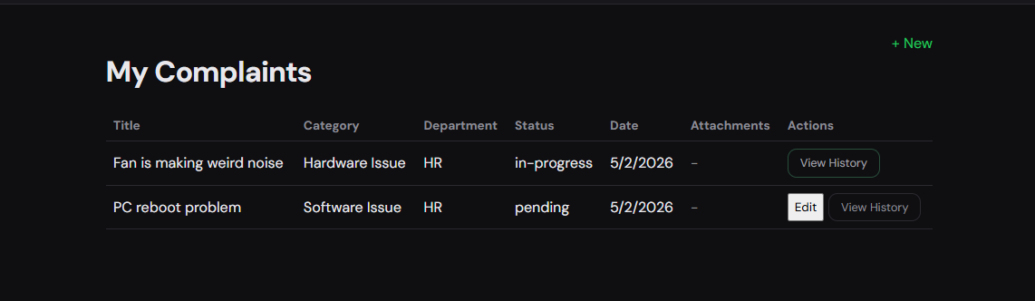

Sprint 2 (Complaint Management)
1.Complaint editing before assignment
2.View personal complaint history
3.Assign complaints to departments
4.Department-specific complaint inbox
5.Update complaint status during resolution

1.Complaint editing before assignment

Here, we can update the complaint after submitting and before assignment.

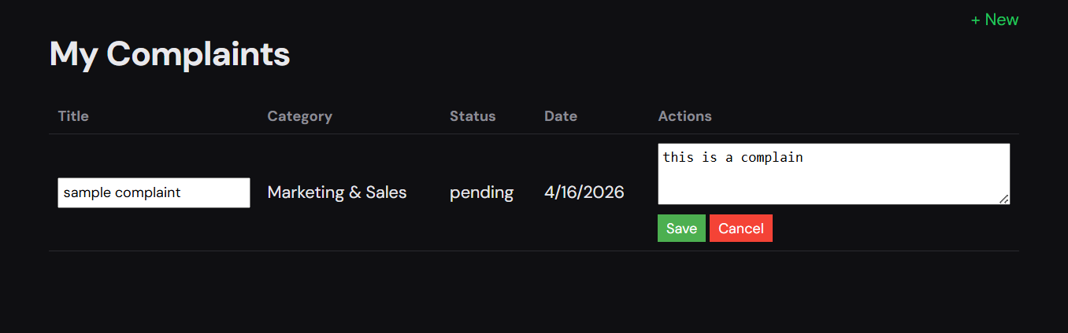

Now editing the complaint:

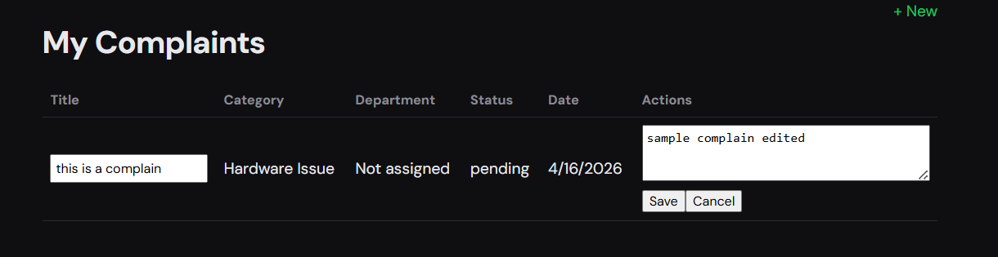

before:

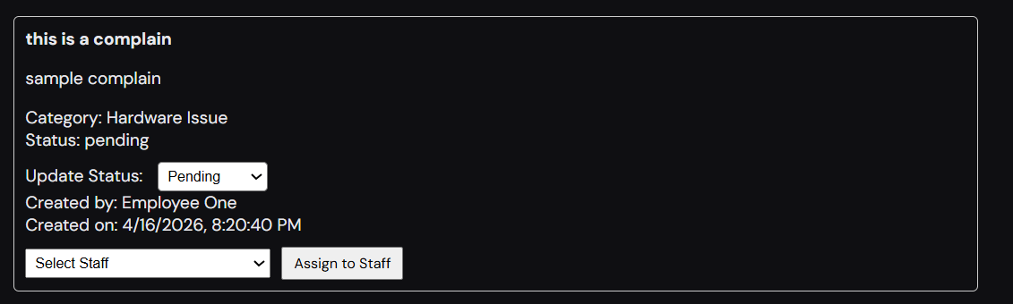
After:
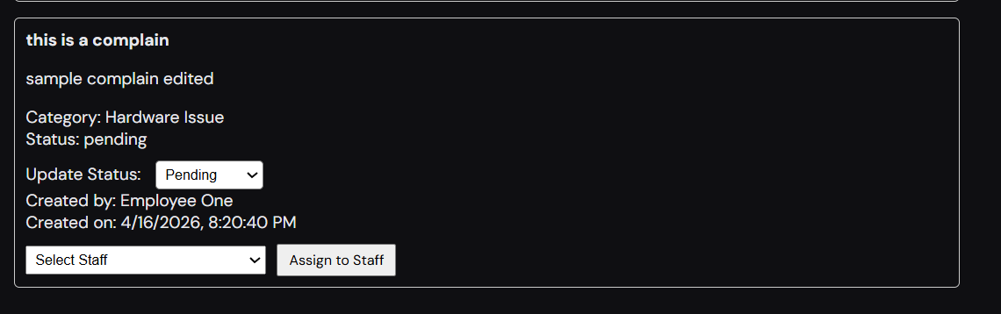

2.View personal complaint history

Employees can view their personal complaint history here.
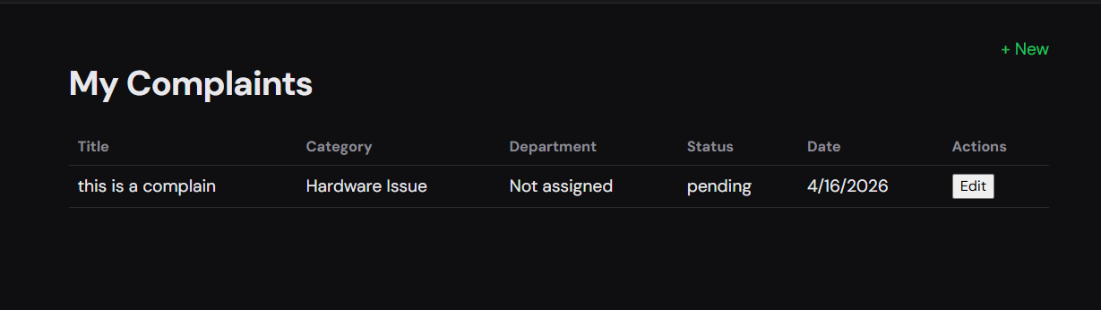

3. Assign complaints to departments

Here , we can assign complaints to individual departments.

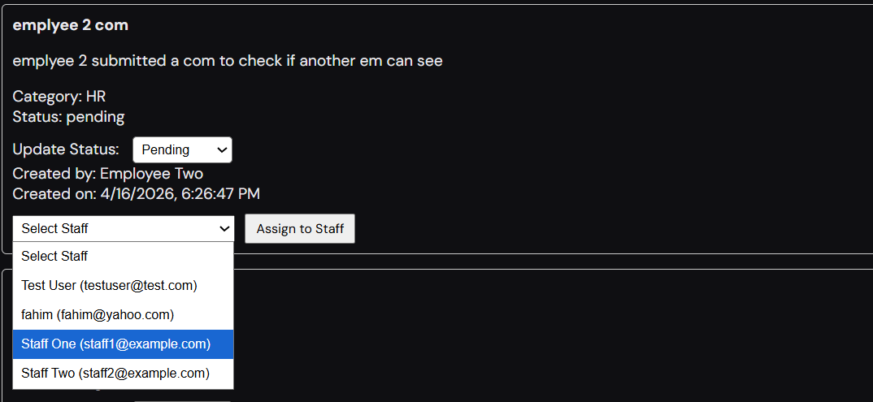
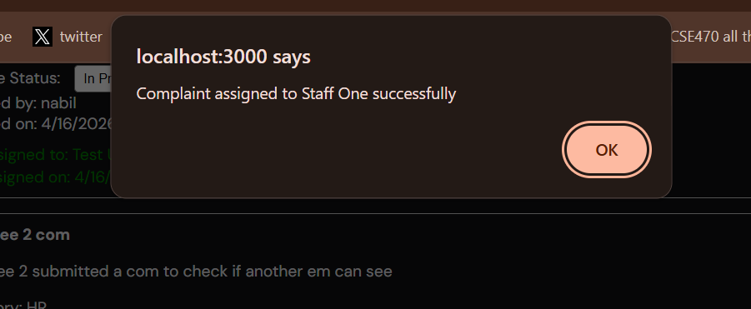
then , after logging into staff1@example.com , we see:
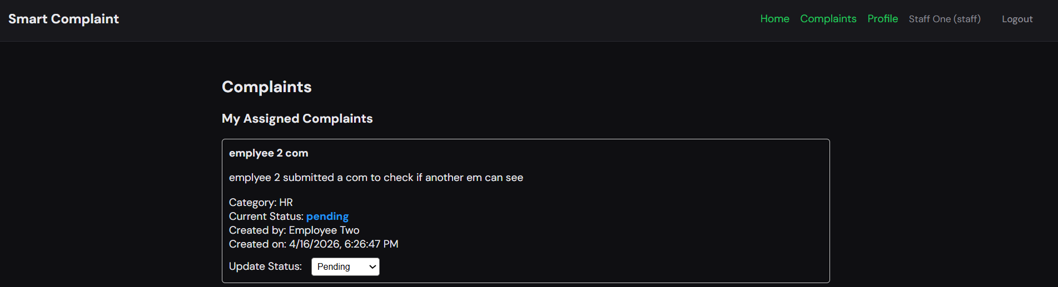
4.Department-specific complaint inbox

This is a detailed view of complaint lists.

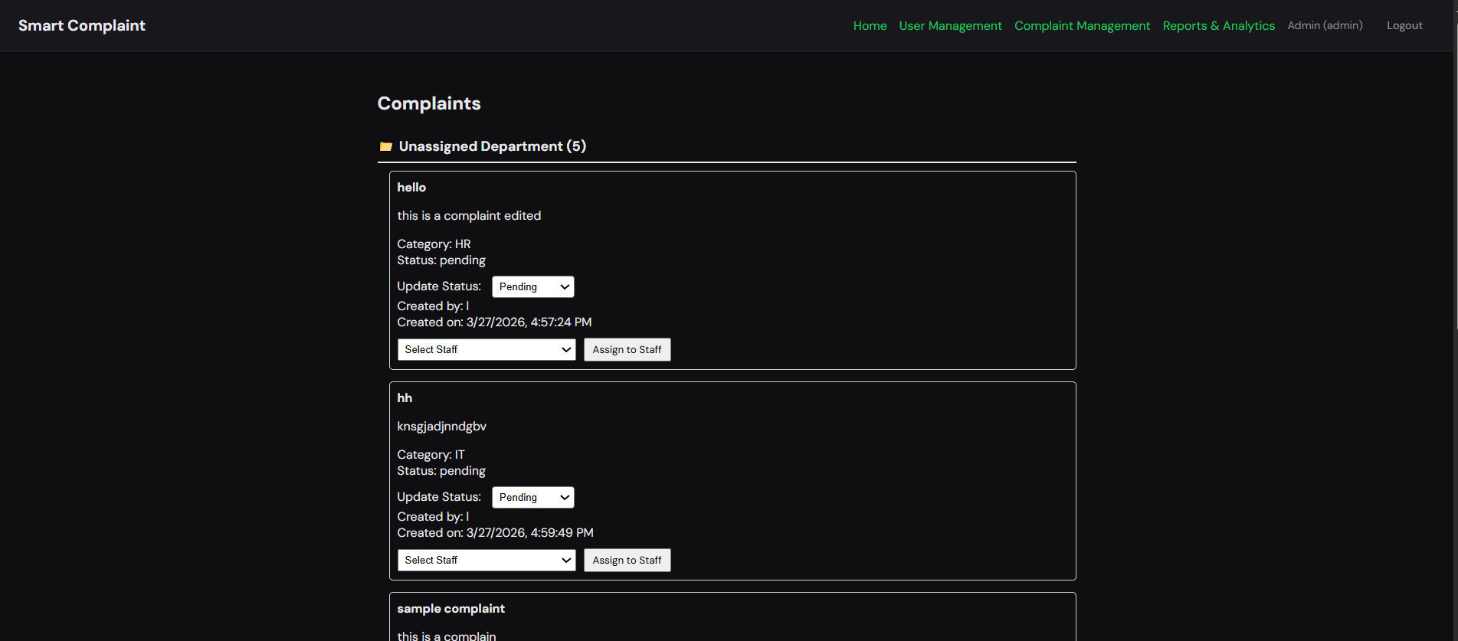

5.Update complaint status during resolution

Here , after submitting complaints , the admin can update the status of complaints.
First , we put status to ASSIGNED
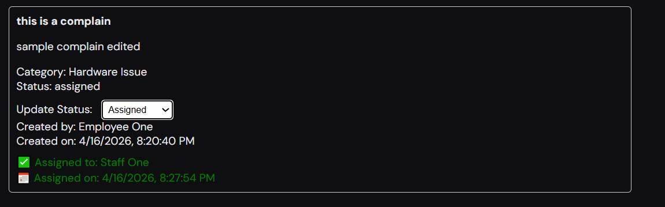

Then , on the employee1 track complaint option , we see status as ASSIGNED .

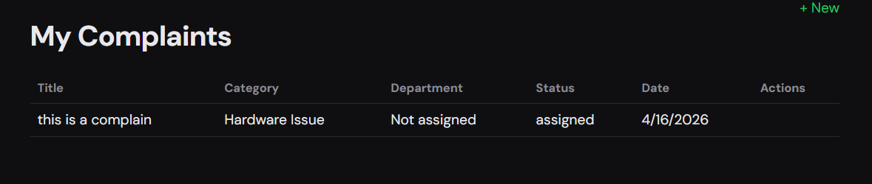

Now after changing to In Progress:
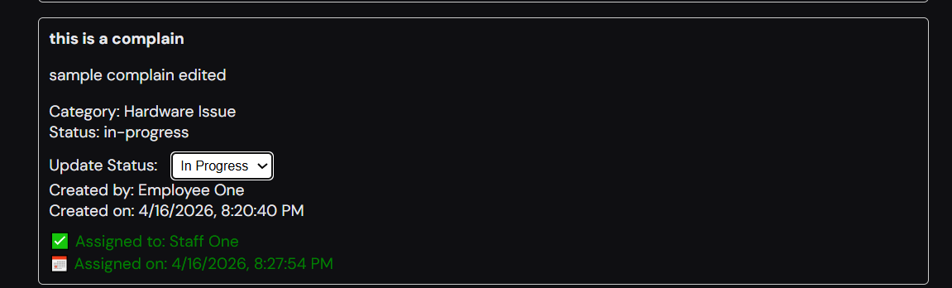

We see:

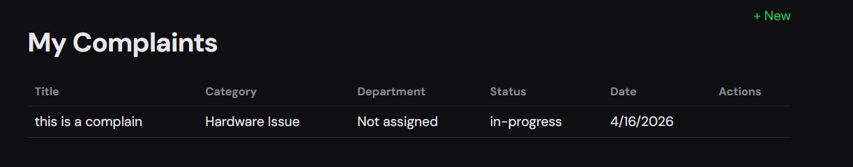

Sprint 3 (Workflow + Enhancements)
1.​ Add resolution comments and notes
2.​ Maintain a complaint action history log
3.​ Attachment upload
4.​ Complaint search and filter
5.​ Automated notifications

SS-01 (Feature 1+2 = COMMENT + HISTORY)
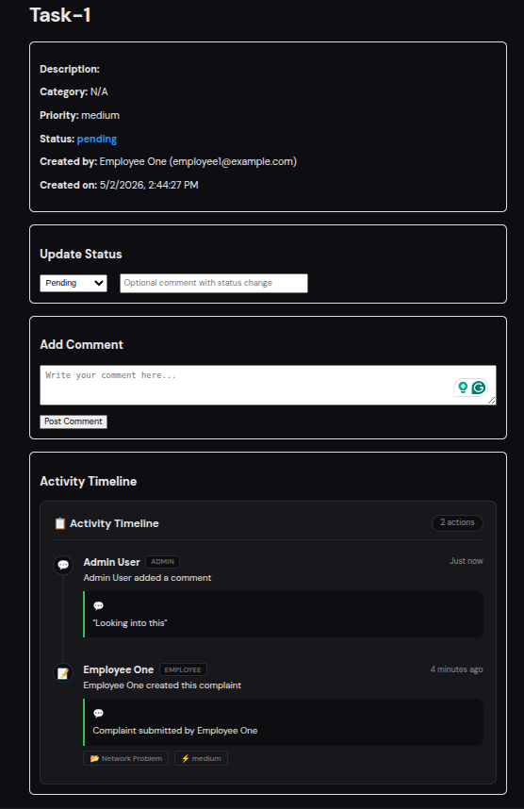
SS-02 (Feature 3 Attachment upload)

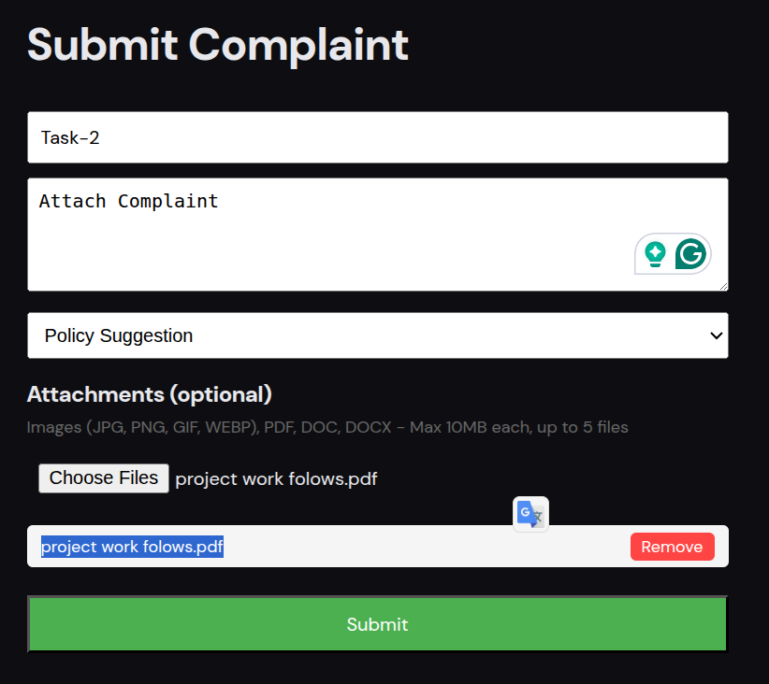

SS-03 (Feature 4 + 5 Complaint search and filter + Automated notifications)

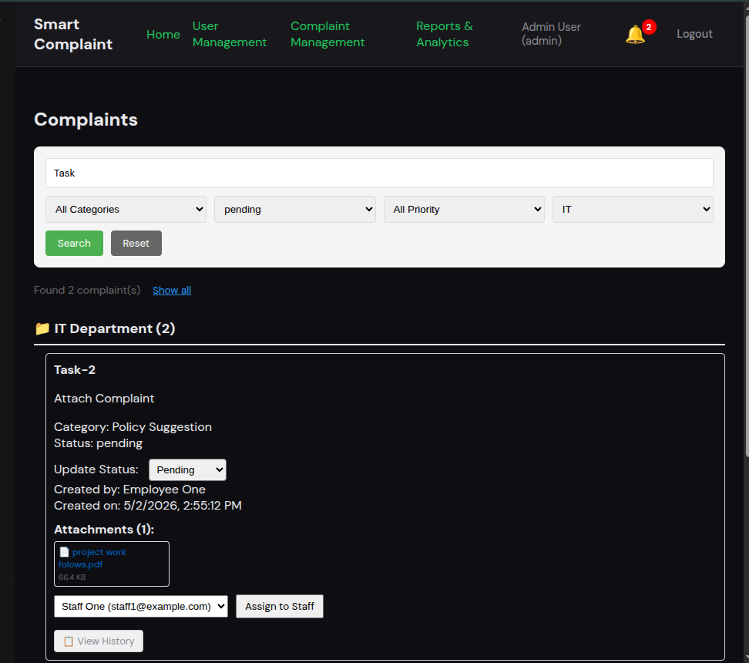

Sprint 4 (Priority and Analysis)
1. Priority Escalation System - Increases Priority but cannot be increased after Priority = critical.
2. Admin Dashboard - Shows the Report and Statistics.
3. Department-wise Report - Shows report and chart for each department.
4. Priority-wise Statistics - Shows statistics for low, medium, high and critical priorities.
5. Average Resolution time Analytics - Calculates average resolution time and rate for each department and priorities.

1. Priority Escalation System

Before and after Escalation
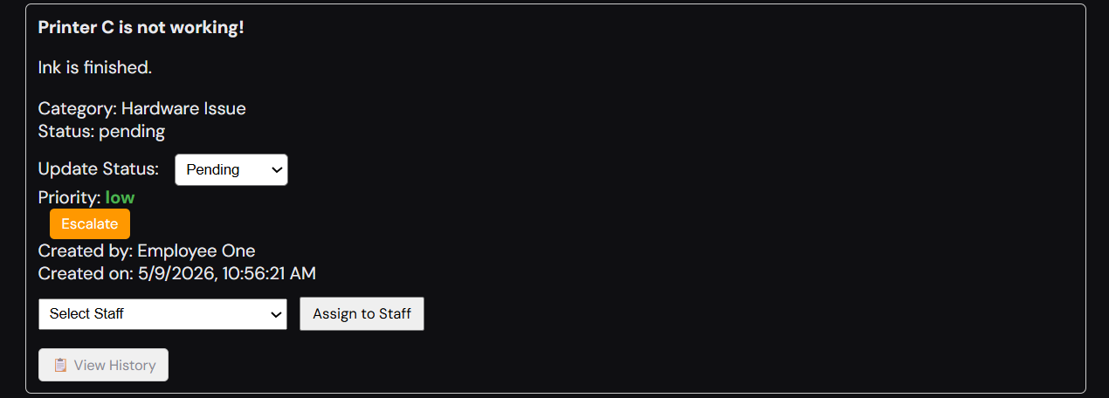
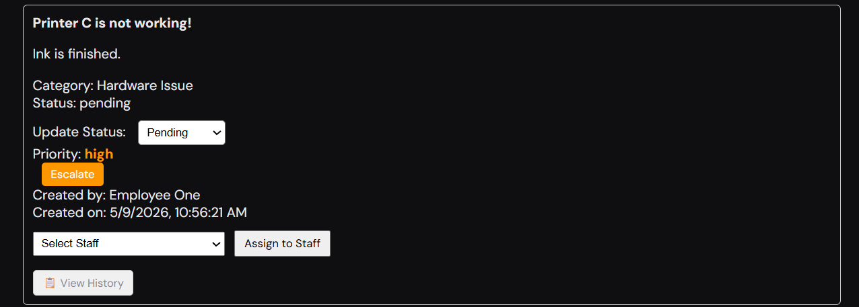

No more escalations after critical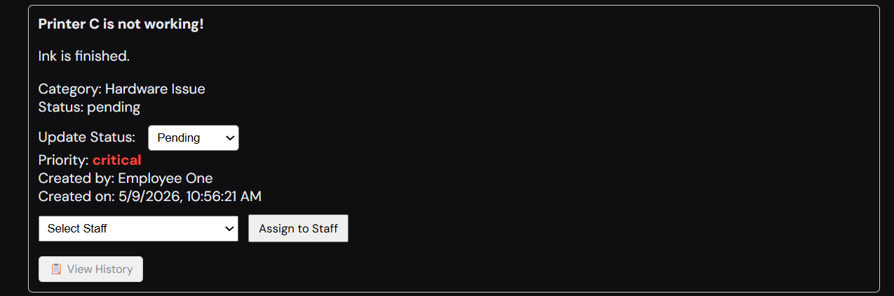

2. Admin Dashboard
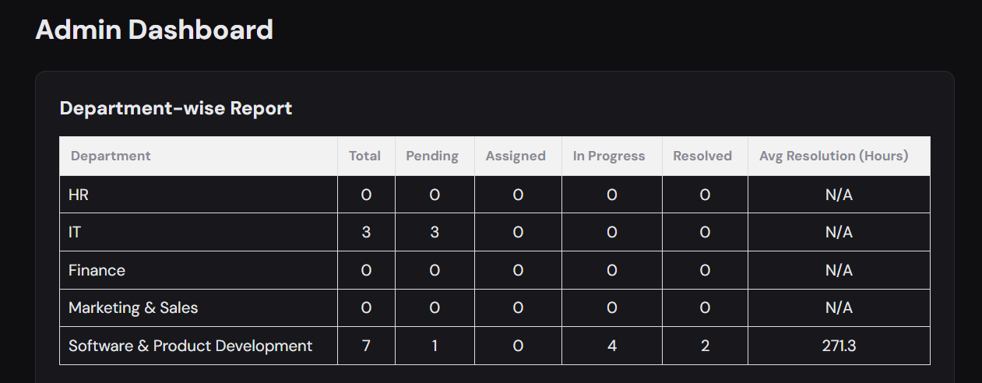
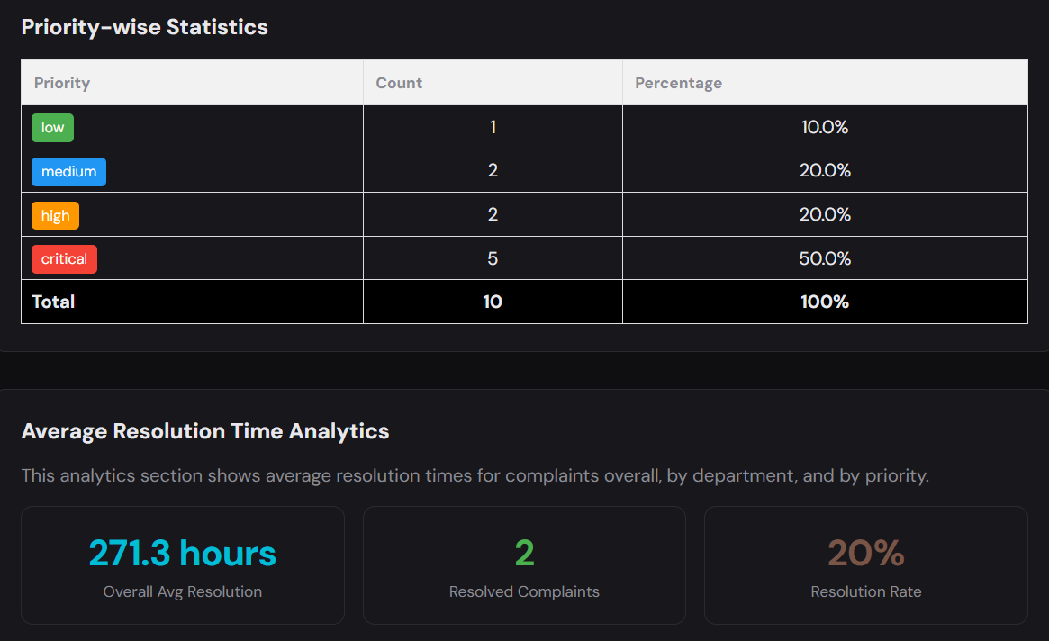

3. Department-Wise Report
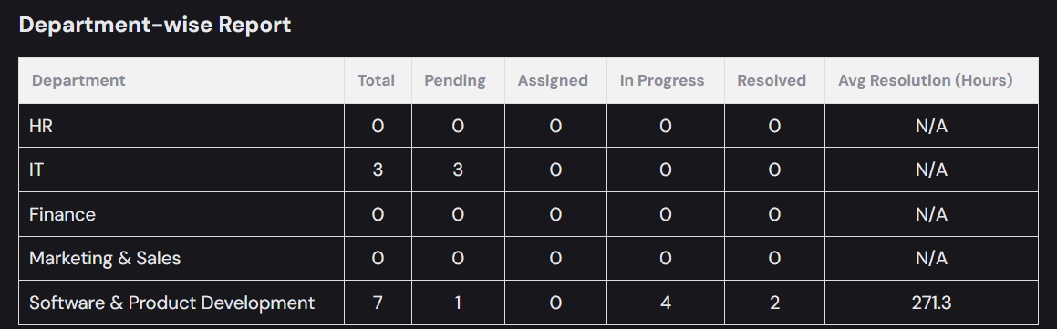

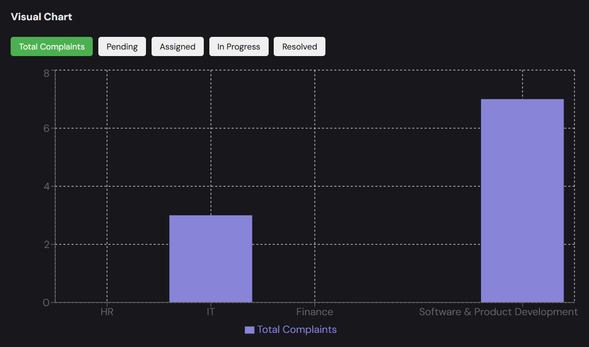

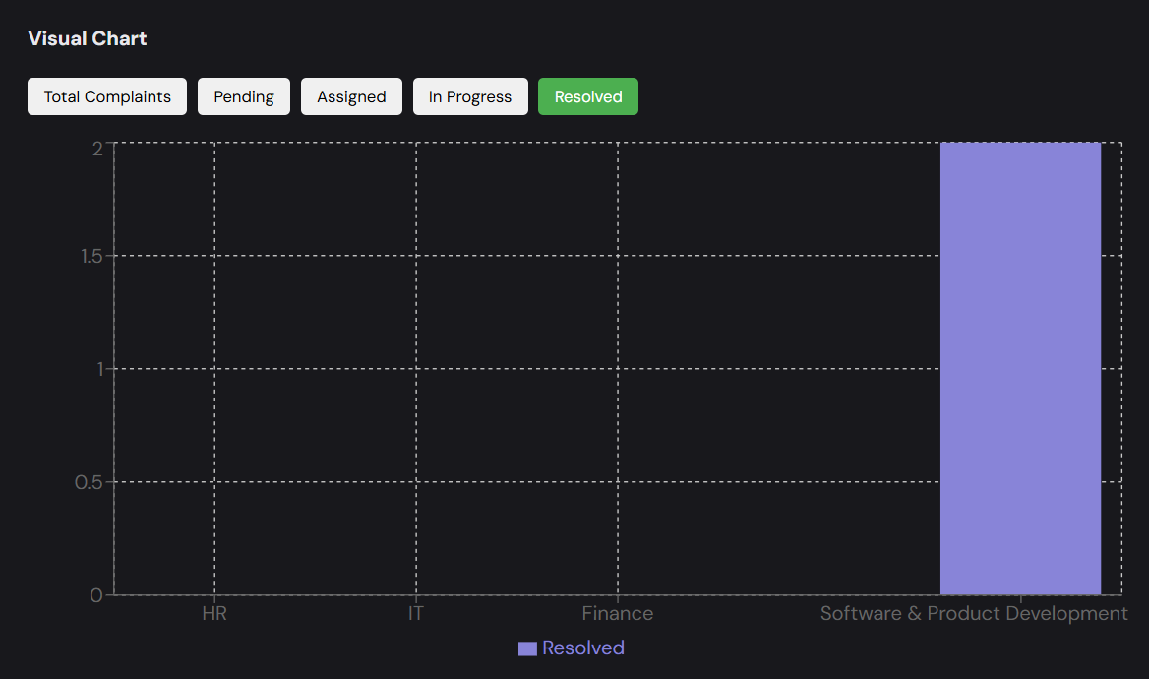

4. Priority-Wise Statistics
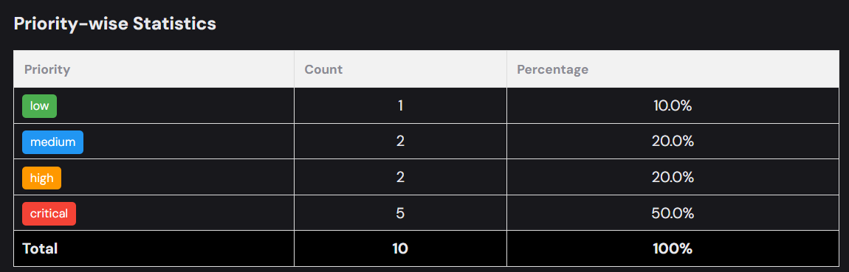

5. Average Resolution Time Analytics
