**Project Documentation**

**Submitted By:**

**Member 1: Emaz Uddin Ahmad (C173035)**

**Member 2: Habibullah Md. Asif (C173089)**

**Student ID: C173035, C173089**

**Project Name: Take A Trip**

**Course Instructor: DR. Abdul Kadar Muhammad Masum**

**Date Of Submission: 15-01-2021**

**Course Code: CSE-3640**

**Course Title: Software Development**

**Introduction**

**Project Name:** Take A Trip

**Project Description:** This is a web application where you can select a place for your next tour. There are several tour packages. You can select a place then the packages that are available. Select the set meal for your trip and transportation system. You have to select all that and we will book it for you. The payment system will be in bkash.

**Purpose:**  Our aim is to provide the people a comfortable journey and better travel experience for the traveler. From our website anyone can reserve a travel location inside Bangladesh in a cheap cost. The traveler doesn’t have to worry about ticket booking or resort booking or anything. The customer just have to reserve their trip in our website then we will arrange everything for him including that we will also provide a local guide. Our main purpose is to make travel easy for the people of our country, so that they can travel to their desired location without any hassle.

**The Scope Of the Work:** Now a days travelling is becoming a trend to the people of our country. Through the social media now a largest amount of people know that there are many places to visit in our country and the places are beautiful. So people are travelling to the tourist spot more than ever. So our project has a big scope in this field. In near future the demand will be more increased as we hope.

**Requirement Analysis**

**System Requirements:**

* Software Requirement.
* Hardware Requirements.

**Software Requirements:**

* Operating System : Windows 7,8.
* Technology : PHP, MySql,Sql
* Web technology : Html, CSS , JavaScript, Bootstrap.
* IDE : VS Code
* Database : Xampp

**Hardware Requirements:**

* Processor : intel core i3 or higher.
* Ram : 2GB (minimum), 4GB( recommended)
* Hard disk : 1TB
* Graphics Card : Not recommended
* Input Device : Mouse, Keyboard.
* Output Device : Monitor

**Functional Requirement:**

**Number of Modules:** After careful analysis the system has been identified to have the followingmodules:

**1. Administrator module**

**2. Travels module**

**3. Routes module**

**4. Reservations module**

**1. ADMINISTRATOR MODULE:**

This module provides administrator related functionality. Administrator manages all information and has access rights to add, delete, edit and view the data related to places, travels, routes, bookings, restaurants etc.

**2. TRAVELS MODULE:**

This module provides the details of various travel agencies. A user can select the appropriate agency depending on convenience and accessibility.

**3. ROUTES MODULE:**

This module provides information related to various routes connecting sources and destinations. For each route, information such as source, destination, fare, reservation details, pick up points etc are provides. Only administrator can add , delete, edit and manage the data. Users can only view the information.

**4. RESERVATIONS MODULE:**

This module provides functionalities that allow a user to book tickets or cancel previously booked tickets. The module maintains the details of all reservations made so far and allows administrator to either confirm or reject the bookings.

**Non-Functional Requirements:**

**Performance:** We have make sure that our website will not fail due to more user. Due to more user the performance of the website will not drop.

**External Requirements:** We will try to merge with bkash for improvising our payment system.

**Feasibility Study**

**Feasibility Study:** Feasibility study is an assessment of the practicality of a proposed project or system. Our project Take A Trip is feasible because of the following cause or feasibility:

**Technical Feasibility:** It was decide that the Take_A_Trip application system was technically feasible because of the following Take A Trip is a web based application. The technology and tools that are used for this project are:

**Frontend:**

* Html
* CSS
* JavaScript
* Bootstrap

**Backend:**

* PHP
* MySql
* Sql

Each of the technologies are freely available and there are thousand online resources for all of this. Initially it is our plan to host the web application in a free web hosting space. But for later on it will be hosted in paid web hosting space with a sufficient bandwidth. Bandwidth required in this application is very low as it does not contain too much multimedia file. This web application is also user friendly as for the following cause:

* The system has very simple structure and easy to understand by its user.
* Also software used to build the system is simple enough in their usage and functionality.
* To operate this system only a web browser is needed. The system is platform independent and browser independent and supports all kinds of web browsers like Internet Explorer, Mozilla Firefox, Google Chrome, etc .
* The system can be expanded if so decided.

**Operational Feasibility :** It was decided that proposed system could be created as a web based applicition that be operated by all the clients.

1. The system is designed in such a way that it is a easy to operations.

2. The system does not in involve any complex operations.It handles only simple data oriented functions.

3. It is aimed at giving an easy way to generate reports.

4. Amount of knowledge and expertise required for being able to used this system is not much more than what it requires to operate a computer system.

5. The Client must have only the basic knowledge of web browsers.

6. The web server and database server should be protected from hacking, virus etc.

7. Customer will use the forms for their various transactions i.e. for adding new routes, viewing the routes details. Also the customer wants the reports to view various transactions based on the constraints. These forms and reports are generated as user-friendly to the Client.

8. The application will be developed using standard open source software like python,Internet Explorer Browser etc these software will work both on Windows and Linux o/s. Hence portability problems will not arise. Hence there is no need of any special person with any particular qualification or expertise in any filed to use the Take_A_Trip application.

**Economic Feasibility:** Our project Take A Trip is economically feasible. The cost to build this web application is low. And there are hundreds of travel agents in Bangladesh to whom this application will be very useful. So it can be further used by the agencies to do their work easily. As they don’t need to contact their customers physically until they confirm their trip. As for the customers they will use it because it will help them to find the best trip in a minimum cost. This application will be easy to use so almost everyone can use it. In cost benefit analysis the benefit drawn from this project should overcome the cost of this project.

**Legal Feasibility:** The proposed project Take A Trip does not conflict with any of the legal requirements so it is legally feasible. As the travel agencies that have legal licence that is issued by the govt. And the contents of this project are all tourism based so the project must not conflict with the laws of government.

**Schedule Feasibility:** The project is a simple web based application. The project will be completed within its scheduled time limit. As the functionality of the application is very simple we can hope that the project will successfully completed before the scheduled time limit.

**SWOT analysis of the project:**

**Strengths:** Low cost of products and services.

**Weakness:** As a new web application in this field, it might take some time for ourorganization to break into the market because there are already many webapplication available in this field like tripmate, tripadvisor and so gain acceptanceespecially from corporate clients in the already saturated travels and toursindustry; that is perhaps our major weakness.

**Opportunities:** The opportunities of this application is massive considering the number of individuals, families and corporate organizations who travels on a daily basis within the Bangladesh and to other parts of the world. We are ready to take advantage of any opportunity that comes our way.

**Threat:** Some of the threats that we are likely going to face as a few number of travels and tours agencies operating in the Bangladesh have govt. licence, and there are many application that are available for free in this sector which are operating for a long time now. So taking place in this competitive market is the biggest treat we will face .There is hardly anything we can do as regards these threats other than to be optimistic that things will continue to work for our good.

**Implementation**

**Used Software & tools:** VS Code,Xampp

**Frontend:** Html, CSS, JavaScript, Bootstrap

**Backend:** PHP, MySql, Sql.

**Base:** Website.

**Base Website:**  Tripadvisor**:** <https://www.tripadvisor.in/>

Tripmate: <http://www.tripmate.com/>

**Data Flow Diagram Of the Project:**

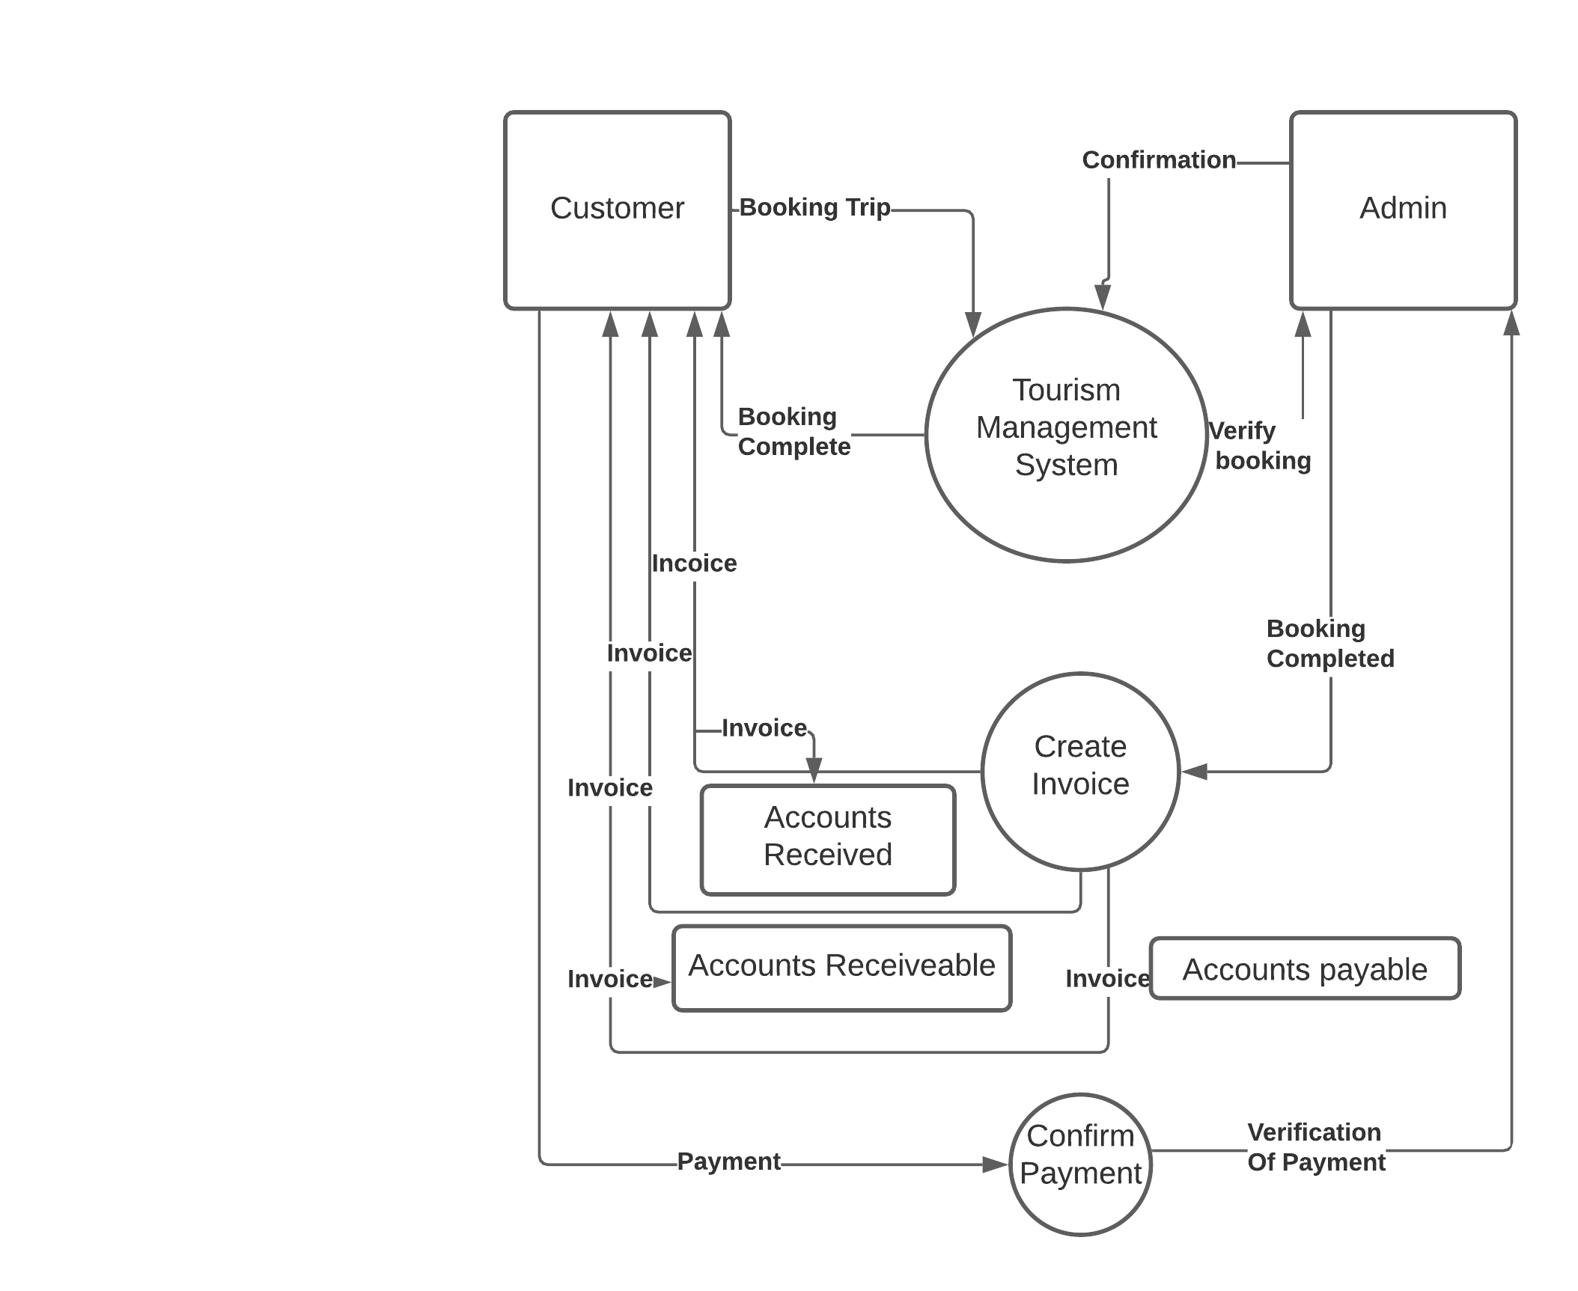

|  |  |  |
| --- | --- | --- |
| **Symbol** | **Name** | **Description** |
|  | External Entity | Entity is the persons who are interacting  In the dfd. |
|  | Data Flow | This symbol shows the data flow in dfd. |
| **Symbol** | **Name** | **Description** |
|  | Process | This symbol shows the data process in dfd. |
|  | Data Store | This symbol shows the data store in dfd. |

**Use Case Diagram:**

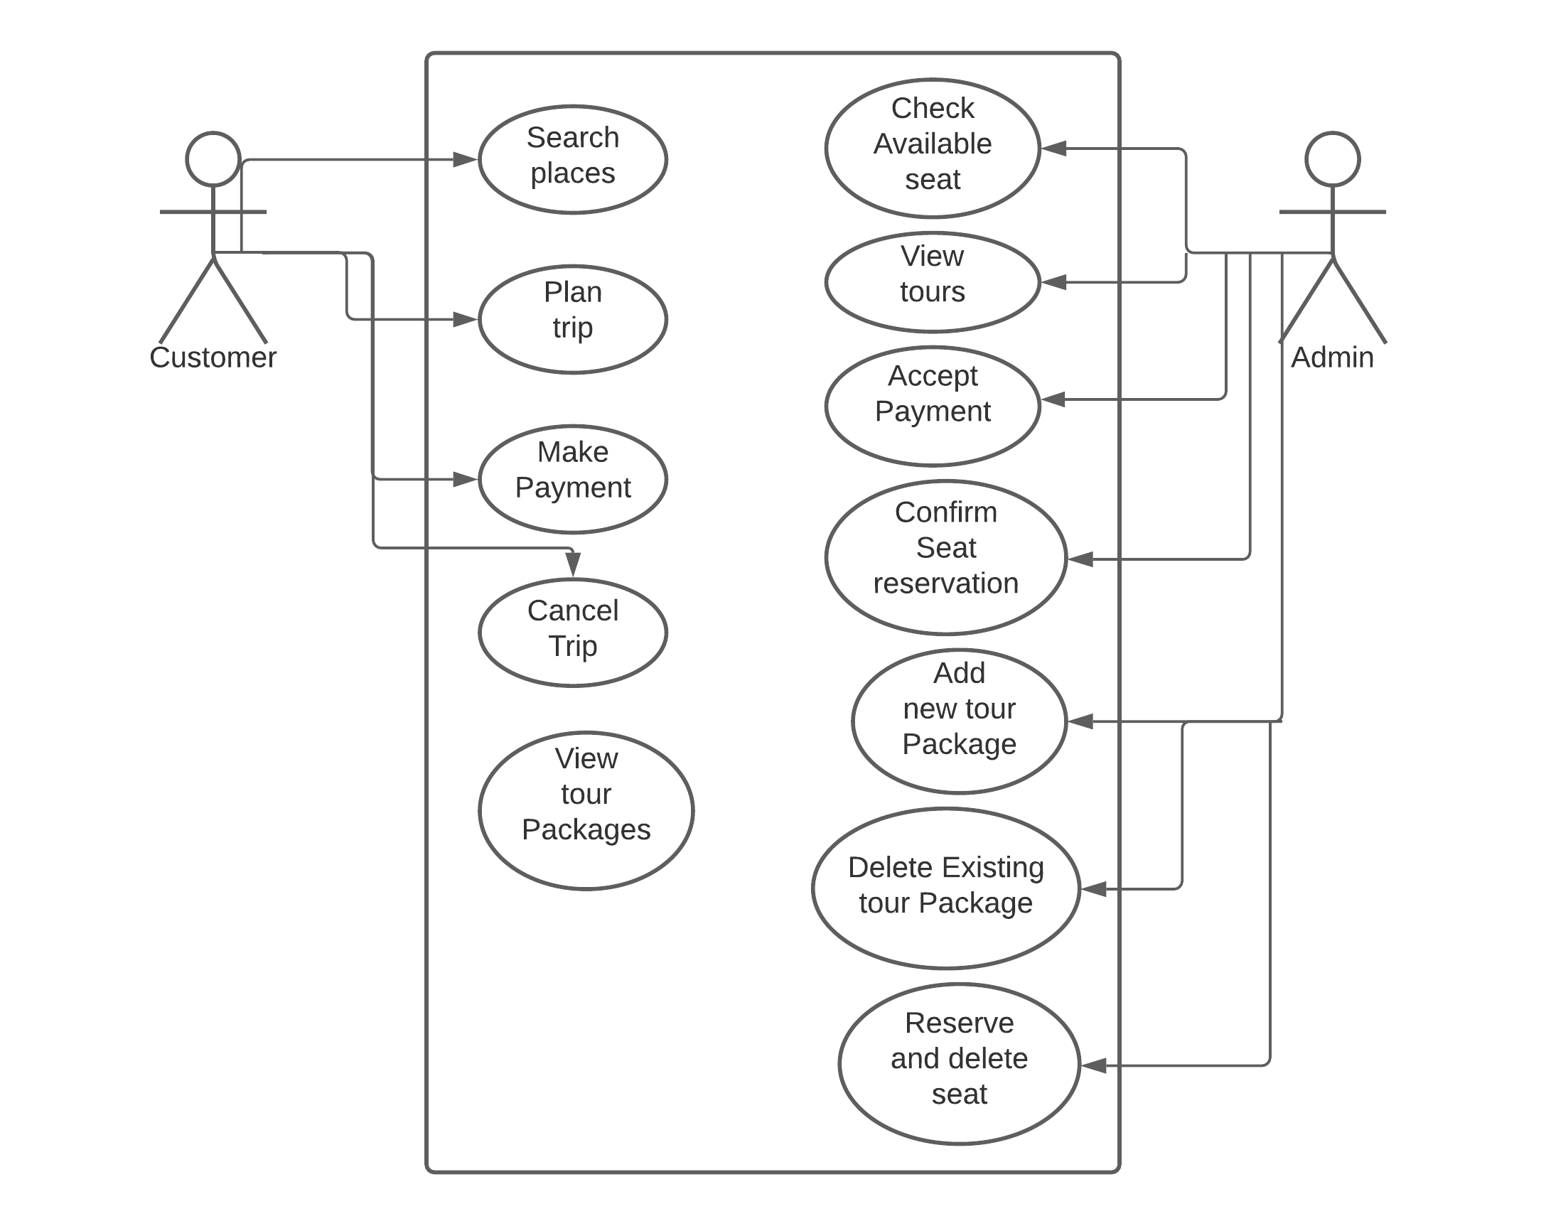

**Fig: DFD of Take A Trip Project**

**E-R Diagram:**

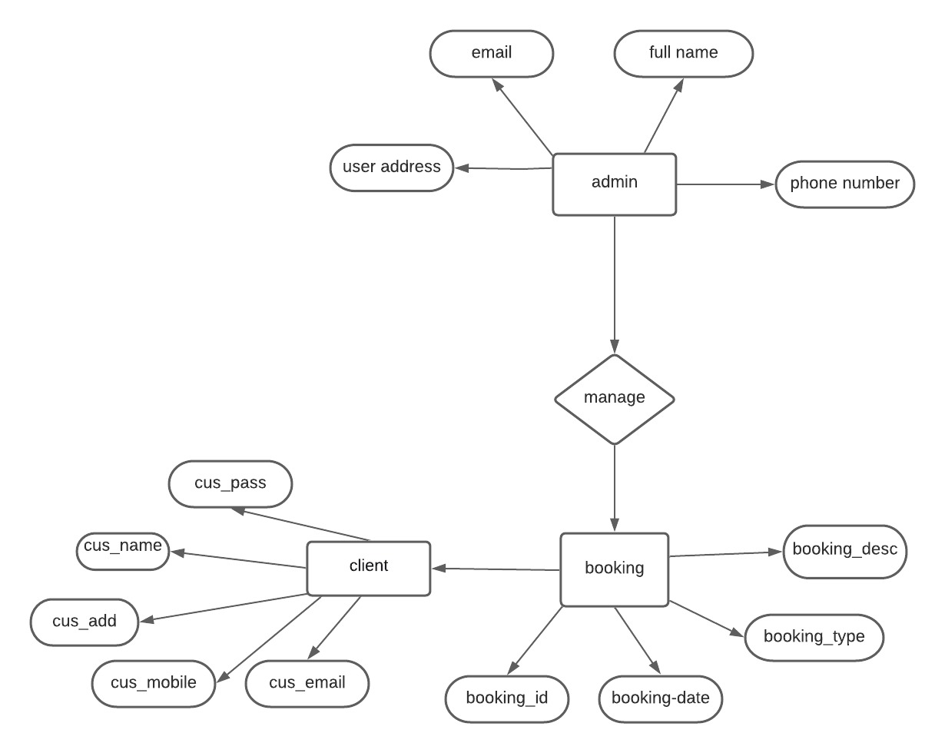

**Fig: ERD of Take A Trip Project**

**Website Front-Page:**

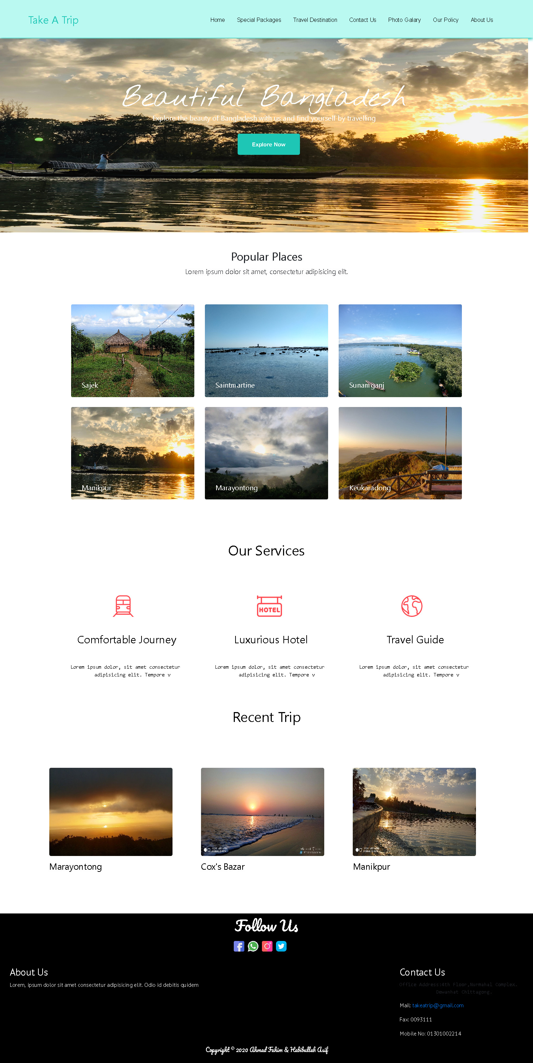

**Destination Page:**

The popular destination are added in our website. We have designed it by a picture of that place and with some formal description of that place. There are some of the packages that we offer to our clients. Like super deluxe package, deluxe package and standard package. There is also a reserve button which will take the client to the form page after that. There are six places are now available in our website we are taking reservation of that six places.

The design of the place is given below:

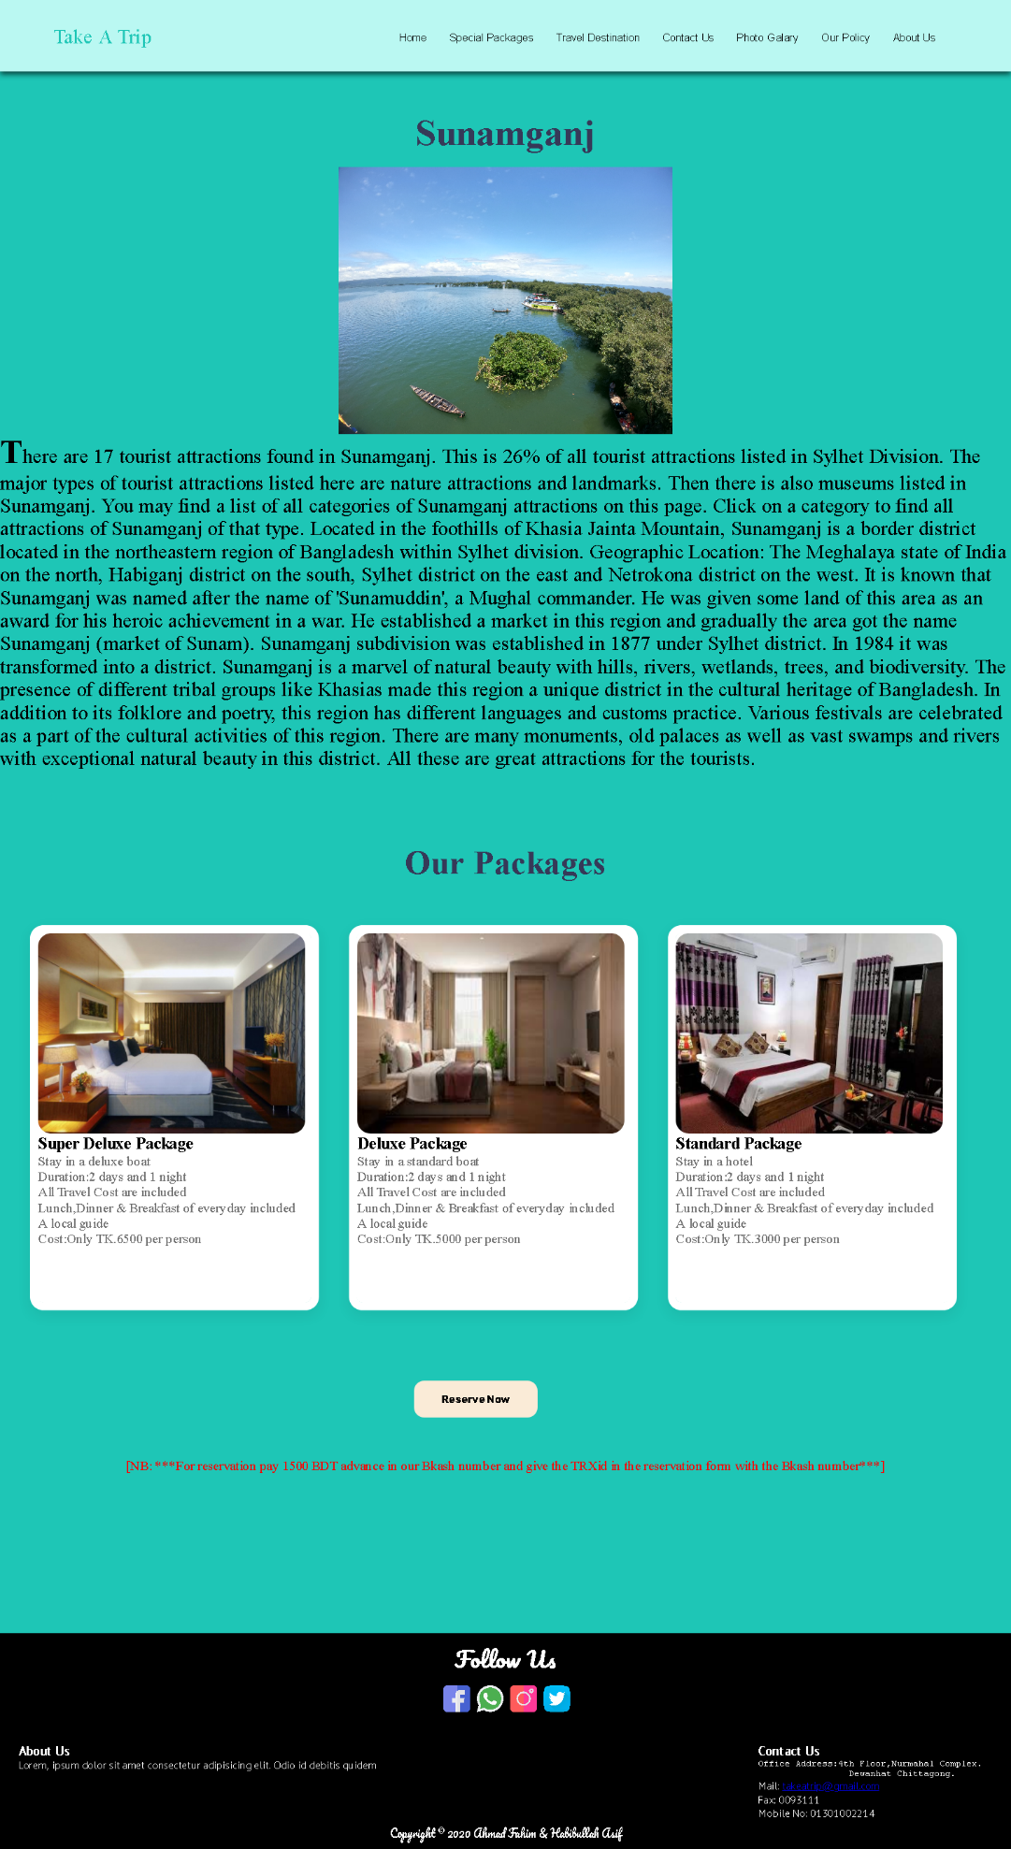

**Reservation Page:** In this page we have designed a creative form for our clients. Our clients can reserve their tour through this form. But everyone have to pay a minimum amount of money as advance for the reservation. They have to provide the transaction id and the amount of money they have advanced in the form and their reservation will be confirmed. Our executive will contact them through the phone number they have given in the reservation form.

The sample of the reservation form is given below:

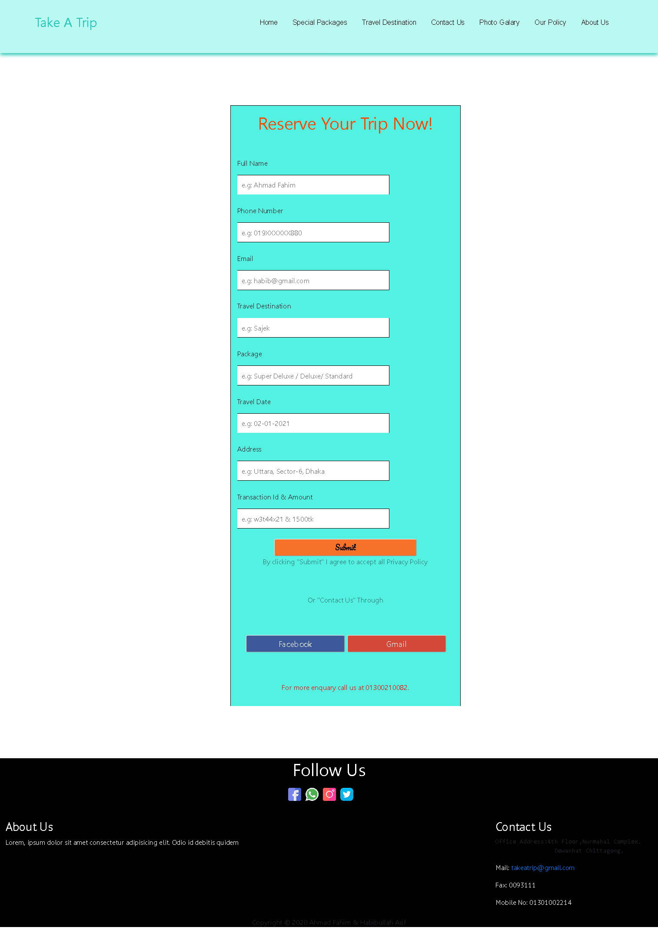

**Database:**  In the database the information of the client who have reserved for a trip are stored.

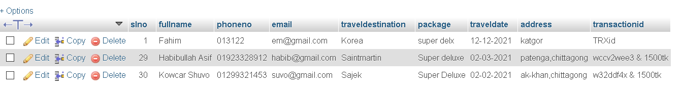

**Conclusion:** We have tried to make a travel management website which will help the people to visit the popular tourist places in our country. We have made the project using Html,CSS, JavaScript, Bootstrap and PHP. We have completed the project successfully. Because of this project I find out more about the technologies we have used. Some of the functionalities does not work fully but we are working to solve that problem.