**BMH.COM**

**INTRODUCTION:**

BMH.com is a hotel room booking website which provides the fascility to book the hotel rooms of their choice in Sagar,Karnataka.

In regular, traditional method of hotel room booking system, customer approaches the hotel and enquires with personnel there about availability of the room, services and fascility etc.

Also if the customer is new to the area he/she will not have any idea about location of good hotels in that area. Hence, he/she has wonder about the streets in search of hotels. Especially during night, it is difficult to search the hotel in that area which is new to the customer. Also, he/she will not have any idea about cost which suits his/her budget.

Also, personnel at the hotel face the problems related to tracking the status of the rooms related to availability, the profile of the occupant, services available by him/her, building, tracking the history of such information when required. They feel difficult to keep the record of such things.

As a solution to these problems comlete activity of booking hotel rooms at any hotel in the area can be brought under a single fascility by automating it and providing access to the application online. When it avialble in online as a website then anybody can know the hotels available in the area, the availability of the rooms in the listed hotels, cost, sevices, fascility etc. Hence, for customer it saves a time, can provide information about the cost, fascilities, comparison of costs. Most important advantage is that the customer can book the room in advance with/without paying in advance.

**System Requirements:**

**1. Hardware Requirement**

* Processor Series: Intel core i3 or equilant
* Physical Memoty: 2GB or higher
* Hard Disk Space: 10Gb

**2. Software Reauirement**

* Operating System: Windows10
* Programming Languages used: Html, Css, Javascript
* DBMS: MYSQL
* A Compatible Web Browser

**Project Screenshots:**

1.Home Page

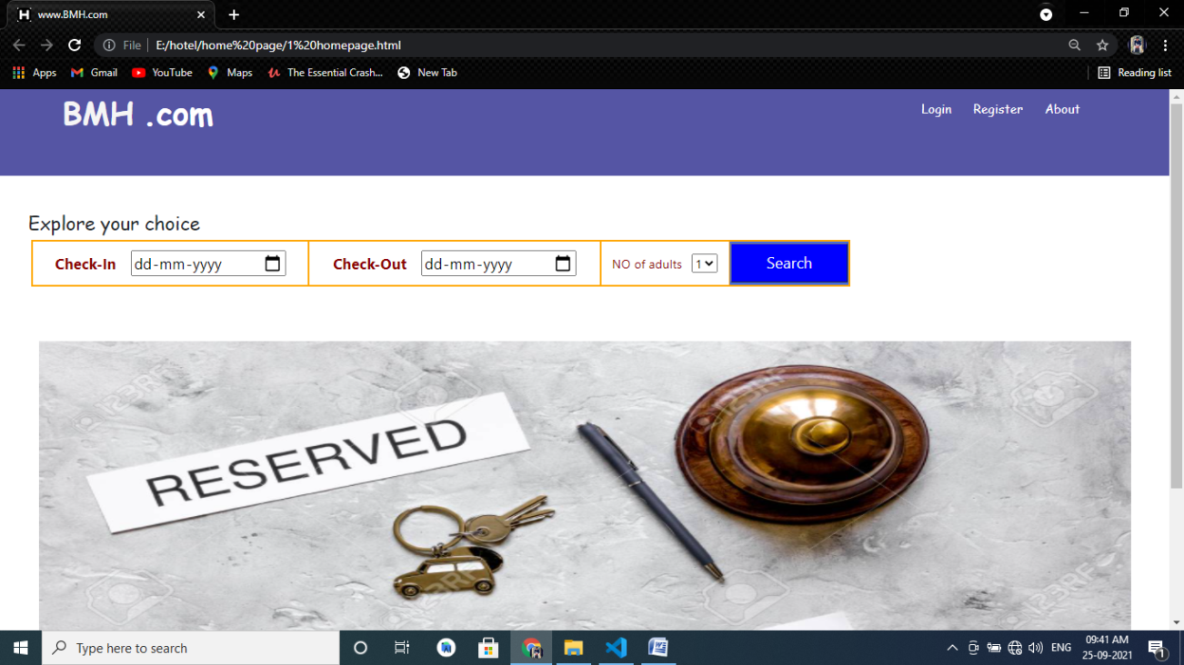

2. Hotel List

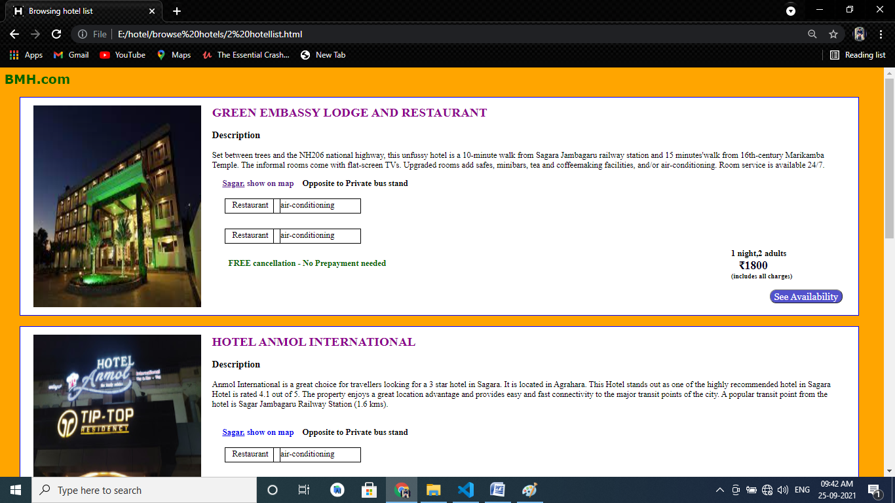

3. Hotel Details

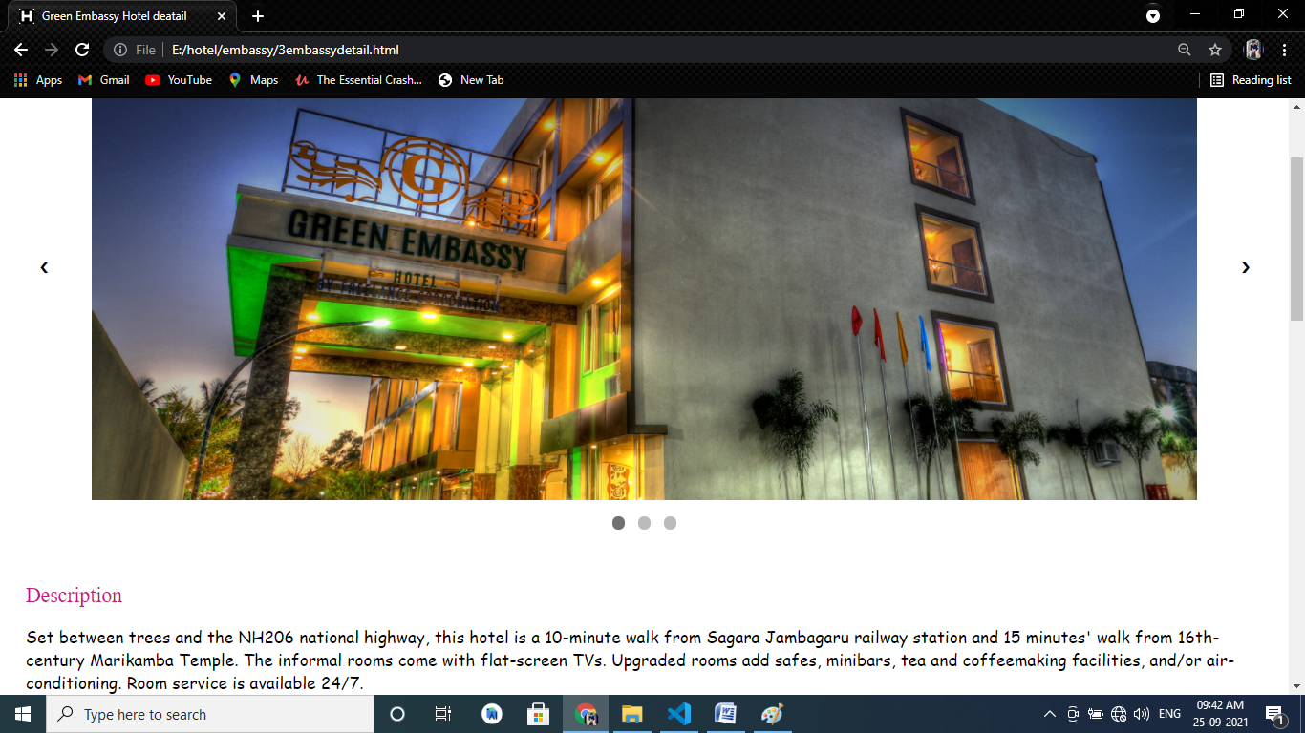

4. Final payment page

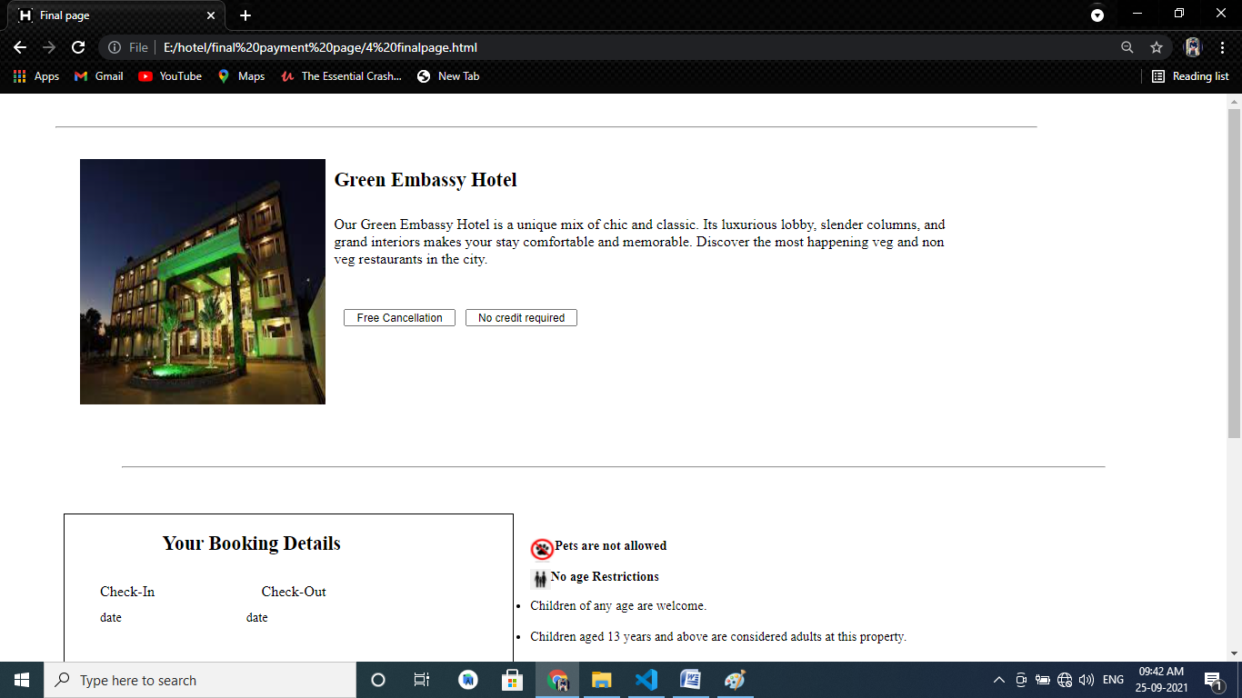

**Conclusion:**

The proposed web application is for the Hotel Room Booking service online. I have successfully completed Front-end Design for it. The application surely reduces the paper work, workload involved in booking and managing the details of the customers, rooms, hotels and processes.

It is intended to be a user friendly application which anybody can use without any difficulties. It can operated through Smart Phone, Laptops and the Tablets.

The application surely proves to be a helpful application to both Customers and the Hotel.

**Future Enhancement:**

My next goal is to make this website completely dynamic and workable by writing backend script and Designing the Database.

So that anyone can go through the Website and easily book the hotel rooms of their choice.