Final Project Report

Virtual Online Academy



Project Supervisor
MADEEHA RASHID

Submitted By

F1702834E6

Asif Ramzan BC140402040
Adeel Ahmed BC130402634

Software Projects & Research Section,
Department of Computer Sciences,
Virtual University of Pakistan


CERTIFICATE

This is to certify that Asif Ramzan (BC140402040), Adeel Ahmed (BC130402634) have worked on and completed their Software Project at Software & Research Projects Section, Department of Computer Sciences, Virtual University of Pakistan in partial fulfillment of the requirement for the degree of BS in Software Engineering under my guidance and supervision.

In our opinion, it is satisfactory and up to the mark and therefore fulfills the requirements of BS in Software Engineering.

Supervisor / Internal Examiner

MADEEHA RASHID
Supervisor,
Software Projects & Research Section,
Department of Computer Sciences
Virtual University of Pakistan

___________________
(Signature)

External Examiner/Subject Specialist
<<External Supervisor Name>>

___________________
(Signature)

Accepted By:

_____________
(For office use)

EXORDIUM

In the name of Allah, the Compassionate, the Merciful.

Praise be to Allah, Lord of Creation,
The Compassionate, the Merciful,
King of Judgment-day!

You alone we worship, and to You alone we pray for help,
Guide us to the straight path

The path of those who You have favored,

Not of those who have incurred Your wrath,
Nor of those who have gone astray.

DEDICATION

Our eyes are the incarnation of the phenomenon of resplendence and perspicuity. The former descends from radiance of my father and the later originates from the filial aspirations of our mother.
We dedicate our humble endeavor to our parents--- a primrose path to our heaven. After that to all our teachers and friends who helped us in any way and at any time.

Regards:
Asif Ramzan (BC140402040)
Adeel Ahmed (BC130402634)
ACKNOWLEDGEMENT

We are grateful to almighty ALLAH, the most Gracious, Merciful and Beneficent WHO helps us in every field of life. By HIS grace we have been able to complete this project successfully. And countless Darood-o-Salam to Hazarat Muhammad Mustafa (PBUH) because of Him, ALLAH blessed me to achieve all that.
We are thankful to my supervisor Miss Madeeha Rashid whose guidance is always with us whenever we found ourself in difficulty. She always encouraged us, and her guidance helped us to complete this project.
We feel proud to be son of our teachers, whose consideration boosts us moral to get higher education. In fact their prayers enable us to reach this stage and complete this project. We heartily express our thanks to our loving brothers and sisters for their love and care. We are much thankful to our friends for their co-operation.
Our appreciations also go to all the people who participated by sharing their precious views and suggestions about the Virtual Online Academy. Thanks a lot for all the time and effort they have given us, without their co-operation, we would not be able to do such stupendous work.

Asif Ramzan (BC140402040)
Adeel Ahmed (BC130402634)

PREFACE
This Documentation is about the Web Based Social Media App for Sports. The main objective behind all this work was to develop such a system that enhances not only the vision of its developers but also expand their vision about the vast field of system analysis and software development.
During this document preparation we are guided by our kind, respected, and experienced teacher Miss. Madeeha Rashid, who helped us a lot to refine our project and its concern document. She with her knowledge and experience told us the art of designing the system.
During this process we studied the present system and got information about this system by studying the existing documents, reports they prepared. On the basis of this information we tried our level best to fulfill the needs by designing the system. Various types of input screen were designed after studying the various types of alternatives present to solve this problem, which were identified in the result of initial investigation and feasibility study.
Finally, system development was done under guidance of our respected teachers.
TABLE OF CONTENTS

CHAPTER NO. 1
gathering & Analyzing info 9

1.1 Introduction

1.2 purpose

1.3 scope

1.4 definitions, acronyms and abbreviations

1.5 Project requirements

1.5.1 Functional Requirements

1.5.2 Non-Functional Requirements

1.6 use cases and usage scenarios

1.6.1 Use Case Diagrams

1.6.2 Usage Scenarios

1.7 Development Methodology

1.7.1 Chosen Methodology

1.7.2 Reasons for Chosen Methodology
1.7.2 Work Plan (Gantt Chart)
1.7.2 Project Schedule (Submission Calendar)

CHAPTER NO. 2
designing the project 24

2.1 Introduction

2.2 purpose

2.3 scope

2.4 definitions, acronyms and abbreviations

2.5 Architectural Representation (Architecture Diagram)

2.6 Dynamic Model: Sequence Diagrams

2.7 Object Model/Logical Model: Class Diagram

2.8 Database Model (Database Diagram)

2.9 Graphical User Interfaces

Chapter no.3
DEvelopment 67
3.1 Development plan (Architecture Diagram)

CHAPTER 1
Gathering & Analyzing Info

Introduction:

This is the Final Report of the Virtual Oline Academy Project. Online academy is an institution reaching out of the people homes. Our mission is the provision of a first class learning experience that will equip students with the skills, ability & knowledge to successfully complete in their chosen discipline. This report provides an overview of the project, the methodology and a review of the outcomes.

Project requirements:

Functional Requirements
- System will maintain record of number of subject specialists/teachers
- System will manage list of short courses and semester subjects details
- System will allow students to register for course(courses)
- Teachers will manage course outline , roadmap and will manage course contents
- Students will be able to see details/testimonials of teachers and will be able to select teacher for a course
- Teachers will be able to upload virtual books/notes and web based tutorials on main concepts.
- Teacher will be able to upload audio lectures
- E-library will maintain a list of links to interactive educational sites
- Teacher will be able to conduct surprise quiz
- Lesson Problems solutions will be uploaded by teacher
- Students will also be able to attempt Self Assessment Quiz
- Students will be able to download helping material
- Teacher will be able to check students’ progress report
Non Functional Requirements
- Performance requirements.
- User interface consideration.
- Global access and functionality.
- Database management.
- Business domains.
- Flexibility and scalability.

Use Case Diagram(s):

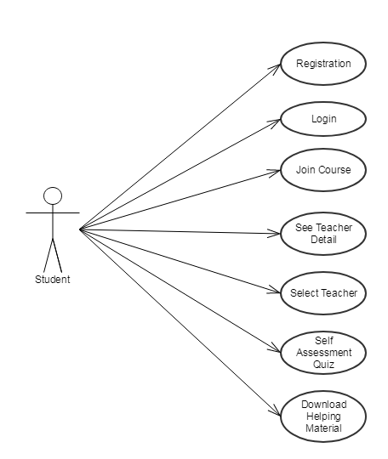

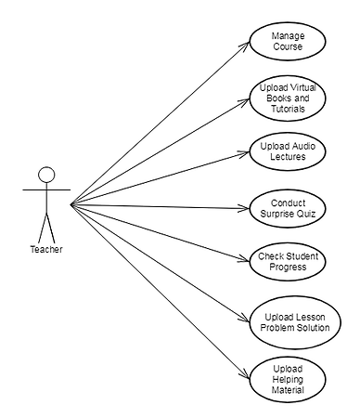
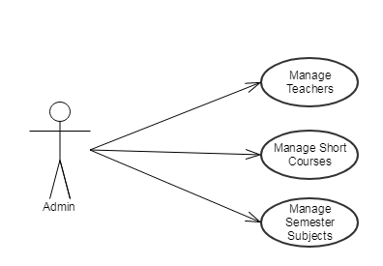

Usage Scenarios:

Use Case Title | Student Registration
Use Case Id | 1.1
Actions | - Student types an Email Address.  - Student types a password.  - Student type a confirmation password.  - Student types all basic information.  - System checks if Email is not in use.  - System checks if password and confirmation password is identical.  - System register a new student with given parameters.
Description | - Student visits register page.  - Student enter all required information.  - Student click register button.  - Student is successfully registered.
Alternative Path | 5a. Email address is already in use.  - Student is requested to enter another email address..  6a. Password and confirmation password are not identical.  - Student is requested to reenter identical password and confirmation password.
Pre-Conditions | - Student select the “Register” link and Registration page is loaded
Post-Conditions | - Successfully Registered
Author | - Student
Exceptions | Exception #1  - Description: Invalid data is entered by the Student.  - Exception Handling: Warn the student about the problem with a message.  - Post Conditions After Exception: The Student is redirected back to the Registration page.

Use Case Title | Student Login
Use Case Id | 1.2
Actions | - Student type Email Address.  - Student type password.  - Click on the login button.  - System check if Email or password is correct.
Description | - Student will visit the page.  - Typing his Email address and password  - Click on log in button.  - Successfully logged in.
Alternative Path | - Log in Email Address or password is incorrect,  - System give option to reset password after some quarries,
Pre-Conditions | - Student select the “Login” link and login page is loaded
Post-Conditions | - Successfully logged in
Author | - Student
Exceptions | Exception #1  - Description: Invalid data is entered by the Student.  - Exception Handling: Warn the student about the problem with a message.  - Post Conditions After Exception: The Student is redirected back to the Login page.

Use Case Title | StudenT join course
Use Case Id | 1.3
Actions | - Student will join course.
Description | - Student will visit courses page.  - Student will select course from given list.
Alternative Path
Pre-Conditions | - Courses pages loaded
Post-Conditions | Successfully joined the course.
Author | Student
Exceptions | Exception #1  - Description: No courses available.  - Exception Handling: Warn the student about the problem with a message.  - Post Conditions After Exception: The Student is redirected back to the Home page.

Use Case Title | View TEACHER DETAIL
Use Case Id | 1.4
Actions | - Student will click on teacher profile button.
Description | - Student will visit teacher profile page.  - Student will view teacher detail.
Alternative Path
Pre-Conditions | - Teacher profile page loaded
Post-Conditions | Successfully visited.
Author | Student
Exceptions | Exception #1  - Description: Teacher detail is not available.  - Exception Handling: Warn the student about the problem with a message.  - Post Conditions After Exception: The Student is redirected back to the Home page.

Use Case Title | Select TEACHER
Use Case Id | 1.5
Actions | - Student will click on select teacher button.  - Student will select teacher for a course.
Description | - Student will visit teacher profile page.  - Student will click select teacher.
Alternative Path
Pre-Conditions | - Teacher profile page is loaded and student click on select teacher button.
Post-Conditions | Successfully selected a teacher..
Author | Student
Exceptions | Exception #1  - Description: Teacher is not available for course.  - Exception Handling: Warn the student about the problem with a message.  - Post Conditions After Exception: The Student is redirected back to the Home page.

Use Case Title | Self-Assessment Quiz
Use Case Id | 1.6
Actions | - Student will click on self-assessment button.  - Student will select answer of questions.  - Student will submit the quiz.
Description | - Student will visit Self-assessment quiz page.  - Student will successfully attempt quiz.
Alternative Path
Pre-Conditions | - Self-assessment quiz page is loaded and all questions are shown to student.
Post-Conditions | - Successfully attempt a quiz.
Author | Student
Exceptions | Exception #1  - Description: Quiz is not active.  - Exception Handling: Warn the student about the problem with a message.  - Post Conditions After Exception: The Student is redirected back to the Home page.

Use Case Title | Download helping material
Use Case Id | 1.7
Actions | - Student will click on Download Helping Material button.  - Student will select a helping material.
Description | - Student will visit Download Helping Material page.  - Student will download a helping material.
Alternative Path
Pre-Conditions | - Download Helping Material page is loaded and all helping materials are shown to student.
Post-Conditions | - Successfully downloaded a helping material.
Author | Student
Exceptions | Exception #1  - Description: No Helping Material is available.  - Exception Handling: Warn the student about the problem with a message.  - Post Conditions After Exception: The Student is redirected back to the Home page.

Use Case Title | Manage course
Use Case Id | 2.1
Actions | - Teacher will click on manage course button.  - Teacher will select a course.  - Teacher will edit course  - Click on the Submit button.
Description | - Teacher will visit the manage course page.  - Teacher update a course.
Alternative Path
Pre-Conditions | - Teacher select the “Manage Course” link and page is loaded
Post-Conditions | - Successfully managed course
Author | Teacher
Exceptions | Exception #1  - Description: Teacher does not have authority to manage selected course.  - Exception Handling: Warn the teacher about the problem with a message.  - Post Conditions After Exception: The Teacher is redirected back to the Manage Course page.

Use Case Title | Upload Virtual Books and tutorials
Use Case Id | 2.2
Actions | - Teacher will click on upload tutorial button.  - Teacher will select a file.  - Click on the upload button.
Description | - Teacher will visit the upload tutorials page.  - Teacher will upload virtual book or tutorial.
Alternative Path
Pre-Conditions | - Upload tutorial page is loaded.
Post-Conditions | - Successfully uploaded virtual book or tutorial.
Author | Teacher
Exceptions | Exception #1  - Description: Teacher select invalid file extension.  - Exception Handling: Warn the teacher about the problem with a message.  - Post Conditions After Exception: The Teacher is redirected back to the upload tutorial page.

Use Case Title | Upload AUDIO lECTURE.
Use Case Id | 2.3
Actions | - Teacher will click on upload lecture button.  - Teacher will select audio lecture.  - Click on the upload button.
Description | - Teacher will visit the upload lecture page.  - Teacher will upload audio lecture.
Alternative Path
Pre-Conditions | - Upload audio lecture page is loaded.
Post-Conditions | - Successfully uploaded audio lecture.
Author | Teacher
Exceptions | Exception #1  - Description: Teacher select invalid file extension.  - Exception Handling: Warn the teacher about the problem with a message.  - Post Conditions After Exception: The Teacher is redirected back to the upload audio page.

Use Case Title | Conduct quiz
Use Case Id | 2.4
Actions | - Teacher will click on conduct quiz button.  - Teacher will click upload quiz content button.
Description | - Teacher will visit the conduct quiz page.  - Teacher will upload quiz content.
Alternative Path
Pre-Conditions | - Upload quiz content page is loaded.
Post-Conditions | - Successfully uploaded quiz content.
Author | Teacher
Exceptions | Exception #1  - Description: Teacher select invalid file extension.  - Exception Handling: Warn the teacher about the problem with a message.  - Post Conditions After Exception: The Teacher is redirected back to the conduct quiz page.

Use Case Title | Check Student Progress
Use Case Id | 2.5
Actions | - Teacher will click on student progress button.
Description | - Teacher will check the student progress page.
Alternative Path
Pre-Conditions | - Student progress page is loaded.
Post-Conditions | - Successfully checked student progress.
Author | Teacher
Exceptions | Exception #1  - Description: No progress found.  - Exception Handling: Warn the teacher about the problem with a message.  - Post Conditions After Exception: The Teacher is redirected back to the Home page.

Use Case Title | Upload Lesson Problem Solution.
Use Case Id | 2.6
Actions | - Teacher will click on upload lesson problem solution button.  - Teacher will select solution file.  - Click on the upload button.
Description | - Teacher will visit the upload lesson problem solution page.  - Teacher will upload problem solution.
Alternative Path
Pre-Conditions | - Upload lesson solution page is loaded.
Post-Conditions | - Successfully uploaded problem solution.
Author | Teacher
Exceptions | Exception #1  - Description: Teacher select invalid file extension.  - Exception Handling: Warn the teacher about the problem with a message.  - Post Conditions After Exception: The Teacher is redirected back to the upload problem solution page.

Use Case Title | Upload Helping Material.
Use Case Id | 2.7
Actions | - Teacher will click on upload helping material button.  - Teacher will select file.  - Click on the upload button.
Description | - Teacher will visit the upload helping material page.  - Teacher will upload helping material.
Alternative Path
Pre-Conditions | - Upload helping material page is loaded.
Post-Conditions | - Successfully uploaded helping material.
Author | Teacher
Exceptions | Exception #1  - Description: Teacher select invalid file extension.  - Exception Handling: Warn the teacher about the problem with a message.  - Post Conditions After Exception: The Teacher is redirected back to the upload helping material page.

Use Case Title | Manage Teachers.
Use Case Id | 3.1
Actions | - Admin will click on manage teachers button.  - Admin will click on add/edit teacher button.  - Admin will provide teacher detail.  - Admin will click on submit button
Description | - Admin will visit the Add/Edit Teacher page.  - Admin will Add/Edit Teacher.
Alternative Path
Pre-Conditions | - Add/Edit Teacher page is loaded.
Post-Conditions | - Successfully Added/Edited Teacher.
Author | Admin
Exceptions | Exception #1  - Description: Error in loading the page.  - Exception Handling: Warn the teacher about the problem with a message.  - Post Conditions After Exception: The Teacher is redirected back to the Manage Teachers page.

Use Case Title | Manage Short Courses.
Use Case Id | 3.2
Actions | - Admin will click on manage short course button.  - Admin will click on add/edit short course button.  - Admin will provide course detail.  - Admin will click on submit button
Description | - Admin will visit the Add/Edit Short course page.  - Admin will Add/Edit course.
Alternative Path
Pre-Conditions | - Add/Edit Short Course page is loaded.
Post-Conditions | - Successfully Added/Edited Short Course.
Author | Admin
Exceptions | Exception #1  - Description: Error in loading the page.  - Exception Handling: Warn the teacher about the problem with a message.  - Post Conditions After Exception: The Teacher is redirected back to the Manage Teachers page.

Use Case Title | Manage sEMESTER Subject
Use Case Id | 3.3
Actions | - Admin will click on manage semester subject button.  - Admin will click on add/edit semester subject button.  - Admin will provide semester subject detail.  - Admin will click on submit button
Description | - Admin will visit the Add/Edit semester subject page.  - Admin will Add/Edit semester subject.
Alternative Path
Pre-Conditions | - Add/Edit semester subject page is loaded.
Post-Conditions | - Successfully Added/Edited semester subject.
Author | Admin
Exceptions | Exception #1  - Description: Error in loading pages.  - Exception Handling: Warn the teacher about the problem with a message.  - Post Conditions After Exception: The Teacher is redirected back to the Manage Subject page.

Adopted Methodology

The waterfall was the first Process model to be introduced. It is also referred to as a linear-sequential life cycle model. The Waterfall model is the earliest SDLC approach that was used for software development. The waterfall Model illustrates the software development process in a linear sequential flow. Requirement analysis which software require for this project. Secondly system design then implementation then we will test the system project.

CHAPTER 2
Designing the Project

The purpose of this document is to describe the implementation of the virtual academy web based application. This web application will consist of major functions like students can learn, watch lectures & downloads handouts, Notes & past papers etc. In this application, admin made a register and login option then they can use this application if they register & then login. This system provide online study students can online study. In this document we show application with respect diagrams like ERD, sequence, Architecture, Class, Database & interface design diagrams also shows test cases. With respect to this we will develop a web application (Online Virtual Academy).

Entity Relationship Diagram (ERD)
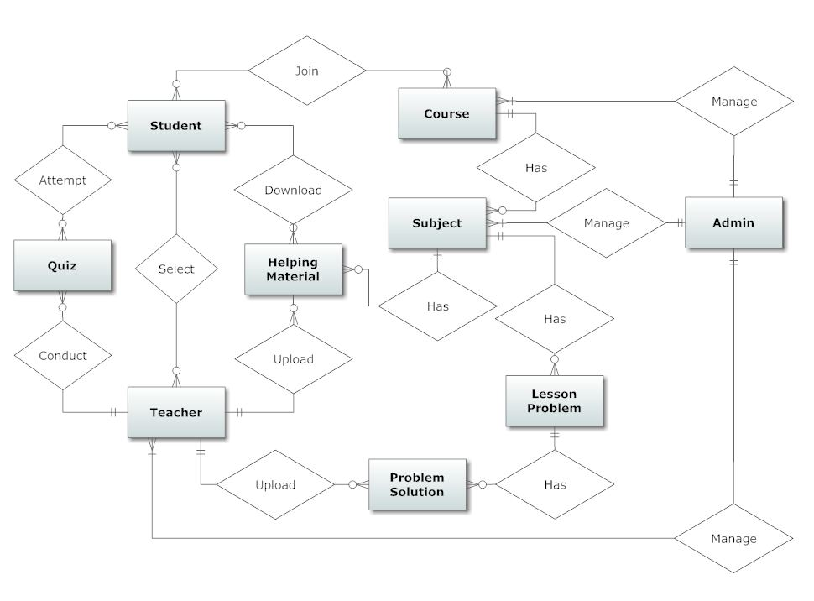

Sequence Diagrams
Teacher
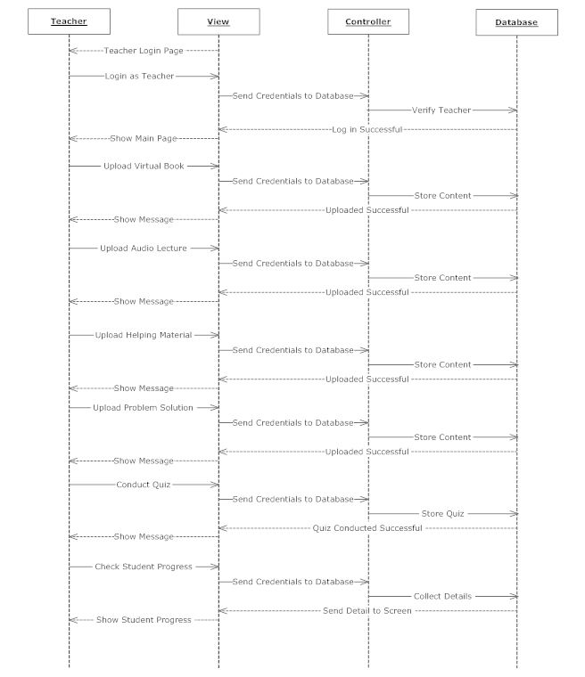

Student
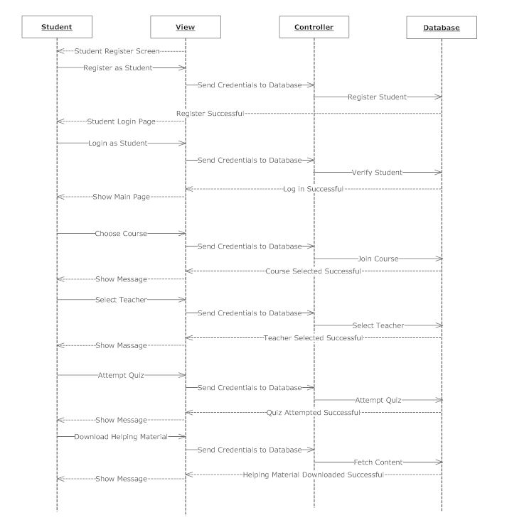

Admin
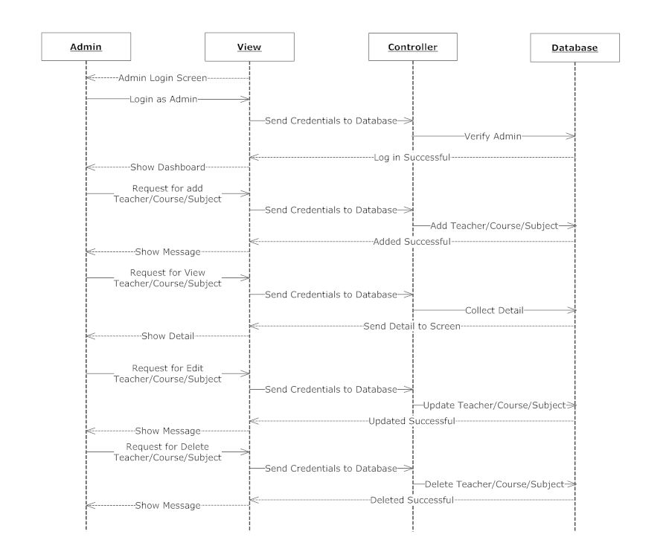

Architecture Design Diagram

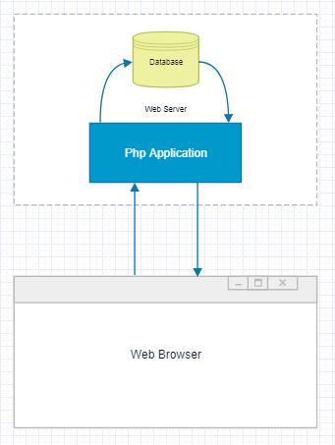

Class Diagram

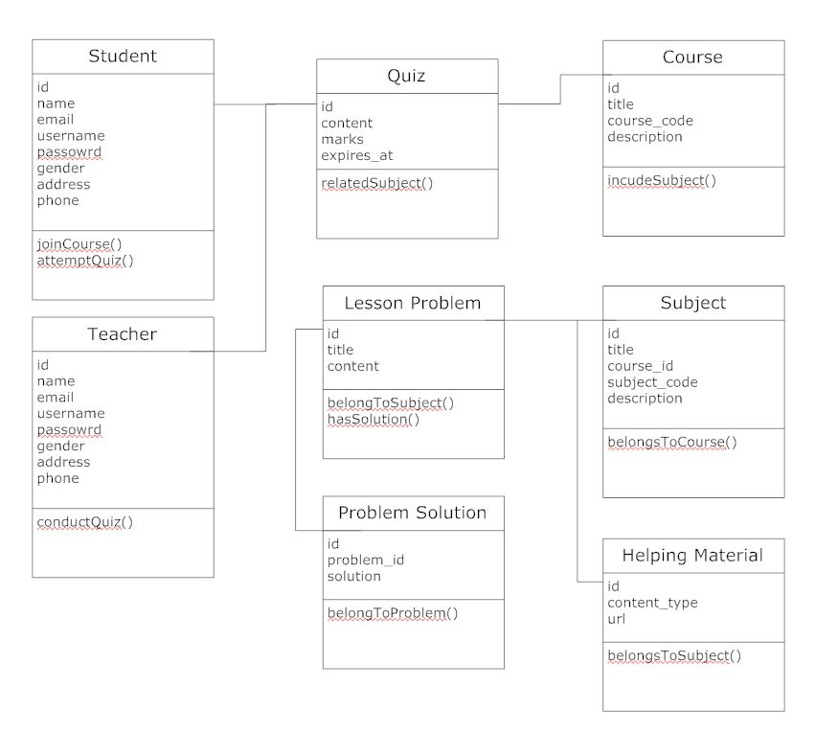

Database Design

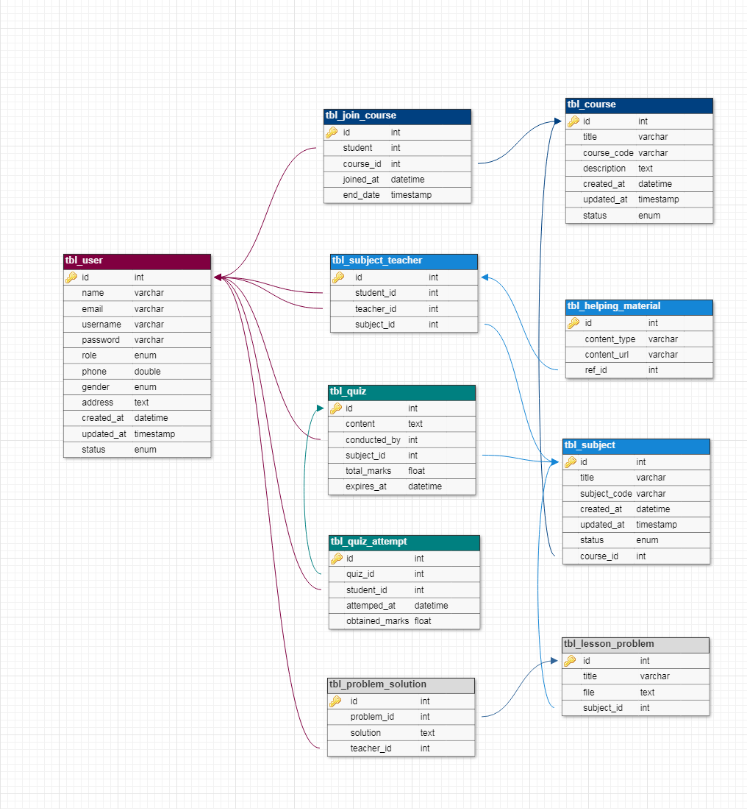

User Interfaces:

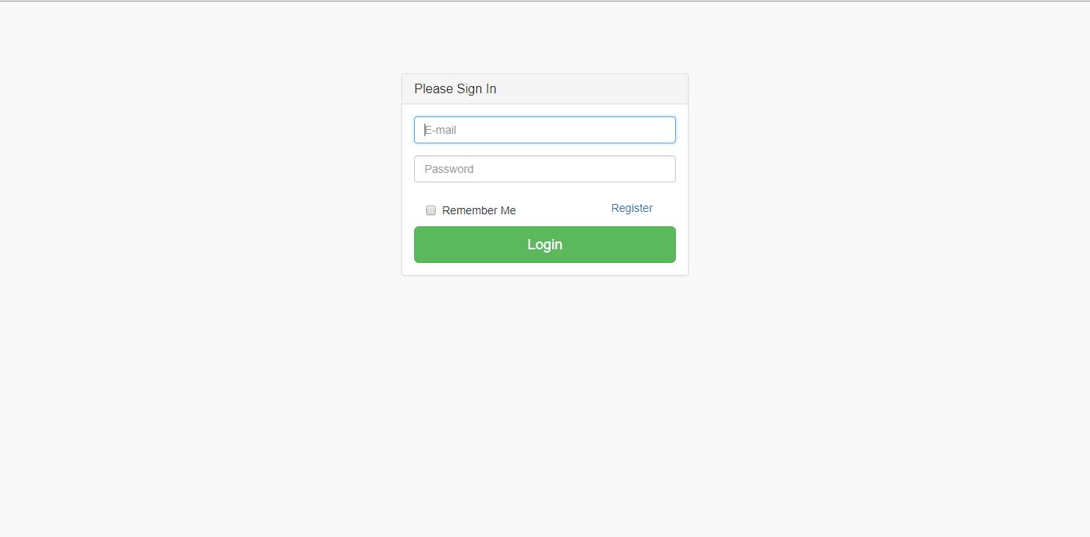
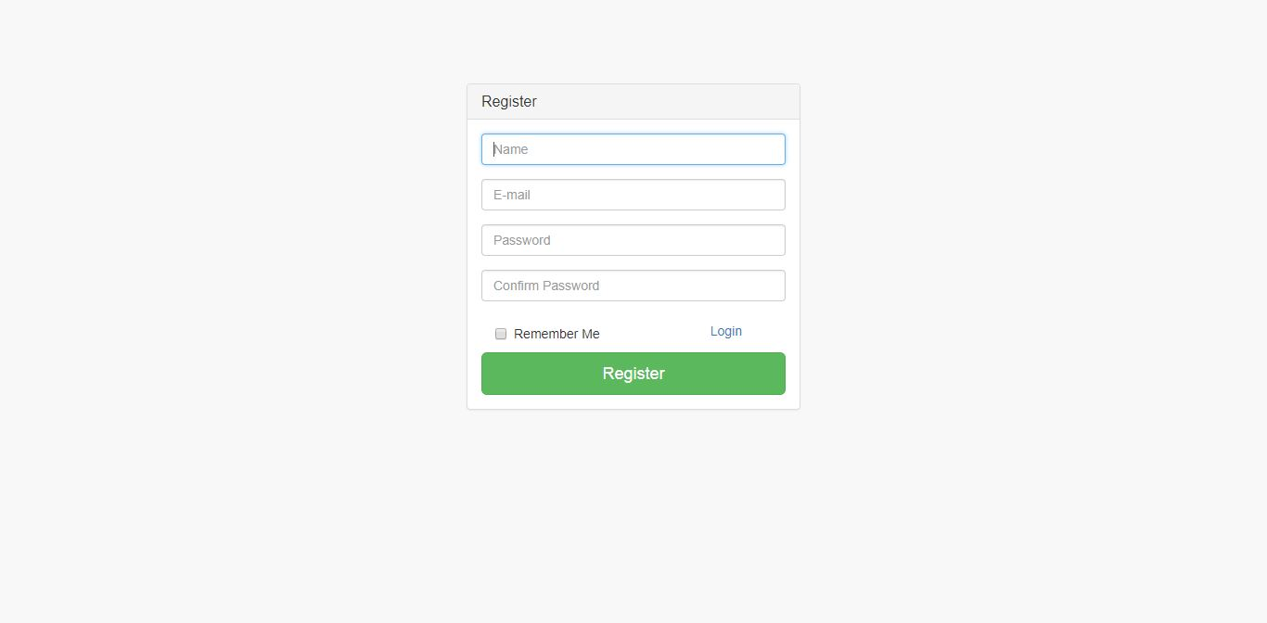
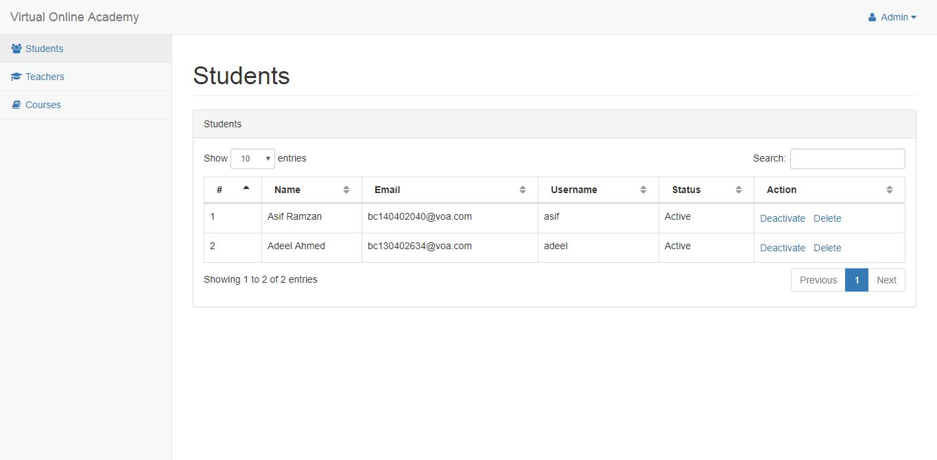
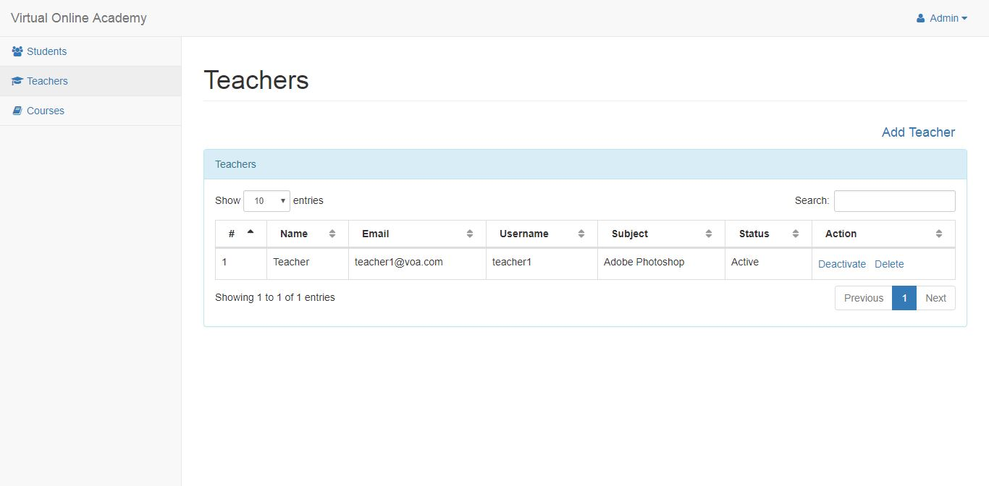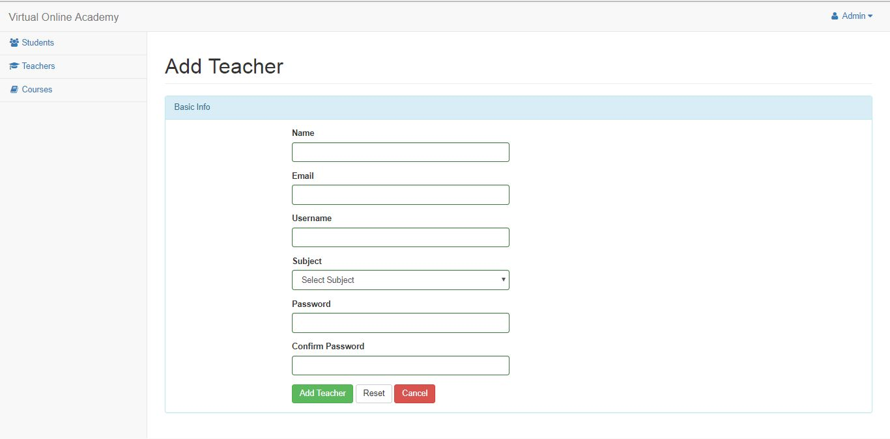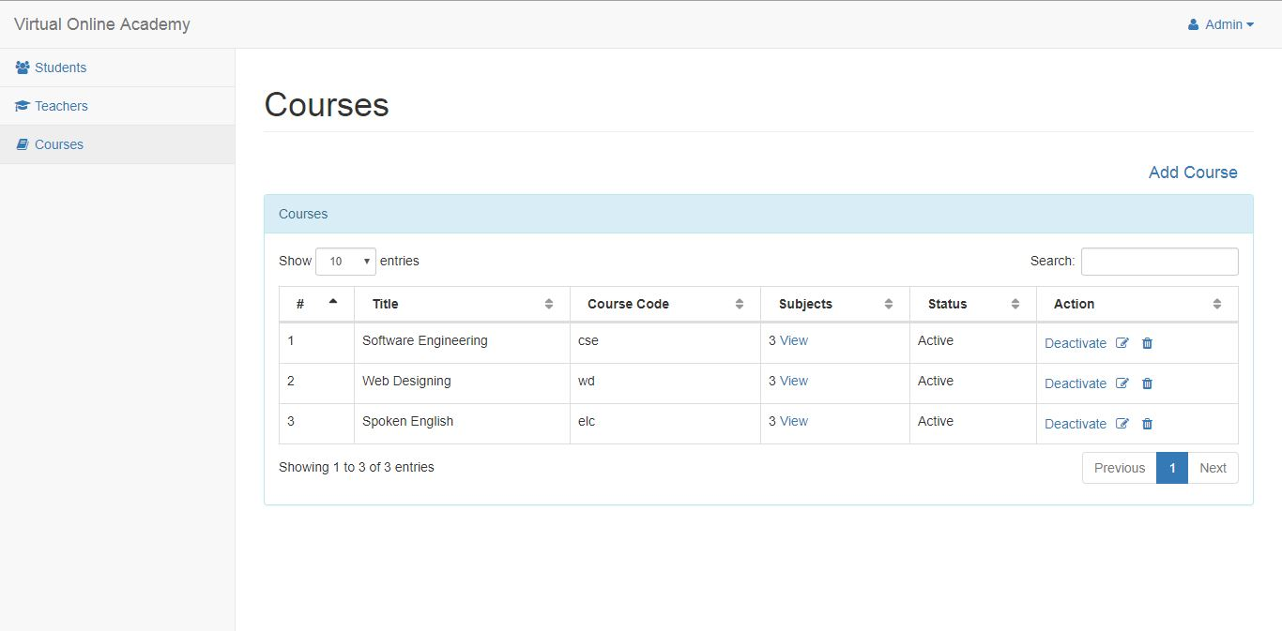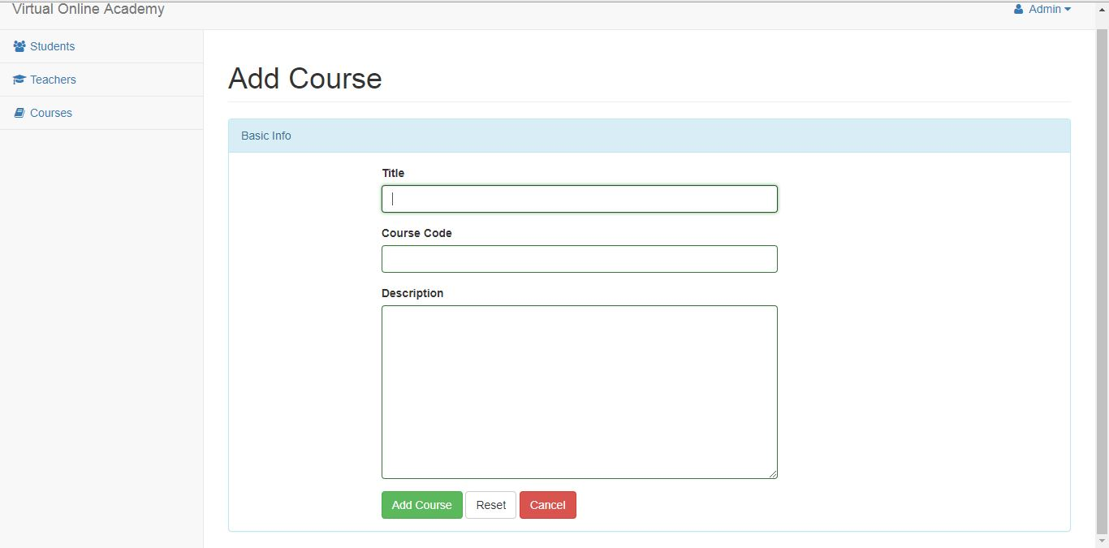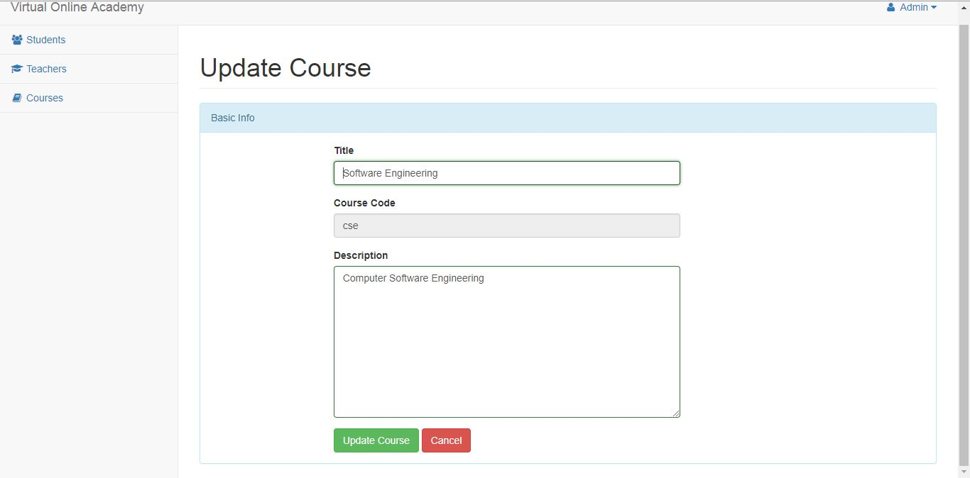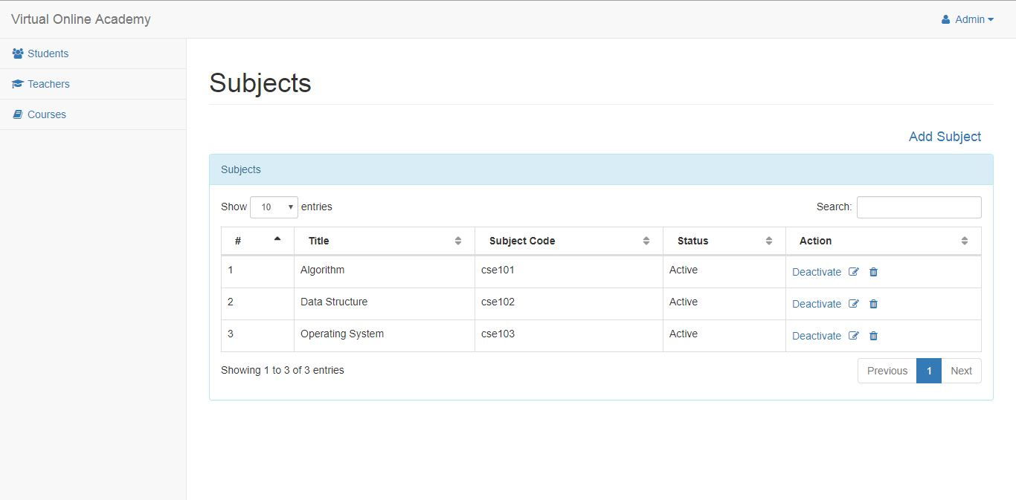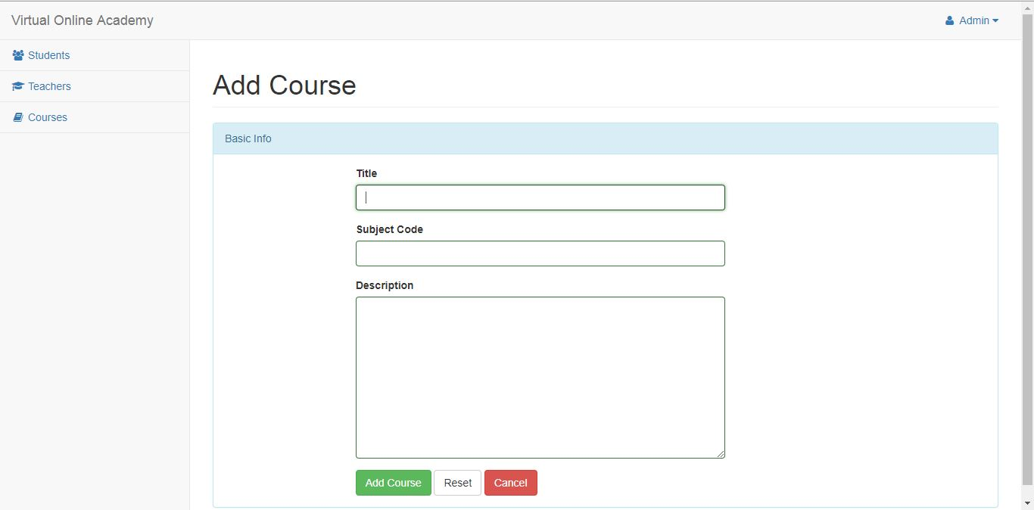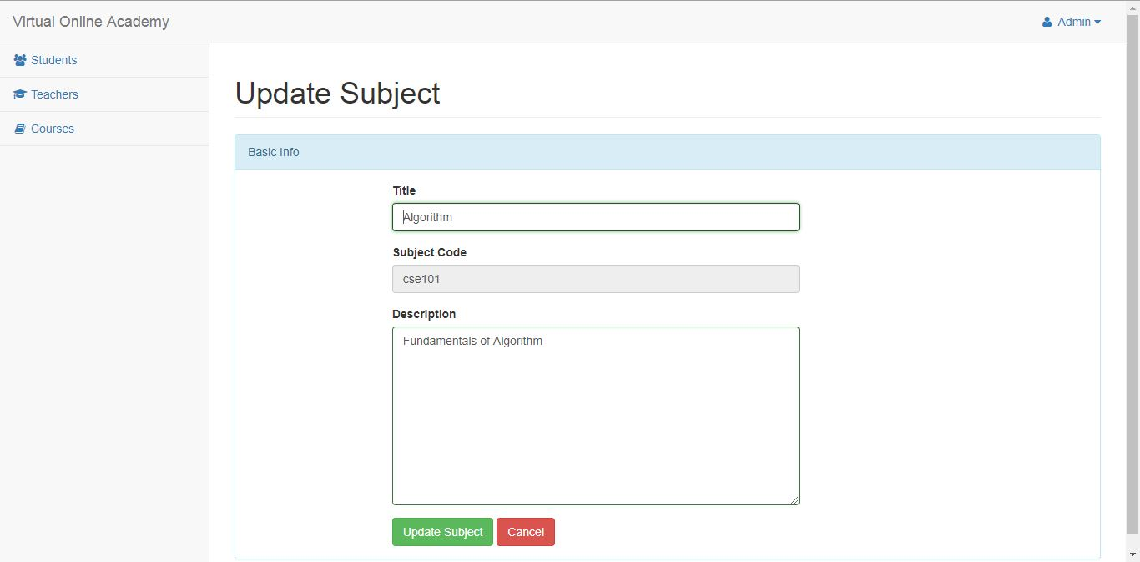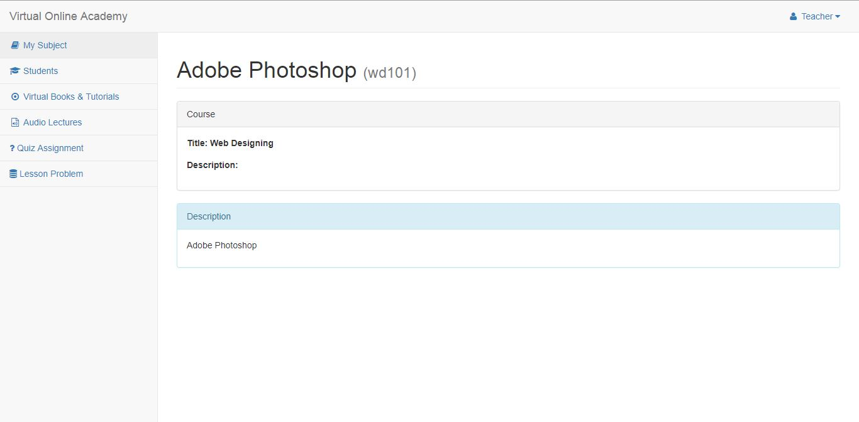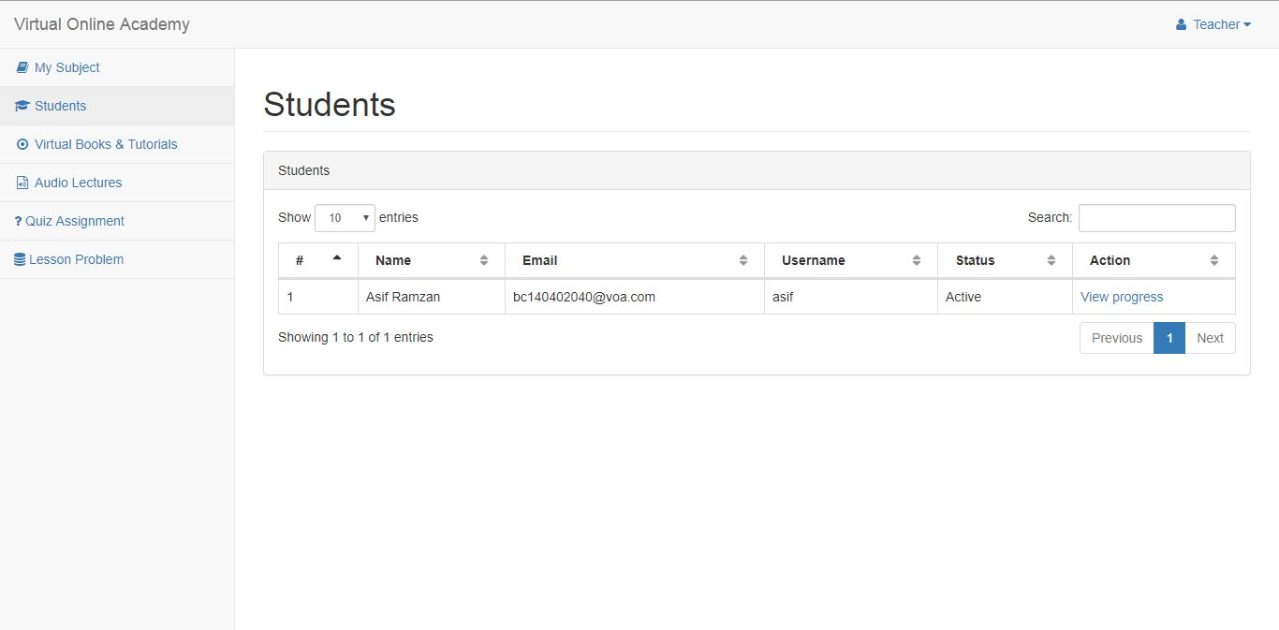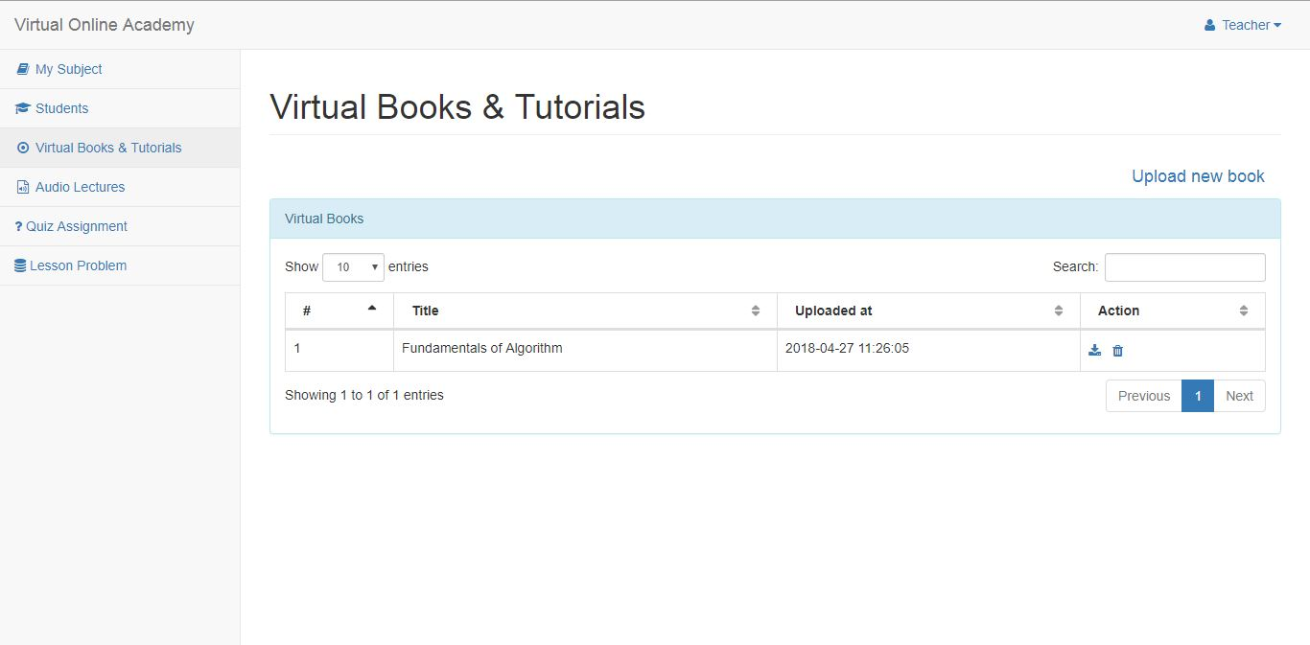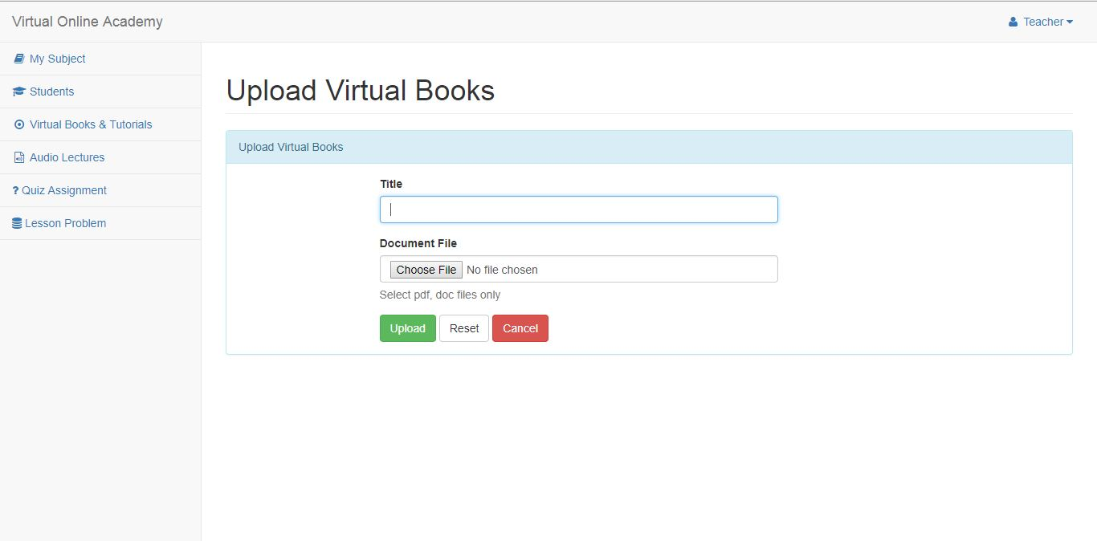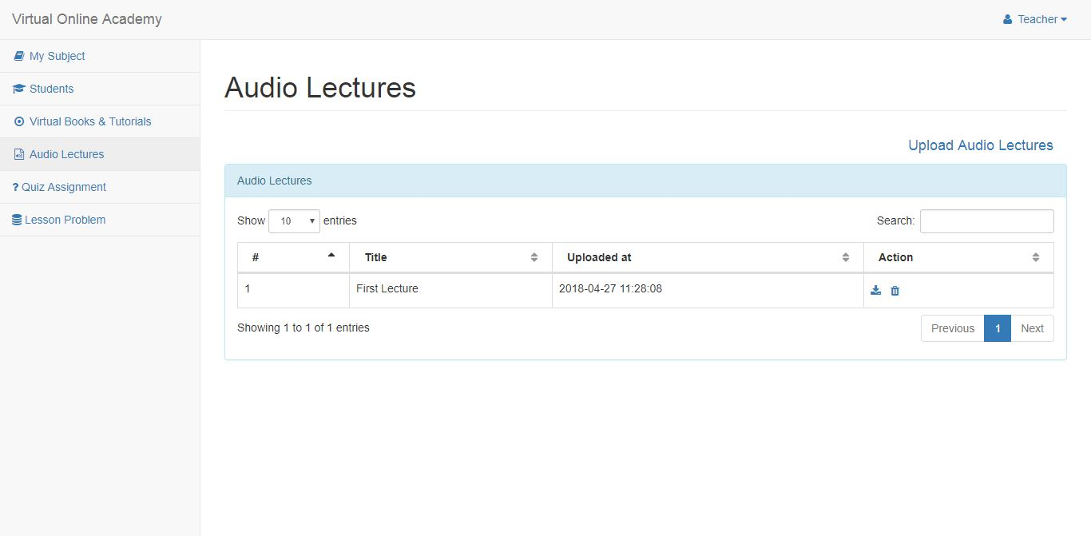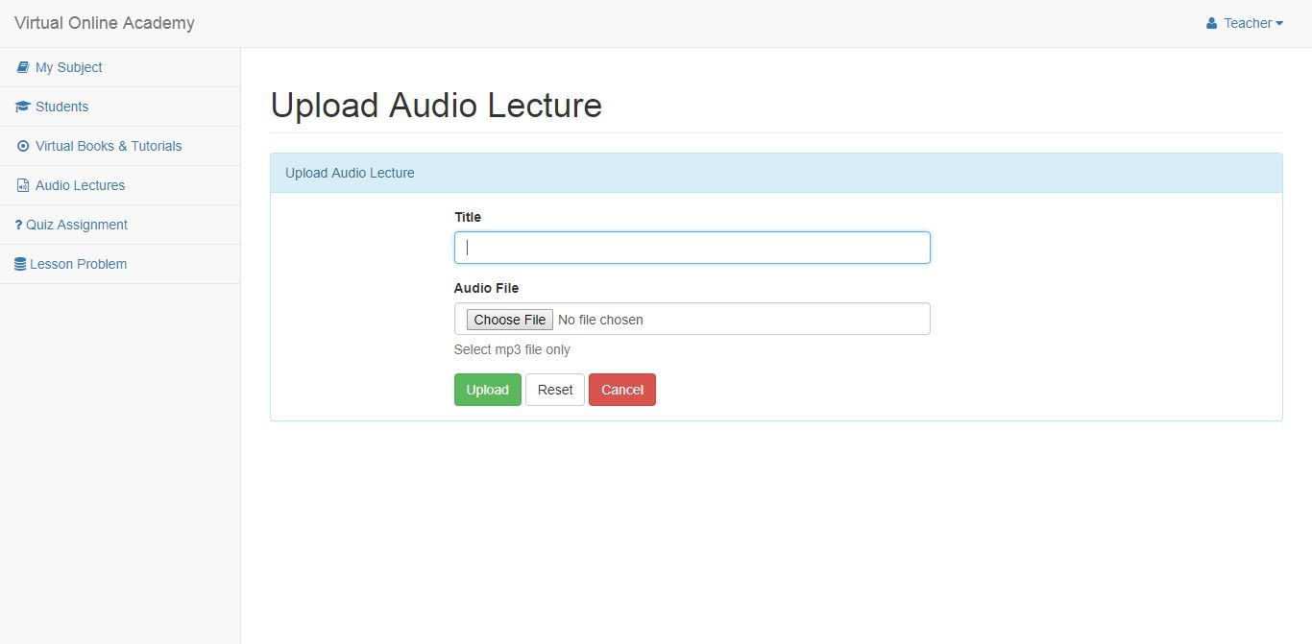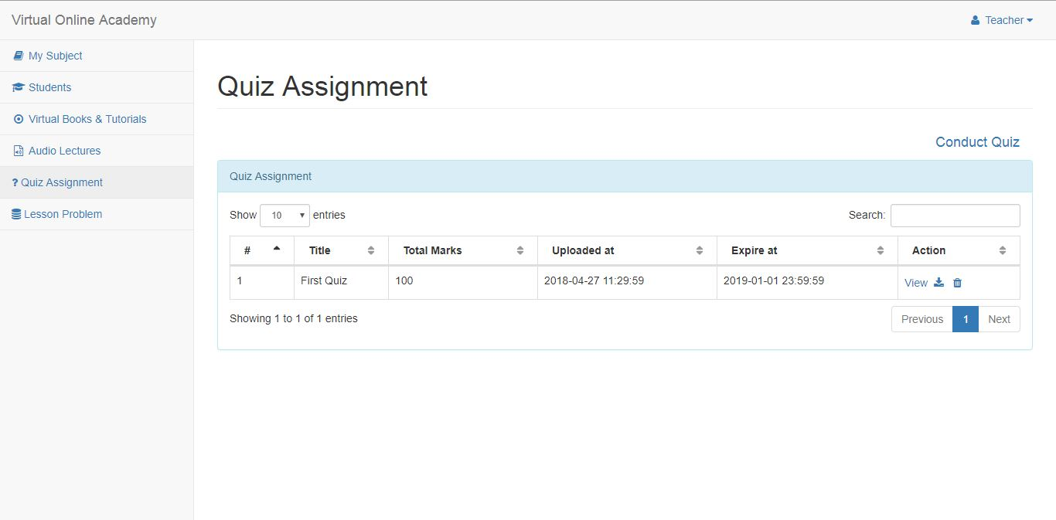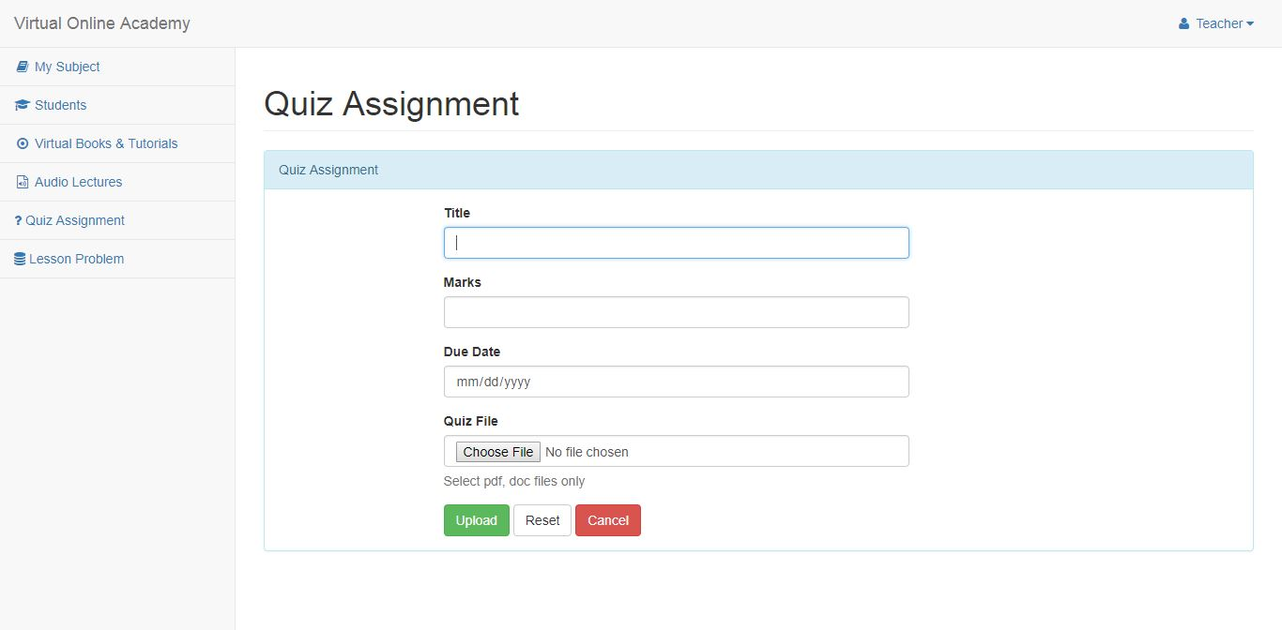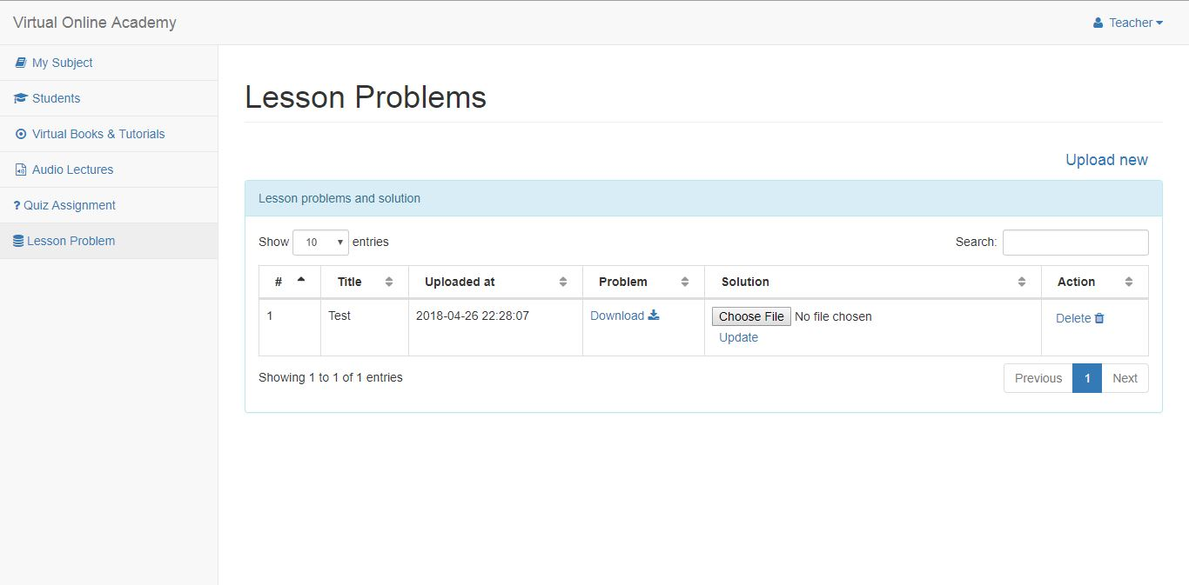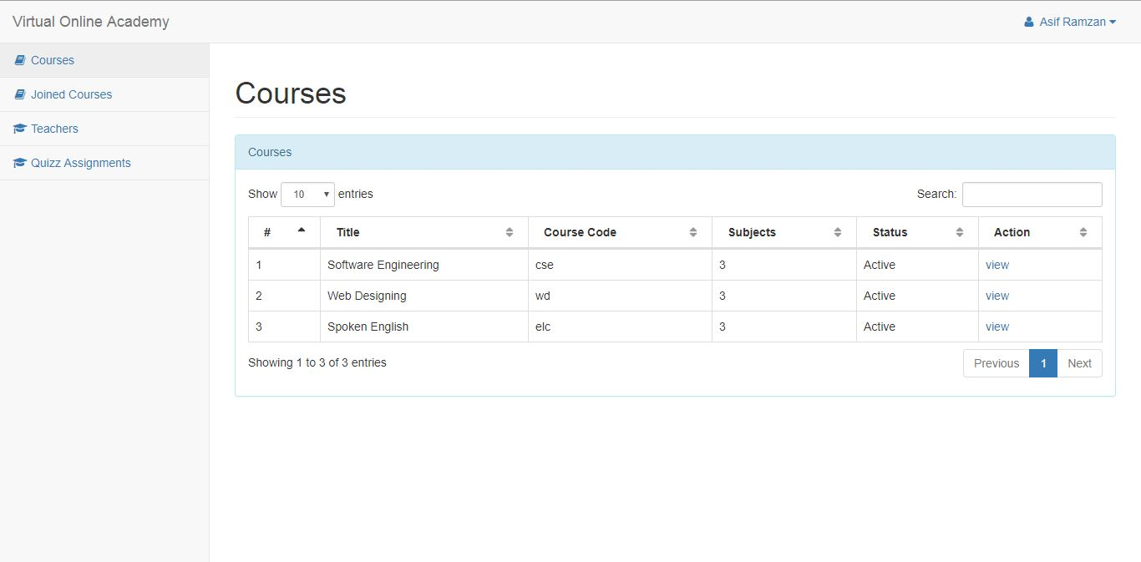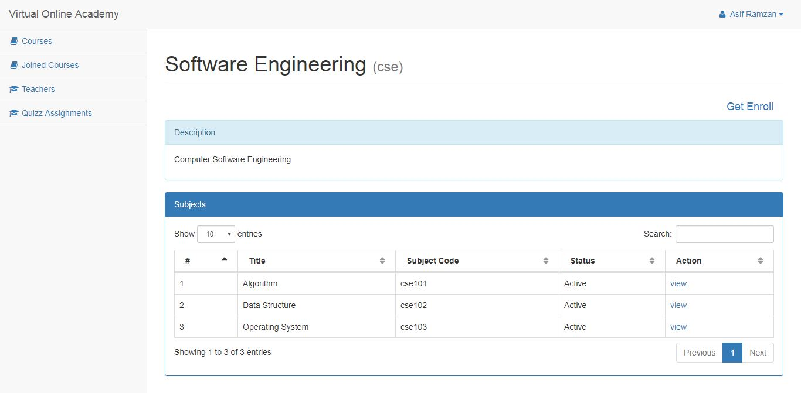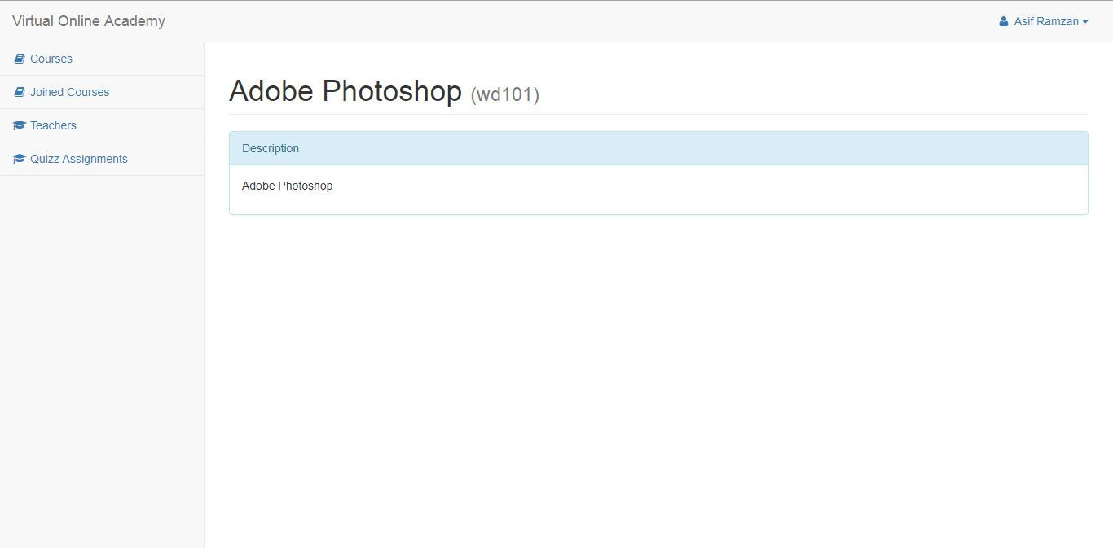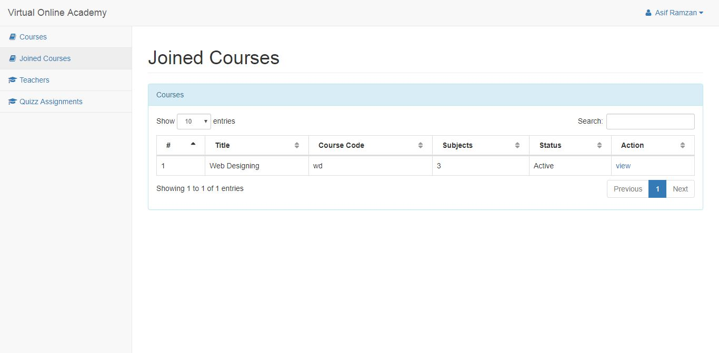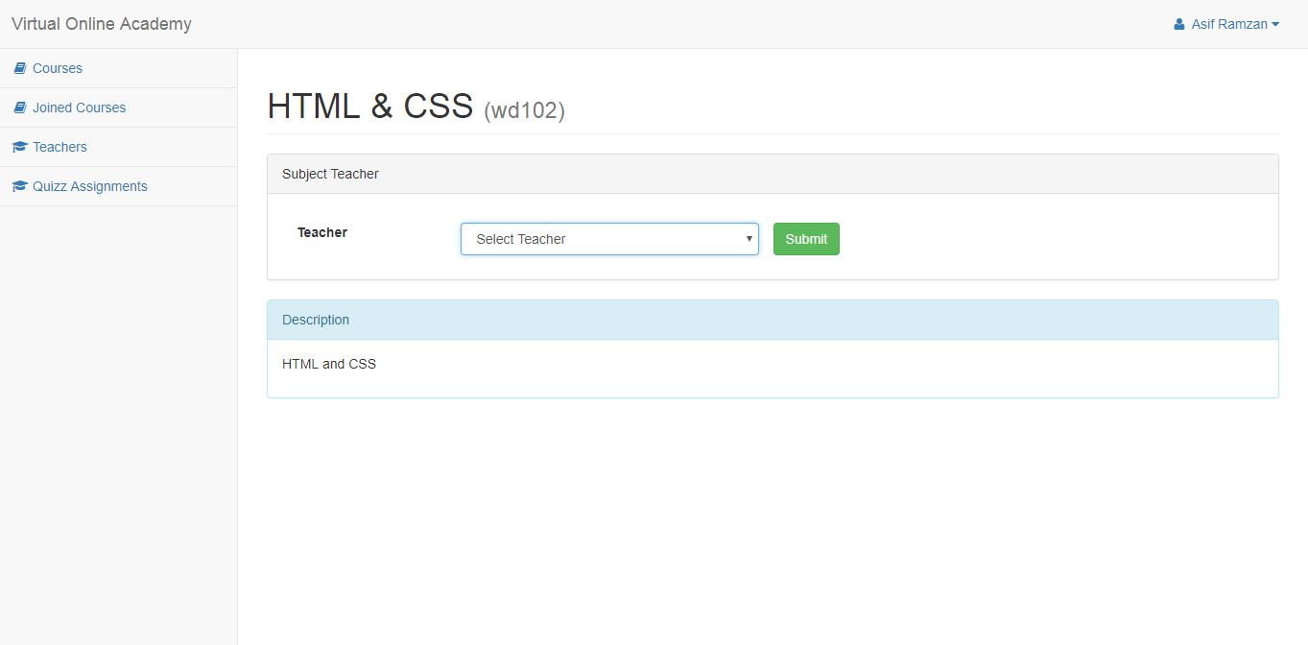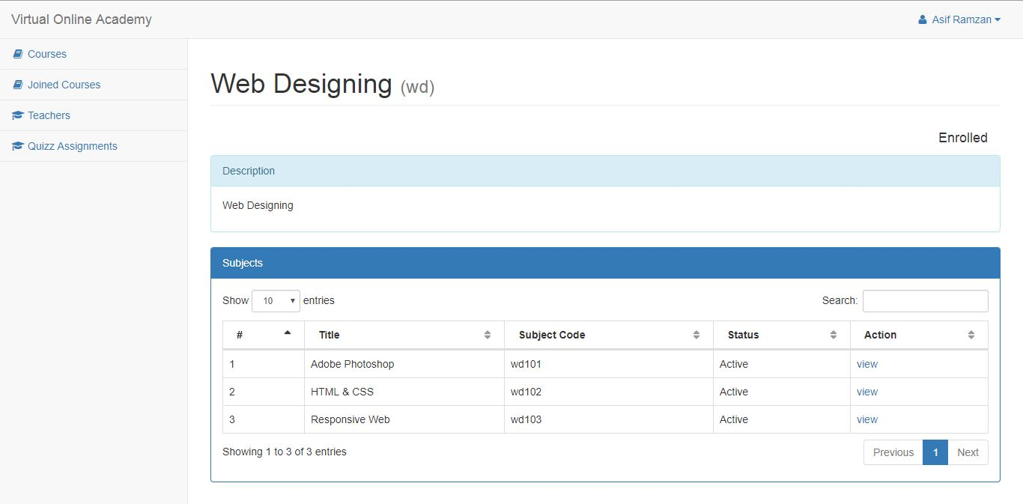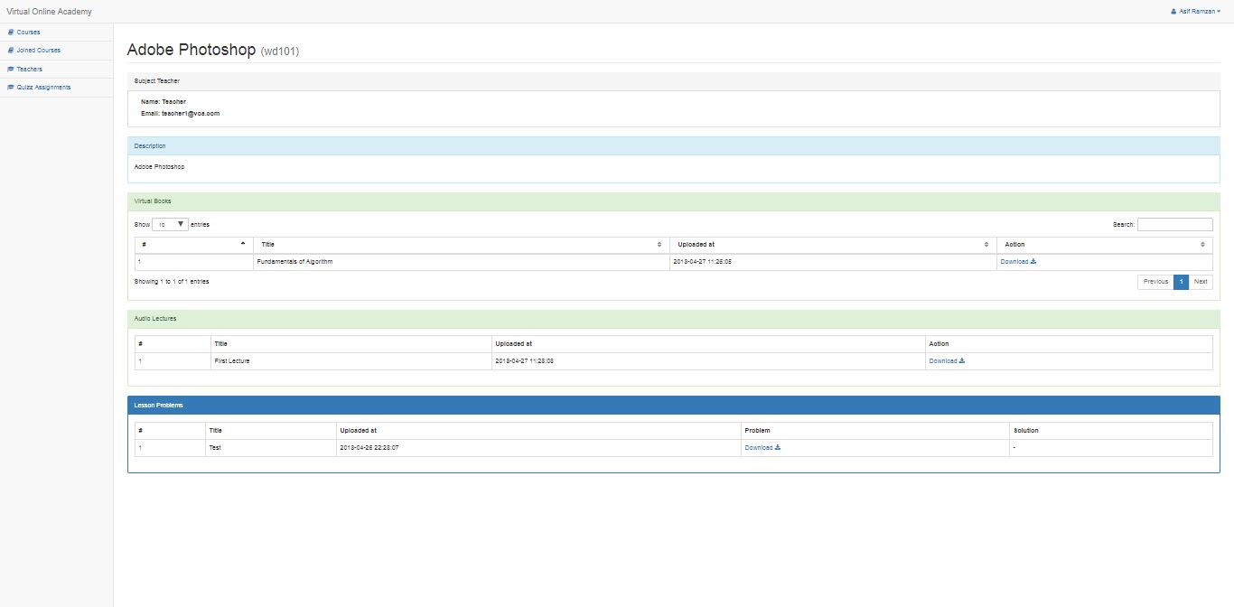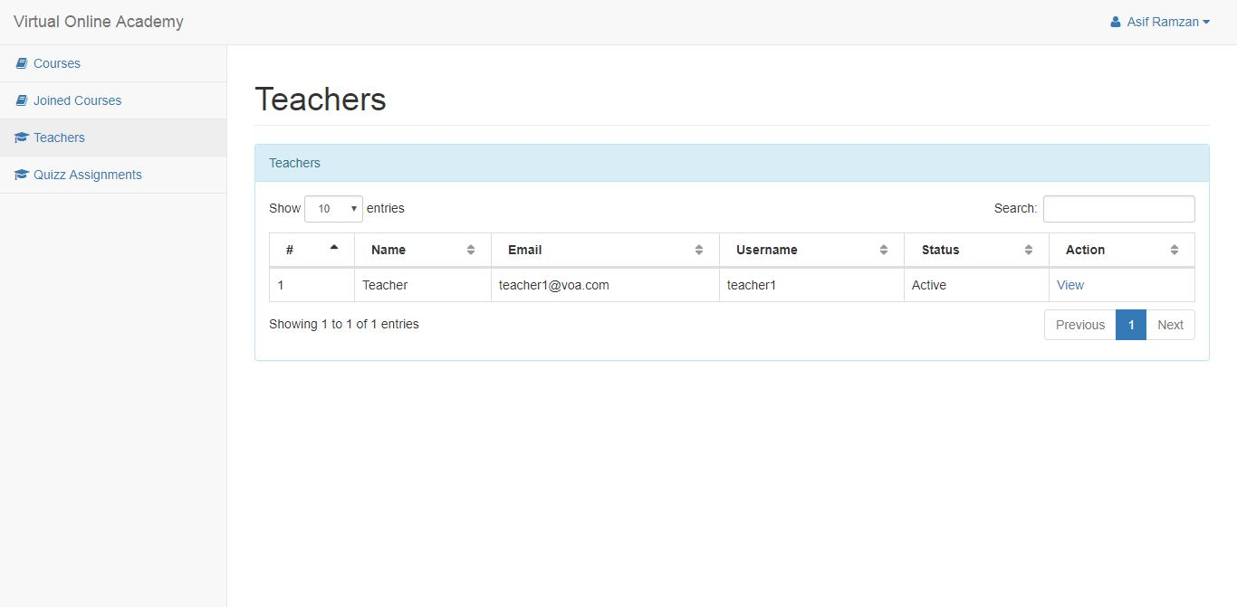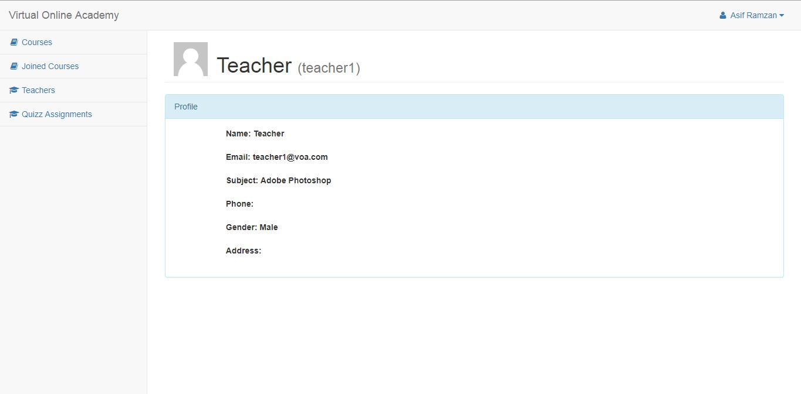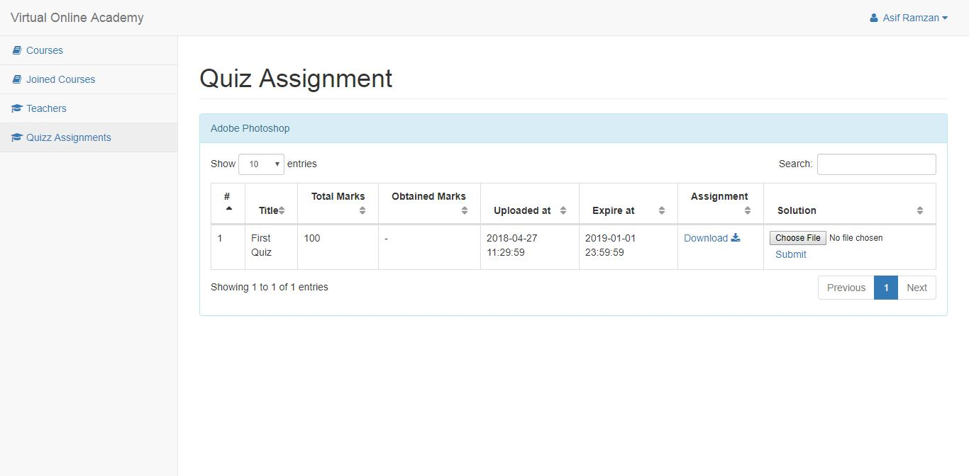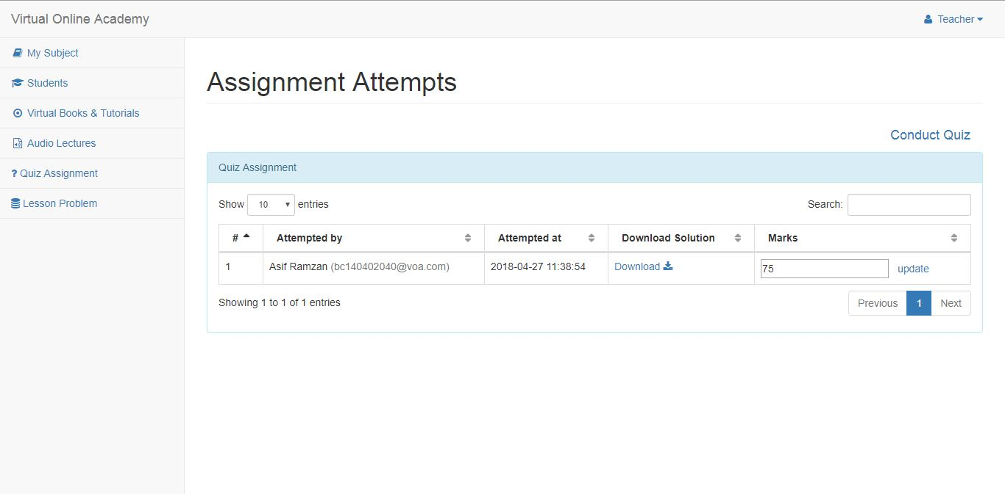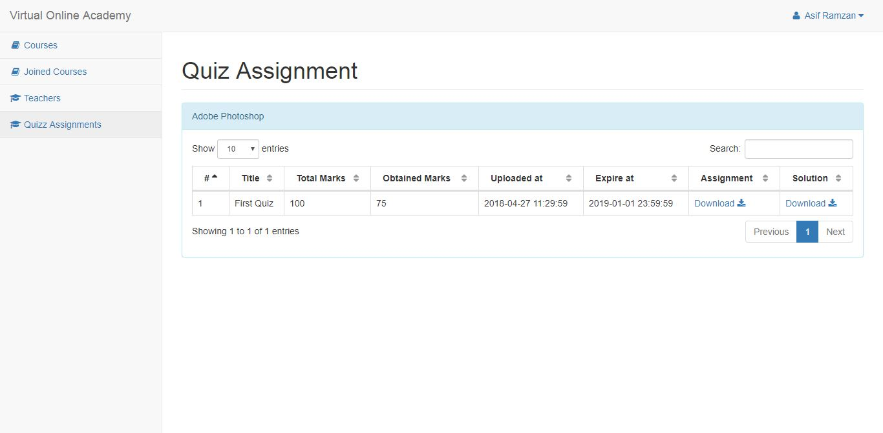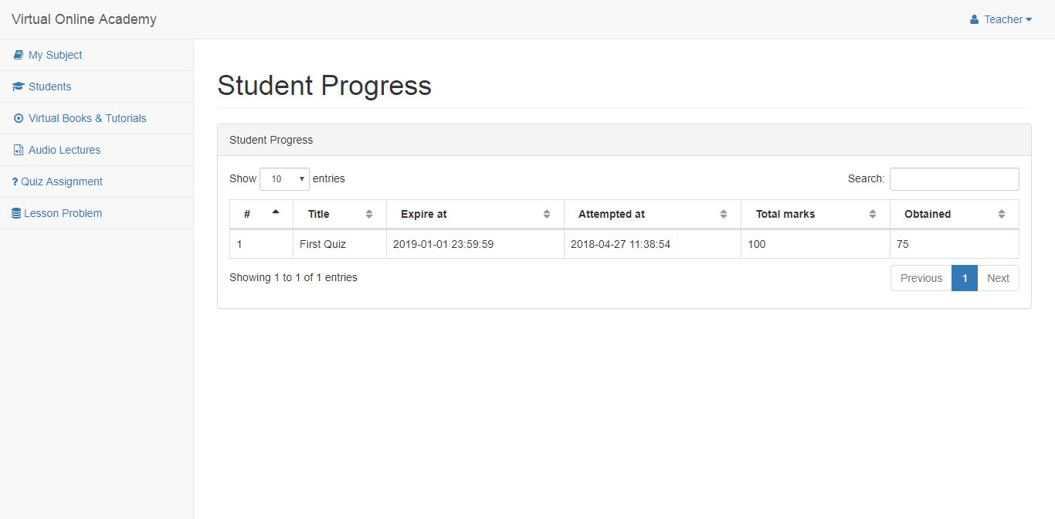

CHAPTER 3
Development

3.1 Technology Selection
Following are some of the popular server side technologies which are famously used during the development of the dynamic web applications.
As our Project is to build web base social media application, so server side programming is an essential part of my project. Most commonly used server side technologies are:
3.1.1 Server Side Includes (SSIs)
Server side includes are the simplest form of the parsed HTML. SSIs are the short directives, you can embed an HTML document to indicate files to be read and included in the final output. This might useful if the designer want to make one file with footer information, such as an address and copyright, and then append it to all pages dynamically.

3.2 Core languages
Following are the core languages on which the whole project is based. These languages are used as a tool to build the whole website. Some libraries are used to reduce the complexity and efficiency of the project.

3.2.1 HTML5
HTML is a markup language. The word markup was used by editors who marked up manuscripts (usually with a blue pencil) when giving instructions for revisions. "Markup" now means something slightly different: a language with specific syntax that instructs a Web browser how to display a page. Once again, HTML separates "content" (words, images, audio, video, and so on) from "presentation" (instructions for displaying each type of content). HTML uses a pre-defined set of elements to define content types. Elements contain one or more "tags" that contain or express content. Tags are enclosed by angle brackets, and the closing tag begins with a forward slash.
HTML5 is the fifth revision and newest version of the HTML standard. It offers new features that provide not only rich media support, but also enhance support for creating web applications that can interact with the user, his/her local data, and servers, more easily and effectively than was possible previously.
Some HTML5 features remain unsupported by some browsers. However, Gecko, and by extension, Firefox, has very good support for HTML5, and work continues toward supporting more of its features. Gecko began supporting some HTML5 features in version 1.8.1. You can find a list of all of the HTML5 features that Gecko currently supports on the main HTML5 page. For detailed information about multiple browsers' support of HTML5 features, refer to the CanIUse website.
3.2.2 CSS
CSS is used to style and lay out webpages — for example to alter the font, color, size and spacing of your content, split it into multiple columns, or add animations and other decorative features. This module gets you started on the path to CSS mastery with the basics of how it works, including selectors and properties, writing CSS rules, applying CSS to HTML, how to specify length, color, and other units in CSS, cascade and inheritance, and debugging CSS.

3.2.3 JAVASCRIPT
JavaScript (JS) is a lightweight, interpreted, programming language with first-class functions. Most well-known as the scripting language for Web pages, many non-browser environments also use it, such as node.js and Apache Couch DB. JS is a prototype-based, multi-paradigm, dynamic scripting language, supporting object-oriented, imperative, and declarative (e.g. functional programming) styles. Read more about JavaScript.
JavaScript is most commonly used as a client side scripting language. This means that JavaScript code is written into an HTML page. When a user requests an HTML page with JavaScript in it, the script is sent to the browser and it's up to the browser to do something with it.
The fact that the script is in the HTML page means that your scripts can be seen and copied by whoever views your page. Nonetheless, to my mind this openness is a great advantage, because the flip side is that you can view, study and use any JavaScript you encounter on the WWW.
JavaScript can be used in other contexts than a Web browser. Netscape created server-side JavaScript as a CGI-language that can do roughly the same as Perl or ASP. There is no reason why JavaScript couldn’t be used to write real, complex programs. However, this site exclusively deals with the use of JavaScript in web browsers.
3.2.4 PHP
PHP (recursive acronym for PHP: Hypertext Preprocessor) is a widely-used open source general-purpose scripting language that is especially suited for web development and can be embedded into HTML.
PHP started out as a small open source project that evolved as more and more people found out how useful it was. Rasmus Lerdorf unleashed the first version of PHP way back in 1994. PHP is a server side scripting language that is embedded in HTML. It is used to manage dynamic content, databases, session tracking, even build entire e-commerce sites. PHP is pleasingly zippy in its execution, especially when compiled as an Apache module on the UNIX side. The MySQL server, once started, executes even very complex queries with huge result sets in record-setting time. PHP supports a large number of major protocols such as POP3, IMAP, and LDAP. PHP4 added support for Java and distributed object architectures (COM and CORBA), making n-tier development a possibility for the first time.

Characteristics of PHP
Five important characteristics make PHP's practical nature possible −
- Simplicity
- Efficiency
- Security
- Flexibility
- Familiarity

3.2.5 jQuery (A JAVASCRIPT LIBRARY)
jQuery is a lightweight, "write less, do more", JavaScript library. The purpose of jQuery is to make it much easier to use JavaScript on your website. jQuery takes a lot of common tasks that requires many lines of JavaScript code to accomplish, and wraps it into methods that you can call with a single line of code.jQuery also simplifies a lot of the complicated things from JavaScript, like AJAX calls and DOM manipulation.
The jQuery library contains the following features:
- HTML/DOM manipulation
- CSS manipulation
- HTML event methods
- Effects and animations
- AJAX
- Utilities

3.3 Frameworks and Dependencies
In general, a framework is a real or conceptual structure intended to serve as a support or guide for the building of something that expands the structure into something useful.
A web framework (WF) or web application framework (WAF) is a software framework that is designed to support the development of web applications including web services, web resources and web APIs. Web frameworks aim to alleviate the overhead associated with common activities performed in web development. For example, many web frameworks provide libraries for database access, templating frameworks and session management, and they often promote code reuse. Though they often target development of dynamic websites they are also applicable to static websites.
Application Dependency or "Depends on Applications “is a list of other applications that are required for this application to properly work. If you do not allow the application and its dependency through the Palo Alto Networks firewall, then the application will not work.
The "Implicitly Use Applications" is a subset of "Depends on Applications", whereby the dependent applications are implicitly allowed. The application still does depend on these applications, however they do not need to be explicitly permitted in security policy. Dependent applications can be allowed implicitly, when the firewall is able to determine the correct application by a specific point in the session.

3.3.1 Bootstrap (front-end framework)
Bootstrap is a free and open-source front-end library for creating websites and web applications. It contains HTML- and CSS-based design templates for typography, forms, buttons, navigation and other interface components, as well as optional JavaScript extensions. It aims to ease the development of dynamic websites and web applications.
Bootstrap is a front end web framework, that is, an interface for the user, unlike the server-side code which resides on the "back end" or server.
Bootstrap, originally named Twitter Blueprint, was developed by Mark Otto and Jacob Thornton at Twitter as a framework to encourage consistency across internal tools. Before Bootstrap, various libraries were used for interface development, which led to inconsistencies and a high maintenance burden.

Structure and function
Bootstrap is modular and consists essentially of a series of Less stylesheets that implement the various components of the toolkit. A stylesheet called bootstrap less includes the components stylesheets. Developers can adapt the Bootstrap file itself, selecting the components they wish to use in their project.
Adjustments are possible to a limited extent through a central configuration stylesheet. More profound changes are possible by the Less declarations
Stylesheets
Bootstrap provides a set of stylesheets that provide basic style definitions for all key HTML components. These provide a uniform, modern appearance for formatting text, tables and form elements.
Re-usable components
In addition to the regular HTML elements, Bootstrap contains other commonly used interface elements. These include buttons with advanced features (e.g. grouping of buttons or buttons with drop-down option, make and navigation lists, horizontal and vertical tabs, navigation, breadcrumb navigation, pagination, etc.), labels, advanced typographic capabilities, thumbnails, warning messages and a progress bar. The components are implemented as CSS classes, which must be applied to certain HTML elements in a page.
JavaScript components
Bootstrap comes with several JavaScript components in the form of jQuery plugins. They provide additional user interface elements such as dialog boxes, tooltips, and carousels. They also extend the functionality of some existing interface elements, including for example an auto-complete function for input fields.
3.3.2 Laravel 5 (back-end framework)
Laravel is a free, open-source PHP web framework, created by Taylor Otwell and intended for the development of web applications following the model–view–controller (MVC) architectural pattern. Some of the features of Laravel are a modular packaging system with a dedicated dependency manager, different ways for accessing relational databases, utilities that aid in application deployment and maintenance, and its orientation toward syntactic sugar
Laravel 5 Features
- The following features serve as Laravel's key design points (where not specifically noted, descriptions refer to the features of Laravel 3)
- Bundles provide a modular packaging system since the release of Laravel 3, with bundled features already available for easy addition to applications. Furthermore, Laravel 4 uses Composer as a dependency manager to add framework-agnostic and Laravel-specific PHP packages available from the Packagist repository
- Eloquent ORM (object-relational mapping) is an advanced PHP implementation of the active record pattern, providing at the same time internal methods for enforcing constraints on the relationships between database objects. Following the active record pattern, Eloquent ORM presents database tables as classes, with their object instances tied to single table rows
- Query builder, available since Laravel 4, provides a more direct database access alternative to the Eloquent ORM. Instead of requiring SQL queries to be written directly, Laravel's query builder provides a set of classes and methods capable of building queries programmatically. It also allows selectable caching of the results of executed queries.
- Application logic is an integral part of developed applications, implemented either by using controllers or as part of the route declarations. The syntax used to define application logic is similar to the one used by Sinatra framework.
- Reverse routing defines a relationship between the links and routes, making it possible for later changes to routes to be automatically propagated into relevant links. When the links are created by using names of existing routes, the appropriate uniform resource identifiers (URIs) are automatically created by Laravel.
- Restful controllers provide an optional way for separating the logic behind serving HTTP GET and POST requests.
- Class auto loading provides automated loading of PHP classes without the need for manual maintenance of inclusion paths. On-demand loading prevents inclusion of unnecessary components, so only the actually used components are loaded.
- View composers serve as customizable logical code units that can be executed when a view is loaded.
- Blade templating engine combines one or more templates with a data model to produce resulting views, doing that by transpiling the templates into cached PHP code for improved performance. Blade also provides a set of its own control structures such as conditional statements and loops, which are internally mapped to their PHP counterparts. Furthermore, Laravel services may be called from Blade templates, and the templating engine itself can be extended with custom directives.
- Migrations provide a version control system for database schemas, making it possible to associate changes in the applications codebase and required changes in the database layout. As a result, this feature simplifies the deployment and updating of Laravel-based applications.
- Database seeding provides a way to populate database tables with selected default data that can be used for application testing or be performed as part of the initial application setup.
- Unit testing is provided as an integral part of Laravel. Which itself contains unit tests that detect and prevent regressions in the framework. Unit tests can be run through the provided artisan command-line utility.
- Automatic pagination simplifies the task of implementing pagination, replacing the usual manual implementation approaches with automated methods integrated into Laravel.
- Form request is a feature of Laravel 5 that serves as the base for form input validation by internally binding event listeners, resulting in automated invoking of the form validation methods and generation of the actual form.
Artisan CLI
Laravel's command-line interface (CLI), called Artisan, was initially introduced in Laravel 3 with a limited set of capabilities. Laravel's later migration to a Composer-based architecture allowed Artisan to incorporate different components from the Symphony framework, resulting in the availability of additional Artisan features in Laravel 5
The features of Artisan are mapped to different subcommands of the artisan command-line utility, providing functionality that aids in managing and building Laravel-based applications. Common uses of Artisan include managing database migrations and seeding, publishing package assets, and generating boilerplate code for new controllers and migrations; the latter frees the developer from creating proper code skeletons. The functionality and capabilities of Artisan can also be expanded by implementing new custom commands, which, for example, may be used to automate application-specific recurring tasks.
3.3.3 Laravel 5 Dependencies
Application Dependency or "Depends on Applications “is a list of other applications that are required for this application to properly work. If you do not allow the application and its dependency through the Palo Alto Networks firewall, then the application will not work.
- Guzzle
PHP comes with the native cURL client (if enabled), that can be frightening to the newcomer or hard to use to consume SOAP services. Other frameworks implement their versions of HTTP, REST, and SOAP clients to some degree. However, if you do not wish to use cURL, you do not have a framework or you are not a fan of your framework's solution, Guzzle to the rescue.
Guzzle is an independent HTTP client for PHP
Version: ~5.3|~6.0

- Predis
Flexible and feature-complete Redis client for PHP >= 5.3 and HHVM >= 2.3.0.
Predis does not require any additional C extension by default, but it can be optionally paired with phpiredis to lower the overhead of the serialization and parsing of the Redis RESP Protocol. For an experimental asynchronous implementation of the client you can refer to Predis\Async.
Version: 1.1@dev

- Carbon
The Carbon class is inherited from the PHP DateTime class. Carbon has all of the functions inherited from the base DateTime class. This approach allows you to access the base functionality if you see anything missing in Carbon but is there in DateTime.
Version: 1.21

3.4 Database Systems
A relational database is a digital database whose organization is based on the relational model of data.
A database can be understood as a collection of related files. How those files are related depends on the model used. Early models included the hierarchical model (where files are related in a parent/child manner, with each child file having at most one parent file), and the network model (where files are related as owners and members, similar to the network model except that each member file can have more than one owner).
The relational database model was a huge step forward, as it allowed files to be related by means of a common field. In order to relate any two files, they simply need to have a common field, which makes the model extremely flexible
3.4.1 MySQL
MySQL is a unified visual tool for database architects, developers, and DBAs. MySQL provides data modeling, SQL development, and comprehensive administration tools for server configuration, user administration, backup, and much more. MySQL is available on Windows, Linux and Mac OS X.

Design
MySQL enables a DBA, developer, or data architect to visually design, model, generate, and manage databases. It includes everything a data modeler needs for creating complex ER models, forward and reverse engineering, and also delivers key features for performing difficult change management and documentation tasks that normally require much time and effort.

Develop
MySQL delivers visual tools for creating, executing, and optimizing SQL queries. The SQL Editor provides color syntax highlighting, auto-complete, reuse of SQL snippets, and execution history of SQL. The Database Connections Panel enables developers to easily manage standard database connections, including MySQL Fabric. The Object Browser provides instant access to database schema and objects.

Administer
MySQL provides a visual console to easily administer MySQL environments and gain better visibility into databases. Developers and DBAs can use the visual tools for configuring servers, administering users, performing backup and recovery, inspecting audit data, and viewing database health.

Visual Performance Dashboard
MySQL provides a suite of tools to improve the performance of MySQL applications. DBAs can quickly view key performance indicators using the Performance Dashboard. Performance Reports provide easy identification and access to IO hotspots, high cost SQL statements, and more. Plus, with 1 click, developers can see where to optimize their query with the improved and easy to use Visual Explain Plan.

Database Migration
MySQL now provides a complete, easy to use solution for migrating objects and data to MySQL. Developers and DBAs can quickly and easily convert existing applications to run on MySQL both on Windows and other platforms. Migration also supports migrating from earlier versions of MySQL to the latest releases.

3.5 Our Selection

We selected PHP for our Project Server side programming.

3.5.1 Why PHP?

PHP has many advantages over other platforms when it comes to creating Web applications. Probably the most significant advantage is its integration with the Windows server and programming tools. Web applications created with PHP are easier to create, debug, and deploy because those tasks can all be performed within a single development environment—Macromedia Dreamweaver 8.
2nd Main reason is that it is an open source and every one can use easily without any problem.

3.5.2 Reasons for selecting PHP
Following are some of the reasons due to which I have selected PHP for server side programming.
- Large applications can be written in very less amount of code as compare to other frameworks.
- It provides simpler development work with an event driven, server side programming model.
- Writing & Maintenance of pages is very easy in PHP because source code and HTML are together.
- Execution of source code on the server provides more power and flexibility.
- It use to improve developers productivity as it provides easy programming models, flexible language models, great tool support, rich class framework.
- Its performance is also very fine because more users can be benefited with same hardware as it allows compiled execution, rich output catching etc.
- Executable portions of a Web application compiled so they execute more quickly than interpreted scripts.
- On-the-fly updates of deployed Web applications without restarting the server.
- Automatic state management for controls on a Web page (called server controls) so that they behave much more like Windows controls.
- The ability to create new, customized server controls from existing controls.
- Built-in security through the Windows server or through other authentication/authorization methods.
PHP is the framework widely used by programmers for the web solutions regarding web development.
3.6 Internet
The internet is an international network of computers that exchange information with each other. We can also consider internet as a global network of distributed computers that share information with each other. The World Wide Web is a vast interconnected library if information, art and commerce. Now we will discuss some terminologies associated with internet.
3.6.1 Web Server
Web server is a special piece of software that processes the code at that time when a user requests for any PHP page from a web.
3.6.2 Web Browser
Browser is software, which can interpret the HTML tags. It passes the request to the web Browser.
3.6.3 Web
The web is the collection of all browsers, servers, files and browser accessible services available through the internet.
3.7 Hardware Requirements
The Minimum hardware requirement for organization and simple net user are:
- Core i3 @ 2.4 Ghz
- 2 GB of RAM
- 1 GB Storage on Hard Disk
REFERENCES

https://www.google.com/

https://www.w3schools.com/

https://www.tutorialspoint.com/

https://getbootstrap.com/docs/4.1/getting-started/introduction/

http://php.net/

https://stackoverflow.com/

https://laravel.com/

https://laracasts.com/

