

Software Engineering Project-II (Web Programming)
SWE332
PROJECT TITLE

Online Diagnostic Lab Reporting System
 | NAME:  M. Asif Rahman |  |  | ID:151-35-1020
 | Supervisor Name |  |  | Md Alamgir Kabir
 | Department: |  |  | Software Engineering
 | Faculty of Science and Information Technology
February, 01 2018

Project title Table of Content

Table of Contents
Chapter 1 1
- Introduction 1
  - About the System 1
  - Purpose 1
  - Scope 1
  - Vision 1
  - Why this system is necessary? 1
  - Proposed Solution 1
Chapter 2 2
- System Analysis 2
  - Use Case Model 2
  - Use Case Description (Detailed) 3
    - Add crop’s name 4
    - Specify the amount of land 5
    - View Procedure 6
  - System Sequence Diagrams 7
    - Add crop’s name 8
    - Specify the amount of land 9
    - View procedure 10

Introduction
The system is an online agricultural program application. This system is very effective for all the farmers because this system will show the process of all crop cultivation. Here farmers should select only their crop names and mention the amount of land.

1.1 About the System
Online Farmers Confidence system

Purpose
The main purpose of this application is to make a farmer aware of the cultivation of new crops when he wants to cultivate a new crop. This system will help him to understand how he will cultivate that new crop in his specific land area.

Scope
Farmer is one of the main users of this online system. This project will make agriculture project easier and by utilizing very few inputs the farmers can produce more crops in their land at the right rate.

Vision
The proposed Farmers Confidence system is very much graceful and lively. The main objective of this system is to provide a proper solution to how any crop should be distributed to any quantity of the soil.

Why this system is necessary?
Farmers can easily take advantage of any crop field cultivation process in their respective fields.

Proposed Solution
- Aim is to establish an Online Agriculture procedure reporting System.
- Farmers can check the all crops procedure from online.
- The system automatic describe all types of cultivation procedure.
- This provides quick and effective services.

2. System Analysis
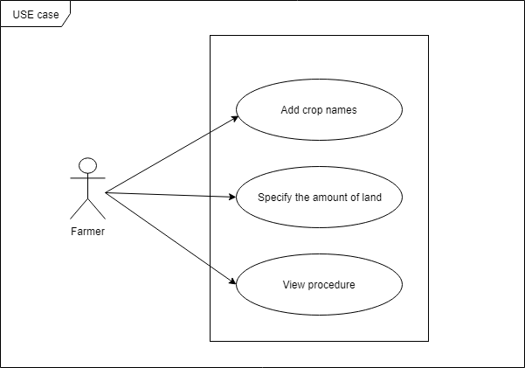
2.1 Use Case Model

Figure: USE Case Diagram for farmer’s confidence System
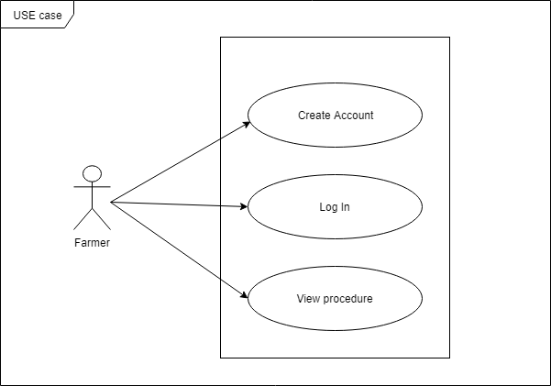
Figure: USE Case Diagram for farmer’s confidence System

USE CASE DESCRIPTION
Use Case Name: | Add Crop Names
Scenario : | Manage the all register web user
Brief Description: | When a farmer registers the system and collects the information about the crop, he will select the crop name.
Actors: | Farmer
Stakeholders: | Web user
Preconditions: | Web user must exist.  Internet must be connected.  Registration form must be provided.
Post conditions: | Crops list must be provided.  Add option must be provided.
Flow of Events: | Actor System
  - Create registration option.  - Listed the require information.  - Farmer request for registration form. | 1.1. Create registration form.  2.1. Provides form with require information.  3.1. Provides farmer registration form.
Exception Conditions: | 1.1. If the user can use the site without registration there is no important of this use case.  1.2. If the user do not need to provide their information administrator they will not pause this use case.

Use Case Name: | Specify the amount of land
Scenario : | Manage the all register web user
Brief Description: | When a farmer registers the system and collects the information about the crop, farmers can add the amount of land to the system.
Actors: | Farmers
Stakeholders: | Web user
Preconditions: | Land Size always number of percentage point.
Post conditions: | Provides all necessary information.
Flow of Events: | Actor System
  - Add number of soil size. | 1.1. Collect size and calculate with crops procedure  1.2. Provides procedure information.
Exception Conditions: | 1.1. If no amount of land is mentioned, no action will be taken.

Use Case Name: | View Procedure
Scenario : | Showing accepted result
Brief Description: | When a user inputs the amount of his land and the name of the crop, he can see crop operation or procedure.
Actors: | Web User
Stakeholders: | Web user
Preconditions: | Web user must exist.  Internet must be connected.  Registration and login must be done.
Post conditions: | All type of crop operation must be provided.  Availability must be provided.
Flow of Events: | Actor System
  - Login with information  - Add crop name and field size.  - Request for procedure. | 1.1. Verify user  2.1. Provides procedure with require information.
Exception Conditions: | - If a user does not exist this use case will paused by the user.

2.3 System Sequence Diagrams
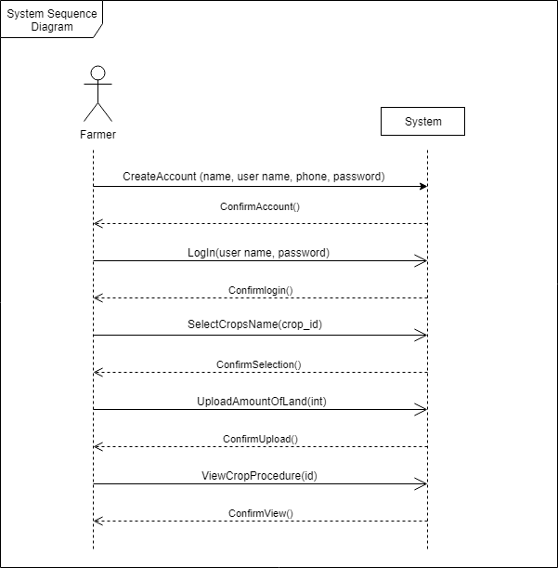

2.3.1 Add crop’s name
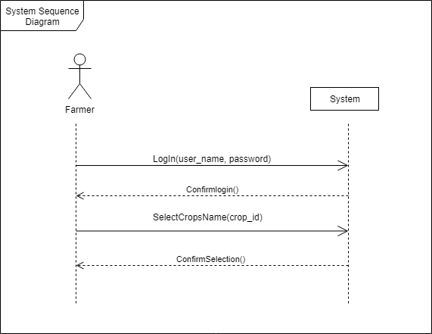

2.3.2 Specify the amount of land
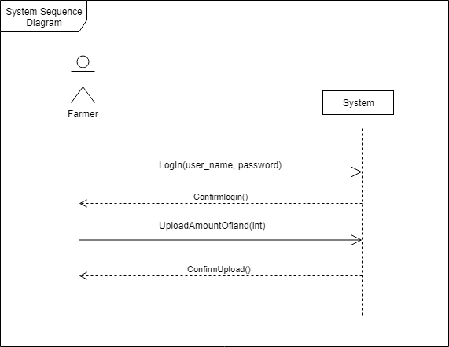

2.3.3 View procedure
