# Assignment-4:

**Creating a Database Using MongoDB and Mongosh**

**Name:** Shaik Khadir Asif Pasha

**Email:** [**208x1a0589@khitguntur.ac.in**](mailto:208x1a0589@khitguntur.ac.in)

**Roll.NO:** 208x1a0589

**Phone:** 9347054547

**College:** Kallam Haranadhareddy Institute Of Technology

**Requirements:**

* MongoDB
* MongoDB Compass

**Database Setup:**

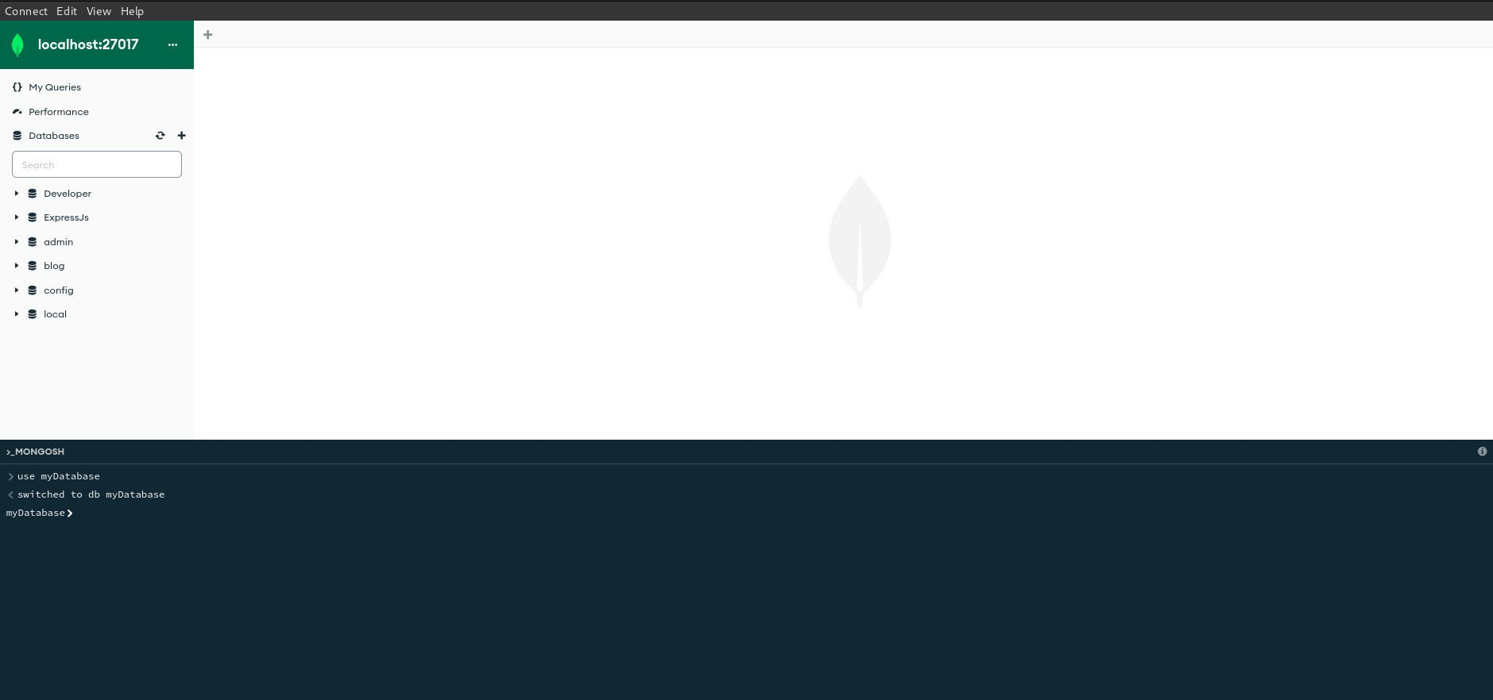

**Collection Creation:**

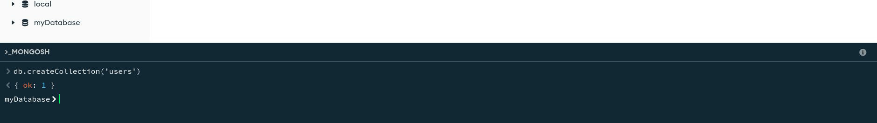

After Creation of collection ‘users’, MongoDB Compass shows us the Database ‘myDatabase’ and its collection ‘users’ as shown below:

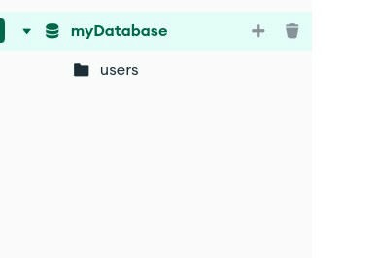

**Document Insertion:**

Inserting With ‘insertOne’:

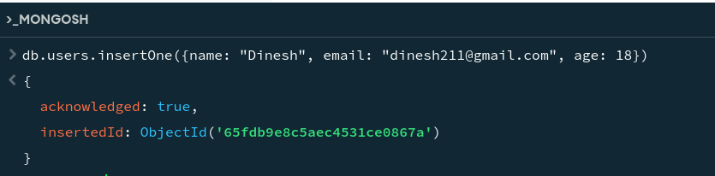

After Inserting:

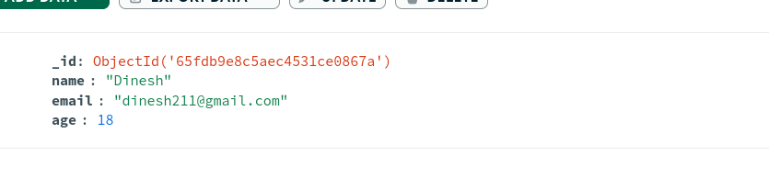

Inserting with ‘insertMany’:

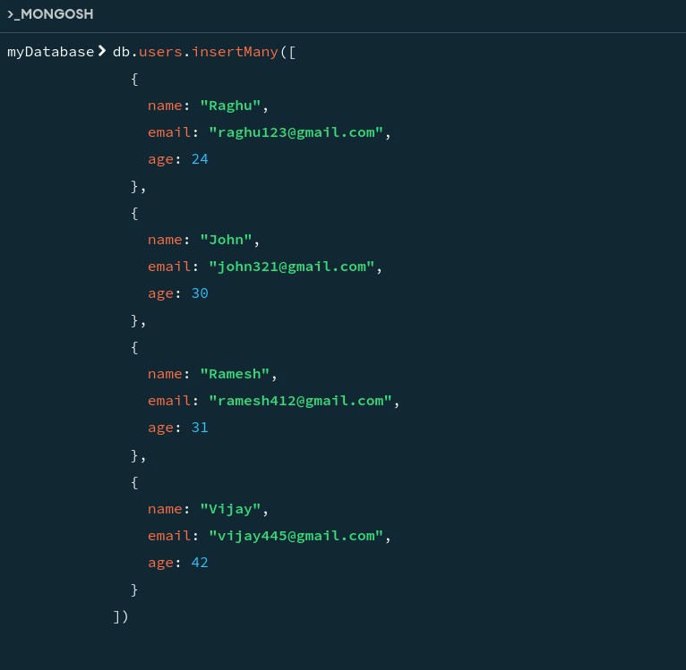

After Inserting the above, the database looks like the following:

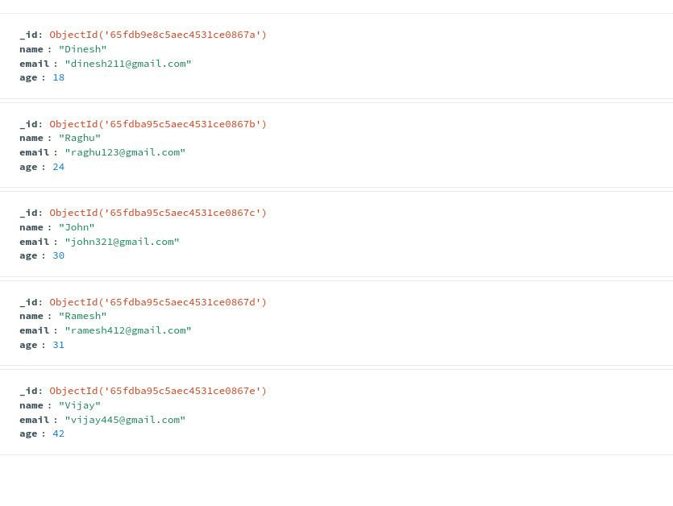

## Querying to retrieve the data:

To retreive all the users from the ‘users’ collection, find() is used.

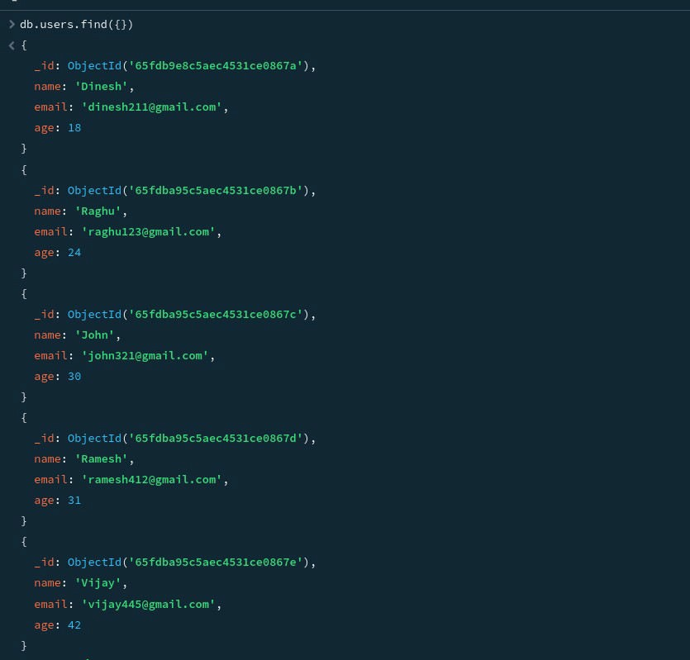

To retrieve a specific user, we can use findOne(),

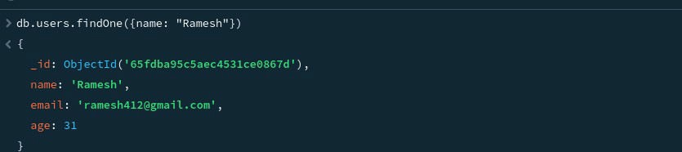

To Find Users with age greater than 30,

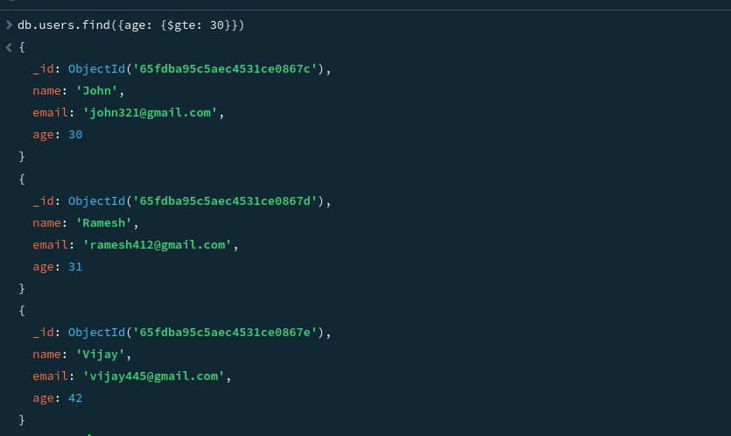

## Update Operation:

To update the age of a user with a specific email address,

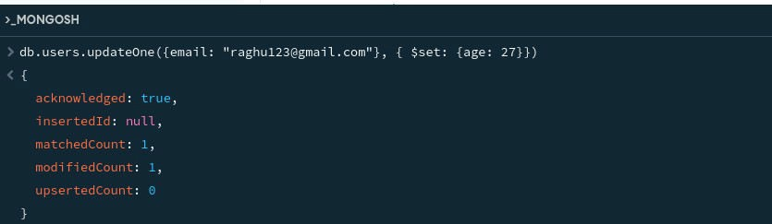

## Delete Operation:

To delete a user with a specific email address,

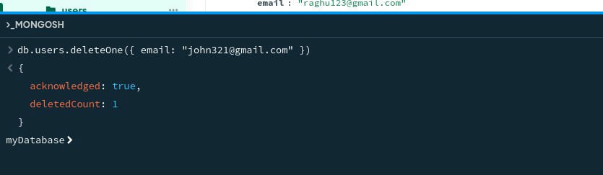

After deleting the user, the database looks like the following:

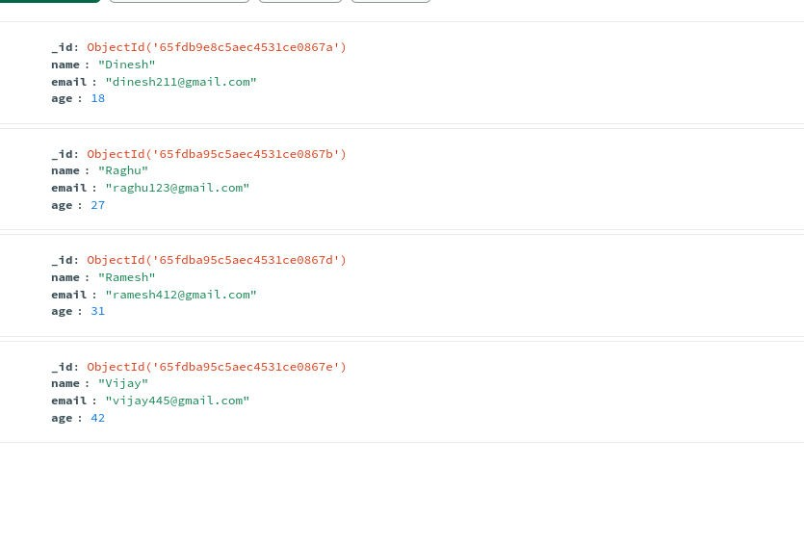

**Index Creation:**

To create a index on a field, createIndex() is used.

Before creating index for email field, the indexes of ‘users’ collection are,



Creating a index on email field:



After creating, the indexes are:

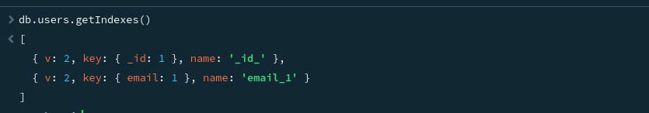

## After all the operations, finally the database looks like the following:

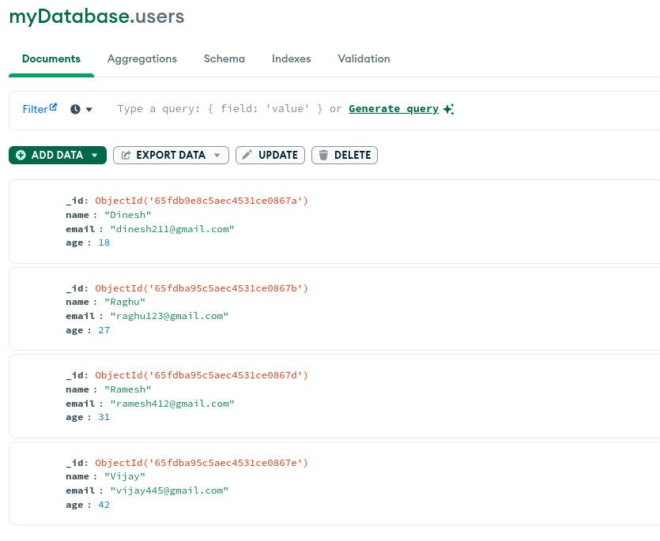

**Indexes:**

