**Assignment-2:**

**Card And Button Components**

**Name**: Shaik Khadir Asif Pasha **Email**: [208x1a0589@khitguntur.ac.in](mailto:208x1a0589@khitguntur.ac.in) **Phone No**. : 9347054547

**Roll.No** : 208X1A0589

**College Name**: Kallam Haranadhareddy Institute Of Technology

**Code:**

**Page.js** Code:

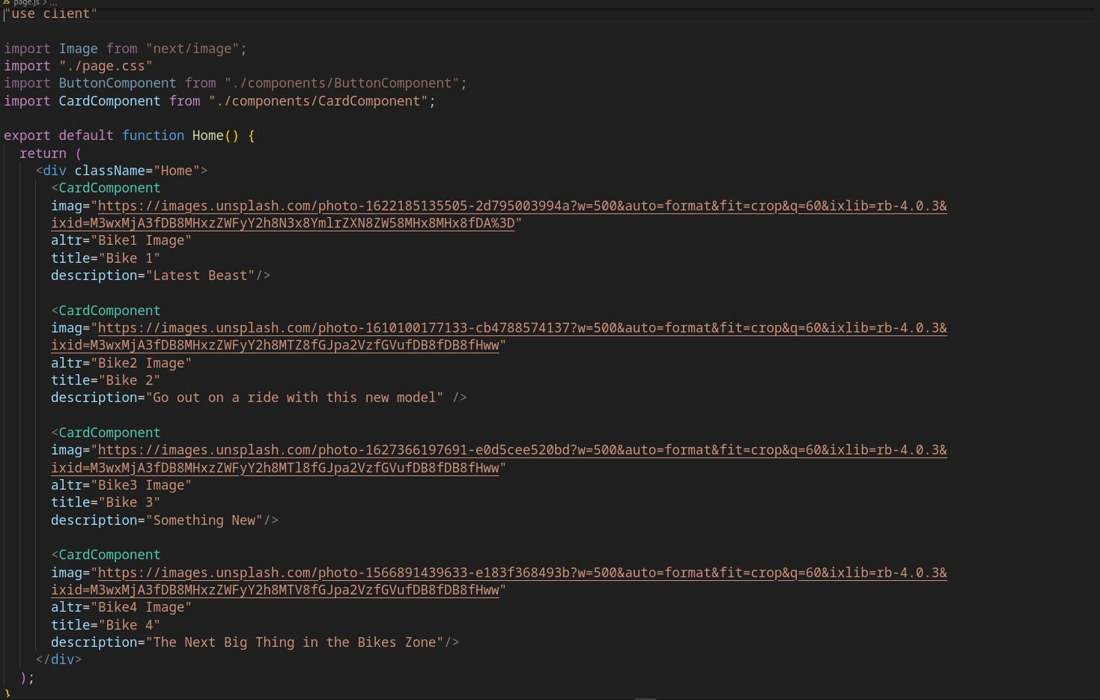

# Page.css Code:

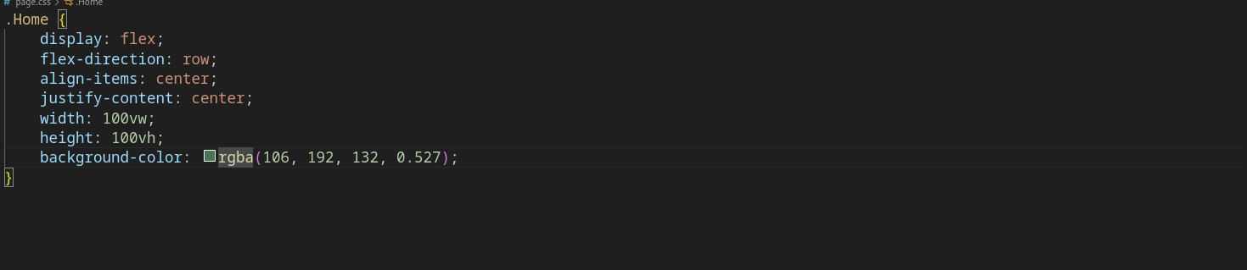

**Card Component Code:**

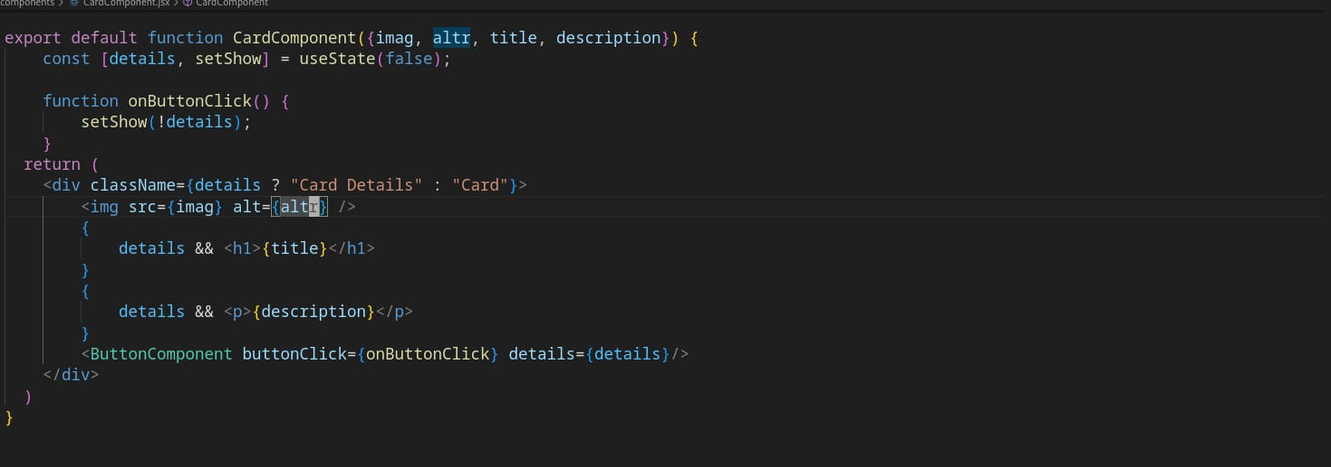

**CardComponent.css Code:**

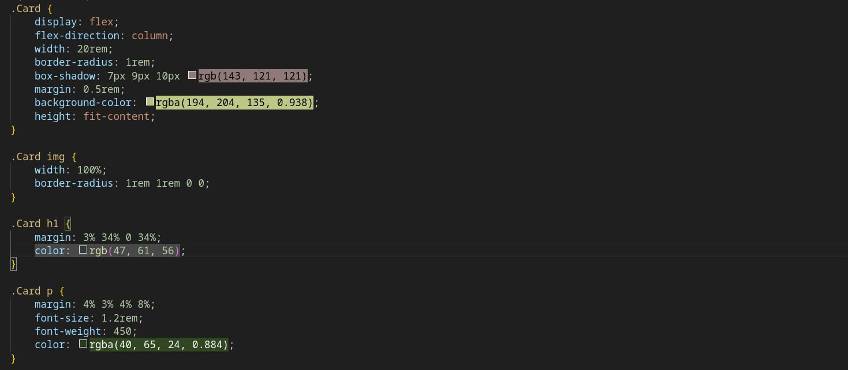

**Button Component Code:**

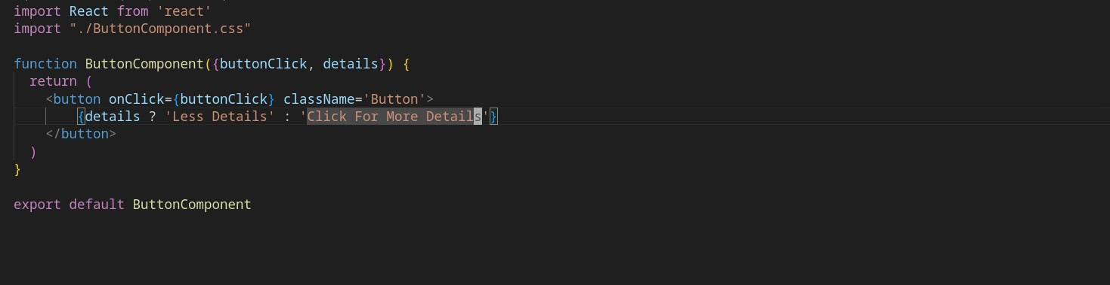

**ButtonComponent.css Code:**

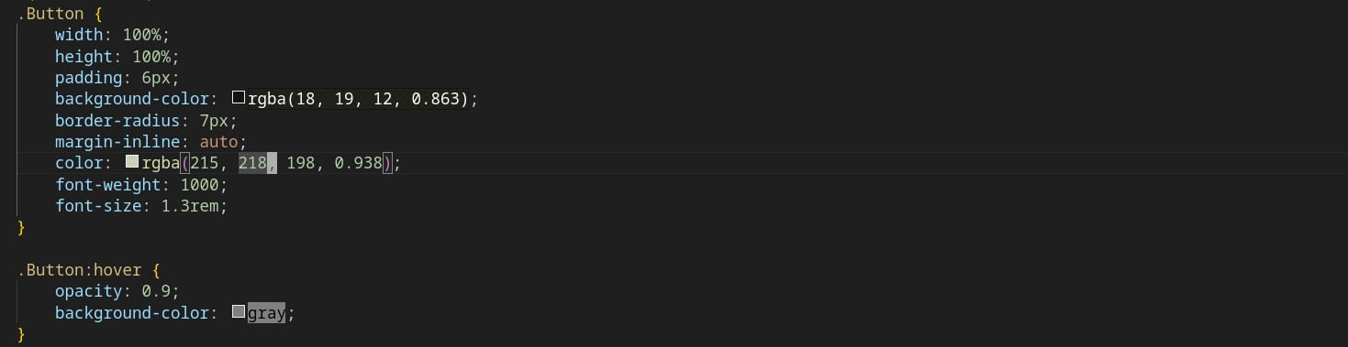

**Description Of The Coding Process:**

Used ReactJs Features to code Cards and Buttons, Each with separate Components Command to run: **npm run dev**

# Output:

**Before Click:-**

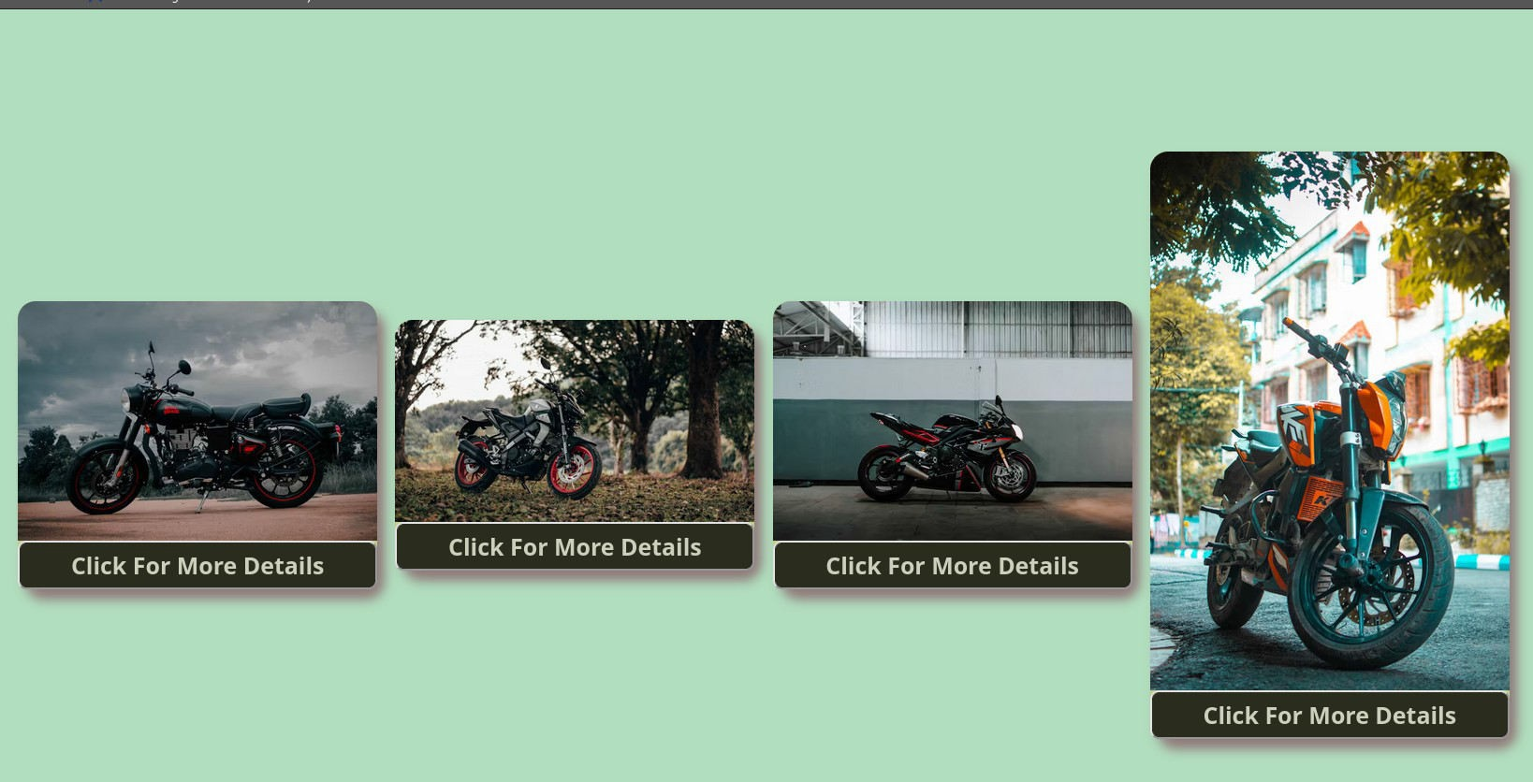

**After Button Click:**

