**Assignment-3: Create a RESTful API using express.js and create a database and index in MongoDB**

**Name:** Shaik Khadir Asif Pasha

**Email:** 208x1a0589@khitguntur.ac.in

**Roll.NO:** 208x1a0589

**Phone:** 9347054547

**College:** Kallam Haranadhareddy Institute Of Technology

**Source Code:**

# Index.js File:

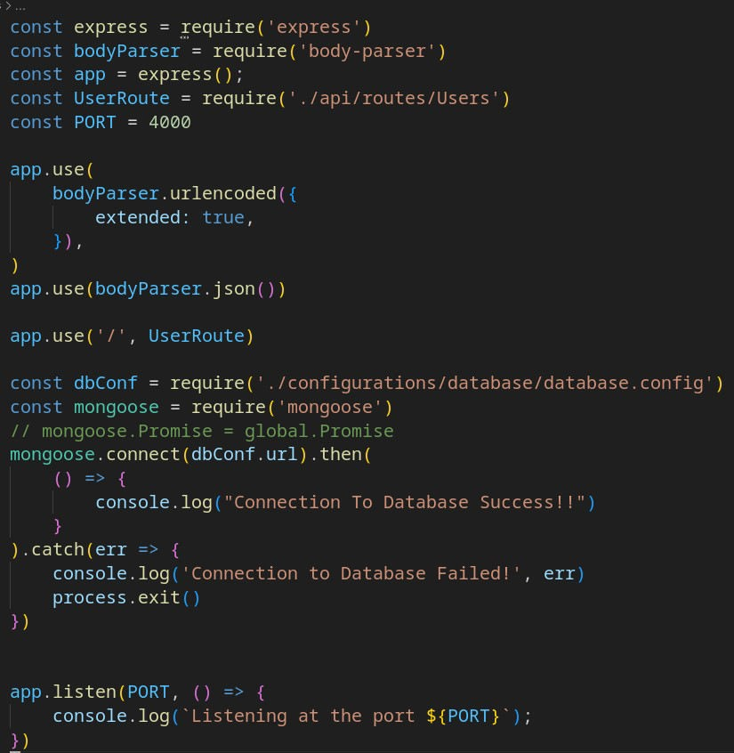

### Database Configuration: database.config.js:

**API Setup:**

***Routes:***

### UsersRoute.js:

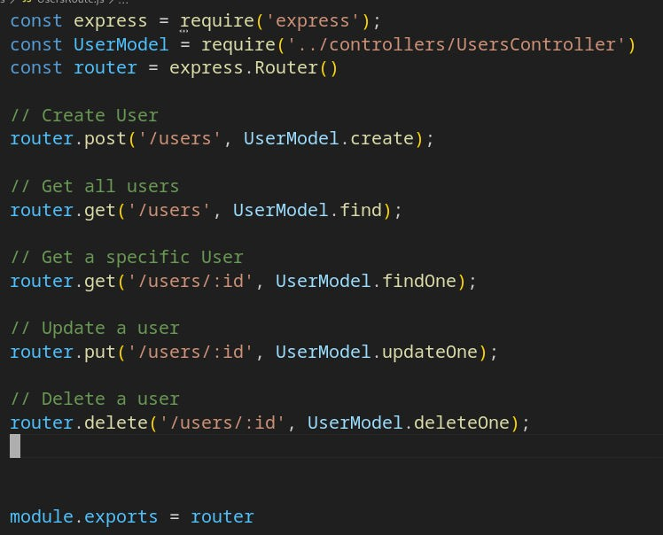

***Controllers:***

### UsersController.js:

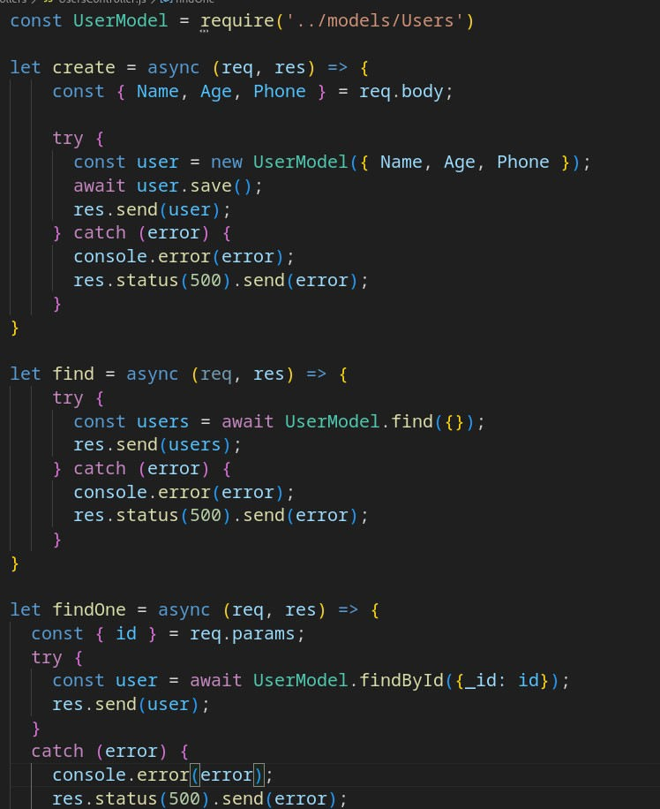

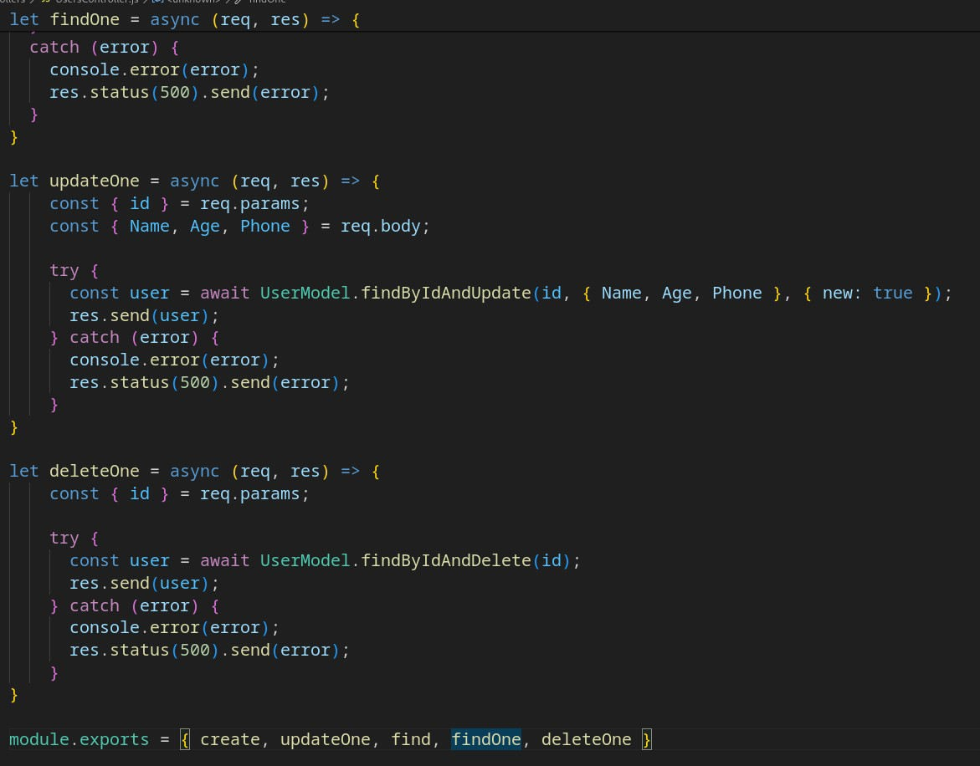

***Model:***  ***Users.js:***

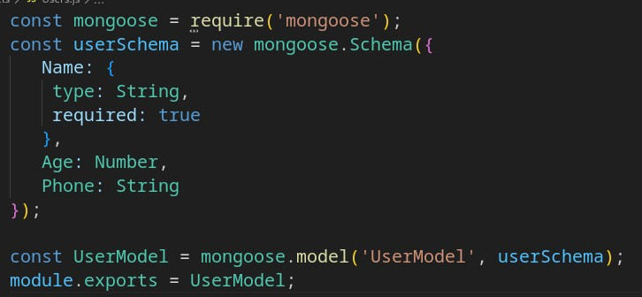

### Modules Used:

* Express
* nodemon
* body-parser
* mongoose

### Using nodemon to start server:

To restart the server automatically when changes occur, nodemon is used.

### How to use ‘nodemon’ module:

To use nodemon, we have to install it with the following command.

After Installing update the scripts key in ‘package.json’ file in our express project with the following,

* **“start”: “nodemon index.js” For Example:**

**package.json File:**

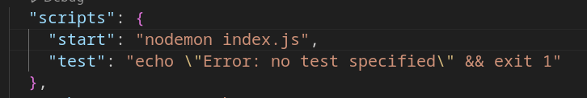

**Starting the server: Command: npm start**

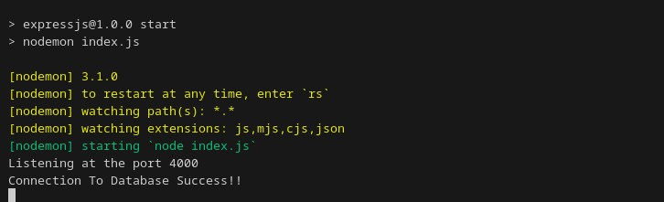

**To Perform CRUD Operations and Testing of RESTful API, Thunderclient extension of VSCode Is Used**



**Create(POST):**

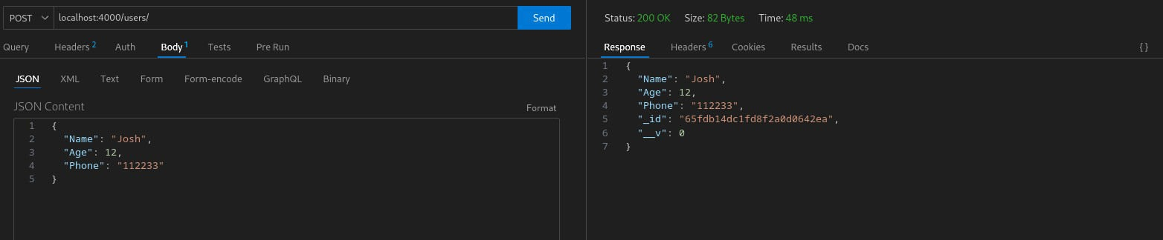

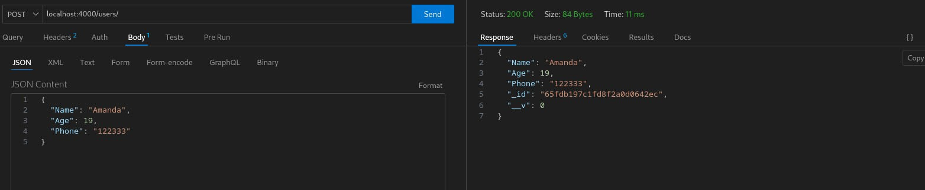

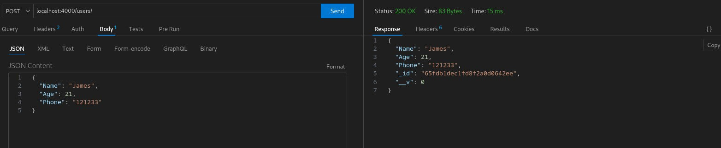

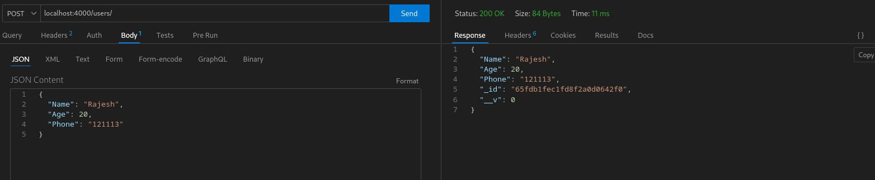

**Read(GET): FindAll:**

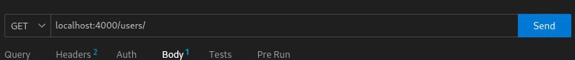

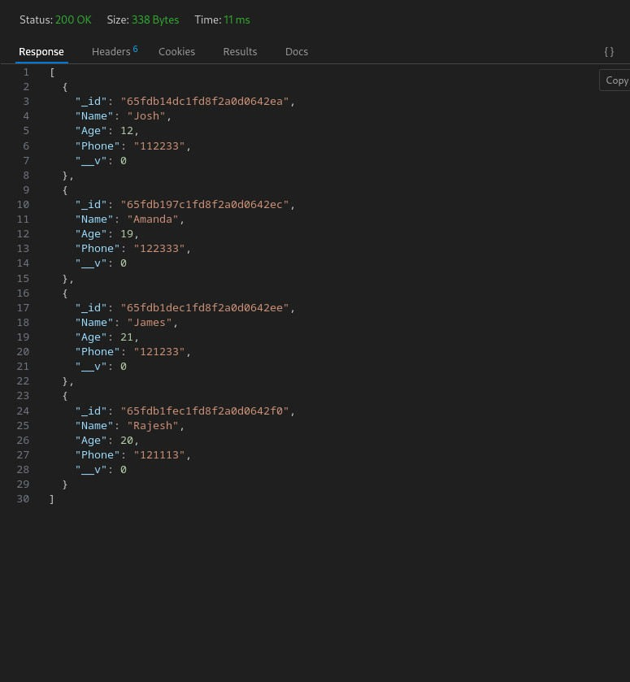

**FindByID:**

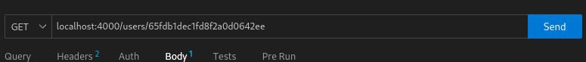

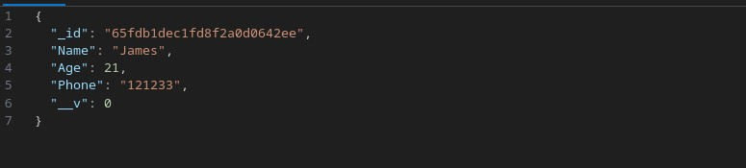

**Update(PUT): Before Updating:**

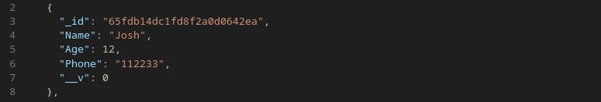

**Updating With PUT:**

Changing Name from “Josh” to “Arnold”

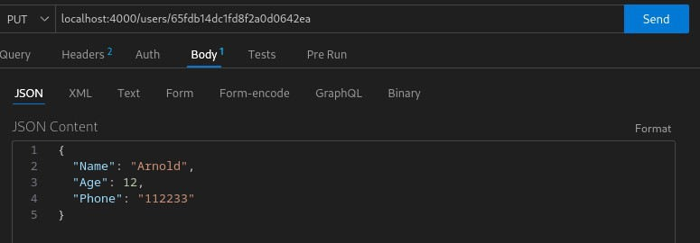

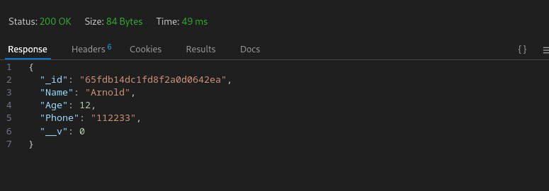

### Delete(Delete):

Deleting a user with ‘ObjectID’

### Before Deleting,

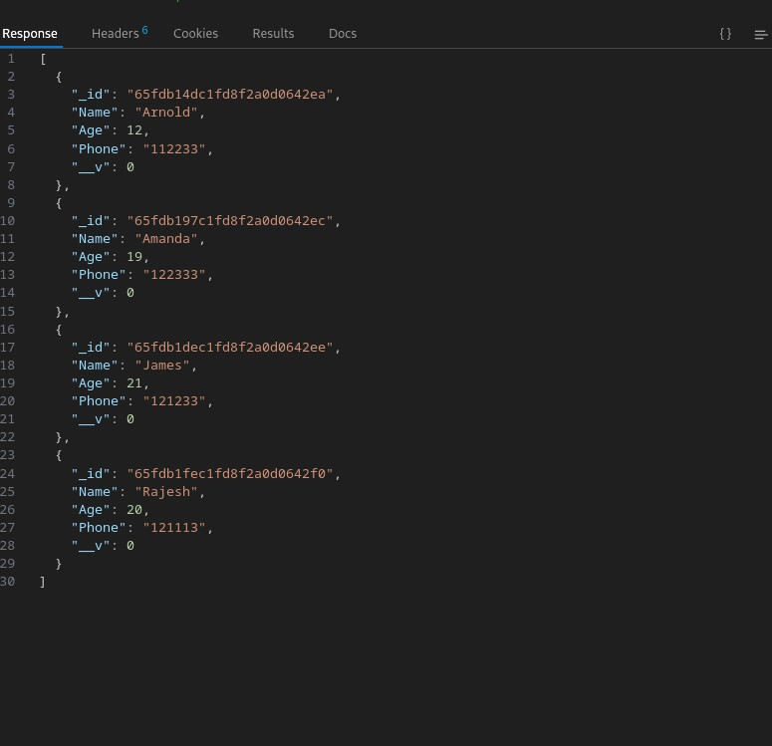

**Deleting A User:**

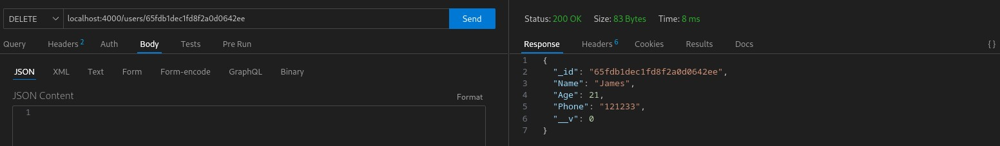

### After Deleting:

