Assignment Report

Drone Navigation System using Brute-Force Convex Hull

Aim
To determine the boundary points of obstacles using the Brute-Force Convex Hull Algorithm for safe drone navigation.

Problem Statement
A drone must identify the outer boundary of obstacle points before planning a safe route. The Convex Hull algorithm computes the smallest convex polygon enclosing all obstacle points.
Screen Short:
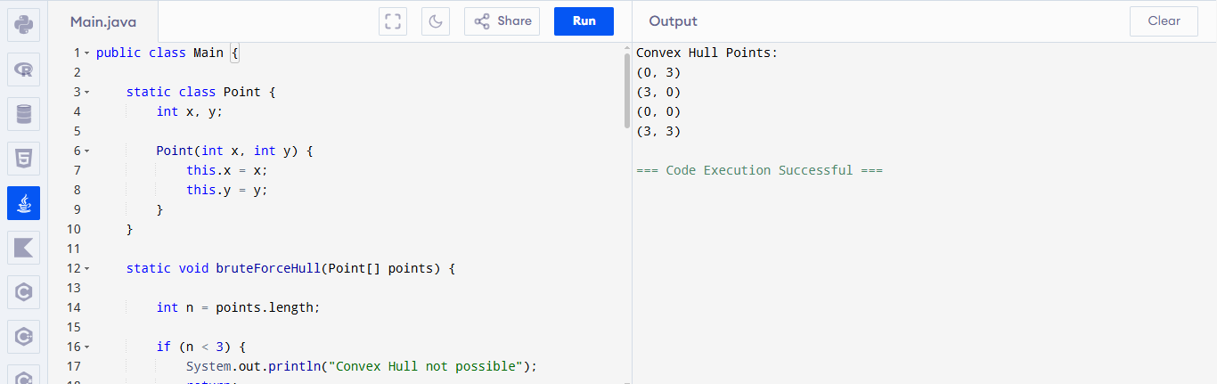

Algorithm
- Input obstacle coordinates.
- Select every pair of points.
- Check whether all remaining points lie on one side of the selected line.
- If true, both points belong to the convex hull.
- Repeat for all pairs.
- Display all boundary points.

Explanation (Q30)

(a) How Convex Hull is Computed
The Brute-Force Convex Hull algorithm examines every pair of points.
- A line is formed between two points.
- Every remaining point is checked.
- If all points lie on one side of the line, the line is an edge of the convex hull.
- The endpoints of that line become hull vertices.
- Repeating this process for all pairs gives the complete convex hull.

(b) Time Complexity
There are three nested loops.
- First loop → n points
- Second loop → n points
- Third loop → checks remaining n points
Therefore,
Time Complexity
O(n³)
Space Complexity
O(n)

(c) Scalability Challenges
The Brute-Force algorithm is inefficient for large datasets because:
- Every pair of points is checked.
- Each pair requires scanning all points.
- Processing time increases rapidly.
- Real-time drone navigation becomes slow.
- High CPU usage for thousands of obstacle points.
Hence, Brute-Force Convex Hull is suitable only for small datasets.

Input
(0,3)
(2,2)
(1,1)
(2,1)
(3,0)
(0,0)
(3,3)

Output
Convex Hull Points

(0,3)
(3,3)
(3,0)
(0,0)

Applications
- Drone navigation
- Robot path planning
- GPS mapping
- Image processing
- Geographic Information Systems (GIS)
- Computer graphics

Result
The Brute-Force Convex Hull algorithm successfully identified the boundary points surrounding the obstacle locations, enabling safer path planning for the drone.

# Drone Navigation System using Brute-Force Convex Hull

## Description

This project demonstrates how a drone identifies the boundary points of obstacles using the Brute-Force Convex Hull Algorithm.

## Features

- Finds outer boundary points
- Simple Java implementation
- Demonstrates computational geometry
- Suitable for educational purposes

## Algorithm

1. Choose every pair of points.
2. Check whether all other points lie on the same side.
3. If yes, both points belong to the convex hull.
4. Print all hull points.

## Time Complexity

O(n³)

## Space Complexity

O(n)

## Input

```
(0,3)
(2,2)
(1,1)
(2,1)
(3,0)
(0,0)
(3,3)
```

## Output

```
Convex Hull Points
(0,3)
(3,3)
(3,0)
(0,0)
```

## Applications

- Drone navigation
- Robotics
- GIS
- Computer Graphics
- Object boundary detection

## Author

Asif

