Assignment Report

Debugging Sorting Code (Mixed Ascending and Descending Conditions)

Aim
To debug a sorting algorithm containing inconsistent ascending and descending comparison conditions and implement a clean, optimized Bubble Sort algorithm.

Problem Statement
The given sorting algorithm uses ascending comparison in some passes and descending comparison in others. This inconsistency results in partially sorted output and unnecessary operations.
Screen Short:
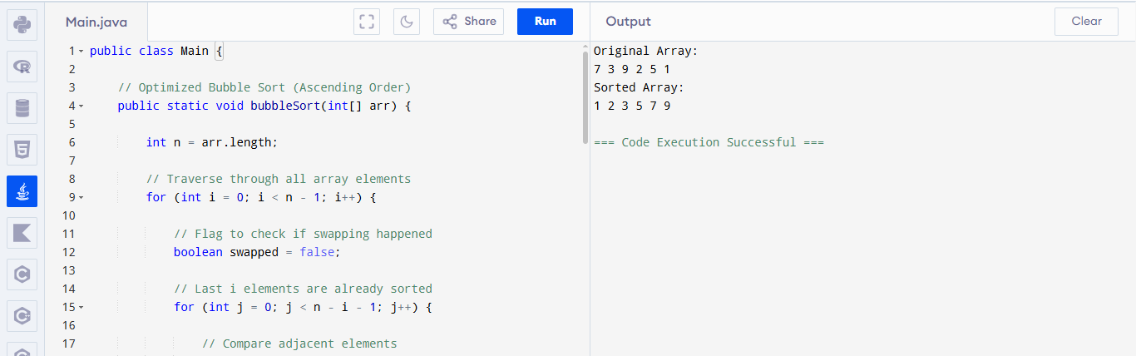

Problem Analysis
Original code:
if i % 2 == 0:
if arr[j] > arr[j+1]:
swap
else:
if arr[j] < arr[j+1]:
swap
The algorithm alternates between ascending and descending order.
This causes:
- Incorrect sorting
- Partial sorting
- Unnecessary swaps
- Poor readability

Algorithm
- Read the input array.
- Compare adjacent elements.
- If the left element is greater, swap them.
- Continue until the largest element reaches the end.
- Repeat for the remaining unsorted elements.
- Stop early if no swaps occur.
- Display the sorted array.

Debugging Process

Issue 1
Mixed ascending and descending comparisons.

Fix
Use only ascending comparison:
if(arr[j] > arr[j+1])

Issue 2
Unnecessary passes.

Fix
Added a swapped flag.
If no swap occurs, terminate the algorithm early.

Issue 3
Poor readability.

Fix
Added meaningful comments and removed redundant conditions.

Optimizations
- Consistent ascending comparison.
- Early termination using swapped.
- Cleaner and more readable code.
- Reduced unnecessary iterations.

Time Complexity

Best Case
Already sorted array.
Time Complexity: O(n)

Average Case
Random input.
Time Complexity: O(n²)

Worst Case
Reverse sorted array.
Time Complexity: O(n²)

Space Complexity
Only one Boolean variable is used.
Space Complexity: O(1)

Input
7 3 9 2 5 1

Output
Original Array:
7 3 9 2 5 1

Sorted Array:
1 2 3 5 7 9

Applications
- Sorting student records
- Sorting marks
- Database processing
- Data analysis
- Searching algorithms
- Educational demonstrations

Result
The inconsistent sorting logic was successfully debugged by replacing mixed ascending and descending comparisons with a single ascending comparison. The optimized Bubble Sort correctly sorts the array while improving readability and reducing unnecessary operations.

# Debugging Sorting Code (Mixed Ascending and Descending Conditions)

## Description

This project demonstrates how to debug a sorting algorithm that incorrectly alternates between ascending and descending comparisons. The corrected implementation uses an optimized Bubble Sort algorithm.

## Features

- Correct ascending sorting
- Optimized Bubble Sort
- Early termination using a swapped flag
- Well-commented Java code
- Simple and easy to understand

## Algorithm

1. Compare adjacent elements.
2. Swap if the left element is greater.
3. Repeat until the array is sorted.
4. Stop early if no swaps occur.

## Time Complexity

| Case | Complexity |
|------|------------|
| Best | O(n) |
| Average | O(n²) |
| Worst | O(n²) |

## Space Complexity

O(1)

## Input

```
7 3 9 2 5 1
```

## Output

```
Original Array:
7 3 9 2 5 1

Sorted Array:
1 2 3 5 7 9
```

## Applications

- Data Sorting
- Database Management
- Searching Algorithms
- Educational Projects
- Software Development

## Author

Asif

