REPORT

NETWORK PACKET ANALYSIS SYSTEM USING MERGE SORT AND BINARY SEARCH

Experiment No.
30

Aim
To develop a Network Packet Analysis System that efficiently sorts packet IDs using Merge Sort and searches packet IDs using Binary Search.

Objective
- Understand Divide and Conquer.
- Implement Merge Sort.
- Implement Binary Search.
- Analyze Time Complexity.
- Improve searching efficiency on large packet datasets.

Screenshot:
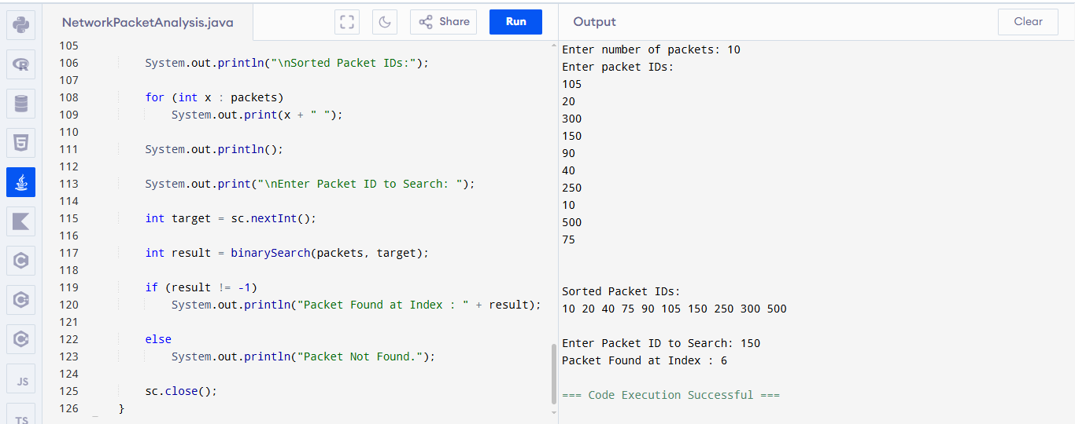

Problem Statement
A network monitoring system processes thousands of incoming packet IDs.
Since packets arrive in random order, searching directly is inefficient.
To improve performance:
- First sort the packet IDs.
- Then perform Binary Search.
This minimizes searching time even for very large datasets.

Algorithm

Step 1
Read packet IDs.

Step 2
Apply Merge Sort.
Divide array into two halves.
Recursively sort.
Merge sorted halves.

Step 3
Display sorted packets.

Step 4
Read target packet ID.

Step 5
Apply Binary Search.
If found
Display packet position.
Else
Display Packet Not Found.

Divide and Conquer Technique

Merge Sort
Divide
Split array into halves.
Conquer
Sort left half.
Sort right half.
Combine
Merge both sorted arrays.

Binary Search
Divide
Find middle element.
Conquer
Search left half or right half.
Repeat until element found.

Processing Speed Analysis
Without Sorting
Linear Search
Time = O(n)
Every packet may need comparison.

After Sorting
Binary Search
Time = O(log n)
Very few comparisons.
Suitable for huge packet databases.

Data Size Analysis
For small data
Sorting overhead is acceptable.
For medium data
Binary Search becomes much faster.
For large data
Sorting once and searching multiple times provides excellent performance.

Time Complexity

Merge Sort
Best Case
O(n log n)
Average Case
O(n log n)
Worst Case
O(n log n)

Binary Search
Best Case
O(1)
Average Case
O(log n)
Worst Case
O(log n)

Overall Complexity
Sorting
O(n log n)
Searching
O(log n)
Overall
O(n log n)
Sorting dominates the total execution time.

Advantages
- Fast searching.
- Efficient for large packet data.
- Stable sorting.
- Uses Divide and Conquer.
- Scalable for networking applications.

Disadvantages
- Merge Sort requires extra memory.
- Initial sorting takes time.
- Binary Search requires sorted data.

Applications
- Network Packet Monitoring
- Firewall Systems
- Intrusion Detection Systems
- Router Packet Lookup
- Packet Log Analysis
- Data Center Traffic Monitoring

Output
(Insert Screenshot of Source Code)
(Insert Screenshot of Program Execution)

Result
The Network Packet Analysis System was successfully implemented using Merge Sort and Binary Search.
Packet IDs were sorted efficiently using the Divide and Conquer strategy. Binary Search successfully located the required packet in logarithmic time. The implementation achieved an overall time complexity of O(n log n), making it suitable for large-scale network packet analysis.

