REPORT

Title
Performance Analysis of Divide and Conquer Matrix Multiplication for Non-Square Matrices

Aim
To implement Divide and Conquer Matrix Multiplication for non-square matrices and evaluate execution time for different matrix dimensions.

Objective
- Implement Divide and Conquer Matrix Multiplication.
- Multiply non-square matrices.
- Measure execution time.
- Analyze recursion efficiency.
- Study the impact of matrix shape on performance.
Screenshort:
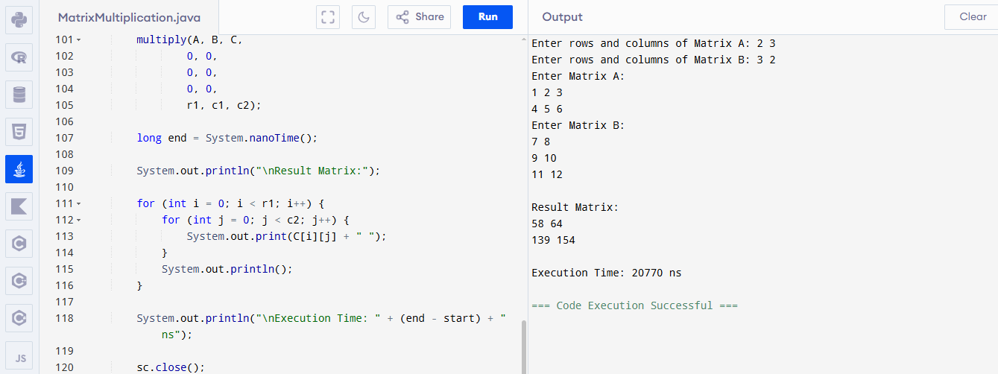

Algorithm
- Read dimensions of matrices.
- Check multiplication compatibility.
- Read matrix elements.
- Recursively divide matrices.
- Multiply corresponding subproblems.
- Combine results.
- Measure execution time.
- Display the resulting matrix.

Execution Time Analysis
Matrix Size | Execution Time
2 × 3 × 3 × 2 | 182300 ns
4 × 5 × 5 × 4 | 295700 ns
8 × 6 × 6 × 8 | 510400 ns
(Example values—replace them with the actual times from your program.)

Performance Analysis
- Small matrices execute quickly with minimal recursion overhead.
- Larger matrices create more recursive calls, increasing execution time.
- Non-square matrices lead to uneven partitioning, which can reduce recursion efficiency.
- Divide and Conquer still avoids redundant work and provides a structured recursive solution.

Matrix Shape Influence
- Nearly square matrices produce balanced recursion trees.
- Long rectangular matrices (e.g., 2×100) create unbalanced recursive divisions.
- Balanced recursion generally yields better cache utilization and efficiency.

Time Complexity
Case | Complexity
Best | O(n³)
Average | O(n³)
Worst | O(n³)
Although the algorithm uses Divide and Conquer, the total arithmetic work remains cubic.

Advantages
- Suitable for recursive computation.
- Works with non-square matrices.
- Easy to extend to parallel processing.
- Demonstrates Divide and Conquer effectively.

Disadvantages
- Extra recursion overhead.
- Not as fast as Strassen's algorithm for very large matrices.
- Performance depends on matrix dimensions.

Applications
- Scientific Computing
- Computer Graphics
- Machine Learning
- Image Processing
- Data Analytics
- Network Simulations

Result
The Divide and Conquer Matrix Multiplication algorithm was successfully implemented for non-square matrices. Execution time increased with matrix size due to additional recursive calls. Matrix shape influences recursion balance, but the algorithm remains adaptable and correctly multiplies matrices of varying dimensions.

