SIMATS ENGINEERING
ASSESSMENT TOOL 1 Experiments

COURSE NAME: Computer Networks COURSE CODE: CSA0704

COURSE OUTCOME COVERED

CO3: Analyze the performance of core network protocols such as TCP, UDP, HTTP, and
DNS under varying conditions
Assessment Tool Weightage: 40%
SOFTWARE: CISCO PACKET TRACER, WIRESHARK

EXPERIMENTS

QUESTIONS:4 Total Marks:40

- Design a simple LAN consisting of two PCs connected through a switch using Cisco Packet Tracer. Configure appropriate IP addresses for both hosts and verify connectivity using the ping command. Simultaneously capture the packet exchange using Wireshark. Identify the Ethernet frame fields such as Source MAC Address, Destination MAC Address, EtherType, and Frame Check Sequence (FCS). Explain how the Data Link layer uses MAC addressing to ensure successful frame delivery within the local network.
- Create a network topology consisting of two LANs connected through a router in Cisco Packet Tracer. Configure IPv4 addressing, subnet masks, and default gateways for all devices, and verify end-to-end communication using the ping command. Capture the ICMP packets using Wireshark and analyze the IPv4 header fields, including Source IP Address, Destination IP Address, Time-ToLive (TTL), Protocol Number, and Header Length. Explain the role of the Network layer in forwarding packets between different networks.
- Construct a local area network with multiple hosts connected through a switch in Cisco Packet Tracer. Clear the ARP cache on one of the hosts and initiate communication with another host using the ping command. Capture the communication in Wireshark and identify the ARP Request and ARP Reply packets. Analyze the sender and target MAC/IP addresses and explain how the Address Resolution Protocol resolves logical IP addresses into physical MAC addresses before data transmission.
- Develop a simple network consisting of two PCs connected through a router in Cisco Packet Tracer. Configure the required IP addresses and test connectivity using the ping command. Capture the ICMP traffic using Wireshark and identify the Echo Request and Echo Reply messages. Examine important ICMP fields such as Type, Code, Identifier, and Sequence Number, and calculate the Round Trip Time (RTT). Discuss how ICMP assists in network troubleshooting and connectivity verification.
- Create a client-server network in Cisco Packet Tracer by configuring a web server and a client PC. Enable the HTTP service on the server and access the hosted webpage from the client using a web browser. Capture the communication in Wireshark and identify the TCP three-way handshake, followed by the HTTP GET request and HTTP response messages. Analyze the application-layer communication and explain how TCP provides reliable delivery for HTTP traffic through connection establishment, acknowledgments, and ordered data transfer.

RUBRICS FOR CALCULATION

Criteria | Weightag  e | Level 4 –  Exemplary | Level 3 –  Proficient | Level 2 –  Developing | Level 1 –  Beginning
Understandin g of Concepts | 25 | Demonstrates thorough  understanding and effectively  integrates multiple concepts/technologi  es | Good understanding with proper  integration of most concepts | Basic understanding  ; limited or partial integration | Poor understanding  ; unable to integrate concepts
Experimental Design | 30 | Well-planned, systematic  implementation  with optimal solution | Correct implementati  on with minor issues | Basic implementati  on with errors or  inefficiencies | Incorrect or incomplete  implementati on
Use of Tools | 20 | Effective and advanced use of  tools/technologies with proper configuration | Appropriate use of tools  with correct execution | Limited or inconsistent use of tools | Incorrect or minimal use of tools
Analysis of Results | 15 | Insightful analysis with accurate  interpretation and validation of results | Good  analysis with reasonable interpretation | Basic analysis with limited insights | Poor or incorrect  analysis of results
Documentati on | 10 | Clear, wellstructured  documentation with diagrams, code, and  results | Organized documentatio n with  necessary details | Basic documentatio n with  missing details | Poor or incomplete  documentatio  n

Answers
1.Design a simple LAN consisting of two PCs connected through a switch using Cisco Packet Tracer. Configure appropriate IP addresses for both hosts and verify connectivity using the ping command. Simultaneously capture the packet exchange using Wireshark. Identify the Ethernet frame fields such as Source MAC Address, Destination MAC Address, EtherType, and Frame Check Sequence (FCS). Explain how the Data Link layer uses MAC addressing to ensure successful frame delivery within the local network.

Aim:
To design a simple LAN consisting of two PCs connected through a switch using Cisco Packet Tracer, configure IP addresses, verify connectivity using the ping command, and analyze the Ethernet frame using Wireshark by identifying the Source MAC Address, Destination MAC Address, EtherType, and FCS.

Procedure:
- Open Cisco Packet Tracer.
- Place two PCs (PC0 and PC1) and one 2960 switch in the workspace.
- Connect PC0 and PC1 to the switch using Copper Straight-Through cables.
- Configure PC0 with:
  - IP Address: 192.168.1.1
  - Subnet Mask: 255.255.255.0
- Configure PC1 with:
  - IP Address: 192.168.1.2
  - Subnet Mask: 255.255.255.0
- Open the Command Prompt of PC0 and execute:
ping 192.168.1.2
- Verify that all four packets are successfully received.
- Open Wireshark and capture ICMP traffic generated by a ping.
- Apply the Wireshark display filter:
icmp
- Select an ICMP packet and expand Ethernet II.
- Identify the Source MAC Address, Destination MAC Address, and EtherType.
- Check whether the FCS field is available in the captured frame.
- Analyze how MAC addressing supports frame delivery within the LAN.

Implementation:
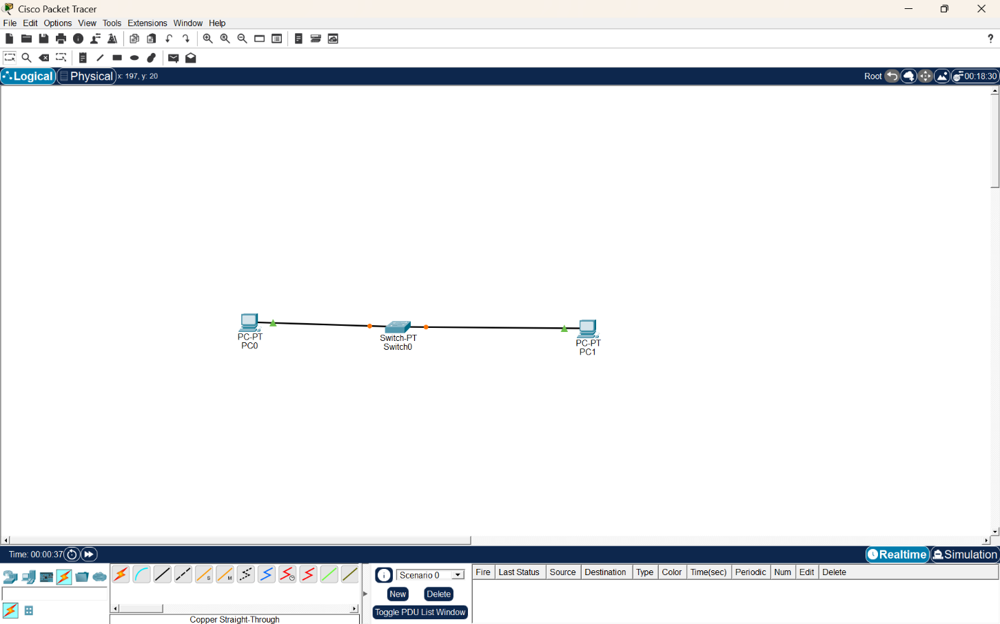
Screenshot 1 – LAN Topology
Figure 1: Simple LAN Topology Using a Switch
Explanation:
The topology consists of two PCs, PC0 and PC1, connected to a central switch. The switch provides communication between the two hosts within the same local area network.
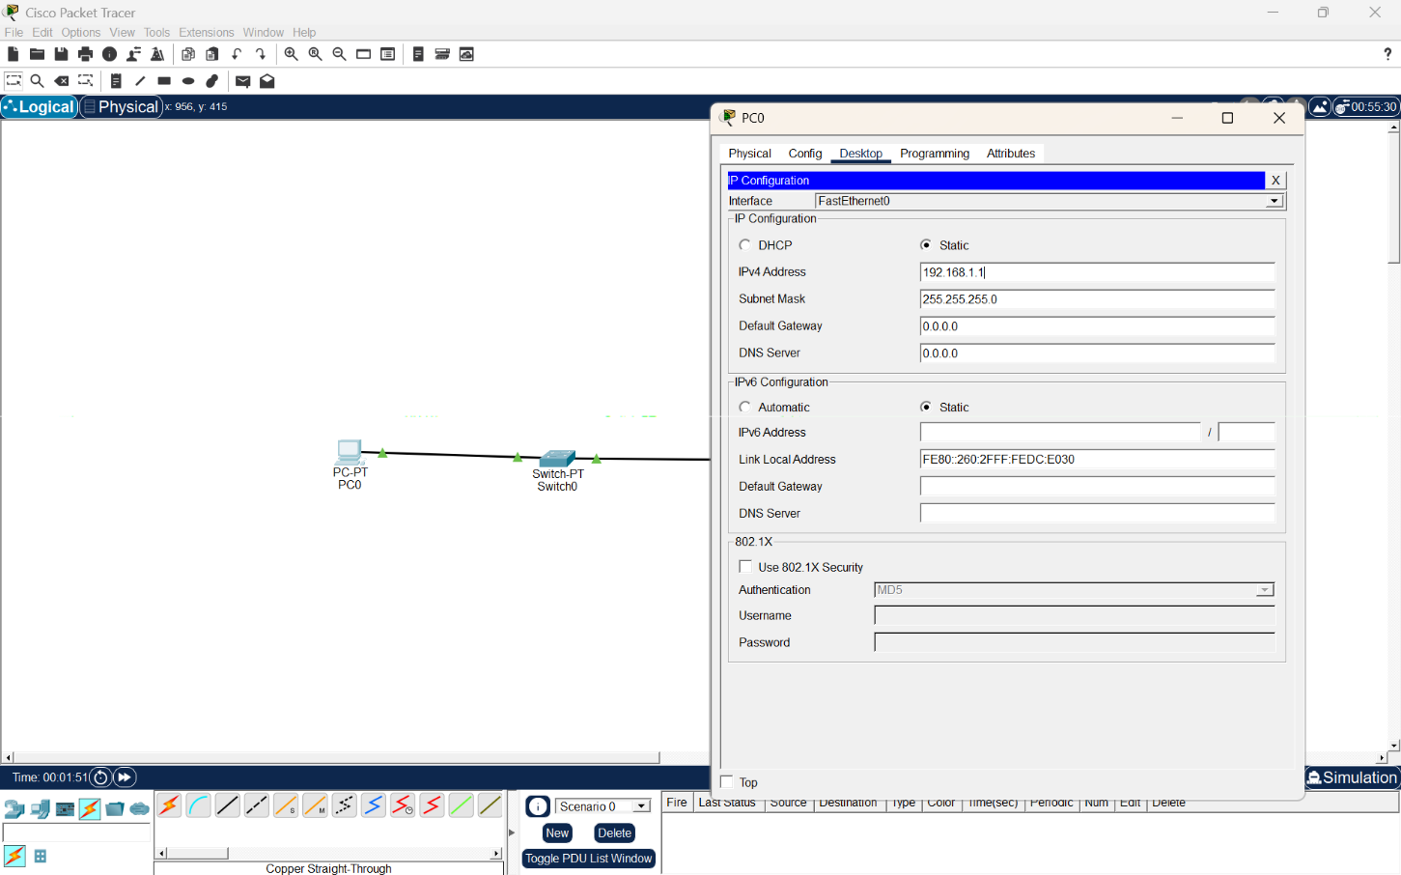
Screenshot 2 – PC0 IP Configuration
Figure 2: IP Configuration of PC0

Configuration:
Parameter | Value
IPv4 Address | 192.168.1.1
Subnet Mask | 255.255.255.0
Default Gateway | 0.0.0.0
Explanation:
PC0 is configured with the IP address 192.168.1.1 and subnet mask 255.255.255.0. Since PC0 and PC1 communicate within the same LAN, a default gateway is not required.

Screenshot 3 – PC1 IP Configuration
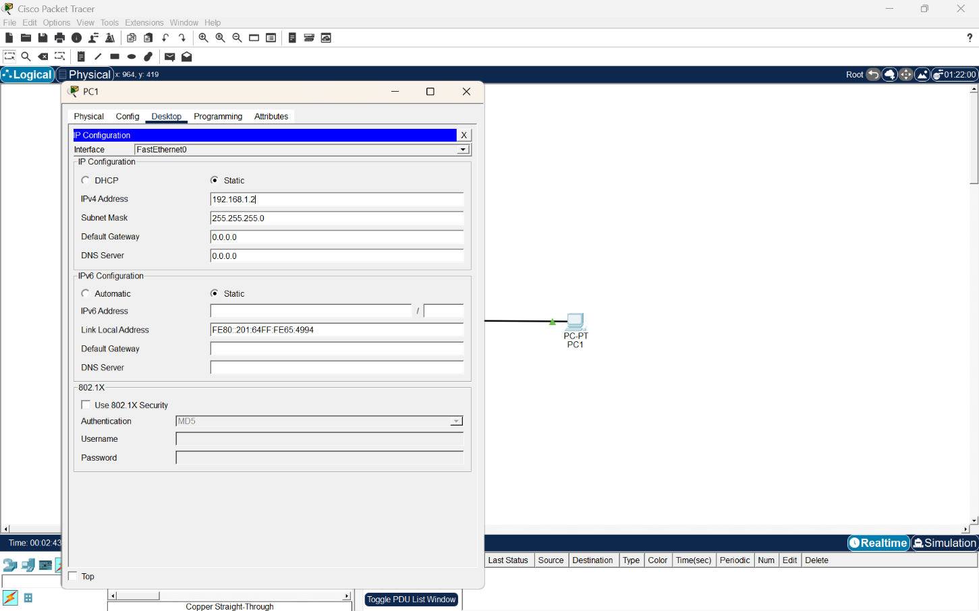
Figure 3: IP Configuration of PC1
Configuration:
Parameter | Value
IPv4 Address | 192.168.1.2
Subnet Mask | 255.255.255.0
Default Gateway | 0.0.0.0
Explanation:
PC1 is configured with the IP address 192.168.1.2 and subnet mask 255.255.255.0. Both PCs belong to the same subnet, allowing them to communicate directly through the switch.
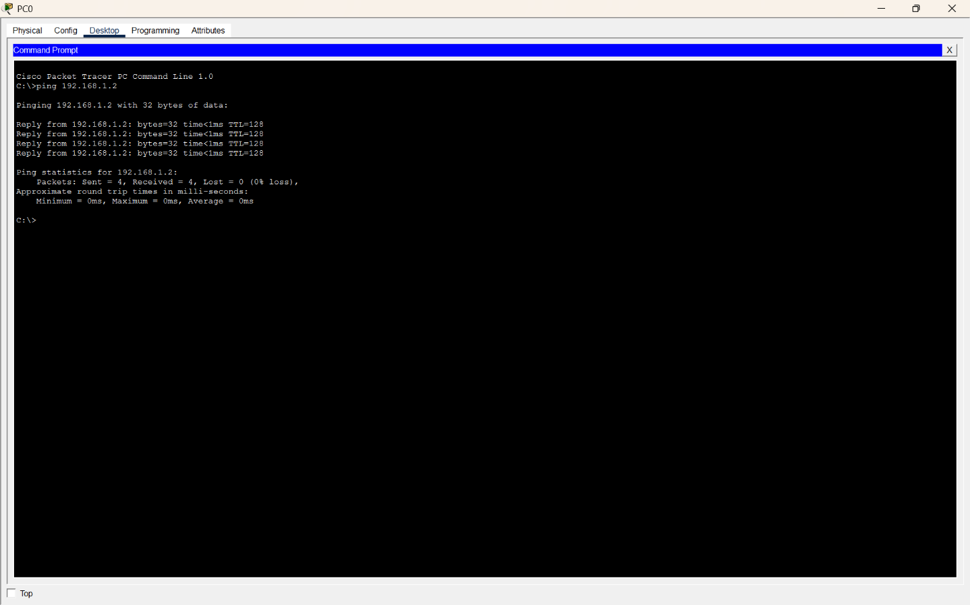
Screenshot 4 – Ping Verification
Figure 4: Successful Ping Between PC0 and PC1
Command:
ping 192.168.1.2
Result:
- Packets Sent = 4
- Packets Received = 4
- Packet Loss = 0%
- Average Response Time = 0 ms
Explanation:
The ping command successfully verifies connectivity between PC0 and PC1. All four packets were received successfully with 0% packet loss, confirming that the LAN configuration and connectivity are working correctly.

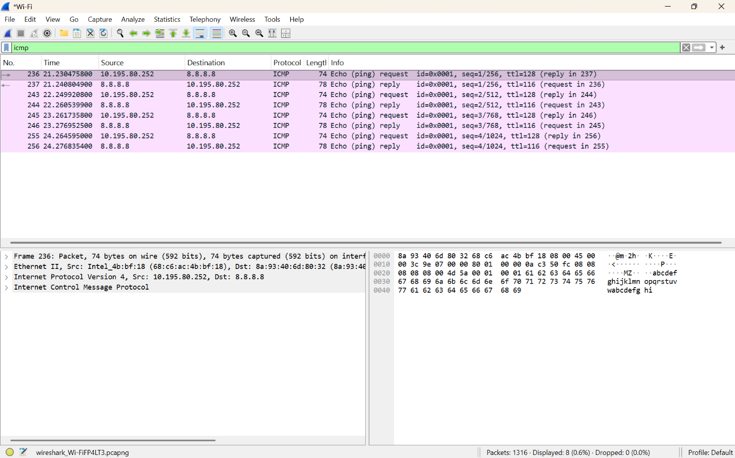
Screenshot 5 – Wireshark ICMP Capture
Figure 5: ICMP Packet Capture Using Wireshark
Explanation:
Wireshark captures the ICMP Echo Request and Echo Reply packets generated by the ping operation. The packet capture shows the communication between the local host and the destination 8.8.8.8. The packet contains the Ethernet II, IPv4, and ICMP protocol layers.
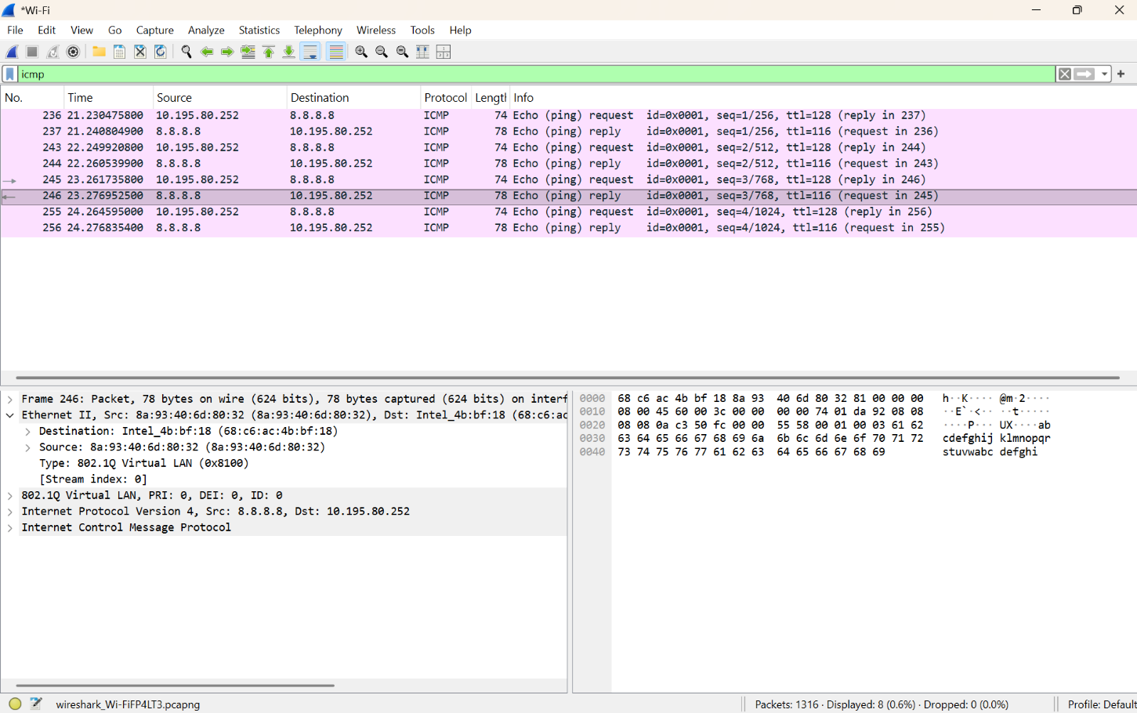
Screenshot 6 – Ethernet Frame Analysis
Figure 6: Ethernet Frame Fields in Wireshark
From the captured frame:
Field | Observed Value
Destination MAC | 68:c6:ac:4b:bf:18
Source MAC | 8a:93:40:6d:80:32
EtherType | 0x8100
VLAN ID | 0
FCS | Not displayed in the capture
Explanation:
The Ethernet II header contains the source and destination MAC addresses used for frame delivery at the Data Link layer. The captured frame has EtherType 0x8100, indicating an 802.1Q VLAN-tagged frame. The VLAN ID shown in the capture is 0.The FCS (Frame Check Sequence) is an error-detection field used to detect corruption in an Ethernet frame. It is not displayed in this particular Wireshark capture, so no FCS value is reported.
Data Link Layer Analysis
The Data Link layer uses MAC addresses to deliver Ethernet frames within the local network. The source MAC identifies the device transmitting the frame, while the destination MAC identifies the intended device. The switch examines the destination MAC address and forwards the frame through the appropriate switch port. This enables successful communication between devices in the LAN.
Result
A simple LAN with two PCs connected through a switch was successfully designed and configured in Cisco Packet Tracer. PC0 and PC1 were assigned IP addresses 192.168.1.1 and 192.168.1.2, respectively. Connectivity was successfully verified using the ping command with 0% packet loss. Wireshark was used to capture ICMP traffic and analyze the Ethernet frame, including the Source MAC Address, Destination MAC Address, EtherType, and availability of the FCS field. The experiment demonstrates how the Data Link layer uses MAC addressing for successful frame delivery within a local network.

2.Create a network topology consisting of two LANs connected through a router in Cisco Packet Tracer. Configure IPv4 addressing, subnet masks, and default gateways for all devices, and verify end-to-end communication using the ping command. Capture the ICMP packets using Wireshark and analyze the IPv4 header fields, including Source IP Address, Destination IP Address, Time-ToLive (TTL), Protocol Number, and Header Length. Explain the role of the Network layer in forwarding packets between different networks.

Aim:
To create a network topology consisting of two LANs connected through a router using Cisco Packet Tracer, configure IPv4 addresses, subnet masks, and default gateways, verify end-to-end communication using the ping command, and analyze the IPv4 header fields using Wireshark.

Procedure:
- Open Cisco Packet Tracer.
- Place two PCs (PC0 and PC1), two 2960 switches, and one router in the workspace.
- Connect PC0 to Switch0, Switch0 to Router0, Router0 to Switch1, and Switch1 to PC1 using Copper Straight-Through cables.
- Configure PC0 with:
  - IP Address: 192.168.1.2
  - Subnet Mask: 255.255.255.0
  - Default Gateway: 192.168.1.1
- Configure PC1 with:
  - IP Address: 192.168.2.2
  - Subnet Mask: 255.255.255.0
  - Default Gateway: 192.168.2.1
- Configure Router0 with:
  - G0/0 IP Address: 192.168.1.1
  - G0/1 IP Address: 192.168.2.1
- Enable both router interfaces using the no shutdown command.
- Verify the router interfaces using:
show ip interface brief
- Open the Command Prompt of PC0 and execute:
ping 192.168.2.2
- Verify that the packets are successfully received.
- Open Wireshark and capture the ICMP traffic generated by the ping.
- Apply the Wireshark display filter:
icmp
- Select an ICMP packet and expand Internet Protocol Version 4.
- Identify the Source IP Address, Destination IP Address, TTL, Protocol Number, and Header Length.
- Analyze the role of the Network layer in forwarding packets between the two different networks.

Implementation:

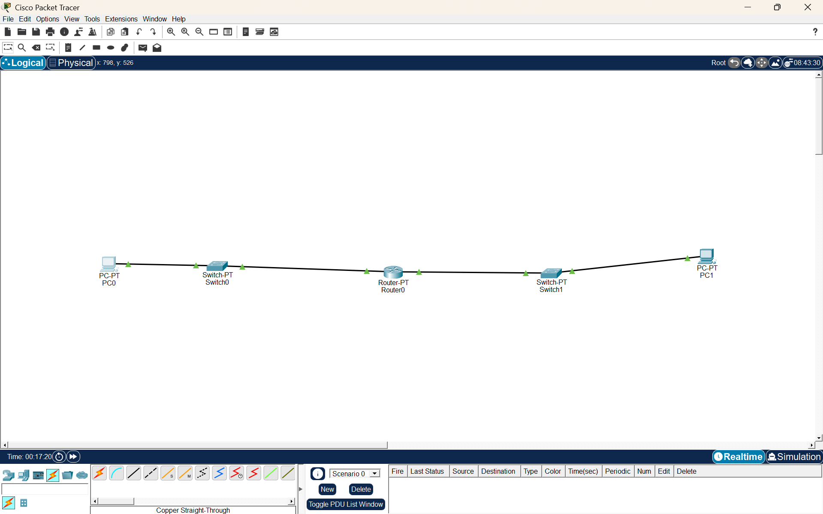
Screenshot 1 – Network Topology
Figure 1: Two LANs Connected Through a Router
Explanation:
The topology consists of two separate LANs connected through a central router. PC0 and Switch0 form the first LAN, while PC1 and Switch1 form the second LAN. The router provides communication between the two different networks.

Screenshot 2 – PC0 IP Configuration
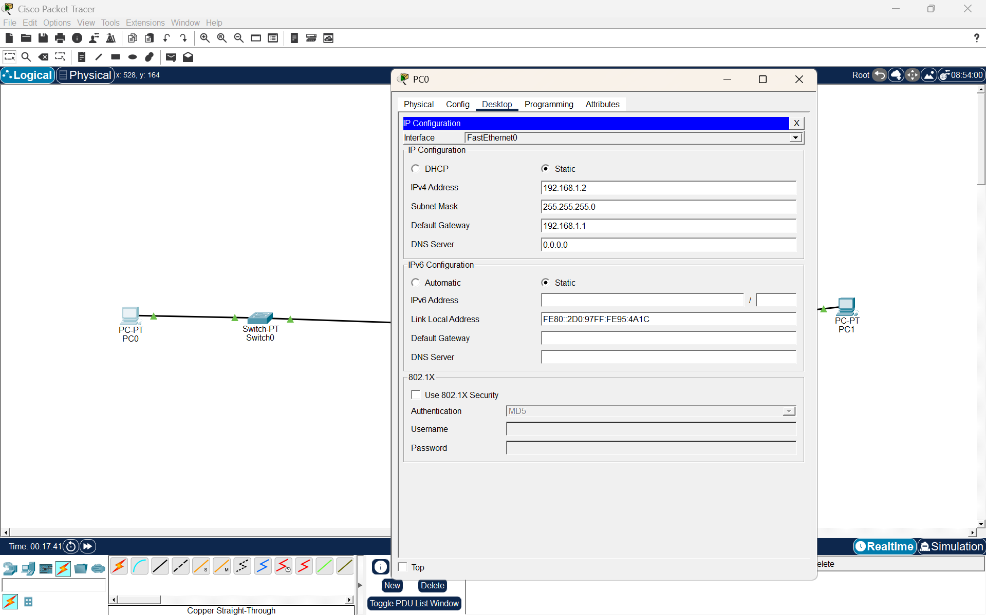
Figure 2: IP Configuration of PC0

Configuration:
Parameter | Value
IPv4 Address | 192.168.1.2
Subnet Mask | 255.255.255.0
Default Gateway | 192.168.1.1
Explanation:
PC0 is configured with the IP address 192.168.1.2 and subnet mask 255.255.255.0. The default gateway is 192.168.1.1, which is the router interface connected to the first LAN.

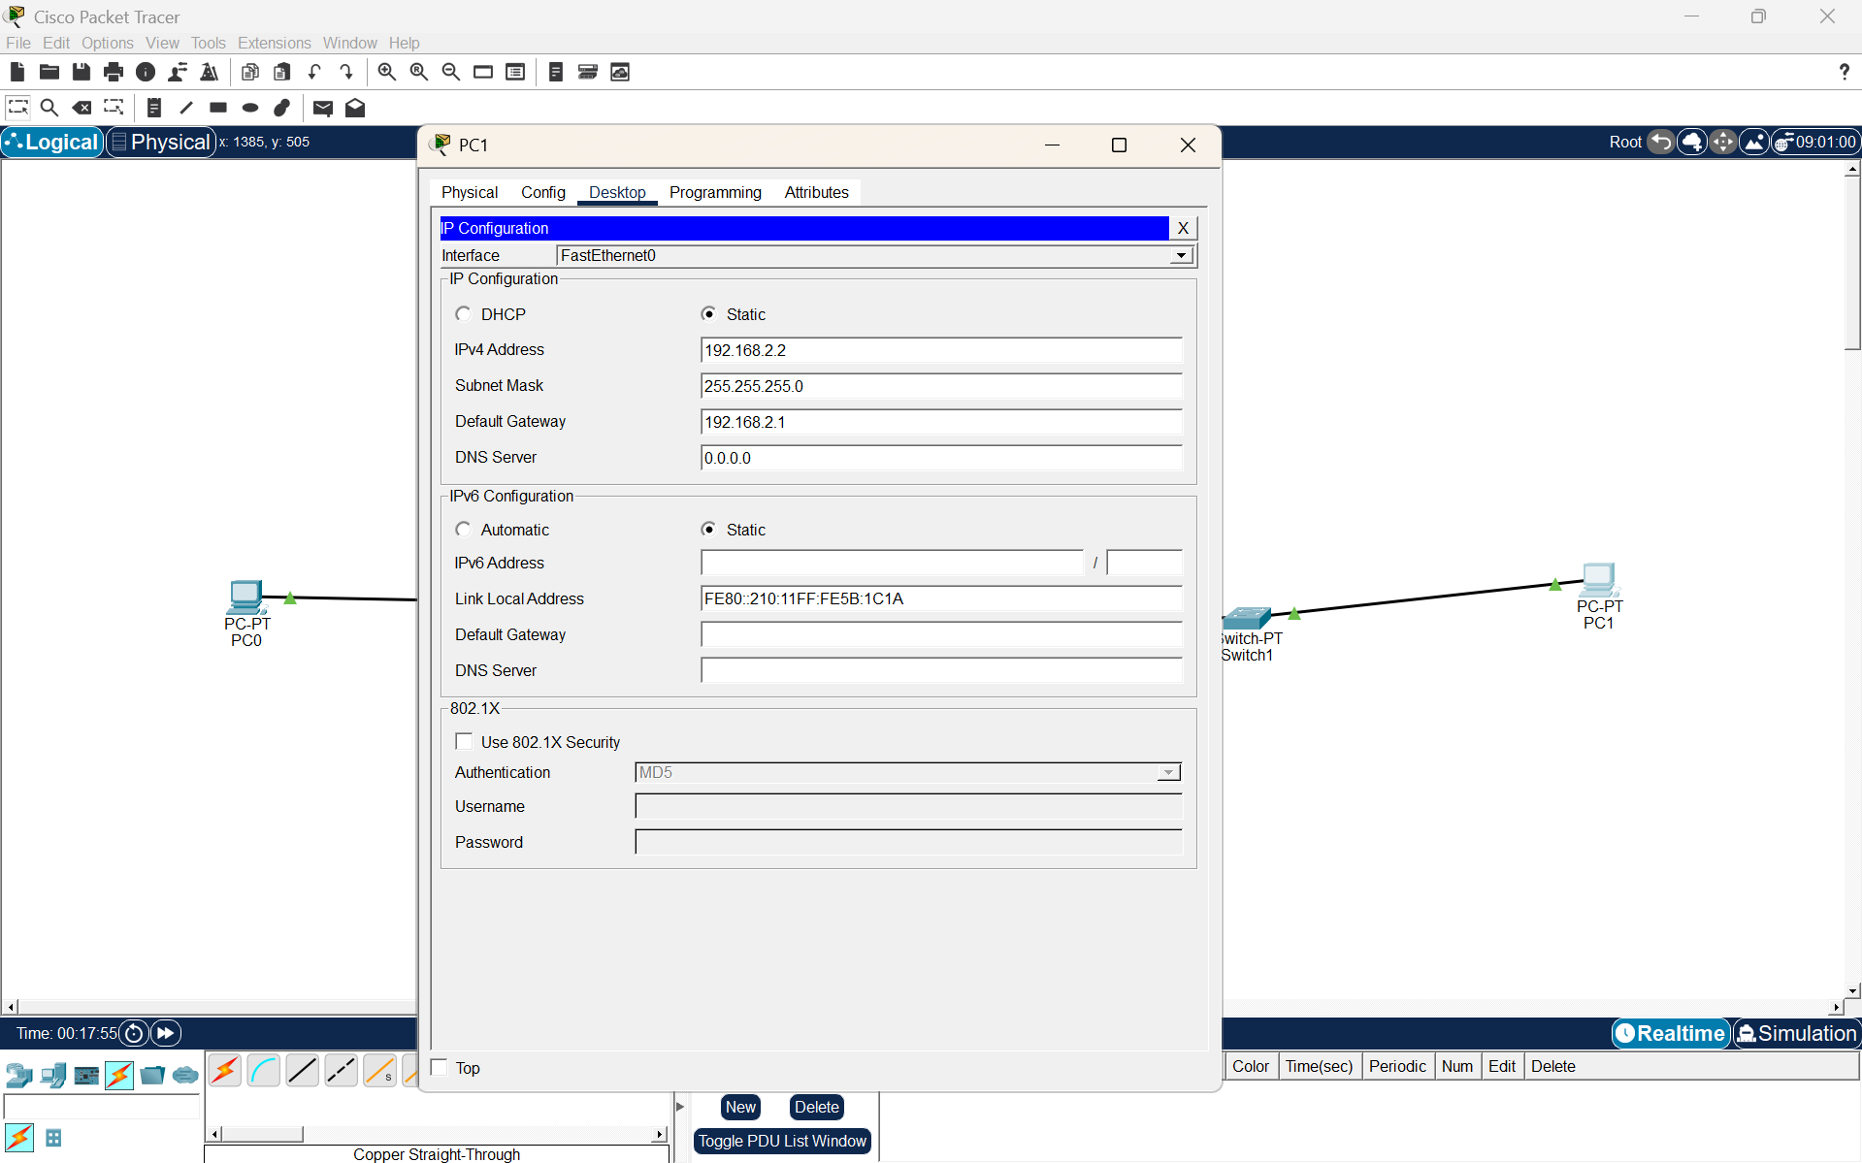
Screenshot 3 – PC1 IP Configuration
Figure 3: IP Configuration of PC1
Configuration:
Parameter | Value
IPv4 Address | 192.168.2.2
Subnet Mask | 255.255.255.0
Default Gateway | 192.168.2.1
Explanation:
PC1 is configured with the IP address 192.168.2.2 and subnet mask 255.255.255.0. The default gateway is 192.168.2.1, which is the router interface connected to the second LAN.

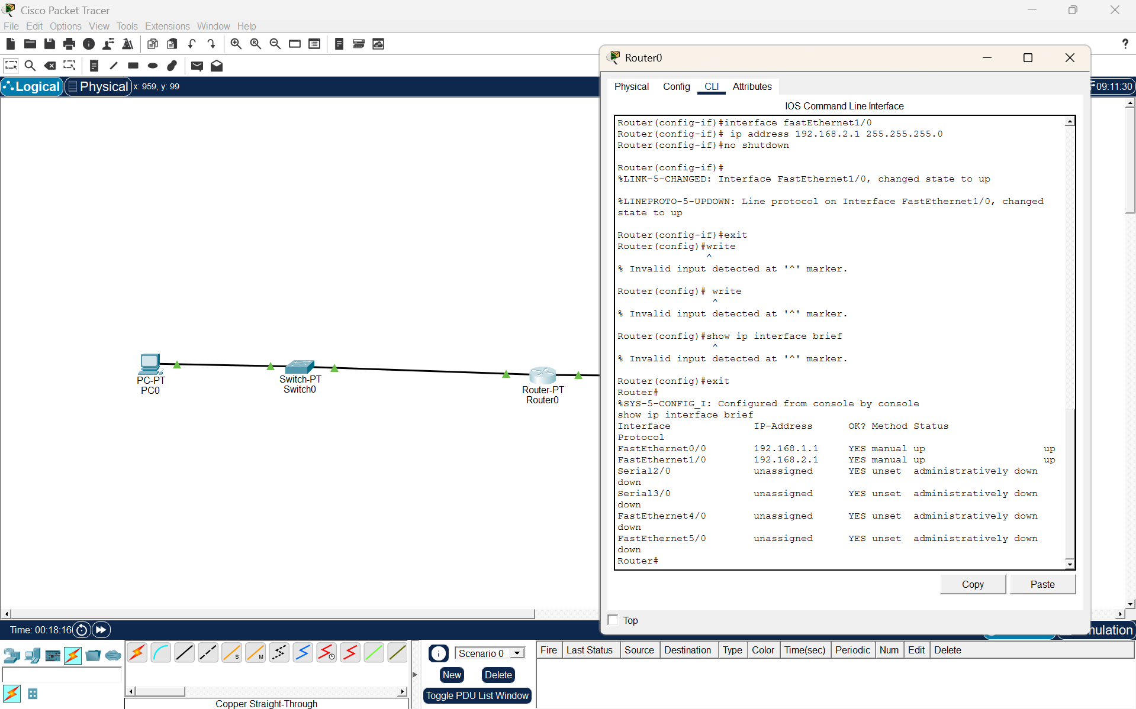
Screenshot 4 – Router Configuration
Figure 4: Router Interface Configuration
Configuration:
Router Interface | IP Address | Subnet Mask | Status
FastEthernet0/0 | 192.168.1.1 | 255.255.255.0 | Up
FastEthernet1/0 | 192.168.2.1 | 255.255.255.0 | Up
Explanation:
Router0 is configured with two FastEthernet interfaces. FastEthernet0/0 is assigned the IP address 192.168.1.1, while FastEthernet1/0 is assigned 192.168.2.1. Both interfaces are enabled and show up/up status, confirming that the router interfaces are operational.

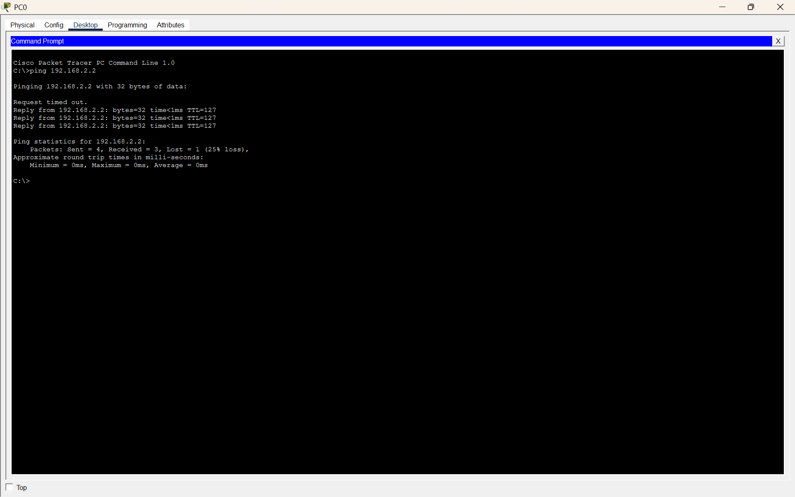
Screenshot 5 – Ping Verification
Figure 5: Successful Ping Between PC0 and PC1
Command:
ping 192.168.2.2
Result:
- Packets Sent = 4
- Packets Received = 4
- Packet Loss = 0%
- Communication Successful
Explanation:
The ping command successfully verifies end-to-end communication between PC0 and PC1. The packets travel from the first LAN through the router to the second LAN. Successful replies confirm that the router is correctly forwarding packets between the two networks.

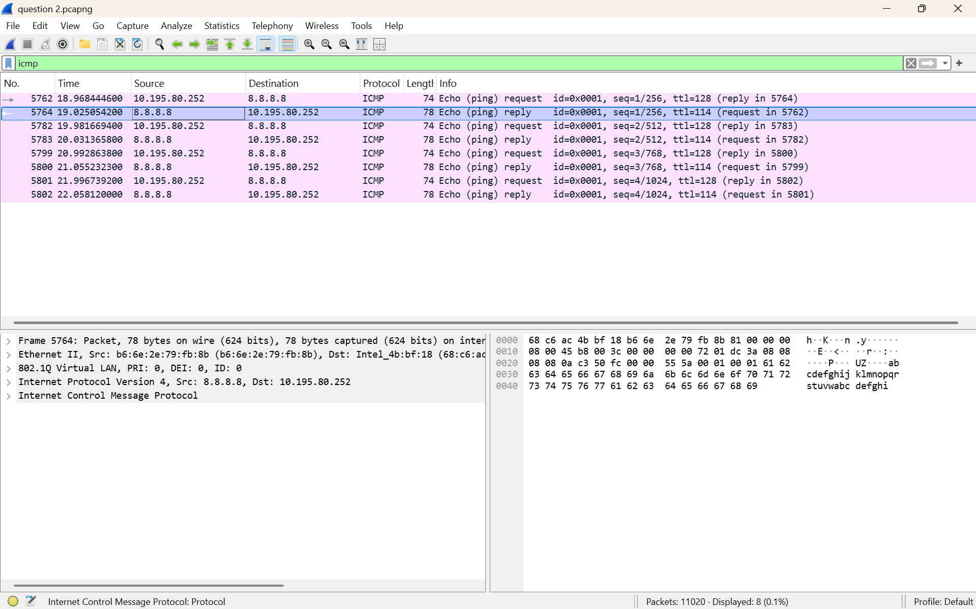
Screenshot 5 – Wireshark ICMP Capture
Figure 5: ICMP Packet Capture Using Wireshark
Explanation:
Wireshark is used to capture the ICMP traffic generated by the ping operation. The display filter icmp is applied to show only ICMP packets. The capture shows Echo (ping) Request packets from 10.195.80.252 to 8.8.8.8 and corresponding Echo (ping) Reply packets from 8.8.8.8 to 10.195.80.252. Four Echo Requests and four Echo Replies are visible, confirming successful ICMP communication.

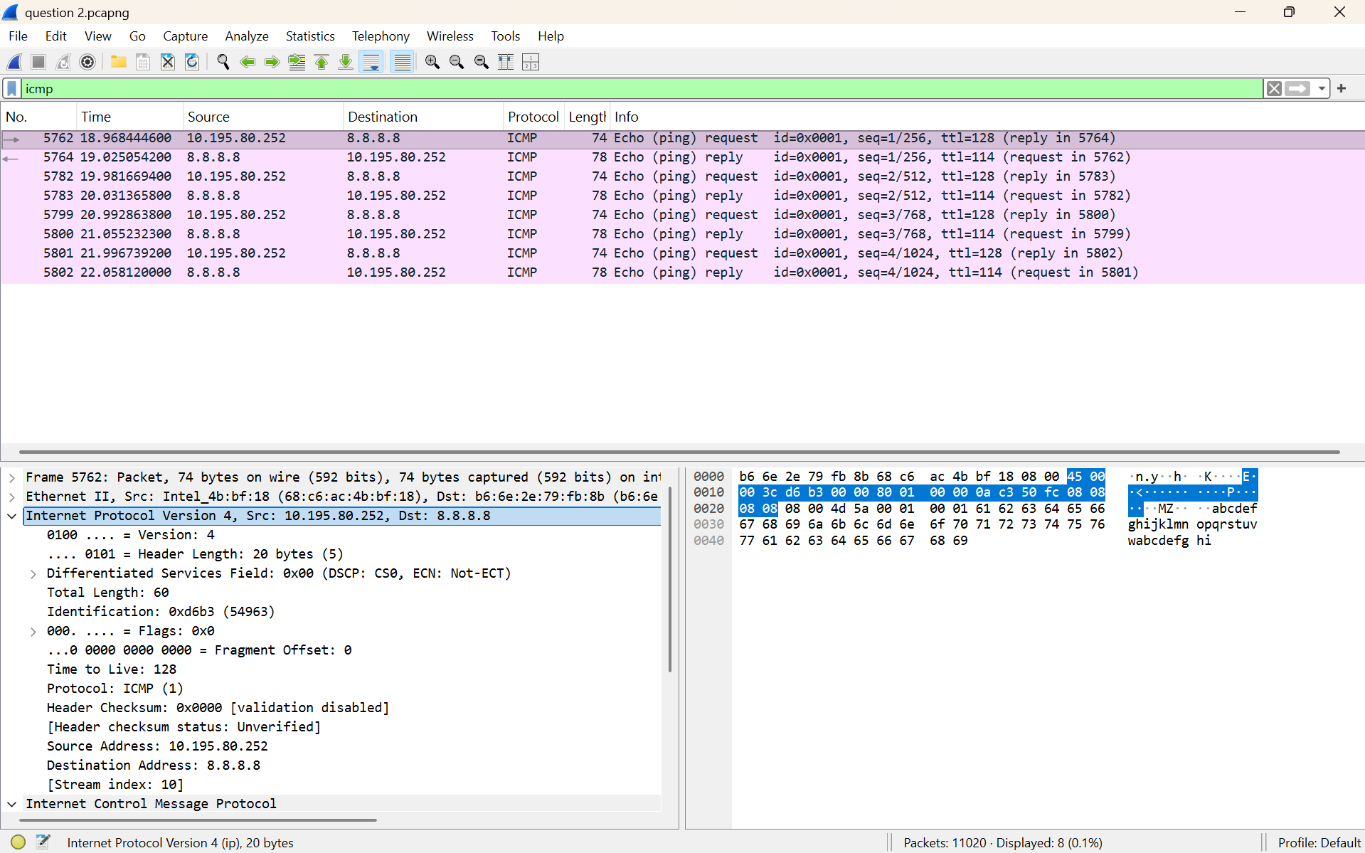
Screenshot 6 – IPv4 Header Analysis
Fig 6: IPv4 Header Fields in Wireshark
Filter Applied: icmp
Observed Communication:
Parameter | Observed Value
Source IP Address | 10.195.80.252
Destination IP Address | 8.8.8.8
Protocol | ICMP
Header Length | 20 bytes
Total Length | 60 bytes
Time to Live (TTL) | 128
Protocol Number | 1
Header Checksum | 0x0000
Ethernet Source MAC | 68:c6:ac:4b:bf:18
Ethernet Destination MAC | b6:6e:2e:79:fb:8b
Explanation:
Wireshark is used to capture and analyze ICMP traffic generated by a ping operation. The display filter icmp shows ICMP Echo Request and Echo Reply packets. In the selected packet, the IPv4 header shows the source IP address as 10.195.80.252 and the destination IP address as 8.8.8.8. The IPv4 header length is 20 bytes, the total length is 60 bytes, and the TTL value is 128. The protocol field is ICMP (1), indicating that the IPv4 packet carries ICMP data.

Network Layer Analysis
The Network layer is responsible for delivering packets between different networks. It uses logical IP addresses to identify the source and destination devices. In this experiment, the router connects the 192.168.1.0/24 and 192.168.2.0/24 networks and forwards packets between the two LANs. The IPv4 header provides information such as the Source IP Address, Destination IP Address, TTL, Protocol, and Header Length.
Result
Two LANs were successfully created and connected through a router using Cisco Packet Tracer. PC0 and PC1 were configured with appropriate IPv4 addresses, subnet masks, and default gateways. End-to-end connectivity between the two LANs was successfully verified using the ping command. Wireshark was used to capture ICMP traffic and analyze the IPv4 header fields, including the Source IP Address, Destination IP Address, TTL, Protocol Number, and Header Length. The experiment successfully demonstrated how the Network layer enables communication between different networks.

