PRODUCT PLAN
Multi-Vendor E-Commerce Platform
Discovery, requirements, design and delivery plan
Version 2.0 · 15 October 2026 · Bangladesh market update · Planning phase
What is inside
Product brief, decisions, Bangladesh compliance (policies, returns, cash on delivery, medicine shops), roles, the schema-driven catalog with dynamic filters, virtual try-on, 44 user stories, use case diagrams, architecture, data model, security, and a 27-week roadmap.
Version 2 merges the comparison with Daraz and Rokomari, and the decisions taken after it.

Contents
1. Summary
2. Product brief
3. Assumptions and decisions
4. Bangladesh market and compliance
5. Roles and permissions
6. Use case diagrams
7. Categories, attributes and dynamic filters
8. Virtual try-on
9. Epics and user stories
10. Prioritisation and MVP
11. Non-functional requirements
12. Tech stack and decisions
13. Architecture
14. Security and threat model
15. Roadmap and delivery
Figures: 7 diagrams, numbered in order.

1. Summary
Build a multi-vendor marketplace for Bangladesh in three releases. R1 is the core marketplace with cash on delivery. R2 adds online payments, courier integration and Bengali. R3 adds virtual try-on. Try-on is the riskiest feature, so it ships last, behind a feature flag, on top of a catalog that already works.
Version 2 (15 Oct 2026) merges a comparison with Daraz and Rokomari, the two largest Bangladeshi references, and the decisions made after it. The full comparison and its sources are in the separate doc "Product Plan vs Daraz and Rokomari".
Key recommendations:
- The catalog is driven by a schema. Admins define a category tree. Each leaf category carries its own typed attributes, such as Brand, Socket and Core count for Processor. Sellers fill those attributes through a form generated from the schema, and the search filters are built from the same attributes. Daraz shows the problem this avoids: its search for "processor" spans 20 categories, including food processors, and offers clothing-size and colour filters.
- Only leaf categories hold products. Each product belongs to exactly one leaf category, and free-form tags do not exist.
- Shoppers see only categories that have live stock. A category is shown to shoppers when at least one active, in-stock product sits under it. Sellers always see the full tree.
- Bangladesh-first compliance from R1. The plan follows the Digital Commerce Operation Guidelines 2021 and the DBID rules, as described in news coverage. That covers listing content, 48 h handover, complaints resolved within 72 h, reviews that are never deleted, a returns policy, seller payment within 10 days and 6-year records.
- Cash on delivery is the only payment method at launch. Cart, wishlist and checkout are built to standard up to the payment step. Online payments come later.
- Medicine shops are licence-gated. A medicine shop is approved only after its approval certificate is verified. There is no prescription upload, by decision.
- Try-on uses a hosted diffusion model, not template overlays. Use a virtual try-on model behind an adapter and run it asynchronously. A pose check at upload time enforces the full-body photo rule.
- Roles are enforced on the server and scoped per shop. There are four roles: Platform Admin, Shop Owner, Shop Staff and Customer. Every shop-side query is filtered by shop_id.
- Use a proven, boring stack. TypeScript, Next.js, PostgreSQL, Meilisearch for faceted search, object storage and a job queue.

2. Product brief
Market. Bangladesh only. Prices in BDT, Bangladesh address format, local mobile numbers. UI and policy text are in English at launch, with Bengali terms before the public launch.
Problem. Small and mid-size Bangladeshi shops of any type (pharmacy, bookstore, clothing, electronics) need a place to sell online without building a store themselves. Shoppers need to find the right product quickly and trust what they buy. Today they meet noisy, cross-category filters, and when buying clothes they can't tell how something will look on them.
Personas
Persona | Role in system | Main job
Platform Admin | Admin | Runs the marketplace: approves shops, verifies medicine licences, owns the category and attribute schema, publishes policies, resolves complaints
Shop Owner | Organization admin | Sets up and runs one shop, invites and manages staff, sees orders, returns and sales
Shop Staff | Shop user | Lists products, updates stock and prices, fulfils orders and handles returns for their shop
Customer | Normal user | Browses, searches and filters, keeps a wishlist and cart, checks out with cash on delivery, requests returns, uses try-on

Goals
- A shopper reaches a relevant product list with correct filters in 3 clicks or one search.
- A seller can list a product correctly in under 5 minutes, guided by the form for its category.
- Every order meets the Bangladesh guideline timings: handover within 48 h and complaints resolved within 72 h.
- Try-on returns a believable result in under 30 seconds for supported garments.
Non-goals (for now)
- Online payments (bKash, Nagad, cards) in R1. Cash on delivery only.
- Courier integration and delivery-speed promises such as same day. These depend on the provider and come in R2.
- A Bengali UI in R1. Bengali terms are still needed before the public launch.
- Prescription upload for medicines (decision).
- Native mobile apps. The site is responsive and mobile-first.
- Seller-defined categories or free-form tags.
- Try-on for garments other than tops and bottoms.
Success metrics (targets to confirm)
Metric | Target
Search-to-product-view rate | 40% or more
Filter usage on category pages | 25% or more of sessions
Seller listing completion rate | 85% or more of started listings
Cart-to-order rate | 30% or more of carts reaching order placement
Cash-on-delivery delivery success | 90% or more of orders delivered (not refused or returned)
Shop orders handed over within 48 h | 95% or more
Complaints resolved within 72 h | 95% or more
Try-on to add-to-cart rate | Higher than the same products without try-on (A/B test)

3. Assumptions and decisions
The decisions below were made on 15 Oct 2026 after the competitor comparison. The remaining assumptions should be confirmed before Sprint 1.
Decisions
# | Decision | Effect on the plan
D1 | Bangladesh is the only market | BDT, Bangladesh address format, Bangladesh guidelines apply
D2 | Cash on delivery is the only payment method in R1 | No gateway in R1. Refunds recorded and paid manually. Escrow applies once online payments arrive
D3 | Policy pages and UI in English for now | Bengali terms added as text before the public launch
D4 | Delivery speed depends on the courier, which is added later | Flat inside-Dhaka and outside-Dhaka charges set by the admin. Orders are built ready to plug a courier in
D5 | Medicine shops must upload their approval certificate, verified by the admin before approval | New stories US-015 and US-016, and a shop_licence table
D6 | No prescription upload. Customers buy medicine directly | Legal check before launch. Fallback: a per-product "OTC" flag
D7 | Before payment, everything must be complete and standard: cart, wishlist, checkout, policies, returns | New epics: Cart and wishlist, Returns and support, Compliance

Assumptions
# | Assumption | If wrong
A1 | One platform, many independent shops, one shared cart split into one order per shop | One shop per checkout simplifies orders
A2 | Shops must be approved by the Platform Admin before they can sell | Self-serve onboarding needs stronger fraud controls
A3 | Only the Platform Admin can create categories and attributes. Sellers can request new ones | —
A4 | Try-on covers tops and bottoms | Full dresses need a different model mode
A5 | A small team (2–3 developers) on a modest cloud budget | Changes the build-vs-buy choices
A6 | Variants (size, colour) carry their own stock | —

Open questions
- Is selling prescription-only medicines without a prescription allowed? Get a legal opinion or ask the drug administration before launch.
- What flat delivery charges apply inside and outside Dhaka?
- What commission does the platform take from shops?
- Is there a budget for a paid try-on API, or must try-on be self-hosted?

4. Bangladesh market and compliance
R1 follows the Bangladesh rules that apply to an online marketplace. The sources are news summaries of the Digital Commerce Operation Guidelines 2021, the DBID registration guideline 2022 and the Personal Data Protection Ordinance 2025, so confirm against the official text before launch.

4.1 How the plan meets the guidelines
Requirement | Source | How the plan meets it | Story
Listings show quantity, ingredients, price, delivery charges, images, and purchase and return conditions | Guidelines 2021 | Required fields in every category schema | US-023
Hand over within 48 h. Deliver within 5 days in the same city and 10 days elsewhere | Guidelines 2021 | 48 h handover timer with overdue alerts. Delivery time depends on the courier (R2) | US-053
Complaints recorded and resolved within 72 h | Guidelines 2021 | Complaint tickets with a 72 h timer | US-072
Ratings and reviews visible and never erased by the platform | Guidelines 2021 | Buyer-only reviews. Hidden with a logged reason, never deleted | US-055
Sellers paid within 10 days after commission | Guidelines 2021 | Cash-on-delivery collections logged per shop, with a 10-day payout cycle | US-082
Business records kept for 6 years | Guidelines 2021 | 6-year retention for orders, shops, complaints and audit logs | US-081
Medicine sales need a drug-administration licence | Guidelines 2021 | Certificate upload and admin verification before shop approval | US-015, US-016
DBID shown on the site. Terms published (in Bengali) | DBID guideline 2022 | DBID in the footer. English terms now, Bengali before public launch | US-080, US-081
Advance payments held in escrow until delivery | Bangladesh Bank escrow policy | Not needed in R1 (cash on delivery). Applies when online payments arrive | R2
Specific consent, purpose and retention notices, breach reports, cross-border limits | Personal Data Protection Ordinance 2025 | Privacy policy, consent records, breach runbook, try-on provider region check | US-080, US-063

4.2 Policy pages (English text)
Page | Must cover
Terms and Conditions | Platform role as marketplace, shop responsibilities, account rules, DBID number, governing law (Bangladesh)
Privacy Policy | What is collected, why, how long it is kept, who sees it, try-on photo handling, how to delete data, contact for complaints
Return and Refund Policy | 7-day window, eligible reasons, exclusions, condition rules, process and refund timing (below)
Delivery and Cash on Delivery Policy | Flat charges inside and outside Dhaka, handover within 48 h, cancellation before handover, refused deliveries
Seller Policy | Approval, required documents (trade licence or DBID; drug licence for medicine shops), listing rules, prohibited items, payout cycle

Pages are versioned. Users accept the current Terms and Privacy Policy at sign-up and the Return and Delivery policies at checkout, and each acceptance is recorded.

4.3 Return and refund policy
- Window: 7 days from delivery.
- Eligible: damaged, defective, wrong item, wrong size or colour, incomplete, or not as described. Change of mind is accepted for fashion only, unworn with tags.
- Excluded: food and perishables, innerwear, medicine, digital and custom-made items.
- Process: the customer requests a return in the app with a reason and photos. The shop accepts or rejects within 48 h, and the admin decides disputes. The item is collected or dropped off, then inspected.
- Refund: until online payments exist, refunds for cash-on-delivery orders are recorded and paid manually to the customer's bKash or bank account, within 7 days of the return being accepted. Delivery charges are refunded when the shop is at fault.

4.4 Cash on delivery rules
- Phone number verified by OTP before the first order.
- Order confirmation by SMS and email, and an email invoice listing price, delivery charge and total.
- Free cancellation until the shop hands the order over.
- New accounts can hold at most 3 open cash-on-delivery orders. Repeated refusals block cash on delivery for that account.
- Flat delivery charge per shop order: one rate inside Dhaka and one outside, set by the admin.

4.5 Medicine shops
- Choosing the Medicine shop type requires the drug licence number, expiry date and certificate document.
- The admin verifies the certificate before approving the shop. Until then the shop can't list products.
- Medicine categories accept products only from verified medicine shops.
- The system warns the shop 30 days before expiry and suspends medicine listings when the licence lapses.
- No prescription upload (decision D6). Medicine is excluded from returns except for wrong or damaged items.

5. Roles and permissions
There are four roles, and two of them are scoped to a single shop. A user has one personal account and profile. Roles are attached to the account: PLATFORM_ADMIN applies globally, while SHOP_OWNER and SHOP_STAFF are held through a membership row tying the user to a shop. Every account is a Customer by default, so a shop owner can also shop.
Capability | Platform Admin | Shop Owner | Shop Staff | Customer
Own profile, photo and addresses | Yes | Yes | Yes | Yes
Wishlist, cart, checkout, try-on | Yes | Yes | Yes | Yes
Manage category tree and attributes | Yes | No (can request) | No | No
Approve or suspend shops | Yes | No | No | No
Verify medicine licences | Yes | Upload own | No | No
Edit shop profile and settings | Any shop | Own shop | No | No
Invite or remove shop staff | Any shop | Own shop | No | No
Create and edit products | Any (moderation) | Own shop | Own shop | No
Delete products | Any | Own shop | Optional, owner-granted | No
Manage stock and prices | No | Own shop | Own shop | No
View and fulfil orders | All | Own shop | Own shop | Own orders
Handle returns | Decide disputes | Own shop | Own shop | Request own
Complaints | Resolve all | Respond for own shop | Respond for own shop | Raise own
Publish policies and delivery charges | Yes | No | No | No
View sales and payouts | All | Own shop | No | No
Manage users and roles | Yes | Own staff only | No | No

Rules:
- The server checks permission on every request and never trusts the UI. Every query on shop-side data includes shop_id = <member's shop>. This guards against IDOR, where a user changes an ID to reach another shop's data.
- Admin actions such as suspending a shop, verifying a licence or hiding a review are written to an audit log.
- At the MVP, Shop Staff get a fixed permission set. Later the owner can toggle permissions per staff member.

6. Use case diagrams
Six actors use the system. A solid line links an actor to a use case, «include» marks a step that always runs, «extend» marks optional behaviour, and a hollow triangle means the lower actor can do everything the upper one can.
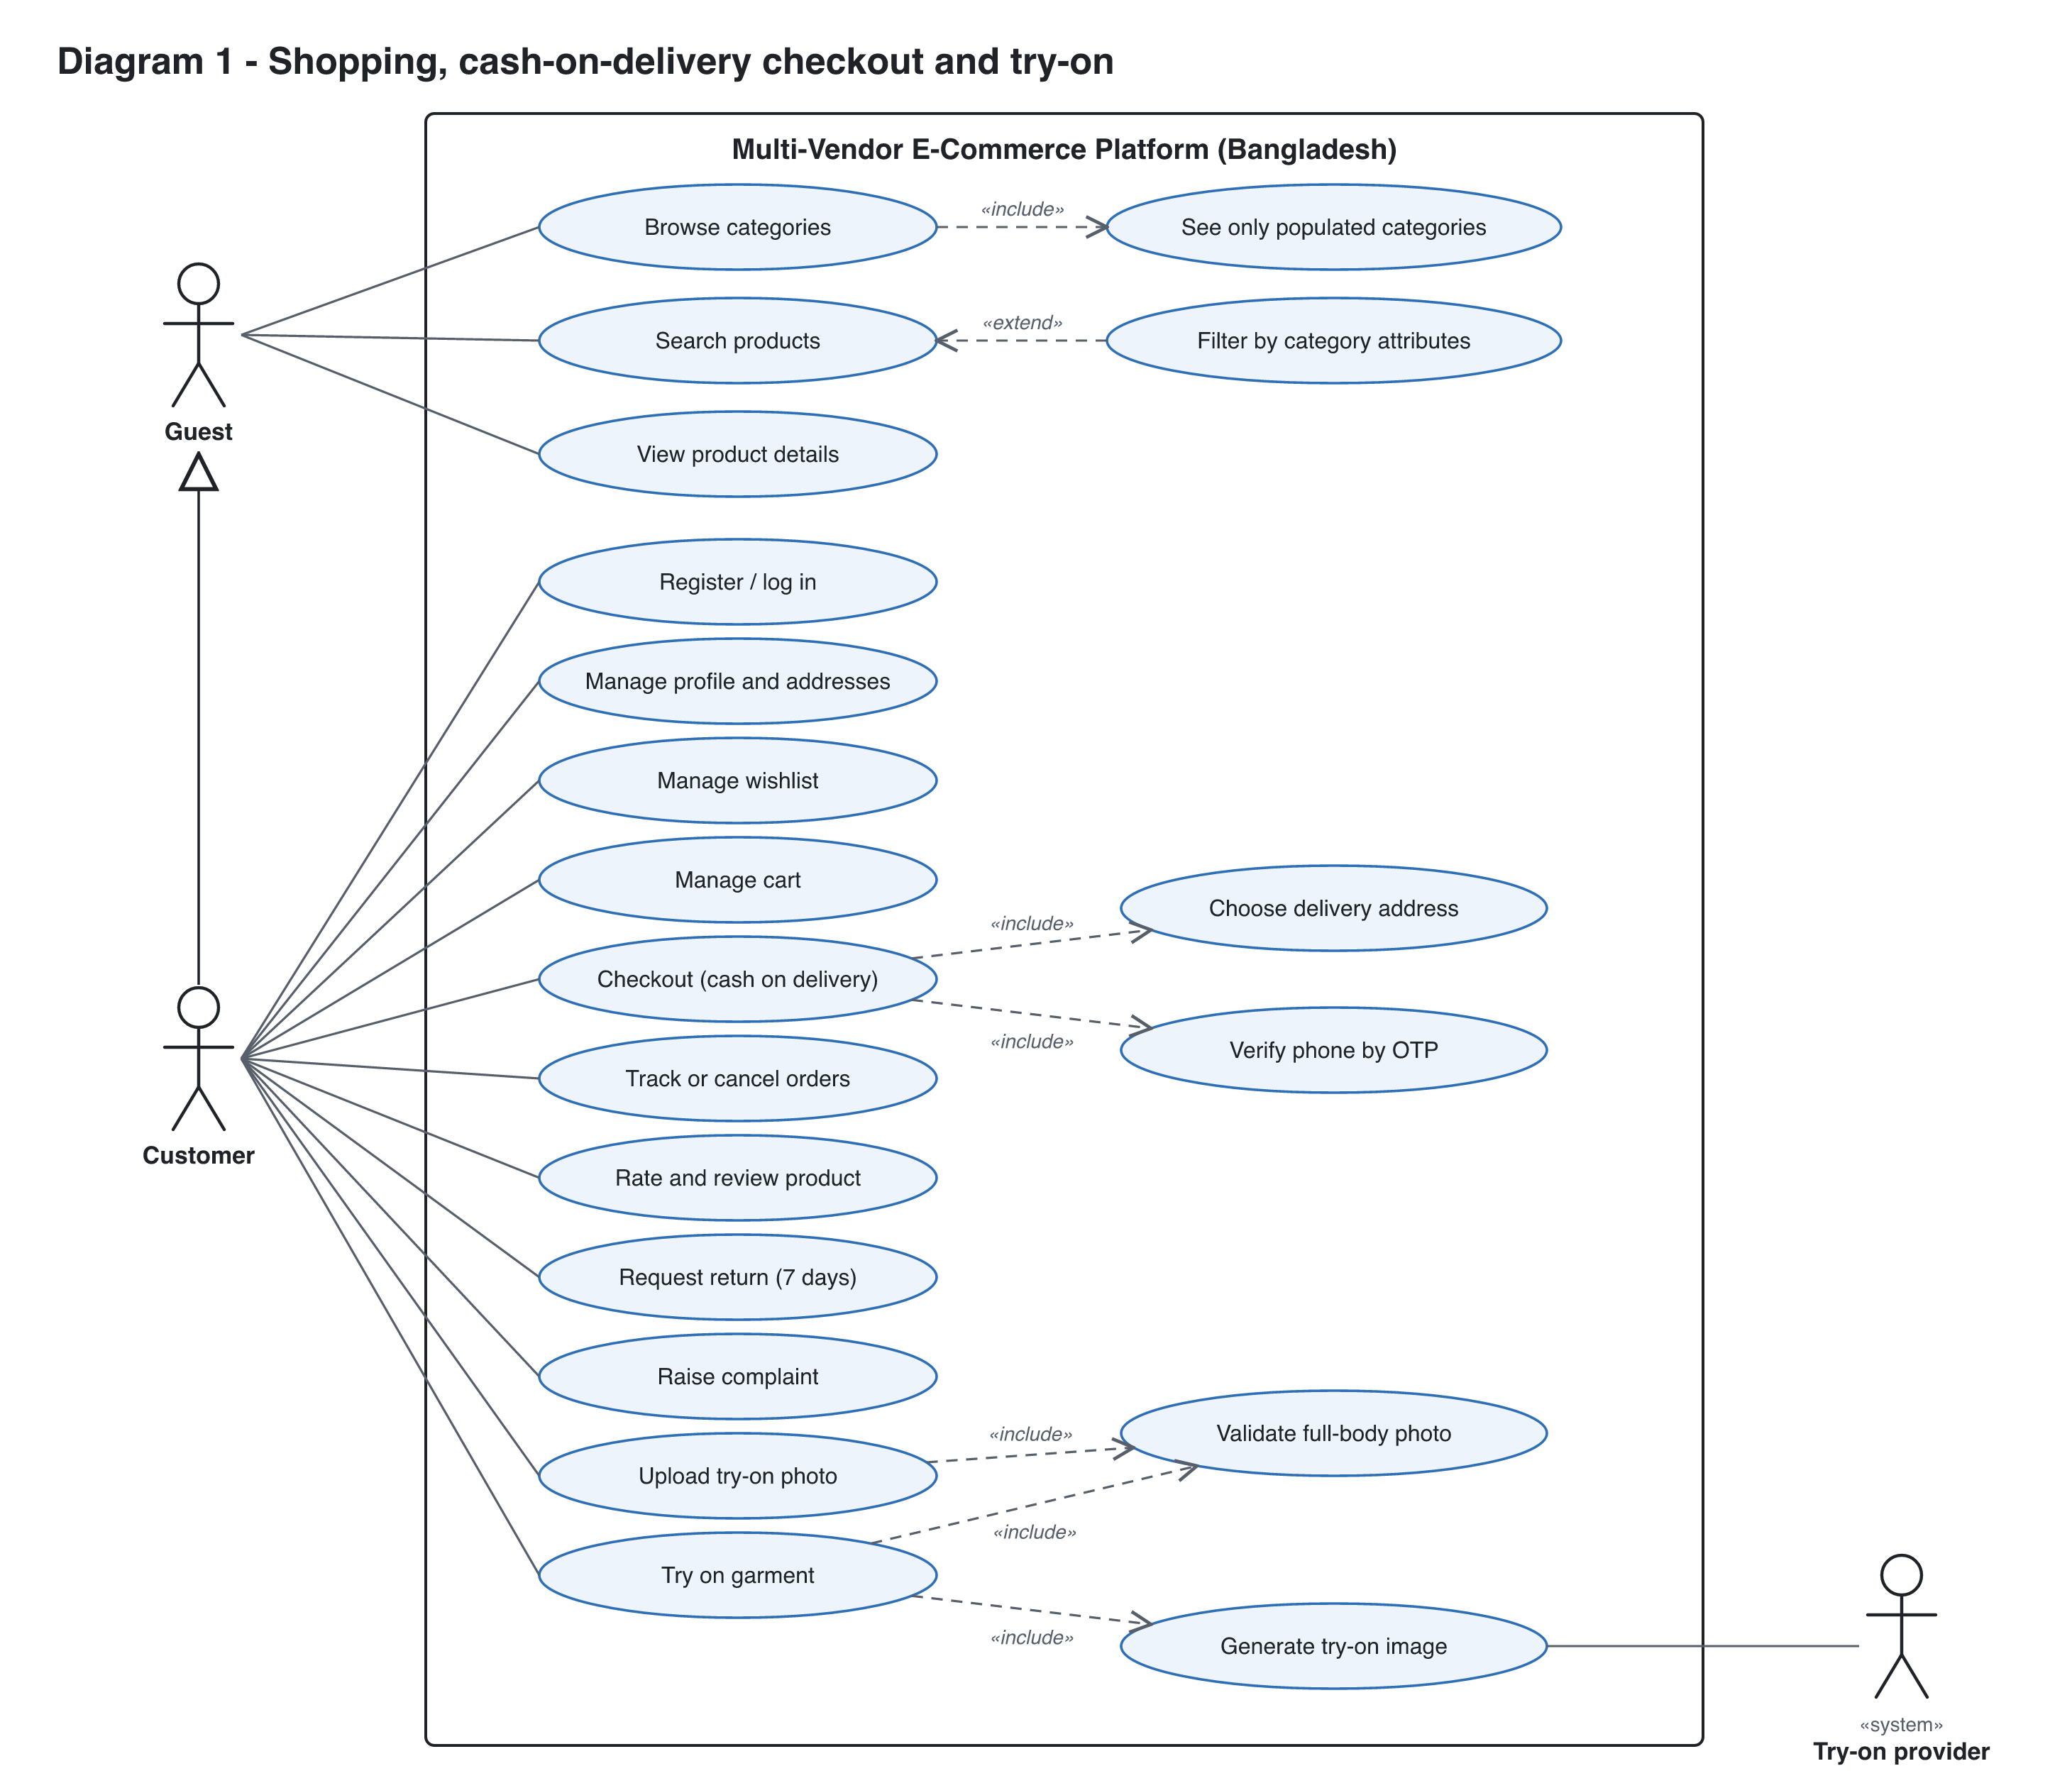
Figure 1. Shopping and virtual try-on (Guest, Customer, Try-on provider).

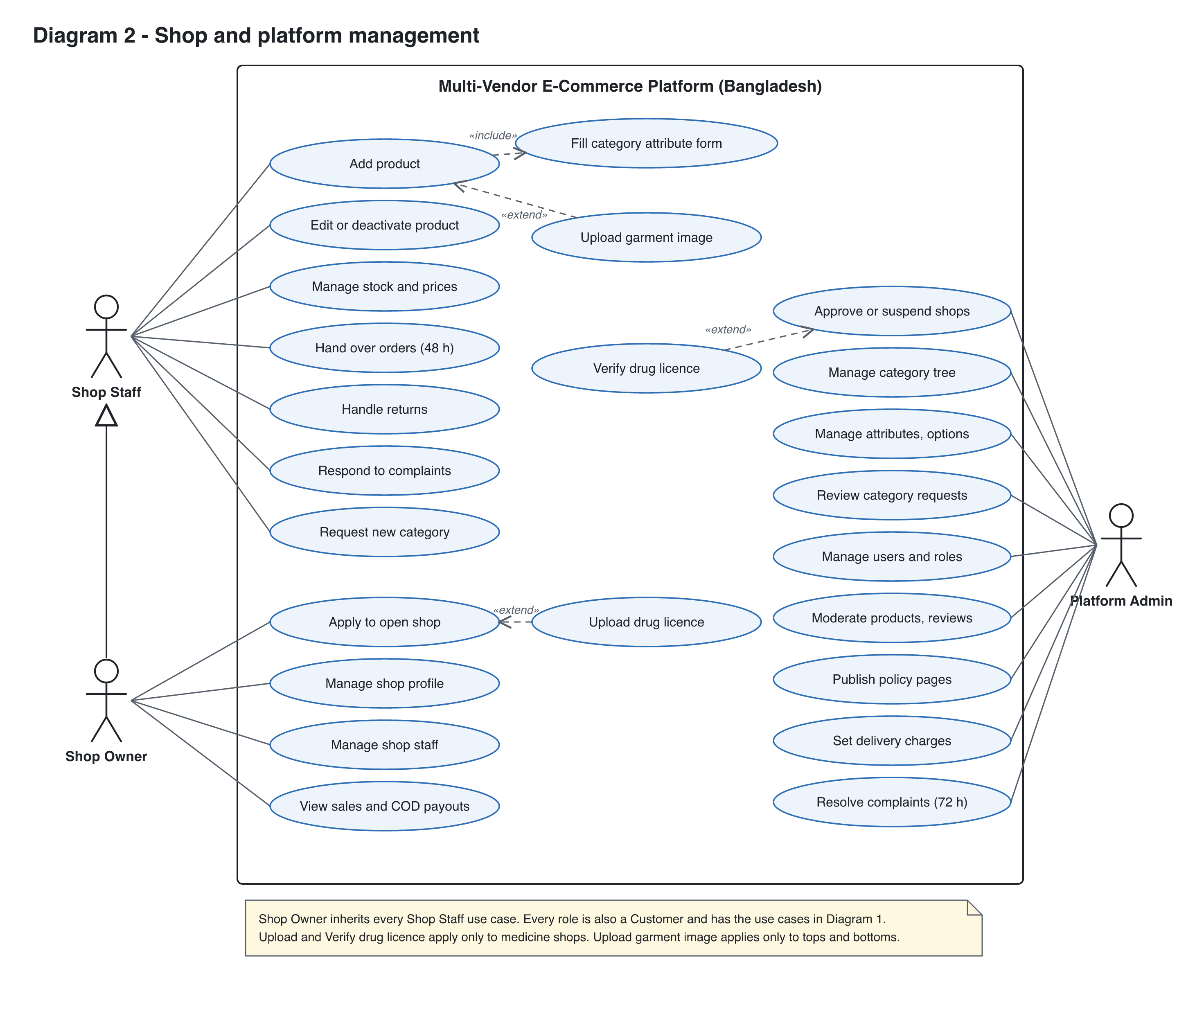
Figure 2. Shop and platform management (Shop Staff, Shop Owner, Platform Admin).

7. Categories, attributes and dynamic filters
One schema per leaf category drives three things: the seller's form, the stored product data and the shopper's filters. The filter panel is built from the schema and the matching products, so it can only show attributes that belong to that category.
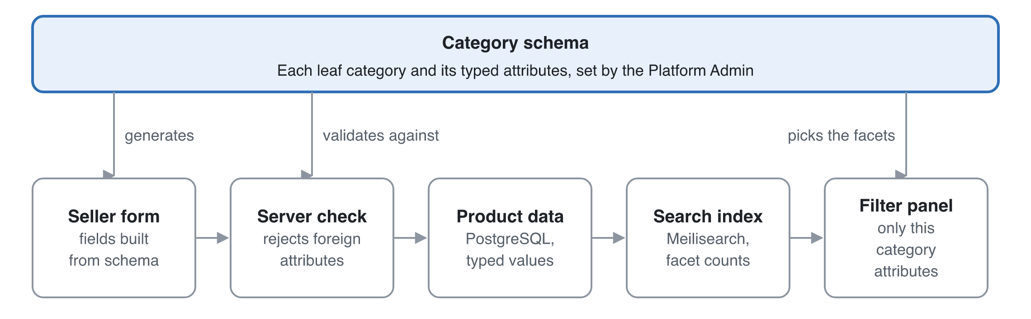
Figure 3. One category schema drives the seller form, the stored data and the filters.
The seller form, the server check and the filter panel all read the same schema, so a Processor page cannot show a Book filter.

7.1 Category tree
- Categories form a tree, for example Electronics → Computer Components → Processor, or Fashion → Men → Pants.
- A product attaches to exactly one leaf category. Parent categories exist only for navigation.
- Only the Platform Admin edits the tree. Sellers can send a "request new category" form, which the admin reviews.

7.2 Attribute definitions
Each attribute is defined once, then assigned to the categories that use it, so "Brand" is a single attribute shared by many categories. The assignment carries category-specific settings.
Field | Purpose | Example (Processor)
name and key | Display label and stable key | Socket / socket
type | enum, multi_enum, number, boolean or text | enum
options | Allowed values for enum types | AM5, LGA1700, LGA1851
unit | For numbers | GHz
required | The seller must fill it | true
filterable | Appears in the filter panel | true
filter_widget | checkbox list, range slider or toggle | checkbox list
display_order | Order in the form and the filter panel | 2
is_variant_axis | Varies per SKU rather than per product (size, colour) | false

Example schemas:
Category | Attributes (filterable ones in bold)
Processor | Brand, Socket, Core count, Base clock (GHz), TDP (W), Integrated graphics, Model number
Books | Author, Language, Format (hardcover, paperback, ebook), Genre, ISBN, Page count
Medicine (verified shops only) | Brand, Generic name, Dosage form (tablet, syrup), Strength (mg), Pack size, OTC flag
Men's Pants | Brand, Fit, Material, Size (variant), Colour (variant), Try-on eligible

7.3 Required listing fields (Bangladesh guidelines)
Every category schema includes these fields, so no listing can go live without them: quantity or unit, ingredients or materials (where relevant), price, images, stock, delivery charge (shown from the admin's flat rates), and return eligibility (eligible, change-of-mind eligible, or excluded). Medicine categories also require the shop's licence to be verified.

7.4 Seller listing flow
- The seller picks a leaf category, either by search ("processor") or by walking the full tree. The full tree is always shown to sellers.
- The form renders from that category's attributes. Required fields are enforced, enum fields become dropdowns that block free text, and number fields take units.
- The server validates the payload against the same schema, using a Zod schema generated from the attribute definitions. Unknown attributes are rejected.
- If an enum option is missing (a new brand, say), the seller requests it. It stays pending until an admin approves it. This keeps the filters free of variants like "AMD", "amd" and "A.M.D".

7.5 How filters are generated
- The shopper opens a category or searches "processor". Search resolves the query to the best-matching leaf category, and the results page is scoped to it.
- The search engine runs one query that returns the matching products and facet counts for every filterable attribute of that category.
- The filter panel renders those facets in display_order. Options with 0 results are hidden or greyed out. A range slider takes its bounds from the min and max of the results.
- Choosing a filter re-runs the query, the facet counts update, and the selection goes into the URL (/c/processor?brand=amd&socket=am5) so it can be shared and indexed by search engines.
- If a free-text search spans several categories ("usb"), the page shows only the common filters (price, rating, shop), plus a "Narrow by category" list. Category-specific filters appear once a category is picked.

7.6 What shoppers see in the category list
A category is shown to shoppers only when it has at least one active, in-stock product in it or under it, from any approved shop. Each category stores a live_product_count. A background job updates it whenever a product is created, deleted or goes out of stock, and navigation reads that count rather than counting on every request.

7.7 Schema changes
- Adding an optional attribute is safe, because existing products simply have no value for it.
- Adding a *required* attribute marks existing products "needs update" and notifies their sellers. They stay visible.
- Renaming or merging enum options runs a migration job that rewrites product values and re-indexes them.
- Attributes are archived, never hard-deleted.

8. Virtual try-on
The recommendation is an image-based virtual try-on model, called asynchronously, with a pose check when the user uploads a photo. Your "template photo" idea is kept in a better form: the seller uploads one clean garment image, and the model fits it to the user's photo.

8.1 Options compared
Option | How it works | Realism | Cost and effort | Verdict
A. 2D template overlay | The seller provides a cut-out garment PNG. The app scales it and warps it onto the body using pose keypoints | Low. It ignores body shape, arm position, folds and lighting, so it looks pasted on | Cheap, runs in the browser, but fiddly per garment | Prototype only
B. Hosted try-on API | Send the person photo and the garment image to a commercial try-on API (FASHN, Google Vertex AI virtual try-on, or similar) | High | Pay per image, little ML work, fastest to ship | Recommended for R3
C. Self-hosted open model | Run an open diffusion try-on model (IDM-VTON, CatVTON, OOTDiffusion or similar) on a GPU worker | High, and tunable | GPU hosting plus ML ops. Check each model's licence: several are non-commercial | Move here later if API costs grow
D. 3D avatar | Build a 3D body from the photo and simulate the cloth | Highest in theory | Needs 3D garment models per product. Not realistic for a marketplace | Not recommended

Provider names and licences need checking in a one-week spike before committing. The comparison is from general knowledge and was not looked up for this doc.

8.2 What each side provides
- Seller, at listing time: for a try-on-eligible category (tops, bottoms), one extra garment image: front view, flat-lay or ghost mannequin, plain background. The form shows an example and blocks upload if the image fails basic checks (resolution ≥ 768 px, garment detected). The seller also marks the garment type as upper or lower, which the model needs.
- Customer, in the profile: one or more try-on photos. These are separate from the avatar.

8.3 Photo validation (full body, head to feet)
Validation runs at upload time, so the user gets feedback straight away rather than after clicking Try on:
- Basic checks: image type (JPEG, PNG, WebP), size ≤ 10 MB and resolution ≥ 768 × 1024. Then strip EXIF data, which can include GPS location.
- Pose check with a pose-landmark model (MediaPipe Pose, for example), run in the browser for instant feedback and again on the server. It requires exactly one person, with nose, both shoulders, both hips, both knees and both ankles all detected above a confidence threshold, and the person must fill at least about 50% of the image height.
- The photo is saved with a status of valid_full_body or invalid, plus a reason.
- Clicking Try on with no valid photo shows: "Please upload a full-length photo (head to feet) to use Try on", with a link to upload one.

8.4 Try-on flow
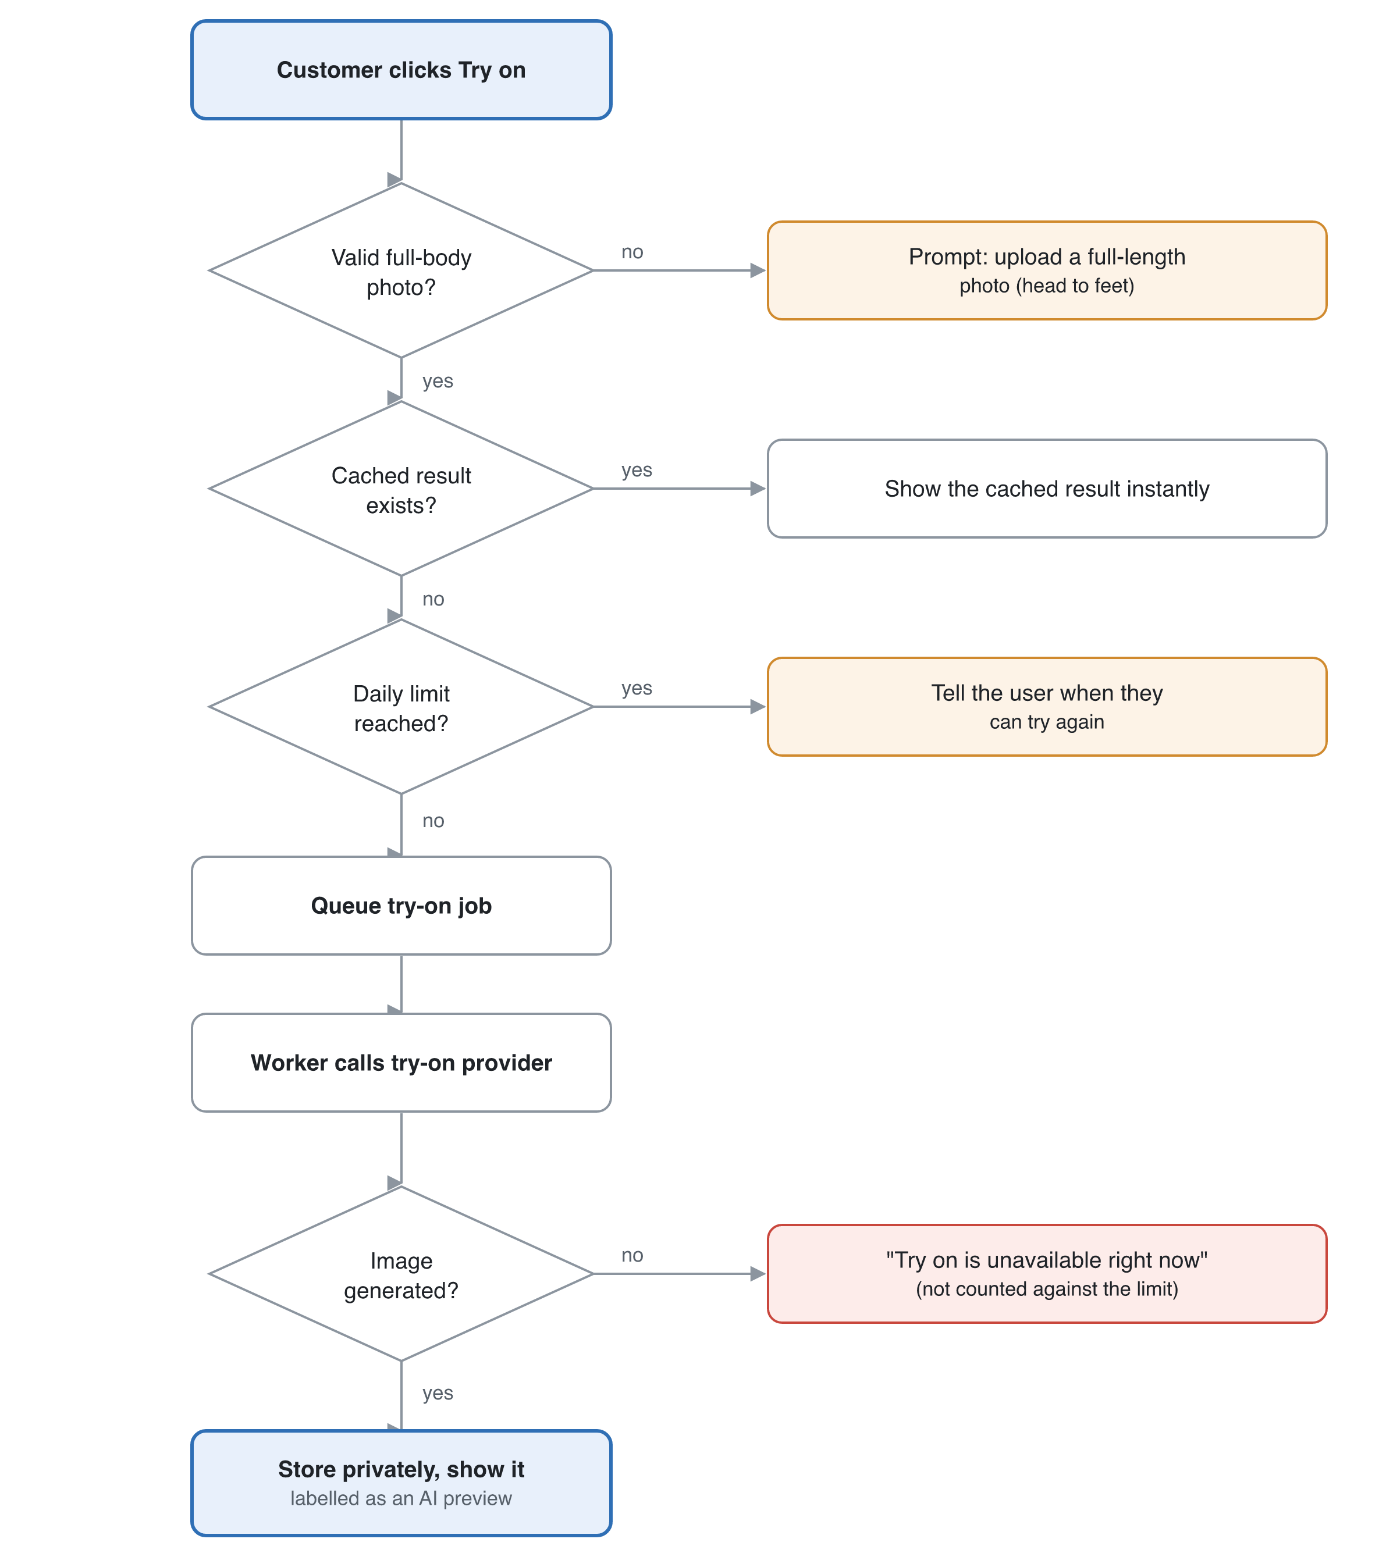
Figure 4. Try-on decision flow: every exit gives the customer a clear message.
- The customer clicks Try on for an eligible product. The server checks the photo is valid and the garment image exists.
- A cached result for this photo and garment pair is returned straight away.
- Otherwise a job is queued. The UI shows a progress state, and the result arrives by polling or a server-sent event.
- The worker calls the try-on provider with the person image, the garment image and the garment type, and stores the result in private storage.
- The result is shown next to the product photos with a note that it is an AI preview. The user can save or delete it.
Usage is rate-limited per user, for example 20 try-ons a day, to control cost.

8.5 Privacy (body photos are sensitive)
- Ask for explicit, specific consent before the first upload, and say why the photo is collected, who processes it and how long it is kept, as the Personal Data Protection Ordinance 2025 requires.
- Keep photos in a private bucket and serve them only through short-lived signed URLs. They are never public.
- Choose a provider that does not keep or train on uploaded images, and that processes them in a region allowed for cross-border transfer. Otherwise self-host.
- The user can delete their photos and results at any time. Results are deleted automatically after 30 days.
- Never show try-on photos to sellers or admins in normal admin views.
- Test local garments (saree, salwar kameez, panjabi) in the try-on spike, because loose garments may fail.

9. Epics and user stories
The plan has 44 stories in 10 epics. Version 2 adds the Cart and wishlist, Returns and support, and Compliance epics, the medicine-licence stories and phone verification, and makes reviews a Must. Full acceptance criteria are written below for the highest-risk stories.
ID | Epic | Story | Priority
US-001 | Accounts | As a visitor, I want to sign up with email or Google so that I can buy products | Must
US-002 | Accounts | As any user, I want to edit my profile (name, phone, avatar) so that my details are correct | Must
US-003 | Accounts | As any user, I want to reset my password and verify my email so that my account is secure | Must
US-004 | Accounts | As a Platform Admin, I want to view, suspend and change the roles of users so that I can keep the platform safe | Must
US-005 | Accounts | As a customer, I want to verify my mobile number by OTP so that I can place cash-on-delivery orders | Must
US-006 | Accounts | As a customer, I want to save addresses in Bangladesh format (division, district, upazila or thana, area) so that checkout is quick and accurate | Must
US-010 | Shops | As a customer, I want to apply to open a shop (name, type, trade licence or DBID) so that I can sell | Must
US-011 | Shops | As a Platform Admin, I want to approve, reject or suspend shops so that only legitimate sellers operate | Must
US-012 | Shops | As a Shop Owner, I want to edit my shop profile (logo, banner, policies) so that customers trust my shop | Must
US-013 | Shops | As a Shop Owner, I want to invite staff by email and remove them so that my team can help run the shop | Must
US-014 | Shops | As a customer, I want to see a shop's page with its products so that I can browse one seller | Should
US-015 | Shops | As an owner applying for a Medicine shop, I want to upload my drug licence certificate so that the admin can verify and approve my shop | Must
US-016 | Shops | As a Platform Admin, I want to verify medicine licences and be alerted before they expire so that only licensed shops sell medicine | Must
US-020 | Catalog schema | As a Platform Admin, I want to manage the category tree so that products are organised consistently | Must
US-021 | Catalog schema | As a Platform Admin, I want to define attributes and assign them to leaf categories so that each category has the right fields and filters | Must
US-022 | Catalog schema | As a seller, I want to request a new category or enum option so that I can list items that don't fit yet | Should
US-023 | Catalog schema | As a Platform Admin, I want the guideline fields (quantity, ingredients, delivery charge, return eligibility) required in every schema so that listings are compliant | Must
US-030 | Listings | As shop staff, I want to create a product in one leaf category through a form generated for it so that my listing is complete and filterable | Must
US-031 | Listings | As shop staff, I want to add variants (size, colour) with their own stock and price so that customers can pick the right one | Must
US-032 | Listings | As shop staff, I want to upload product images so that customers can see the product | Must
US-033 | Listings | As shop staff, I want to edit, deactivate or delete products and update stock so that the catalog stays accurate | Must
US-034 | Listings | As shop staff, I want to bulk-import products from CSV for one category so that I can onboard quickly | Could
US-040 | Discovery | As a customer, I want to see only categories that have products so that I never land on an empty page | Must
US-041 | Discovery | As a customer, I want to search products by keyword so that I find what I need | Must
US-042 | Discovery | As a customer, I want filters that match the category I'm browsing so that I can narrow results precisely | Must
US-043 | Discovery | As a customer, I want to sort by price, newest and rating so that I can compare | Should
US-044 | Discovery | As a customer, I want a product detail page with specs, images, variants, delivery charge, return eligibility and shop info so that I can decide | Must
US-050 | Cart and wishlist | As a customer, I want to add items from several shops to one cart, grouped by shop, so that I can buy together | Must
US-051 | Cart and wishlist | As a customer, I want to check out with a saved address and cash on delivery, and see every charge before I confirm, so that I can complete my purchase | Must
US-052 | Cart and wishlist | As a customer, I want to see my order history and status so that I can track deliveries | Must
US-056 | Cart and wishlist | As a customer, I want to change quantities, remove items and save items for later, with prices and stock re-checked, so that my cart stays accurate | Must
US-057 | Cart and wishlist | As a customer, I want a wishlist I can add to, remove from and move items into my cart so that I can buy later | Must
US-053 | Orders | As shop staff, I want to confirm, pack and hand over orders within 48 h, with overdue alerts, so that I meet the delivery rules | Must
US-054 | Orders | As a Shop Owner, I want to see sales, cash-on-delivery collections and payout reports so that I know how my shop is doing | Should
US-055 | Orders | As a customer, I want to rate and review a delivered product so that others can benefit | Must
US-070 | Returns and support | As a customer, I want to request a return within 7 days with a reason and photos so that I can get a refund | Must
US-071 | Returns and support | As shop staff, I want to accept or reject return requests within 48 h, and record the refund, so that returns are handled on time | Must
US-072 | Returns and support | As a customer, I want to raise a complaint and have it resolved within 72 h so that problems are fixed | Must
US-080 | Compliance | As a Platform Admin, I want to publish versioned policy pages and record user acceptance so that terms are disclosed and provable | Must
US-081 | Compliance | As a Platform Admin, I want the DBID shown in the footer and records kept for 6 years so that the platform meets the registration and record rules | Must
US-082 | Compliance | As a Platform Admin, I want cash-on-delivery collections logged per shop with a 10-day payout cycle so that sellers are paid on time | Must
US-060 | Try-on | As a customer, I want to upload a full-body photo with instant validation so that I can use Try on | Should
US-061 | Try-on | As shop staff, I want to upload a garment image for apparel products so that they become try-on eligible | Should
US-062 | Try-on | As a customer, I want to click Try on and see the garment on my photo so that I know how it looks on me | Should
US-063 | Try-on | As a customer, I want to delete my try-on photos and results so that I control my data | Must (with try-on)

9.1 Acceptance criteria for the highest-risk stories
US-015 and US-016 Medicine shop verification
- Given I choose the Medicine shop type, when I submit the application without a licence number, expiry date and certificate file, then the submission is blocked.
- Given my medicine shop is pending, when I try to create a product, then the request is rejected until the admin verifies the licence.
- Given the admin rejects my certificate, when I open my application, then I see the reason and can upload a new one.
- Given a verified licence expires in 30 days, when the daily job runs, then the shop owner and the admin are notified.
- Given the licence has expired, when the job runs, then the shop's medicine listings are hidden until a new certificate is verified.
- Given a non-medicine shop, when its staff try to list in a medicine category, then the request is rejected.
US-030 Create product through the category form
- Given I am shop staff and pick the leaf category "Processor", when the form loads, then it shows exactly the attributes assigned to Processor plus the required guideline fields, in display order.
- Given a required attribute is empty, when I submit, then the save is blocked and the field shows an error.
- Given I send an attribute that does not belong to Processor, through the API directly, when the server validates it, then the request is rejected with a 422 and the attribute named.
- Given I pick a non-leaf category, when I submit, then the request is rejected.
- Given I am staff of shop A, when I try to create a product for shop B, then the request is rejected with a 403.
US-042 Dynamic filters
- Given I am on Processor results, when the filter panel renders, then it shows only Processor's filterable attributes plus the common ones (price, rating, shop).
- Given I select Brand = AMD, when results update, then the other facets show counts within the AMD results, and options with 0 results are hidden or disabled.
- Given I copy the URL with filters applied, when someone opens it, then they see the same results and filter state.
- Given my search spans several categories, when results render, then only common filters and a "Narrow by category" list appear.
US-050 and US-056 Cart
- Given I add items from two shops, when I open the cart, then items are grouped by shop with a subtotal and delivery charge for each.
- Given a variant has 3 in stock, when I set quantity to 5, then the quantity is capped at 3 with a message.
- Given a price changed since I added the item, when I open the cart or checkout, then I see the new price and a notice before I can continue.
- Given I added items as a guest, when I log in, then the guest cart merges into my account cart.
- Given I choose Save for later, when the cart reloads, then the item moves out of the totals into a saved list.
US-051 Checkout with cash on delivery
- Given my phone is not verified, when I reach checkout, then I must complete the OTP before placing the order.
- Given my address is outside Dhaka, when the review page loads, then each shop order shows the outside-Dhaka delivery charge and the total.
- Given I have not accepted the current Return and Delivery policies, when I place the order, then the order is blocked until I accept.
- Given I place an order with items from two shops, when it is confirmed, then two shop orders are created, and I receive one SMS and one email invoice listing all charges.
- Given I am a new account with 3 open cash-on-delivery orders, when I try a fourth, then I see the limit message.
US-057 Wishlist
- Given I am a guest, when I tap the wishlist icon, then I am asked to log in and the item is saved after login.
- Given an item in my wishlist, when I move it to the cart, then it appears in the cart with a variant chosen and is removed from the wishlist.
- Given a wishlisted item goes out of stock, when I open the wishlist, then it shows Out of stock and can't be moved to the cart.
US-070 and US-071 Returns
- Given my order was delivered 8 days ago, when I request a return, then the request is blocked with the 7-day policy message.
- Given a medicine item that is not damaged or wrong, when I request a return, then the request is blocked with the exclusion reason.
- Given a valid return request, when the shop has not responded in 48 h, then it is escalated to the admin.
- Given a return is accepted, when the refund is paid manually, then the shop records the method and reference, and I am notified.
US-062 Try on
- Given I have no valid full-body photo, when I click Try on, then I see the upload prompt and no job is created.
- Given a valid photo and an eligible top, when I click Try on, then I see progress and a result within 30 s at p90, labelled as an AI preview.
- Given the provider fails or times out, when the job ends, then I see "Try on is unavailable right now" and am not charged against my daily limit.

10. Prioritisation and MVP
The MVP proves the core loop for Bangladesh: approved shops list products through category forms, customers find them with correct filters, keep a wishlist and cart, and place a cash-on-delivery order. Returns, complaints and the policy pages are part of the MVP because the guidelines require them.
Release | Scope | Stories
R1 — MVP (Bangladesh, cash on delivery) | Accounts with phone OTP and Bangladesh addresses, shop onboarding with medicine-licence verification, category schema with guideline fields, schema-driven listings, search with dynamic filters, product page, wishlist, multi-shop cart, checkout up to payment with cash on delivery, order lifecycle with 48 h handover, reviews, returns, complaints, policy pages, compliance records | US-001–006, 010–013, 015–016, 020–021, 023, 030–033, 040–042, 044, 050–053, 055–057, 070–072, 080–082
R2 — Payments, delivery and Bengali | bKash, Nagad and cards through an escrow-compliant gateway, courier integration and delivery estimates, Bengali UI, listing review and "Verified brand" badge, "report listing", shop pages, sorting, category requests, sales reports, vouchers | US-014, 022, 043, 054, plus payment, courier and Bengali stories to write
R3 — Try-on | Try-on photo upload and validation, garment images, try-on generation, data controls | US-060–063
Later | CSV bulk import, per-staff permissions, recommendations, pre-orders, native apps | US-034

Won't do now: online payments in R1, prescription upload, multi-currency, live chat between buyer and seller, and seller-defined tags.

11. Non-functional requirements
Area | Requirement
Performance | Core Web Vitals at p75: LCP < 2.5 s, INP < 200 ms, CLS < 0.1, on mid-range Android phones over 4G. Search and filter API p95 < 300 ms. Product page server render p95 < 500 ms
Try-on latency | p90 < 30 s end to end. The UI never blocks while it runs
Scale (initial) | 1,000 shops, 100,000 products and 200 concurrent users without redesign
Security | OWASP Top 10 and ASVS level 2 practices. Role and shop-scoped authorisation on every endpoint. Rate limits on auth, OTP, search, checkout and try-on
Compliance | Digital Commerce Operation Guidelines 2021: required listing fields, 48 h handover timer, 72 h complaint timer, reviews never deleted, 10-day seller payout cycle, 6-year record retention. DBID in the site footer
Privacy | Personal Data Protection Ordinance 2025: specific consent with purpose and retention notices, consent records, a breach runbook with prompt reporting to the national data authority, cross-border transfer checks for any third-party processor. Try-on photos private, EXIF stripped, results deleted after 30 days
Payments | R1: cash on delivery only, so no payment data is stored. Later: hosted payment pages of an escrow-compliant local gateway, so no card or wallet credentials touch our servers
Localisation | English UI and policy text at launch. Bengali Terms before the public launch, Bengali UI in R2. BDT prices, Bangladesh address format, +880 mobile numbers validated as 11 digits starting 01
Accessibility | WCAG 2.2 AA. The filter panel, cart and checkout work by keyboard, and the try-on result has alt text and an announced status
SEO | Server-rendered category and product pages, clean filter URLs, canonical tags on filter combinations, sitemap, Product structured data
Reliability | 99.5% uptime target. Daily database backups with 7-day point-in-time recovery. RPO 24 h or less, RTO 4 h or less. Try-on failures degrade gracefully
Observability | Structured logs, error tracking (Sentry), uptime checks, and alerts on 5xx rate, search latency, overdue handovers, overdue complaints and try-on failure rate
Devices | Mobile-first and responsive. The last 2 versions of Chrome, Safari, Firefox and Edge

12. Tech stack and decisions
The recommendation is a TypeScript full-stack app on Next.js and PostgreSQL, with Meilisearch for faceted search and a separate worker for try-on jobs. Exact versions are pinned in Sprint 0 from the current stable releases; they were not looked up for this doc.

12.1 Application framework
Option | Fit for this app | Learning curve | Cost and hosting | Verdict
Next.js (App Router) + TypeScript | Server-rendered category and product pages for SEO, one language end to end, large ecosystem | Moderate | Vercel, or a container on any cloud | Chosen
NestJS API + React SPA | Clean API boundary, but SEO needs extra work and there are two apps to deploy | Moderate to high | Two services | Fallback if a separate mobile app is planned soon
Laravel or Django monolith | Mature admin and auth, fast CRUD | Low if the team knows it | Cheap | Good if the team already knows PHP or Python

12.2 Faceted search
Option | Facets | Ops effort | Verdict
PostgreSQL only (JSONB + GIN indexes) | Possible, but facet counts get slow and complex as the catalog grows | None extra | Fine for a prototype
Meilisearch | Built-in facet counts and filters, typo-tolerant search | Low: one service, or the managed cloud | Chosen for R1
OpenSearch or Elasticsearch | Most powerful aggregations | High | Move here if past about 5M products or if complex ranking is needed

12.3 Rest of the stack
Concern | Choice
Database | PostgreSQL with Prisma or Drizzle ORM
Product attribute storage | Typed product_attribute_value rows as the source of truth, plus a denormalised JSONB copy on the product for fast reads (ADR-002)
Auth | Auth.js (NextAuth) or Better Auth: email and password plus Google, with phone OTP for cash on delivery. Sessions in an httpOnly cookie
SMS | A local Bangladeshi SMS gateway for OTP and order confirmations, behind an adapter
Validation | Zod, with schemas generated from category attribute definitions
UI | Tailwind CSS with shadcn/ui components
Files | S3-compatible object storage with a CDN. Separate private buckets for try-on photos, licence certificates and return photos
Jobs | Redis with BullMQ for search indexing, category counts, handover and complaint timers, licence-expiry checks, try-on jobs, SMS and email
Try-on | Hosted try-on API behind an adapter interface, so it can later swap to a self-hosted model
Pose check | MediaPipe Pose: the web build in the browser and the server build
Payments (R2) | bKash, Nagad and cards through an escrow-compliant local gateway, behind an adapter. R1 is cash on delivery only
Courier (R2) | Courier provider API behind an adapter. R1 uses flat delivery charges
Testing | Vitest, Testing Library, Playwright
CI/CD | GitHub Actions: lint, typecheck, tests, preview deploys
Monitoring | Sentry, plus the host's logs and uptime checks

12.4 Architecture Decision Records
ADR | Decision | Why | Consequence
ADR-001 | Category schema (EAV-lite) over free-form tags | Guarantees correct, category-specific filters | Admins must curate the schema, and sellers can't invent fields
ADR-002 | Typed attribute rows plus a JSONB copy | Integrity and validation from the rows, fast reads and indexing from the JSONB | Both must be written in one transaction
ADR-003 | Meilisearch for search and facets | Facet counts out of the box, low ops | One more service, and index sync jobs to maintain
ADR-004 | Single tenant database with shop_id scoping | Simple, cross-shop search is easy | Every query must be scoped, enforced in a data-access layer and covered by tests
ADR-005 | Hosted try-on API behind an adapter | Ships fastest and avoids GPU ops | Cost per image and a third party handles body photos, which needs a DPA and a region check
ADR-006 | Asynchronous try-on jobs | Generation takes seconds, and HTTP requests shouldn't block | Needs a queue, a worker and result polling
ADR-007 | Cash on delivery only in R1, with payment and courier adapters | Matches the market, avoids escrow and KYC work in R1 | Manual refunds and payouts until R2. Fake-order controls needed
ADR-008 | Medicine shops gated by licence verification | The guidelines require a drug-administration licence | A shop_licence table, admin review queue and expiry job

13. Architecture
One Next.js app serves pages and the API. PostgreSQL is the source of truth, Meilisearch serves search and facets, and a background worker handles indexing, counts and try-on jobs.
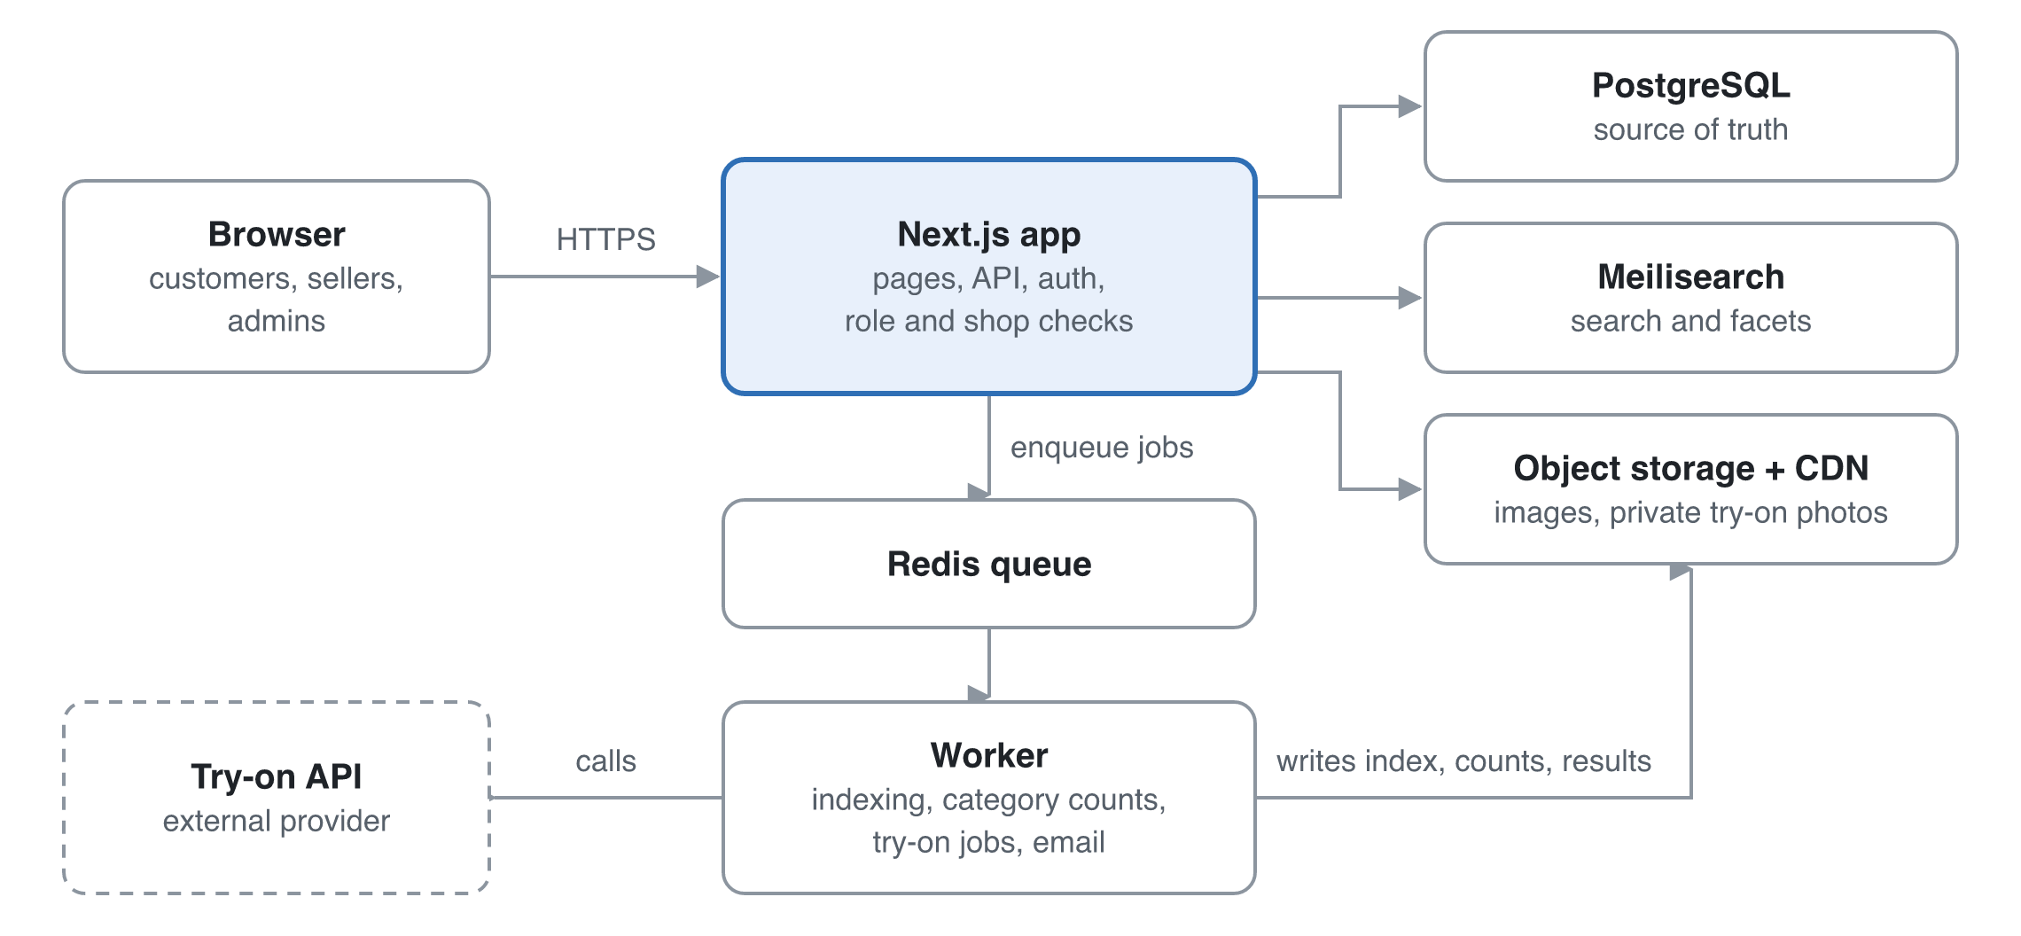
Figure 5. System architecture: slow work goes through the queue to the worker.
Requests never wait on slow work: indexing, category counts and try-on generation go through the queue to the worker.

13.1 Data model (key tables)
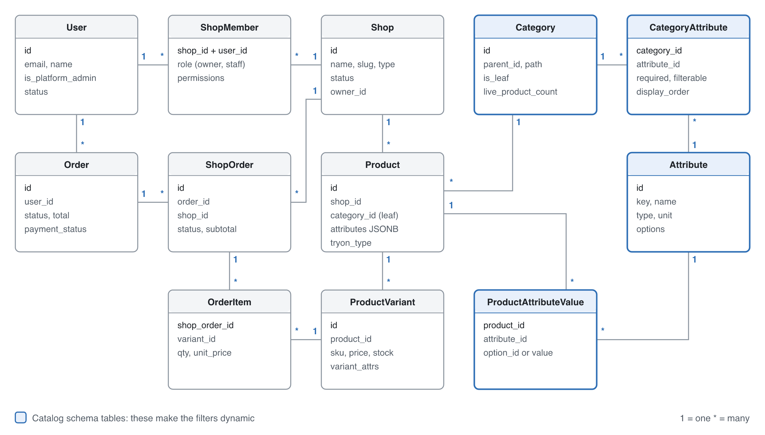
Figure 6. Core catalog and order model. Wishlist, cart, licence, returns, complaints, policy, payout, try-on and audit tables are in the table below.
Table | Key fields | Notes
user | id, email, password_hash, name, phone, phone_verified_at, avatar_url, is_platform_admin, status | Every person, every role
address | id, user_id, name, phone, division, district, upazila, area, line1, is_default | Bangladesh format
shop | id, name, slug, type, logo_url, trade_licence_or_dbid, status (pending, approved, suspended), owner_id
shop_licence | id, shop_id, licence_no, expiry_date, document_key, status (pending, verified, rejected, expired), reviewed_by, reviewed_at, reason | Medicine shops. Private bucket
shop_member | shop_id, user_id, role (owner, staff), permissions JSONB | Unique on (shop_id, user_id)
category | id, parent_id, name, slug, is_leaf, requires_licence, live_product_count, path | requires_licence true for medicine
attribute | id, key, name, type, unit | Defined once globally
attribute_option | id, attribute_id, value, label, status (active, pending) | Values for enum attributes
category_attribute | category_id, attribute_id, required, filterable, filter_widget, display_order, is_variant_axis | Assignment with category-specific settings
product | id, shop_id, category_id (leaf only), title, slug, description, status, attributes JSONB, return_eligibility, tryon_type | Index on (category_id, status)
product_attribute_value | product_id, attribute_id, option_id or value_number or value_text | Typed source of truth
product_variant | id, product_id, sku, price, stock, variant_attrs JSONB | Size and colour SKUs
product_image | id, product_id, url, kind (gallery, garment), position | garment is the try-on input
wishlist_item | user_id, product_id, created_at | Unique on (user_id, product_id)
cart_item | user_id or guest_token, variant_id, qty, saved_for_later, price_at_add | Guest cart merges at login
delivery_rate | zone (inside_dhaka, outside_dhaka), amount, effective_from | Set by the admin
order | id, user_id, status, total, payment_method (cod), address snapshot, policy_versions | One customer order
shop_order | id, order_id, shop_id, status, subtotal, delivery_charge, handover_due_at, cancel_reason | Split by shop for fulfilment
order_item | shop_order_id, variant_id, qty, unit_price, title snapshot
cod_collection | shop_order_id, amount, collected_at, payout_due_at, paid_out_at | 10-day payout cycle
review | id, product_id, user_id, order_item_id, rating, text, status (visible, hidden), hidden_reason | Never deleted
return_request | id, order_item_id, reason, photos, status, shop_due_at, refund_amount, refund_method, refund_reference, refunded_at | 7-day window
complaint_ticket | id, user_id, order_id, subject, status, due_at, resolved_at | 72 h timer
policy_document | id, type, version, body, published_at | Versioned text
policy_acceptance | user_id, policy_id, version, context (signup, checkout), accepted_at | Proof of acceptance
tryon_photo | id, user_id, storage_key, status (valid_full_body, invalid), reason, consent_at | Private bucket
tryon_result | id, user_id, photo_id, product_id, status, storage_key, expires_at | Cache key is (photo_id, product_id)
audit_log | id, actor_id, action, entity, entity_id, data, at | Kept 6 years

13.2 API surface
Area | Endpoints | Who
Auth and profile | POST /auth/*, POST /me/phone/otp, GET/PATCH /me, /me/addresses, GET /geo/divisions, /geo/districts, /geo/upazilas | Any signed-in user
Catalog (public) | GET /categories?visible=true, GET /search?q=&category=&filters=&sort=&page= (items plus facets), GET /products/:slug | Public
Category schema | GET /categories/:id/schema, POST/PATCH /admin/categories, /admin/attributes, /admin/category-attributes | Read: sellers. Write: admin
Shop management | POST /shops (apply), POST /shops/:id/licence, PATCH /shops/:id, POST/DELETE /shops/:id/members | Owner; admin for approval
Seller products | POST/PATCH/DELETE /shops/:id/products, /variants, /images | Owner and staff of that shop
Wishlist and cart | GET/POST/DELETE /wishlist, POST /wishlist/:id/move-to-cart, GET/POST/PATCH/DELETE /cart/items, POST /cart/merge | Customer (cart also guest)
Checkout and orders | POST /checkout/review, POST /checkout/place (cash on delivery), GET /orders, POST /orders/:id/cancel, PATCH /shops/:id/orders/:orderId | Customer; shop for its own orders
Reviews, returns and complaints | POST /reviews, POST /returns, PATCH /shops/:id/returns/:returnId, POST /complaints, PATCH /admin/complaints/:id | Customer, shop, admin
Policies | GET /policies/:type, POST /policies/:type/accept, POST /admin/policies | Public; admin to publish
Try-on | POST /me/tryon-photos, DELETE /me/tryon-photos/:id, POST /tryon, GET /tryon/:jobId | Customer
Admin | /admin/shops/:id/approve, /admin/licences/:id/verify, /admin/delivery-rates, /admin/users, /admin/reviews/:id/hide, /admin/payouts, /admin/audit | Platform Admin

Errors use one JSON shape: { error: { code, message, fields? } } with 400, 401, 403, 404, 409, 422 and 429 used consistently.

13.3 Code structure
The code is organised by feature, with folders for auth, shops, licences, catalog-schema, products, search, wishlist, cart, checkout, orders, returns, complaints, reviews, policies, payouts, tryon and admin. Each folder holds its UI, server actions or routes, services, Zod schemas and tests. All database access goes through a repository layer that requires a scope (shopId or userId), which makes cross-shop leaks hard to write by accident. Payments, couriers and SMS sit behind adapters so providers can be added or swapped later.

13.4 Environments
There are three: local (Docker Compose with Postgres, Redis, Meilisearch and MinIO), staging with a preview per pull request, and production. Secrets live in the host's secret store and are never committed. The try-on provider runs in sandbox mode outside production.

14. Security and threat model
The biggest risks are one shop reaching another shop's data, the leak of customers' body photos, and fraud around cash on delivery and medicine. Each is designed out, as the table below shows.
Threat | Example | Mitigation
Broken object-level access (IDOR) | Staff of shop A edits a product of shop B by changing the ID | A scoped repository layer, ownership checks in every handler, and automated tests for each endpoint across roles
Privilege escalation | Staff tries to invite users or a customer calls admin APIs | Role checks on the server, admin routes behind middleware, audit log
Try-on photo leak | A guessable URL or public bucket exposes body photos | Private bucket, random keys, signed URLs valid for 5 minutes or less, deletion on request, a DPA and region check with the provider
Forged medicine licence | A shop uploads an edited certificate | Admin verification against the issuing authority's records where possible, expiry tracking, audit log, suspension on fraud
Fake cash-on-delivery orders | A bot or prankster places many orders that are refused | Phone OTP, a limit of 3 open orders for new accounts, refusal tracking that blocks cash on delivery
Counterfeit or wrong-item listings | A shop lists fakes of a known brand | Shop approval with trade licence or DBID, returns for "not as described", reviews, and listing review in R2
Review manipulation | Shops post fake reviews | Reviews only from delivered order items, one per item, hiding logged rather than deleting
Malicious uploads | SVG with script, oversized files, polyglot files in images, certificates or return photos | Allow-list of types, re-encode images, scan PDFs, size limits, separate file domain
Account takeover | Credential stuffing | Rate limits and lockout on login, breached-password check, optional 2FA for shop owners and admins
Injection and XSS | Product descriptions or policy text with HTML | ORM-parameterised queries, a sanitised markdown subset, a strict CSP
Price or stock tampering | The client sends its own price at checkout | The server recomputes every price, delivery charge and stock in a transaction at order placement
OTP abuse | A script triggers thousands of SMS | Per-number and per-IP rate limits, cooldowns, CAPTCHA after failures
Abuse of costly try-on | A script triggers thousands of try-ons | Per-user daily limit, per-IP rate limit, cached results, alert on spend

15. Roadmap and delivery
The plan assumes a team of 2–3 developers working in 2-week sprints. The added Bangladesh scope moves the MVP to around week 15 and try-on to around week 27. Weeks are counted from the project start, which is still to be set.

15.1 Sprint plan
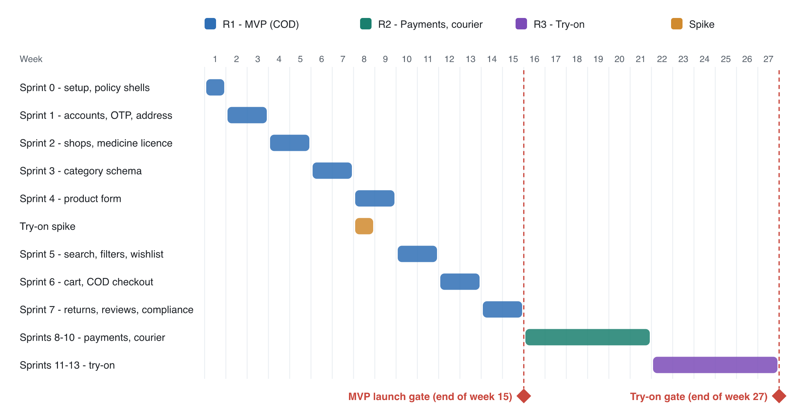
Figure 7. Delivery timeline by week, with the two release gates.
Sprint | Weeks | Focus | Stories
0 | 1 | Repo, CI, environments, auth skeleton, design system, policy page shells | —
1 | 2–3 | Accounts, profile, phone OTP, Bangladesh addresses, admin user management | US-001–006
2 | 4–5 | Shop application, approval, staff invites, medicine-licence upload and verification | US-010–013, 015, 016
3 | 6–7 | Category tree, attribute schema admin, required guideline fields | US-020, 021, 023
4 | 8–9 | Schema-driven product form, variants, images. Try-on spike runs in parallel (1 week) | US-030–033
5 | 10–11 | Search index, dynamic filters, populated-category navigation, product page, wishlist | US-040–042, 044, 057
6 | 12–13 | Cart, checkout up to payment, cash-on-delivery order placement, order split, invoices | US-050–052, 056
7 | 14–15 | Order lifecycle with 48 h timer, reviews, returns, complaints, policy acceptance, records and payout ledger. MVP launch gate | US-053, 055, 070–072, 080–082
8–10 | 16–21 | Online payments with escrow, courier integration, Bengali UI, listing review and verified brands, shop pages, sorting, reports | US-014, 022, 043, 054, plus R2 stories
11–13 | 22–27 | Try-on photo validation, garment images, try-on jobs, privacy controls. Try-on gate | US-060–063

MVP launch gate: all Must stories done, the cross-role authorisation tests pass, a Lighthouse score of 90 or more on key pages, a security review done, the DBID registered and shown, English policies published with Bengali Terms added, and the legal check on medicine sales complete.
Try-on gate: at least 80% of 50 test try-ons rated acceptable by an internal panel (including local garments), p90 under 30 s, and the provider's DPA and processing region confirmed.

15.2 Definition of Ready
- The story has acceptance criteria in Given/When/Then form, including error cases.
- UI wireframe attached where the story has a UI.
- Dependencies known, and the story is small enough to finish in one sprint.

15.3 Definition of Done
- Code reviewed and merged, with types, lint and tests passing in CI.
- Unit and integration tests cover the acceptance criteria, and an end-to-end test covers critical flows.
- Authorisation is tested for every role the endpoint touches.
- Accessibility checked (keyboard and an axe scan).
- Deployed to staging, acceptance criteria verified there, and the docs updated.

15.4 Risk register
Risk | Likelihood | Impact | Mitigation
Customer distrust after past e-commerce scandals (58,720 complaints and about Tk 3,869 crore claimed, Aug 2026) | High | High | Cash on delivery, a visible 7-day returns policy, DBID in the footer, complaints within 72 h
Prescription-only medicines sold without a prescription may not be allowed | Medium | High | Legal check before launch. Fallback: per-product "OTC" flag, listing only flagged items
Launching with a compliance gap | Medium | High | Compliance epic in R1, gate criteria, legal review before launch
Fake or refused cash-on-delivery orders | High | Medium | Phone OTP, open-order limit, refusal tracking
Counterfeit and wrong-item listings | Medium | High | Shop approval with documents, "not as described" returns, reviews, listing review in R2
Delivery delays before a courier is integrated | Medium | Medium | 48 h handover timer and alerts. Courier integration first in R2
Manual refunds and payouts don't scale | Medium | Medium | Ledger tables now, so R2 can automate on top of them
Try-on quality disappoints, especially on loose local garments | Medium | High | Spike in Sprint 4 with saree, salwar kameez and panjabi samples, quality gate, label results as previews
Try-on photos breach the 2025 data ordinance | Medium | High | Consent records, provider region check or self-hosting, deletion as designed
Try-on cost per image grows with usage | Medium | Medium | Cache results, daily limits, an adapter allowing a move to a self-hosted model
Category schema too rigid for new shop types | Medium | Medium | Seller request flow, admin tooling for fast schema edits, migration jobs
Sellers list in the wrong category | High | Medium | Category search with suggestions, admin moderation queue, "report listing" in R2
Competing on breadth against Daraz | High | Medium | Launch in 2–3 niches where clean filters matter most, as Rokomari did with books
Search index drifts from the database | Low | Medium | Index on every write through the queue, plus a nightly full reconcile
Cross-shop data leak | Low | High | Scoped repositories, role-by-endpoint test matrix, audit log

