Use Case Diagrams - Multi-Vendor E-Commerce Platform
These UML use case diagrams show what each of the six actors can do in the system. Diagram 1 covers shopping and virtual try-on. Diagram 2 covers shop and platform management. A table of actors and a full use case list with story references follow the diagrams.
Notation: a solid line links an actor to a use case. A dashed arrow marked «include» is a step that always runs. A dashed arrow marked «extend» is optional behaviour. A hollow triangle means generalisation, so a Customer can do everything a Guest can, and a Shop Owner can do everything Shop Staff can.

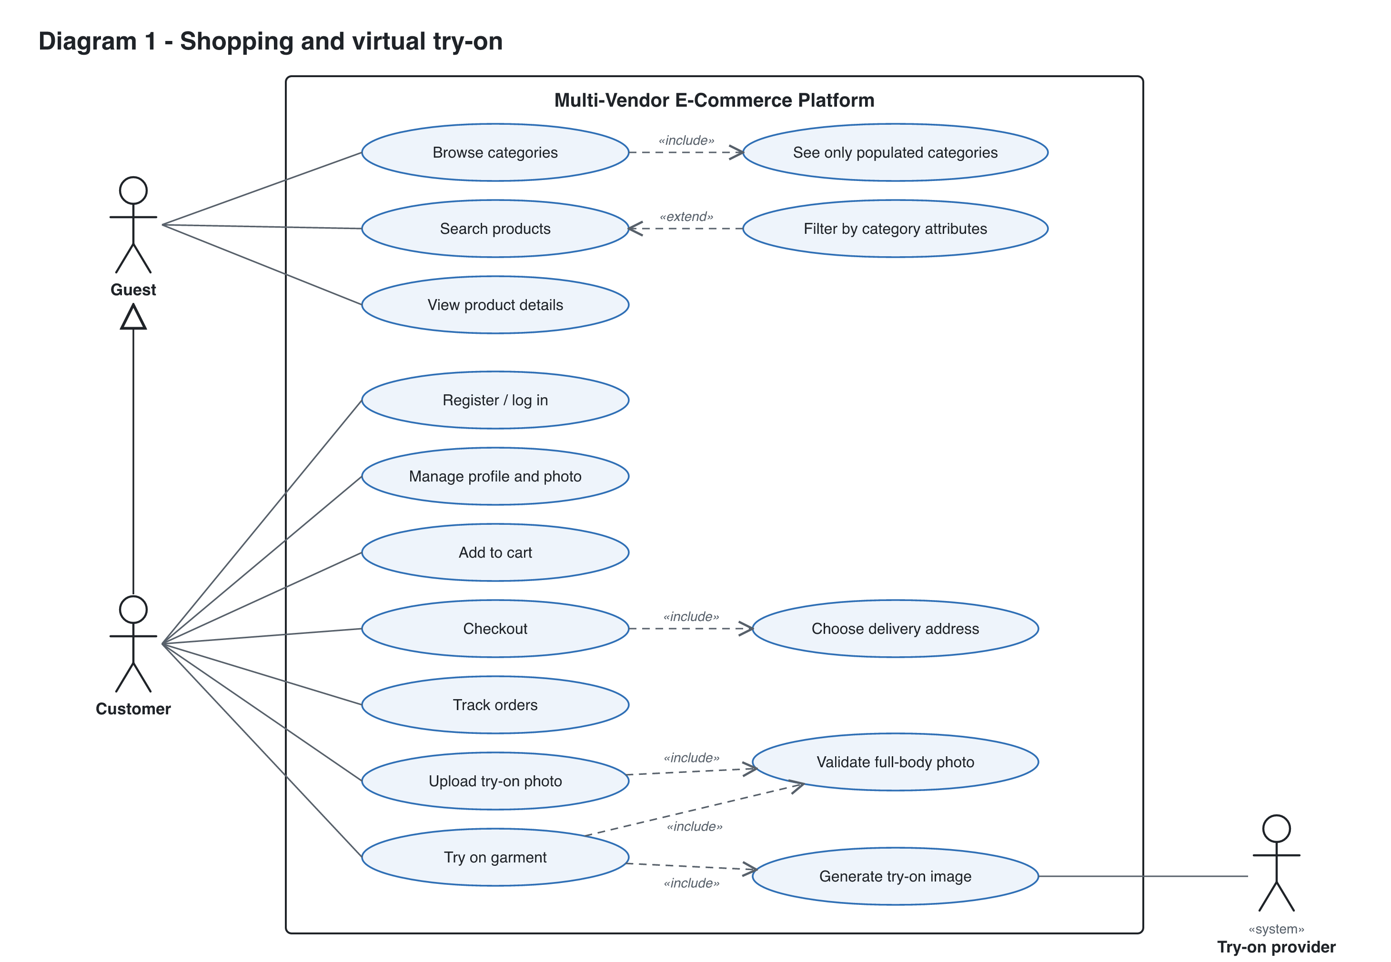
Diagram 1. Guest and Customer use cases, including the try-on flow and the external Try-on provider.

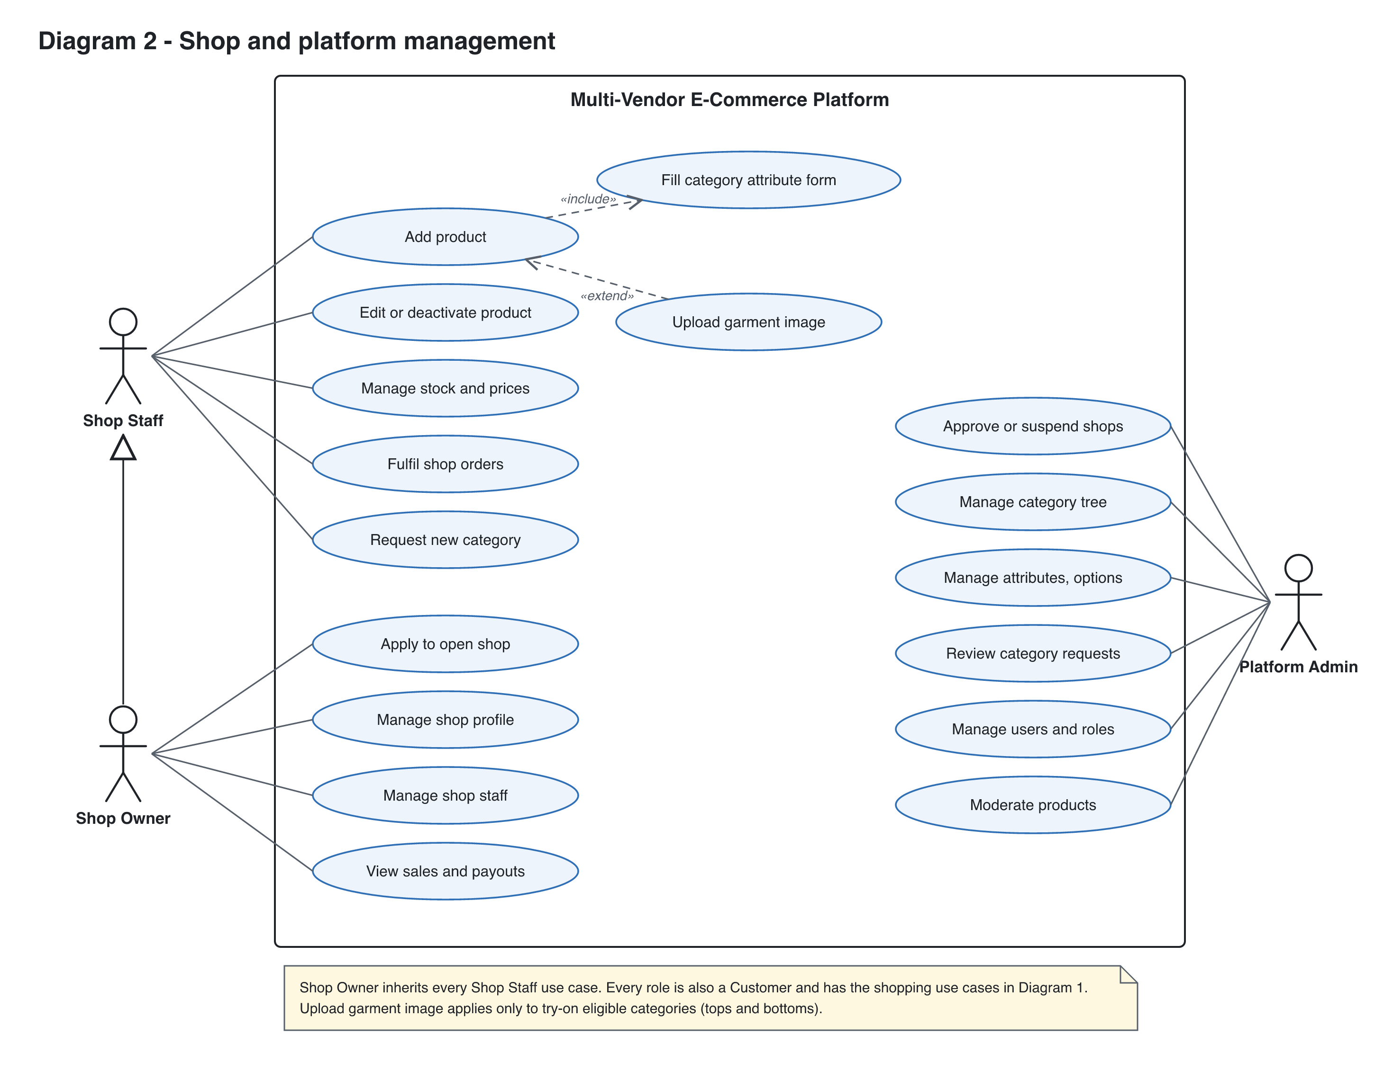
Diagram 2. Shop Staff, Shop Owner and Platform Admin use cases.

Actors
Actor | Type | Description
Guest | Primary, human | Unsigned visitor. Can browse, search, filter and view products.
Customer | Primary, human (specialises Guest) | Registered user. Buys products, manages profile and photo, uses try-on.
Shop Staff | Primary, human | Works for one shop. Lists products, manages stock and fulfils orders.
Shop Owner | Primary, human (specialises Shop Staff) | Organization admin of one shop. Runs the shop and manages its staff.
Platform Admin | Primary, human | Holds all power. Approves shops, owns the category schema, manages users.
Try-on provider | Secondary, external system | AI service that generates the try-on image from the user photo and garment image.

Use case list
ID | Use case | Actor | Relationships | Story
UC-01 | Browse categories | Guest | «include» See only populated categories | US-040
UC-02 | Search products | Guest | Extended by Filter by category attributes | US-041
UC-03 | Filter by category attributes | Guest | «extend» Search products | US-042
UC-04 | View product details | Guest | - | US-044
UC-05 | Register / log in | Customer | - | US-001, 003
UC-06 | Manage profile and photo | Customer (all roles) | - | US-002
UC-07 | Add to cart | Customer | - | US-050
UC-08 | Checkout | Customer | «include» Choose delivery address | US-051
UC-09 | Track orders | Customer | - | US-052
UC-10 | Upload try-on photo | Customer | «include» Validate full-body photo | US-060
UC-11 | Try on garment | Customer | «include» Validate full-body photo, Generate try-on image | US-062
UC-12 | Add product | Shop Staff | «include» Fill category attribute form; extended by Upload garment image | US-030, 031, 032
UC-13 | Upload garment image | Shop Staff | «extend» Add product (try-on categories only) | US-061
UC-14 | Edit or deactivate product | Shop Staff | - | US-033
UC-15 | Manage stock and prices | Shop Staff | - | US-033
UC-16 | Fulfil shop orders | Shop Staff | - | US-053
UC-17 | Request new category | Shop Staff | - | US-022
UC-18 | Apply to open shop | Shop Owner | - | US-010
UC-19 | Manage shop profile | Shop Owner | - | US-012
UC-20 | Manage shop staff | Shop Owner | - | US-013
UC-21 | View sales and payouts | Shop Owner | - | US-054
UC-22 | Approve or suspend shops | Platform Admin | - | US-011
UC-23 | Manage category tree | Platform Admin | - | US-020
UC-24 | Manage attributes, options | Platform Admin | - | US-021
UC-25 | Review category requests | Platform Admin | - | US-022
UC-26 | Manage users and roles | Platform Admin | - | US-004
UC-27 | Moderate products | Platform Admin | - | -

