Use Case Diagrams - Multi-Vendor E-Commerce Platform
These UML use case diagrams show what each of the six actors can do in the system. Diagram 1 covers shopping and virtual try-on. Diagram 2 covers shop and platform management. A table of actors and a full use case list with story references follow the diagrams.
Notation: a solid line links an actor to a use case. A dashed arrow marked «include» is a step that always runs. A dashed arrow marked «extend» is optional behaviour. A hollow triangle means generalisation, so a Customer can do everything a Guest can, and a Shop Owner can do everything Shop Staff can.

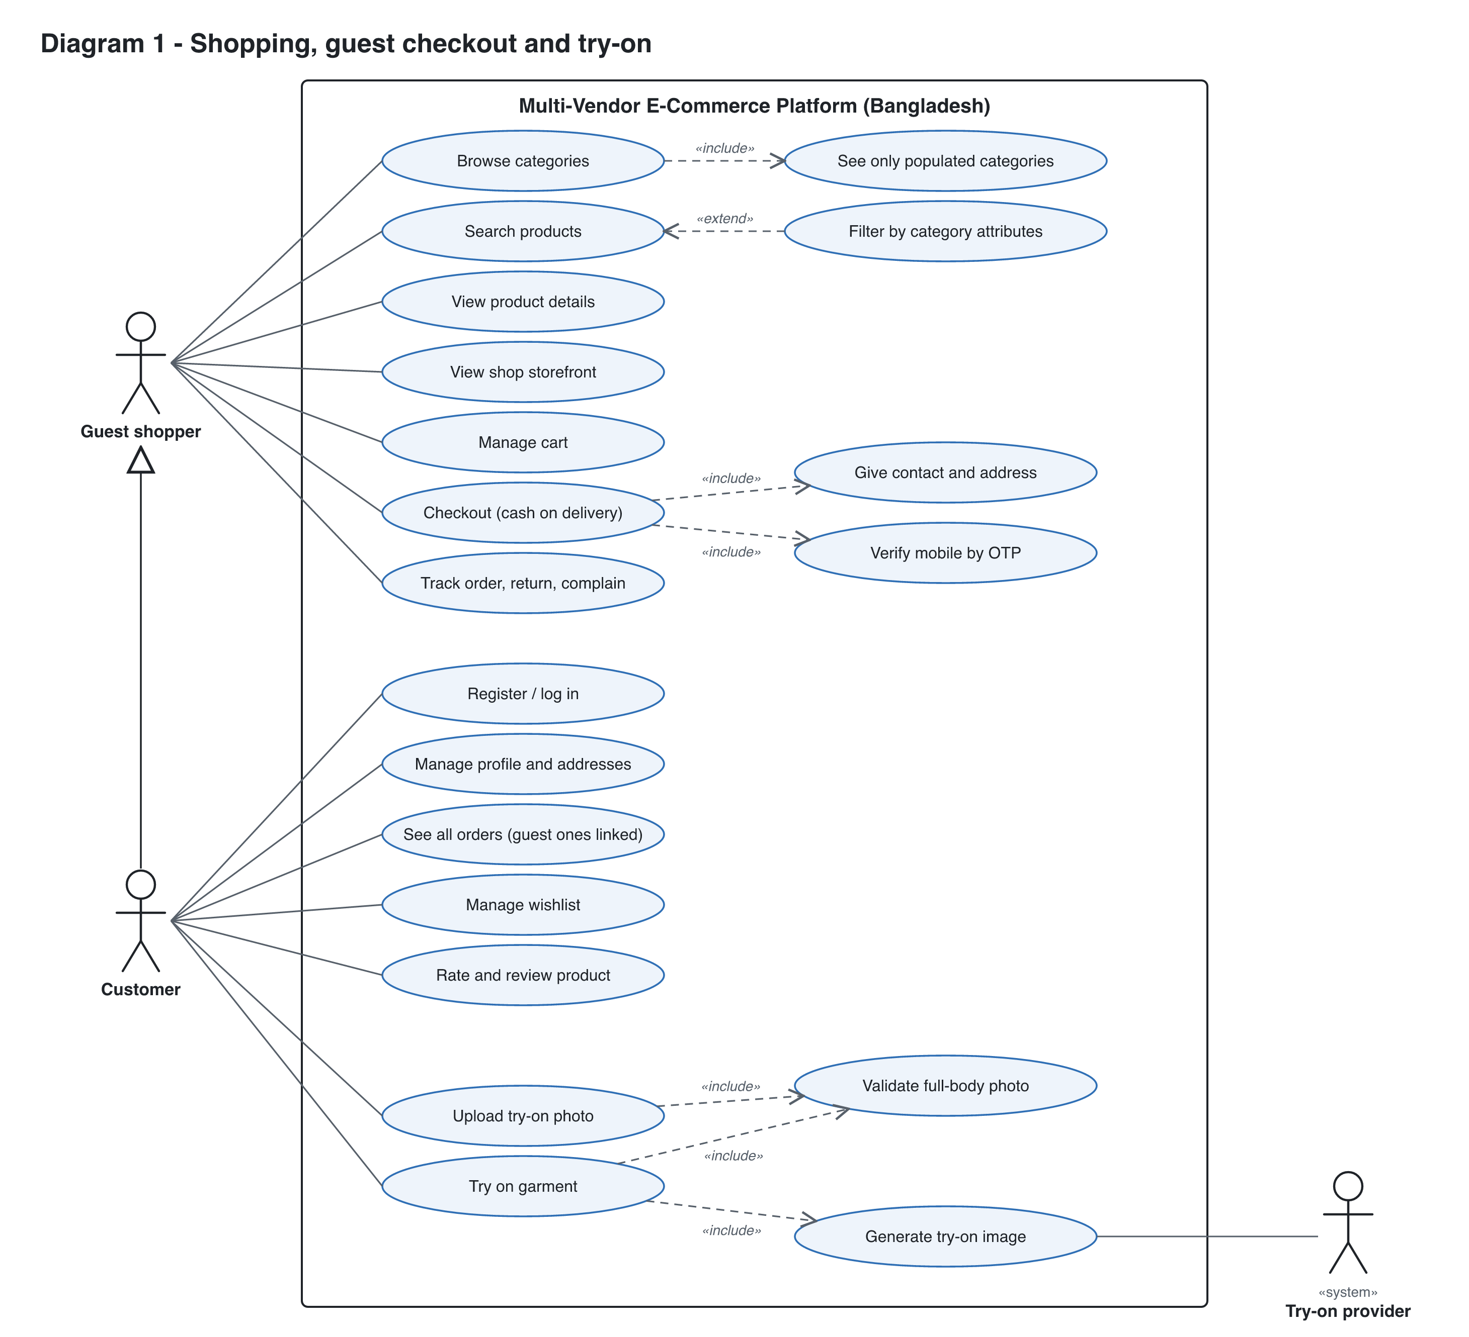
Diagram 1. Guest and Customer use cases, including the try-on flow and the external Try-on provider.

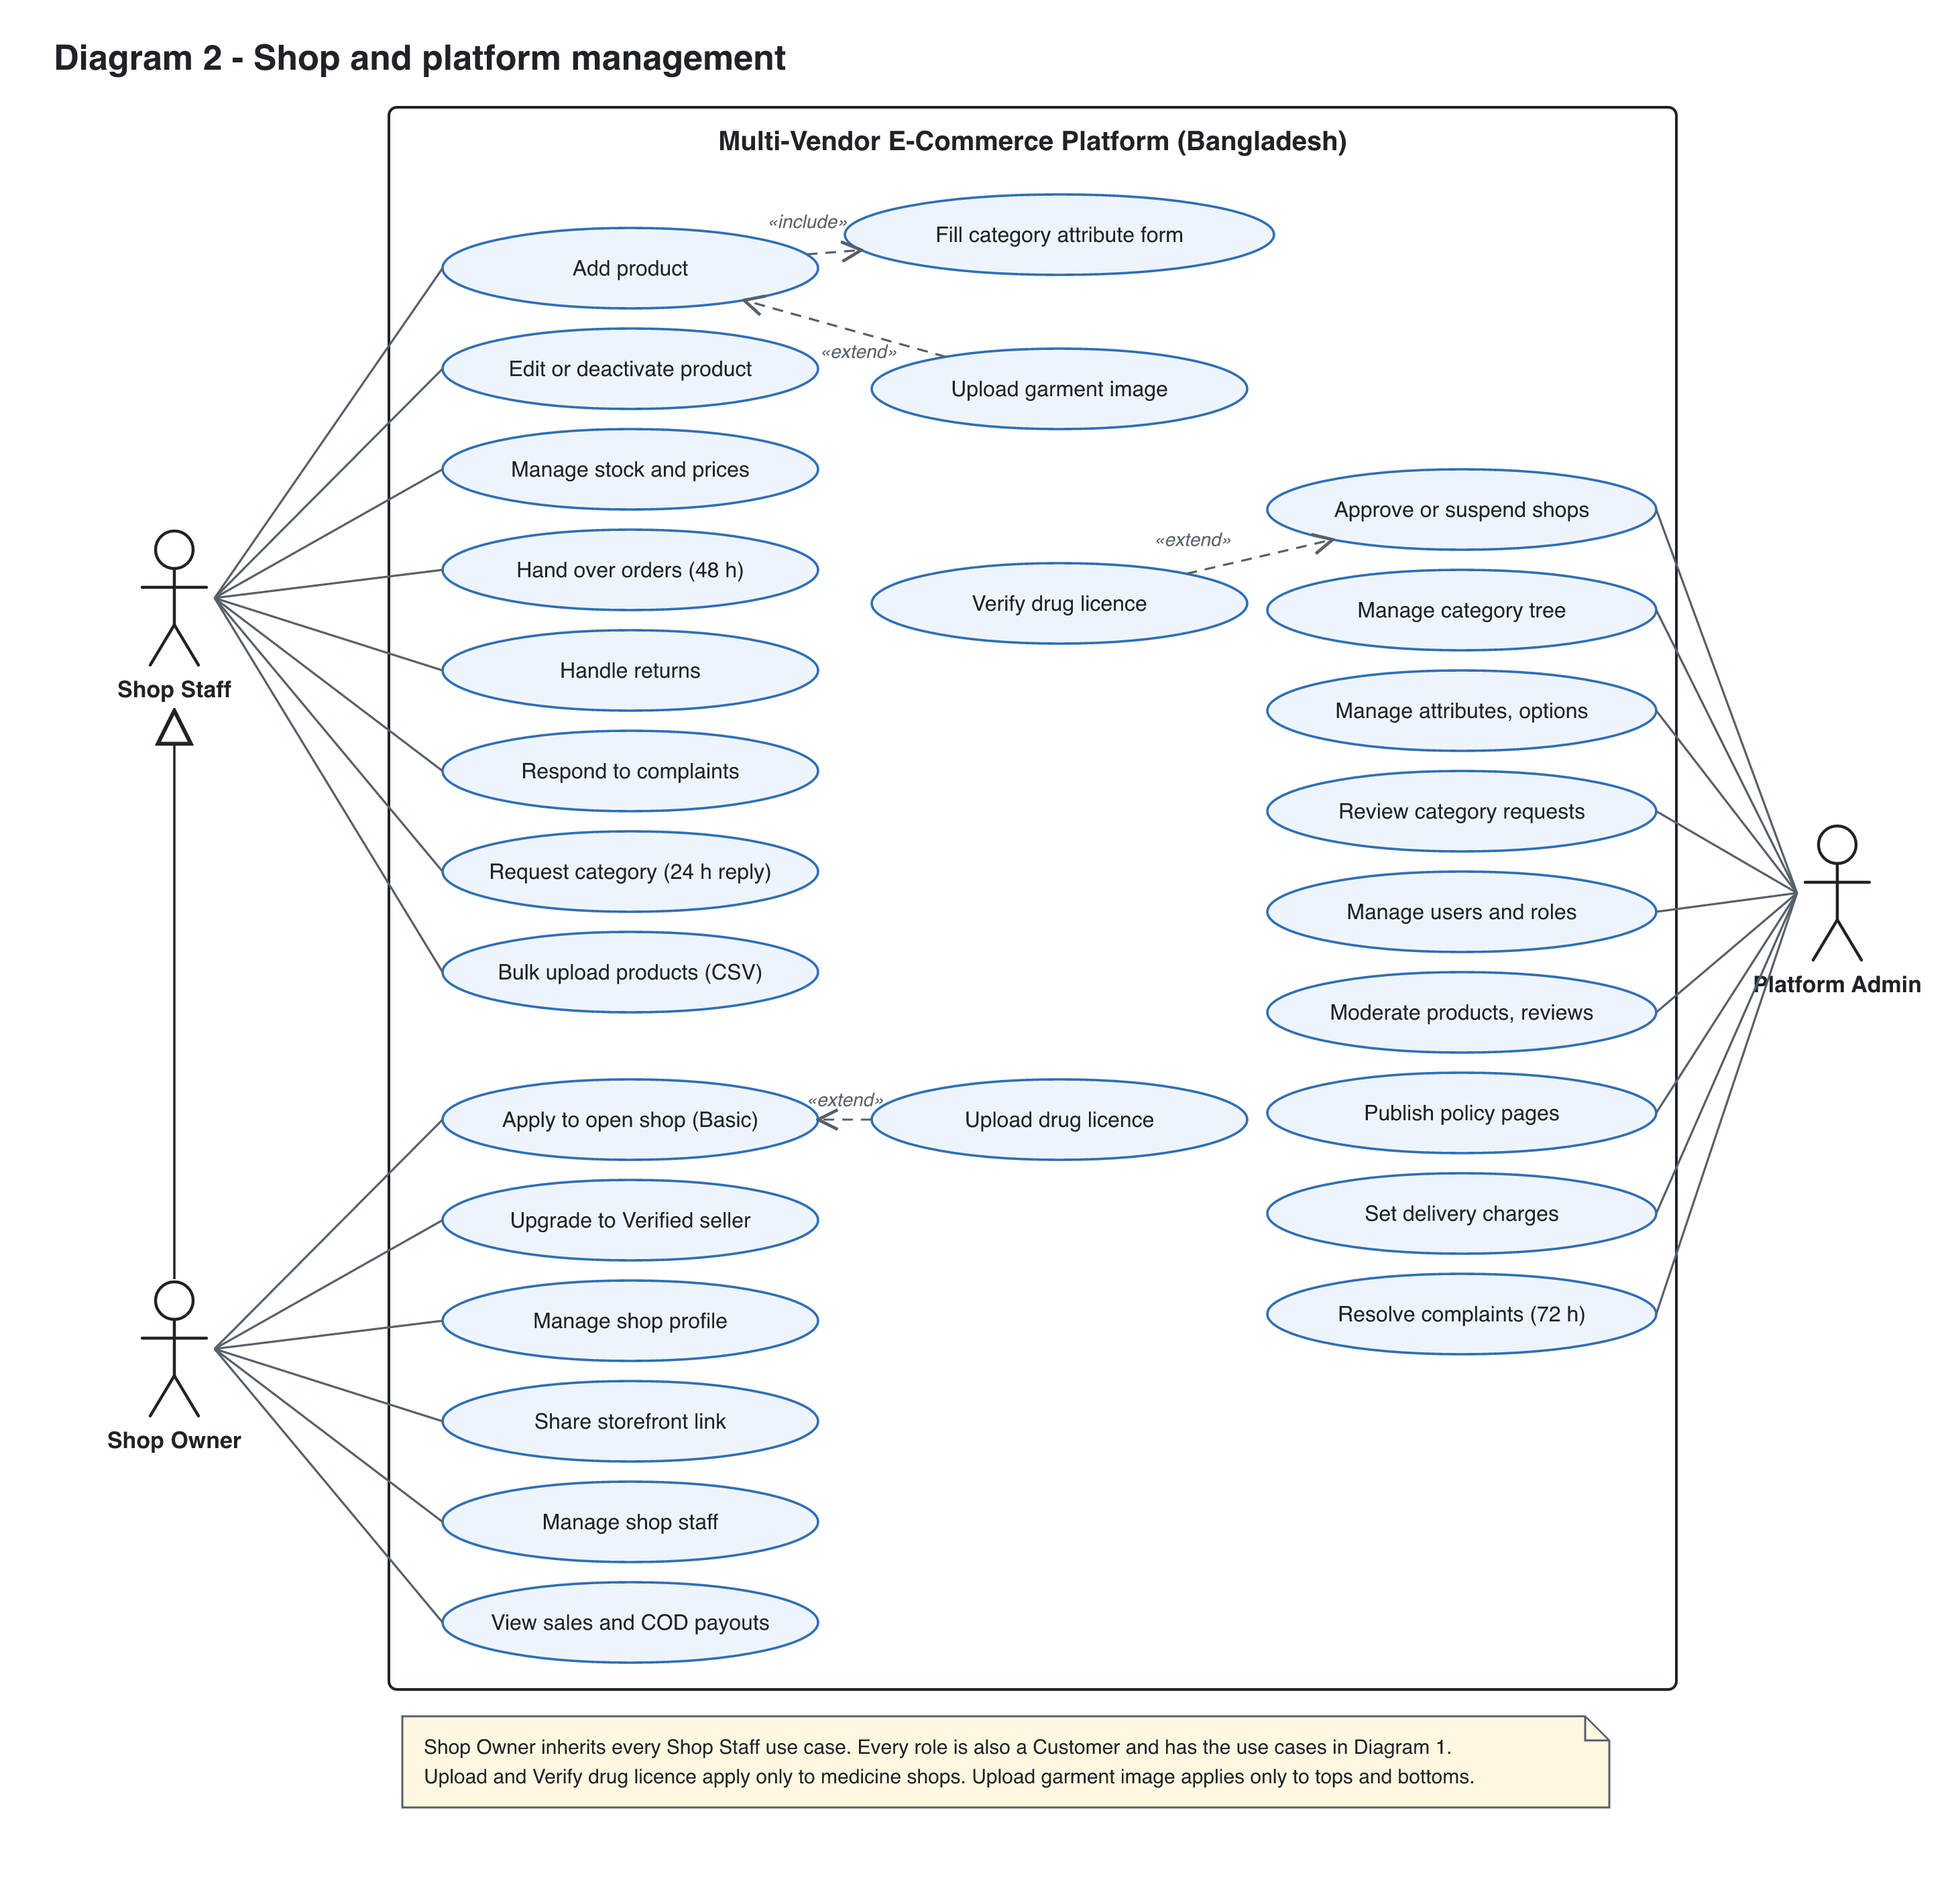
Diagram 2. Shop Staff, Shop Owner and Platform Admin use cases.

Actors
Actor | Type | Description
Guest shopper | Primary, human | Not logged in. Can browse, search, filter, use the cart, check out with cash on delivery (mobile OTP and email) and track orders by order number plus OTP.
Customer | Primary, human (specialises Guest shopper) | Logged in with mobile or email. Sees all orders including linked guest orders, uses wishlist, reviews and try-on.
Shop Staff | Primary, human | Works for one shop. Lists products, manages stock and fulfils orders.
Shop Owner | Primary, human (specialises Shop Staff) | Organization admin of one shop. Runs the shop and manages its staff.
Platform Admin | Primary, human | Holds all power. Approves shops, owns the category schema, manages users.
Try-on provider | Secondary, external system | AI service that generates the try-on image from the user photo and garment image.

Use case list
ID | Use case | Actor | Relationships | Story
UC-01 | Browse categories | Guest | «include» See only populated categories | US-040
UC-02 | Search products | Guest | Extended by Filter by category attributes | US-041
UC-03 | Filter by category attributes | Guest | «extend» Search products | US-042
UC-04 | View product details | Guest | - | US-044
UC-05 | Manage cart | Guest shopper | - | US-050, 056
UC-06 | Checkout (cash on delivery) | Guest shopper | «include» Give contact and address, Verify mobile by OTP | US-005, 007, 051
UC-07 | Track order, return, complain | Guest shopper | Order number plus OTP for guests | US-008, 052, 070, 072
UC-08 | Register / log in (mobile or email) | Customer (required for every other role) | - | US-001, 003
UC-09 | Manage profile and addresses | Customer (all roles) | - | US-002, 006
UC-10 | See all orders (guest ones linked) | Customer | Guest orders attach through a verified mobile or email | US-009, 052
UC-11 | Manage wishlist | Customer | - | US-057
UC-12 | Rate and review product | Customer | - | US-055
UC-13 | Request return or complain (logged in) | Customer | - | US-070, 072
UC-14 | Upload try-on photo | Customer | «include» Validate full-body photo | US-060
UC-15 | Try on garment | Customer | «include» Validate full-body photo, Generate try-on image | US-062
UC-16 | Add product | Shop Staff | «include» Fill category attribute form; extended by Upload garment image | US-030, 031, 032
UC-17 | Upload garment image | Shop Staff | «extend» Add product (try-on categories only) | US-061
UC-18 | Edit or deactivate product | Shop Staff | - | US-033
UC-19 | Manage stock and prices | Shop Staff | - | US-033
UC-20 | Hand over orders (48 h) | Shop Staff | - | US-053
UC-21 | Handle returns | Shop Staff | - | US-071
UC-22 | Respond to complaints | Shop Staff | - | US-072
UC-23 | Request new category | Shop Staff | - | US-022
UC-24 | Apply to open shop | Shop Owner | Extended by Upload drug licence | US-010
UC-25 | Upload drug licence | Shop Owner | «extend» Apply to open shop (medicine shops only) | US-015
UC-26 | Manage shop profile | Shop Owner | - | US-012
UC-27 | Manage shop staff | Shop Owner | - | US-013
UC-28 | View sales and COD payouts | Shop Owner | - | US-054, 082
UC-29 | Approve or suspend shops | Platform Admin | Extended by Verify drug licence | US-011
UC-30 | Verify drug licence | Platform Admin | «extend» Approve or suspend shops (medicine shops only) | US-016
UC-31 | Manage category tree | Platform Admin | - | US-020
UC-32 | Manage attributes, options | Platform Admin | - | US-021, 023
UC-33 | Review category requests | Platform Admin | - | US-022
UC-34 | Manage users and roles | Platform Admin | - | US-004
UC-35 | Moderate products, reviews | Platform Admin | - | US-055
UC-36 | Publish policy pages | Platform Admin | - | US-080, 081
UC-37 | Set delivery charges | Platform Admin | - | US-051
UC-38 | Resolve complaints (72 h) | Platform Admin | - | US-072
UC-39 | View shop storefront | Guest shopper | - | US-014
UC-40 | Bulk upload products (CSV) | Shop Staff | - | US-034
UC-41 | Upgrade to Verified seller | Shop Owner | - | US-017
UC-42 | Share storefront link | Shop Owner | - | US-014

