Use Case Diagrams - Multi-Vendor E-Commerce Platform
These UML use case diagrams show what each of the six actors can do in the system. Diagram 1 covers shopping and virtual try-on. Diagram 2 covers shop and platform management. A table of actors and a full use case list with story references follow the diagrams. Every user story maps to at least one use case. Small extensions (sorting, Bengali search, offer comparison, delivery charge per shop, shop score, the "Other" category) appear only in the table, to keep the diagrams readable.
Notation: a solid line links an actor to a use case. A dashed arrow marked «include» is a step that always runs. A dashed arrow marked «extend» is optional behaviour. A hollow triangle means generalisation, so a Customer can do everything a Guest can, and a Shop Owner can do everything Shop Staff can.

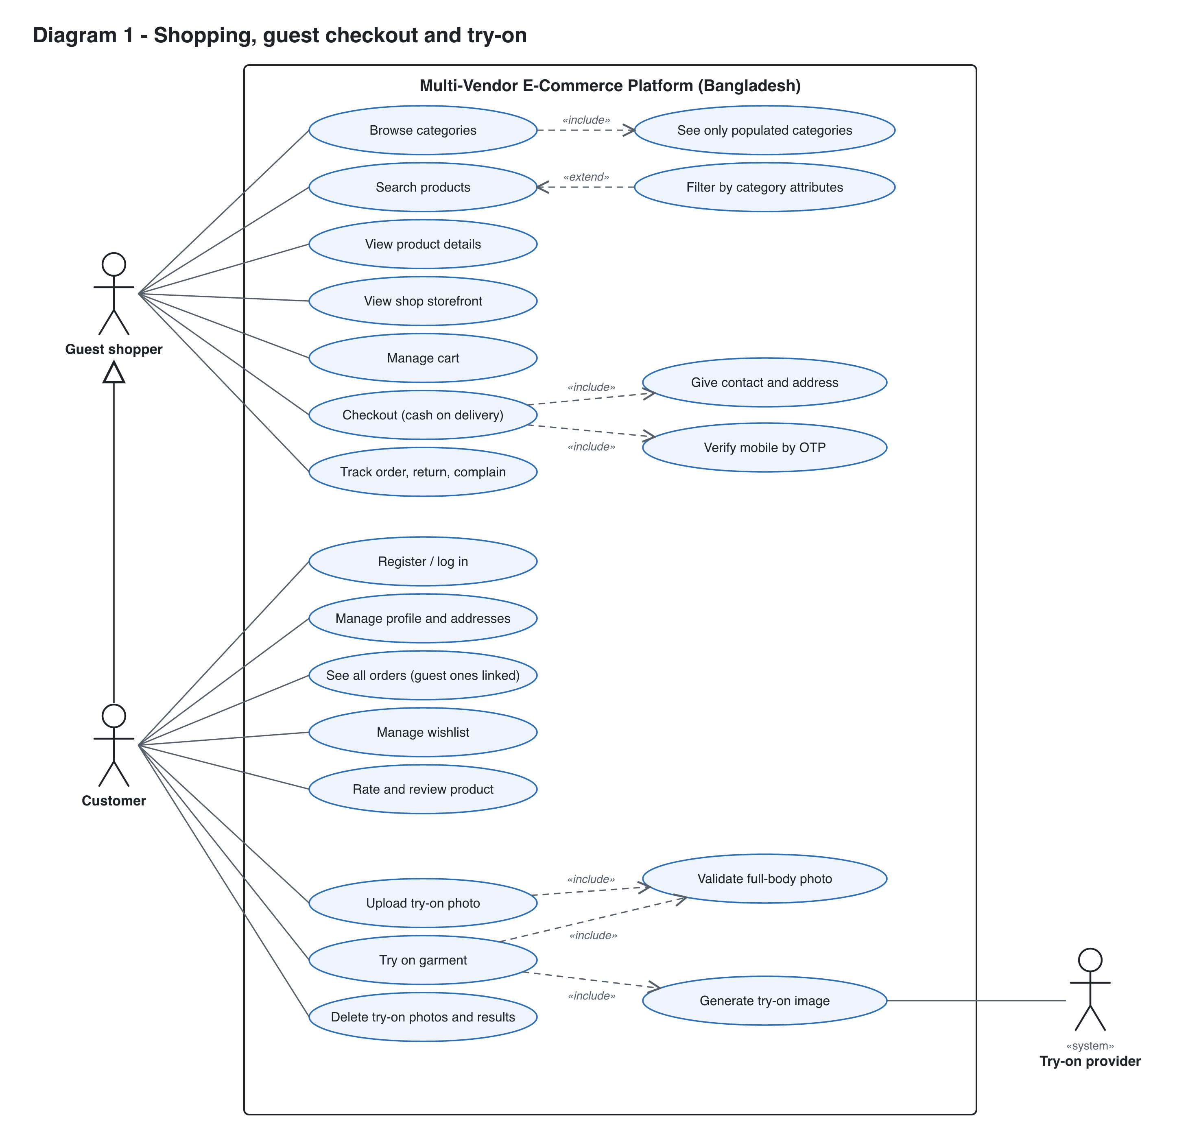
Diagram 1. Guest and Customer use cases, including the try-on flow and the external Try-on provider.

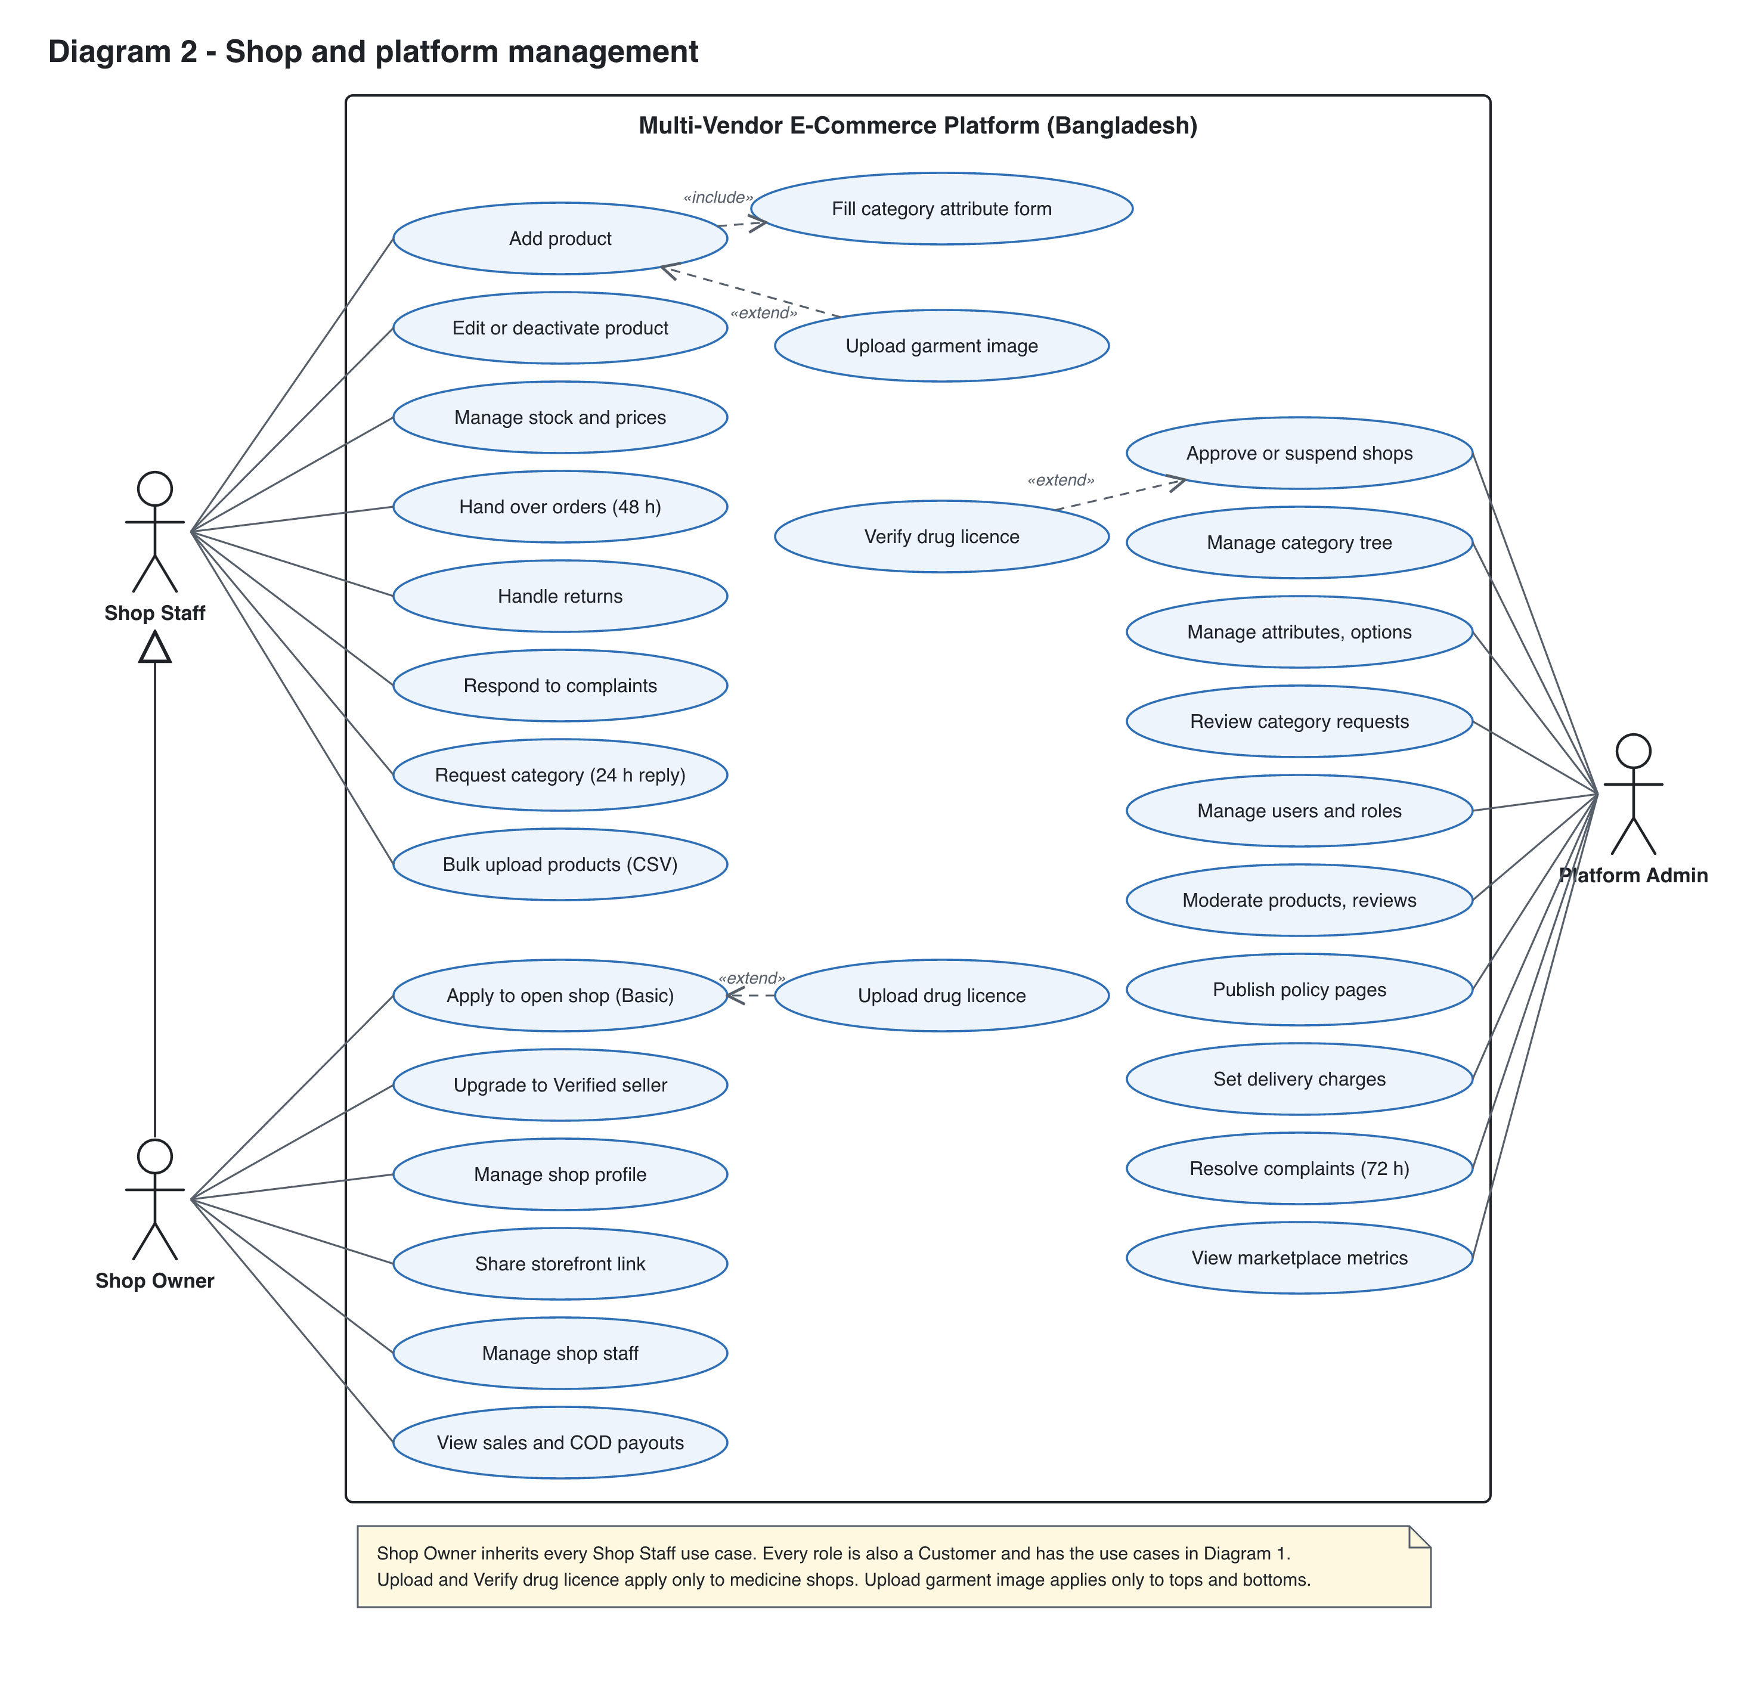
Diagram 2. Shop Staff, Shop Owner and Platform Admin use cases.

Actors
Actor | Type | Description
Guest shopper | Primary, human | Not logged in. Can browse, search, filter, use the cart, check out with cash on delivery (mobile OTP and email) and track orders by order number plus OTP.
Customer | Primary, human (specialises Guest shopper) | Logged in with mobile or email. Sees all orders including linked guest orders, uses wishlist, reviews and try-on.
Shop Staff | Primary, human | Works for one shop. Lists products, manages stock and fulfils orders.
Shop Owner | Primary, human (specialises Shop Staff) | Organization admin of one shop. Runs the shop and manages its staff.
Platform Admin | Primary, human | Holds all power. Approves shops, owns the category schema, manages users.
Try-on provider | Secondary, external system | AI service that generates the try-on image from the user photo and garment image.

Use case list
ID | Use case | Actor | Relationships | Story
UC-01 | Browse categories | Guest | «include» See only populated categories | US-040
UC-02 | Search products | Guest | Extended by Filter by category attributes | US-041
UC-03 | Filter by category attributes | Guest | «extend» Search products | US-042
UC-04 | View product details | Guest | - | US-044
UC-05 | Manage cart | Guest shopper | - | US-050, 056
UC-06 | Checkout (cash on delivery) | Guest shopper | «include» Give contact and address, Verify mobile by OTP | US-005, 007, 051
UC-07 | Track order, return, complain | Guest shopper | Order number plus OTP for guests | US-008, 052, 070, 072
UC-08 | Register / log in (mobile or email) | Customer (required for every other role) | - | US-001, 003
UC-09 | Manage profile and addresses | Customer (all roles) | - | US-002, 006
UC-10 | See all orders (guest ones linked) | Customer | Guest orders attach through a verified mobile or email | US-009, 052
UC-11 | Manage wishlist | Customer | - | US-057
UC-12 | Rate and review product | Customer | - | US-055
UC-13 | Request return or complain (logged in) | Customer | - | US-070, 072
UC-14 | Upload try-on photo | Customer | «include» Validate full-body photo | US-060
UC-15 | Try on garment | Customer | «include» Validate full-body photo, Generate try-on image | US-062
UC-16 | Add product | Shop Staff | «include» Fill category attribute form; extended by Upload garment image | US-030, 031, 032
UC-17 | Upload garment image | Shop Staff | «extend» Add product (try-on categories only) | US-061
UC-18 | Edit or deactivate product | Shop Staff | - | US-033
UC-19 | Manage stock and prices | Shop Staff | - | US-033
UC-20 | Hand over orders (48 h) | Shop Staff | - | US-053
UC-21 | Handle returns | Shop Staff | - | US-071
UC-22 | Respond to complaints | Shop Staff | - | US-072
UC-23 | Request new category | Shop Staff | - | US-022
UC-24 | Apply to open shop | Shop Owner | Extended by Upload drug licence | US-010
UC-25 | Upload drug licence | Shop Owner | «extend» Apply to open shop (medicine shops only) | US-015
UC-26 | Manage shop profile | Shop Owner | - | US-012
UC-27 | Manage shop staff | Shop Owner | - | US-013
UC-28 | View sales and COD payouts | Shop Owner | - | US-054, 082
UC-29 | Approve or suspend shops | Platform Admin | Extended by Verify drug licence | US-011
UC-30 | Verify drug licence | Platform Admin | «extend» Approve or suspend shops (medicine shops only) | US-016
UC-31 | Manage category tree | Platform Admin | - | US-020
UC-32 | Manage attributes, options | Platform Admin | - | US-021, 023
UC-33 | Review category requests | Platform Admin | - | US-022
UC-34 | Manage users and roles | Platform Admin | - | US-004
UC-35 | Moderate products, reviews | Platform Admin | - | US-055
UC-36 | Publish policy pages | Platform Admin | - | US-080, 081
UC-37 | Set delivery charges | Platform Admin | - | US-051
UC-38 | Resolve complaints (72 h) | Platform Admin | - | US-072
UC-39 | View shop storefront | Guest shopper | - | US-014
UC-40 | Bulk upload products (CSV) | Shop Staff | - | US-034
UC-41 | Upgrade to Verified seller | Shop Owner | - | US-017
UC-42 | Share storefront link | Shop Owner | - | US-014
UC-43 | List in "Other" category | Shop Staff | «extend» Add product | US-024
UC-44 | Sort search results | Guest shopper | «extend» Search products | US-043
UC-45 | Search in Bengali or Banglish | Guest shopper | «extend» Search products | US-045
UC-46 | Compare offers from several shops (R2) | Guest shopper | «extend» View product details | US-046
UC-47 | See delivery charge per shop | Guest shopper | «include» from Manage cart | US-058
UC-48 | View shop performance score | Guest shopper | «extend» View shop storefront | US-059
UC-49 | Delete try-on photos and results | Customer | - | US-063
UC-50 | View marketplace metrics | Platform Admin | - | US-083

