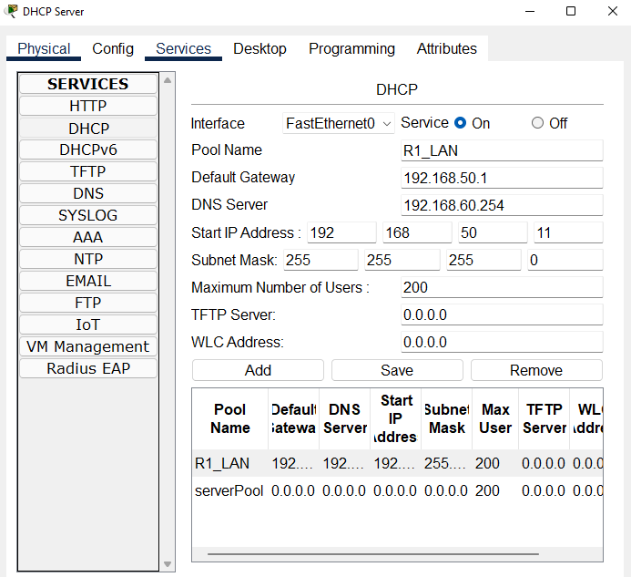

**Router Configuration**

R1>?

Exec commands:

<1-99> Session number to resume

connect Open a terminal connection

disable Turn off privileged commands

disconnect Disconnect an existing network connection

enable Turn on privileged commands

exit Exit from the EXEC

logout Exit from the EXEC

ping Send echo messages

resume Resume an active network connection

show Show running system information

ssh Open a secure shell client connection

telnet Open a telnet connection

terminal Set terminal line parameters

traceroute Trace route to destination

R1>en

R1#?

Exec commands:

<1-99> Session number to resume

auto Exec level Automation

clear Reset functions

clock Manage the system clock

configure Enter configuration mode

connect Open a terminal connection

copy Copy from one file to another

debug Debugging functions (see also 'undebug')

delete Delete a file

dir List files on a filesystem

disable Turn off privileged commands

disconnect Disconnect an existing network connection

enable Turn on privileged commands

erase Erase a filesystem

exit Exit from the EXEC

logout Exit from the EXEC

mkdir Create new directory

more Display the contents of a file

no Disable debugging informations

ping Send echo messages

reload Halt and perform a cold restart

R1#clear ?

aaa Clear AAA values

access-list Clear access list statistical information

arp-cache Clear the entire ARP cache

cdp Reset cdp information

frame-relay Clear Frame Relay information

ip IP

ipv6 IPv6

line Reset a terminal line

mac-address-table MAC forwarding table

vtp Clear VTP items

R1#clear

% Incomplete command.

R1#conf t

Enter configuration commands, one per line. End with CNTL/Z.

R1(config)#exit

R1#

%SYS-5-CONFIG_I: Configured from console by console

e

% Ambiguous command: "e"

R1#show ip interface

GigabitEthernet0/0 is up, line protocol is up (connected)

Internet address is 192.168.50.1/24

Broadcast address is 255.255.255.255

Address determined by setup command

MTU is 1500 bytes

Helper address is 10.1.1.2

Directed broadcast forwarding is disabled

Outgoing access list is not set

Inbound access list is not set

Proxy ARP is enabled

Security level is default

Split horizon is enabled

ICMP redirects are always sent

ICMP unreachables are always sent

ICMP mask replies are never sent

IP fast switching is disabled

IP fast switching on the same interface is disabled

IP Flow switching is disabled

IP Fast switching turbo vector

IP multicast fast switching is disabled

IP multicast distributed fast switching is disabled

Router Discovery is disabled

R1#show ip interface brief

Interface IP-Address OK? Method Status Protocol

GigabitEthernet0/0 192.168.50.1 YES manual up up

GigabitEthernet0/1 192.168.60.1 YES manual up up

Serial0/0/0 10.3.3.1 YES manual up up

Serial0/0/1 unassigned YES unset administratively down down

Vlan1 unassigned YES unset administratively down down

R1#int g0/0

^

% Invalid input detected at '^' marker.

R1#int f

^

% Invalid input detected at '^' marker.

R1#en

R1#conf t

Enter configuration commands, one per line. End with CNTL/Z.

R1(config)#int g0/0

R1(config-if)#ip helper 192.168.254

^

% Invalid input detected at '^' marker.

R1(config-if)#ip helper 192.168.253

^

% Invalid input detected at '^' marker.

R1(config-if)#ip-helper 192.168.253

^

% Invalid input detected at '^' marker.

R1(config-if)#ip helper-address 192.168.253

^

% Invalid input detected at '^' marker.

R1(config-if)#ip helper-address 192.168.252

^

% Invalid input detected at '^' marker.

R1(config-if)#ip helper-address 192.168.253

^

% Invalid input detected at '^' marker.

R1(config-if)#exit

R1(config)#exit

R1#

%SYS-5-CONFIG_I: Configured from console by console

**Main Commands**

**R1#en**

**R1#conf t**

**Enter configuration commands, one per line. End with CNTL/Z.**

**R1(config)#int g0/0**

**R1(config-if)#ip helper ?**

**A.B.C.D IP destination address**

**R1(config-if)#ip ?**

**access-group Specify access control for packets**

**address Set the IP address of an interface**

**authentication authentication subcommands**

**flow NetFlow Related commands**

**hello-interval Configures IP-EIGRP hello interval**

**helper-address Specify a destination address for UDP broadcasts**

**mtu Set IP Maximum Transmission Unit**

**nat NAT interface commands**

**ospf OSPF interface commands**

**proxy-arp Enable proxy ARP**

**split-horizon Perform split horizon**

**summary-address Perform address summarization**

**R1(config-if)#ip helper-address 192.168.60.253**

**R1(config-if)#no shut**

**R1(config-if)#exit**