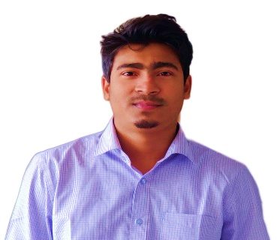Asif Hossen Nipun

To lead a challenging and responsible career and be a part of progressive local larger IT organization under a dynamic team where I can utilize my skill and knowledge to achieve company’s goals and objectives.

**CONTACT**

|  |  |
| --- | --- |
| Hashem Mansion, 826/B, North Pahartoli,Chattogram. |  |
| +8801728860371 |  |
| asifhossen190@gmail.com |  |
| [linkedin.com/in/asifhossen190/](https://www.linkedin.com/in/asifhossen190/) |  |
| [github.com/AsifHossenNipun](https://github.com/AsifHossenNipun) |  |
|  |  |
|  |  |

**Education**

January, 2017 – February, 2022

* Bachelor of Science in Computer Science & Telecommunication Engineering from Noakhali Science and Technology University, Noakhali.
  + CGPA – 3.19 out of 4.00

**SKILLS**

|  |  |
| --- | --- |
| C/C++ | Proficient |
| C# | Basic |
| Python | Intermediate |
| HTML5/CSS | Proficient |
|  |  |
| Object Oriented Programming | Intermediate |
| Data Structure and Algorithm | Intermediate |
| Linux | Proficient |
|  |  |

2014 - 2016

* Higher Secondary Certificate in 2016 from Sitakunda Degree College, Chattogram.
  + GPA – 5.00 out of 5.00

2009 - 2014

* Secondary School Certificate in 2014 from Sitakunda Govt. High School, Chattogram.
  + GPA – 5.00 out of 5.00

# COMPETITIVE PROGRAMMING PROFILE

* Codeforces Handle : [__Believer__](https://codeforces.com/profile/__Believer__)
* Problem solve in different OJ - 500+
* NSTU PI Day Programming Contest,2019 - **3’rd** Position.
* NSTU PI Day Programming Contest,2017 - **5’th** Position.
* BUET IUPC, 2018 (Regional) - **141’th** position.
* ICPC Dhaka Preliminary (National Level) **– 464’th** Position.

# PERSONAL PROJECTS & THESIS

* **Thesis:** User Privacy & Security in Internet: A Concern for Bangladesh. Thesis link -https://www.researchgate.net/publication/361589794_User_Privacy_Security_in_Internet_A_Concern_for_Bangladesh
* **C++ project:** Meal Management – A project using c++ programming language for managing meal system in residence. Project Link - https://github.com/AsifHossenNipun/Projects/
* **All Project Link -** https://github.com/AsifHossenNipun/Projects

# CO-CURRICULAR ACTIVITIES

# Problem Setter - NSTU PI Day Programming Contest 2020.

# Facebook & Reuters Digital Journalism Course.

# Regular contestant at Aqeeda & Seerat Contest.

* ffff

