**Assignment -1**

Dr Md. Monzur Morshed (DMMM)

1. Write a program to find the grade for a given mark according to the grading rule of your university.
2. Write a program to test a year if it is leap year or not.
3. Write a program to evaluate the following series 12+32+52+………………………. Up to n terms
4. Write a program to evaluate the following series 1-2+3-4+………………………. Up to n terms
5. Write a program to find the factorial of a number.
6. Write a program to find the power for a given base and exponent.
7. Write a program to find the Bangla season form a given month using if/switch.
8. Write a program to find the largest number in a list of Array.
9. Write a program to sort some numbers in ascending order.
10. Write a program to find the number having highest frequency.
11. Write a program to multiply two matrix.

**Assignment -2**

Write a program in Java that uses a class **Student**. Include the following members:

Data members

* Student identification number
* Student name
* Department name
* Course Number
* Marks obtained

Constructor

* Initialize all the variables

Methods

* Take input for all the variables
* Check if the student is passed or not (pass marks 40%)
* To display all the variables

|  |
| --- |
| **Student** |
| -id: int  -name: String  Dept: String  CourseNumber: String  marks: double |
| **Student** ()  **Student** (int, String, String, String, double)  +displayGrade(): void |

Also write a class **StudInfo** for main program that uses the **Student** class to create objects with the constructors to initialize with any values you like. Display the information with grades of the students with the displayGrade() method.Follow the university grading rules.

**Assignment -3**

Design a class **Account** that represents a bank account. Include the following members:

Data members

* Account holders name
* Account number
* Type of account
* Balance amount in the account

Constructor

* To assign initial values( i.e., account holders name, account no, account type and initial deposit)

Methods

* To deposit an amount
* To withdraw an amount after checking balance
* To display the name and balance

**Assignment -4**

Write a program in Java that uses a class **Employees**. Include the following members:

Data members

* Id
* Name
* Basic Salary
* House rent

Constructor

* Initialize all the variables (use parameters as arguments)

Methods

* To Take input for an employee.
* Compute the house rent of the employee . House rent is 50% of the basic salary if the basic salary is more than 20000 otherwise 60%
* Display the employee information showing the total monthly salary

OR

Implement the following UML Diagram using Java:

|  |
| --- |
| **Employee** |
| -id: int  -name: String  basic: double  houserent: double |
| Employee()  Employee(int, String, double)  +calculate(): double  +dispaySalary(): void |

Implement the Employee UML diagram. Also write a class **EmpInfo** for main program that uses the **Employee** class to create Employee objects with the constructors to initialize with any values you like. Then calculate the house rent (*houserent)* of the employee in the **calculate()** method. House rent is 50% of the basic salary (*basic*) if the *basic* is more than 40000, otherwise the house rent is 60% of the basic salary. Call all the methods used on your written Java code. Total salary is the summation of *basic* and *houserent*. Display the information ( id, name, basic, houserent, Total Salary) of the employee with the displaySalary() method.

**Assignment -5**

An organization keeps the following information for customers.

* + - Data members

id, name, bill

* + - Constructor
      1. To assign initial values( i.e., id, name, bill)
    - Methods

1. Take input for a customer.
2. Compute the discount.

Customers get 10% discount if purchase Tk2000 or more.

1. Display the information showing the total bill after discount

Write a program in java using class.

**Or**

**Convert the following UML into Java code**

|  |  |  |
| --- | --- | --- |
| Customer |  |  |
| - ID: int  -Name: String  Bill: double |  | The constructors are for initialization. getDiscount() method returns the discount from the total bill. Discount is 10% if the total bill exceed Tk.10000. |
| Customer()  Customer(id, Name, bill)  +getDiscount(): double  +displayBill() |  | displayBill() method displays the bill with the customer’s ID and name. |

**Assignment -6**

Implement the following UML Diagram using Java:

|  |
| --- |
| **Circle** |
| -radius: double |
| +Circle()  +Circle(radius: double)  +getRadius() double  +setRadius( radius: double) void  +getArea():double  +dispayArea(): void |

Implement the Circle UML diagram also write a main program **TestCircle** that uses the **Circle** class to create a circle object with the radius 5 and then modifies the radius to 10 using the *setRadius* method of the circle class. Call all the methods used on your written Java code. Display the area using *displayArea* method.

**Assignment -7**

|  |
| --- |
| Suppose you need to process course information. Each course has a name and has students enrolled. You should be able to add/drop a student to/from the course. You can use a class to  model the courses, as shown in the following UML Diagram:  E:\Desktop\222\Course_UML.PNG  Course object can be created using the constructor *Course(String name)* by passing a course *name*. You can add students to the course using the *addStudent(String student)* method, drop a student from the course using the *dropStudent(String student)* method, and return all the students for the course using the *getStudents()* method.  Write a Java program named *TestCourse.java* where the Course class is implemented and it shows the name of the course and enrolled students of that course from main *[i.e. public static void main (String []args)].* |

**Assignment -8**

|  |
| --- |
| Convert the following UML into JAVA code also explain why the constructor’s modifiers are protected?  E:\Desktop\Exam\CSE-222\Abstract_UML.PNG |

**Assignment -9**

Convert the following UML into Java code.

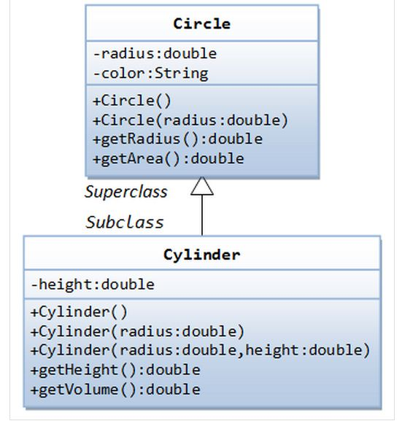

**Assignment -10**

Consider the following UML:

Emp

Id: String

name: String

dept: String

Emp()

Emp( String , String, String)

SalaryInfo

+Pos: String

+Basic\_Salary: double

SalaryInfo ()

+SalaryInfo (String , String , String, String , double)

Calculate(): double

DisplayAll():void

Write a program for the UML above. Implement both the constructors. Calculate House rent from the salary in Calculate() method. Display all the information of the employee in DisplayAll() method. House rent(HR) is calculated as follows:

HR = 60% of the basic salary if the basic salary>=Tk20000

50% otherwise

**Assignment -11a**

Consider the following UML:

**Employee**

#Id: int

+name: String

+Dept: String

Employee ()

Employee ( int, String, String)

**Salaryinfo**

Month: String

Basic\_Salary: double

Salaryinfo ( int , String, String , String, double)

CalculateSalary(): double

+DisplaySalary()

**Pension**

-No\_of\_years: int

-Lastbasic: double

Pension( int , String, String. int , double)

DisplayPension()

Write a program in Java for the UML above. Implement all the constructors. Calculate House rent from the salary in CalculateSalary() method. Display all the information of the employee in DisplaySalary() method. House rent(HR) is calculated as follows:

HR = 60% of the basic salary if the basic salary>=Tk30000

50% otherwise

Pension is calculated as follows:

Total Pension = (length of service in years) **×** 10 **×** (70% of Last Basic salary)

Display pension information in DisplayPension() method.

**Assignment -11b**

Consider the following UML

**Student**

#Id: int

name: String

**Student** ()

**Student** ( int, String)

**Payment**

fees\_payment: double

payment\_status: boolean

Payment( int , String, double , boolean)

displayPayment()

**Grade**

-coursename: String

-marks: double

Grade ( int , String, String , double)

+displayGrade()

Write a program in Java for the UML above. Create the necessary objects in the main method of another class. Follow the grading system of your University. Show the payment and payment status. Show the grade of the students using +displayGrade() method only if the payment\_status is true.

**Assignment -12a**

Consider the following UML [12]

**User**

#userid: String

#passwd: String

+User(String, String)

+display():void

Lives\_at

**Address**

Road\_No: String

House\_No: String

City: String

**Customer**

name: String

email: String

-amount: double

Customer (String, String, double)

+getDiscount(): double

+displayBill():void

|  |
| --- |
| The constructors are for initialization. getDiscount() method returns the discount from the total bill.  Discount is 10% if the total bill amount exceeds Tk.10000  displayBill() method displays the bill with the customer’s ID, name and address. |

**Assignment -12b**

Consider the following UML:

Lives-at

**Address**

Road\_No: String

House\_No: String

City: String

**Employee**

#Id: int

+name: String

+Dept: String

Employee ()

Employee ( int, String, String)

**Salaryinfo**

Month: String

Basic\_Salary: double

Salaryinfo ( int , String, String , String, double)

CalculateSalary(): double

+DisplaySalary()

Write a program in Java for the UML above. Implement all the constructors. Calculate House rent from the salary in CalculateSalary() method. Display all the information of the employee in DisplaySalary() method. House rent (HR) is calculated as follows:

HR = 40% of the basic salary if the basic salary>=Tk30000

50% otherwise

**Assignment -12c**

Consider the following UML:

Lives-at

**Address**

Road\_No: int

House\_No: String

City: String

**Employee**

#Id: int

+name: String

+Dept: String

Employee ()

Employee ( int, String, String)

**Salaryinfo**

Month: String

Basic\_Salary: double

Salaryinfo ( int , String, String , String, double)

CalculateSalary(): double

+DisplaySalary()

**Pension**

-No\_of\_years: int

-Lastbasic: double

Pension( int , String, String. int , double)

DisplayPension()

Write a program in Java for the UML above. Implement all the constructors. Calculate House rent from the salary in CalculateSalary() method. Display all the information of the employee in DisplaySalary() method. House rent(HR) is calculated as follows:

HR = 60% of the basic salary if the basic salary>=Tk30000

50% otherwise

Pension is calculated as follows:

Total Pension = (length of service in years) **×** 10 **×** (70% of Last Basic salary)

Display pension information in DisplayPension() method.

**Assignment -12d**

Consider the following UML:

Lives-at

**Address**

Road\_No: int

House\_No: String

City: String

**Student**

#Id: int

name: String

**Student** ()

**Student** ( int, String)

**Payment**

-costpercredit: double

-credithour: double

Payment( int , String, double , double)

displayPayment()

**Grade**

-coursename: String

-marks: double

Grade ( int , String, String , double)

+displayGrade()

Write a program in Java for the UML above. Follow the grading system of your University.

**Assignment -12e**

Consider the following UML:

Lives-at

**Address**

Road\_No: int

House\_No: String

City: String

**Programmer**

#Id: int

+name: String

+Dept: String

Programmer ()

Programmer ( int, String, String)

**Performance**

p\_id: int

p\_allowance: double

Performance( int , String, String. int , double)

displayInfo()

**Salaryinfo**

-Month: String

-Basic\_Salary: double

SalaryInfo ( int , String, String , String, double)

calculateSalary(): double

+displaySalary()

Write a program in Java for the UML above. Implement all the methods and constructors. Calculate House rent from the salary in calculateSalary() method. Display all the information of the Programmers in displaySalary() method. House rent(HR) is calculated as follows:

HR = 50% of the basic salary if the basic salary<=Tk30000

40% otherwise

**Assignment -13**

|  |
| --- |
| Implement the following UML object model using Java:  Interface |

**Assignment -14**

Implement the following UML object model using Java:

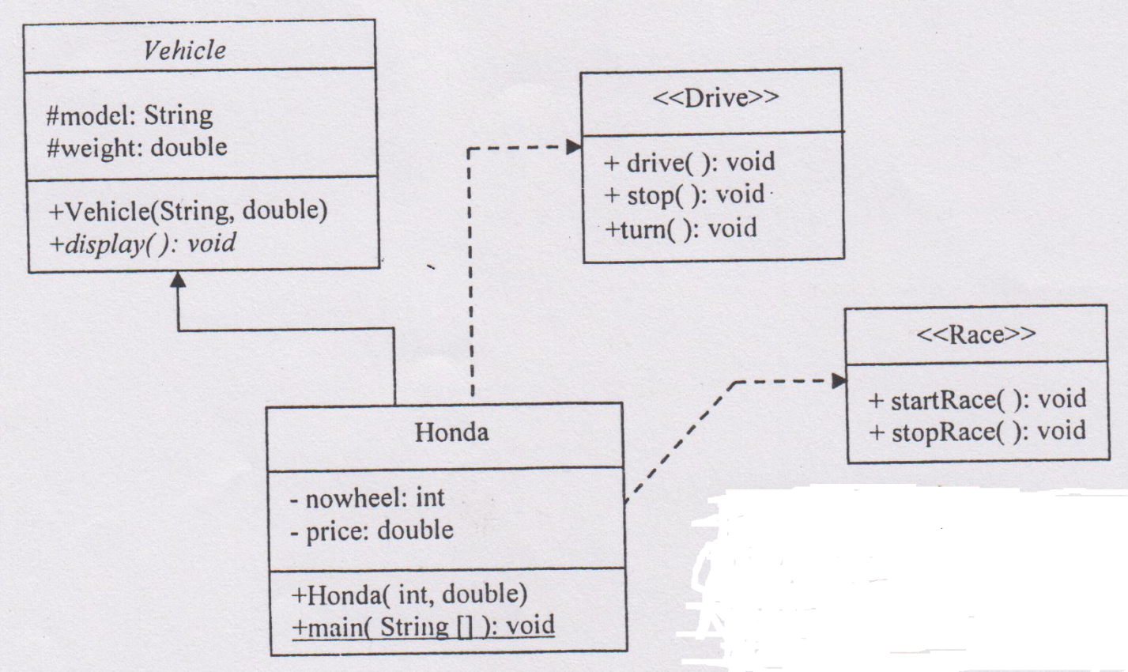

**Assignment -15**

Implement the UML in Java. There is course and its marks in each department. Take all the inputs from the keyboard in getValue() method. Show the grades with all the information in displayAll() method.

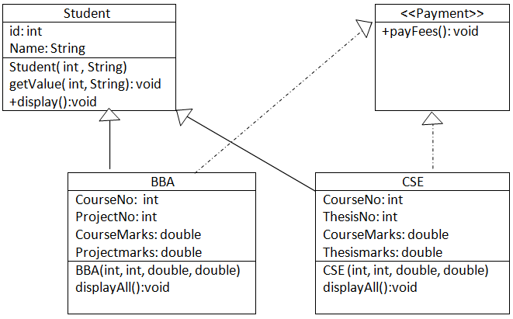

**Assignment -16**

We have a "MS Access/MY SQL" database "STUDENT" which contains a table called "***RESULT***", with 4 columns, as shown below:

Id: int

Name: varchar(30)

Dept: varchar(20)

Marks: float

Write a Java program with necessary code that connect with this database and show all the information from the ***RESULT*** table. Also find the Grade from marks. Assume any grading system.