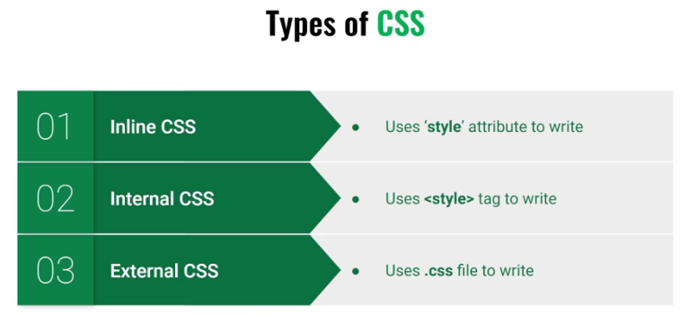

rgba can be used to set color and opacity. The last number is rgba is for setting opacity.

**Units**

Pixel is a type of fixed length. If height/width is set in pixels then, it will be fixed irrespective of the screen size.

Relative units like %, em, rem, vh, vx, etc., take the parent element or the screen size into consideration as the height/width is set as a percentage of the parent element or the view-port/screen size.

**Id, Class**

One id should be used only once for one element.

A class can be used for multiple elements.

**Styling group of elements and a smalls portion of an element**

To style a group of elements, those elements can be put inside div tags.

To style a small portion of an element, that portion can be put in span tags.

Border

**Margin**

40px [top/bottom/left/right] 40px 10px 100px 200px [top, left, bottom, left]

40px 10px [top/bottom, left/right] 40px 10px 100px [top, left/right, bottom]

Margin-top, margin-bottom, margin-left and margin-right can also be used.

Margin: 0 auto [Here auto means that left and right margin will take equal space]

**Padding**

It creates space around the content.

Padding can also be set in the same way as margin.

**Text-alignment**

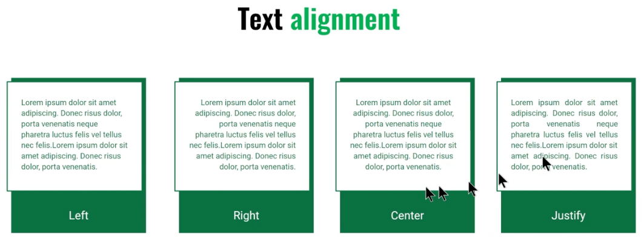

**Display: inline/block/inline-block**

**Block element:** created on a new line (line break is added and them element is placed) e.g. p tag, h tag, div tag, etc.

**Inline element:** created on the same line (no line break is added before placing element) e.g. a tag, span tag, small tag, etc.

**Inline-block element:** Compared to inline, inline-block allows to set a width and height on the element and the top and bottom margins/paddings are respected.

Compared to block, inline-block element does not add a line-break after the element, so the element can sit next to other elements.

