# Design Decision

The application was written as a Java Application. An object-oriented approach was used where encapsulation and separation of concerns were implemented by created function specific classes. To run the application, install an IDE of choice (I used netbeans) and install Junit Library for automated test results.

# Design Diagram

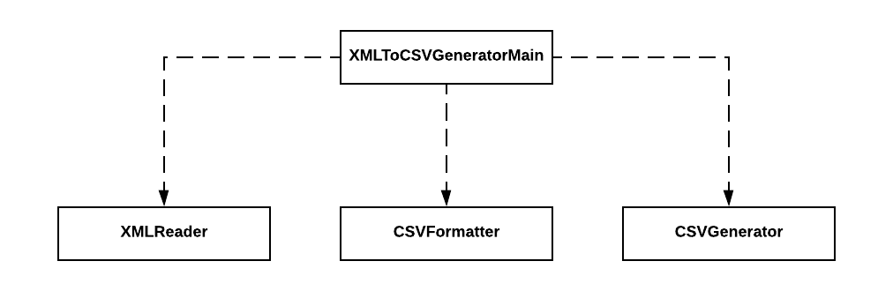

# What Was Done

* Reading in an XML file
* Extraction out the data found in the CSVIntervalData element with the following conditions:
  + Create a CSV for each block of data that starts with 200
  + Each CSV will have the 100 row as a header, and the 900 row as the trailer
  + Each CSV will be named from the second field in the 200 row
  + Remove leading and trailing white spaces, newlines, tabs, etc.
* Allow user to input xml file name (must add extension .xml)
* Allow user to change input and output file paths

# What Would Be Done with More Time

* Continuing with application if incorrect filename is entered – application stops and shows exception message “Can’t open file IO error”
* Add more exception handlers that allows program to continue
* Change all linear array searches to binary search
* Use of LinkedLists instead of ArrayLists
* Do more rigorous unit tests

# Application Run Example

## IDE Run

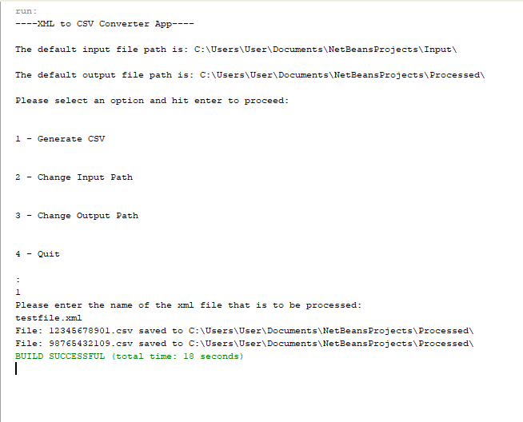

## Input File

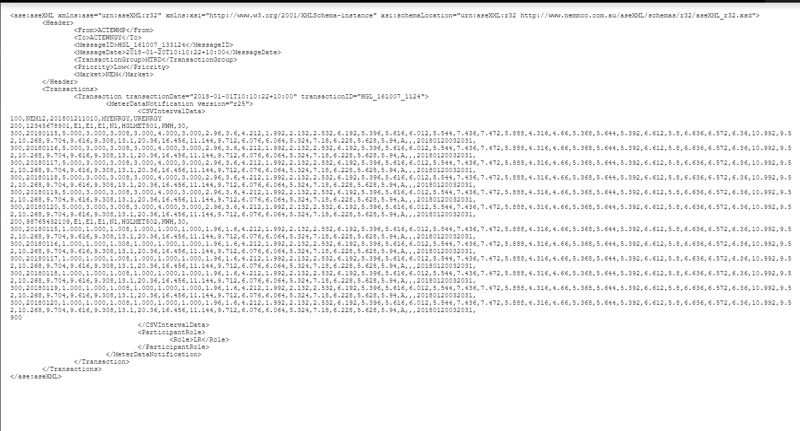

## Output File

