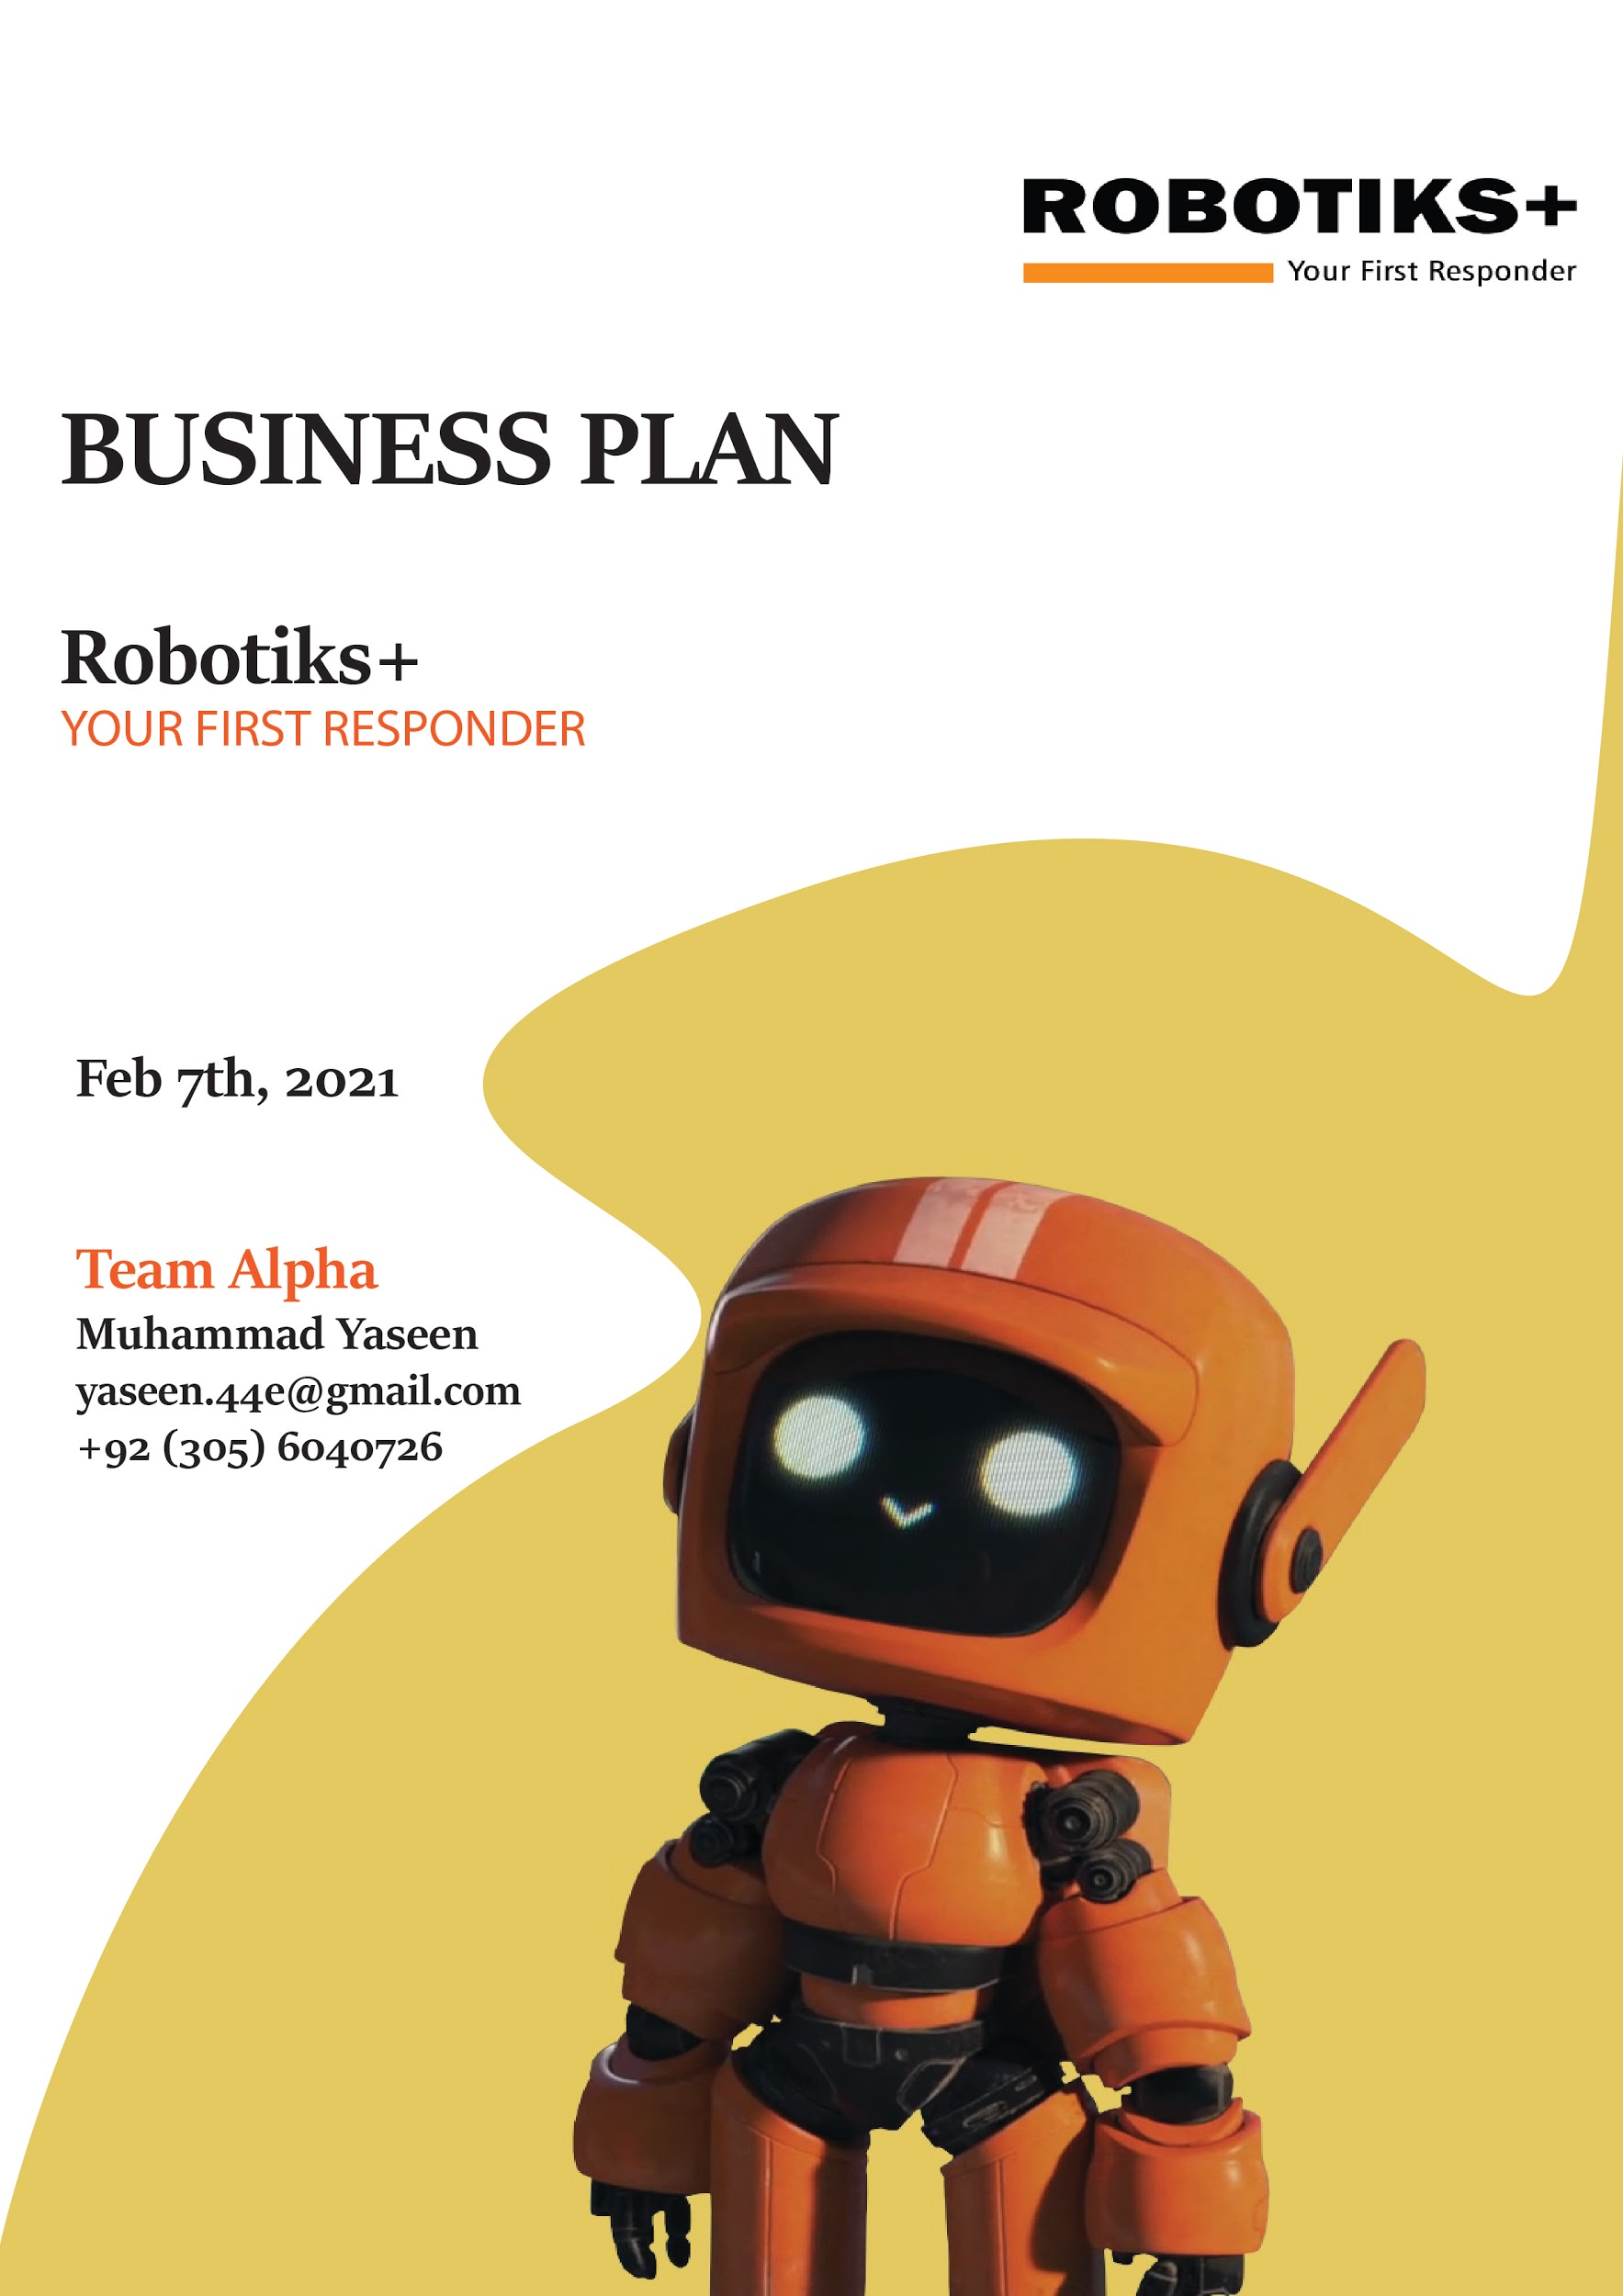

**COMPANY overview** **3**

**problem & solution** **4**

THE PROBLEM 4

OUR SOLUTION 4

**TARGET MARKET** **6**

MARKET SIZE & SEGMENTS 6

**COMPETITION** **7**

CURRENT ALTERNATIVES TARGET BUYERS ARE USING 7

OUR COMPETITIVE ADVANTAGES 7

**PRODUCT OR SERVICE OFFERINGS** **8**

PRODUCT OR SERVICE 8

**marketing** **11**

MARKETING PLAN 11

**Timeline and Metrics** **13**

TIMELINE 13

MILESTONES 13

KEY PERFORMANCE METRICS 14

**FINANCIAL FORECASTS** **15**

KEY ASSUMPTIONS 15

**FINANCING** **16**

SOURCES OF FUNDING 16

USE OF FUNDING 16

# **COMPANY overview**

|  |  |  |  |  |  |  |  |  |
| --- | --- | --- | --- | --- | --- | --- | --- | --- |
| |  |  | | --- | --- | | **Mission Statement** | **Govt & Economic Influences** | | **In Pakistan, due to lack of good infrastructure, firefighting vehicles face difficulty in reaching the place of fire incident. Our mission is to assist their rescue process by deploying robots on crucial places, who possess the ability to sense fire and take quick action to stop the spread of fire and ensure minimal loss of goods and human lives.** | **Pakistan may be Asia's next big tech startup market, according to a** [**report**](https://www.dw.com/en/pakistan-the-next-big-asian-market-for-tech-startups/a-52183841) **published by Germany's *Deutsche Welle*. Pakistani startups are garnering support worldwide.In the last year $75 millions, Rs 124 million and fund of worth 1 billion was allocated by Govt of Pakistan, IT department and ministry of Planning respectively to encourage young entrepreneurs and small startups.** | | **Industry Trends** | **Our vision** | | **In Pakistan, Technology is becoming the “Internet of Bodies” with connected health, medical and communication devices attached to the human body. According to a report presented by Telenor Pakistan, the Tech Trends in the coming years will be the combination of 5G, IoT and AI spurring industrial collaboration, sharing competence and co-create world changing platform.** | **Our vision is to manufacture value-driven small fire fighting robots at low costs. We strongly commit to technology and strive to earn client satisfaction.** | |

# **problem & solution**

## **THE PROBLEM**

|  |
| --- |
|  |

## **OUR SOLUTION**

|  |
| --- |
|  |

# **TARGET MARKET**

## Points scoredMARKET SEGMENTS

|  |
| --- |
|  |

# **COMPETITION**

## CURRENT ALTERNATIVES TARGET BUYERS ARE USING

|  |
| --- |
|  |

## **OUR COMPETITIVE ADVANTAGES**

|  |
| --- |
|  |

# **PRODUCT OR SERVICE OFFERINGS**

## **PRODUCT OR SERVICE**

|  |
| --- |
|  |

# **marketing**

## **MARKETING PLAN**

|  |
| --- |
|  |

|  |
| --- |
| **Pie chart diagram shows the 30% of Overall business cost spend on Marketing** |

# **Timeline and Metrics**

## TIMELINE

|  |  |  |
| --- | --- | --- |
| **ACTIVITY** | **DESCRIPTION** | **COMPLETION DATE** |
| Planned Documentation | We discussed and designed the documentation of our business. | 06/02/2021 |
| Mobile Application Development | Team members designed the mobile application with the help of design patterns | 06/02/2021 |
| Hardware Collection and Prototype Assembling | Few team members visited the market and purchased the most suitable hardware components and assembled the prototype. | 07/02/2021 |
| Water Cannon Design and Integration | We’ll design an accurate and efficient water cannon to put on the top of the body. | 15/02/2021 |
| Autonomous Features | We are well planned to design autonomous algorithms to make it fully self functioned. | 28/02/2021 |
| Business Launching | We are aiming to launch our business in above mentioned markets. | 01/04/2021 |

## MILESTONES

|  |  |  |
| --- | --- | --- |
| **MILESTONE** | **DESCRIPTION** | **COMPLETION DATE** |
| Mobile Application | Mobile Application Interface was discussed and designed along with backend development. | 06/02/2021 |
| Robot Prototype Development and Integration. | In this milestone we discussed the main components and designed a prototype. | 07/02/2021 |
| Testing | Unit Testing, Integration Testing | 07/02/2021 |
| Revenue Collection | We’ll market our business and try to collect maximum funds | 20/03/2021 |
| Large Assembly plant | We’ll establish assembling plant at most suitable place with minimal cost | 31/03/2021 |
| Company Inauguration | Establishing the company by meeting the maximum requirements | 01/04/2021 |

## **KEY PERFORMANCE METRICS**

|  |  |  |
| --- | --- | --- |
| **ACTIVITY** | **DESCRIPTION** | **KEY METRIC** |
| Software to Hardware Integration | How fast software and hardware can work collectively | Performance |
| Assembling Robots at large | Demand and Production with Quality measures | Quality Analysis |
| Testing | Unit Testing and Integration Testing | Value and Quality |
| Cost and Profit Analysis | Measuring cost and total revenue | Success of the Business |

# **FINANCIAL FORECASTS**

## KEY ASSUMPTIONS

|  |
| --- |
| * All these finances are being measured in per unit. (1 Robot)  **Revenue**  · **Product Revenue:** We are aiming to get maximum revenue in the initial months of the business launch with best marketing techniques.  · **Securing large projects:** We will design such marketing techniques which will let us bring large contracts which will result in high revenue generation.  · **Total Revenue:** $300 per unit.  **Expenses:**  · **Direct Cost:** We are planning our expenses on hardware material, employee wages etc.  · **Administrative and General Costs:** We’ll also calculate administrative costs like advertisement, office rents, utilities etc.  · **Total Expense:** $200 per unit.  **Total Income:**  · **Gross Income:** Revenue - Expenses  $300 - $200 = $100  **Income Taxes:**  · It depends on the location where we’ll establish our business.  **Net Income:**  · Total Income - Income Taxes  $100 - Income Taxes = **Net Income** |

# **FINANCING**

## SOURCES OF FUNDING

|  |
| --- |
| * Javed Afridi (CEO Haier) * Ministry of IT Pakistan * Business Revenue |

## USE OF FUNDING

|  |
| --- |
| * Raw Material Purchase * Direct and Indirect Costs * Marketing and Advertising |