# Test Results: Exchange Rates API Integration for Historical Analysis

Table of Contents

Test Results: Exchange Rates API Integration for Historical Analysis 1

**1.** **Manual Test Cases** 2

Clean Run – Execute main.py 2

Check Output of Exchange Rate Fetcher (default) 2

Check Output of Exchange Rate Fetcher (change date range) 3

Check Output of Exchange Preprocess (one date/value missing) 4

Check Output of Exchange Preprocess (date/value missing at left border) 5

Check Output of Exchange Preprocess (date/value missing at right border) 6

Check Output of Exchange Preprocess (multiple date/value) 7

2. **Automated Test Cases** 7

Test Exchange Rate Fetcher 7

Test Exchange Rate Preprocessor 8

Test Exchange Rate Analyze 8

# **Manual Test Cases**

## Clean Run – Execute main.py

**Output:**

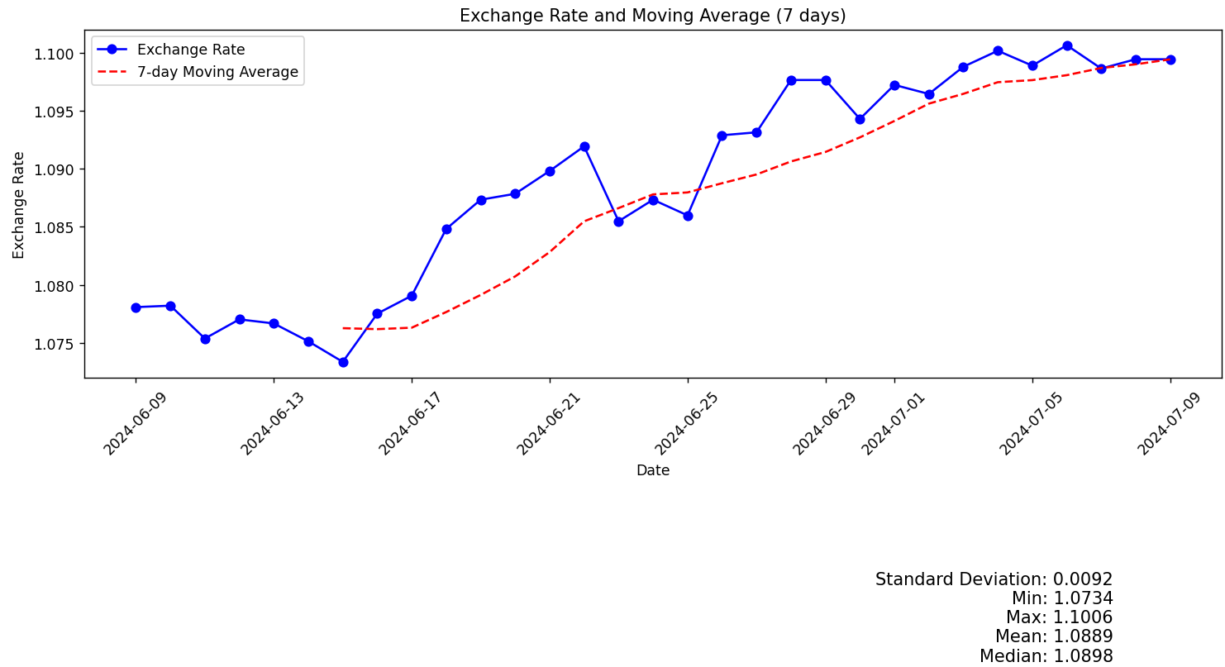

## Check Output of Exchange Rate Fetcher (default)

**Observation:** Json File is returned for 30 days from current date (AUD to NZ)

**Image1:** Shows currency dates going back till 30 days

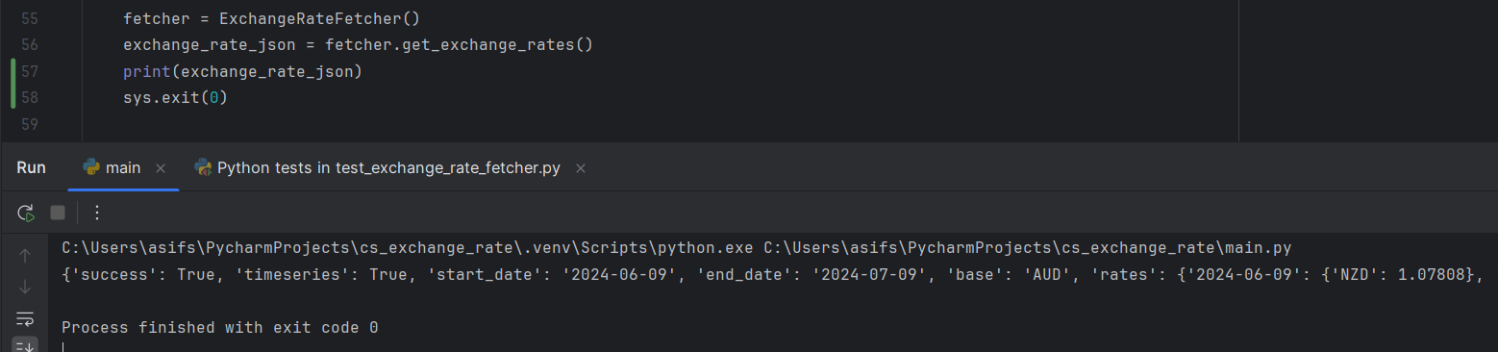

**Image 2** – Shows Current Date

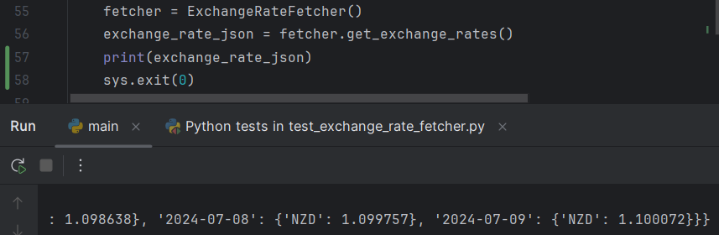

## Check Output of Exchange Rate Fetcher (change date range)

**Observation:** Results show exchange rates for 8 days

**Image1:** Configuration file updated to 8 days and exchange rate fetcher script result

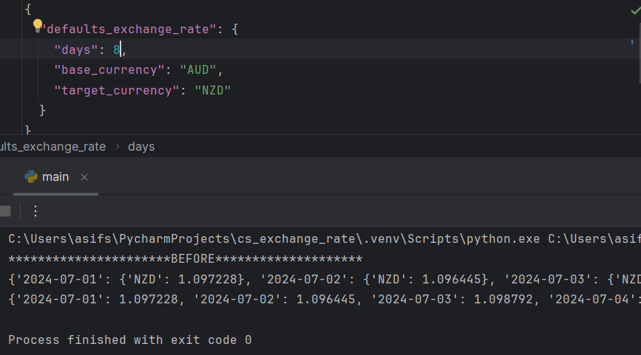

**Image2:** Result of Exchange Rate Analyzer after Configuration file was updated to 8 days

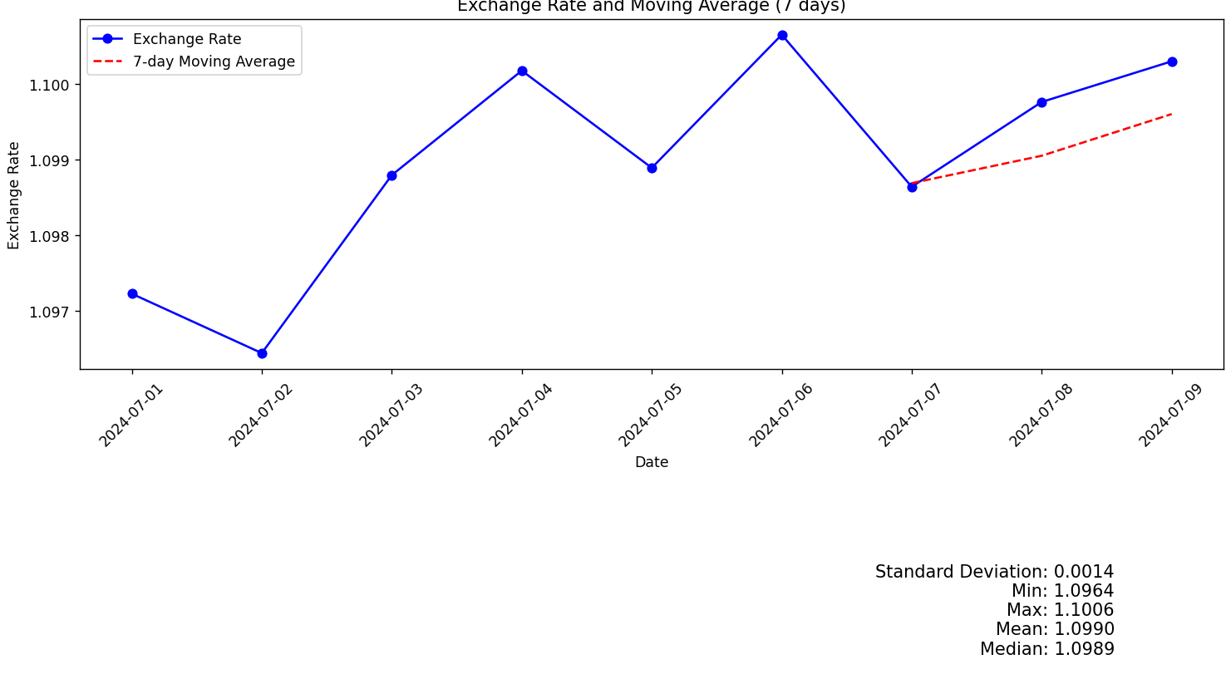

## Check Output of Exchange Preprocess (one date/value missing)

**Observation:** Missing date/value was interpolated

**Image1:** 2024-07-02 was missing as input for exchange rate preprocessor, which has inserted interpolated i.e. average value.

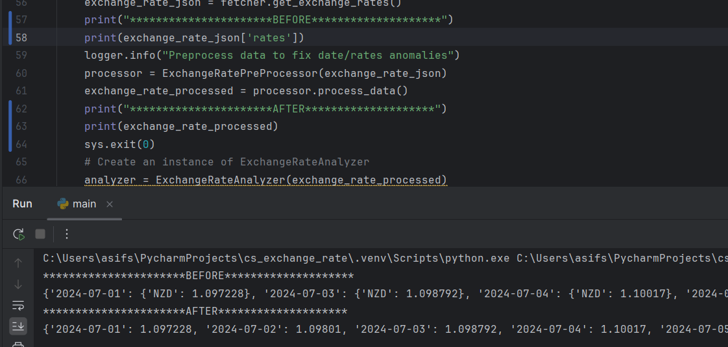

## Check Output of Exchange Preprocess (date/value missing at left border)

**Observation:** Missing date/value was interpolated even if the date is on left border

**Image1:** 2024-07-01 was missing as input for exchange rate preprocessor, which has interpolated i.e. same value as 2024-07-02.

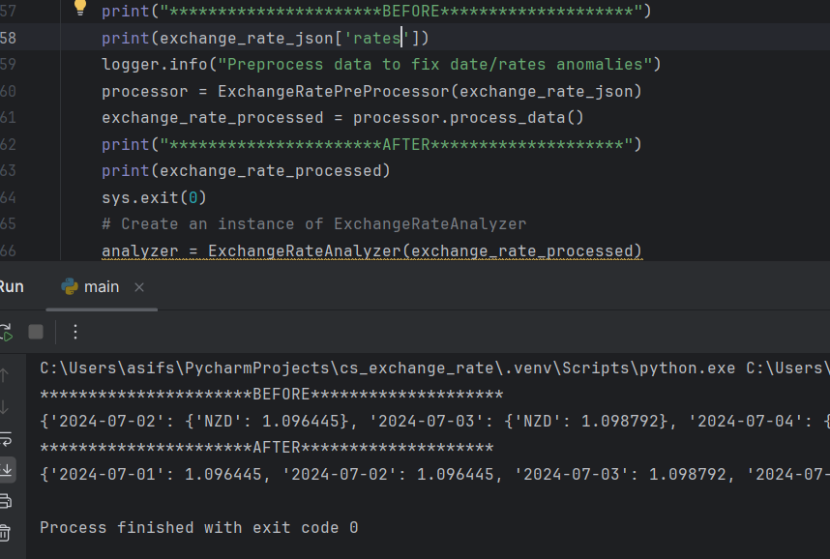

## Check Output of Exchange Preprocess (date/value missing at right border)

**Observation:** Missing date/value was interpolated even if the date is on right border

**Image1:** 2024-07-09 was missing as input for exchange rate preprocessor, which has interpolated i.e. same value as 2024-07-08.

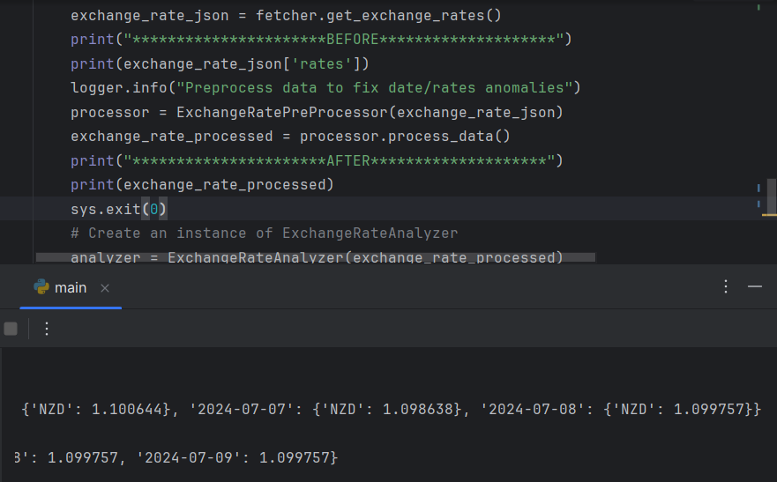

## Check Output of Exchange Preprocess (multiple date/value)

**Observation:** Multiple Missing date/value were interpolated

**Image1:** 2024-07-02 and 2024-07-03 was missing as input for exchange rate preprocessor, which has interpolated values for both based on values from 2024-07-01 and 2024-07-04 i.e. average.

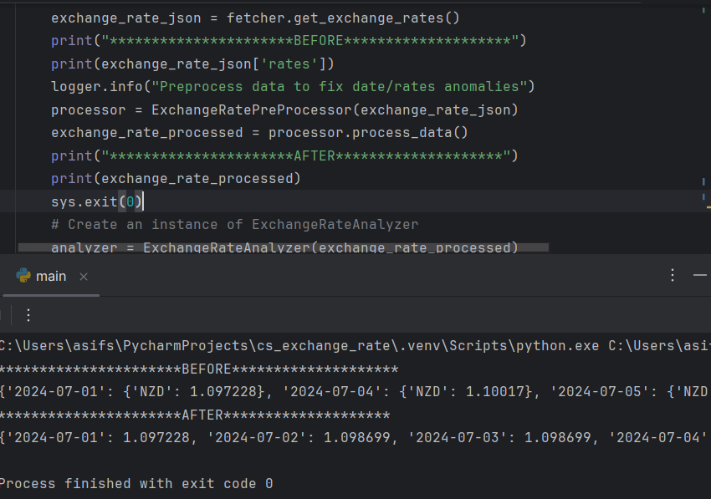

# **Automated Test Cases**

**Automated tests are to show the usage of unittest python package. These scripts are still to be enhanced to make them robust.**

## Test Exchange Rate Fetcher

**test case 1:** data retrieved correctly for configuration variable set to 4 days, AUD to NZD

**test case 2:** whether code is flexible to fetch from different end point

**test case 3:** whether code responds with error message when an invalid url is passed

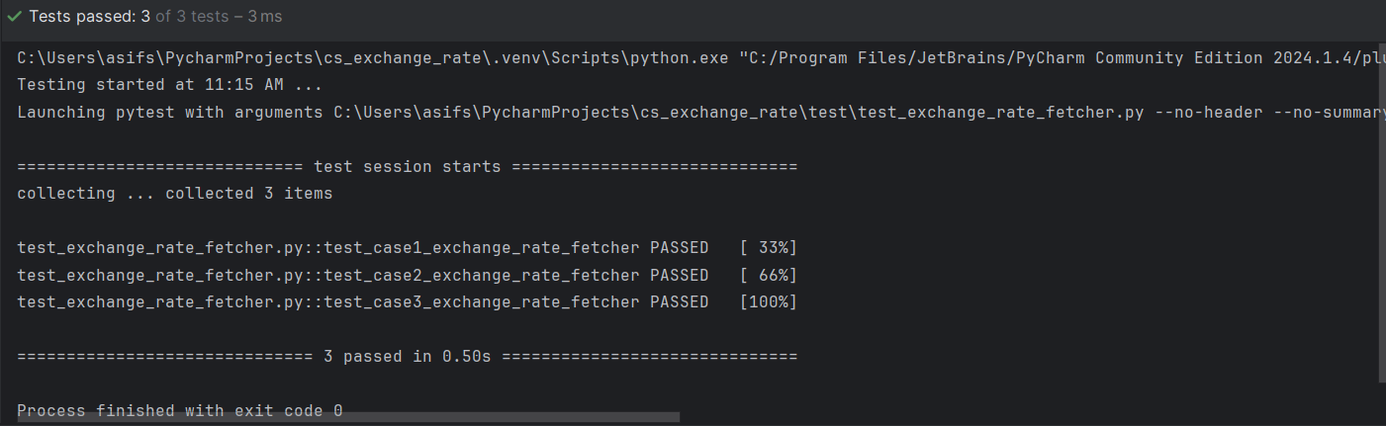

## Test Exchange Rate Preprocessor

**test case 1:** Check whether code fixes Missing date and interpolate corresponding value. This date is picked from middle of the list of dates.

**test case 2:** Check whether code fixes Missing date and interpolate corresponding value. This date is picked from left end of the list of dates.

**test case 3:** Check whether code fixes Missing date and interpolate corresponding value. This date is picked from right end of the list of dates.

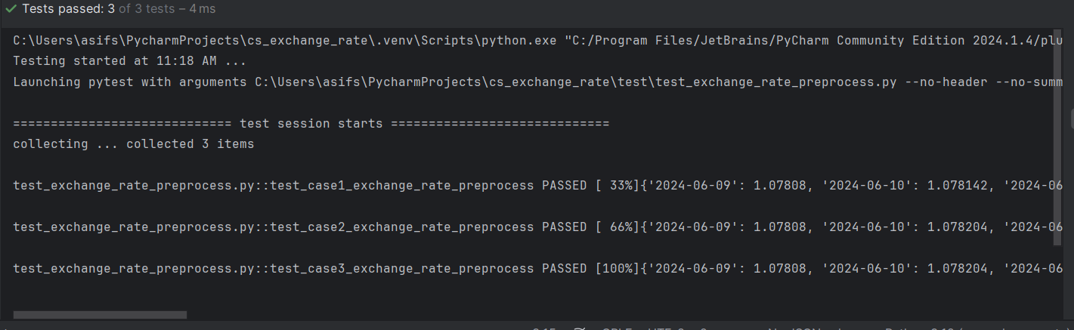

## Test Exchange Rate Analyze

**test case 1:** Validate whether analyze script is returning valid statistical results i.e. mean, min, max

