OMS Real-Time Interim Service
Architecture Version 1.1
DOCUMENT TYPE | Architecture Design
SYSTEM | OMS / Trading Engine
VERSION | 1.1
DATE | August 2026
CLASSIFICATION | Internal Use Only
STACK | Node.js/C#, Redis, MSMQ (EF Gateway), MSSQL (DB)

Asif Zaman
Junior Executive
LankaBangla Securities PLC

Create/Modification History card

Sl | Date | Version | Description | Changed by
01 | 20 Aug 2026 | 1.0 | Created | Asif Zaman
02 | 24 Aug 2026 | 1.1 | Updated the Sequence Diagram | Asif Zaman

Contents
Problem Statement | 4
Architecture Overview | 5
Component Diagram | 6
Data Flow Diagram | 8
Sequence Diagram — Trade Event Flow | 10
Design Alternatives Considered | 11
Scenario Analysis — Four Failure Modes | 12
Recovery Procedures | 14
Operational Runbook | 15
Fallback Hierarchy | 16
Summary | 17

1. Problem Statement
The OMS Real-Time State Engine maintains all derived financial metrics — net positions, cash map, weighted average cost, and unrealized P&L — in process memory. These values update on every trade execution and price tick. Because the engine's authoritative view of the trading day lives in memory, the architecture needs a clearly-defined way to recover that state after any crash, without losing or double-counting a single trade.

The Naive Approach
A straightforward implementation would write every trade event to Redis using a fire-and-forget XADD and periodically snapshot the in-memory state, also to Redis. This works until Redis itself becomes unavailable: events during the outage are silently dropped, and — critically — the snapshot timer fails during the very same outage, so the next successful snapshot reflects only the state from before the outage began. The result is an event log with an invisible, irrecoverable hole in it.
The exact failure sequence looks like this if Redis were the only durability layer:
10:00:00 | Snapshot-A saved to Redis (streamId: X) — state is consistent.
10:00:01 | Trades flowing normally. State engine running. Redis XADD succeeding.
10:03:00 | Redis crashes — connection lost to the event log and snapshot store.
10:03:00 | Trade-1 executes -> XADD fails silently -> event lost from the log.
10:03:30 | Trade-2 executes -> XADD fails silently -> event lost from the log.
10:04:00 | Trade-3 executes -> XADD fails silently -> event lost from the log.
10:05:00 | Snapshot-B timer fires -> Redis still down -> snapshot not saved.
10:05:00 | Redis recovers — but Trade-1, 2, 3 are gone from the event log. [Here the calculation misses the events of downtime]
10:10:00 | Snapshot-B finally saved — but it reflects state from 10:00:00 only.
10:10:01 | Any subsequent crash replays from Snapshot-A, missing Trade-1, 2, 3.

Problem
The state engine keeps running correctly in memory throughout a Redis outage like this — traders see correct P&L and positions on screen the whole time. The gap is invisible until a crash or restart forces a replay, at which point the executed trades vanish from the reconstructed state.

The Design Principle Behind This Architecture
Redis alone is not an acceptable single point of truth for trade events, because a Redis outage and the snapshot timer's failure are correlated — they happen together. The architecture in this document splits durability into two layers with different jobs: Redis Streams give the OMS a fast local cache for sub-second crash recovery, while the exchange gateway's MSMQ-backed write path into the MSSQL database — running entirely independently of the OMS process and of Redis — guarantees that every trade execution is durably recorded regardless of what is happening inside the OMS. Recovery always prefers the fast Redis path, and falls back to the database only when it has to. This closes the gap shown above without asking the OMS to run a second broker of its own.

2. Architecture Overview
The OMS keeps its state engine and Redis cache exactly where you'd expect them, and treats the exchange gateway's MSMQ -> MSSQL write path as an independent, already-guaranteed durability layer sitting underneath. No broker is introduced inside the OMS itself. A Redis outage does not risk event loss, because the database is updated through a completely separate route that never touches Redis or the OMS Node.js process.

Three-Layer Durability Model
Layer | Component | Durability Guarantee | Failure Impact
In-Memory | State Engine (Node.js/C# service) | None — Ephemeral and volatile | Recoverable via Layer 2 or 3
Local Cache | Redis Streams + Snapshot | AOF-persisted, Xrange replay, but only as current as Redis's own uptime | Fast recovery source. If degraded, Layer 3 is used
Source of Truth | Gateway MSMQ -> MSSQL DB | Disk-persisted at the gateway, independent of OMS/Redis | Guaranteed recovery source, slower rebuild

Data Path — Normal Operation
During normal trading, two paths run in parallel and never block one another: the OMS's own socket-to-Redis path (for live client updates and fast recovery), and the gateway's socket-to-database path (for guaranteed durability).
- Stage 1 — Socket Receive. omsws delivers PRICE_TICK events and TRADE_EXEC events. More over essentials like (UP, DOWN) data comes from smisws as well. Both are enqueued to the in-process event bus immediately on receipt.
- Stage 2 — State Apply. The single-threaded state engine dequeues events one at a time. State engine calculates and updates net position, cash map, and average cost all the required calculations for broadcasting in real-time. The OMS delta is emitted to connected clients immediately after each apply — no downstream service is awaited.
- Stage 3 — Redis Persist (local cache) the state engine latest calculations and updates. After the calculation in state engine, the event is written to the Redis Stream via XADD. This is asynchronous, non-blocking, and best-effort that it exists purely to make restarts fast, not to guarantee durability on its own.
- Parallel path — Gateway MSMQ -> DB. Separately from the OMS socket path, the exchange gateway captures the same trade execution and, via MSMQ, guarantees it is written to the MSSQL trade_events table. This path does not depend on the OMS Node.js process or Redis in any way. This is the single source of truth.

3. Component Diagram
The diagram below shows every system component, how they are grouped, and how they connect. Blue is the core state path, teal is Redis (local cache), plum is the gateway/MSMQ/DB durability path, and rose is the socket layer. Dashed lines are recovery-only paths.
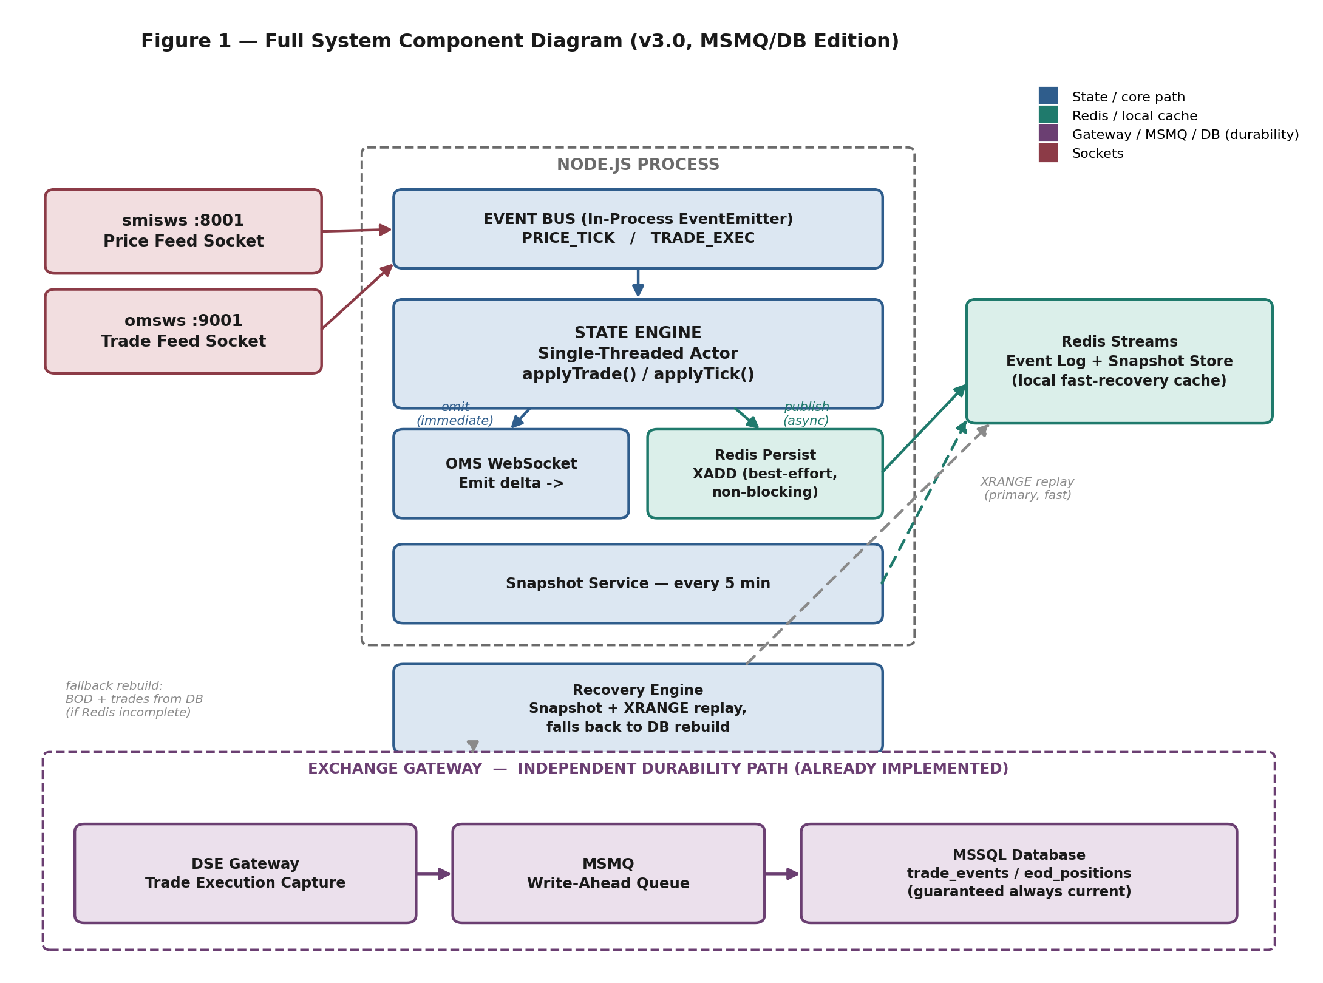
Figure 1 — Full System Component Diagram

Walking Through the Diagram, Step by Step
Step 1 — Feeds arrive. The DSE trade feed (omsws) and price feed (smisws) push events straight into the Node.js process's in-memory event bus as soon as they occur. Nothing is written to disk at this point.
Step 2 — Event bus hands off. The event bus enqueues each PRICE_TICK or TRADE_EXEC and hands it to the single-threaded State Engine, one event at a time, strictly in arrival order — this is what keeps the state engine free of race conditions.
Step 3 — State is applied in memory. The State Engine calculates and calls required intermediate operations, updating net position, cash map, average cost, or unrealized P&L entirely in memory. No, I/O happens as part of this step.
Step 4 — Clients are told immediately. Right after applying the event calculations, the State Engine emits the resulting delta to every connected OMS WebSocket client. This happens before any persistence step runs, so what traders see on screen is never delayed by disk or network I/O.
Step 5 — Redis is updated in the background. In parallel with step 4, the same event is handed to the Redis Persist module, which issues a non-blocking XADD into the day's Redis Stream. This is best-effort: if it fails or falls behind, trading is unaffected because Redis is only the fast local cache, not the durability guarantee.
Step 6 — Snapshots checkpoint the stream. Every 5 minutes, the Snapshot Service serializes the full in-memory state plus the current Redis stream ID into a Redis key. This gives the Recovery Engine a recent starting point so it never has to replay the entire day.
Step 7 — The database is updated independently. At the same time as steps 1–6, and without depending on any of them, the exchange gateway captures the same trade execution and publishes it to MSMQ. MSMQ guarantees delivery into the MSSQL database tables and trade executions whether or not the OMS process or Redis happens to be running at that moment.
Step 8 — Recovery picks the best available source. On restart, the Recovery Engine first tries the fast path: load the Redis snapshot and XRANGE-replay the stream since it (the upper dashed arrow). If Redis is unavailable, or its stream looks incomplete, the Recovery Engine instead queries the database directly (the lower dashed arrow) and rebuilds state from the Beginning-of-Day baseline forward.

Component Responsibilities
- smisws / omsws. External DSE WebSocket feeds. smisws delivers PRICE_TICK; omsws delivers TRADE_EXEC. Both auto-reconnect on disconnect.
- State Engine. Single-threaded actor. Processes one event at a time from the internal queue. Applies deterministic update functions. Emits delta to OMS clients. Never waits for any downstream service.
- Redis Persist. Lightweight module inside the Node process. Writes every TRADE_EXEC to the Redis Stream via XADD after applyTrade() completes. Non-blocking, best-effort.
- Redis Streams. Append-only local event log, one stream per trading day (oms:events:YYYYMMDD). Used as the fast path for crash recovery. Requires AOF persistence.
- Snapshot Service. Runs on a 5-minute timer. Serialises full in-memory state and the current Redis stream ID into a Redis key. Used as the starting point for fast replay on recovery.
- Recovery Engine. Activated on startup. Tries the Redis snapshot + stream replay first. If Redis is unavailable, or the stream is missing events, it falls back to querying MSSQL for the day's trade_events and rebuilds state from the Beginning-of-Day baseline.
- DSE Gateway / MSMQ / MSSQL DB. The gateway captures every trade execution and, via MSMQ, guarantees it lands in the MSSQL trade_events / eod_positions tables — regardless of whether the OMS Node.js process or Redis is up.

4. Data Flow Diagram
The data flow diagram traces how a single TRADE_EXEC event propagates through the system — from socket receipt to client emission to the local Redis cache — alongside the independent gateway path that guarantees the same event reaches the database.
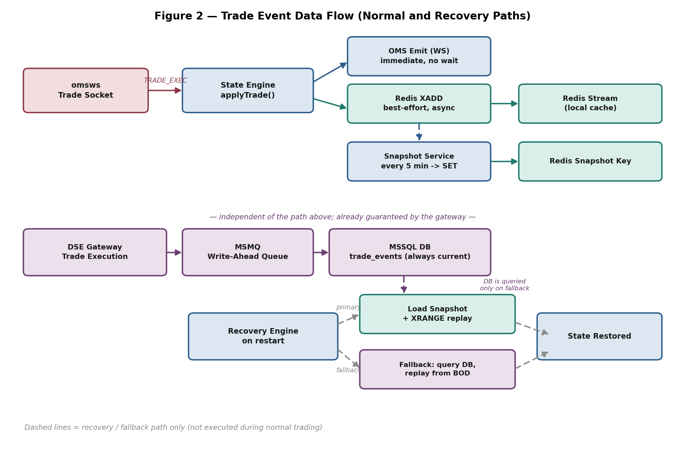
Figure 2 — Trade Event Data Flow (Normal and Recovery Paths)

Walking Through the Diagram, Step by Step
Step 1 — Trade socket to state engine. omsws delivers the TRADE_EXEC event to the State Engine, which calls applyTrade() and updates in-memory state.
Step 2 — Two outputs, same instant. From applyTrade(), two things branch off at once: the OMS Emit path, which sends the delta to clients immediately with no wait, and the Redis XADD path, which writes the event to the Redis Stream asynchronously in the background.
Step 3 — Stream feeds the snapshot. The Redis Stream accumulates events continuously. Every 5 minutes the Snapshot Service reads current state and issues a SET, writing a fresh Redis Snapshot Key that points at the stream position it corresponds to.
Step 4 — A second, independent lane. Below the OMS path, the DSE Gateway captures the same trade execution on its own and hands it to MSMQ. MSMQ writes it into the MSSQL DB's trade_events table. This lane shares no component with the OMS path above it — it doesn't call into the State Engine, Redis, or the Node.js process at all.
Step 5 — Recovery starts with the fast option. On restart, the Recovery Engine's primary path is to load the Redis Snapshot and XRANGE-replay the stream from that point — shown as the upper dashed route into "State Restored".
Step 6 — Recovery falls back only when necessary. If Redis's snapshot or stream is unavailable or looks incomplete, the Recovery Engine instead queries the MSSQL DB — the lower dashed route — replaying from the Beginning-of-Day baseline using the guaranteed-complete trade_events table. Either route ends at the same place: a fully restored in-memory state.

Key Data Flow Invariants
- The state engine never awaits any downstream service. applyTrade() completes in memory, the delta is emitted, and the Redis write happens asynchronously afterward.
- Redis XADD is best-effort. If it fails, the local cache simply falls behind — this does not risk data loss, because the gateway's MSMQ -> DB path is unaffected.
- The gateway MSMQ -> DB path runs independently of the OMS socket path. It is not triggered by, and does not wait on, anything in the Node.js process.
- Recovery prefers Redis (snapshot + stream) because it is fast. It only queries the database when Redis is unavailable or its stream is incomplete — the database is always correct, but a full-day replay is slower than a short Redis XRANGE.

5. Sequence Diagram — Trade Event Flow
This diagram traces a single TRADE_EXEC event end-to-end across seven lanes — the exchange socket, the state engine, connected OMS clients, Redis, the snapshot service, and the gateway/MSMQ/DB path — including the fallback branch used when Redis is unavailable during recovery.
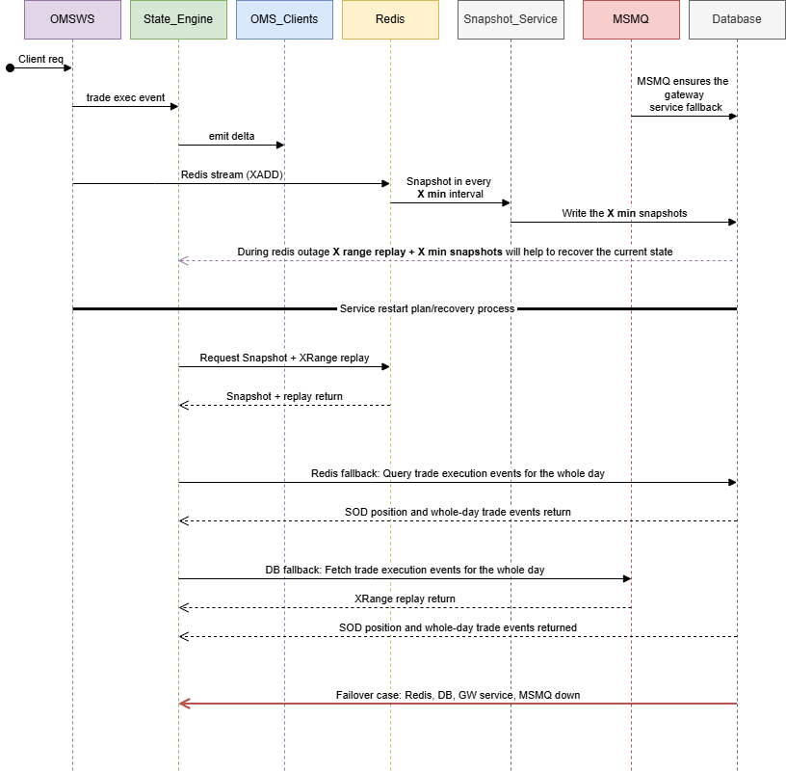
Figure 3 — Sequence Diagram: Trade Execution, Persistence, and Recovery

6. Design Alternatives Considered
Several approaches to closing the durability gap described in Section 1 were evaluated. The table below summarises each option and why it was accepted or rejected.
Option | Survives Redis Down | Survives Node Crash | Extra Infra | Decision
Fire-and-forget XADD | No — events lost | No | None | Rejected
In-memory write-ahead buffer only | Yes — held in RAM | No — RAM lost on crash | None | Rejected
File-backed write-ahead buffer | Yes | Yes — file survives | None | Rejected — still single-host
Dedicated message broker (e.g. RabbitMQ) | Yes — independent broker | Yes — queue persisted to disk | New broker server (2 GB RAM, 10 GB disk) | Rejected — duplicates a guarantee the gateway already provides
BullMQ | No — needs Redis itself | Yes, if Redis is up | None (uses Redis) | Rejected — same failure point as Redis
Kafka | Yes | Yes | Kafka cluster (3 brokers minimum) | Rejected — disproportionate for this workload
Gateway MSMQ -> MSSQL DB (chosen) | Yes — independent of Redis | Yes — independent of Node.js | None — runs on existing gateway infrastructure | Accepted

Reasoning
- The gateway's MSMQ path already guarantees a trade event is durably recorded outside of Redis, on infrastructure that is independently owned and operated from the OMS.
- A dedicated broker would add an ACK/redelivery protocol, a dead-letter queue, prefetch tuning, and a queue-depth monitoring surface — operational overhead for a guarantee that is not, in fact, missing.
- Keeping the OMS to two components (Node.js and Redis) rather than three keeps the recovery story simple to reason about and to explain during an incident.
- The trade-off of relying on the database as the fallback layer, rather than a broker, is recovery speed rather than recovery completeness: if both Redis and Node.js are down together, recovery falls back to a database rebuild (slower) instead of a short Redis replay. This is addressed directly in Scenario C below.

7. Scenario Analysis — Four Failure Modes
The following scenarios cover every realistic failure combination during a trading session.
Scenario A — Redis Crashes, Node.js and Gateway/DB Remain Up | RESOLVED

10:00:00 | Snapshot-A saved to Redis. All systems nominal.
10:03:00 | Redis crashes. Local cache writes (XADD) start failing.
10:03:01 | Trade-1 executes -> calculation succeeds in memory (local/redis) -> delta emitted to OMS clients.
10:03:01 | Trade-1 also captured at the gateway -> MSMQ delivers it to MSSQL trade_events, unaffected by the Redis outage.
10:03:30 / 10:04:00 | Trade-2, Trade-3 execute -> same path -> both land in the database via the gateway regardless of Redis's state.
10:05:00 | Snapshot timer fires -> Redis still down -> local snapshot not saved (does not matter — see below).
10:05:00 | Redis recovers. XADD resumes for new events; the local stream has a small gap for 10:03-10:05, but the database does not.
10:05:05 | RESOLVED: Zero event loss. The database already has Trade-1, 2, 3. If Node.js also crashed during the outage, recovery would use the database fallback (see Scenario C) instead of the gapped Redis stream.

Scenario B — Node.js Crashes, Redis and Gateway/DB Remain Up | RESOLVED

10:00:00 | Snapshot-A saved. All in-memory state current.
10:03:00 | Trades executing normally. Redis stream and gateway/DB both current.
10:04:00 | Node.js process killed (OOM, SIGKILL, or hardware fault). All in-memory state lost. OMS clients disconnected.
10:04:30 | Node.js restarted (systemd / PM2 auto-restart).
10:04:31 | Startup: Redis snapshot check -> Snapshot-A found and current -> loaded, streamId noted.
10:04:31 | XRANGE from snapshot.streamId -> replay all events since 10:00 from the Redis stream.
10:04:35 | State fully restored from the fast Redis path. OMS clients reconnect.
10:04:36 | RESOLVED: Recovery time typically under 5 seconds.

Scenario C — Redis and Node.js Both Crash, Gateway/DB Remains Up | RESOLVED

10:00:00 | Snapshot-A saved. All systems nominal.
10:03:00 | Redis and Node.js both crash (e.g. shared host failure). Local cache and in-memory state both lost.
10:03:00-10:06:00 | Trades continue to be captured at the gateway and written to MSSQL trade_events via MSMQ — this path does not run on the same host and is unaffected.
10:06:00 | Node.js restarted. Redis is also still down (or its stream is stale/incomplete).
10:06:01 | Recovery Engine checks Redis first -> unavailable or incomplete -> falls back to the database.
10:06:02 | Fallback: load Beginning-of-Day positions and query MSSQL trade_events for every trade executed today.
10:06:08 | Full day replayed in chronological order -> state rebuilt exactly, including every trade during the outage window.
10:06:10 | OMS WebSocket reopened to clients.
10:06:11 | RESOLVED: Zero event loss. Recovery is slower than the Redis fast path — seconds to low minutes depending on the day's trade volume — but is always complete, because the gateway/DB path never depended on Redis or Node.js.

Scenario D — Total Failure: Node.js, Redis, and Gateway/DB All Down | FAILURE MODE

10:00:00 | All systems nominal.
10:03:00 | Total, simultaneous failure of the OMS host and the gateway/MSMQ/DB infrastructure (e.g. a full data-centre outage spanning both systems).
10:03:00-10:06:00 | No path is recording trade executions: in-memory state is gone, Redis is gone, and the database write path is also down.
10:06:00 | Infrastructure restored. Redis and Node.js recover; database confirmed reachable again.
10:06:01 | Recovery Engine rebuilds state from the last good source (Redis snapshot or database, whichever is more current) up to 10:03:00.
10:06:02 | The window 10:03-10:06 cannot be reconstructed automatically from any internal system, because no internal system was recording during that window.
10:06:03 | Manual reconciliation required: cross-reference exchange (DSE) trade reports for 10:03-10:06 and apply any missing trades manually.
10:06:04 | PARTIAL RECOVERY: everything before the outage is safe and complete. The outage window requires ops intervention.

Problem
This is the only unrecoverable scenario in this architecture, and it requires the OMS/Redis host and the independently-owned gateway/MSMQ/DB infrastructure to fail at the same time — two systems that do not share infrastructure. The only defence against this residual case is the exchange's own trade reporting, used for manual reconciliation.

8. Recovery Procedures
Recovery restores the in-memory state engine to a consistent state after any failure. The procedure always tries the fast Redis path first and only falls back to the database when it has to.

Automatic Recovery (Node.js restart)
Step | Action
1. Process starts | Node.js/C# service starts (manually or via PM2/systemd auto-restart).
2. Redis check | Check for the oms:snapshot:latest key in Redis, and whether the stream since that snapshot looks complete.
3a. Redis usable | Desterilize the snapshot into the in-memory state map. Note the streamId. XRANGE from snapshot.streamId to replay events since the snapshot.
3b. Redis unavailable / incomplete | Fallback: load Beginning-of-Day positions from MSSQL, then query MSSQL trade_events for every trade executed so far today.
4. Replay | Apply each recovered event and price change, in chronological order, regardless of which source it came from.
5. Open to clients | Only after state is fully restored, open the OMS WebSocket server to client connections.
6. Resume feeds | Reconnect smisws and omsws. Resume normal operation, including Redis XADD writes for new events.

Manual Recovery (Database Reconciliation)
If automatic recovery produces a state that looks inconsistent, the fastest check is to compare the Redis stream's event count for the day against the MSSQL trade_events row count for the same day. A mismatch means Redis fell behind at some point — re-run recovery to force the database fallback path rather than trusting the Redis replay.
Because the gateway/MSMQ/DB path is owned and operated independently of the OMS, there is no OMS-side dead-letter queue to inspect for this path. If the database itself is suspected to be missing trades, escalate to the gateway/MSMQ team directly rather than attempting to reconstruct events on the OMS side.

9. Operational Runbook (Conceptual)

Health Check Endpoints
Endpoint | Method | What It Shows
GET /health | GET | Service status, event log count, snapshot age, Redis connectivity
GET /state | GET | Full in-memory state: all positions, cash map, last LTP per symbol
GET /state/:symbol | GET | Positions for one symbol across all clients
GET /state/client/:id | GET | All positions and cash for one client ID
POST /snapshot | POST | Trigger a manual snapshot immediately
GET /events/count | GET | Number of events in today's Redis Stream
GET /reconcile/count | GET | Compares today's Redis stream event count against the MSSQL trade_events row count

Monitoring Alerts (Recommended)
Metric | Alert Threshold | Meaning
Redis stream vs DB trade_events count (mismatch) | > 0 mismatch during trading hours | Redis fell behind - recovery should prefer the database fallback
Redis stream length growth rate | Stopped growing during trading | Redis write path may have stopped — local cache is stale but DB is unaffected
Snapshot age | > 7 minutes during trading hours | Snapshot timer failed - check Redis
State engine event queue depth | > 1000 | State engine falling behind - investigate socket flood
Gateway/MSMQ/DB connectivity (from OMS perspective) | Reconcile endpoint unreachable | Escalate to the gateway/MSMQ team - this path is outside OMS ownership

End-of-Day Procedure
- After market close: trigger POST /snapshot to save a final snapshot.
- Reconcile the Redis stream's event count against the MSSQL trade_events count for the day — the two should match at end of day even if they drifted temporarily during any Redis blip.
- Run EOD reconciliation: compute final net positions, write to the MSSQL EOD_positions table.
- Archive today's Redis Stream (copy to cold storage or MSSQL) for audit purposes.
- Clear the oms:snapshot:latest key and today's stream key in Redis ahead of the next session.

10. Fallback Hierarchy
The system is designed with layered fallbacks. If a component at one layer fails, the next layer down provides the safety net.
Priority | Layer | Covers | If Unavailable
1st | In-Memory State Engine | Live trading state — positions, cash, P&L | All trading visibility lost. Recovery depends on layers below.
2nd | Redis Streams + Snapshot | Fast local replay source for crash recovery | Recovery falls back to the database (Layer 3) — slower, still complete.
3rd | Gateway MSMQ -> MSSQL DB | Guaranteed-complete trade record, independent of OMS/Redis | Falls back to manual reconciliation from exchange reports.
4th | Exchange Trade Reports | Manual reconciliation for total failure | Last resort. Used only in Scenario D (total infrastructure failure).

Maximum Data Loss by Failure Combination
Failure Combination | Maximum Event Loss | Recovery Source
Redis only | Zero | Database, if Node.js also needs to restart; otherwise no recovery needed
Node.js only | Zero | Redis snapshot + stream replay (fast path)
Redis + Node.js | Zero | Database fallback rebuild (Beginning-of-Day + trade_events replay)
Redis + Node.js + Gateway/MSMQ/DB (all simultaneously) | Up to the length of the simultaneous outage | Manual reconciliation from exchange trade reports

11. Summary
This architecture closes the event-loss gap described in Section 1 by relying on two layers with different jobs: Redis Streams give the OMS a fast-local cache for sub-5-second restarts, and the exchange gateway's MSMQ-backed write path into MSSQL — already running independently of the OMS — provides the guaranteed source of truth underneath it. Recovery always prefers the fast path and only falls back to the database when it has to.
Design Rule | Implementation
No database writes from the OMS during trading | State lives in memory only inside the OMS; the gateway (a separate system) handles the DB write independently.
Immediate OMS emission | emitFn() called inside every _apply() before any async operation.
Trade events never silently lost | Guaranteed by the gateway's MSMQ -> DB path, independent of OMS/Redis health.
Redis downtime does not cause a gap | Redis is a local cache only; the database path is unaffected by Redis's state.
Snapshot caps replay window | Every 5 minutes, for the fast Redis recovery path.
Single-threaded actor | FIFO queue, one event processed at a time. No race conditions.
Auto-reconnect everywhere | smisws, omsws, and the Redis client all reconnect with backoff.
Graceful shutdown | SIGINT/SIGTERM triggers a final snapshot before process exits.
Database as backstop, not primary path | Recovery prefers Redis (fast); it only queries MSSQL when Redis is unavailable or incomplete.

Infrastructure Requirements
Component | Minimum Spec | Notes
State Engine server | 8 cores, 16 GB RAM | State engine + socket receivers + API
Redis server | 4 cores, 8 GB RAM, SSD (local) | AOF persistence required (appendonly yes) — local cache only
Gateway MSMQ / MSSQL | Default | Default
Network | Default | Default
UPS | State engine and Redis on UPS if local | Trading session must not drop on a power glitch

