RISC-V SoC with ECC-Protected Memory
Capstone Design Project — Project 03
Technical Report — Verification Track
Field | Detail
Project Title | RISC-V SoC with ECC-Protected Memory
Team | Group of Three
Team Members | Fatima Azeemi, Asifa Siraj, Eemaan Jawaid Rao
Track | Verification (UVM)
Simulator | QuestaSim 2024.1 (UVM-1.1d)
Date | September 2026

Table of Contents
Table of Contents 2
1. Project Overview 2
1.1 Project Title 2
1.2 Team Members 2
1.3 Project Objective 2
1.4 Brief Description of the Proposed System 2
2. System Architecture 3
2.1 Top-Level / Block Diagram 3
2.2 RISC-V Core and Major Modules 3
2.3 Interfaces and Data / Control Flow 4
3. RTL Design 5
3.1 Module Hierarchy 5
3.2 Description of Major RTL Modules 5
3.2.1 ECC Encoder / Decoder — SEC-DED Hamming(39,32) 5
3.2.2 ECC Memory and Fault Injection 5
3.2.3 Peripheral Subsystem 6
3.2.4 Control Unit 6
3.3 Important Design Decisions 6
3.4 Simulation Results / Waveforms 7
3.4.1 Golden Test — Clean-Path Baseline 7
3.4.2 Single-Bit Test — Correction 7
3.4.3 Double-Bit Test — Detection and Fail-Safe Coupling 7
3.4.4 MMIO Test — Clean Peripheral Register Path 8
3.4.5 Stress Test — Combined Randomized Faults 9
3.4.6 Peripheral Test — Sustained Peripheral Operation 9
3.4.7 Fail-Safe Test — Watchdog-Triggered Safety Interlock 10
4. Verification 11
4.1 Verification Strategy 11
4.2 Testbench Architecture 11
4.3 Test Scenarios 11
4.4 Test Results 11
4.5 Assertions and Scoreboard 12
4.5.1 Protocol Assertions (risc_v_if.sv) — 9 total 12
4.5.2 Scoreboard 12
5. Track-Specific Work — Verification Track 13
5.1 UVM Architecture 13
5.2 Agents and Sequences 13
5.3 Scoreboard 13
5.4 Assertions 13
5.5 Functional Coverage 13
5.6 Code Coverage 13
6. Results 15
6.1 Simulation and Pass/Fail Results 15
6.2 Coverage Results 15
6.3 Aggregated Scoreboard Metrics (recomputed directly from the seven official test logs) 15
6.4 LEC / Tool Reports 15
7. Individual Contributions 16
7.1 Fatima Azeemi 16
7.2 Asifa Siraj 16
7.3 Eemaan Jawaid Rao 16
Appendix: Test Logs 17

1. Project Overview

1.1 Project Title
RISC-V SoC with ECC-Protected Memory (Capstone Project 03, Team of Three).

1.2 Team Members
Member | Primary Area
Fatima Azeemi | Datapath RTL; ECC-memory/bus integration; test infrastructure & build flow; profile & fail-safe peripheral logic; driving/sampling (UVM)
Asifa Siraj | Control-unit RTL; ECC encoder/decoder math; scoreboard reference model; SPI peripheral logic; sequence-item (transaction) definition
Eemaan Jawaid Rao | Memory & top-level integration RTL, instruction memory, testbench top; fault-injection & sticky status logic; UVM sequences; functional coverage; PWM/RPM peripheral logic

1.3 Project Objective
Design a synthesizable 32-bit RV32I processor core with ECC-protected data memory, in which single-bit faults in memory are transparently corrected and double-bit faults are detected and reported, and verify the design's correctness and safety behaviour using a UVM-based verification environment.

1.4 Brief Description of the Proposed System
The system is a single-cycle RV32I RISC-V core integrated into a small SoC. Data memory is protected by a SEC-DED (Single-Error-Correct, Double-Error-Detect) extended Hamming code (32-bit data → 39-bit codeword), with a dedicated fault-injection block used purely for verification. Beyond the core and ECC memory, the SoC exposes a memory-mapped peripheral subsystem (SPI master, PWM generator, RPM/tachometer measurement, an 8-word profile memory, and a watchdog-driven fail-safe unit) at address range 0x8000_0000 and above. The fail-safe unit forces the PWM output off whenever either an uncorrectable ECC double-bit fault occurs or the watchdog times out, coupling the memory-safety subsystem directly to the peripheral safety subsystem. The complete design is verified with a UVM environment covering CPU execution, ECC fault handling, peripheral behaviour, and the fail-safe safety property, across seven directed and constrained-random test scenarios, all of which pass with zero scoreboard errors.

2. System Architecture

2.1 Top-Level / Block Diagram
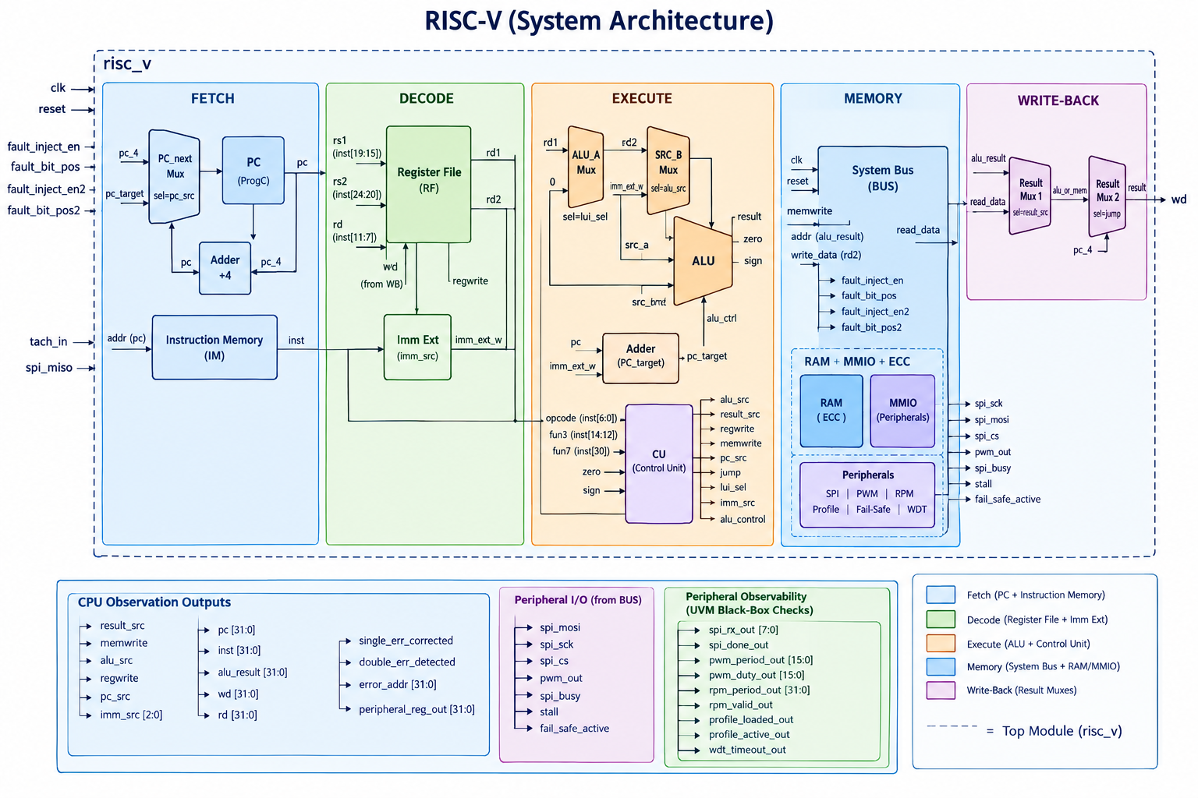
Figure 1. Top-level block diagram of the risc_v SoC: Fetch → Decode → Execute → Memory → Write-back, with fault-injection stimulus, the RAM+MMIO+ECC memory subsystem, and full peripheral I/O and observability signal groups.

2.2 RISC-V Core and Major Modules
The core is a classic single-cycle RV32I datapath. Every instruction completes fetch, decode, execute, memory access, and write-back within one clock period; only the PC, register file, ECC memory array, and peripheral registers are actually clocked state — everything else in the datapath is combinational.
Stage | Modules | Function
Fetch | pc, adder (+4), instr_mem, mux (PC select) | Computes next PC (sequential or branch/jump target) and fetches the 32-bit instruction word.
Decode | reg_file, imm_ext | Reads two source registers (x0 hardwired to 0) and sign/zero-extends the instruction's immediate field according to instruction type (I/S/B/J/U).
Execute | alu, alu_control, cu (control_unit), adder (branch target) | Computes the ALU result (arithmetic/logic/comparison) and the branch/jump target address; the control unit decodes opcode/funct3/funct7 into every downstream control signal.
Memory | sys_bus, ecc_data_mem (+ecc_encoder/decoder/fault_injector/error_status_reg), peripherals | Address-decodes between ECC-protected RAM and the MMIO peripheral space and performs the actual read/write.
Write-back | mux (result select) ×2 | Selects between ALU result, memory read data, or PC+4 (for JAL) as the value written back to the register file.

2.3 Interfaces and Data / Control Flow
The system bus (sys_bus) performs address decoding on a single bit: addr[31] = 0 routes the access to the ECC-protected RAM (ecc_data_mem); addr[31] = 1 routes it to the memory-mapped peripheral block (peripherals). Read data is muxed back to the core: read_data = mmio_en ? mmio_rd : ram_rd. This keeps the core itself completely unaware of ECC or peripheral logic — it only ever issues ordinary load/store transactions to what looks like flat 32-bit memory.
Address Range | addr[31] | Device
0x0000_0000 – 0x7FFF_FFFF | 0 | ecc_data_mem — 16 × 39-bit ECC-protected words
0x8000_0000 – 0xFFFF_FFFF | 1 | peripherals — SPI, PWM, RPM, profile memory, watchdog/fail-safe
Fault-injection stimulus (fault_inject_en/fault_bit_pos and the _2 pair for a second, independently-positioned bit flip) is routed directly into the ECC RAM's read path, between the stored codeword and the decoder, so faults can be injected purely for verification without altering the encoder or the core.

3. RTL Design

3.1 Module Hierarchy
Module | File | Type | Role
risc_v | risc_v.sv | Top-level | SoC top; wires datapath, control unit, bus, and peripherals together
pc | pc.sv | Sequential | Program counter register (async reset)
adder | adder.sv | Combinational | a + b (used for PC+4 and branch/jump target)
mux | mux.sv | Combinational | 2:1 mux (PC select, ALU operand select, write-back select)
instr_mem | instr_mem.sv | ROM (behavioural) | Instruction memory / program store
reg_file | reg_file.sv | Sequential | 32×32 general-purpose register file, x0 hardwired to 0
imm_ext | imm_ext .sv | Combinational | I/S/B/J/U immediate sign/zero extension
alu | alu.sv | Combinational | 8-operation ALU with zero/sign flags
control_unit | control_unit.sv | Combinational | Main opcode decoder
alu_control | alu_control.sv | Combinational | ALU operation decode (aluop + funct3 + funct7)
cu | cu.sv | Combinational | Top control block: control_unit + alu_control + branch-taken logic
sys_bus | sys_bus.sv | Interconnect | Address decode and RAM/MMIO read-data mux
ecc_encoder | ecc_encoder.sv | Combinational | 32→39-bit SEC-DED Hamming encode
ecc_decoder | ecc_decoder.sv | Combinational | 39→32-bit decode, single-bit correct / double-bit detect
ecc_data_mem | ecc_data_mem.sv | Sequential | 16-word ECC-protected RAM array
fault_injector | fault_injector.sv | Combinational | XOR-mask fault injection (2 independent channels), verification-only
error_status_reg | error_status_reg.sv | Sequential | Sticky single/double-error flags and faulting address latch
peripherals | peripherals.sv | Sequential + comb. | SPI master, PWM, RPM, profile memory, watchdog & fail-safe

3.2 Description of Major RTL Modules

3.2.1 ECC Encoder / Decoder — SEC-DED Hamming(39,32)
The encoder places 32 data bits and 6 parity bits (at bit positions 1, 2, 4, 8, 16, 32 of a 38-bit word) so that each parity bit covers exactly the data positions whose binary index has that power-of-two bit set. A 39th, overall-parity bit is appended, which is what upgrades the code from single-error-correcting (SEC) to single-error-correcting / double-error-detecting (SEC-DED).
The decoder recomputes the 6 expected parity bits from the received data, XORs them against the received parity bits to obtain a 6-bit syndrome, and separately checks the overall parity. The classification is:
syndrome | overall parity | Verdict | Action
0 | matches | No error | Data passed through unchanged
0 | mismatches | Overall parity bit itself flipped | Flagged single_err_corrected; data unaffected
≠ 0 | mismatches | Single-bit error — syndrome = exact bit position | Bit flipped back; single_err_corrected asserted
≠ 0 | matches | Double-bit error — uncorrectable | double_err_detected asserted; data passed through as-is

3.2.2 ECC Memory and Fault Injection
ecc_data_mem stores 16 words as 39-bit codewords. On write, the encoder's output is stored; on read, the raw codeword passes through fault_injector (a pure XOR mask driven by the two independent fault-injection channels used only by the testbench) before being decoded. Error flags are qualified by mem_sel so that an access to peripheral space can never spuriously latch an ECC error. error_status_reg then latches single_err_corrected, double_err_detected, and the faulting address as sticky bits that persist until reset.

3.2.3 Peripheral Subsystem
peripherals.sv implements a full memory-mapped peripheral block: an SPI master (MSB-first, configurable clock divider, busy/done status, receive shift register), a 16-bit PWM generator (period/duty compare), an RPM measurement unit (edge-to-edge tachometer period counter), an 8-word profile memory with a load/active status pair, and a watchdog timer. Two independent conditions can latch the sticky fail_safe_active flag: an uncorrectable ECC double-bit fault (double_err_detected, routed in directly from the ECC memory), or a watchdog timeout (256 cycles without a tachometer edge after the watchdog is armed). While fail_safe_active is latched, the PWM output is unconditionally forced to 0, regardless of the programmed duty cycle — this is the design's core safety interlock.

3.2.4 Control Unit
control_unit.sv decodes the instruction opcode into every control signal the datapath needs (alu_src, result_src, regwrite, memwrite, branch/jump, imm_src, aluop). alu_control.sv further decodes the ALU operation from aluop plus funct3/funct7. cu.sv combines both, and additionally derives branch_taken from the ALU's zero/sign flags and the branch funct3 field, producing the final pc_src select.

3.3 Important Design Decisions
- Single-cycle microarchitecture: simplifies control (no hazards/forwarding needed) at the cost of a longer critical path through the ECC decoder; an explicit, documented trade-off given the project's RTL scope.
- ECC is transparent to the core: all encode/decode/fault-injection logic lives inside the memory subsystem behind sys_bus; the CPU datapath issues ordinary loads/stores and has no ECC-specific logic anywhere in its own RTL.
- Single-bit address decode (addr[31]): the simplest possible RAM/MMIO split, sufficient for a 2-device memory map and easy to verify exhaustively.
- Fail-safe is a single sticky latch fed by two independent trigger paths (ECC double-bit fault, watchdog timeout): this couples the memory-safety and peripheral-safety subsystems through one clearly auditable signal (fail_safe_active) rather than duplicating safety logic in each consumer.
- Fault injection is verification-only logic, physically separated (fault_injector.sv) from the encoder/decoder so the synthesizable ECC path itself contains no test-only logic.

3.4 Simulation Results / Waveforms
The following waveforms were captured directly from QuestaSim for each of the seven UVM test scenarios, and are cross-referenced against that test's console transcript in Section 5.4 / Section 7.

3.4.1 Golden Test — Clean-Path Baseline
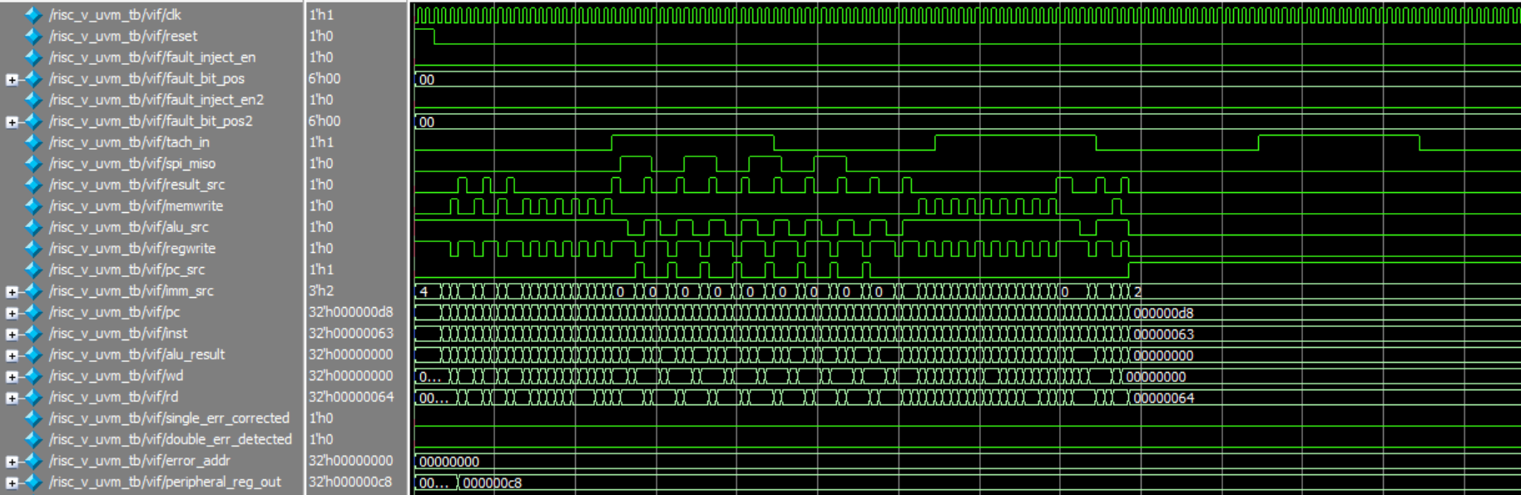
Figure 2. risc_v_golden_test: fault_inject_en/en2 remain low throughout; single_err_corrected and double_err_detected stay flat at 0; the core executes normally (pc, inst, memwrite, regwrite all toggle as expected) and a clean MMIO write is visible (peripheral_reg_out settles at 0x000000c8).
Interpretation: this is the design's nominal-operation baseline — with no faults injected, neither ECC flag ever asserts, confirming the decoder does not produce false positives on clean data. This matches the transcript exactly: Single-bit corrections = 0, Double-bit detections = 0, and the run finishes with 142/142 scoreboard checks passing.

3.4.2 Single-Bit Test — Correction
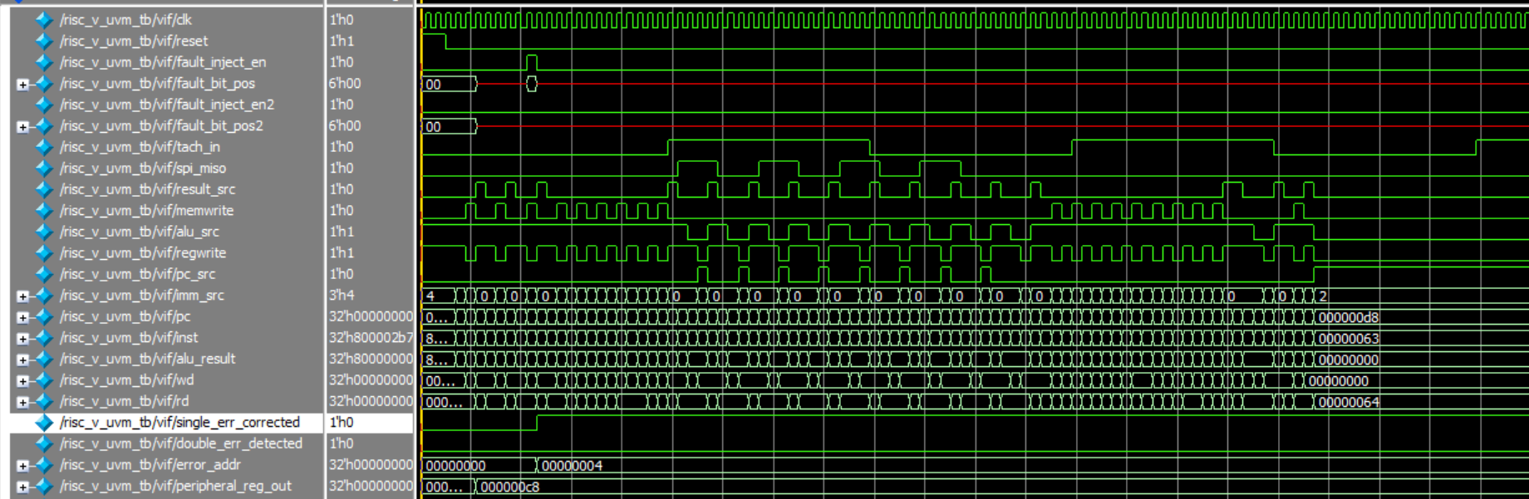
Figure 3. risc_v_single_bit_test: fault_inject_en pulses once (the transcript reports the fault injected at bit 32); single_err_corrected transitions high immediately afterward and latches; error_addr updates from 0x00000000 to 0x00000004, correctly identifying the faulting word.
Interpretation: this proves the SEC half of SEC-DED end-to-end — a real single-bit corruption is silently corrected and the correct word (0x00000064, matching the value written earlier in the program) is still returned to the core. The transcript confirms 103 single-bit corrections sampled by the scoreboard's per-instruction functional coverage collector, 0 double-bit detections, and 113/113 checks passing.

3.4.3 Double-Bit Test — Detection and Fail-Safe Coupling
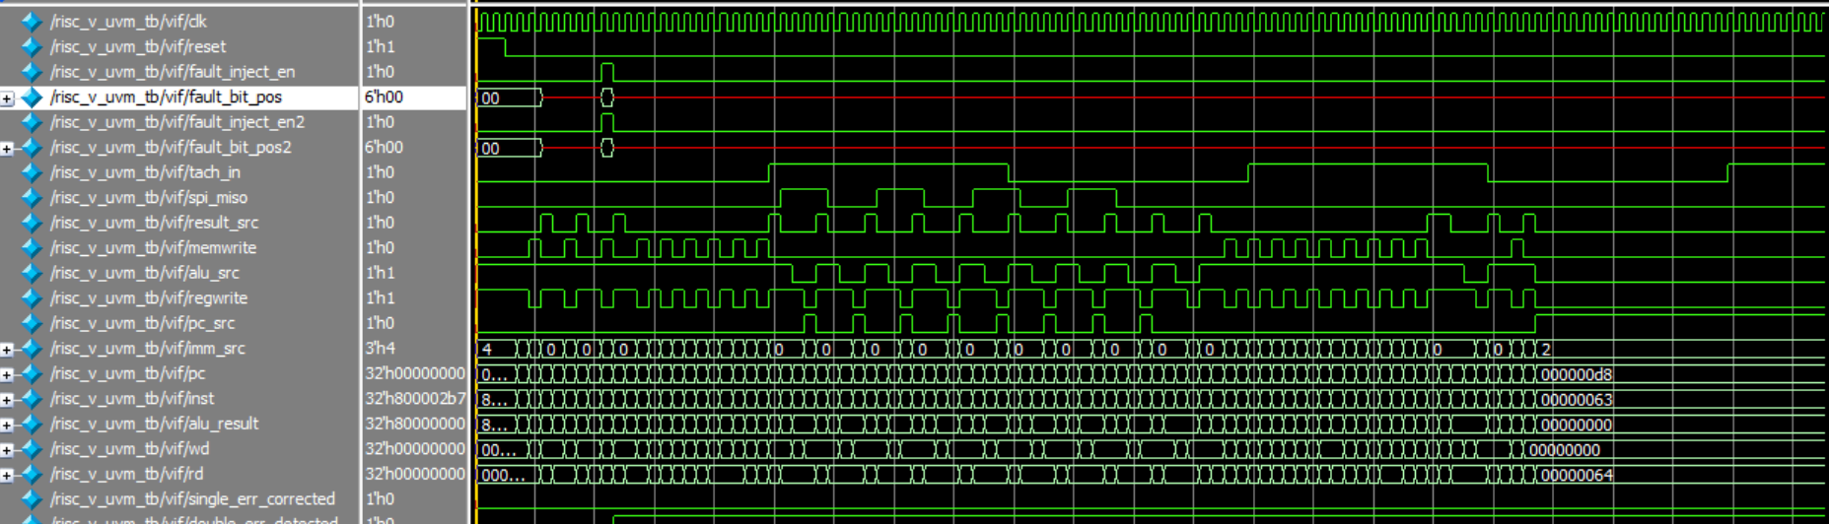
Figure 4a. risc_v_double_bit_test, part 1: fault_inject_en and fault_inject_en2 both pulse at distinct bit positions (transcript: bits 1 and 23).
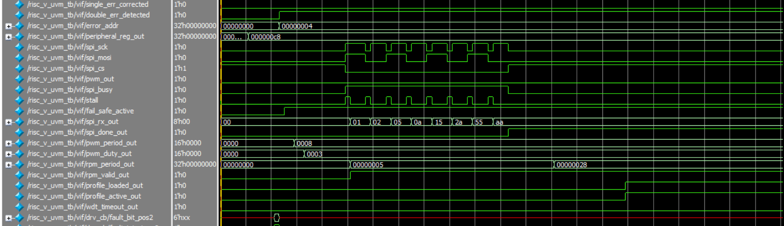
Figure 4b. risc_v_double_bit_test, part 2: double_err_detected and fail_safe_active step high together, immediately after the fault window — direct waveform evidence of the RTL coupling between the ECC subsystem and the fail-safe latch. The same window also shows a complete SPI transfer (spi_rx_out ramping 0x01→…→0xaa, spi_done_out pulsing), stall pulsing in sync with spi_busy, and PWM/RPM configuration taking effect.
Interpretation: this is the most significant pair of waveforms in the regression. It demonstrates not only that an uncorrectable double-bit fault is correctly detected (rather than mis-corrected), but that this detection genuinely propagates into the peripheral safety subsystem via the double_err_detected → fail_safe_active RTL path — closing the loop between the ECC track and the fail-safe requirement in the same test. Transcript: 103 double-bit detections, 0 single-bit corrections, 102 fail-safe active cycles, 113/113 checks passing.

3.4.4 MMIO Test — Clean Peripheral Register Path
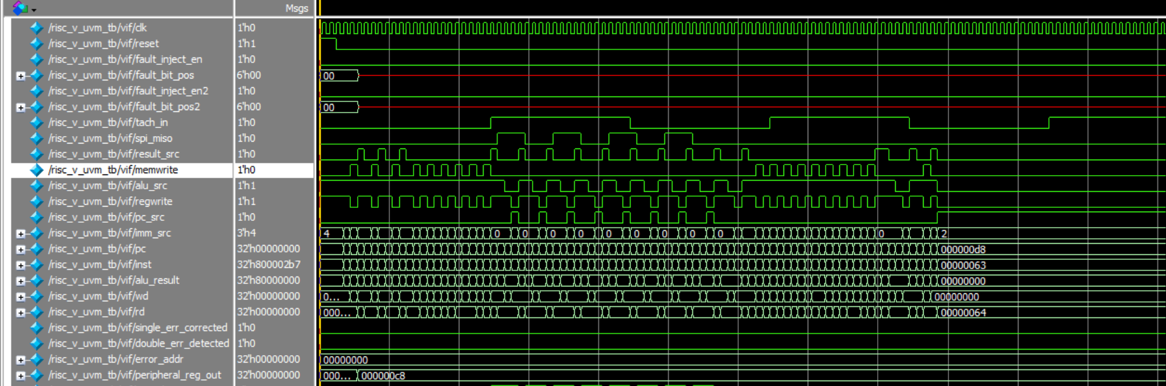
Figure 5. risc_v_mmio_test: no faults injected (both ECC flags flat); normal core execution with clean MMIO reads/writes; peripheral_reg_out updates to 0x000000c8, confirming the TRACE register read/write round-trip through sys_bus independent of the ECC path.
Interpretation: exercises the addr[31]=1 MMIO decode path in isolation from any ECC activity. Transcript confirms 118 MMIO accesses observed, 0/0 ECC flags, and 122/122 checks passing.

3.4.5 Stress Test — Combined Randomized Faults
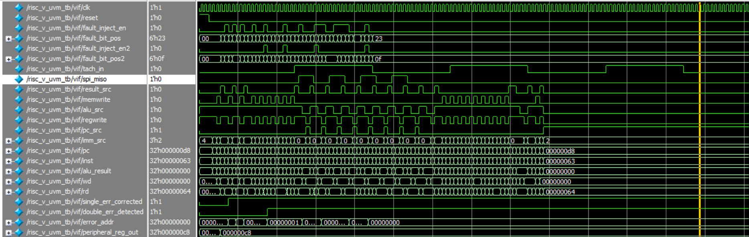
Figure 6a. risc_v_stress_test, part 1: fault_inject_en and fault_inject_en2 pulse repeatedly with varying fault_bit_pos values (0x23, 0x0f, etc.) across the run, rather than a single fixed position.
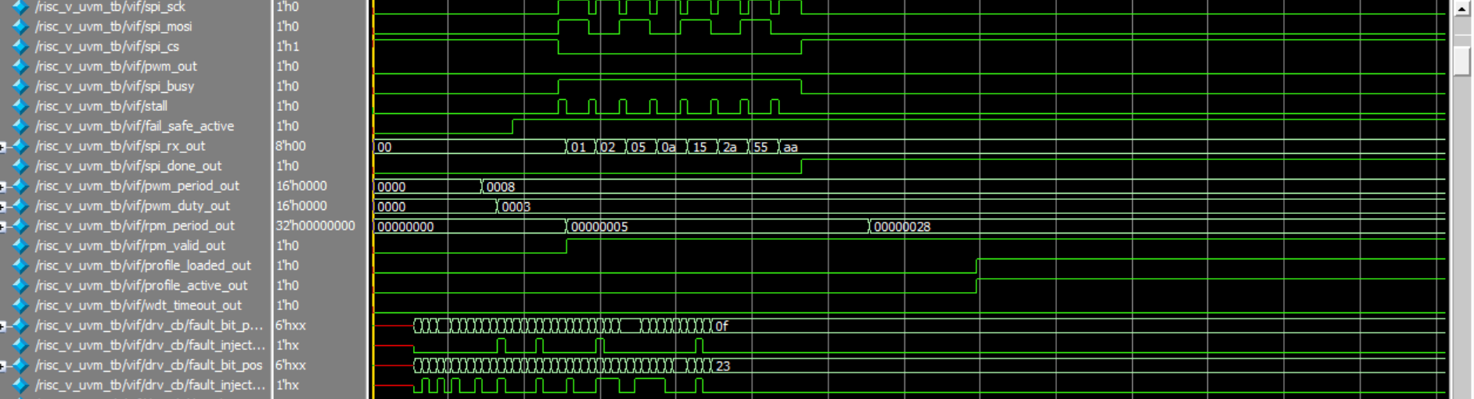
Figure 6b. risc_v_stress_test, part 2: single_err_corrected and double_err_detected both latch and remain high (sticky, as multiple faults of both types occur across the run), and fail_safe_active also asserts — reproducing the double-bit→fail-safe coupling under stress conditions. Peripheral activity (SPI/PWM/RPM/profile) continues correctly throughout.
Interpretation: this test combines everything the directed tests check individually into one constrained-random run and is also the highest-instruction-coverage test (66.7%), since varied fault positions combined with varied instructions exercise more coverage bins than any single directed test. Transcript: 136 single-bit corrections, 126 double-bit detections, 125 fail-safe active cycles, 142/142 checks passing.

3.4.6 Peripheral Test — Sustained Peripheral Operation
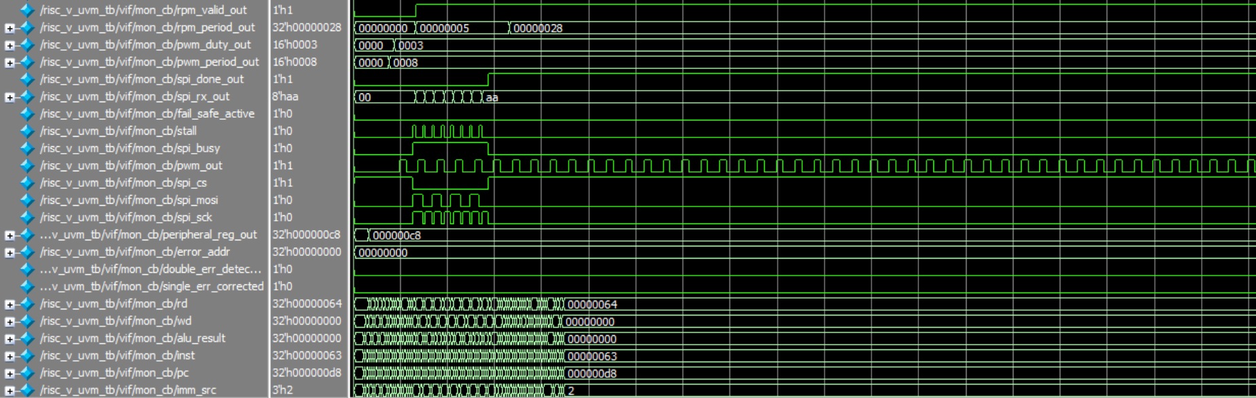
Figure 7. risc_v_periph_test (captured via the UVM monitor's clocking block, mon_cb): pwm_out toggles continuously with a steady duty cycle across the visible window; a full SPI transfer completes (spi_rx_out settles at 0xaa, spi_done_out pulses); stall correctly pulses in sync with spi_busy; rpm_period_out/rpm_valid_out update. All ECC signals remain flat, as expected.
Interpretation: this is the peripheral-heaviest test by instruction count (402 instructions) and directly exercises SPI, PWM, RPM, and stall detection under sustained operation rather than a single isolated event. Sampling through mon_cb additionally demonstrates that the UVM monitor itself correctly observes DUT peripheral behaviour. Transcript: 347 SPI transfers, 48 PWM high-runs, 378 RPM validation cycles, 324 profile events, 402/402 checks passing.

3.4.7 Fail-Safe Test — Watchdog-Triggered Safety Interlock
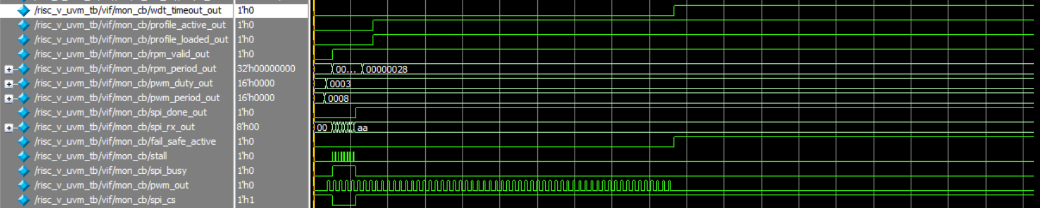
Figure 8. risc_v_failsafe_test: wdt_timeout_out rises first; fail_safe_active follows immediately after; pwm_out — toggling steadily beforehand — stops dead the instant fail_safe_active asserts.
Interpretation: this is the longest test in the regression (962 instructions) and, unlike the double-bit test, its fail-safe trigger is purely the watchdog path (0 ECC faults reported), since the rotor is deliberately stalled to force a 256-cycle watchdog timeout. Together with Figure 4b, this proves both independent trigger paths into the fail-safe latch work correctly. Transcript: 482 fail-safe active cycles, 0/0 ECC flags, 81.9% peripheral coverage (the highest of any test, since the long run visits nearly every peripheral state), 962/962 checks passing.

4. Verification

4.1 Verification Strategy
The design is verified with a constrained-random UVM environment rather than a purely directed testbench, since the combination of a busy peripheral address map, independent fault-injection channels, and a safety interlock with two trigger paths benefits from reusable sequences, decoupled checking, and measurable functional coverage. Verification targets eight goals: CPU datapath correctness, single-bit correction, double-bit detection, the MMIO register path, robustness under combined/randomized faults, peripheral functional correctness, the fail-safe safety property under both trigger paths, and protocol-level invariants via assertions.

4.2 Testbench Architecture
uvm_test_top (one of seven risc_v_*_test classes, selected via +UVM_TESTNAME) instantiates risc_v_env, which wires two agents, an independent-reference-model scoreboard, and a functional coverage collector:
- risc_v_agent — CPU / fault-injection agent: sequencer, risc_v_driver (drives the four fault-injection signals via a clocking block), risc_v_monitor (samples all core/ECC/MMIO observation signals every cycle).
- risc_v_periph_agent — peripheral-world agent: sequencer, risc_v_periph_driver (drives the tachometer and emulates an SPI slave for loopback/echo), risc_v_periph_monitor (samples all 15 peripheral observability signals every cycle).
- risc_v_scoreboard — an independent software reference model of the CPU, bus, ECC, and peripherals, cross-checking every DUT-observed transaction against its own prediction.
- risc_v_coverage — three covergroups (instruction-level, peripheral-level, and PC-reachability) sampled from both agents' analysis ports.
risc_v_if.sv is the single virtual interface connecting the testbench to the DUT, with separate clocking blocks for the driver and each monitor for race-free sampling, and carries the design's protocol assertions (Section 4.5).

4.3 Test Scenarios
Test | Stimulus | Purpose
risc_v_golden_test | Clean cycles, no faults | Baseline: core, ECC, and MMIO all behave correctly with no faults present
risc_v_single_bit_test | One fault-injection channel active | SEC: single-bit errors are corrected, data returned intact
risc_v_double_bit_test | Both fault-injection channels, distinct positions | DED: double-bit errors are detected as uncorrectable, and correctly trigger fail-safe
risc_v_mmio_test | Clean cycles, MMIO-focused program region | MMIO register read/write path verified independent of ECC
risc_v_stress_test | Constrained-random single/double faults | Combined/randomized fault tolerance; highest coverage achieved
risc_v_periph_test | Full peripheral program, sustained SPI/PWM/RPM/profile activity | Peripheral functional correctness under sustained, realistic operation
risc_v_failsafe_test | Watchdog armed, tachometer stalled | Fail-safe safety property via the watchdog trigger path; PWM forced off

4.4 Test Results
Test | Instrs | Single-bit | Double-bit | Fail-safe cyc. | Instr Cov | Periph Cov | Checks | Errors
golden | 142 | 0 | 0 | 0 | 32.0% | 70.8% | 142 | 0
single_bit | 113 | 103 | 0 | 0 | 42.9% | 70.8% | 113 | 0
double_bit | 113 | 0 | 103 | 102 | 43.3% | 76.4% | 113 | 0
mmio | 122 | 0 | 0 | 0 | 32.0% | 70.8% | 122 | 0
stress | 142 | 136 | 126 | 125 | 66.7% | 76.4% | 142 | 0
periph | 402 | 0 | 0 | 0 | 32.0% | 70.8% | 402 | 0
failsafe | 962 | 0 | 0 | 482 | 32.0% | 81.9% | 962 | 0
Total: 7 / 7 tests PASSED — 1,996 scoreboard checks, 0 errors, 0 UVM_ERROR, 0 UVM_FATAL.

4.5 Assertions and Scoreboard

4.5.1 Protocol Assertions (risc_v_if.sv) — 9 total
# | Assertion | Checks
1 | PC word-alignment | pc[1:0] == 0 every cycle
2 | No consecutive reset | reset is not re-asserted on back-to-back cycles
3 | SPI: CS low ⇒ BUSY | spi_cs low implies an SPI transfer is in progress
4 | SPI: SCK idle while CS high | no clock toggling when no transfer is active
5 | Stall ⇒ SPI busy | the stall signal only ever asserts while SPI is busy
6 | Fail-safe active ⇒ PWM low | pwm_out is forced to 0 whenever fail_safe_active is high
7 | WDT timeout ⇒ fail-safe | a watchdog timeout is always accompanied by fail_safe_active
8 | RPM valid sticky | rpm_valid_out never deasserts once it has gone high
9 | SPI RX stable after DONE | the received byte does not change after spi_done_out pulses

4.5.2 Scoreboard
risc_v_scoreboard.sv implements an independent, cycle-level software model of the CPU (ALU/load/store/branch/JAL/LUI prediction against a shadow register file), the ECC memory (shadow RAM + expected single/double-error flags per injected fault), and every peripheral (predicted SPI RX byte, PWM high-run length vs. programmed duty, RPM period vs. driven tachometer period, profile load/active state, and fail-safe/watchdog state). Every checked transaction increments a Checks counter and any mismatch increments Errors; all seven tests finished with Errors = 0.

5. Track-Specific Work — Verification Track

5.1 UVM Architecture
Covered in full in Section 4.2. In summary: two agents (CPU + fault-injection; peripheral world), one independent-reference-model scoreboard, and one functional-coverage collector, wired through a single virtual interface with per-role clocking blocks.

5.2 Agents and Sequences
Five CPU-side sequences (golden, single-bit fault, double-bit fault, constrained-random stress, MMIO) and five peripheral-side sequences (default rotor+SPI loopback, tachometer-off, SPI echo, tachometer speed sweep, watchdog/fail-safe) drive the seven registered test classes.

5.3 Scoreboard
See Section 4.5.2.

5.4 Assertions
See Section 4.5.1 — 9 SVA properties covering reset/PC hygiene and SPI/stall/fail-safe/RPM protocol invariants.

5.5 Functional Coverage
Functional coverage is collected in three covergroups (instr_cg, periph_cg, pc_cg) and merged across all seven tests using QuestaSim's vcover merge. The merged result:
Covergroup | Coverage | Notes
instr_cg | 70.59% | Opcode bins 6/7 hit (jal never executed by the fixed program); single/double-error and fault-position-category bins each 100%; ALU-op bins only and_/add_sub hit (sll/slt/or/srl_sra never exercised)
periph_cg | 83.33% | SPI/PWM/RPM/profile/stall/fail-safe/WDT bins nearly all 100%; a few cross-coverage combinations (e.g. clean-access × non-default SPI RX byte) unhit
pc_cg | 100.00% | All 15 reachable program-counter addresses individually covered
Total (merged, all 7 tests) | 84.64%

5.6 Code Coverage
Code coverage was collected with QuestaSim's +cover=bcst instrumentation (statement, branch, condition, toggle) and merged across all seven tests with vcover merge / vcover report.
Metric | Result | Interpretation
Blended total (all metrics, all instances) | 47.29% | Dominated by toggle coverage, which is structurally the largest bin pool (see below)
Statement coverage — ECC/peripheral RTL | 95–100% on most modules | ecc_encoder, ecc_data_mem, error_status_reg, fault_injector, sys_bus all 100%; peripherals 99.2%
Branch coverage — ECC/peripheral RTL | 95–100% on most modules | peripherals 95.6%; sys_bus and ecc_data_mem 100%
Branch coverage — alu.sv | 36.36% | Only add_sub and and_ paths exercised by the fixed firmware; sll/slt/or/srl/sra branches never taken — a genuine, program-bounded gap
Branch coverage — ecc_decoder.sv (correction case) | 35.13% | All four structural fault-position categories (low/mid/high data, parity) are exercised (matches cp_fault_pos = 100% in functional coverage), but not every one of the 32 individual Hamming bit positions is individually triggered
Toggle coverage — most modules | 18–52% | Test data values stay numerically small (e.g. 0x64, 0xc8, small immediates), so the upper bits of 32-bit buses rarely toggle; this is a data-diversity limitation, not a logic-path gap, and is reflected only in toggle coverage — not in statement/branch coverage
In summary: the design's actual logic paths (statements and branches) in the ECC and peripheral subsystems are almost fully exercised. The lower blended number is driven by toggle coverage, a bit-level metric that this fixed-program regression was not specifically designed to maximise, and by two concrete, identified gaps (five under-exercised ALU operations; not-fully-swept Hamming bit positions) that are documented here as known limitations rather than hidden.

6. Results

6.1 Simulation and Pass/Fail Results
All seven UVM tests were executed under QuestaSim 2024.1 (UVM-1.1d) via +UVM_TESTNAME, from official, unmodified transcript logs. Every test reports *** TEST PASSED *** with 0 UVM_ERROR and 0 UVM_FATAL. See Section 4.4 for the full per-test table.
Result | Value
Tests run | 7 / 7 PASSED
Total scoreboard checks | 1,996
Scoreboard errors | 0
UVM_ERROR / UVM_FATAL | 0 / 0
Merged functional coverage | 84.64%
Merged code coverage (blended) | 47.29%
Assertions | 9, all holding across the full regression

6.2 Coverage Results
See Sections 5.5 and 5.6 for the full functional- and code-coverage breakdowns and their interpretation.

6.3 Aggregated Scoreboard Metrics (recomputed directly from the seven official test logs)
Metric | Total across all 7 tests
SPI transfers completed | 1,611
Total stall cycles observed | 56
PWM high-runs checked | 147
RPM validation cycles | 1,828
Profile load events | 1,450
Fail-safe active cycles | 709

6.4 LEC / Tool Reports
Not applicable — this team's track is Verification; logic-equivalence checking and the physical-design flow are out of scope per the evaluation brief.

7. Individual Contributions
Contributions are consolidated below by team member, drawn from the module-ownership tables agreed across the RTL, ECC, and UVM work packages.

7.1 Fatima Azeemi
- RTL — Datapath (feature/datapath): pc.sv, adder.sv, mux.sv, reg_file.sv — PC update, adders, muxes, register file.
- RTL — ECC memory integration (feature/ecc-memory-integration): ecc_data_mem.sv, sys_bus.sv — memory array and bus integration, including the mem_sel gating fix.
- RTL — Peripherals (Profile + Fail-Safe): the profile-memory and watchdog portions of peripherals.sv, the watchdog sequence in risc_v_periph_seqs.sv, and risc_v_if.sv.
- UVM — Stimulus (P2-C): risc_v_driver.sv, risc_v_monitor.sv — driving and sampling.
- UVM — Checking/infrastructure (P3-C): risc_v_test.sv, plus sim/filelist.f, sim/run.tcl, sim/run_tests.bat — test classes and the build/run flow.

7.2 Asifa Siraj
- RTL — Control logic (feature/control-unit): alu.sv, alu_control.sv, control_unit.sv, cu.sv — ALU and all control decoding.
- RTL — ECC codec (feature/ecc-codec): ecc_encoder.sv, ecc_decoder.sv — the Hamming(39,32) SEC-DED math.
- RTL — Peripherals (SPI): the SPI portion of peripherals.sv, risc_v_periph_seq_item.sv, and the SPI-echo sequence in risc_v_periph_seqs.sv.
- UVM — Stimulus (P2-A): risc_v_seq_item.sv — the CPU-side transaction definition.
- UVM — Checking (P3-A): risc_v_scoreboard.sv — the reference model and checks.

7.3 Eemaan Jawaid Rao
- RTL — Memory & integration (feature/memory-toplevel): imm_ext .sv, instr_mem.sv, ecc_data_mem.sv (shared), risc_v.sv, and the pre-UVM testbench — immediate generation, memories, top-level wiring.
- RTL — ECC status & fault (feature/ecc-status-fault): fault_injector.sv, error_status_reg.sv — the two-channel bit-1/bit-2 fault injection and the sticky status latches.
- RTL — Peripherals (PWM + RPM): the PWM and RPM portions of peripherals.sv, risc_v_periph_monitor.sv, and the tachometer sweep/off sequences in risc_v_periph_seqs.sv.
- UVM — Stimulus (P2-B): risc_v_seqs.sv — the five CPU-side sequence classes (golden, single-bit, double-bit, stress, MMIO).
- UVM — Checking (P3-B): risc_v_coverage.sv — the functional coverage model (instr_cg, periph_cg, pc_cg).
- Verification execution: ran and captured the full seven-test regression (waveforms, transcripts, merged functional and code coverage) documented in Sections 3.4, 4.4, 5.5, and 5.6 of this report.

Appendix: Test Logs
Full, unmodified console transcripts for all seven tests (golden, single_bit, double_bit, mmio, stress, periph, failsafe) are included in the project Git repository under uvm_tb/sim/*.log, and are the source of every result quoted in this report.

