Marketplace Research Documents
Coinbase NFT
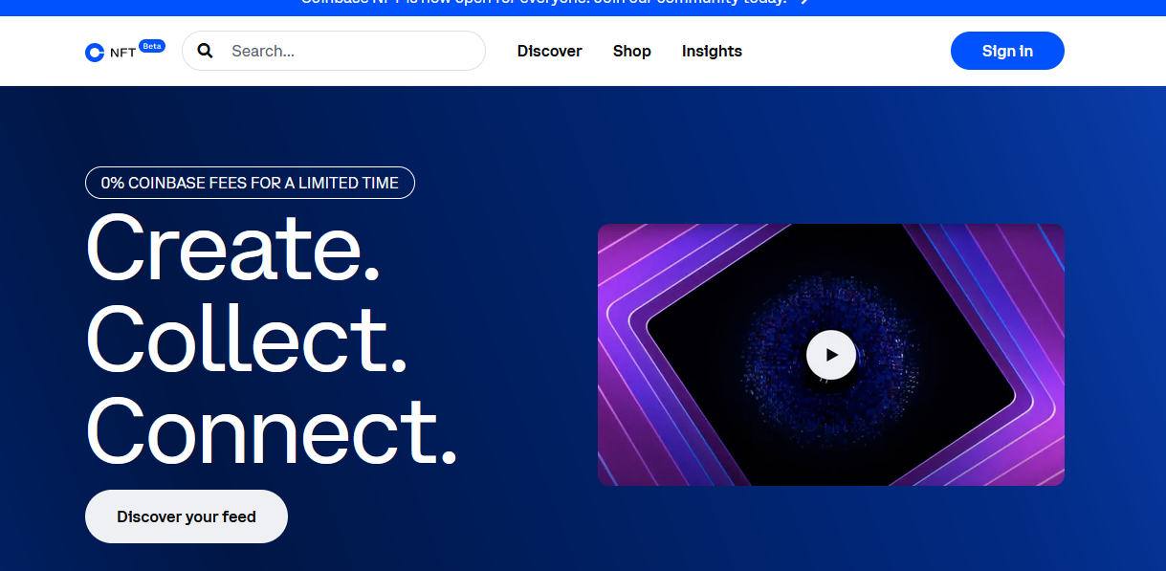

SHORT HISTORY
Coinbase was founded in 2012 by Brian Armstrong and Fred Ehrsam. Armstrong was previously an engineer at Airbnb while Ehrsam was a trader at Goldman Sachs.
Coinbase is based in San Francisco, California, and also operates offices in Portland, Oregon, and New York, New York. The company also has offices in Ireland, Japan, and the United Kingdom. In total, Coinbase has over 1,000 employees in six locations.
After the wake of the global financial crisis in 2009, cryptocurrencies have risen as a new asset class that has seen extraordinary returns in the past decade. And some other forms of cryptocurrencies such as Litecoin, Ethereum, Ripple, Tether, and Bitcoin Cash soon followed.
- In 2011, with people investing in multiple crypto assets at the same time, this created an opportunity for Coinbase founders Brian Armstrong and Fred Ehrsam to create a platform where a single place to manage all of their crypto assets safely and efficiently.

- In 2012, eventually Coinbase launched an App, https://www.coinbase.com/
- Users could easily create a Coinbase account on either the company’s website or a mobile app without any costs.
- Once the account has been made and a bank account has been linked, users can now begin trading instantaneously.
- Services to buy and sell bitcoins through bank transfers.

- In 2015 after gaining trust, the company launched a US-based bitcoin exchange for professional traders called Coinbase Exchange https://www.coinbase.com/exchange

- In 2019, a potential cyber attack was blocked by the company’s security team. No cryptocurrency was stolen. In the same year, the company also generated around $543 million in revenues, up from $529 million generated from the previous year.

- In 2020, Coinbase announced that it will be offering a Visa debit card program as well as an IPO by the end of the year or early 2021.

- Now in current year 2022, it has launched NFT Marketplace on date 04-05-2022, https://nft.coinbase.com/ with new feature similar to an Instagram profile.
- Coinbase is also aiming to implement a “web3 social marketplace.

MAIN FUTURES
- 0% Coinbase fees for a limited time.
(No transaction fee on buy & sell (besides Ethereum gas costs and creator-
implemented royalties) but will eventually implement a “low, single-digit fee”).

II) Explore collections
All the hottest NFT collections are on Coinbase NFT

III) Build your community
Find and follow creators and collectors

IV) Shop NFT.
This product is more than just buying and selling, it is about building your community,

V) Insights.
This future allows to see individuals and their separate collection wall managed by an individual along social-media (NFT community).
VI) A user’s “follower graph,” which they will be able to take with them from platform to platform.

Coinbase NFT aims to implement a Web3 social marketplace
VII) Coinbase NFT aims to implement a Web3 social marketplace to allow creators, artists, and collectors to interact directly. NFT enthusiasts at the top of Coinbase NFT’s waiting list get the opportunity to participate in beta testing of the platform. This includes creating a profile and showcasing NFT collections. Also, users can follow, comment, and like other profiles and content via Coinbase’s NFT marketplace.

EXPLORE COLLECTION & BUILD YOUR COMMUNITY ON SAME MARKETPLACE SAME AS INSTAGRAM OR FACEBOOK etc.
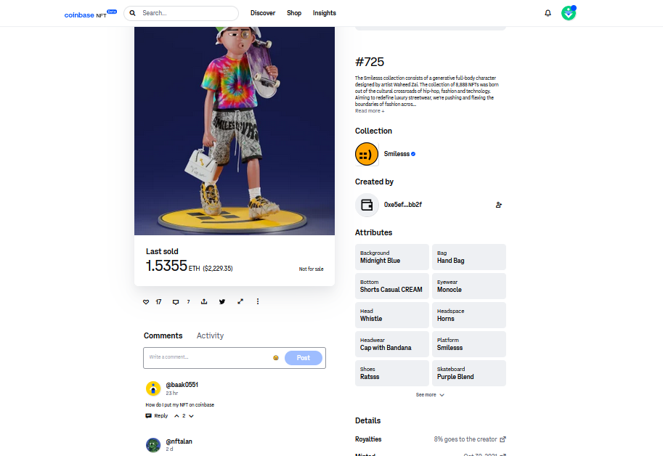

- New flavor with a social-media spin that could distinguish Coinbase from competitors. where one would showcase their photographs — but in this case, it’s NFTs. People can follow, comment and interact with one another through its marketplace.

- This platform also allows user to showcase their personal profile and follow accounts whose content appears in a “For You” feed, which is visually similar to social-media platforms like Instagram and TikTok. Users also be able to “like” and comment on each other's posts.

- Although features like commenting or following other NFT accounts aren’t on-chain or decentralized, the company’s goal is to progressively decentralize all those features and make them on-chain over time.

RESEARCH PARAMETERS
Parameters | Details
Supported Blockchains | Ethereum (other blockchain will support in future)
Payment Methods | Ether, also via credit card (New Future)
Buyer Fee | 0% (No fee for limited time) (eventually will implement Low-single-digit fee)
Seller Fee | 0% (No fee for limited time)
Royalties | besides Ethereum gas costs and creator-implemented royalties
Listing Type/ Selling Methods | Direct Sale
Categories | - NFT art  - Generative art  - Crypto culture & NFT art  - NFT gaming  - Crypto's social layer  - All roads lead to Web3
Recommended Wallets | Coinbase, Metamask, WalletConnect,
Support File Format | - Images (.jpg, .png, .svg)  - GIFs (.gif)  - Videos (.mov, .mp4)  - Videos can be uploaded with or without audio.  https://help.coinbase.com/en/nft/manage/file-support
Coinbase NFT does not | - Audio only (.mp3, .wav)  - Text (.txt, .doc)
Max File Size | 2MB maximum
Media Storage | BitTorrent and Kademlia DHT networks
Decentralization | Yes
Protocol Supported | lorem ipsum, lorem ipsum,
Ownership | Yes (digital proof of ownership)
Licensing | Open Source
Governance | No
Staking | On coinbase exchange
KYC | No
Regulation | lorem ipsum,lorem ipsum,
Company Registration | US-based crypto firm, Coinbase is a leading North American crypto exchange and was publicly listed on Nasdaq in 2021
Community Engagement | Yes (user can make profile and showcase its NFT. It allow comments like other social media plate form

CONTRIBUTORS
Name | Email | Role
Ali Wisam | raliwisaam73@gmail.com | Team Leader
Asif Ali | asif.ham515@gmail.com | Researcher
Ruwaifa Tahir | ruwaifatahir@gmail.com | Repo

RESOURCE

- https://docs.cloud.coinbase.com/wallet-sdk/docs/welcome
- https://www.coinbase.com/exchange
- https://nft.coinbase.com/
- https://docs.cloud.coinbase.com/wallet-sdk/docs/welcome
- https://www.coinbase.com/exchange
- https://nft.coinbase.com/
- https://successstory.com/companies/coinbase
- https://successstory.com/companies/snowflake
- https://www.coindesk.com/business/2022/04/20/coinbase-nft-marketplace-goes-live-can-it-rival-opensea/
- https://academy.moralis.io/blog/coinbase-nft-exploring-coinbases-nft-marketplace
- https://docs.cloud.coinbase.com/sign-in-with-coinbase/docs/api-users
- https://techcrunch.com/2022/04/20/coinbase-launches-nft-marketplace-in-hopes-of-appealing-to-crypto-and-mainstream-users/
- https://github.com/coinbase/nft-dapp-starter-kit
Coinbase supports an ecosystem of approximately 11,000 financial institutions.

COINBASE EXCHANGE
Coinbase facilitates simple asset swaps using a sleek interface. Users can deposit fiat currencies and exchange them for crypto assets or vice versa. Plus, Coinbase offers staking rewards for locking up crypto assets.
. This includes limit/stop orders and trading indicators. Both Coinbase and Coinbase Pro use state-of-the-art security features. Moreover, around 98% of users’ assets are stored offline in cold storage. Plus, all users must implement two-factor authentication. Other product offerings include the self-custodial Coinbase Wallet, Coinbase Intelligence, and the Coinbase crypto debit card

DAO (decentralized autonomous organization)
some marketplaces implement a decentralized autonomous organization (DAO) model to facilitate community governance.

https://www.forbesindia.com/article/crypto-made-easy/coinbase-opens-nft-marketplace-to-all/76007/1
/forbes writer Twitter: @bhardwajshash

