LAB ASSIGNMENT – 3
DATE: 02/02/2026
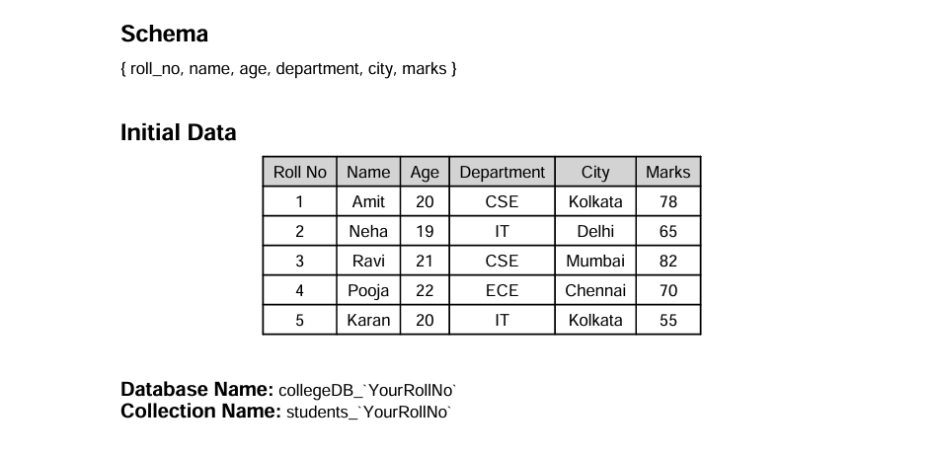
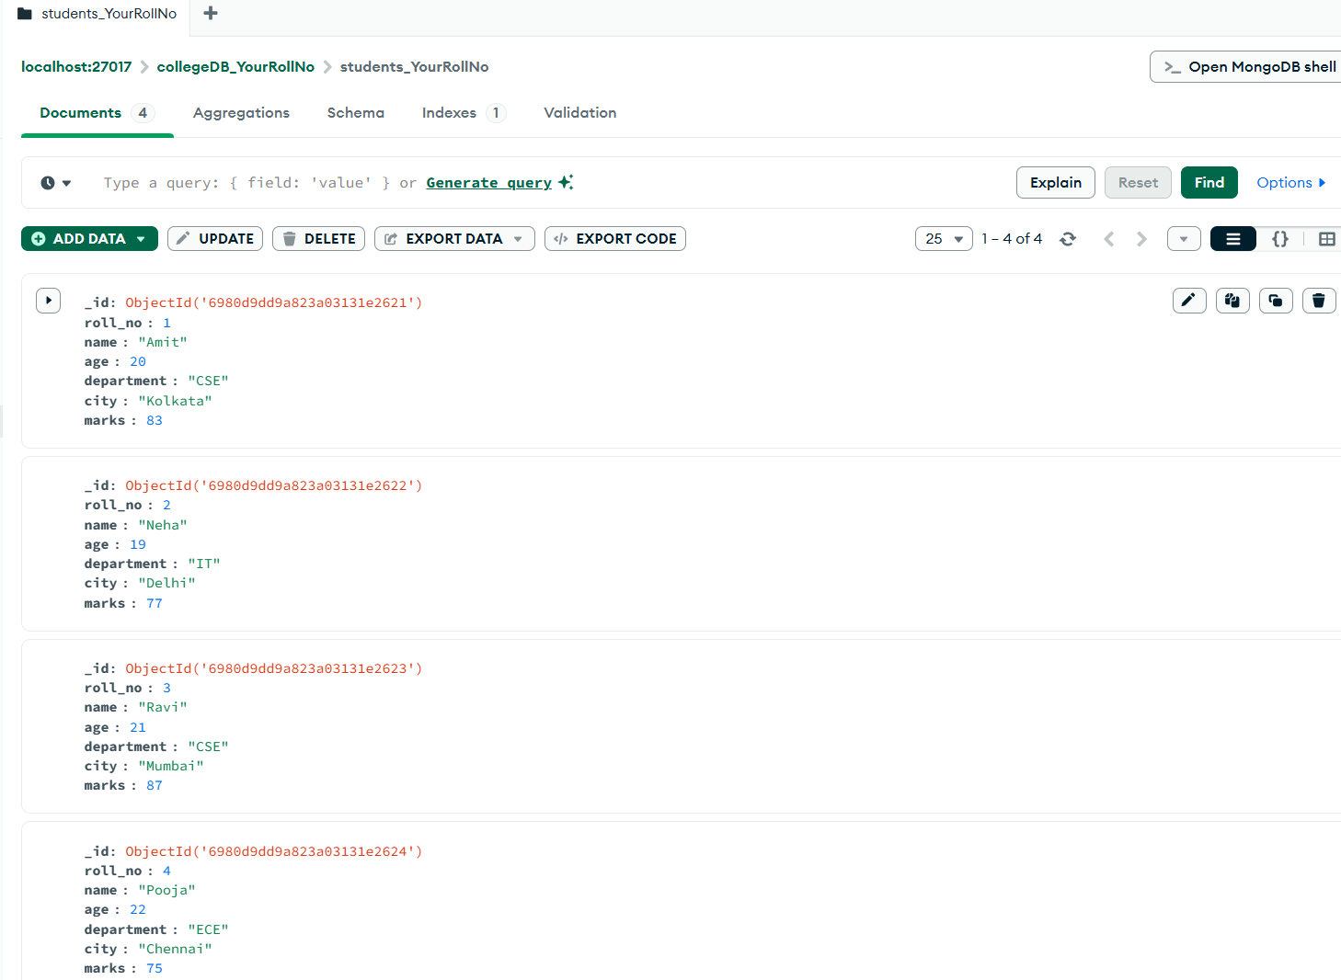
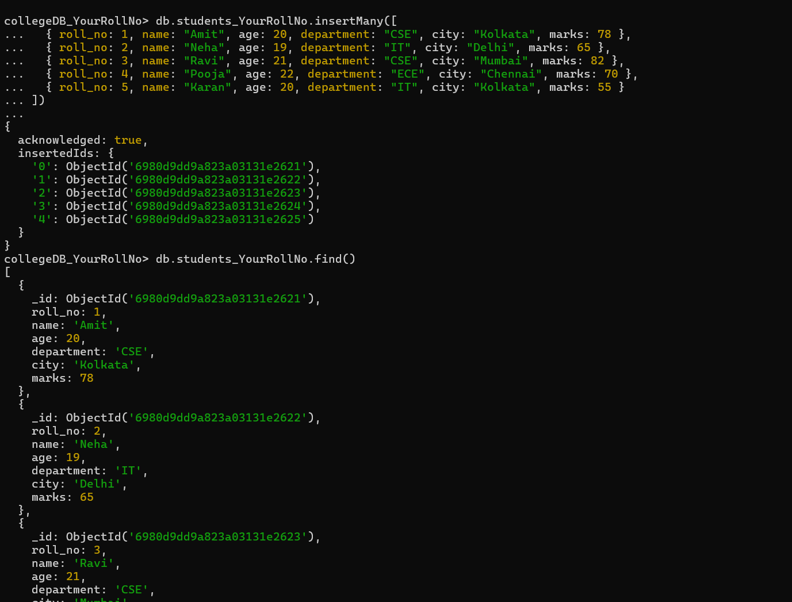
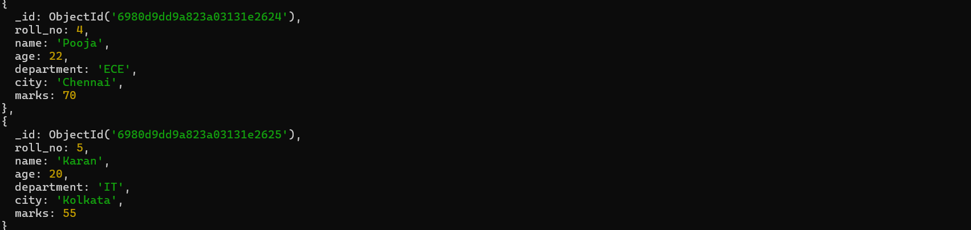

LAB Questions:
1)Display all students records from the collection.
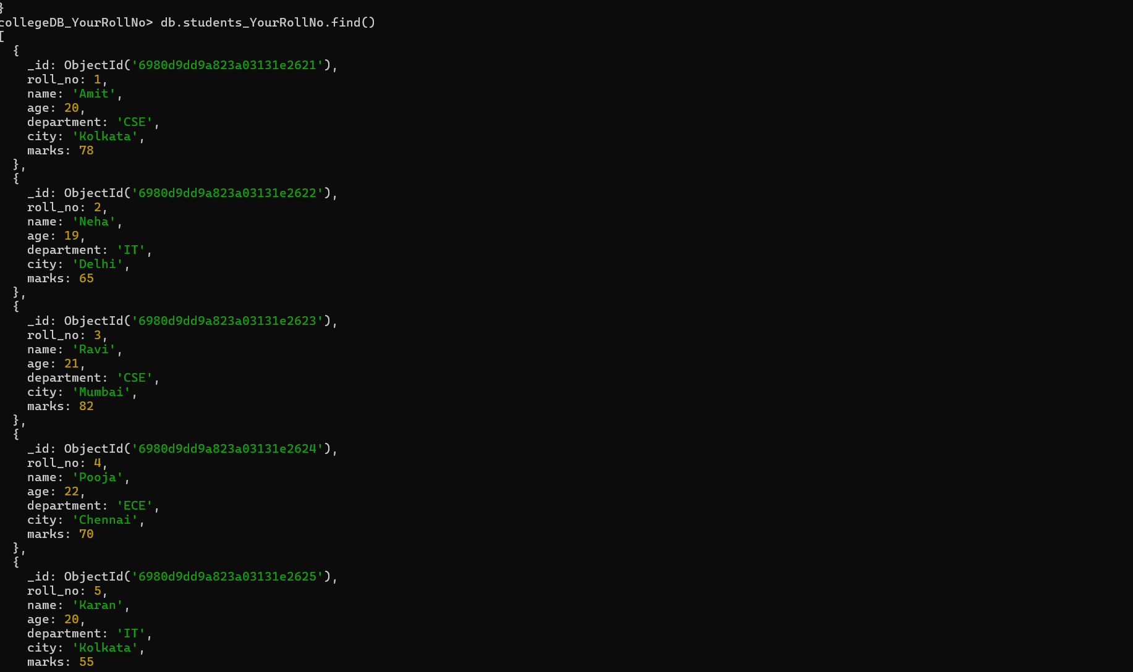
2)Display only the name and department of all students.
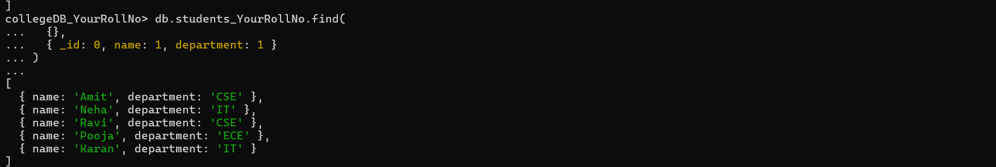
3)Find students belonging to CSE department.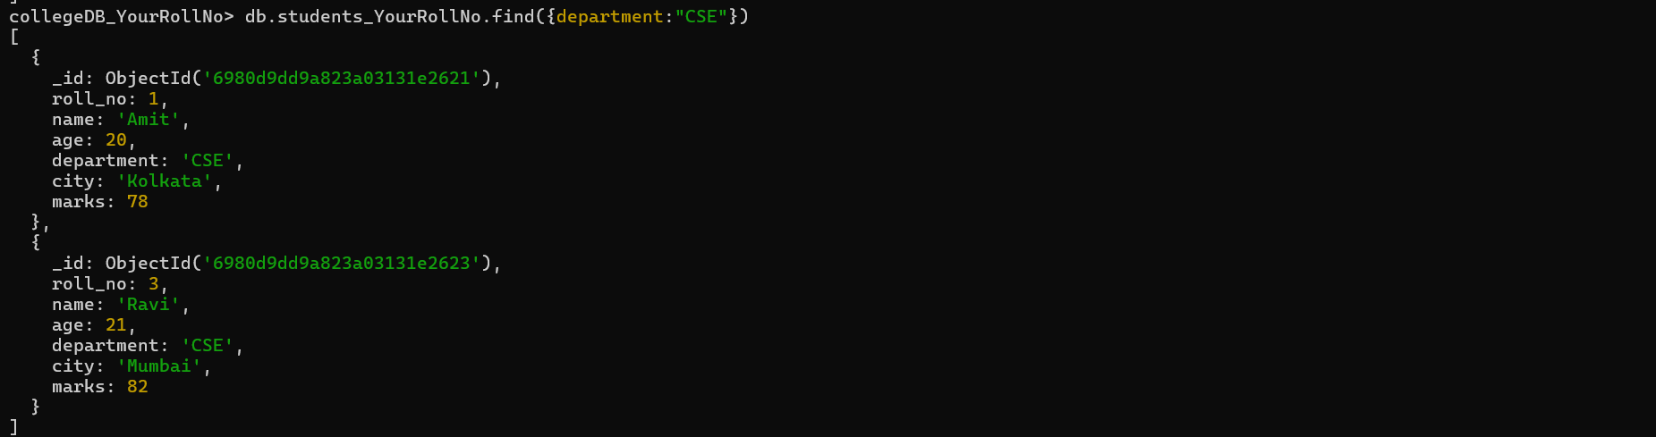

4)Find storage whose age is greater than 20.
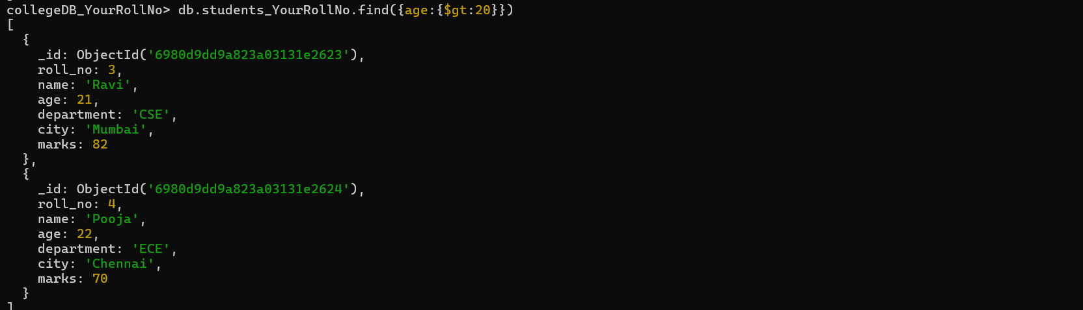

5)Find students whose scored less than 70 marks.
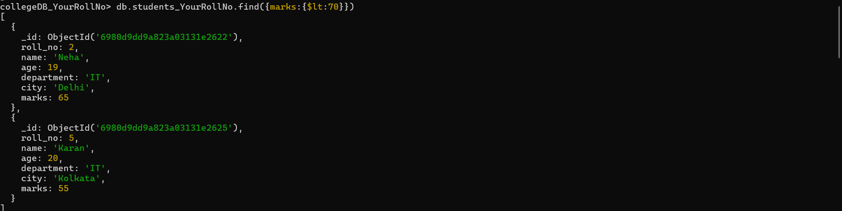

6)Display students belonging to Kolkata city.
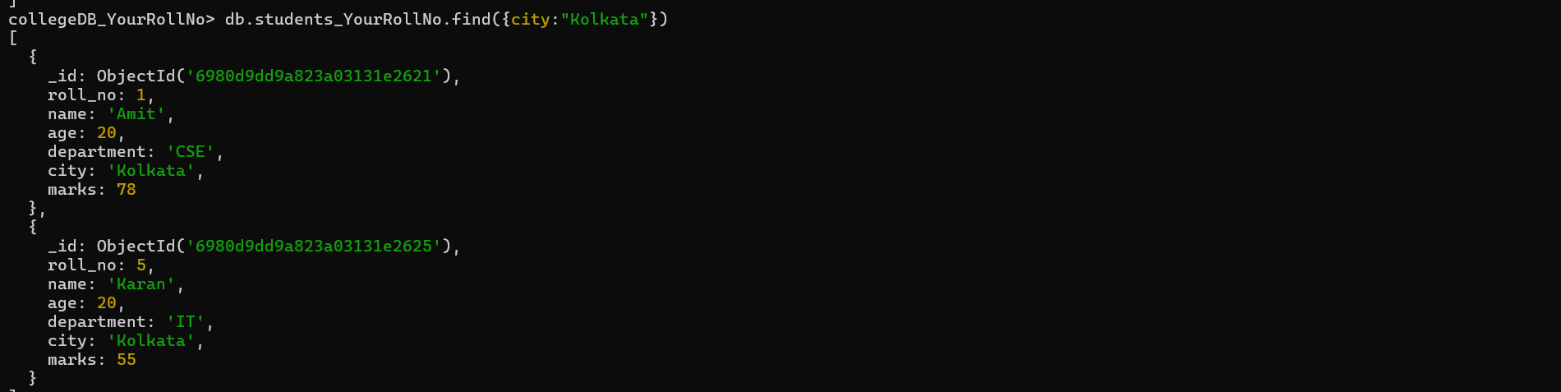

7)Sort students by age in ascending orders.
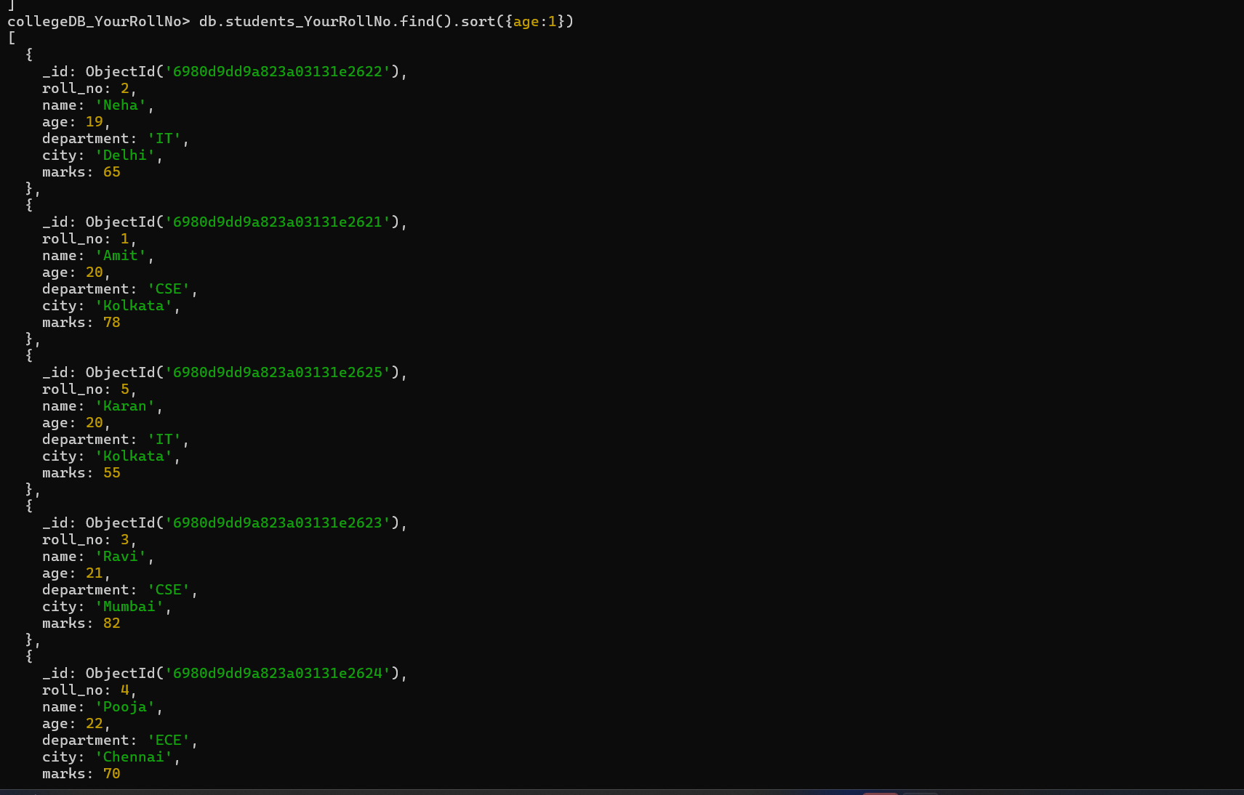
8)Sort students by marks in descending orders.
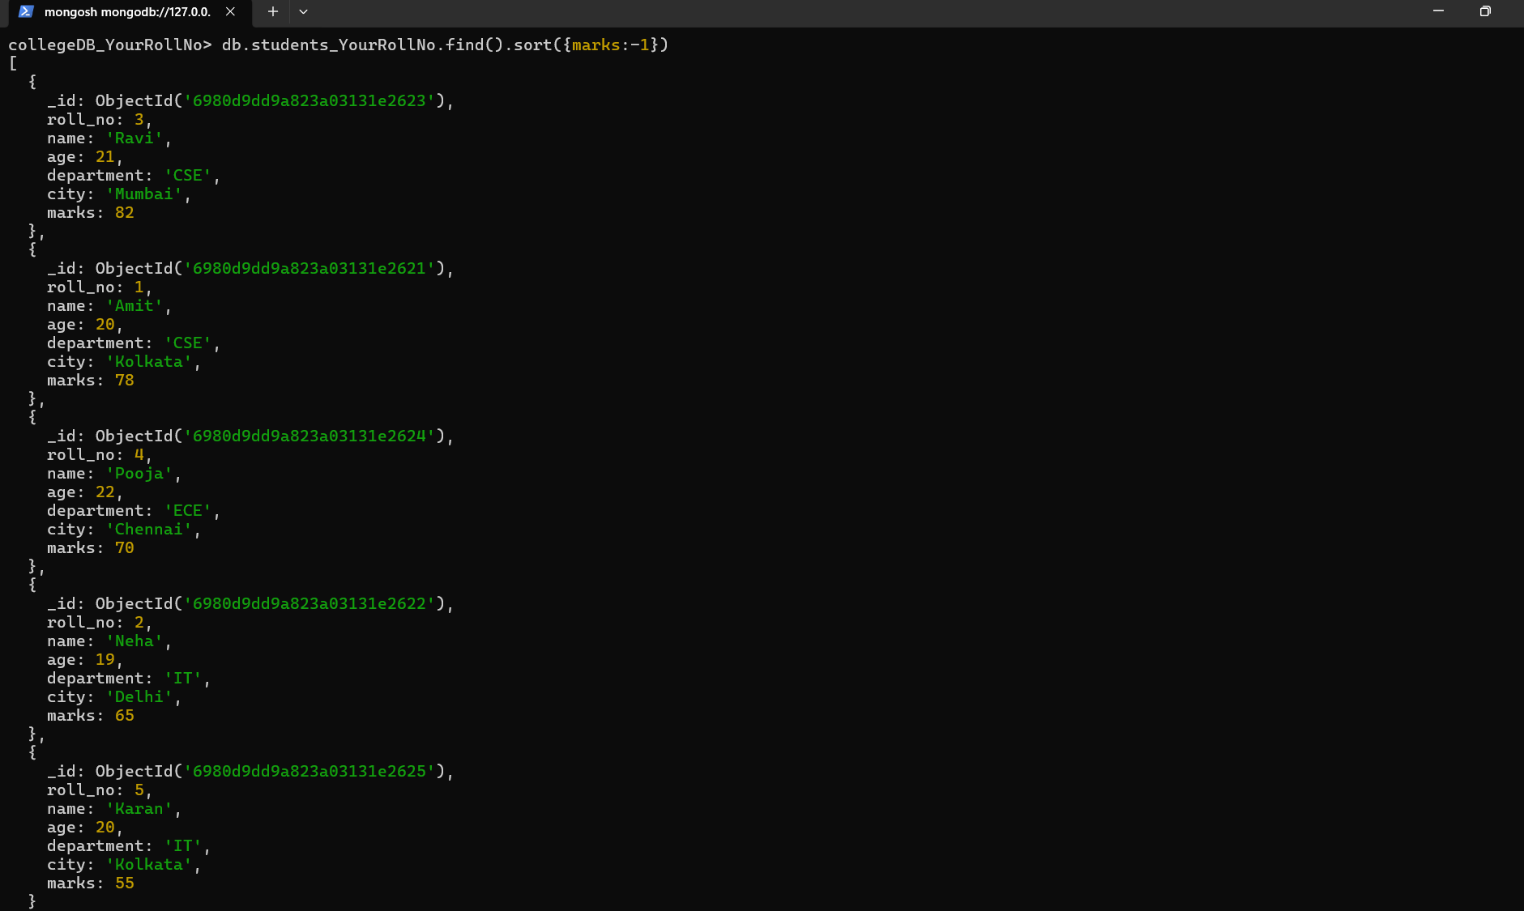
9)Display only the first three students records.
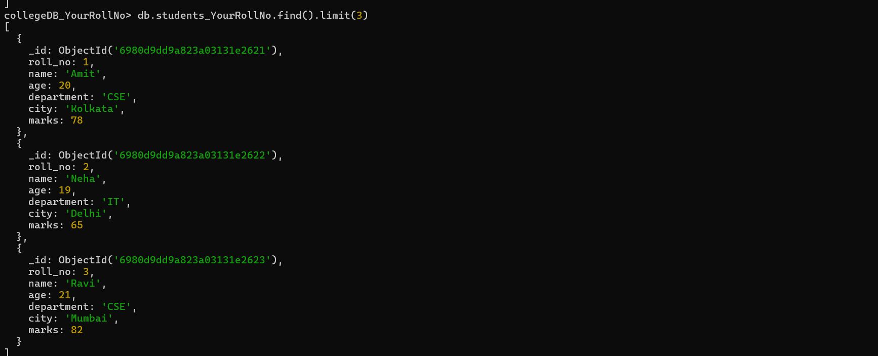
10)Update the marks of student Neha to 72.
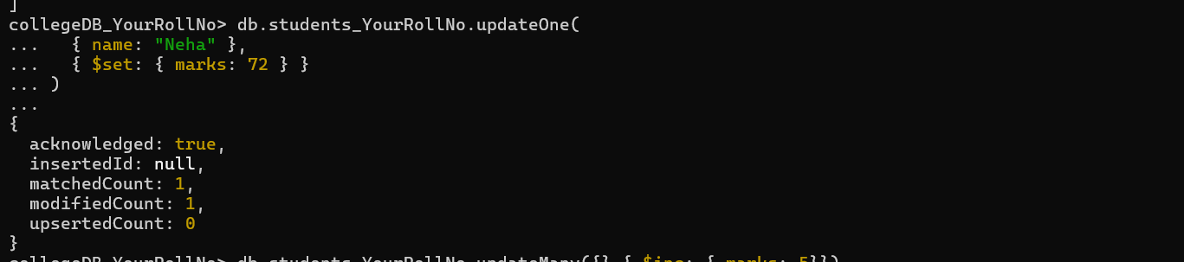
11)Increase the marks of all students by 5.
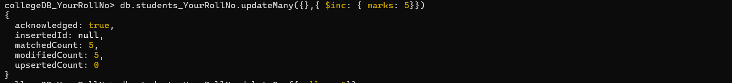
12)Delete the student having roll number 5.

13)Find students whose age is between 20 and 22.
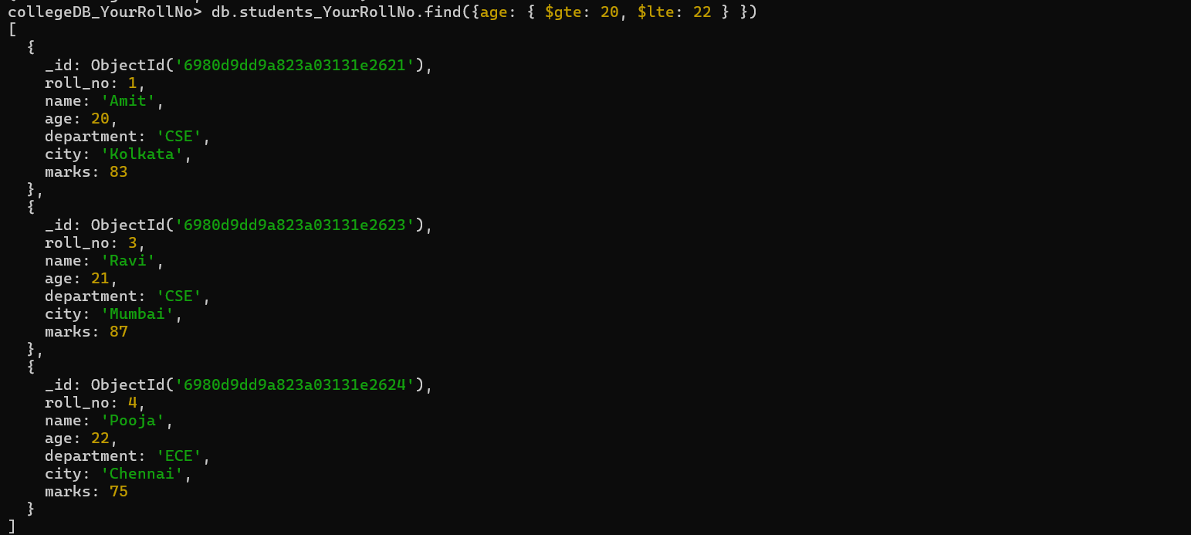
14)Display students belonging to either CSE or IT departments.
