UBAKA TECH LTD
Internal Systems MIS

ENTITY RELATIONSHIP DIAGRAM (ERD) — ESMK MIS
Project: School NFC Pocket Money & Visibility Platform (Phase 1: Pocket Money Module)
Company: Ubaka Tech Ltd
Author: benit@ubakatech.co.rw
Version: 1.0
Date: September 16, 2026
Companion documents: SRS v1.1, PRD v1.0, SAD v1.0 — this document defines the actual database tables and relationships that implement them.

1. Purpose
This document defines the data model: the tables (entities), their fields, and how they relate to each other. Every table and relationship here exists to satisfy a specific rule already agreed in the SRS — for example, 'a card can never be linked to more than one active student' (SRS FR-1.4) and 'no existing ledger entry can ever be edited or deleted' (SRS FR-5.1) are not just behaviors the code must enforce; they are structural decisions in how these tables are built.

2. Entity Relationship Diagram
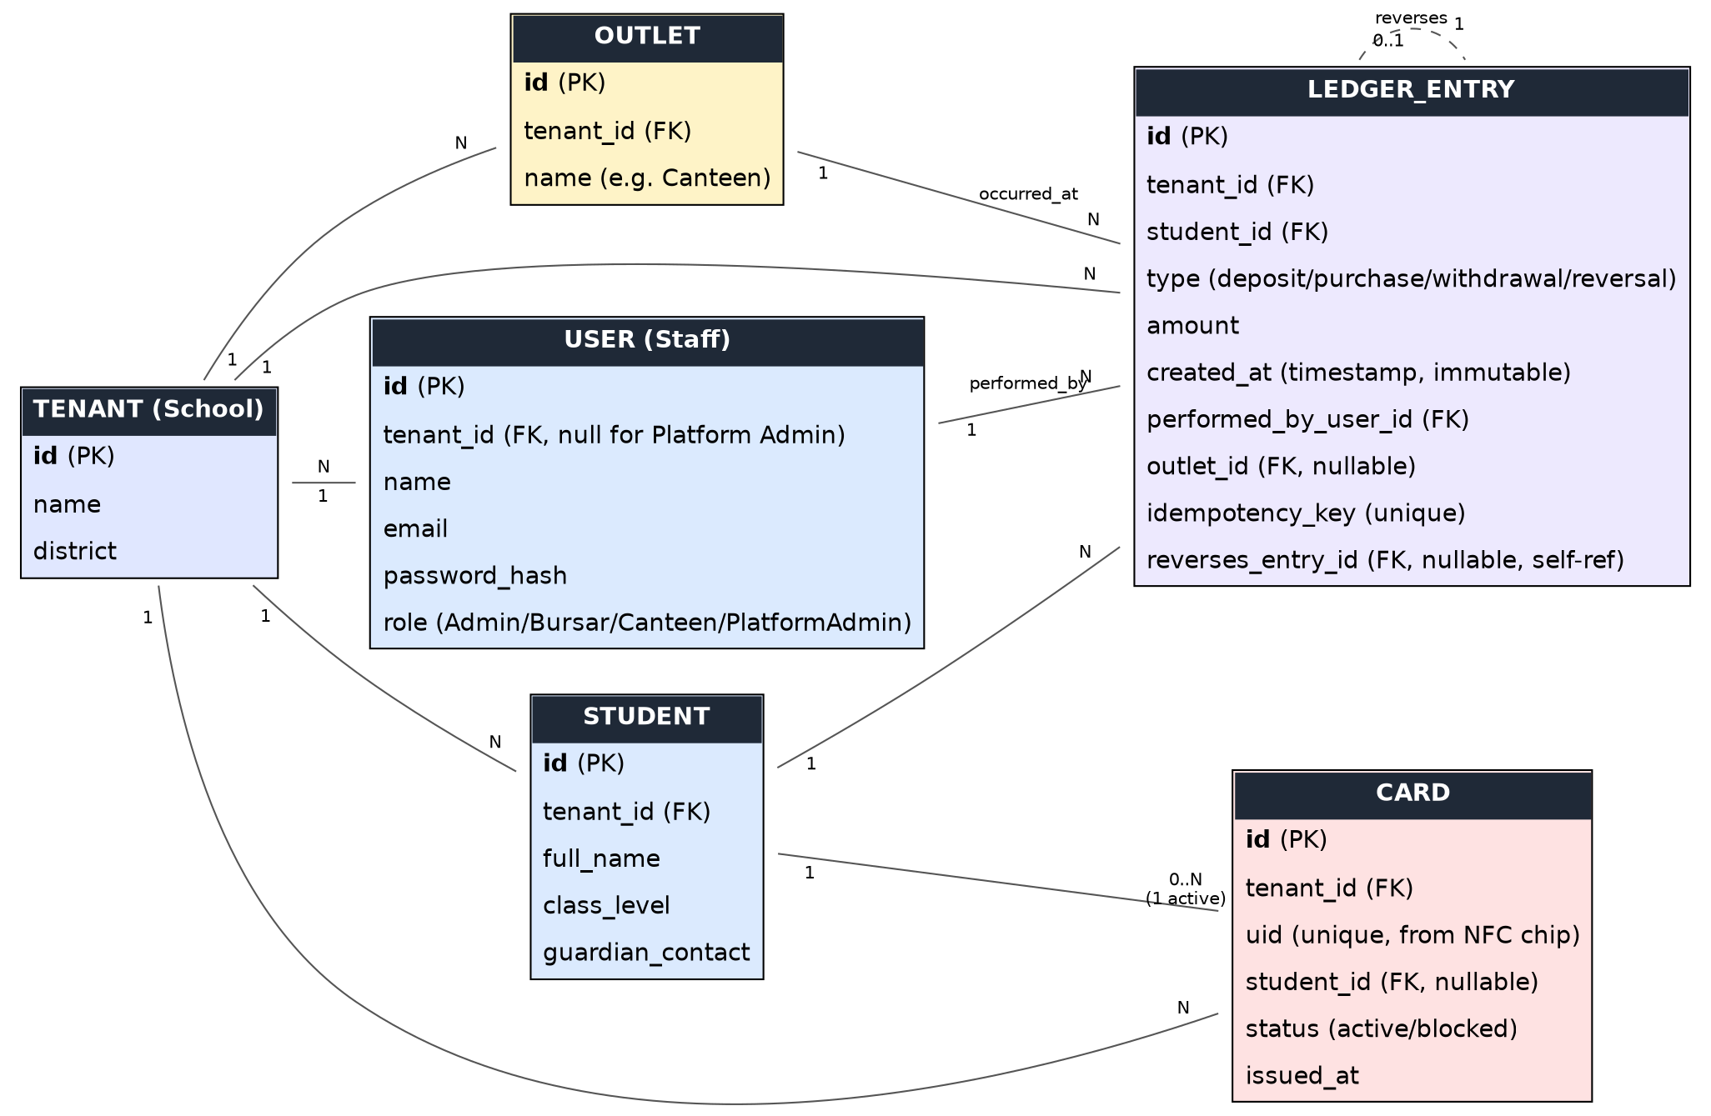
Figure 1 — ESMK MIS Phase 1 data model

3. Entities

3.1 TENANT (School)
Represents one school using the platform. Every other entity below belongs to exactly one tenant, which is what makes SRS FR-8.1 (one school's data is never visible to another) enforceable at the data level, not just in application code.
Field | Type | Notes
id | Primary Key | Unique identifier for the school
name | Text | School name, e.g. Ecole Secondaire Sancta Maria de Karambo
district | Text | e.g. Gicumbi District

3.2 USER (Staff)
Any staff member who logs into the system: Director/Admin, Bursar, Canteen Staff, or a Ubaka Tech Platform Admin. The role field drives what that user is allowed to do, matching the roles table in the SRS (Section 2.3).
Field | Type | Notes
id | Primary Key
tenant_id | Foreign Key -> Tenant | Null only for a Platform Admin, who is not tied to one school
name | Text
email | Text, unique | Used to log in
password_hash | Text | Never stored in plain text (SRS NFR-5)
role | Enum | Admin / Bursar / Canteen Staff / Platform Admin

3.3 STUDENT
One record per enrolled student. Holds only what the Pocket Money module needs — full academic records stay in CAMIS, not here.
Field | Type | Notes
id | Primary Key
tenant_id | Foreign Key -> Tenant
full_name | Text
class_level | Text | e.g. S4, S6 MPC
guardian_contact | Text | Phone number for the parent/guardian

3.4 CARD
Represents one physical NFC card. Deliberately holds no balance and no student personal data (SAD Section 3.1) — it is only an identity pointer.
Field | Type | Notes
id | Primary Key
tenant_id | Foreign Key -> Tenant
uid | Text, unique | The physical NFC chip's own identifier
student_id | Foreign Key -> Student, nullable | Null if the card has not been issued yet, or has been deactivated
status | Enum | active / blocked — enforces SRS FR-1.4: only one active card per student at a time
issued_at | Timestamp
Design note: when a card is lost (SRS FR-1.3), the old row's status is set to blocked and its student_id is cleared, then a new Card row is created linking the same student_id. The student's balance is untouched because balance is never stored on the card — it lives entirely in the Ledger Entry history below.

3.5 OUTLET
A point of sale within the school — the canteen today, potentially a shop or library later. Kept as its own table now, even with only one outlet, because SRS FR-6.3 requires settlement summaries per outlet, and NFR-8 requires that future modules not force a redesign of this one.
Field | Type | Notes
id | Primary Key
tenant_id | Foreign Key -> Tenant
name | Text | e.g. Main Canteen

3.6 LEDGER_ENTRY
The single most important table in the system. Every deposit, purchase, withdrawal, and reversal is one row here — and rows are never updated or deleted after creation (SRS FR-5.1). A student's current balance is not a stored number; it is calculated by summing this table's rows for that student, which is exactly what makes the system auditable (SRS NFR-6).
Field | Type | Notes
id | Primary Key
tenant_id | Foreign Key -> Tenant
student_id | Foreign Key -> Student | Whose balance this entry affects
type | Enum | deposit / canteen_purchase / cash_withdrawal / reversal
amount | Decimal | Positive for deposits/reversal-credits, negative for purchases/withdrawals — sign convention is decided once here and used consistently everywhere
created_at | Timestamp | Set once, never changed
performed_by_user_id | Foreign Key -> User | Who carried out the action — required for the audit trail (SRS NFR-6)
outlet_id | Foreign Key -> Outlet, nullable | Set for canteen purchases; null for deposits and withdrawals
idempotency_key | Text, unique | Prevents a retried request from being charged twice (SRS FR-7)
reverses_entry_id | Foreign Key -> Ledger_Entry, nullable, self-referencing | Points to the original entry being corrected (SRS FR-5.2); left null for ordinary entries

4. Relationships Summary
- One Tenant has many Students, Users, Cards, Outlets, and Ledger Entries — and a record in any of those tables belongs to exactly one Tenant. This is the mechanism behind multi-tenancy (SAD Section 5).
- One Student can have many Cards over time (if replaced after loss/damage), but only one may be active at once — enforced by the Card.status field plus application logic, not by the database structure alone.
- One Student has many Ledger Entries — their entire financial history.
- One User (staff member) performs many Ledger Entries over time.
- One Outlet is the site of many Ledger Entries (specifically, canteen purchases).
- A Ledger Entry may optionally reference exactly one other Ledger Entry that it reverses — this is a self-referencing relationship, used only for corrections and refunds (SRS FR-5.2), and never for ordinary transactions.

5. Why Balance Is Not Its Own Table or Column
A natural first instinct is to give Student a balance field that gets updated on every transaction. This design deliberately avoids that. If balance were a single mutable number, a bug, a race condition, or a missed edge case could silently push it out of sync with reality, and there would be no way to reconstruct what went wrong. By instead deriving the balance from summing Ledger Entry rows, the number shown on the dashboard is always provably correct — it is calculated fresh from a permanent, append-only history, not trusted as a cached value. This is the same event-sourcing idea introduced in the SAD, now expressed as an actual table structure.

6. Approval
Role | Name | Date
Author | benit@ubakatech.co.rw | Sept 16, 2026
Reviewed by | asifiwe@ubakatech.co.rw
Ubaka Tech Ltd — www.ubakatech.co.rw — info@ubakatech.co.rw

