UBAKA TECH LTD
Internal Systems MIS

SYSTEM ARCHITECTURE DOCUMENT (SAD) — ESMK MIS
Project: School NFC Pocket Money & Visibility Platform (Phase 1: Pocket Money Module)
Company: Ubaka Tech Ltd
Author: benit@ubakatech.co.rw
Version: 1.0
Date: September 16, 2026
Companion documents: SRS v1.1 (behavior/requirements), PRD v1.0 (goals/scope) — this document defines the actual system structure that satisfies both.

1. Purpose
This document describes how the ESMK MIS Pocket Money module is structured internally: its components, how they communicate, where data lives, and why each decision was made. Every design choice here traces back to a specific requirement in the SRS — this is not a separate wishlist, it is the concrete implementation of what was already agreed.

2. Architecture Overview
The system follows a client-server architecture with three layers: the client layer (POS app and admin dashboard), the backend (API, authentication, ledger engine), and the data layer (PostgreSQL database plus its backup). In Phase 1, everything runs on a single server located at the school, reachable over the school's local network — not the public internet — matching the local-first, cost-conscious deployment decision made earlier for this pilot.
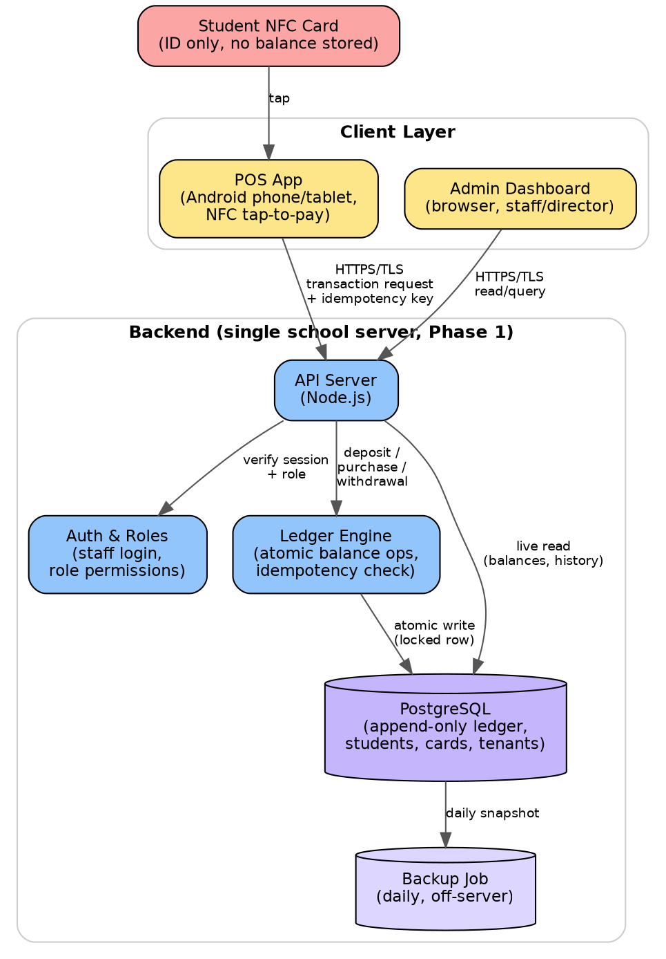
Figure 1 — Phase 1 system architecture and data flow

3. Components

3.1 Student NFC Card
Holds only a unique ID (UID) — no balance, no personal data. This is a deliberate constraint (SRS Section 2.5): the card is an identity token, never a store of value. If a card is lost, the data at risk is a meaningless number, not money or student information.

3.2 POS App (Client Layer)
Runs on an Android phone or tablet at the canteen. Reads the card's UID on tap, attaches a unique idempotency key generated on the device (SRS FR-7.1), and sends a transaction request to the API server over HTTPS. Never approves a transaction itself — it only ever displays what the server decided (SRS NFR-4: no offline approval).

3.3 Admin Dashboard (Client Layer)
A browser-based interface for the bursar and director. Reads live data from the API (balances, transaction history, settlement summaries) and lets authorized roles initiate deposits and withdrawals. Runs on whatever device staff already have — no special hardware needed.

3.4 API Server
The single entry point for every request from both the POS app and the dashboard. Its job is to validate the request, check the caller's identity and role with the Auth component, then hand off the actual money logic to the Ledger Engine. The API server itself holds no business logic about money — that separation keeps the riskiest code (balance changes) isolated in one place, which is easier to test and audit.

3.5 Auth & Roles
Verifies staff logins and enforces what each role is allowed to do, matching the roles table in the SRS (Section 2.3) and PRD (Section 4): Director/Admin, Bursar, Canteen Staff, Platform Admin. Every request to the API server passes through this check before anything else happens.

3.6 Ledger Engine
The core of the system. Handles every deposit, purchase, and withdrawal as a single atomic operation (SRS NFR-2): read balance, check sufficiency, write the new entry — all inside one database transaction, so no other request can interleave and cause a race condition. Also checks incoming idempotency keys here, rejecting any transaction ID it has already processed (SRS FR-7.2).

3.7 PostgreSQL Database
Stores students, cards, tenants (schools), and the ledger itself. The ledger table is append-only (SRS FR-5.1) — rows are never edited or deleted, only added. A student's current balance is not stored as a single number that gets overwritten; it is calculated from the sum of their ledger entries, which is what makes the system auditable and resistant to silent data corruption.

3.8 Backup Job
Runs daily, copying the database to storage physically separate from the primary server (SRS NFR-11), so a single hardware failure — a common risk with a single on-site server — cannot destroy both the live data and its backup at once.

4. Data Flow — Canteen Purchase (Worked Example)
Walking through Figure 1 for the most frequent action in the system:
- Student taps their card on the POS device at the canteen.
- POS app reads the card's UID, generates a unique idempotency key for this attempt, and sends both plus the purchase amount to the API server over HTTPS.
- API server checks the staff session is valid and authorized for this outlet (Auth & Roles).
- Request is passed to the Ledger Engine, which opens a database transaction: locks the student's row, checks the idempotency key has not been seen before, confirms the balance covers the purchase, writes the new ledger entry, and releases the lock — all as one atomic step.
- The result (approved or rejected) returns to the POS app within the 2-second target (SRS NFR-1).
- The new transaction appears on the admin dashboard immediately, without anyone refreshing the page.

5. Multi-Tenancy Approach
Every table that holds school-specific data (students, cards, transactions) includes a tenant_id column identifying which school it belongs to. Every query the API server runs is scoped by tenant_id, so one school's data is never visible to another's (SRS FR-8.1) — this is the shared-database, shared-tables approach, chosen over a separate database per school because it is far simpler to build and maintain for a small number of schools, while still keeping data fully separated at the query level. If a future school ever requires stricter physical isolation, this can be migrated to separate schemas or databases without changing the application logic above it.

6. Security Architecture
- All traffic between POS app, dashboard, and API server is encrypted with TLS/HTTPS, even on the local school network (SRS NFR-5).
- Staff authenticate with a login; POS devices operate under an authenticated staff session, not as anonymous devices.
- Passwords are never stored in plain text — only a securely hashed form.
- Every manual balance adjustment is tied to the specific staff account that made it, supporting the audit trail requirement (SRS NFR-6).
- High-risk actions such as large withdrawals require staff to visually confirm the student's identity — the card tap alone is not treated as sufficient proof of identity for these actions.

7. Technology Stack
Layer | Choice | Why
Backend runtime | Node.js | Matches the SRS's stated operating environment; strong ecosystem for building the API and real-time dashboard updates
Database | PostgreSQL | Strong transactional guarantees (row locking, atomic writes) required for safely handling money
POS client | Android app, NFC-enabled device | NFC tap-to-pay is the core interaction; Android has mature NFC support
Dashboard client | Browser-based, responsive web app | No install needed for staff; works on whatever device is available
Hosting (Phase 1) | Single on-site server on the school's local network | Keeps recurring cost near zero and avoids dependency on internet connectivity for daily operations

8. Deployment View (Phase 1)
The API server, database, and backup job all run on one machine physically located at the school, connected to the school's local network. The POS app and dashboard connect to this machine over WiFi/LAN — not the public internet — so the system continues working even if the school's internet connection is down, as long as the local network itself is up. This is a deliberate cost and reliability decision for the pilot; moving to cloud hosting later (for example, to support a Phase 2 parent portal) is a configuration change to where the same components run, not a redesign of the architecture itself.

9. Traceability
Every component in this document exists to satisfy a specific requirement already agreed in the SRS or PRD. Nothing here introduces new scope — this document answers 'how do we build what we already agreed to build,' not 'what else should we build.'

10. Approval
Role | Name | Date
Author | benit@ubakatech.co.rw | Sept 16, 2026
Reviewed by | asifiwe@ubakatech.co.rw
Ubaka Tech Ltd — www.ubakatech.co.rw — info@ubakatech.co.rw

