UBAKA TECH LTD
Internal Systems MIS

UI/UX PAGE INVENTORY & WIREFRAMES — ESMK MIS
Project: School NFC Pocket Money & Visibility Platform (Phase 1: Pocket Money Module)
Company: Ubaka Tech Ltd
Author: benit@ubakatech.co.rw
Version: 1.0 — Wireframe stage (low-fidelity)
Date: September 16, 2026
Companion documents: SRS v1.1, PRD v1.0, SAD v1.0, ERD v1.0, RAB v1.0 — every screen below exists to satisfy a specific requirement already agreed in those documents.

1. Purpose and Stage
This document inventories every screen the Phase 1 system needs, and shows a low-fidelity wireframe for each of the three highest-priority ones. Wireframes are deliberately plain — boxes, placeholder text, no color scheme or branding decisions yet — because the goal at this stage is to agree on what information appears where and what a user can do on each screen, before any time is spent on visual polish. Mockups (styled, on-brand) and a clickable prototype come after this wireframe set is agreed, not before.

2. Full Page Inventory
Screen | Used by | Purpose | Related requirement
Staff Login | All staff roles | Authenticate before any action is allowed | SRS NFR-5
POS: Tap to Pay (idle) | Canteen Staff | Wait for a card tap, show amount to charge | SRS FR-3.1
POS: Approved result | Canteen Staff | Confirm a successful purchase and new balance | SRS FR-3.5, FR-3.6
POS: Rejected result | Canteen Staff | Show why a tap failed (balance/connection) | SRS FR-3.3, FR-3.4, NFR-4
Bursar Console: Find Student | Bursar | Look up a student before acting on their account | SRS FR-2.1, FR-4.1
Bursar Console: Record Transaction | Bursar | Deposit or withdraw for the found student | SRS FR-2, FR-4
Bursar Console: Student History | Bursar | View that student's full ledger | SRS FR-6.2
Card Management | Bursar, Admin | Issue a new card, deactivate a lost one | SRS FR-1.2, FR-1.3
Admin Dashboard: Overview | Director/Admin, Bursar | Live summary + live transaction feed, school-wide | SRS FR-6.1, FR-6.2
Admin Dashboard: Settlement | Director/Admin, Bursar | Reconcile canteen sales against bursar records | SRS FR-6.3
Admin: Reports Export | Director/Admin, Bursar | Download transaction/settlement reports | SRS FR-6.4
Admin: Staff Accounts | Director/Admin | Create/deactivate staff logins, assign roles | RAB Section 3
Platform Admin: School Onboarding | Ubaka Tech Platform Admin | Set up a new school tenant and its first admin | SRS FR-8.3
Wireframes for the three screens marked below are included in this document because they are the highest-traffic, highest-risk screens — used constantly (POS), handling money directly (Bursar Console), and the primary trust-building tool for the school (Admin Dashboard). The remaining screens follow the same visual language once these three are agreed, and will be wireframed in the same pass before development begins.

3. Wireframe — POS Tap-to-Pay Flow
Three states of the same screen: idle (waiting for a tap), approved, and rejected. This is deliberately the simplest possible flow — SRS NFR-9 requires canteen staff to learn this in under 15 minutes, which means every unnecessary tap, button, or decision on this screen is a design mistake, not a minor detail.
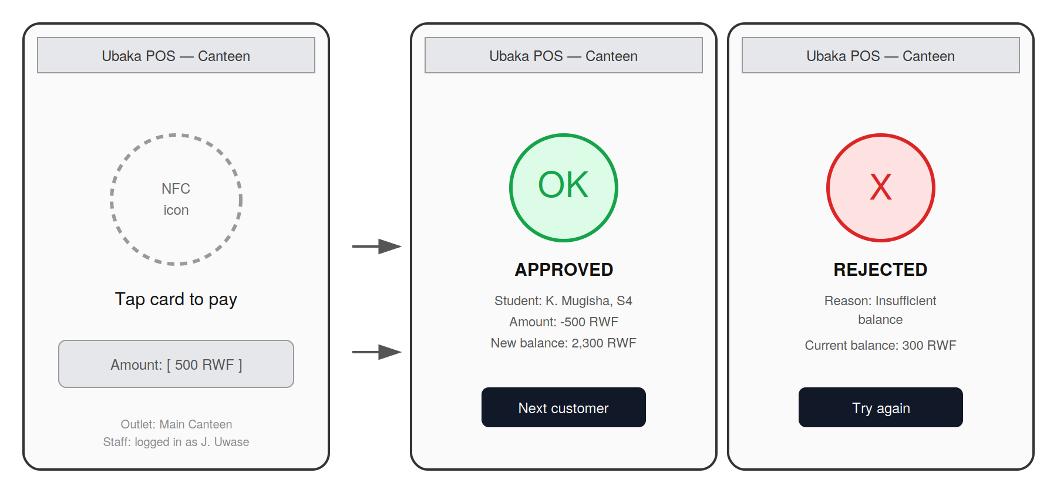
Figure 1 — POS App: idle, approved, and rejected states
- Idle state shows the amount and outlet clearly before any tap happens, so staff confirm the price is right before the student taps.
- Approved and Rejected are visually distinct at a glance (green vs. red) — a busy lunch queue needs an answer readable in under a second, not read carefully.
- Rejected always states a reason (SRS FR-3.3/FR-3.4) — never just a generic failure, since 'insufficient balance' and 'no connection' need different staff responses.

4. Wireframe — Bursar Console
The bursar's primary workspace: find a student, see their balance and card status at a glance, record a deposit or withdrawal, and see their recent history without leaving the page.
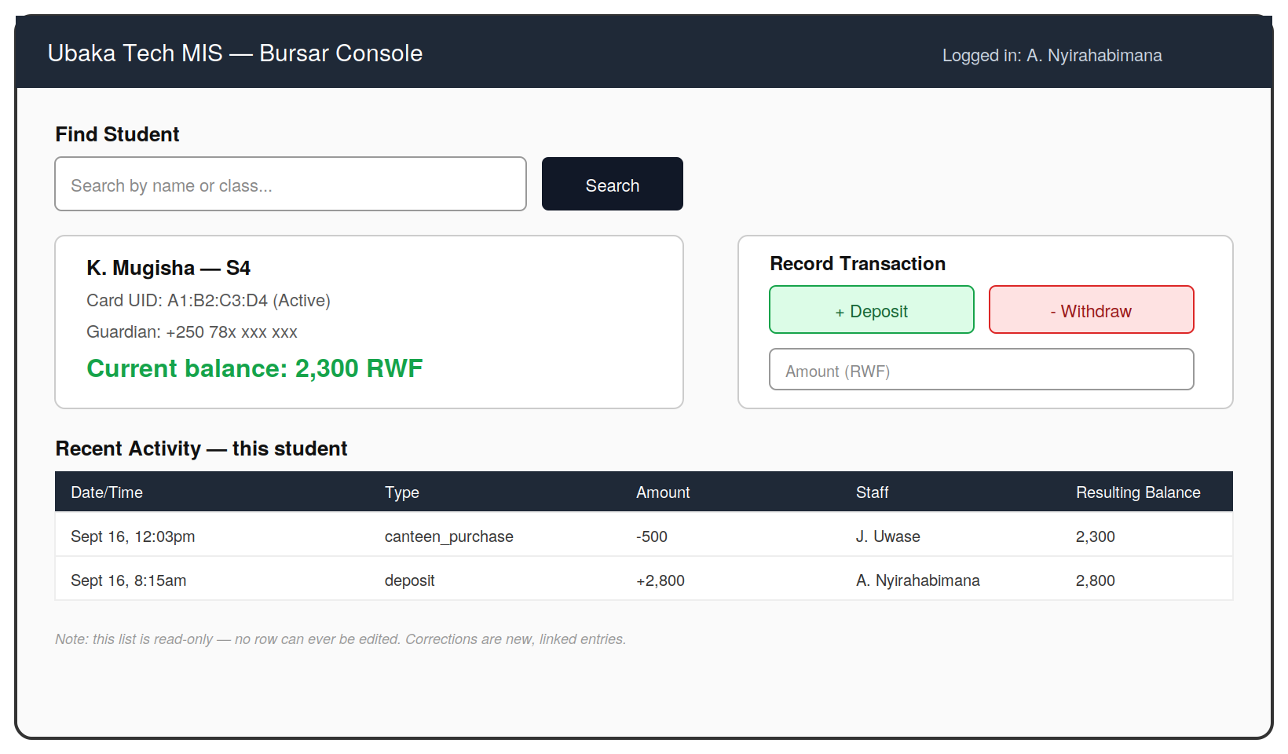
Figure 2 — Bursar Console: student lookup and transaction recording
- Deposit and Withdraw are visually separated (green/red) to reduce the chance of a bursar selecting the wrong action under time pressure.
- Card status (Active/Blocked) is shown directly on the student card, since card issues (SRS FR-1.3) are handled from this same screen.
- The note at the bottom is a deliberate, permanent UI reminder of SRS FR-5.1 — no entry can be edited, only corrected with a new linked entry — so this constraint is visible to the person using the system, not just enforced silently.

5. Wireframe — Admin Dashboard
The director's and bursar's shared view of the whole school's activity. Built around SRS FR-6: everything on this screen updates live, with no manual refresh.
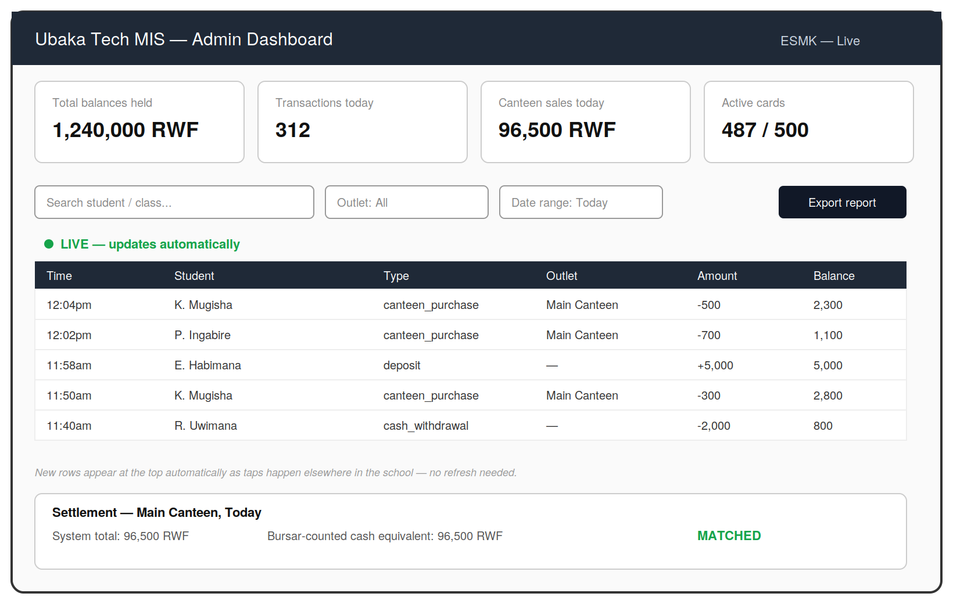
Figure 3 — Admin Dashboard: live overview and settlement
- Summary cards at the top answer the director's most common question at a glance — 'how much money is in the system right now' — without needing to read the full transaction table.
- The live feed (SRS FR-6.1) is explicitly labeled 'LIVE' so users understand new rows will appear on their own — an easy point of confusion if left unlabeled.
- The settlement panel exists specifically to satisfy SRS FR-6.3 — matching system totals against the bursar's own physical count, with a clear MATCHED/MISMATCHED signal.

6. What Comes Next
- Agreement on this wireframe set with your colleague and, if useful, a walkthrough with the school's bursar and a canteen staff member — the people who will actually use these screens daily.
- Mockups: the same layouts, restyled with an actual color scheme, logo, and typography choices.
- A clickable prototype connecting these screens together, used to validate the flow before writing production code.

7. Approval
Role | Name | Date
Author | benit@ubakatech.co.rw | Sept 16, 2026
Reviewed by | asifiwe@ubakatech.co.rw
Ubaka Tech Ltd — www.ubakatech.co.rw — info@ubakatech.co.rw

