All Data needed for final assembly:

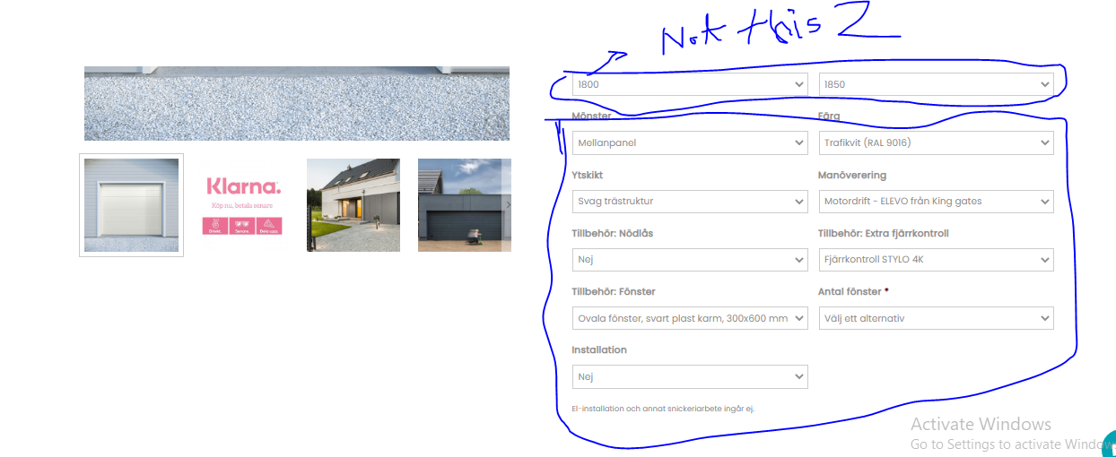All data except height and width in Anpassa garagedoor.(see below)

Home page content:

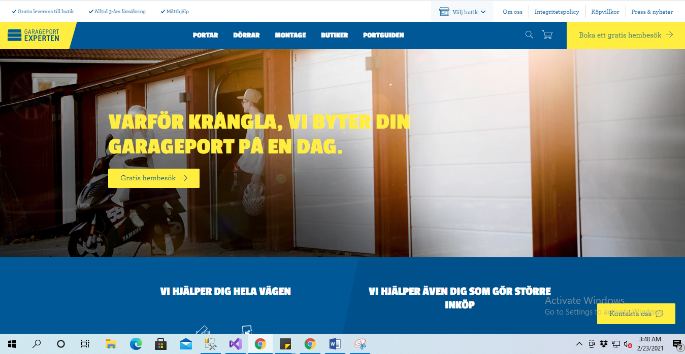

Industrial port:

These 3 images. Just confirm me should I use these same images or not.

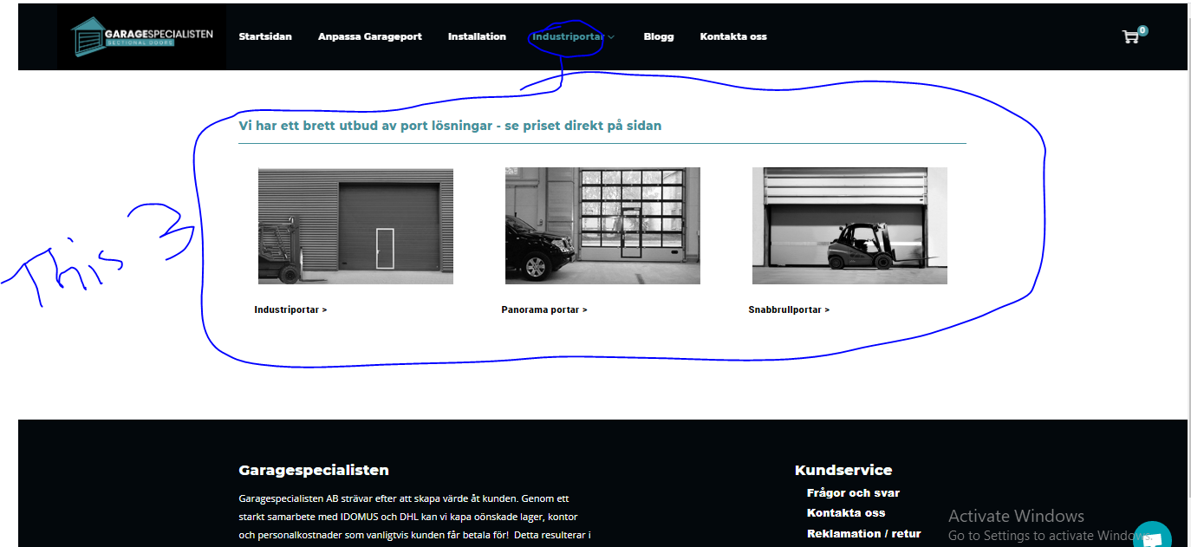

This icon in white color:

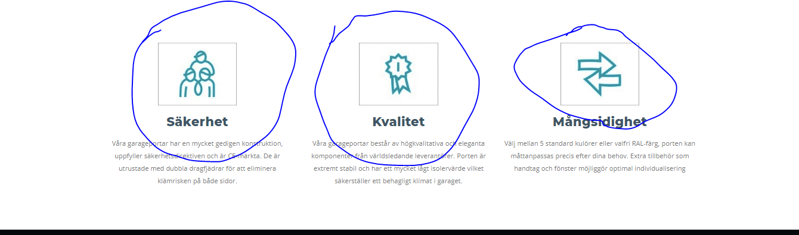

Base anpassa garagedoor:

Price

Image

Description

And all the value for selecting by customer.