**EDGE: BU-CSE Digital Skills Training**

**University of Barishal (BU)**

**Project Name**: **Economic Indicators Data Analysis of Various country.**

**Course name:** Computer Fundamentals and Office Applications (CFOA)

**Submitted To:** **Md Mahbub E Noor**

                        Lecturer

                        Dept. Of Computer Science & Engineering

                        University Of Barisal

**Submitted By**:

**Name:** Asiful Islam Rakib

**Roll No:** 01-029 -02  
 **Course**: Office, Batch 29

**Submission Date**: 08-10-2024.

Table of Contents

Project Report: 3

Abstract 3

Introduction 3

Details: 3

Analysis of GDP: 3

Analysis of Revenue: 4

Analysis of Unemployment: 4

Analysis of population: 5

Conclusion: 5

Project Report: **Various Economic Indicators Analysis of Various country.**

# Abstract

This analysis identifies maximum values of key economic indicators GDP, revenue, unemployment, and population across countries. It highlights the highest GDP and revenue levels, indicating economic strength, while examining peak unemployment rates that signal challenges. Population figures reveal demographic pressures, emphasizing the need for targeted policies to balance economic growth and workforce development in diverse national contexts.

# Introduction

This introduction examines the maximum values of critical economic indicators—GDP, revenue, unemployment, and population—across countries. By identifying extremes, we gain insights into global economic dynamics, highlighting top-performing nations and those facing challenges. Understanding these indicators provides a foundation for analyzing economic health, policy effectiveness, and the interplay between demographic factors and economic performance.

# Details:

# Analysis of GDP:

The U.S. leads in GDP, The countries represent the largest economies, driving global growth and influencing international trade dynamics significantly.

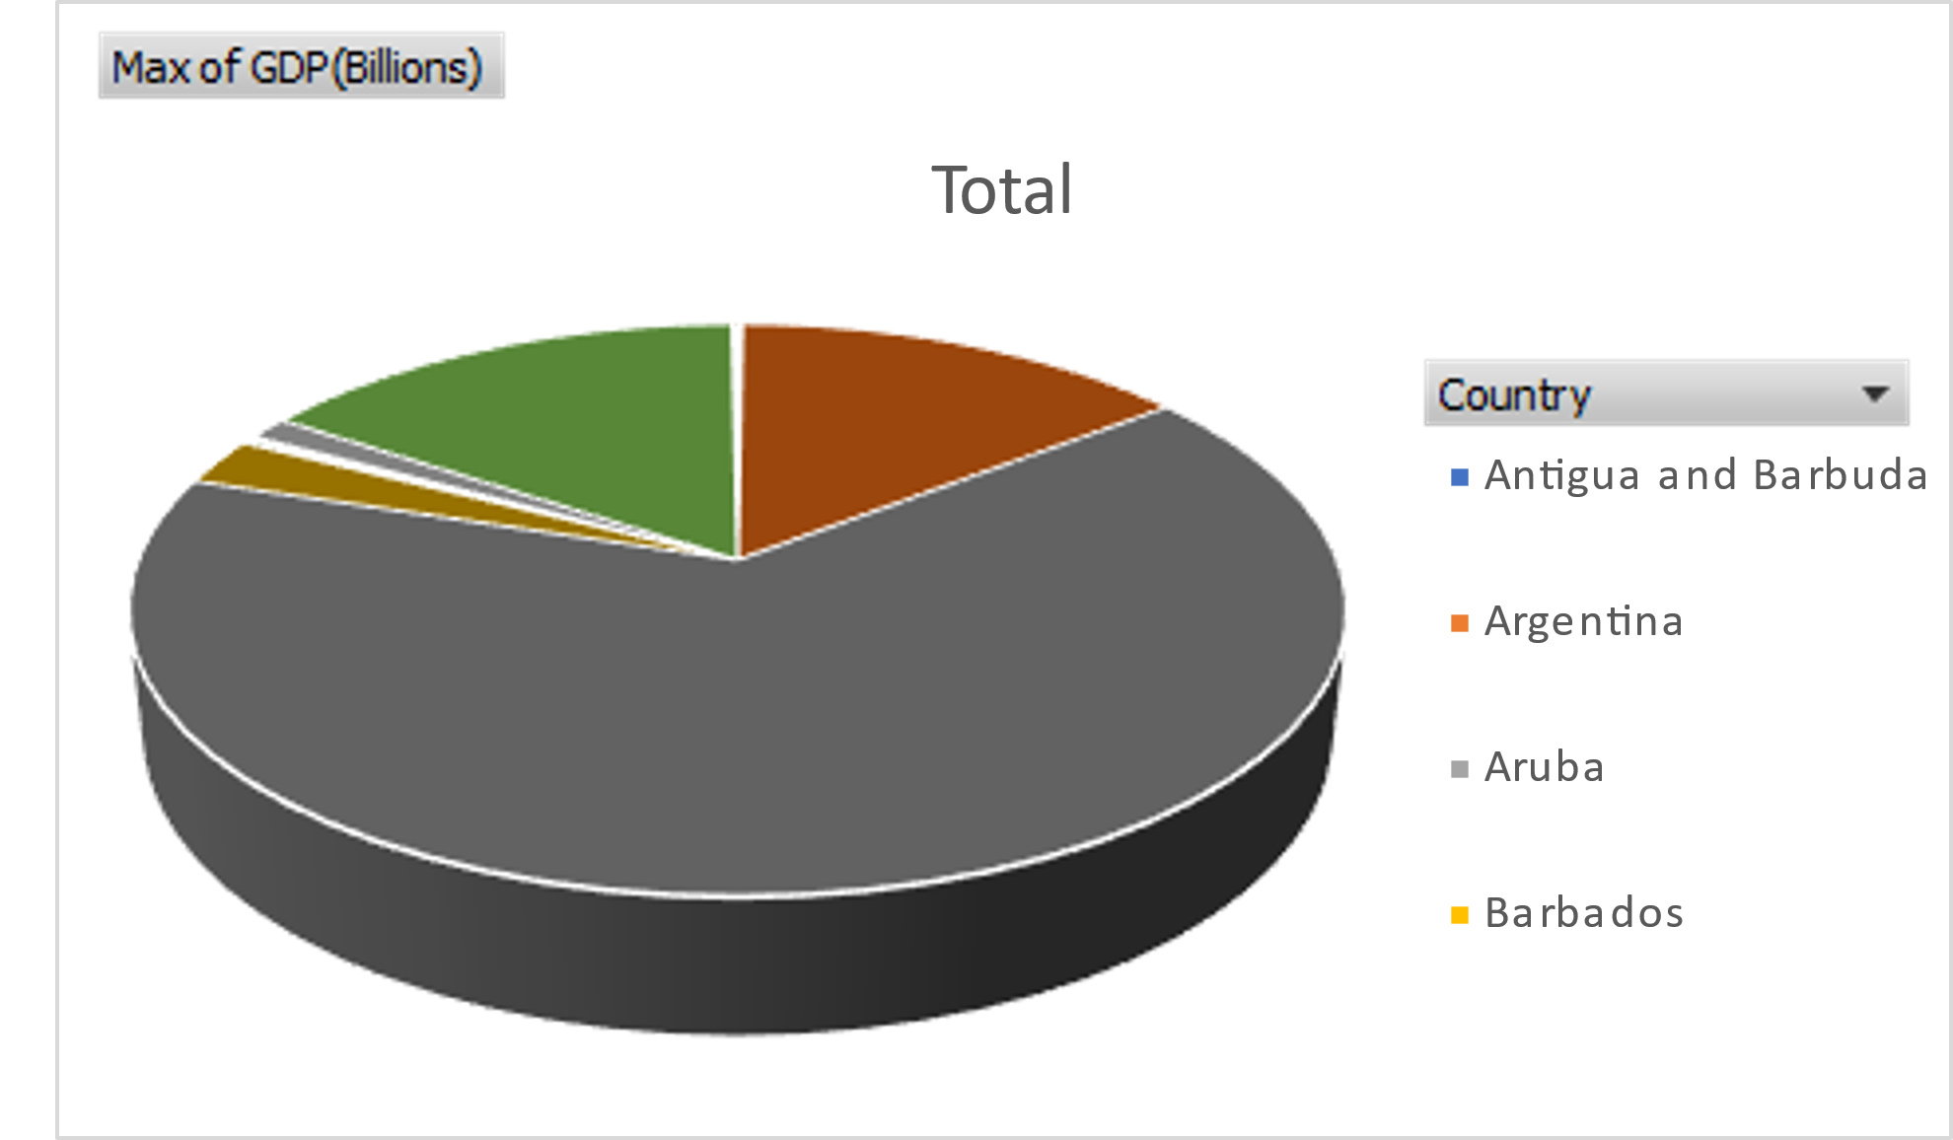

# Analysis of Revenue:

The U.S. tops government revenue, These nations generate substantial income through taxation and state-owned enterprises, crucial for funding public services and infrastructure.

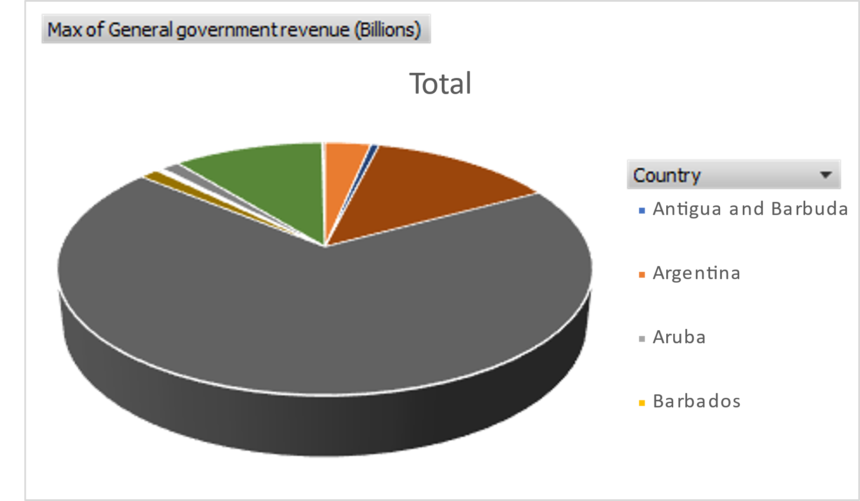

# Analysis of Unemployment:

The unemployment rate of these country approximately same. But, the reflecting significant economic disruptions during many crises.

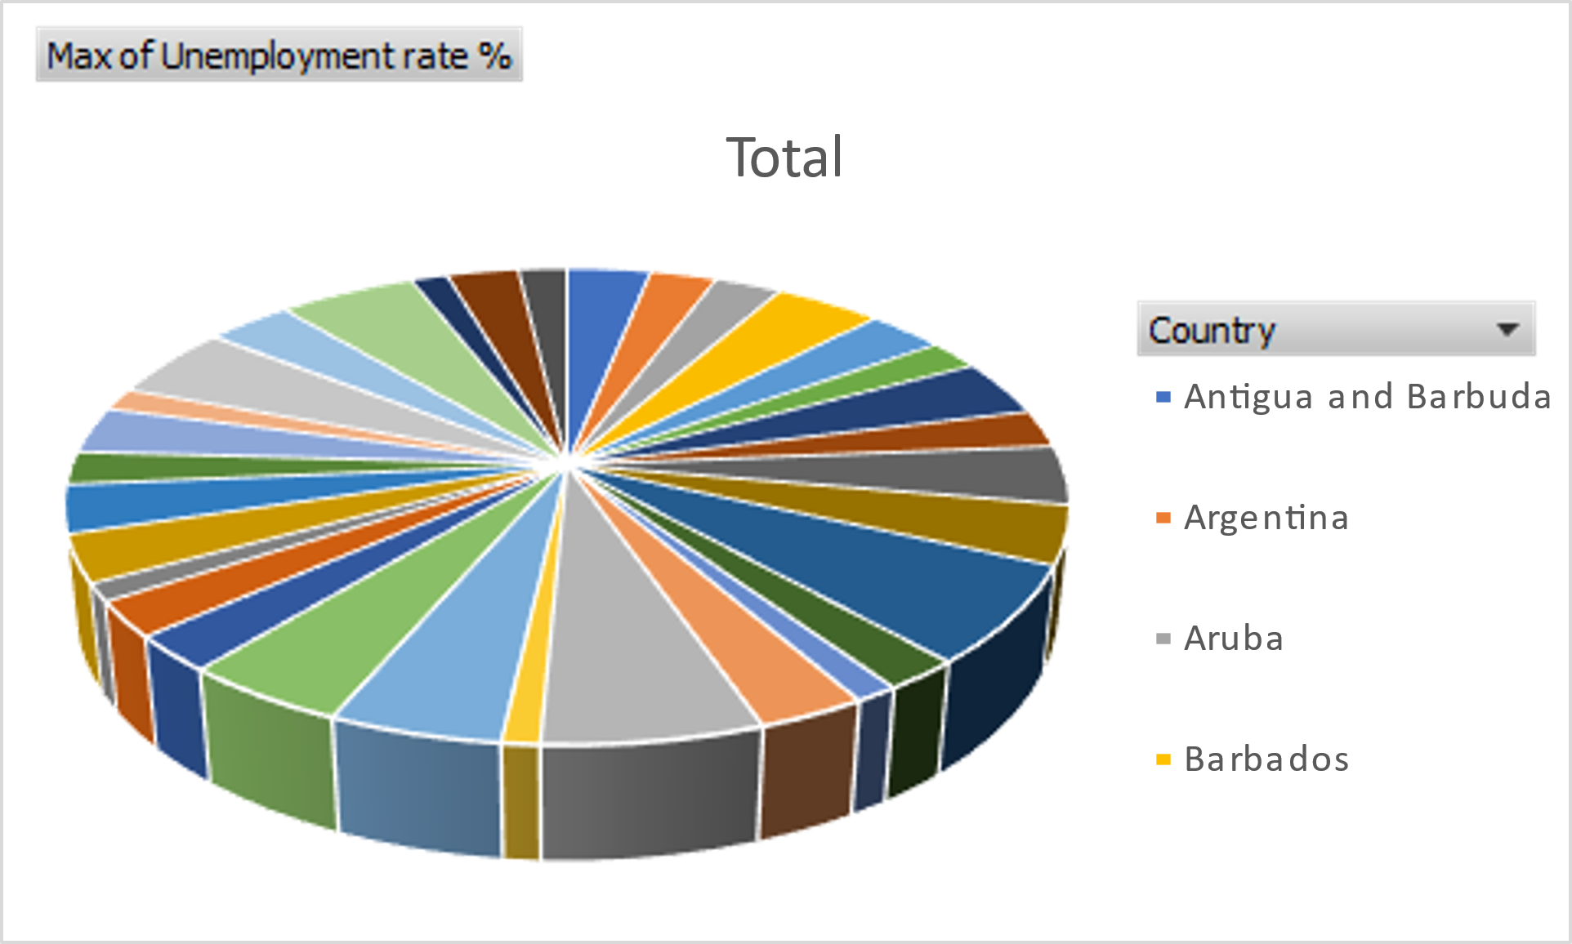

# Analysis of population:

The max population of these pie chart we see the name of the country Antigua and Barbuda. And the second one is Argentina. These significant impacts economic growth, labor markets, and social services across the country.

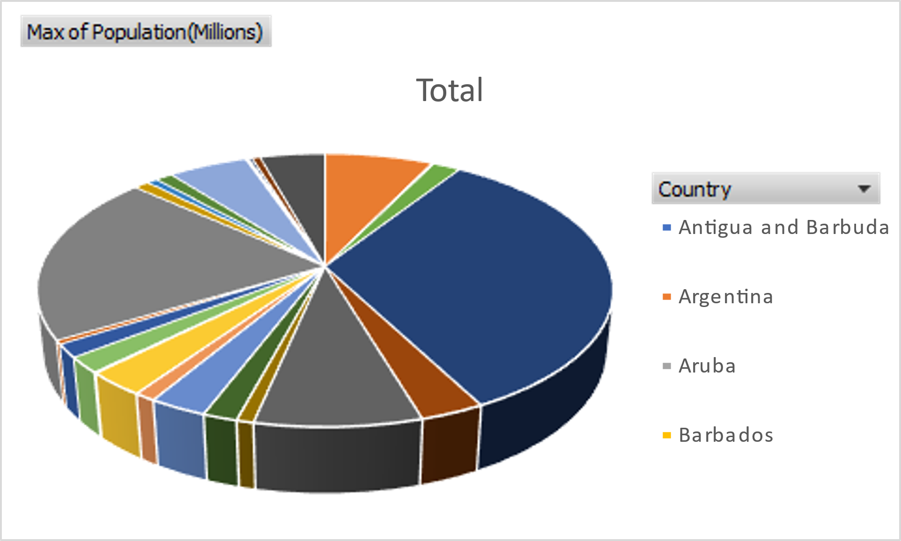

# Conclusion:

In conclusion, examining the maximum values of economic indicators GDP, revenue, unemployment, and population reveals significant disparities among countries. While nations like the U.S. and China lead in GDP and revenue, high unemployment rates in some regions highlight economic vulnerabilities. Understanding these indicators fosters insights into global economic health and guides policies for sustainable development and workforce management.