Askat Medetbayev IS-1608K

JD-3 Report for Microserves

Project: Drug Store System(Онлайн Аптека)

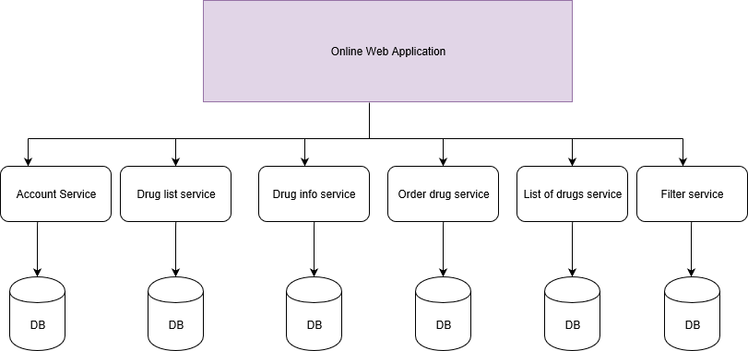

All Controllers in application: Drug, User, Role

At the begin, we will go to login/registration page

This application has two “ROLE”, “USER” and “ADMIN”

“**USER**” role can:

* See all list of drugs
* Filter all the drugs by filters
* Order and pay for the selected drug
* Checkout the product

“**ADMIN**” role can:

* List of drugs, vitamins
* Add drug (Update, Delete)
* See all orders ordered by users.
* List of all clients
* Update profile

**Micro Services**

Account Service

* Login
* Registration
* List of drug
* User Profile
* Update password

Book List Service

* Update
* Delete
* Give
* Order
* Information
* Filter

Drug Info Service

* Information
* Comment

User List Service

* Delete
* Block/Unblock