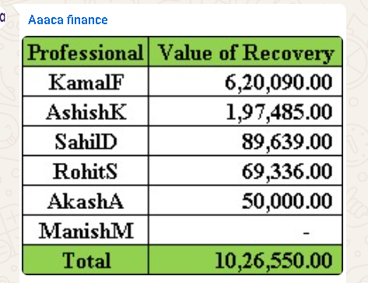

A Very Good Afternoon to Everyone,
I am hereby sharing the client recovery for the Week from 16/05/2026 to 22/05/2026.

With our combined efforts, we have been able to recover a sum of ₹ 10,26,550 /- during this period.

CA Kamal Kumar Ferwani, CA Ashish Kapoor, and CA Sahil Dua have done a good job by recovering ₹ 6,20,090, ₹ 1,97,485 and ₹ 89,639, respectively.

I am sure others have also worked hard and tried to recover as much as possible.

During this period from 26/04/2026 to 22/05/2026 we have recovered total ₹ 38,41,580 /-

