Assmembly

1) PreAssmbly : Create new file with all macros in the file replaced with the macros expressions
- macro table (hashmap,array).
- remove macro defines
- replace macro with macro expressions.
- (optional) remove duplicated spaces and commas, might make out life easier later.
- Input : file.as | output : file.am.

2) Sentence Type Assigner : each line assigned to sentence group (Empty/Comment/Directive/Instructional).
- Determine which type a sentence is.
- Save offset of sentence to the corresponding data structure.
- Check for syntax errors/if sentence does not belong to any group.
- Input : file.am | output : directive_table , instruction_table

3) Symbol Handle : Create table of symbols
- go over code, check for symbols add them to the table.
- If label add address value and offset.
- Add symbol attribute (code/data OR external/entry).
  - Code – symbol label is pointing to instructional sentence.
  - Data – symbol label is pointing to Directive sentence.
  - Entry – symbol initialized with [.entry].
  - External – symbol initialized with [.external].
- Check if each label has a initialized symbol in the code.
- Input : directive_table , instruction_table | output : symbol_table

4) Create machine code:
- Go over instruction table and translate instructions into machine code , leave variable addresses empty.
- translate variables (.data / .string) into machine code .
- Go over instruction table again and fill the empty addresses in instructions with the right variable address.

- create .ext file in the format of
  - { [NAME] BASE [BASE ADDRESS] }
  - { [NAME] OFFSET [OFFSET] }
NAME – variable’s name
BASE ADDRESS – pointer to variable address.
OFFSET – pointer to size of variable.
Note: the order does not matter

- Input : instruction table , directive_table , symbol_table | output : machine code

5) formatting : create and format data in files

- create .ent file in the format of
  - { [NAME],[BASE ADDRESS],[OFFSET]}
NAME – variable’s name
BASE ADDRESS – variable address.
OFFSET – size of variable.
Note: the order does not matter.

- Create binary file .ob from machine code.
  - Format address in group of 5 numbers in the from A-E
    - the letter from A-B is the group, the number between 0-f is the value of the group.
    - format example : { A4-B0-C3-Dc-E1}.
  - First, add the instructions machine code to the file.
  - Second, add the variables machine code to the file.

(1),(2) ALON
(3) ASHER
(4),(5) RONEN

Tables :

instruction_table
| base address | offset | label | command | op1 | op2 |

directive_table
| base address | label | name | attributes | data |

symbol_table
| name | value | base address | offset | attributes |

machine_code
| ARE | opcode | funct | op1 | op1_type | op2 | op2_type | extra_words |

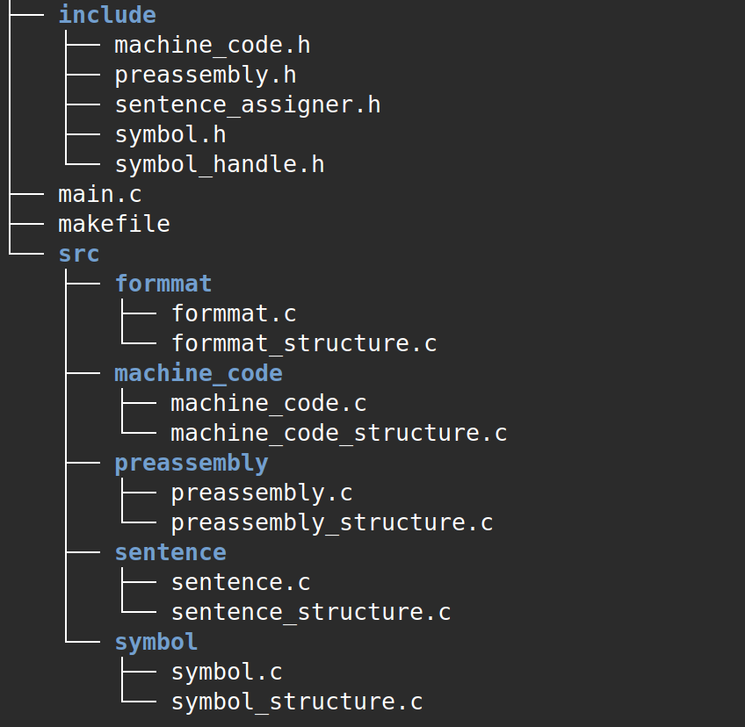

flow

directive_table → symbol_table → machine_code → file.ob
file.as → file.am →
instruction_table →
↓ ↓
file.ext file.ent

