Assignment-16.3:

Execute Session 16 - Assignment 1 (Machine and Sensor data analysis) using Reduce side join and compare which join is faster in normal conditions.

Driver Class: Use Multiple Input paths to get multiple inputs for mapper

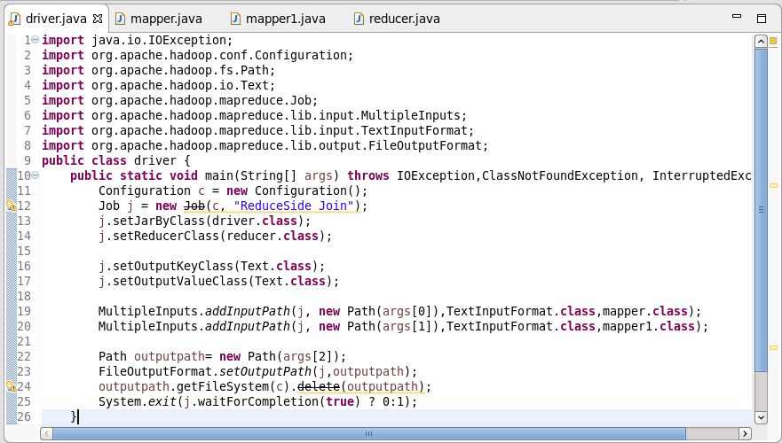

Mapper-1: In Mapper-1 choosing the BUILDING ID as key and Country as value respectively

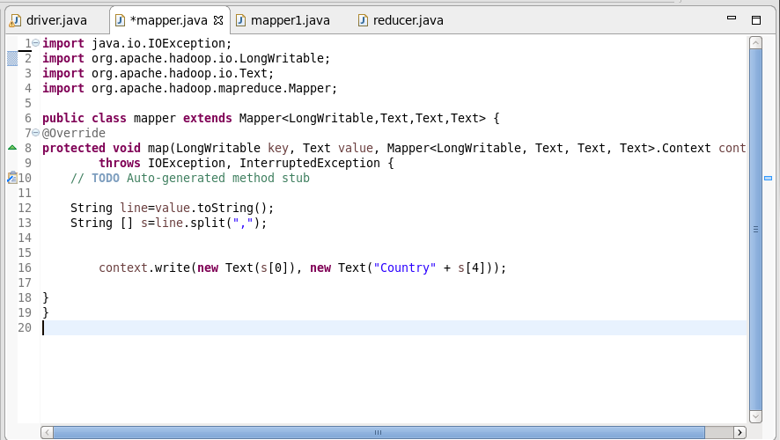

Mapper-2:

In this Mapper Actual temperature and targeted temperature are compared and then selecting BUILDING ID as key and a count of 1 as value

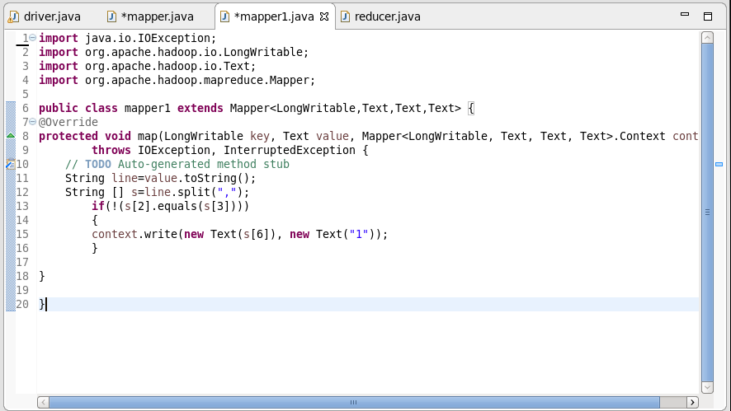

Reducer Class:

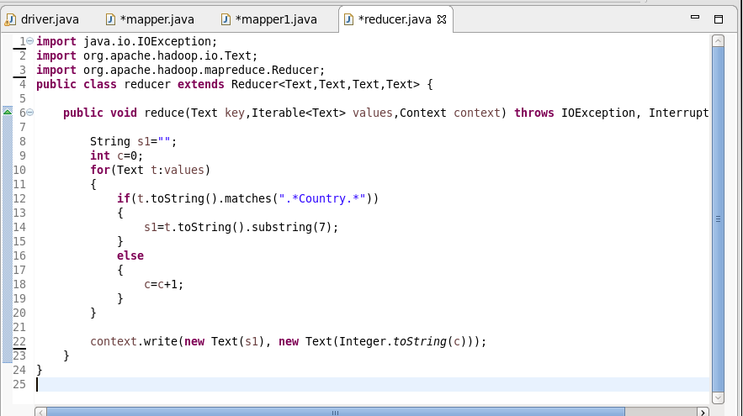In the Reducer Class, If the value matches “Country” . Then the SUBSTRING is used to take the country for a given id else total count is calculated and gave country as key and total count as value

Running the Jar File:

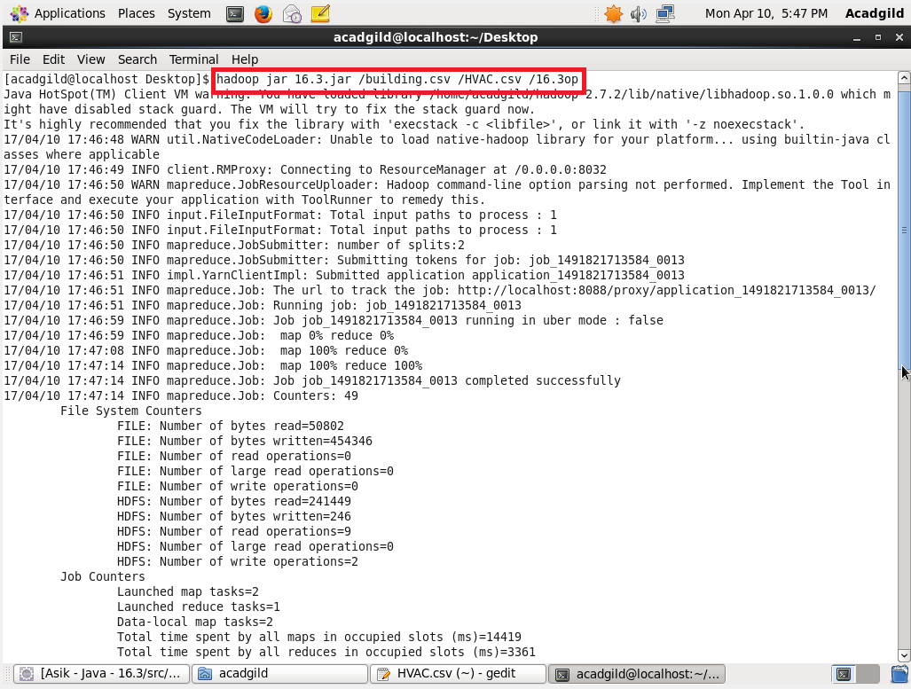

Output:

