CITY

create table City

(

id_city int primary key,

name_city char(20) not null unique

)

create sequence city_sequ start with 1;

create or replace trigger city_bir

before insert on City

for each row

begin

select city_sequ.nextval

into :new.id_city

from dual;

end;

CLIENT

create table Client

(

telephone_cl number(9) primary key,

fio varchar(30) not null,

sale number(2) default 0 check(sale in(0,5,10,15)),

id_city int not null,

constraint fk_city foreign key(id_city) references City(id_city)

);

CLIENT_AUTO

create table Client_auto

(

telephone_cl number(9) not null,

password_cl varchar (25) not null,

constraint fk_client foreign key(telephone_cl) references Client(telephone_cl),

constraint pk_client_auto primary key(telephone_cl)

)

TYPEWORKER

create table TypeWorker

(

typeWorker char(40) not null primary key,

salary number(5) not null

);

STAFF

create table Staff

(

id_staffer int primary key,

fio_staff varchar(30) not null,

telephone_st number(9) not null unique,

birthday date not null,

typeWorker char(40) not null,

constraint fk_typeW foreign key(typeWorker) references TypeWorker(typeWorker)

)

create sequence staff_se start with 1;

create or replace trigger staff_bir

before insert on Staff

for each row

begin

select staff_se.nextval

into :new.id_staffer

from dual;

end;

STAFF_AUTO

create table Staff_auto

(

telephone_st number(9) not null,

password_st varchar (25) not null,

constraint fk_staff foreign key(telephone_st) references Staff(telephone_st),

constraint pk_staff_auto primary key(telephone_st, password_st)

)

SERVICE

create table Service

(

data timestamp with local time zone not null,

id_staffer int not null,

telephone_cl int not null,

constraint fk_id_sta foreign key(id_staffer) references Staff(id_staffer),

constraint fk_c foreign key(telephone_cl) references Client(telephone_cl),

constraint pk_se primary key(data, telephone_cl)

)

REVIEW

create table Review

(

id_review int primary key,

telephone_cl number(9) not null,

note varchar(250) not null,

marks int default 5 check(marks in(1,2,3,4,5)) not null,

constraint fk_client_tel foreign key(telephone_cl) references Client(telephone_cl)

)

create sequence review_sequ start with 1;

create or replace trigger review_bir

before insert on Review

for each row

begin

select review_seq.nextval

into :new.id_review

from dual;

end;

Функция, которая подсчитывает количество визитов каждого клиента:

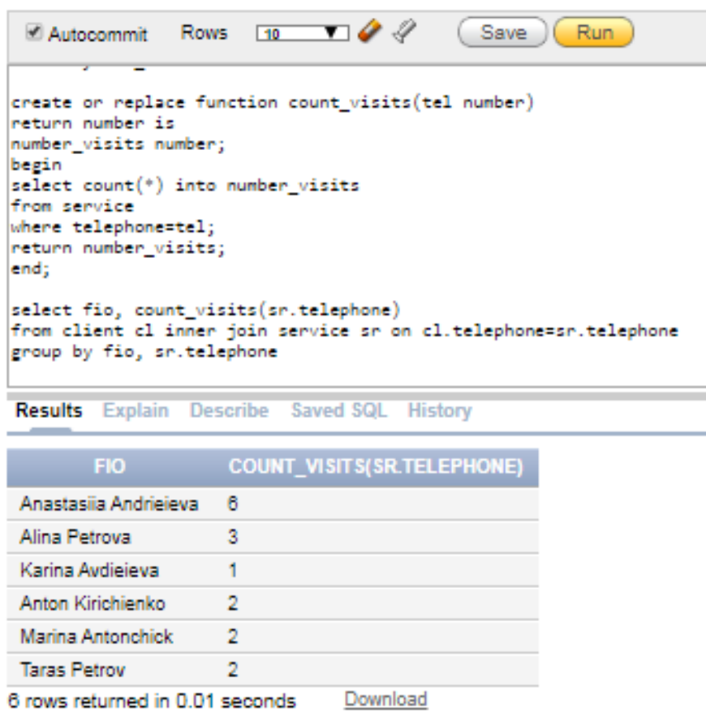

Триггер 1, который при добавлении или обновлении таблицы Service проверяет введенные данные даты и телефон. Если введенная дата больше сегодняшней даты, то триггер возвращает текущую дату. Если в веденном номере телефона более 8 символом, то записывается только 8.

CREATE OR REPLACE TRIGGER trigg1

BEFORE INSERT OR UPDATE ON SERVICE

FOR EACH ROW

BEGIN

IF (:new.data > SYSDATE) THEN :new.data := SYSDATE; END IF;

IF (:new.telephone_cl < 100000000) THEN :new.telephone_cl := :new.telephone_cl*10; END IF;

END;

CREATE OR REPLACE TRIGGER trigg12

BEFORE INSERT OR UPDATE ON STAFF

FOR EACH ROW

BEGIN

IF (:new.data > SYSDATE) THEN :new.data := SYSDATE; END IF;

IF (:new.telephone_st < 100000000) THEN :new.telephone_st := :new.telephone_st*10; END IF;

END;

Триггер 2, который при удалении определенной записи из таблицы Service записывает данные в новую таблицу ServArch. Этот триггер работает как запись в архив.

CREATE OR REPLACE TRIGGER trigg2

AFTER DELETE ON SERVICE

FOR EACH ROW

BEGIN

insert into Serv_Arch values(:old.data, :old.id_staffer, :old.telephone_cl);

END;

Serv_Arch

CREATE TABLE Serv_Arch

(

data timestamp with local time zone not null,

id_staffer int not null,

telephone_cl int not null,

primary key(data, id_staffer, telephone_cl)

);

Триггер 3, который при удалении определенной строки из таблицы Client удаляет все записи из таблиц, которые ссылаются на эту таблицу. Этот триггер работает как каскадное удаление.

Триггер 3:

CREATE OR REPLACE TRIGGER trigg3

BEFORE DELETE ON Client

FOR EACH ROW

DECLARE

PRAGMA AUTONOMOUS_TRANSACTION;

BEGIN

DELETE FROM Service WHERE telephone_cl = :old.telephone_cl;

COMMIT;

END;

CREATE OR REPLACE TRIGGER trigg31

BEFORE DELETE ON Client

FOR EACH ROW

DECLARE

PRAGMA AUTONOMOUS_TRANSACTION;

BEGIN

DELETE FROM Client_auto WHERE telephone_cl = :old.telephone_cl;

COMMIT;

END;

CREATE OR REPLACE TRIGGER trigg32

BEFORE DELETE ON Staff

FOR EACH ROW

DECLARE

PRAGMA AUTONOMOUS_TRANSACTION;

BEGIN

DELETE FROM Service WHERE id_staffer = :old.id_staffer;

COMMIT;

END;

CREATE OR REPLACE TRIGGER trigg33

BEFORE DELETE ON Staff

FOR EACH ROW

DECLARE

PRAGMA AUTONOMOUS_TRANSACTION;

BEGIN

DELETE FROM Staff_auto WHERE id_staffer = :old.id_staffer;

COMMIT;

END;

create or replace procedure test_proc is

newExc exception;

num1 number;

num2 number;

numSale number;

randomSale number;

fioStaffer VARCHAR2(20);

newFioStaffer VARCHAR2(20);

res numeric(3,1);

numStr number;

str VARCHAR2(20);

resNumStr number;

begin

--ZERO_DIVIDE!

dbms_random.seed(SYSTIMESTAMP);

num1 := floor(dbms_random.value(0, 15));

num2 := floor(dbms_random.value(0, 15));

res := num1/num2;

--INVALID_NUMBER!

insert into client(telephone_cl,fio,sale,id_city)

values(998745455, 'Oslov Alexand Petrovich', 'five', 3);

--NO_DATA_FOUND!

randomSale := floor(dbms_random.value(0, 16));

select distinct sale into numSale

from client

where sale = randomSale;

--TOO_MANY_ROWS!

select fio_staff into fioStaffer

from staff

where typeworker like 'waiter%';

--NEW_EXCEPTION!

if randomSale = 1 or randomSale = 2 then raise newExc;

end if;

insert into city(name_city)

values('Kharkiv');

insert into client(telephone_cl,fio,sale,id_city)

values(991213123,'Ivanov Ivan Ivanovich', 0, 1);

insert into client_auto(telephone_cl, password_cl)

values(991213123,'user1');

insert all

into TypeWorker (typeWorker, salary)

values ('manager', 20000)

into TypeWorker (typeWorker, salary)

values ('waiterA', 15000)

into TypeWorker (typeWorker, salary)

values ('waiterB', 11000)

into TypeWorker (typeWorker, salary)

values ('waiterC', 9000)

into TypeWorker (typeWorker, salary)

values ('newbier', 7000)

select * from dual;

insert into staff(fio_staff, telephone_st,birthday,typeworker)

values('Avdeeva Anna Sergeevna', 506689696, '22/12/78', 'waiterA');

insert into Staff_auto(telephone_st,password_st)

values(506689696, 'waitera1');

insert into service(data,id_staffer,telephone_cl)

values(TO_TIMESTAMP('2020-04-02 17:34:00', 'YYYY-MM-DD HH24:MI:SS'),1, 991213123);

insert into review(telephone_cl,note,marks)

values(991213123, 'It is beautiful place with very taste dishes)))', 5);

update city

set name_city = 'Kiev'

where name_city = 'Kharkiv';

update client

set fio = 'Ivanova Irina Ivanovna'

where telephone_cl = 991213123;

update client_auto

set password_cl = 'user2'

where telephone_cl = 991213123;

update typeworker

set salary = 7500

where typeworker = 'newbier';

update staff

set typeworker = 'manager'

where telephone_st = 506689696;

update staff_auto

set password_st = 'manager1'

where telephone_st = 506689696;

update service

set data = TO_TIMESTAMP('2019-04-02 17:34:00', 'YYYY-MM-DD HH24:MI:SS')

where data = TO_TIMESTAMP('2020-04-02 17:34:00', 'YYYY-MM-DD HH24:MI:SS');

delete from review

where telephone_cl = 991213123 and note = 'It is beautiful place with very taste dishes)))' and marks = 5;