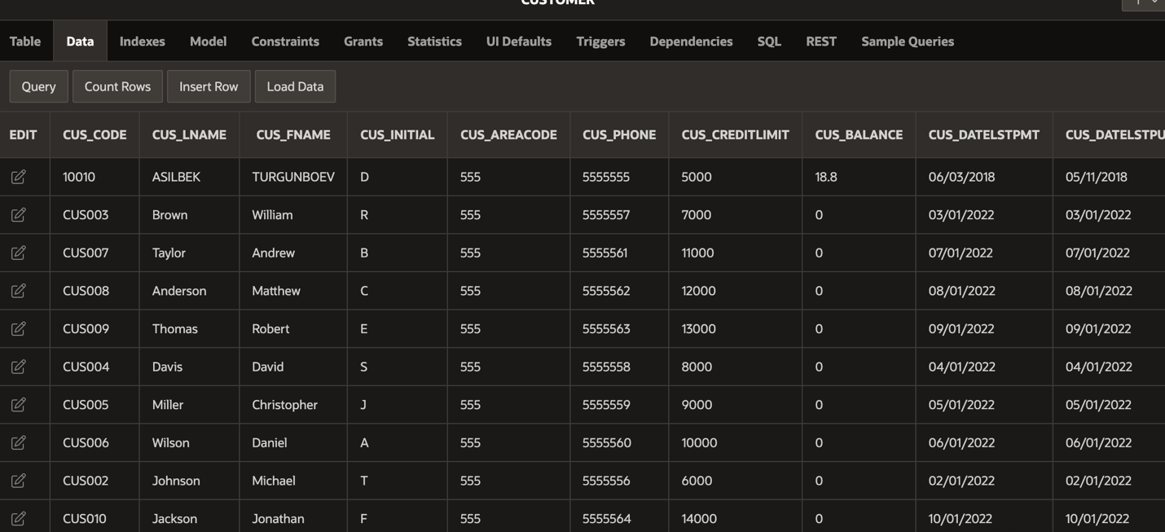 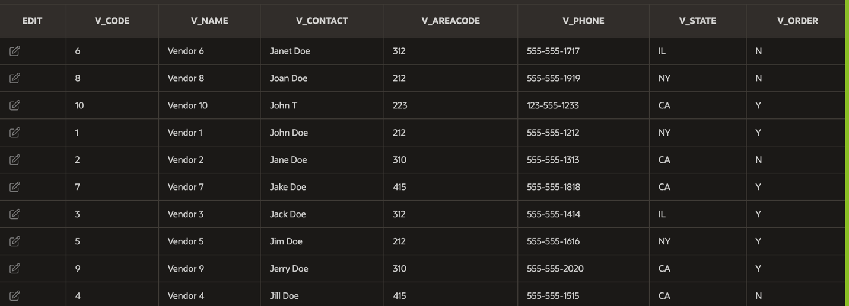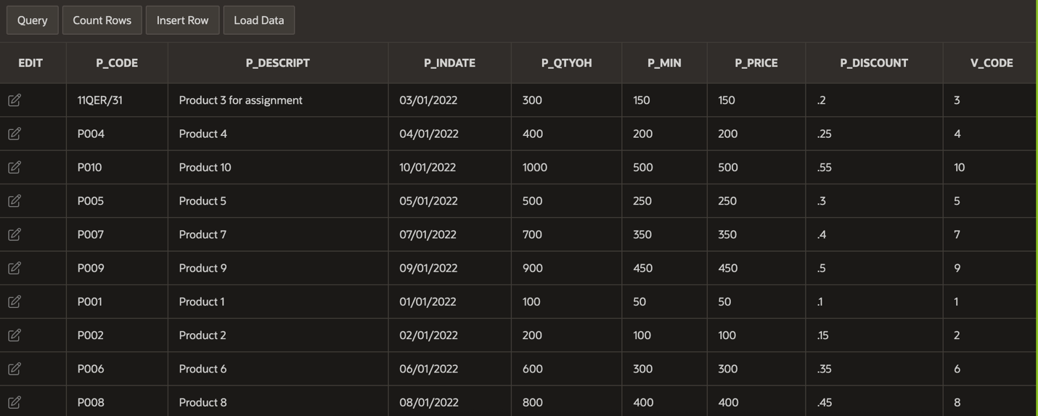

BEGIN TRANSACTION;

INSERT INTO INVOICE (INV_NUMBER, CUS_CODE, INV_DATE, INV_TERMS, INV_TOTAL, INV_STATUS)

VALUES (10983, '10010', '05-11-2018', '30', 110.00 * 1.08, 'OPEN');

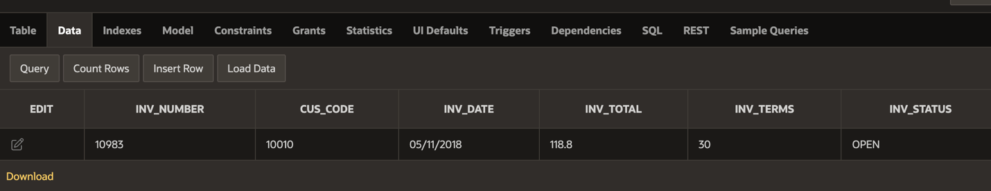

INSERT INTO LINE (INV_NUMBER, LINE_NUMBER, P_CODE, LINE_UNITS, LINE_PRICE)

VALUES (10983,'11QER/31', '11QER/31', 1.00, 110.00);

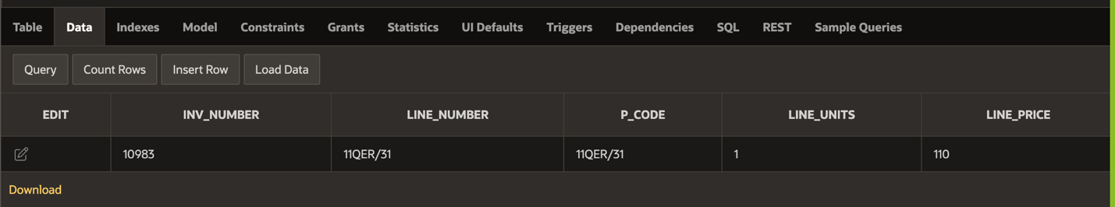

UPDATE CUSTOMER

SET CUS_BALANCE = CUS_BALANCE + (110.00 * 1.08),

CUS_DATELSTPUR = '05-11-2018'

WHERE CUS_CODE = '10010';

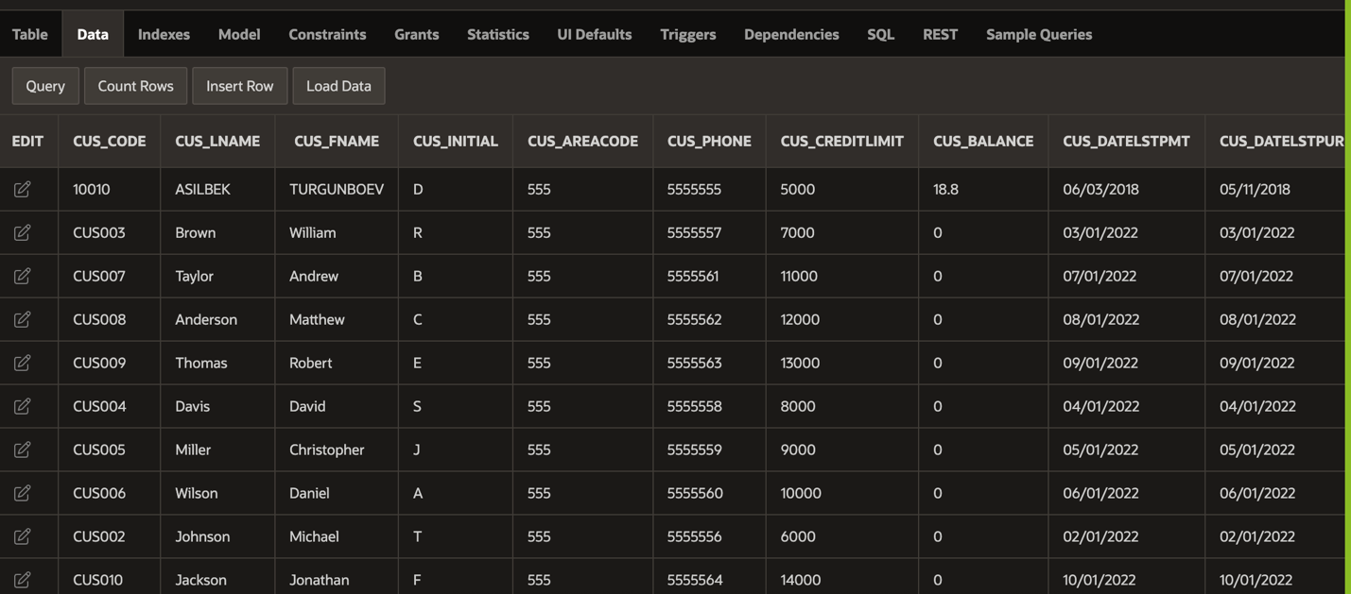



INSERT INTO PAYMENTS (PMT_ID, CUS_CODE, PMT_DATE, PMT_TYPE, PMT_AMT, PMT_DETAILS)

VALUES (3428, '10010', '06-03-2018', 'CASH', 100.00, 'Paying 11QER/31');

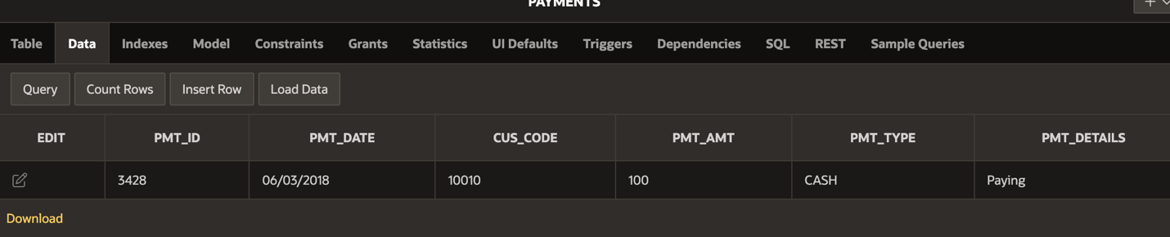

UPDATE CUSTOMER

SET CUS_BALANCE = CUS_BALANCE - 100.00,

CUS_DATELSTPMT = '06-03-2018'

WHERE CUS_CODE = '10010';





COMMIT;