RateIt
Application and Architecture Overview

A photo-and-review sharing web application on AWS (region us-west-2), built with a React single-page app, Lambda and ECS Fargate compute, and DynamoDB storage.

1. Application overview
RateIt is a lightweight web app for rating anything you experience: a fantastic taco, a strange park bench, a confusing street sign. A signed-in user uploads one to five photos, writes a title and a short description, and gives a 1 to 5 star rating. Everyone on the platform sees the same chronological feed of posts and can like them.
Purpose. The product itself is intentionally simple. As an engineering project it is a portfolio and internship build that demonstrates a production-style AWS architecture: a single edge entry point, one authentication enforcement point, mixed serverless and container compute, an event-driven write-behind pipeline for like counts and moderation, infrastructure as code, and a gated CI/CD pipeline. It runs as a single environment in us-west-2 on a shared internship domain.

Features
- Authentication: sign up with email confirmation code, log in, silent token refresh. The whole app, including the feed, requires a session. A custom UI is used (no Cognito Hosted UI).
- Image upload and posting: 1 to 5 JPEG or PNG images per post (up to 10 MB each), uploaded directly from the browser to S3 and shown at full quality.
- Global feed and My posts: newest-first feed with pagination; a toggle shows only the caller's own posts, including those removed by moderation.
- Likes: like and unlike with an optimistic UI that sends only the final state after a short debounce. Counts are derived asynchronously.
- Delete own post: removes the post, its photos and its like counter.
- Automated moderation: new posts' images are checked asynchronously with Amazon Rekognition and a magic-byte check; flagged posts leave the feed.

Frontend
React 18 with Vite, TypeScript, Tailwind CSS and React Router. Authentication uses AWS Amplify's Cognito client with tokens held in sessionStorage. Pages: Login, Signup, Confirm signup, Feed, and New experience. The built site is a static bundle served from a private S3 bucket through CloudFront.

2. Core services used

2.1 Compute
Service | Compute | Trigger | Responsibility
Media Service | Lambda | API Gateway: GET /api/media/upload-url | Validates the content type and returns a short-lived (5 min) presigned S3 POST policy. Key is {userId}/{uuid}.jpg|png, tagged status=pending, size limited to 10 MB.
Experience Service | Lambda | API Gateway: POST /api/experiences, DELETE /api/experiences/{id} | Validates input (title 100 chars, description 1000, rating 1 to 5, 1 to 5 images owned by the caller), writes the post, then tags images status=claimed. Delete is owner-only and also removes the images and the like counter.
Reactions Service | Lambda | API Gateway: PUT and DELETE /api/experiences/{id}/like | Checks the post exists (read-only), then performs one conditional write or delete on the Likes table. Idempotent; never writes to Experiences.
Feed Service | ECS Fargate (FastAPI container, behind an internal ALB) | API Gateway: GET /api/feed via VPC Link | Queries the feed or author index, then decorates each post with likeCount and likedByMe using one BatchGetItem across Likes and LikeCounters. Page size 20. Blue/green deployments with circuit breaker.
Moderation Service | Lambda (async) | DynamoDB stream on Experiences, INSERT events only | Verifies image magic bytes, calls Rekognition DetectModerationLabels (80% confidence, blocks Explicit, Violence, Visually Disturbing, Hate Symbols). On a flag it removes the post's Type attribute and sets removed. Fails open: errors send the post ID to an SQS dead-letter queue.
Counter Service | Lambda (async) | DynamoDB stream on Likes, INSERT and REMOVE | Nets each batch (up to 500 records, 2 s window) per post and applies one transaction with an idempotency marker, updating LikeCounters.
Reconciliation Service | Lambda (scheduled) | EventBridge Scheduler, weekly (Saturday 21:00 UTC) | Scans Likes, compares with LikeCounters, publishes a drift metric. With {"repair": true} it corrects counts using ADD.

2.2 Data stores
All state lives in DynamoDB (on-demand billing) and S3. Table designs are detailed in section 3.
Store | Purpose
DynamoDB: rateit-experiences | Posts. Two global secondary indexes drive the feed and My posts. Stream enabled (NEW_IMAGE) to trigger moderation. Point-in-time recovery on.
DynamoDB: rateit-likes | Source of truth for likes, one row per user per post. Stream enabled (KEYS_ONLY).
DynamoDB: rateit-like-counters | Derived like counts plus short-lived idempotency markers (TTL).
S3: uploads bucket | Private. Holds post images. Objects tagged pending expire after 2 days via lifecycle rule; claimed objects stay. Served only through CloudFront (OAC) under /images/*.
S3: frontend bucket | Private. Holds the built SPA, served only through CloudFront (OAC).
S3: Terraform state | Versioned, encrypted remote state with native S3 locking.

2.3 Supporting services
Service | Role
Route 53 and ACM | DNS alias for rateit.internship.cloudelligent-sandbox.com and its TLS certificate.
CloudFront | Single public entry point. Behaviors: /* to frontend bucket, /images/* to uploads bucket (cached), /api/* to API Gateway (not cached).
AWS WAF | Attached to CloudFront. Rate-based rules per Authorization token and per IP (limit 300 per window).
Cognito user pool | Sign-up, login and JWTs (1-hour ID and access tokens, 30-day refresh). Password: 8+ chars, upper, lower, number.
API Gateway (HTTP API) | Cognito JWT authorizer on every /api route; routes to Lambdas or, through a VPC Link, to the internal ALB. Injects the verified user ID as the x-user-sub header for Feed Service.
VPC | Two private subnets in two AZs, no internet path. Reaches AWS through VPC endpoints (DynamoDB and S3 gateway; ECR, Logs interface).
SQS | rateit-moderation-dlq (failed moderation, with manual redrive) and rateit-like-counter-dlq (failed counter batches).
ECR | Stores the Feed Service container image.
CloudWatch and SNS | Logs, alarms (Lambda errors, ECS/ALB health, DynamoDB throttling, WAF blocks, DLQ depth, stream lag, like-count drift) and a dashboard; alarms notify an SNS email topic.
CodePipeline and CodeBuild | GitHub-triggered pipeline: build, terraform plan, manual approval, terraform apply. Lambdas deploy as versioned aliases.
Terraform | All infrastructure as code, organised as modules under infra/modules.

3. Database design
DynamoDB has no joins, so each table is shaped around the queries the app actually makes. Likes were redesigned (October 2026) so that no single popular post can become a hot partition.

3.1 rateit-experiences (posts)
Setting | Value
Partition key (PK) | experienceId (String, UUID). No sort key.
Attributes | userId (Cognito sub), title, description, rating (1 to 5), imageKeys (list of 1 to 5 S3 keys), CreatedAt (ISO 8601 UTC), Type (feed bucket), removed (set only by moderation).
GSI: TypeCreatedAtIndex | PK Type, SK CreatedAt; projection ALL. Type is a monthly bucket such as POST#2026-10, so feed reads and writes are spread across partitions. The Feed Service walks backward one month at a time (up to 24 months) to fill a page.
GSI: userId-CreatedAt-index | PK userId, SK CreatedAt; projection ALL. Powers My posts, including taken-down posts.
Takedown behaviour | Moderation deletes the Type attribute, so the post vanishes from the feed index (sparse index) but remains reachable by its author through the userId index.
Streams and recovery | Stream NEW_IMAGE (moderation trigger, INSERT only); point-in-time recovery enabled.

3.2 rateit-likes (source of truth for likes)
Setting | Value
Partition key (PK) | userId (String)
Sort key (SK) | experienceId (String)
Attributes | createdAt
Indexes | None, deliberately. An index on experienceId would recreate the hot partition.
Stream | KEYS_ONLY; drives the Counter Service. Like is a conditional put (attribute_not_exists), unlike is a conditional delete, so repeated requests produce no extra events.
Access patterns | Did user X like post Y (GetItem / BatchGetItem). Listing the likers of a post is intentionally unsupported.

3.3 rateit-like-counters (derived counts)
Setting | Value
Partition key (PK) | pk (String). No sort key.
Post counter item | pk = POST#<experienceId>, attribute likeCount (Number). A missing item means zero likes.
Batch marker item | pk = BATCH#<batchId>#<chunk>, attribute expiresAt (TTL, 48 hours). Written in the same transaction as the count updates so a re-delivered stream batch is applied only once.

Access patterns summary. Global feed: Query TypeCreatedAtIndex by month bucket, newest first. My posts: Query userId-CreatedAt-index. Create post: PutItem. Delete post: GetItem, then conditional DeleteItem. Like state for a page: one BatchGetItem for the caller's Likes rows plus the posts' counter rows.

4. Architecture diagram
Numbered arrows follow one request through the system; dashed arrows are asynchronous. The Likes group (orange) and async moderation group (blue) show the event-driven parts.
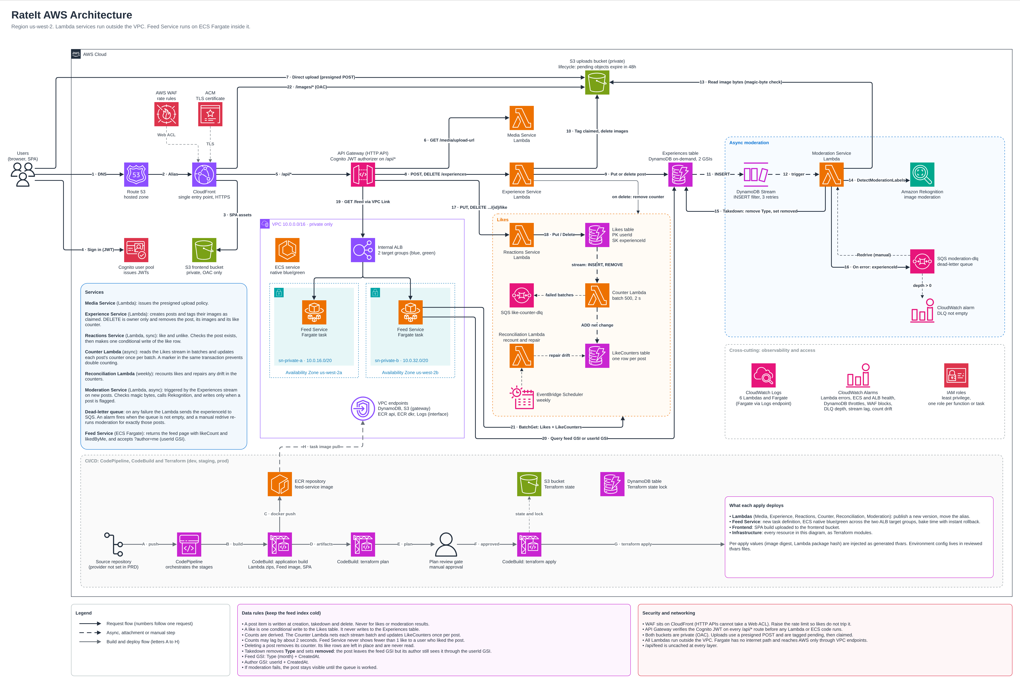

5. How the services work together
A user opens the RateIt domain, which Route 53 resolves to CloudFront. CloudFront is the only public entry point: it applies the WAF rate rules, terminates HTTPS and, by path, serves the React app from the private frontend bucket, serves photos from the private uploads bucket (via origin access control), or forwards /api/* calls to API Gateway. The user signs up and logs in against Cognito, which issues JWTs; the SPA sends the token as a bearer header on every API call, and API Gateway's JWT authorizer rejects bad tokens before any application code runs.
To post, the browser asks the Media Service Lambda for a presigned S3 policy and uploads each image straight to the uploads bucket, tagged pending. It then calls the Experience Service Lambda, which validates the request and writes the post to the Experiences table with a monthly Type bucket, then re-tags the images as claimed so the lifecycle rule does not expire them. The table's stream fires on the new item and triggers the Moderation Service Lambda, which reads the images from S3, runs Rekognition, and, only if the post is flagged, removes its Type so it drops out of the feed (the author still sees it under My posts). If moderation cannot run, the post stays visible and its ID goes to a dead-letter queue and an alarm.
To read the feed, the browser calls GET /api/feed. API Gateway verifies the token, stamps the caller's sub into a trusted header and sends the request through a VPC Link to the internal load balancer, behind which the Feed Service runs on Fargate in private subnets. It queries the Experiences table's feed or author index, then fetches the caller's Likes rows and the posts' LikeCounters rows in one BatchGet, and returns the posts with image URLs that point back at CloudFront.
When a user taps like, the Reactions Service Lambda confirms the post exists and writes a single conditional row to the Likes table, then returns immediately. That table's stream feeds the Counter Service Lambda, which batches events, nets them per post and updates LikeCounters in an idempotent transaction, so a count may trail a like by about two seconds (the Feed Service masks this for the liker). A weekly Reconciliation Lambda recounts the Likes table, reports any drift to CloudWatch and can repair it on demand. Deleting a post removes the item, its images and its counter.
Everything is defined in Terraform and delivered by a GitHub-triggered CodePipeline: CodeBuild builds the Lambda packages, the Feed Service image and the SPA, produces a Terraform plan, waits for manual approval and applies it. CloudWatch logs, alarms and a dashboard, with SNS email notifications, cover the whole stack.

