

**Submitted By:**

**Zain Ul Abdien**

**Submitted To:**

**Aatka Ali**

**Student ID:**

**213036**

**LAB TASK :**

**03**

**Q1**

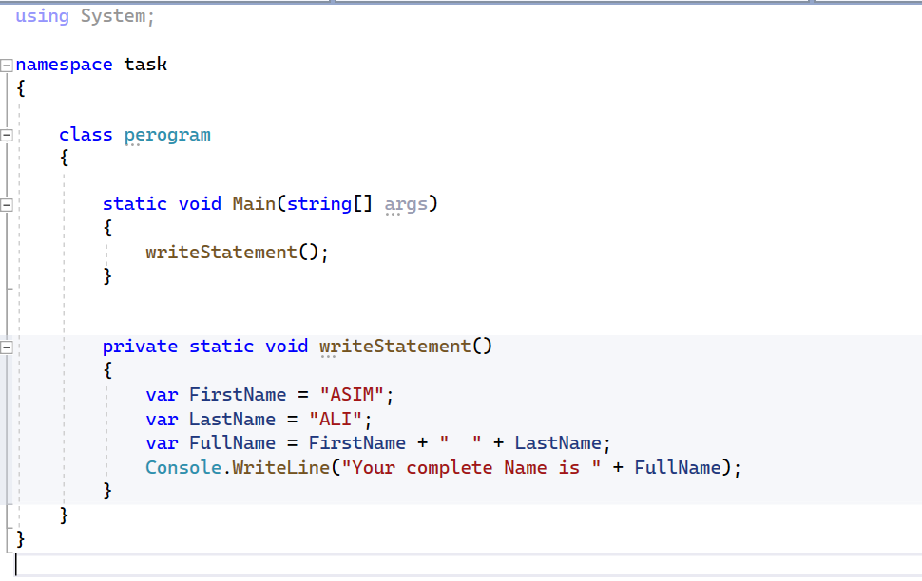

**Description:**

* **Create a private function with name “Write statement**
* **Data type is varchar**
* **Add first and last name**

**output**

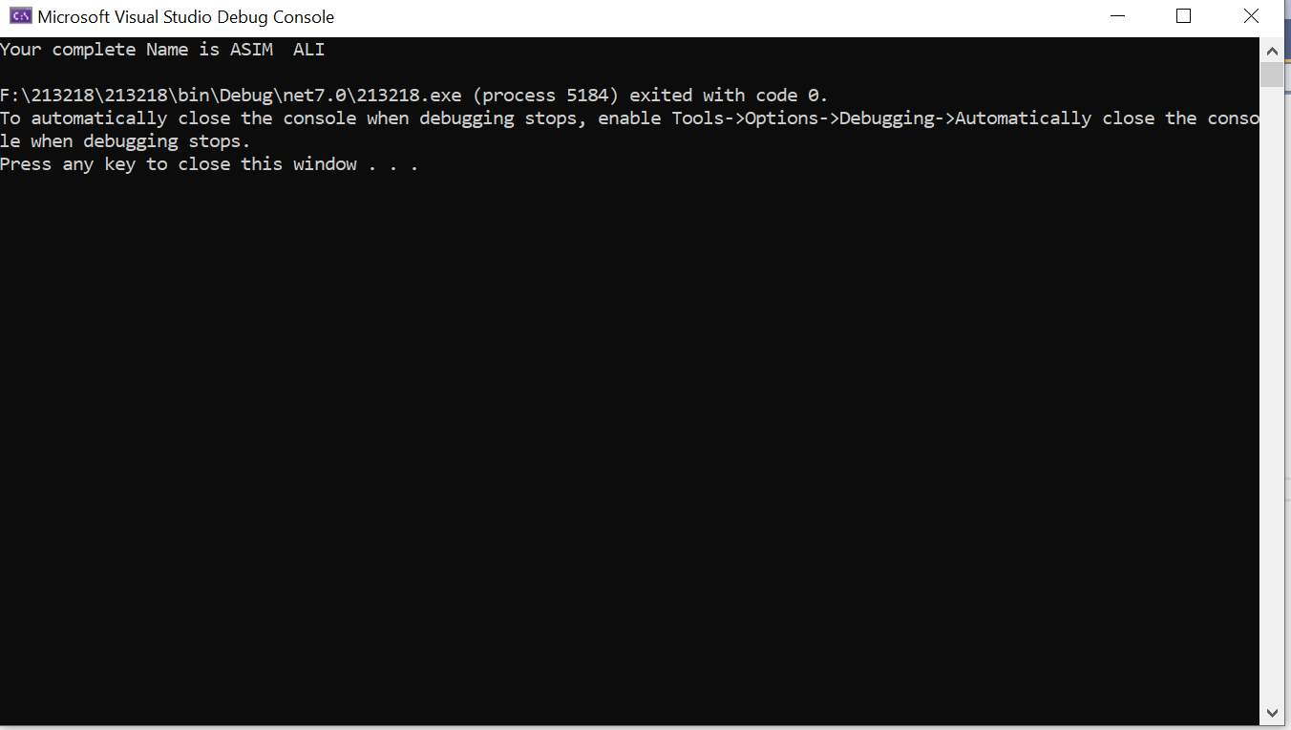

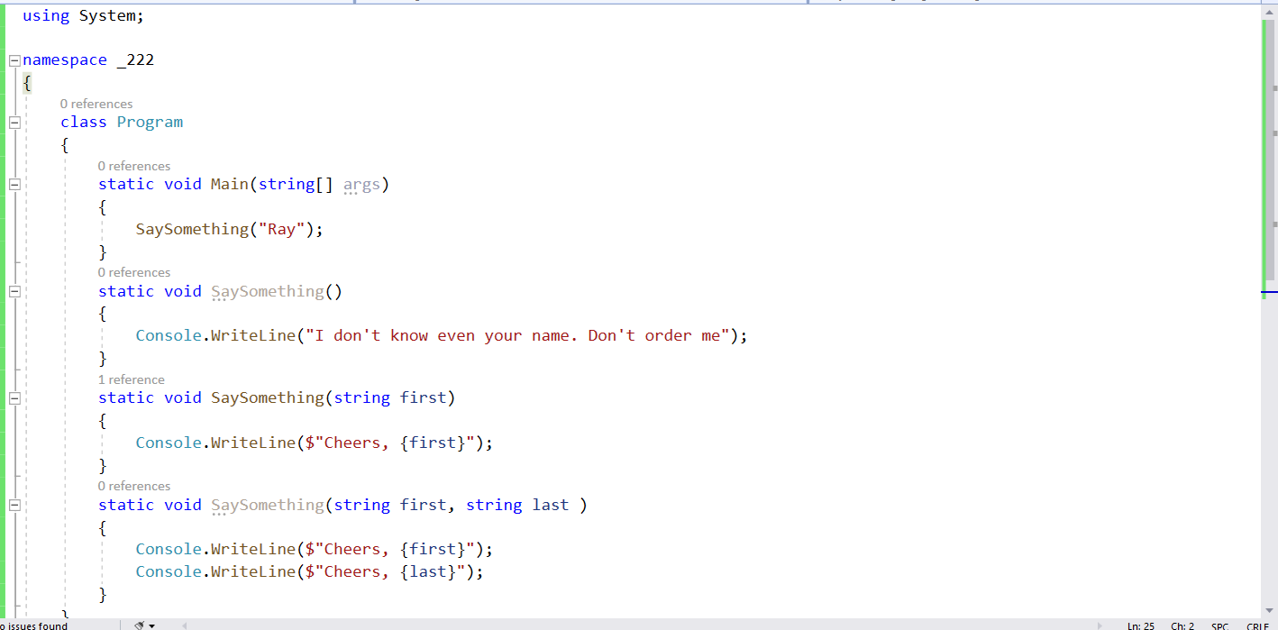**Q2**

**Description:**

* **Create a function and passed parameters**
* **Passed same parameters in this case, overloading occur**

**Output:**

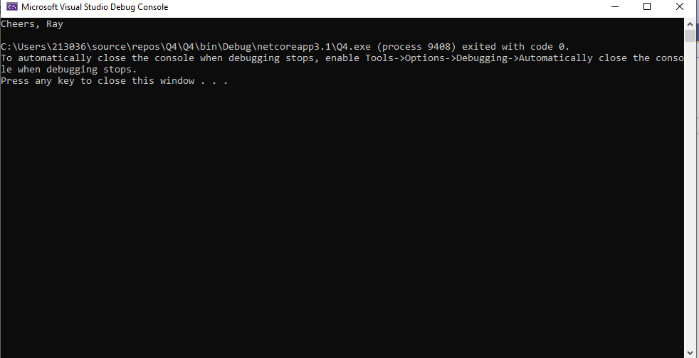

**Q3:**

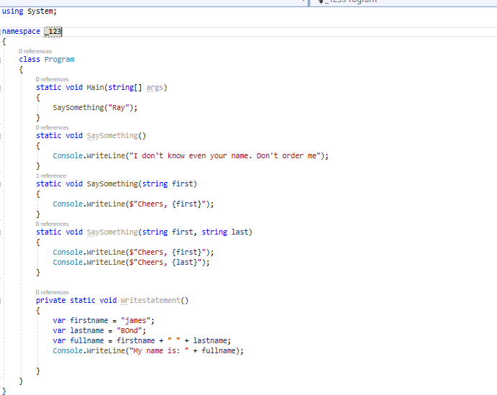

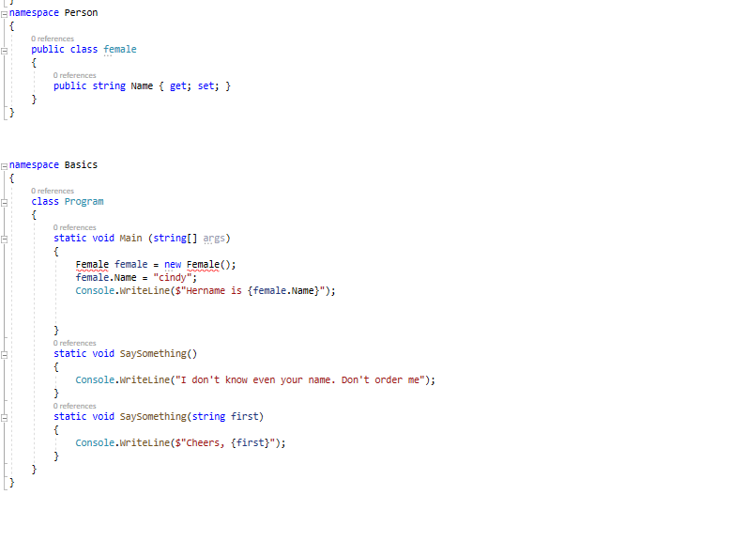



**Q 4:**

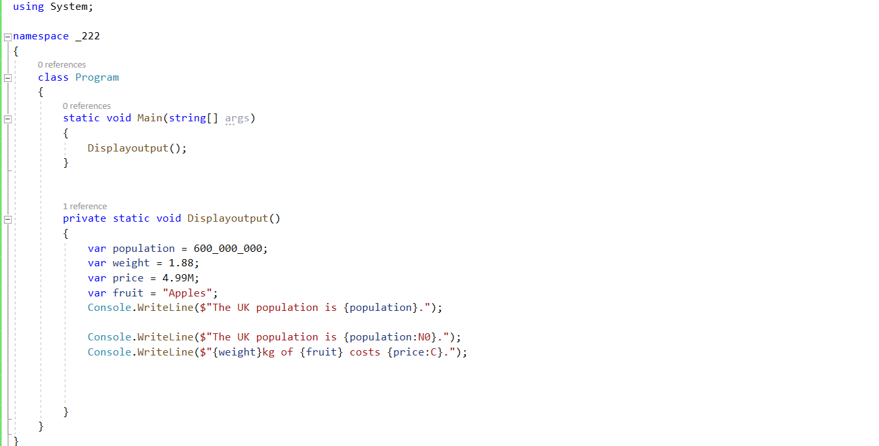

**Output:**

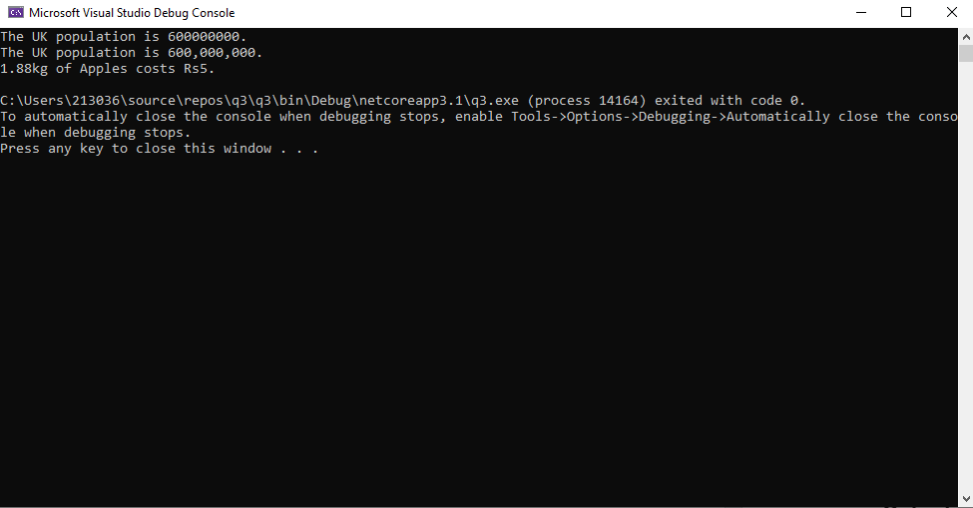

**Q5:**

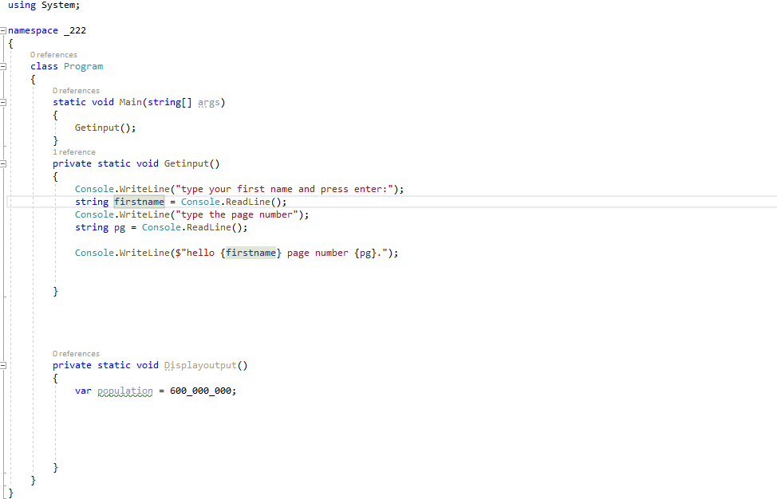

**Output:**

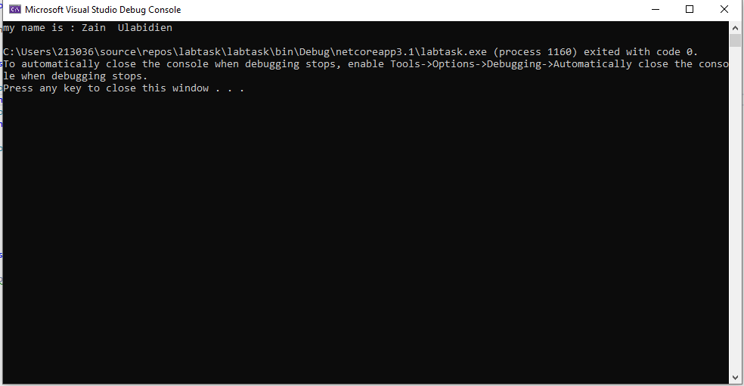

**Github URL :** [**https://github.com/AsimAli789/213218labtask**](https://github.com/AsimAli789/213218labtask)