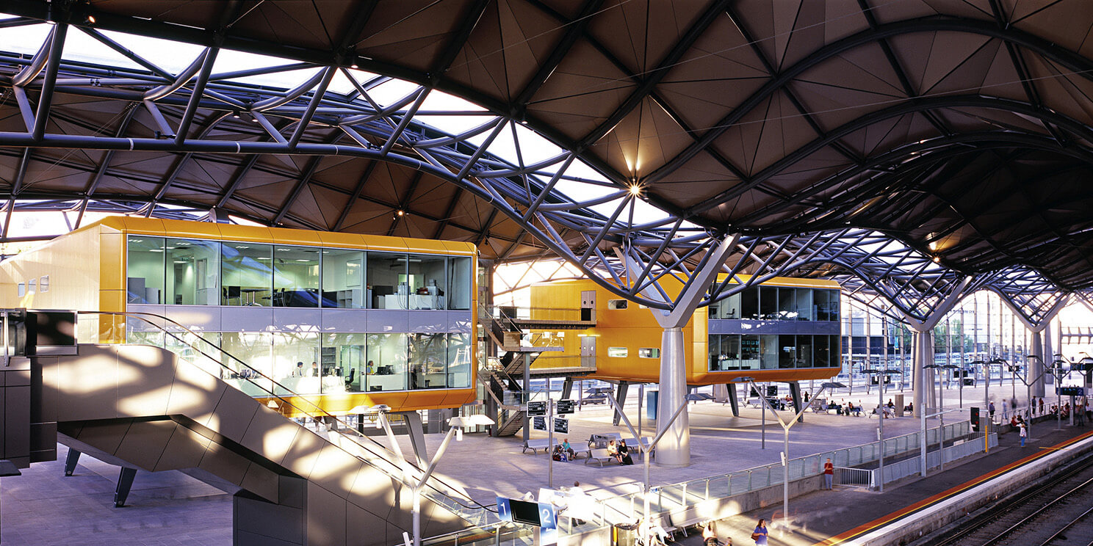

Assignment 1: Low Fidelity Prototyping

Nova Prospekt Nation

Table of Contents

*Overview* 2

*Heuristic Assessment* 3

*Risk assessment* 7

*Briefing* 9

*Scenarios and tasks* 10

*Prototype* 13

*Observations* 17

*Risk Resolution and Prototype Iteration* 22

*Minutes and Summary of Meetings* 23

## *Overview*

*Group Name:*

NOVA PROSPEKT NATION

*Group Members:*

Asim Faiaz 3296512

Huon Cantwell 3270578

Ahmad Al-kanini 3275842

Wajdi Younes 3281849

Reece Rainer 3305947

*Assignment Topic:*

A world where augment reality and head-mounted display technology is commonplace, and everyone has their own headset. Specifically, the project will consider the use of the Microsoft HoloLens21atabus/train interchange (for example the Newcastle Interchange near Wickham). Your group must design the user interface for a bus/train interchange-based HoloLens 2 system.

*Targets:*

* Scenarios
* 3 tasks for each scenarios.
* Prototype on the project
* Testing the Prototype
* Report on the project

## *Heuristic Assessment*

*Visibility of System Status:*

* Users are always able to see the status of their action through clear text instruction, loading symbols and green and red symbols indicating confirmation or rejection of user action.
* Where the users are being prompted to act on the interface, green and red coloring are used to indicate buttons in the user interface to move to the next screen.

*Match between system and the real world:*

* Our user interface has been designed to create a user experience which instils familiarity to the user with our menu and interface buttons, which also promotes clarity and ease of use for the users. Good design includes interface elements that are based on how everyday objects behave, and so by including simplistic buttons such as the Back button with an arrow representing to go back in the menu, and Home button indicating the user can go back to the home screen, we design with good design principles.
* By including symbols which are commonly seen and recognized by the general population alongside the use of text in our interface buttons, ease of use and navigation will be promoted and clarity for the user is achieved.

*User control and freedom:*

* Having a simplistic interface with clearly marked buttons to go back and forth between the pages allows the user to have freedom over which interfaces they wish to navigate to, and if they want to undo an action there is always the option for them to go back to the previous screen, or progress to the next screen if they completed a task.

*Consistency and standards:*

* All buttons through the interface follow the same simplistic design and therefore consistency is upheld throughout the entire interface. We have made all the buttons have the same style and the icons within the buttons are made to be simple for the user to understand and consistent throughout our interfaces.
* One problem our team found during the heuristic evaluation is the potential ambiguity found in the “One Off Ticket” button. Our solution to this was to change the interface to give the One-Off Ticket button its own interface, rather than having to navigate through the Auto-Recharge interface which could cause confusion to the user. Our solution was then integrated into the system to enhance the consistency of our interface.

*Error Prevention:*

* By including only available trains at specified times available for selection, our interface has been designed to forgo the errors associated with selecting unavailable train timings.
* Having fields in the payment method interface which only accept payment details which are the correct format for the selected payment method (e.g. Visa), this will prevent errors of an invalid input nature.
* By having the user confirm their station name from a queried selection of stations according to the users input string, we prevent any errors associated with incorrect, misspelled or non-existing station names.

*Recognition rather than recall:*

* Our interfaces have been designed in a way which prioritizes user intuition and recognition rather than users having to remember various interfaces and previous screens to use the interface functionality.
* Our interfaces have been designed in a way which prioritizes user intuition and recognition rather than users having to remember various interfaces and previous screens to use the interface functionality. This can be seen by having the home screen where the buttons provide the user with other interfaces according to what the symbol and text of the interface button says it will bring the user to.

*Aesthetic and minimalist design:*

* When designing our interfaces for the design prototype, we prioritized having a minimalistic design, while still being reasonably aesthetic to complement the efficiency of the interface. In reference to Tognassini’s first principles of interaction design, “Effective interfaces are visually apparent and forgiving, instilling in their users a sense of control”.
* By having a very simplistic design with clearly marked and labelled buttons to navigate between interfaces, our design allows users to have a sense of control, while being forgiving in nature by going between simple screens and allowing the user to go back. Tognassini’s principles note that “Effective interfaces do not concern the user with the inner workings of the system”, so by designing our prototype with this in mind, we created a minimalistic and aesthetic design for the end users of the system.

*Help users recognize, diagnose and recover from errors:*

* Our interfaces have been designed to provide sufficient error notification for the user if they cause an error through one of their inputs. Initially while we were drafting our prototype the interface assumed that the user would input the correct card details or have a sufficient card balance while using their card.
* During the heuristic evaluation, we proposed a scenario where the user’s card would decline, either through wrong details or insufficient balance. To address this problem, we designed a new interface screen which notified the user that their card was declined, and simple buttons to be able to return to the previous menu.

*Help and Documentation:*

* Systems should theoretically be able to run without any help and documentation. However, the inclusion of help and documentation can be valuable to any users of the system. Our design team decided to include Help and About Us buttons in the menu to provide users of our interface a way to gain more information about the system and help with any generic issues that may be experienced with the interface.

## *Risk assessment*

*Timetables:*

No error notice for incorrect spelling or destinations which may cause the user to get frustrated and stuck on the search page.

Left hand side of the timetable is unclear to the user whether it is referring to the time until they leave or when the train arrives. This also applies to the time on the right-hand side, causing the user to miss his train.

If a user chooses a departure station, the user must input the arrival destination as well. The user may be better acquainted with a drop-down menu in order to easily select the available destinations from the starting destination, preventing the user from getting stuck.

*One Off Ticket:*

The dropdown for the list of stations overshadows the keyboard which may lead to mis clicks from the user.

The destination is a list and the user may be confused on which column to click on in the row to select the destination they plan to go to.

The user may want to type in a language different than English on the keyboard for their card details.

If the user has their card declined, they are forced to go through the whole process again.

The user is not able to see the one-off tickets they have bought, which may cause them to buy additional tickets if they have forgotten or to miss out on rides if they have not bought yet.

The user cannot purchase more than 6 tickets per process which means that if they need more, they need to complete the process multiple times which may cause errors.

No error notice for incorrect spelling or destinations which may cause the user to get frustrated and stuck on the search page.

*Recharge and Auto Recharge:*

The keyboard for recharging is only available in English when the user may need to use a different language for card details.

If a card is constantly declined, the user may get annoyed since there is no process to automatically re-change the card details and the whole process needs to be completed again.

*Tap On and Off:*

The user can tap on, and then subsequently cancel the application causing an unfinished loop which is hard to recover from.

The card scanner is the most important and only item needed for tapping on and off, leading to single point of failure for the system

*Settings:*

The text to speech function in the interface may be risky due to its always on scenario. A user may turn it on and forget how to turn it off, causing a multitude of errors in day to day use.

The user can reduce size of text based on percentages, the user may reduce size of text to 0% and accidently exit creating a difficult situation for the user in case they want to revert the changes

The settings interface also features an update function, but it can be cancelled or gone back during the update. This may cause issues for the user if clicked during update as it may cause issues and be hard to recover from

*Trip Planner:*

Keyboard is dependent on using the English language. A non-native English person may find it particularly difficult to find the destination that they intend to travel to.

The time for the train can be unclear to the user whether it refers to the departure or arrival time since there is no indication to the user.

No error notice for incorrect spelling or destinations which may cause the user to get frustrated and stuck on the search page.

## *Briefing*

The project utilizes the Microsoft HoloLens 2 system to create a functional digital application of using a Train interchange. The application allows the user to both Auto Recharge and Normal Recharge their tickets, to find directions for their destination via the Trip Planner, to purchase a One-Off Ticket and Tap On and Off at the interchange. The application is designed to be extremely intuitive for the user to make it easy to use the Train Interchange.

The Auto Recharge and Recharge function require credit card details from the user to be used. The recharge interface is intuitive for the user and is based on a step by step approach. The user is given the ability to purchase as much they would like. The user will then be notified if the transaction was successful.

The Trip Planner allows the user to search and find information regarding the trip. This involves showing all the available destinations and the time that they run from the user’s destination. The Trip Planner also shows which platform the train is located at and then shows direction to the platform

The last function, the Tap on and Off allows the user entry onto the train by tapping their card on the system.

## *Scenarios and tasks*

*Scenario 1:*

Jumping onto the train or bus and get out from the train or bus often requires tapping on and off the opal card in train interchange machine on both entry and exit. May involve a sign that says 'Tap before entering train' and 'Tap before exiting the train'. The user is require to tap their opal card on entry and exit. Moreover able to see their balance after every tap. User can use one-way ticket as well to go to their destination.

**Task 1**: User navigates to tap on/off interface.

**Task 2:** User taps card on (if currently tapped off).

**Task 3:** User taps card off (if currently tapped on).

**Goal:**Tap on and tap off before hop on and leaving the train.

**Precondition*:*** Must have the opal card.

**Exception*:***Not enough fund.

**Breakdown:**The opal system is not operating.

*Scenario 2:*

When recharging opal card balance to get into the train. The user is able to touch the train interchange machine to see their balance. Then the user will be prompted if they wish to add balance into their account. If the user clicks yes, the user is given the option to either pay in or card. If the user clicks card, he will be prompted to insert his card. Once payment is completed, the user is shown that it was completed and a glimpse of his new balance on opal card.

**Task 1:** User selects to top up their account.

**Task 2:** User selects desired recharge amount.

**Task 3:** User enters payment method and finalizes payment.

**Goal:** Recharge the Opal card.

**Precondition:** Must have the opal card.

**Exception:** Choose the wrong pin code.

**Breakdown:** NO credit in the bank account to recharge or NO internet connection.

*Scenario 3:*

Finding destination using trip planner. User come to the Station. Set up his destination. The screen will show option which platform the train will depart and the time as well. The screen will show if they want to wait for the all stop or the express service. It’s going to show the estimate time to reach the destination.

**Task 1:** Search for destination.

**Task 2:** Select timetable.

**Task 3:** Head to the platform

**Goal:** Find the destination and guide to reach the platform.

**Precondition:** Must have a destination.

**Exception:** No station or bus stop found nearby destination.

**Breakdown:** Failure to navigate due to network connection.

## *Prototype*

*Tap on and off*

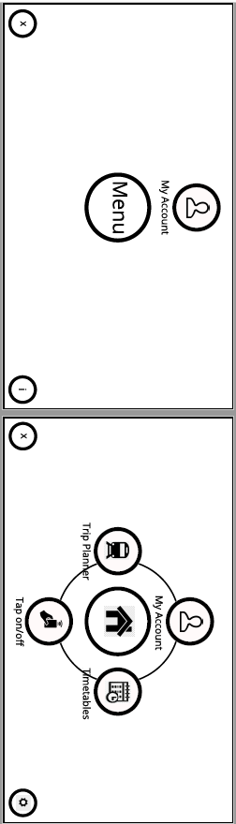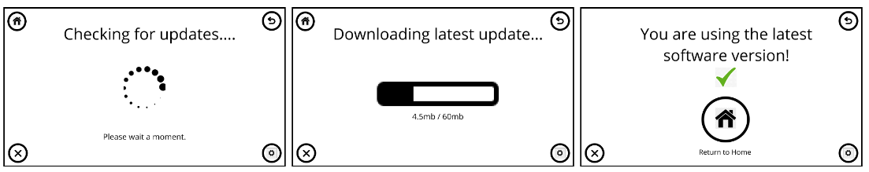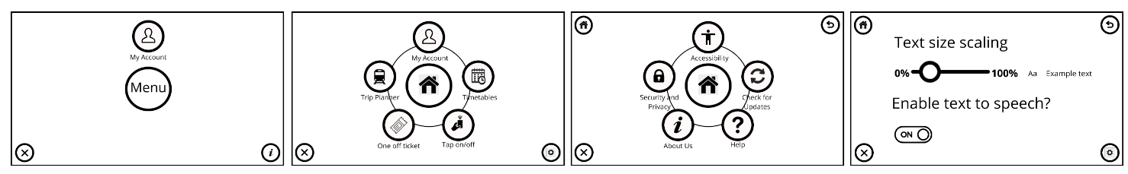*Settings*

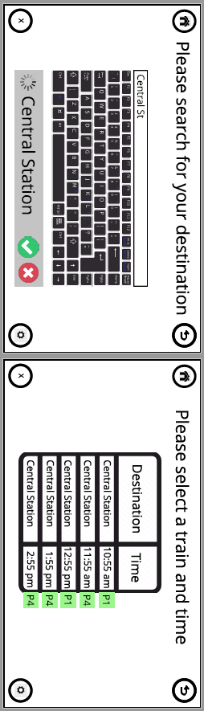*Trip Planner*

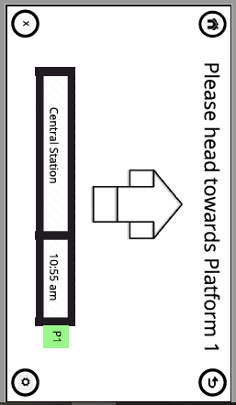

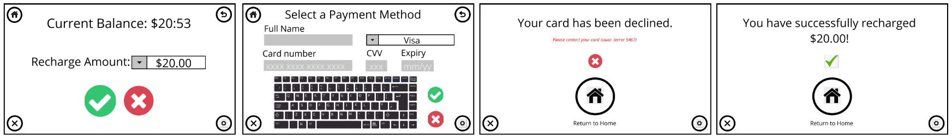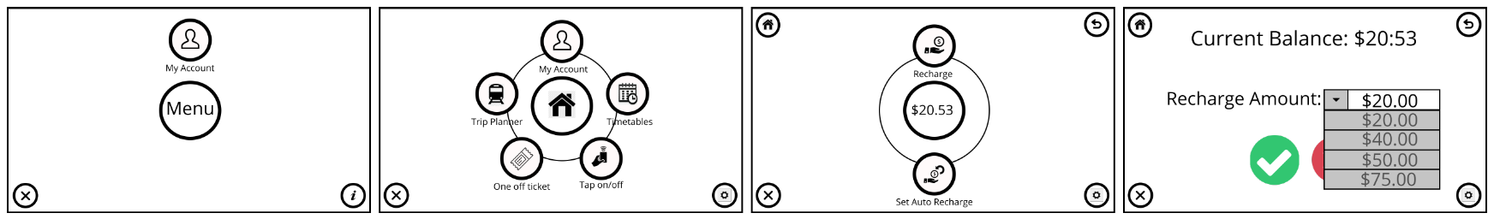*Recharge*

*Auto Recharge*

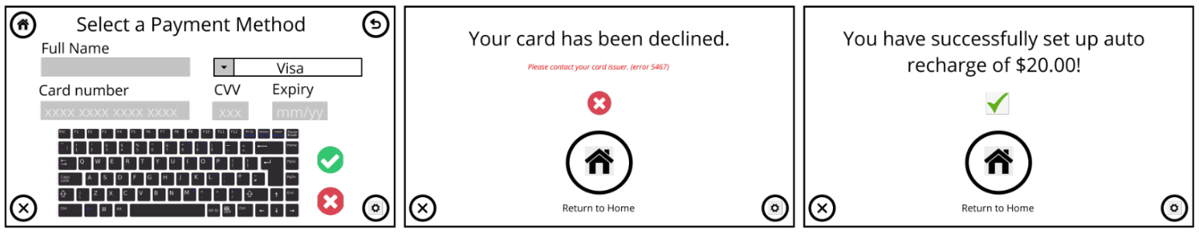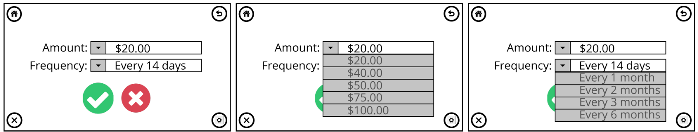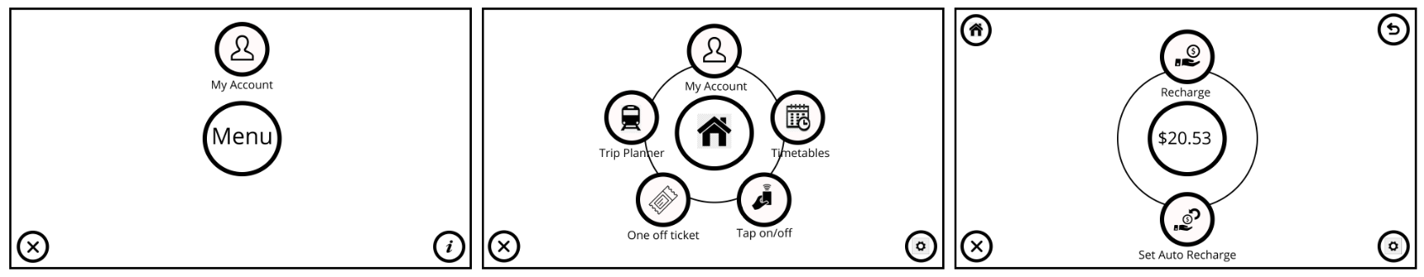

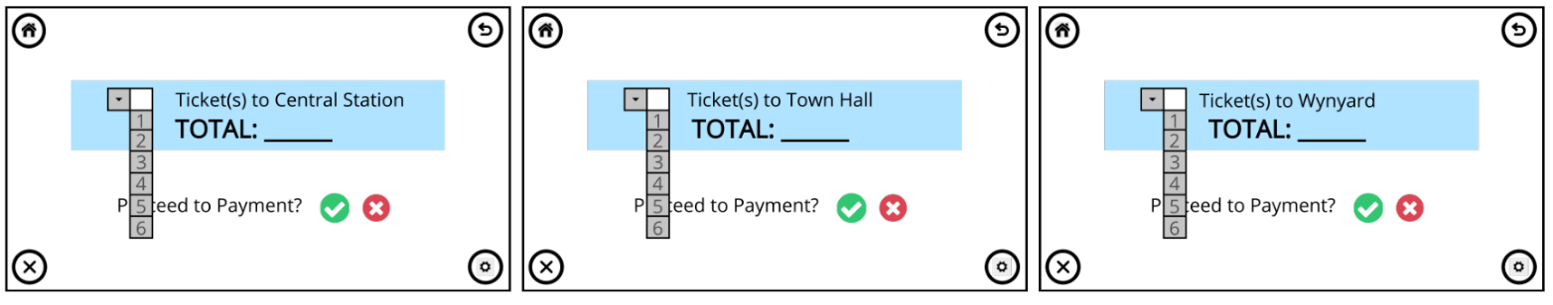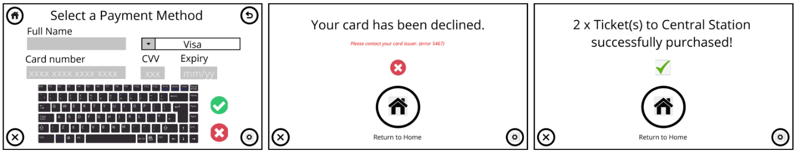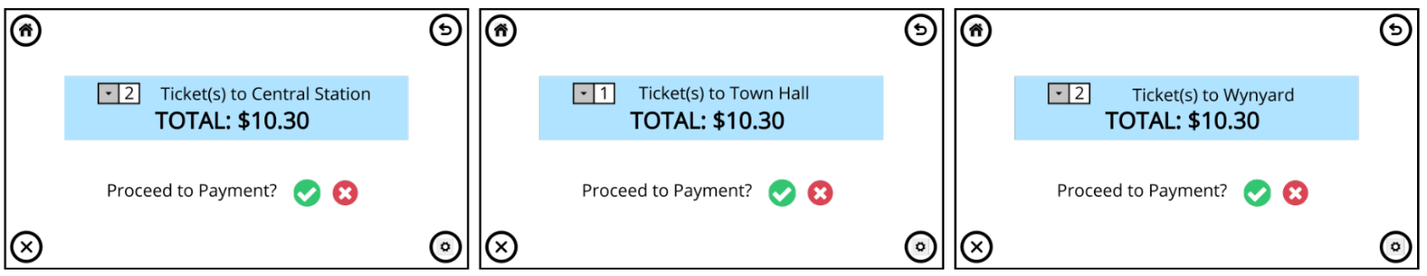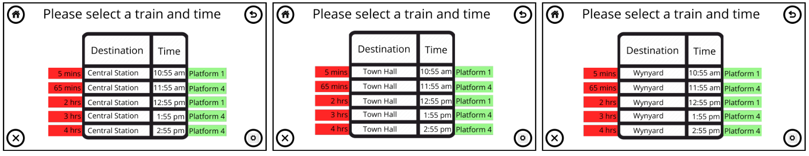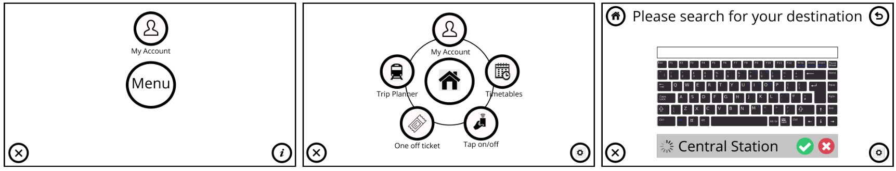*One Off Ticket*

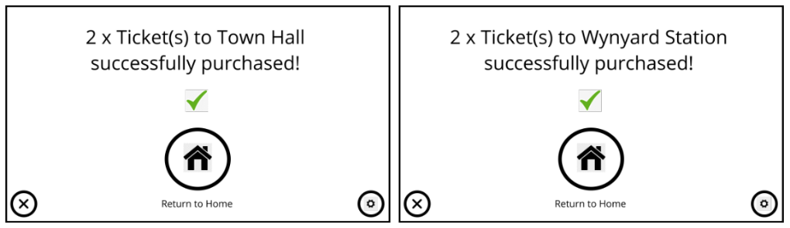

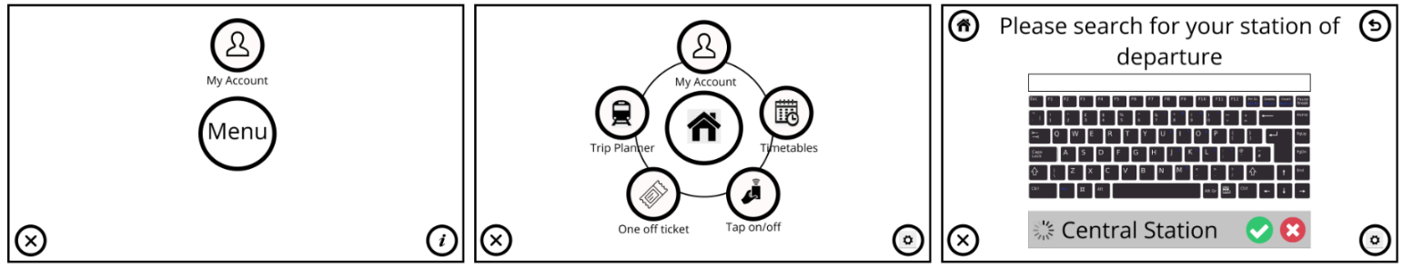*Timetables*

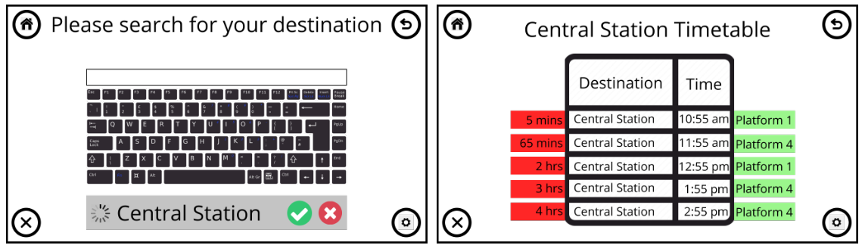

## *Observations*

*User 1*

**First Scenario: Recharge**

It took the user one minute to complete the task.

The user was able to complete the task quick and efficiently without any errors. User commented that it was simple and straight forward to recharge.

**Second Scenario: Tap On and Off**

It took the user less than a minute to complete the task.

The user was confused where to tap the opal card on the scanner. The slide says to tap it but there was no indication for anyone unfamiliar with the system that the tap is the receiving console in the middle. The console in the middle could utilize a ‘TAP HERE’ text to make it easier for the user.

**Third Scenario: Trip Planner**

It took the user 2 minutes to complete this task

The user was confused what to click on the initial page between the User Profile and Main Menu buttons since there was no indication what each one did. The user then found it difficult to discern if the application required to type details and then enter in the destination search box or if the destination was automatically completed and inserted into destination box. The user also was confused on what section of the destination row to click on.

User commented that it could have been simpler and more user intuitive and knowing which icons to click on to navigate was sometimes vague.

*User 2*

**First Scenario: Recharge**

It took the user 1 minutes to complete this task.

The user clicked on the User Account instead of the menu but was able to successfully recharge the opal card without running into any problems.

**Second Scenario: Tap On and Off**

It took the user one minute to complete this task

The user did not run into any problems in tapping on and off at the recharge station. The user noted that it was easy and intuitive to complete the task

**Third Scenario: Trip Planner**

It took the user 2 minutes to complete this task

The user was confused on what platform he is currently on and noted that would be good to have a section saying currently positioned platform. When the user went through the trip planner, the user had difficulty on whether to tap the platform button, time or location since the information is divided into columns and looks divided to the user. There is also no indicator that the menu is touchable.

The user noted that the main menu was confusing with the Account and Menu Button and would like a clearer menu that clearly shows the user which one needs to be clicked in order to successfully complete the task.

*User 3*

**First Scenario: Recharge**

It took the user 1 minute to complete this task

The user encountered no issues and completed the task according to guidelines.

**Second Scenario: Tap On and Off**

It took the user less than one minute to complete this task

The user found no difficulties in completing this task and noted that the big tap on and off button made it intuitive for the user to complete the task.

**Third Scenario: Trip Planner**

The user completed the task in one minute.

The user encountered no difficulties in completing the task. The user noted that each input section and button were big and clear making it easy for the user to know what to click and when to click. By making the buttons and inputs the main focus, the user is less likely to make any mistakes.

*User 4*

**First Scenario: Recharge**

It took the user one minute to complete this task

The user mistakenly clicked on the confirmed button without inputting an amount that he intends to recharge. User noted that an auto pre-filled amount or a selection of recharge options may make it easier for the user to recharge. The user completed the rest of the task without any problems.

**Second Scenario: Tap On and Off**

The user completed the task in less than a minute.

The user encountered no issues and made a comment regarding the fluidity and ease of tapping on and off. The user says the on/off button is big enough and clear to not make any mistakes.

**Third Scenario: Trip Planner**

The user completed the task in less than a minute.

The user completed majority of the task without any problems but when arriving to the end destination screen, the user was confused on which section of the row to tap for the list of destinations. Would be clearer if the destinations were organized in a way that made it apparent that the whole row is one object.

*User 5*

**First Scenario: Recharge**

It took the user 1 minute to complete this task.

The user pressed the ‘My Account’ button instead of the ‘Main Menu’. When the user attempted to use the keyboard, the user noted that he was not sure if a full field view of the keyboard on the screen could be detrimental to the user experience of the application and could cause errors on the move. The user also noted that the window sizes should be adjusted or transparent.

**Second Scenario: Tap On and Off**

It took the user less than 1 minute to complete this task.

The user was confused on whether to click the ‘Main Menu’ to access the tap on function. The user noted that the exit ‘X’ button is confusing due to the concern of not knowing whether clicking the button would cancel the trip.

**Third Scenario: Trip Planner**

It took the user less than 2 minutes to complete this task.

The user managed to complete the task with not much difficulty. The user noted that the timetable for trains is slightly confusing due the uncertainty of whether the time is for departure or arrival, and due to the fact that it does not include buttons to click in order to confirm a ride.

## *Risk Resolution and Prototype Iteration*

The team has found that most of the risks that have been identified in the risk assessment section above have caused usability problems during the user testing phase. Therefore, it is of upmost importance to mitigate those risks to prevent errors from happening as the prototype iterates to its final stages. The useability errors that were discovered during the low fidelity prototype testing are listed below as well as their proposed solution strategies. However, some identified risks have not caused problems during the low fidelity tests, but the team believes that they could cause major issues later on in the project’s lifetime. These risks include:

* Spelling errors during search.

Solution: make suggestions based on the words searched to show the closest named station.

* Language.

Solution: Add an option to change the language in the settings for the users that do not speak English.

* Visibility.

Solution: the sizes and position of the interface windows should be customizable using HoloLens technology by pinching and holding to move the object in and out the field of view of the user.

**First Scenario: Recharge**

|  |  |
| --- | --- |
| Usability Problem | Proposed Solution |
| Some of the users would click on the ‘My Account’ button to get to ‘Recharge’ instead of the ‘Main Menu’ which also leads to ‘My Account’ and then ‘Recharge’ which deems having ‘My Account’ on the starting page redundant | * Remove the starting page and replace it by the menu instead, or * Remove ‘My Account’ from the starting page and replace the top part by the name of the application. |
| The recharge options drop down menu does not have a default amount which caused users to mistakenly click on the confirm button without making a selection | * A default pre-filled recharge amount should be set with the minimum possible recharge amount which can then be changed by the user by clicking on the drop-down menu and making a selection. |
| The keyboard size could block the users’ field of view which could be detrimental to the usability of the application on the move as well as the safety of the user | * Add voice to text option * Make the keyboard window resizable and transparent to a degree where it allows visibility while being clear depending on the lighting of the environment. |

**Second Scenario: Tap On and Off**

|  |  |
| --- | --- |
| Usability Problem | Proposed Solution |
| Tap on and off area is unclear for new users as they may not know where to tap the card | * Add “Tap Here” text in the position where the card is to be tapped. |
| The exit symbol ‘X’ could be confused as a button for cancelling the trip | Eye tracking technology in the HoloLens 2 can be utilized to determine where the user is looking to show text pop ups with a brief description of the symbols that the user looks at much like a mouse hover |

**Third Scenario: Trip Planner**

|  |  |
| --- | --- |
| Usability Problem | Proposed Solution |
| Having ‘Main Menu’ and ‘My Account’ causes confusion for the user when performing the task of planning a trip | * Removing ‘My Account’ from home screen |
| The destination search bar is difficult to understand as it seems like the destination is preselected | * Remove the bottom part of the interface where it says the destination and instead only show train stations based on the search in the form of a drop-down menu if more than one station has similar names. * Remove the keyboard from the interface and instead make it a second interface object that pops up when the search bar is clicked. |
| The train timetable selection is difficult for unfamiliar users as it does not have any clear buttons to click when making a selection | * Add clickable buttons on the right of the table with arrows indicating a selection |
| The train timetable structure is disorganized. Times are ambiguous as they do not specify whether it is arrival or departure time | * Specify arrival and departure times on the table. * No need to specify the destination in every row. |

This concludes the report for the first low fidelity prototype. The team will continue making improvements by implementing the proposed solutions found in this section. The team will also consider any new complications and risks that may arise after updating the prototype as well as run a few more tests to find any errors before moving onto the high-fidelity prototype.

## *Minutes and Summary of Meetings*

Meeting day 1 Meeting day 2

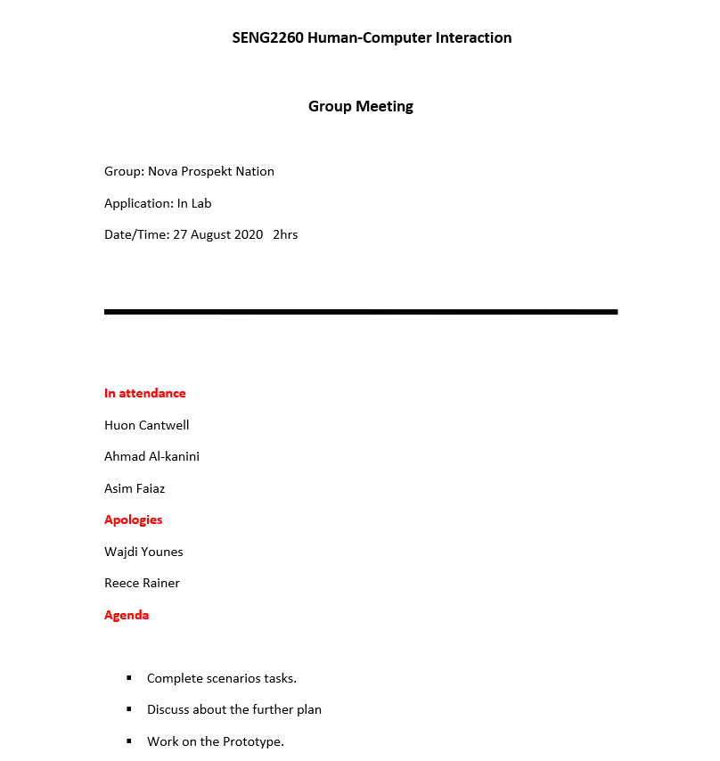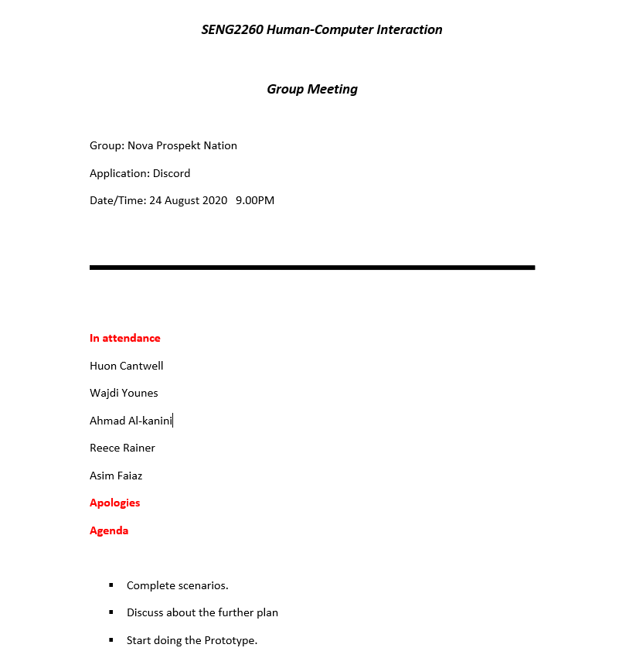

Meeting day 3 Meeting day 4

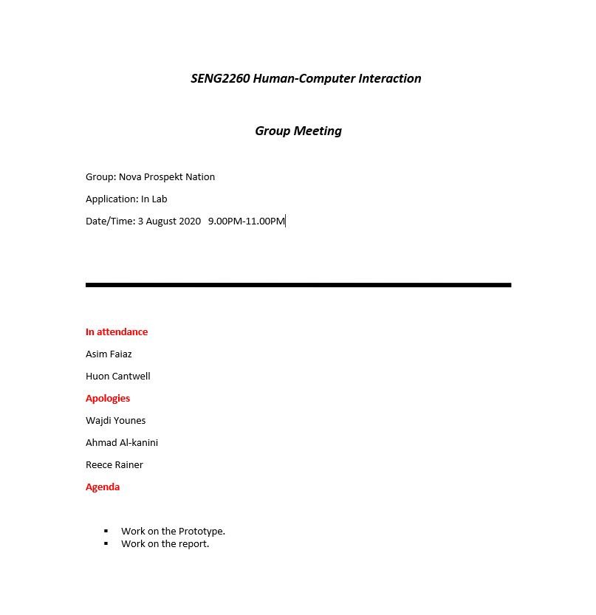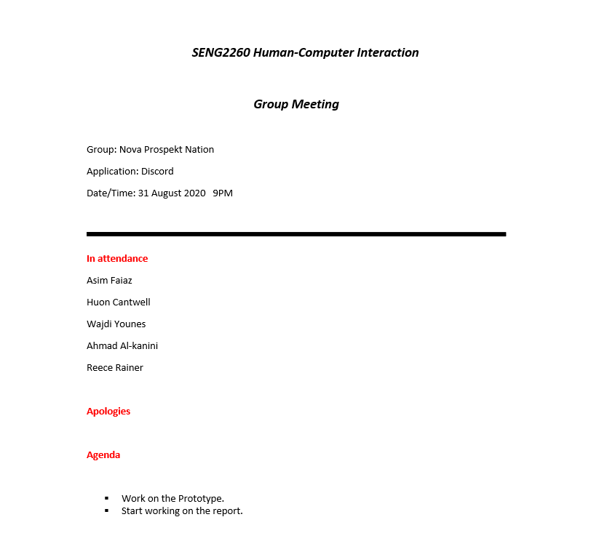

Meeting day 5 Meeting day 6

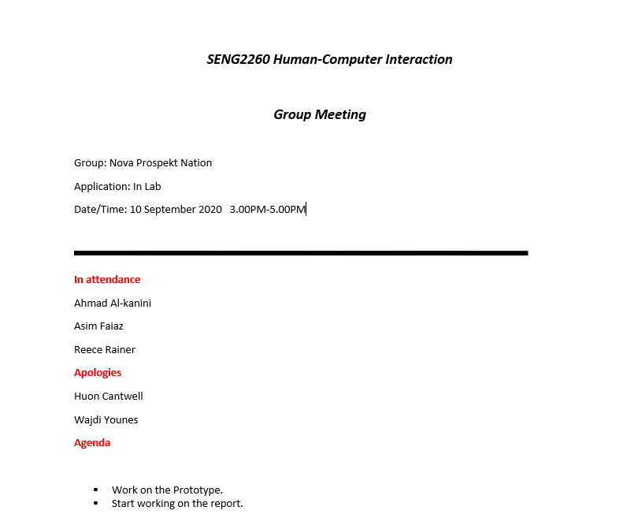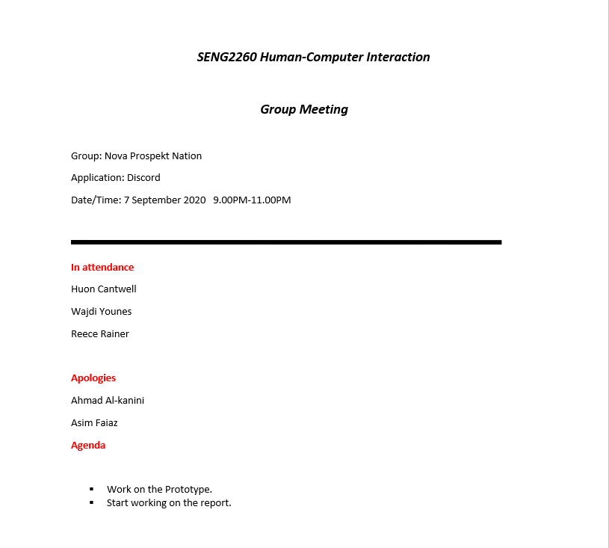

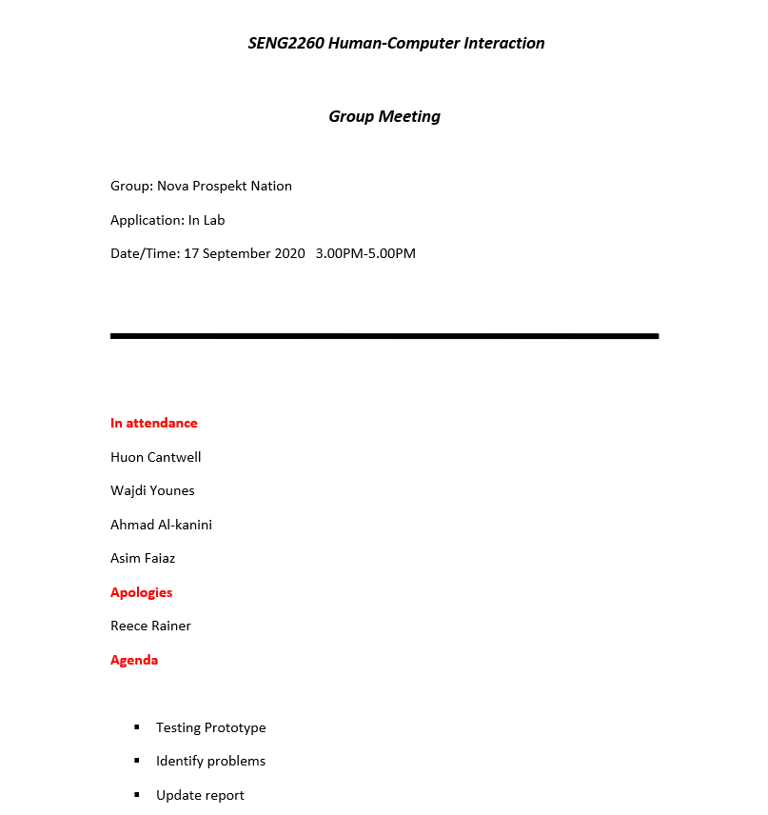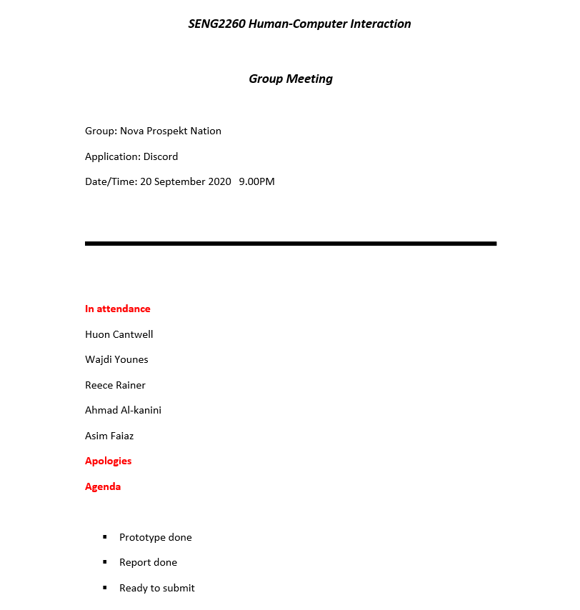Meeting day 7 Meeting day 8

All group members made a solid effort in participating in team meetings and discussions unless they had a reason to be absent such as being sick or an emergency. All members made up the lost time later. The tasks were completed in time and decisions were made with the whole group in agreement. Whenever an issue popped up in completing one of the tasks, the members would consult and would only go through with it once the decision was unanimously agreed upon. The group dynamics were good, and all team members got along. The testing was a joint effort by all the group members and made the completion of the prototype straight forward.