CURRICULUM VITAE

Mr. ABID HUSSAIN

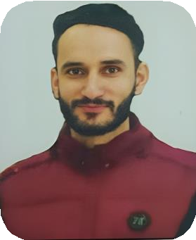

# Contact: +91-6005131540

**Email:** [**adidhussainsalaria@gmai.com**](mailto:adidhussainsalaria@gmai.com)

# PERMANENT ADDRESS:

**RO: Karmail Ramgarh, Distrct: Doda, Jammu & Kashmir, 182143**

**POST APPLIED FOR: CIVIL ENGINEER**

# OBJECTIVE:

B. Tech civil engineering graduate with knowledge in construction, design and material management looking for entry level position in a reputed organization where I can enhance my skills, knowledge and experience.

# PERSONAL PROFILE:

Father Name : Altaf Hussain

Date of Birth : 09-08-1997

Marital Status : Unmarried

Gender : Male

Nationality : Indian

Religion : Islam

Language Known : Urdu/Hindi, English, Punjabi Educational Qualification : 12th Pass

Technical Qualification : B. Tech in civil Engineering Technical Skill : Auto Cad, Revit, MS Office

# PASSPORT DETAIL:

|  |  |  |  |
| --- | --- | --- | --- |
| Passport Number | Date of Issue | Date of Expire | Place of Issue |
| **B6500379** | **07-12-2023** | **06-12-2033** | **JAMMU** |

**WORK EXPERIENCE:**

|  |  |  |
| --- | --- | --- |
| COMPANY NAME | POSITION | PERIOD |
| **GAMMON ENG. & CONSTRUCTION PVT. Ltd.** | **Junior Engineer** | **20-08-2022 To 18-08-2023** |

# DECLARETION:

I hereby declare that above information/s are true in my knowledge and looking bright future from your end.

PLACE:

DATE: **Mr. ABID HUSSAIN**