

STUDENT APPLICATION 2017

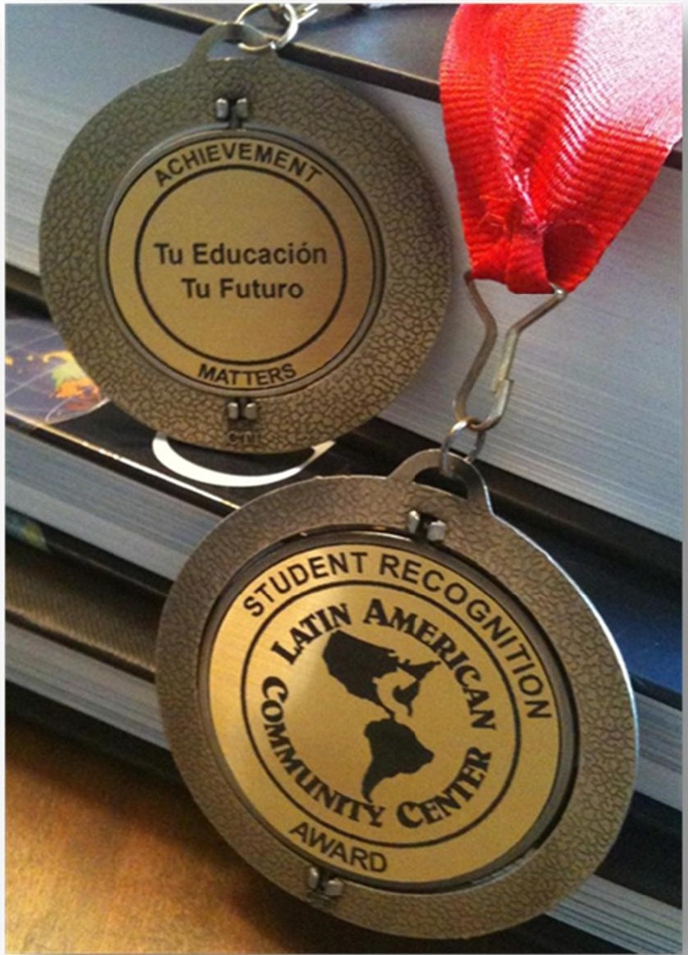

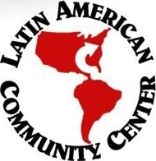LATIN AMERICAN COMMUNITY CENTER

HISPANIC STUDENT RECOGNITION PROGRAM

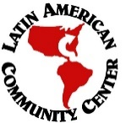

**ABOUT THE PROGRAM**

* The Hispanic Student Recognition Program (HSRP) is an effort by the Latin American Community Center (LACC) to recognize exceptional Hispanic students in high school in the State of Delaware. The program has been a signature event since 1979 and maintains strong school, community, and private sector support. The goal of the program is to open doors for Hispanic students to pursue greater opportunities, inspire pride in our people and our heritage, motivate students to work hard, and motivate their families to support them.
* All nominees attending the awards ceremony will be recognized and honored with a commemorative medal. All award recipients will receive a special award medal and a cash prize. In addition to these prizes, the outstanding students of the year will receive a special plaque.

**ELIGIBILITY**

* Hispanic high school students from any public or private school can apply for achievement awards.
* Nominees must be Delaware residents (i.e., primary residence must have a Delaware address).
* Nominees must be of Hispanic origin, defined as those persons who have at least one parent of Hispanic/Latino heritage.

**APPLICATION INSTRUCTIONS AND SELECTION PROCESS**

* A nomination form is completed and submitted online, [HSRP Application](http://www.thelatincenter.org/" \l "!hsrp-form/qoup8). Nominations do NOT have to come from teachers. We accept nominations from teachers, coaches, family, community organizations, employers, mentors, and any adults familiar with the student. Upon decision of the nomination, the student nominee has to be informed about the nomination and must complete AND submit ALL parts of the online application as **instructed**. This includes, the HSRP online application, a strong personal statement essay, and supplemental materials/information highlighting the relevant award categories: examples of students’ academic achievements, awards and certificates, extracurricular activities, community service, personal qualities and character, the nominee’s creativity or talent. Be sure to complete and submit **ALL** of the requested information and include photo/scanned copies of the required documents such as transcripts, test scores, awards, resumes, report cards, visuals of arts, performances, and/or scientific project. If the application is not fully completed the application will **NOT** be processed. For more information, contact Chastity Galarza at 302-655-7338 ext 7727.
* High school students compete by county for awards in five categories: academic excellence, community service/volunteerism, athletics, the arts, and science/technology/engineering/math (STEM).
* Two state-wide high school students, male and female are selected as Outstanding High School Hispanic Students of the Year. Two state-wide, male and female, are selected as Outstanding High School Hispanic Students of the Year.
* The HSRP selection committee evaluates and rates each application on its merit and submits the candidate’s documentation to the selection committee for review. This committee is comprised of community leaders and educators from both the public and private sectors.
* The selection of the awardees will be done by the selection committee and will be announced at the awards ceremony. The ceremony is open to the public but reservations are required. Winners must be present to receive awards.
* April 8, 2017: The HSRP Ceremony will take place at Cab Calloway School of the Arts, 100 N. DuPont Road, Wilmington, DE 19807

**AWARD CATEGORIES**

**The following awards are given to High School Students. Nominees will submit an online portfolio by email to HSRP@thelatincenter.org in JPG or PDF format of documents and relevant examples that support achievement in the award category.**

* **ACADEMIC EXCELLENCE AWARD:** The Academic Award is bestowed upon a student(s) who has demonstrated the highest level of academic performance. Rating is based on submitting a portfolio that supports academic achievement such as academic honors/awards, number of advanced placement classes, standardized test scores, GPA, advanced placement grades, and personal statement.
* **AWARDS IN THE ARTS:** The Arts award is bestowed upon a student(s) who has distinguished herself or himself in the visual arts, music, dance, and/or theater. Rating is based on honors/awards, creativity, talent, submissions*, and personal statement.
* **ATHLETE OF THE YEAR AWARD:** The Athletic award is bestowed upon a high school athlete whose achievements on and off the field exemplify the best qualities of sportsmanship. Rating is based on academic achievement, team player attitude, leadership, awards received for their contributions, and personal statement.
* **SCIENCE AND/OR TECHNOLOGY AWARD:** The Science/Technology Award is bestowed upon a high school student(s) who has distinguished himself or herself in the field of science (biology, chemistry, mathematics and physics) and/or technology (computer science, audiovisual, science/technology, and information systems). Rating is based on honors/awards, academic performance in related courses, science/technology projects, notable accomplishments, and personal statement.
* **COMMUNITY SERVICE AND VOLUNTEERISM AWARD:** The Community Service award is bestowed upon a student(s) who has demonstrated consistent and ongoing involvement in community/school service. Rating is based on the type of community service, meaning of community service, service hours (must provide documentation for hours completed), service awards, length of time serving the community, and personal statement.

**The Outstanding Hispanic Student of the Year Award is given STATEWIDE to High School Students:**

* **OUTSTANDING HISPANIC STUDENT OF THE YEAR: This award is presented to a male and a female high school student who have shown substantial overall achievement in most/all categories (Academics, Art, Athletics, STEM and Community Service). This student is well-rounded and demonstrates excellence across the board, balancing a variety of activities successfully.**

**COMPLETE STUDENT APPLICATON STARTING NEXT PAGE**

STUDENT - NOMINEE INFORMATION

|  |  |
| --- | --- |
| **FIRST NAME** | **LAST NAME** |
| **EMAIL** | **PHONE CONTACT** |
| **Do you consider yourself Hispanic / Latino:** Yes No  **Why?** | |

AWARD CATEGORIES  
**SELECT ALL THAT APPLY**

ATHLETICS

SCIENCE/TECNOLOGHY

ARTS

COMMUNITY SERVICE/VOLUNTEERISM

**CONTINUE NEXT PAGE**

**PERSONAL STATEMENT**

All applicants, regardless of nomination category, are required to respond to **one** of the following essays.

The response is limited to 7500 characters. Criteria for judging the statements include:

|  |  |
| --- | --- |
| Grammar Spelling and sentence structure | Clear theme or topic |
| Supporting details | Personal or People Impact |
| Effective use of words | Organization of thoughts |
| Relevant Content and Examples | Strong introduction and conclusion |

* “If you, as a Hispanic person, decided to run for president, how would you convince America that you are a strong candidate?” What would be your platform for your campaign (i.e. values)? What do you think one of the biggest issues facing a new president would be?
* In many ways, schools are more segregated today than in past decades, and residential segregation is a fact of life in many areas.  How can you, the student foster the respect for differences even when the school environment lacks diversity?
* QUESTION

PERSONAL STATEMENT: **For best results, type your personal statement in your choice of text editor (example: Microsoft Word) and paste to online application. Maximum characters = 7500.**



**Checklist of Required and Supporting Documents:**

Nominees must submit the appropriate attachments as listed below. Documents may be scanned or sent as a graphic. Upon submission of this application, please submit your videos, recordings, photos, projects, and/or portfolios as an email attachment to [HSRP@thelatincenter.org](mailto:HSRP@thelatincenter.org) in JPG or PDF format. Be sure the email identified the name of the student and school.

If necessary, supporting documents may be sent by mail with the Supplemental Documents Form provided on the website.

Please note all videos, recordings, photos and/or portfolios submitted become the property of the Latin American Community Center (LACC). The LACC reserves the right to use these submissions in any form, including but not limited to the agency website, agency publications and during the Hispanic Student Recognition Program ceremony.

**All Nominees must submit:**

* Resumé - Include a resume listing your achievements. Honors received could include trophies, plaques, and certificates. Activities could include extracurricular activities, community volunteer service hours, and any employment.
* Personal Statement – copy/paste to section above.
* Report Card or transcript – most current complete year and semester.

**Acceptable support materials for submission by award categories: You must provide a portfolio that demonstrates your achievement in the award categories. The following descriptions provide some relevant suggestions but you must present yourself as you deem most appropriate for the award.**

**\* Academics:** GPA (indicate weighted or unweighted), class rank, standardized test scores (e.g. SAT), AP course listing and scores, honors course listing, honor society membership, academic awards, etc.

**\* Art:** Multiple submissions of your art (visual, performance, etc.) are required.

*- VISUAL ARTS:* All Visual Artwork (drawings, paintings, graphic art, photographs, etc.) must be either photographed and printed or submitted electronically.

*- PERFORMING ARTS:* Must submit a video clip or web link (e.g. YouTube), minimum length of 1 minute, and maximum length of 5 minutes. Examples of performing arts may include: Singing, Dancing, Acting, Musical Instruments, Spoken Word, etc.

**\* Science/Technology:** Multiple submissions of something related to science, technology, engineering, or math is required. Examples of previous submissions include: science projects, Computer Aided Design (CAD) architectural drawings, and awards in these fields.

**\* Community Service:** Provide statement regarding reason why place of community service was chosen. This can be submitted in the form of letters, certificates, awards, media clippings, recognitions, etc. *Also, submit the additional form for Community Services Verification Form provided the website.*

*\** **Athletics:**  Examples of document submissions might include: certificates of participation or accolades and letters of recommendation from coaches, newspaper clippings, pictures with trophies / awards, etc.

TERMS AND CONDITIONS

**All of the information that I have provided in this application and additional documents are accurate and complete to the best of my knowledge. I understand and acknowledge that providing false or misleading information may disqualify the nominee from being considered for HSRP awards. If you are under 18, your parent or guardian must also agree to the terms and conditions.**

**Nominee/Student Accept**

**PARENT/GUARDIAN NAME**

 **Parent/Guardian Accept**