Student Name: Andy Simpson
Date: 3/19/20
Course: Foundations Of Programming: Python
Assignment: Assignment09
GitHub Link: https://github.com/Asimps2006/IntroToProg-Python-Mod09

The “Employee Information Database” Python Script
Introduction
In this module and assignment, I learned more about the true power of Object Oriented Programming (OOP). It’s a modern methodology that’s been embraced by the software industry and is used in the creation of the majority of new commercial software. The basic building block in OOP is the software object – often just called an “object”. I learned in this chapter to create multiple objects and define relationships among them so that they can interact together.
Specifically, I learned about:
- Create objects of different classes in the same program
- How to allow objects to communicate with each other
- Create more complex objects by combining simpler ones
- How to derive new classes from existing ones
- How to extend the definition of existing classes
- How to Override method definitions of existing classes
I also learned a bit about GitHub Command Line, how to use this tool on my laptop to create repositories and publish them to GitHub.
Modules:
Script modules are a way to organize your code. Like functions and classes, code modules make your code easier to read and re-use! Module contain classes and the functions. Each module can have many classes, just as each class can have many methods. Data in a class is defined using variables or constants. However, when these are in a class, they are called Fields. Any functions you have in a class are called Methods.

The Import Command:
To create a code module in Python, you make a Python script as you normally would, but you do not directly run the code in that script. Instead, you use code in the module indirectly from another script file. Creating a script whose purpose is to test the module is known as using a "Test Harness." Figure 1 below shows a simple example of connection a Test Harness script to the "import" command.
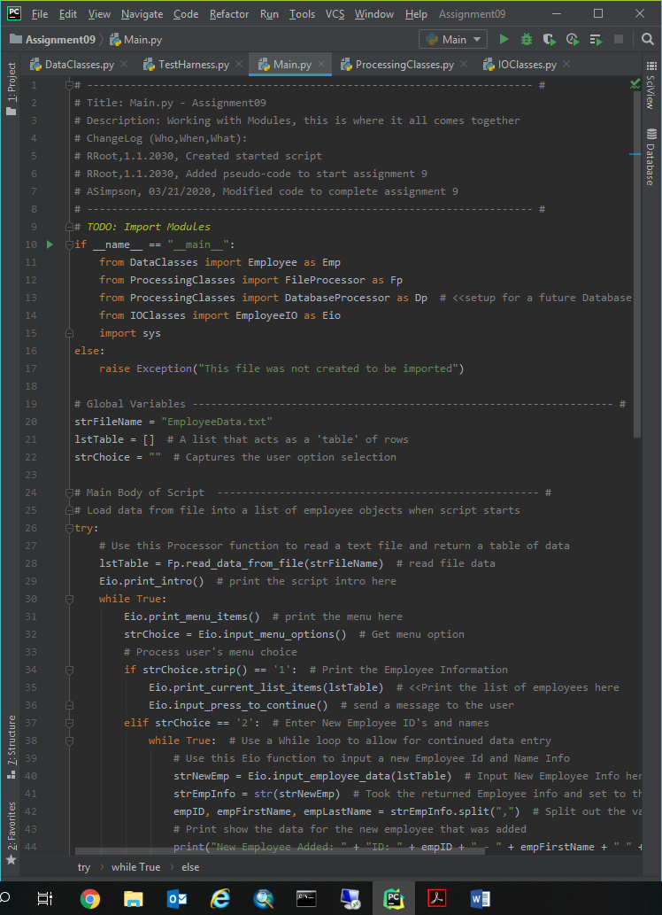
Figure 1 – Example of how to “Import” modules (from Assignment09)
Python and Environmental Variables:
When Python finds an import statement in a script file, it automatically searches and connects to the model’s script file, if it can find it. First, it looks for the file within the same folder, and then it looks in any folder specified by the environment variable “PYTHONPATH,” if one exists. If not, you can create one, and it uses the folders defined within the variable.
Figure 2 – Example of how set the “PYTHONPATH” Environmental Variables (from Module09 notes)
Note: You do not need to create a “PYTHONPATH environment variable for this class, but it is nice to have an example of how a computer uses these variable. You can see all the system variable on your computer using the “set” command on Windows and the “printenv” command on Mac.

The Main Module:
Python applications (programs) are often created using a set of two or more files. However, you typically on run only one of the files directly. Any script file you run directly, at the start of your program, is called the "Main" module.

The __name__ System Variable:
The system variable "__name__" returns the string "__main__" when you execute a script directly using the Python executable. Developers use the Python system variable "__name__" to verify that a script is running as the Main module.

You reference other modules you want to include in your program using an “import” statement at the beginning of the Main module, using a comma-separated list of each module. The code in Listing 4 checks that its script file is running as the main module before it tries to import other modules.

Figure 3 – Example of how to “Import” modules (from Assignment09)
When a script is not ran directly as the main module the "__name__" system variable returns the string with the name of the file. The code in Listing 5 raises an error message when someone tries to run its script file directly. Use this code in all modules that are not your applications main module.
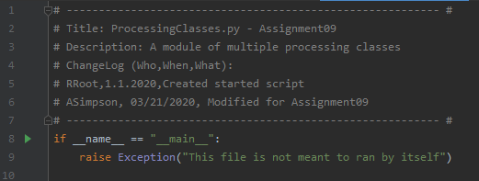
Figure 4 – Example of how to "__name__" module works for non-main scripts (from Assignment09)
Python automatically creates a subfolder called __pycache__ when you first import a module. In there, you will find a binary version of your Python code that is recreated if you delete it.
Linking Modules Together:
Modules are often designed to hold a set of classes or function to support data, processing, or presentation tasks (separation of concerns). Listing 6 shows a module designed for data. You should test modules as you create them. Listing 8 shows a Test Harness that import a data and processing module. The code uses an alias for each module to make the modules more convenient to reference.
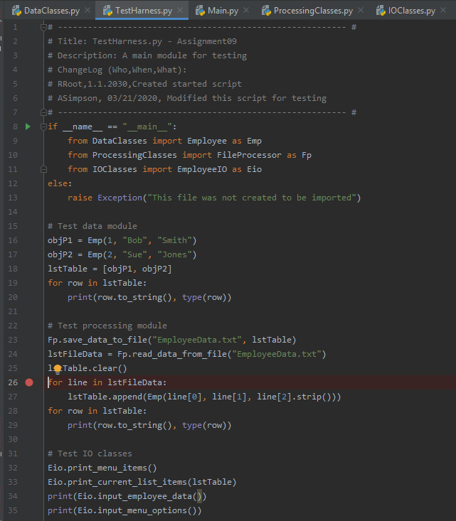
Figure 5 – Example of how different modules can be tested using a “Test Harness” (from Assignment09)

Inheritance:
One of the main advantages of using classes to organize your code is the ability to “inherit” code from another class. Inheriting code is a convenient way for you to write code once and uses it multiple times.
The relationship between the “class” that inherits code from another is often referred to as a “Parent class – Child class” relationship. This can be documented using an arrow point from the child to its parent, like this:
Child class -> Parent class

Oddly, though, you might expect the arrow to indicate otherwise, code is inherited from the Parent class to the Child class. People also use other terms for the inheritance relationship. Two popular ones you should know is a “Derived class – Base class” relationship or and “Sub class – Super class” relationship! Like before, you use an arrow to point to the class whose code is inherited.

Derived class -> Base class
Sub class -> Super class

You can have a long string of inherited classes and the child of one class can be parent of another.

Child class -> Child class -> Child class -> Parent class

Python has a class called "object" that is the ultimate parent class of all classes. In Assignment 9, there’s an example of a Person class that is the parent class for an Employee class. Note how the Person class inherits code from Python's "object" class. Inheritance of the object class is implied if you leave the parenthesis empty.

Understanding Polymorphism:
Polymorphism is the quality of being able treat different types of things the same and have those things each react in their own way. Used in the context of OOP, polymorphism means that you can send a message to objects of different classes related by inheritance and achieve different and appropriate results.

UML:
Unified Modeling Language (UML) is a standard way of modeling relationships between software components. UML consists of many types of modeling diagrams, but let’s look at three of the most common ones.

Class Diagrams:
Class diagrams show relationships between classes. In Figure 8, you can tell that the Employee class is a child of the Person class by looking at the direction the arrow points (It always points from Child to Parent). Class Diagrams also shows the properties and methods included in each class. These diagrams also may show the data types of each properties and method parameters.
Figure 6 – Example of a simple class diagram (from Module09 Notes)

Use Case Diagrams:
"Use Case" diagrams are another popular way to show how components within the software, and the actions they perform, will be used by humans and other software. The person or software using the component is called “Actor,” even when the actor is software, it is represented with a stick figure, as shown in Figure 9.
Figure 9 – Example of a simple “Use Case” diagram (from Module09 Notes)
Composition Diagrams:
The third common UML document we look at uses ovals to represent objects made from classes. The lines between the ovals to indicate a relationship between the objects. The two most common relationship types are Composition and Aggregation (Figure 10). A filled diamond arrow indicates Composition, while a empty diamond represents Aggregation.
Figure 10 – Example of a simple “Composition” diagram (from Module09 Notes)
Aggregation implies a relationship where the child can exist independently of the parent. Example: Class (parent) and Student (child). Composition implies a relationship where the child cannot exist independent of the parent. Example: House (parent) and Room (child).
https://www.visual-paradigm.com/guide/uml-unified-modeling-language/uml-aggregation-vs-composition/
The numbers used in the diagram indicate “Cardinality” or the expected number of objects in the relationship. For example, “0:1” near the EmployeeList object means that there will be either zero or one EmployeeList object connected to Employee objects. The “1:N” near the Employee object indicates that the must be at least 1, but possibly many (of an undefined Number). Composition represents a strong bond, and in this case, the numbers indicate that without at least one Employee the EmployeeList is not needed.
Creating an Application (an example):
To create an application, you identify what you are trying to accomplish and plan it out. You may have to modify your UML documents as you go through the design process.
Planning:
You identify what data, processing and IO tasks you need to accomplish your goal.
You create an object diagram to outline the objects you need.
Implementing:
Once you have your plan, you decide if you need to create new scripts and modules or if you can reuse existing ones. For our application, we can reuse the DataProcessing, Person, and Employees modules, but need to build a IO module.

Assignment09 – The “Employee Information Database” Script:
Figures 9, 10, 11 and 12 show the code from the “Product Price Tracker Program” Python Script. Figures 13 thru 15 show this script running from within the PyCharm IDE. And then Figures 16 thru 19 show the script running from the Command Console.
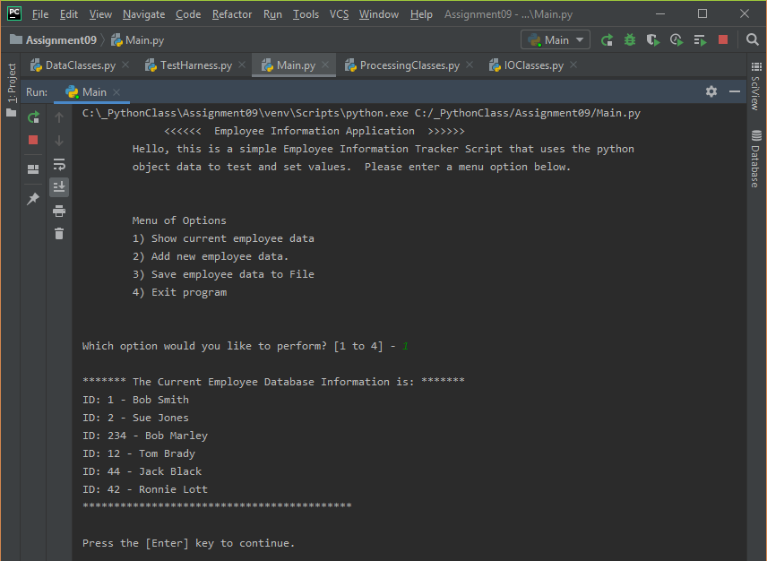
Figure 11 – “Employee Information DB”, Option #1, Python Script (Assignment 9) using PyCharm IDE

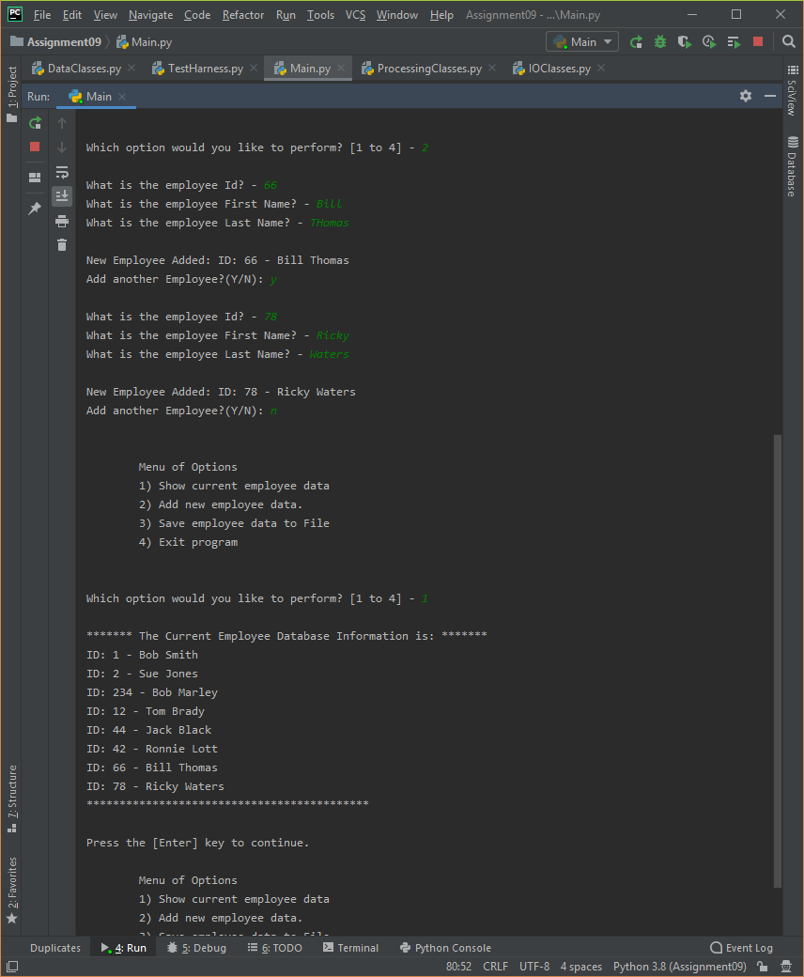
Figure 12– “Employee Information DB”, Option #2 – Add New Employees, then Option #1 Print List, Python Script (Assignment 9) using PyCharm IDE

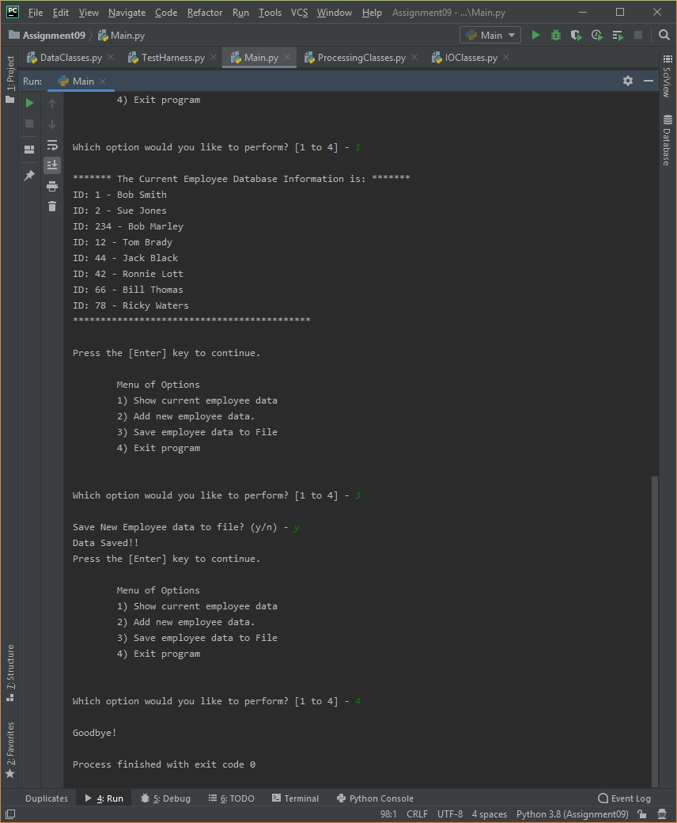
Figure 13 – “Employee Information DB”, Option #3 – Save New Employees Data, then Option #4-Exit Program, Python Script (Assignment 9) using PyCharm IDE
The following screenshots, Figures 14, 15, 16 and 17 shows the Assignment 9 “Employee Information DB Program” script running from within the PyCharm IDE. Please note that I added an introduction to the script as well as a message informing the user that the script has closed.
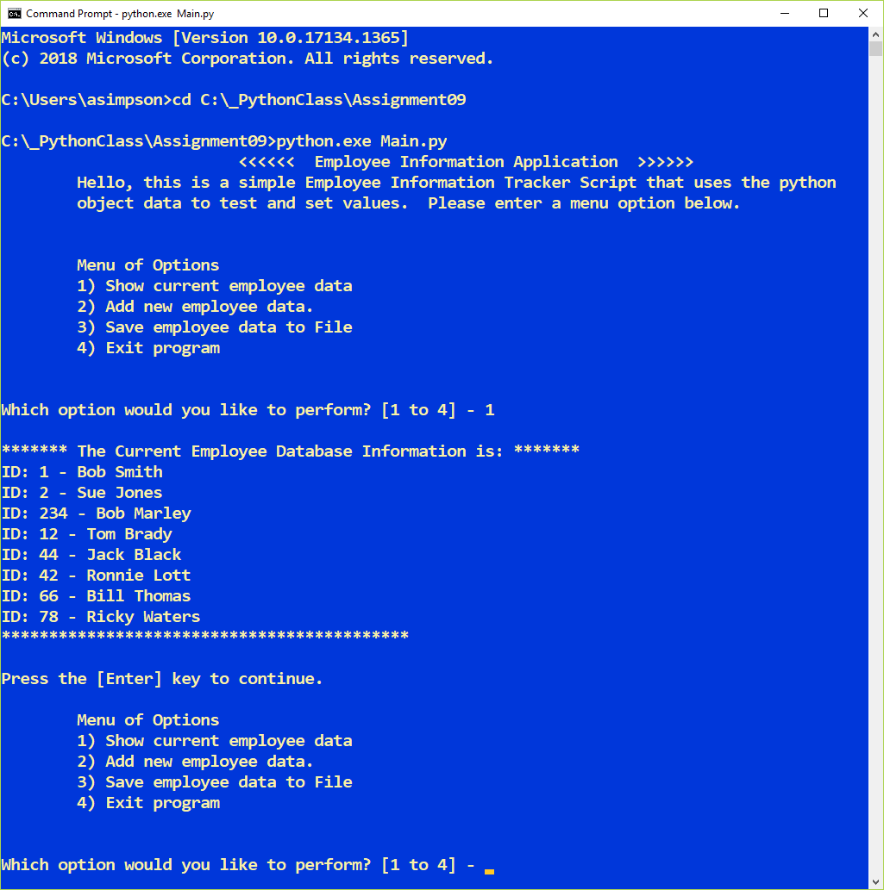
Figure 14 – “Employee Information DB”, Option #1, Python Script (Assignment 9) using the Command Console
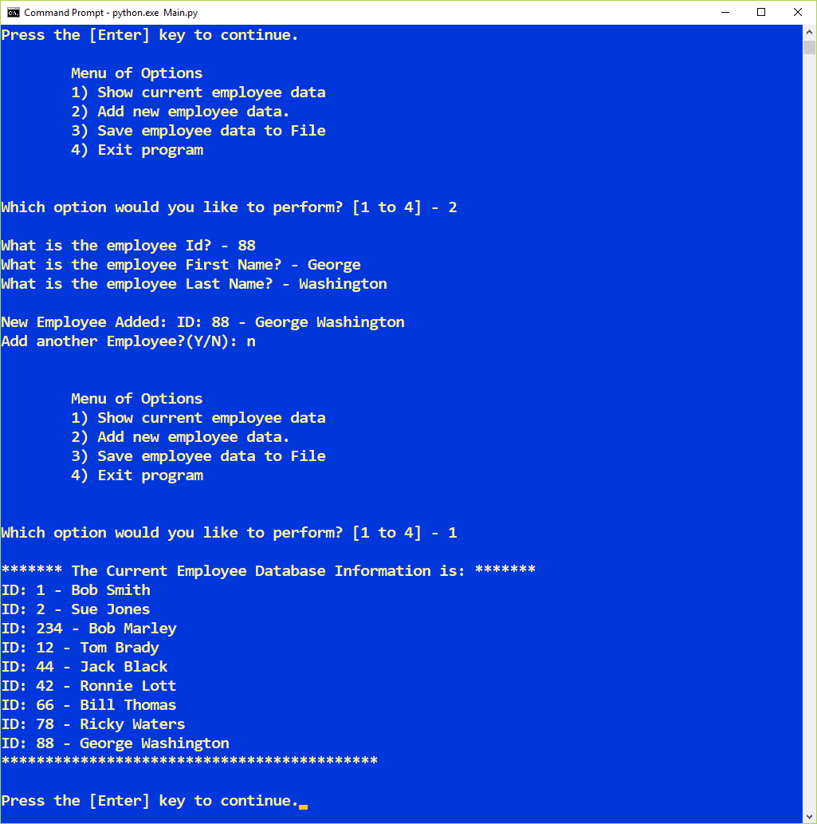
Figure 15 – “Employee Information DB”, Option #2, Python Script (Assignment 9) using the Command Console
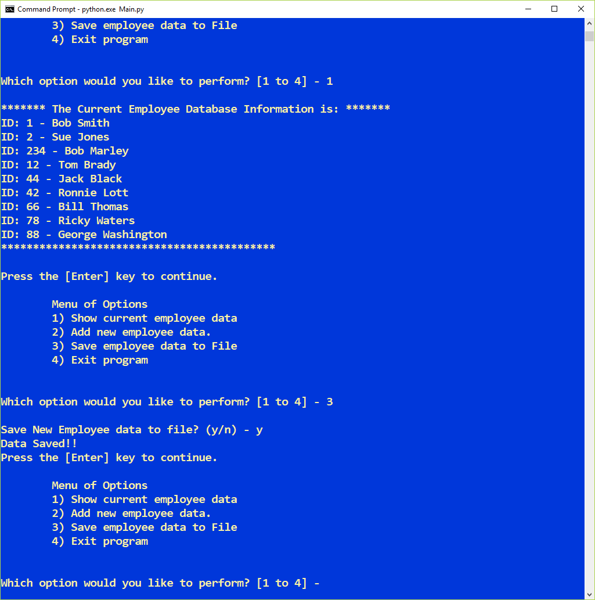
Figure 16 – “Employee Information DB”, Option #3, Python Script (Assignment 9) using the Command Console
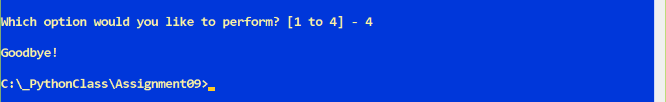
Figure 17 – “Employee Information DB”, Option #4, Python Script (Assignment 9) using the Command Console
Summary
In summary, as part of module 9 and assignment 9, I learned a lot more about object oriented programming.
I learned how to send messages between objects. I learned how to combine objects together to form more complex objects. I also learned about inheritance, the process of creating new classes based on existing ones. I also learned how to extend a derived class by adding new methods. I learned how to write and import modules.
I also learned a bit about application development planning, how to sketch out classes before beginning a project. In conclusion, I put many of the concepts mentioned above into the “Employee Information Database Program” python script. I’m ready to take on chapter 10 where we’ll learn about GUI Development.

GIT Command Line Setup:
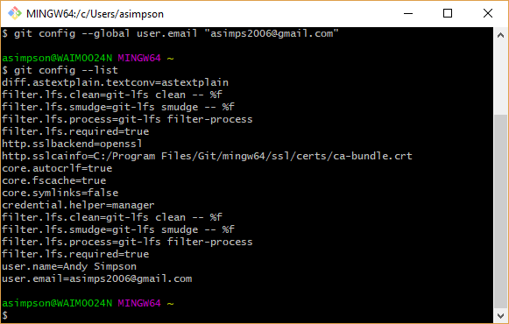
Running Git Command from the Assignment09 Directory
