Student Name: Andy Simpson
Date: 2/18/20
Course: Foundations Of Programming: Python
Assignment: Assignment05
The “To Do List” Python Script
Introduction
In this module and assignment, I learned about creating Python scripts that use Lists and Dictionaries. I found Lists and Dictionaries to be super useful. Whereas lists work with sequences of information, dictionaries work with pairs of data. Dictionaries like real life dictionaries allow you to look up values using another value.
I also learned some new ways to work with Lists such as how to create them, get the index and also how to slice a list. We also covered how to: add and delete an element from a list, methods to append and sort a list, how to work with nested sequences, how to use dictionaries to with pairs of data. We also covered some new concepts such as error handling, functions, script templates and a bit about GitHub
Lists:
Lists are a simple way to hold a collection of objects. And Lists include a lot of built-in functions to help you work with those objects
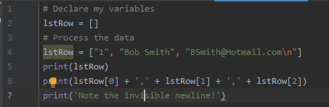
Figure 1 – Example of a List with a Row of data
Storing List Data in a File:
Lists always hold data in a computer’s memory. Memory is cleared, and all data is lost when tan application closes. When a developer wants a user’s data to persist between running the application, they often store data in a file.
In Assignment05, I added the below sample of code (Figure 2) that shows how I used a “for” loop to access each row in my table. The Table is a list of dictionaries.
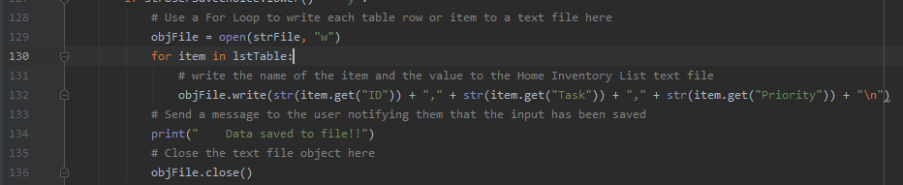
Figure 2 – Example of taking data from a list and adding it to a text file (Assignmnet05)
Loading List Data from a File:
Data in a file must be loaded back into memory if the user wants to continue using this stored data. Since Lists are simple and have many useful functions, developers often load text file data into them. Figure 3 shows a simple way to do this using a “for” list.
Note: the use of the split() function to separate elements of the new list based on comas found in the text file. Also note the use of the strip() function to remove the unwanted carriage return.

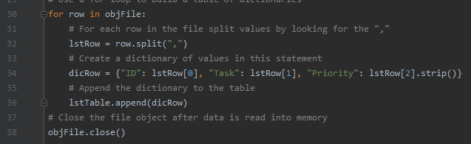
Figure 3 – Example of reading data from a text file into a list (from Assignmnet05)
In the above example, Figure 3, I’m demonstrating how to take data from a file object, reading each line and then finally creating a dictionary for each row of text.
Dictionaries:
We have seen how you access elements of a List, Tuple, or String sequence using an index (numeric) subscript. Dictionaries are very similar to these other sequences, but they replace the index subscripts with key (character) subscripts. You use the braces {} operator to indicate that you want a variable to be a dictionary.

Dictionary keys are a lot like columns in a spreadsheet or database. As such, it is helpful think for a dictionary as a row of data. These “rows” can be added to a List to form a collection of rows, which creates a table like two-dimensional collection of data.
Like the Python List class, the dictionary class has special built-in methods that help you work with the data and keys. Figure 4 below shows how the items(), values(), and keys() functions work.

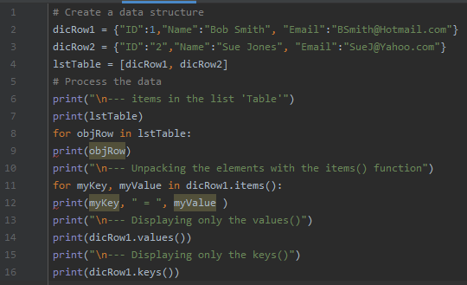
Figure 4 – Example of working with dictionaries, keys and values
Improving Your Scripts:
As your code becomes more complex and your scripts become large, the need to organize and use more professional coding practices becomes vital. Four simple techniques to improve your scripts are the following:
- Use the separation of concerns programming pattern
- Use functions
- Use script templates
- Use structured error handling
Separation of Concerns:
“In computer science, separation of concerns (SoC) is a design principle for separating a computer program into distinct sections, so that each section addresses a separate concern. A concern is a set of information that affects the code of a computer program.”
Functions:
One thing that helps you when sectioning your code is functions. Functions allow you to group a set of programming statements and later reference them by a given name. In Python, function must be defined in a script before they can be called. The statements of a function run later in your program by “calling” the function. For example, we could better organize our code in listing 11 using a new function called DivideValues(). When the script starts, it loads the function into memory but waits to run its statements.
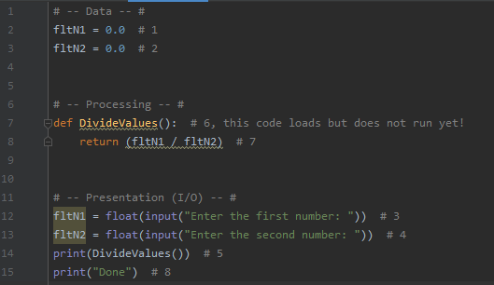
Figure 5 – Example of working with functions
Note: that the code starts running the first statements of the script; this sets up the variables. After the variables are created, it is loads the definition of the function into memory and then moves on to the next statements, and then the next, and then the next. When Python gets to the line that calls to the function it jumps to the section of code where the function is defined. It runs all the code inside the function and then returns to the line of code directly after the function call and continues running all the lines until the end of the script. In Figure 5 above, I have numbered these steps with comments.
Script Templates:
Consistency improves your scripts by making them look more professional and easier to read. Since you know to divide the code into sections of concerns, you would create a script template to help that as well. Figure 6 below shows a simple example of a script template.
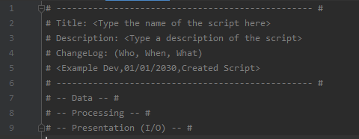
Figure 6 – Example of a Script Template
Setting Up Script Templates in PyCharm:
Using script templates is such a common practice that most advanced Integrated Development Environments (IDE) allow you to save custom templates and use them with each new file.
For example, in figure 13 you can see how to add a new template in PyCharm by using the Tools > Save File as Template… menu option. This option launches the “Save File as a Template” dialog window where you can name your temple and OK its creation. In assignment 5, I learned how to put all of the above concepts together to create the following “To Do List” Script.
Figure 7 – Example of setting up a Script Template in PyCharm
Once a template is created, you use it by right-clicking your project icon in the Project Explorer tree and using the New > “Name of your Template” option in the context menu as shown in figure 8.
Figure 8 – Example of using a Script Template in PyCharm
Error Handling (Try-Except):
Error Handing improves your scripts by managing errors you may not have control over in any other way. For example, you may ask a user for input of a number to calculate but receive a character instead. While you cannot stop people from making mistakes you can actively plan for them and make the process of recovering from errors less painful.
You can trap errors in your programs using a try-except construct. One advantage is its ability to provide more general and user-friendly error messages. Another advantage is that it allows for a simple, organized way of grouping statements to be processed. A third advantage is that if an error occurs in the grouped statements, Python automatically moves to another set of statements where you can handle the error in your own way (instead of the way Python would normally do so). For example, figure 15 shows how a normal “divide by zero” error looks. Note it's a technical explanation of what occurred, which is accurate, but not user-friendly.
Technical messages work fine for developers, but they are too complex for end users. Adding a Try-Except block to your code allows you to customize the error messages.
Figure 9 – Example of using a try/except method of error handling

GitHub:
It has always been a good idea to make backups of your code files and to make them available for others to access. Traditional this has been accomplished using a network share on an organization’s server. While this is still a common practice, more and more organizations have embraced storing this code on the Internet via source control software.
One of the most popular source control software is Git, which can store your files on the Internet at GitHub.com. Here is an excerpt from an article on what GitHub is:
“Version control systems keep these revisions straight, storing the modifications in a central repository. This allows developers to easily collaborate, as they can download a new version of the software, make changes, and upload the newest revision. Every developer can see these new changes, download them, and contribute.
…
Git is the preferred version control system of most developers, since it has multiple advantages over the other systems available. It stores file changes more efficiently and ensures file integrity better. If you’re interested in knowing the details, the Git Basics page has a thorough explanation on how Git works.”

Assignment05 – The “To Do Task List” Script:
Figures 10, 11, 12, 13 and 14 show the code from the “To Do” Task List Python Script. Figures 15, 16, 17 and 18 show this script running from within the PyCharm IDE. And then Figures 19, 20 and 21 show the script running from the Command Console. Finally, I included the text file output as Figure 22 for your review. I could definitely use some functions but I was holding off until we get to Chapter 6.

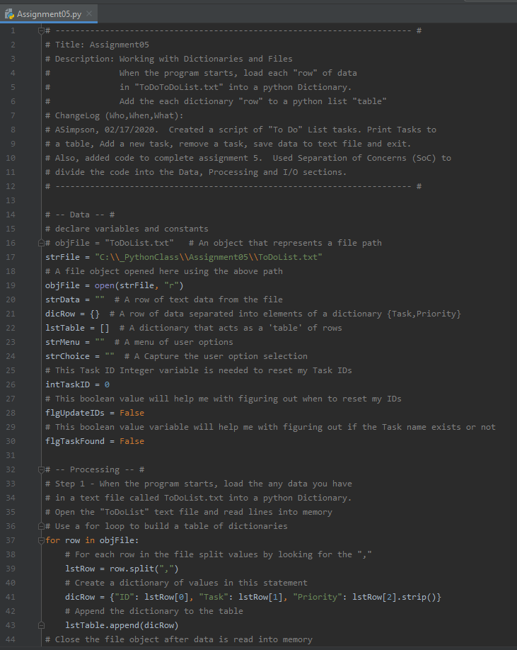
Figure 10 – “To Do List” Python Script (Assignment 5) using PyCharm IDE
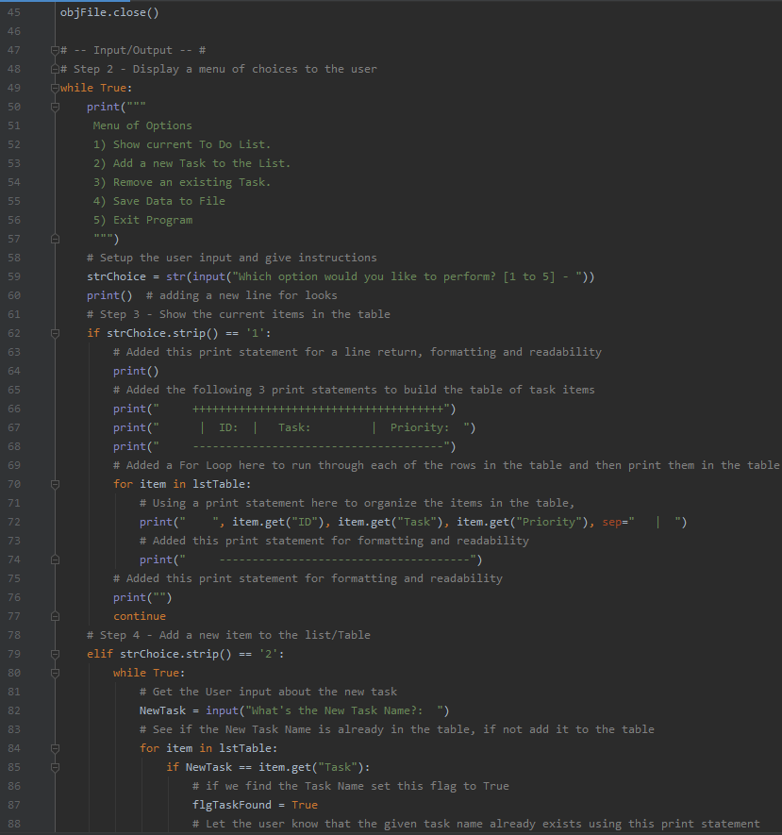
Figure 11 – “To Do List” Python Script (Assignment 5) using PyCharm IDE - Continued
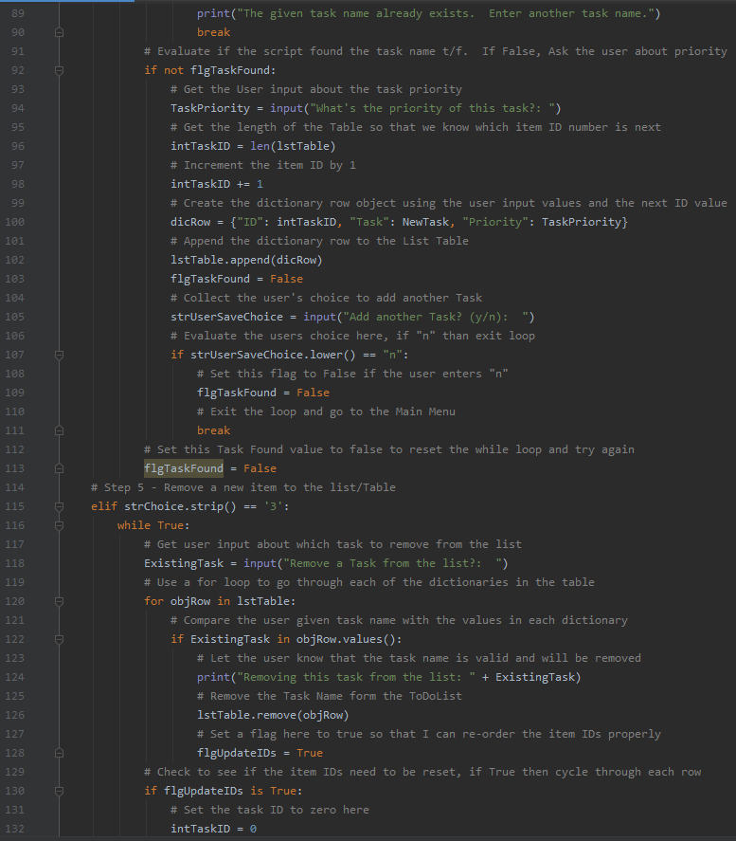
Figure 12 – “To Do List” Python Script (Assignment 5) using PyCharm IDE - Continued
The following screenshots, Figures 14, 15 and 16 shows the Assignment 4 “Home Inventory” script running from within the PyCharm IDE. Please note that I added an introduction to the script as well as a message informing the user that the script has closed.
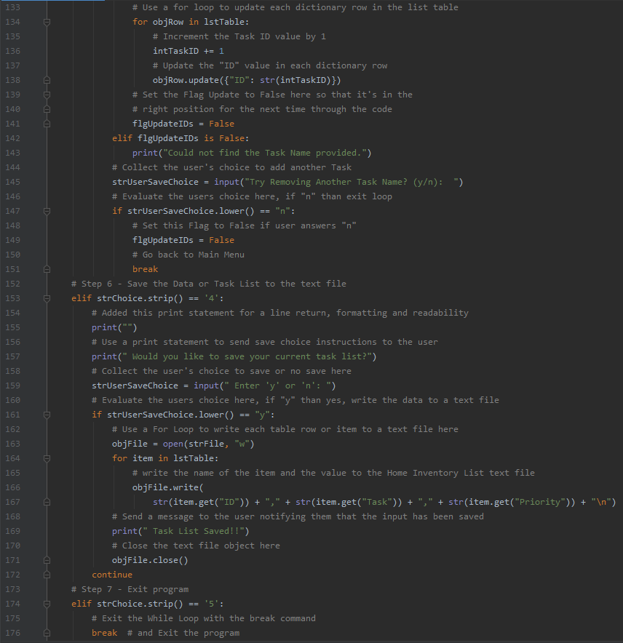
Figure 13 – “To Do List” Python Script (Assignment 5) using PyCharm IDE – Continued

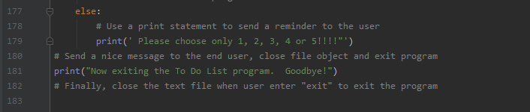
Figure 14 – “To Do List” Python Script (Assignment 5) using PyCharm IDE - Continued
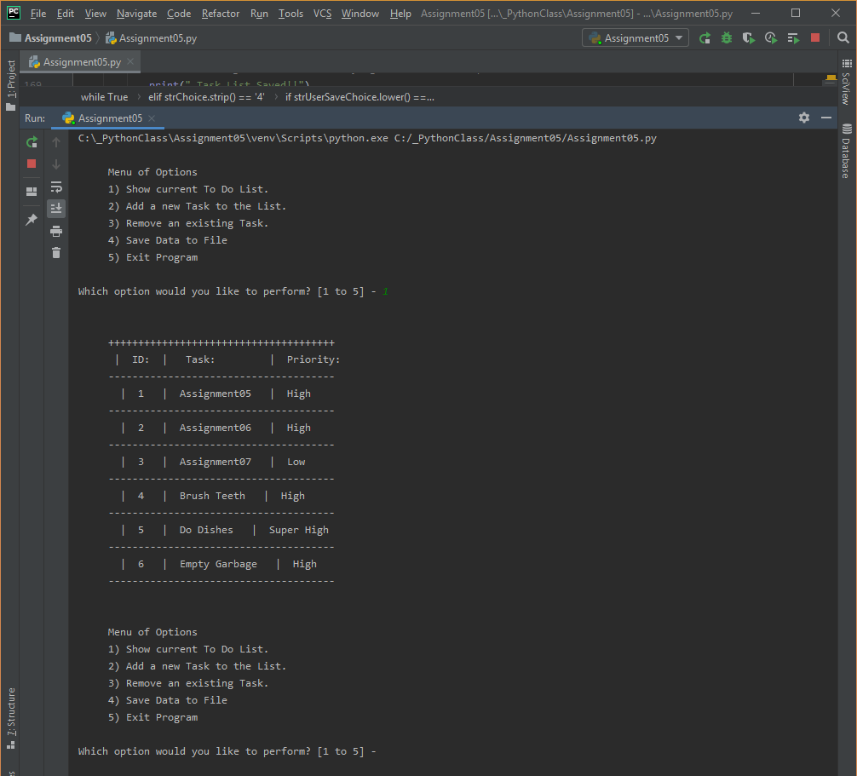
Figure 15 – Running Option #1 from the “To Do List” Python Script using PyCharm IDE (Continued)

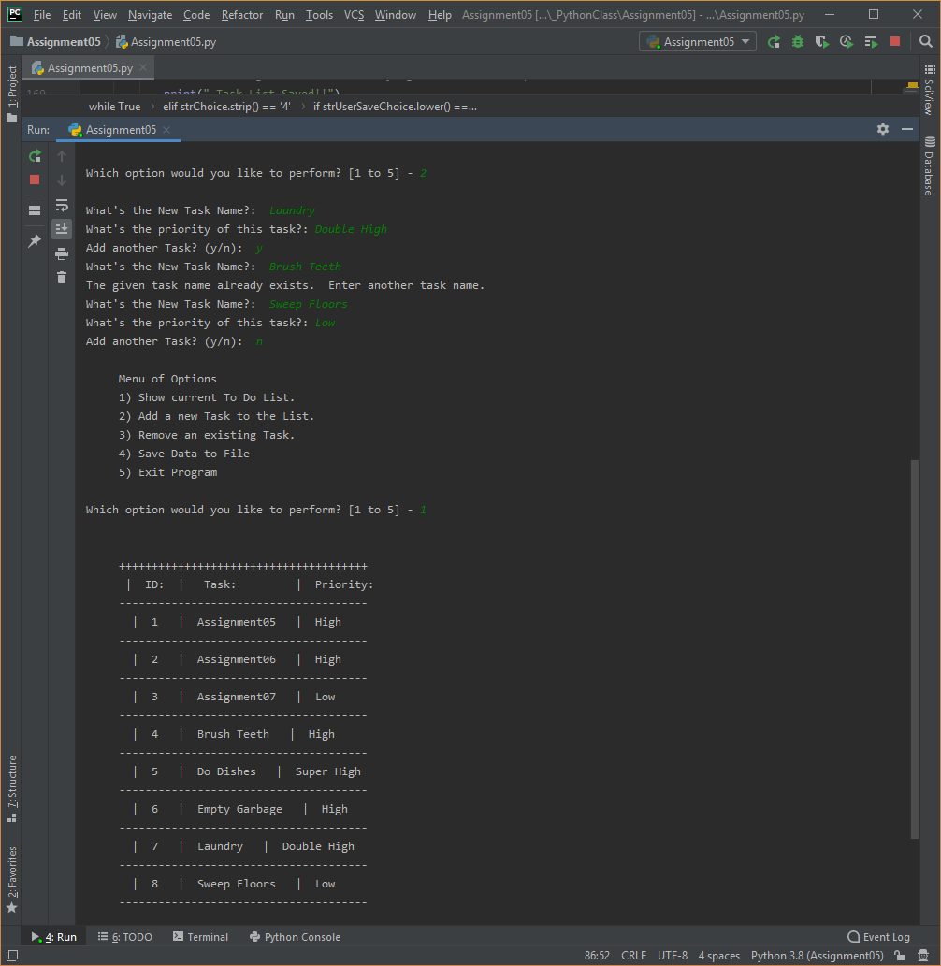
Figure 16 – Running Option #2 & #1 from the “To Do List” Python Script using PyCharm IDE (Continued)
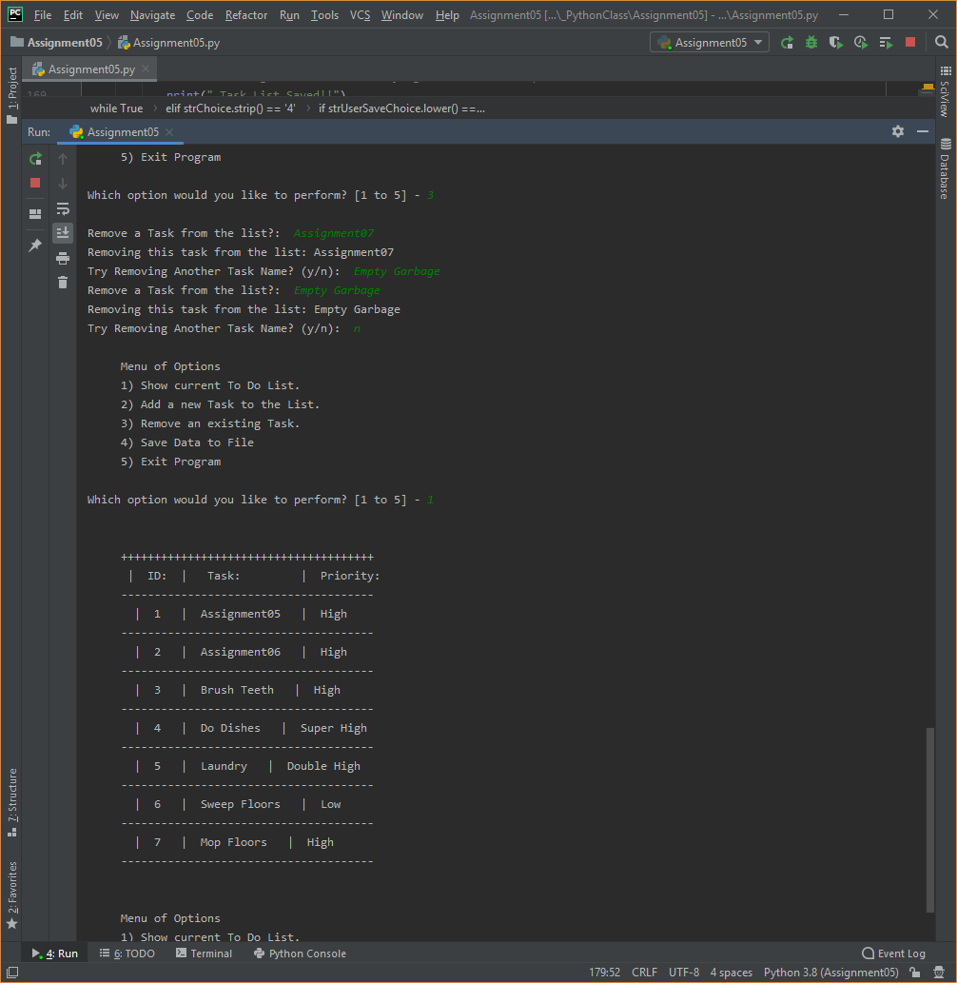
Figure 17 – Running Option #3 & #1 from the “To Do List” Python Script using PyCharm IDE (Continued)

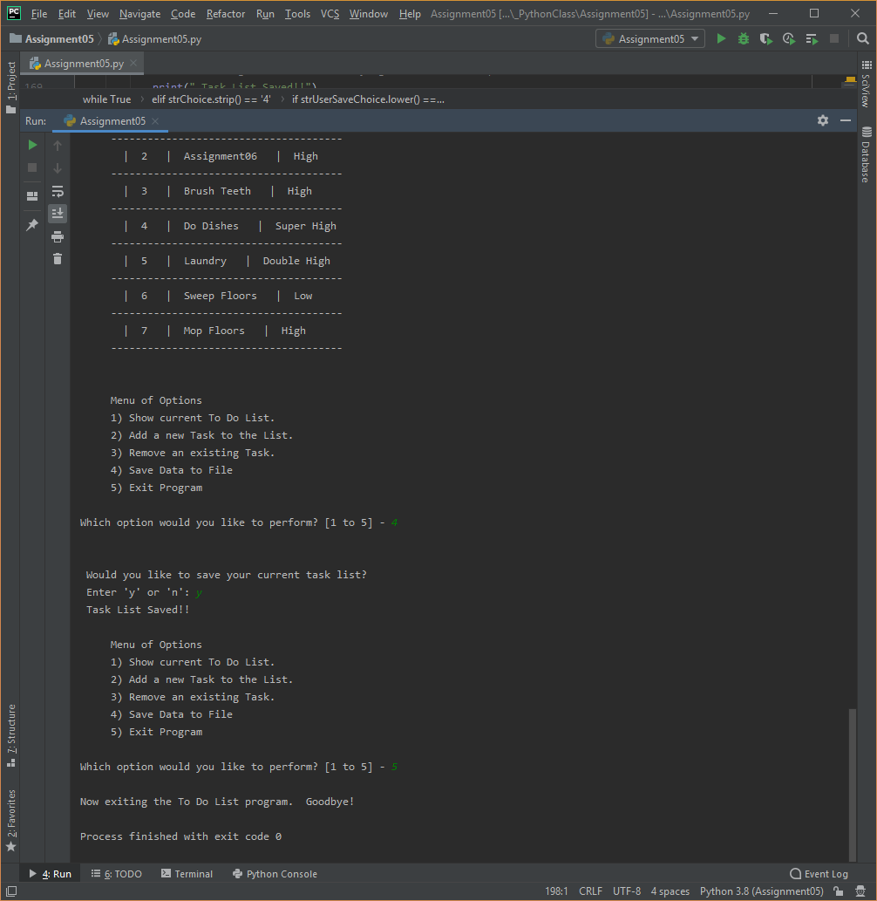
Figure 18 – Running Option #4 & #5 from the “To Do List” Python Script using PyCharm IDE (Continued)

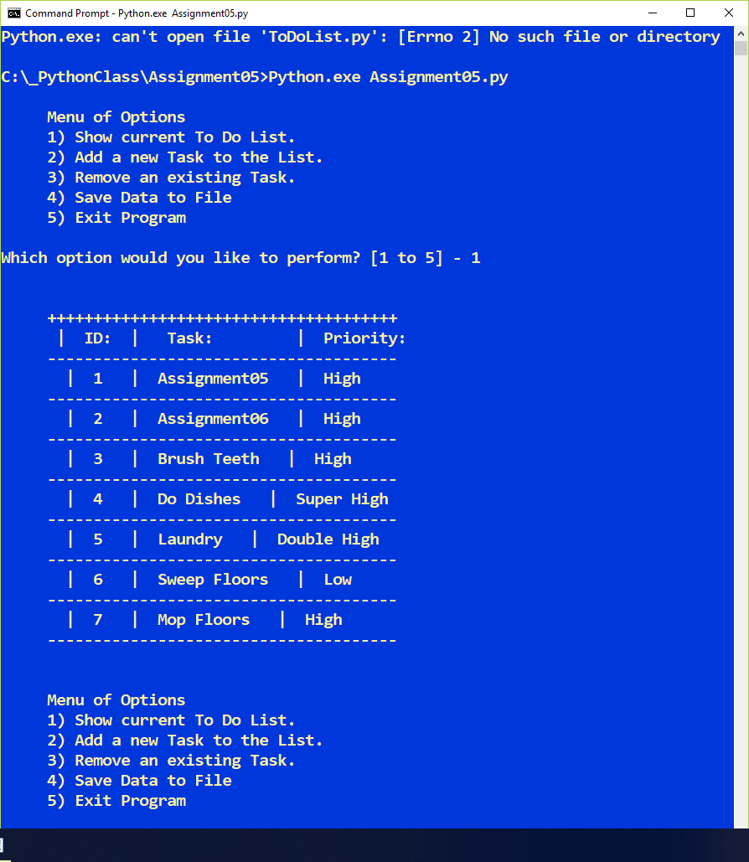
Figure 19 – Option #1 Show Current List, the “To Do List” Python Script running from the Command Console or Command Prompt
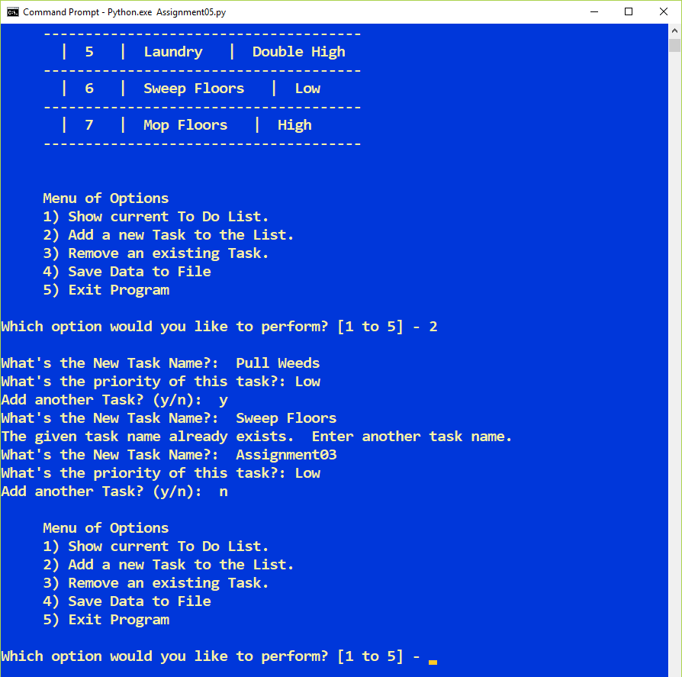
Figure 20 – Option #2 Add a new task “To Do List” Python Script running from the Command Console or Command Prompt

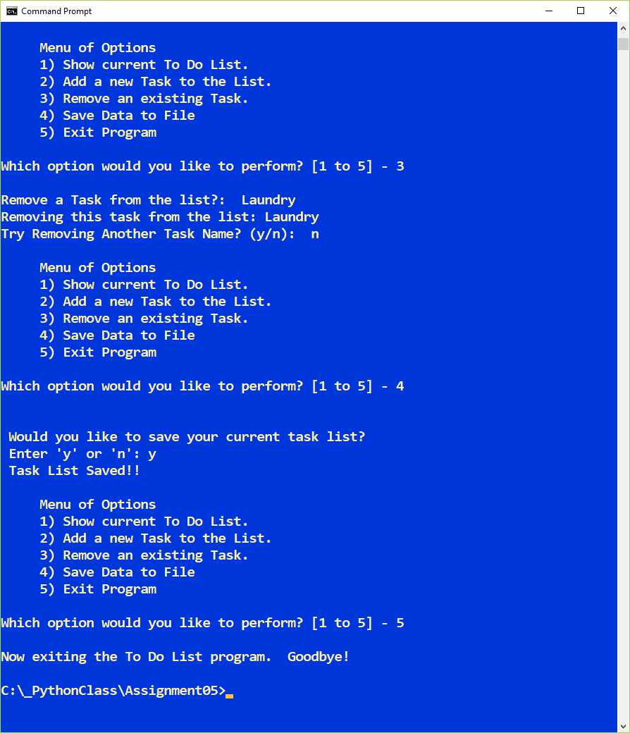
Figure 21 – Option #3, 4 and 5 (Remove an item, save to a text file and Exit the Program) of the “To Do List”2 Python Script running from the Command Console or Command Prompt

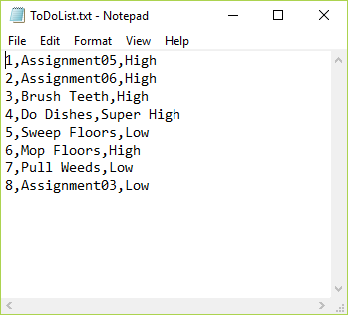
Figure 22 – The “To Do List” text file of user input values as written by the “To Do List” Script

Summary
In summary, as part of module 5, I learned how to use Lists and dictionaries. We then used these lists to query the data, add new values or remove values. We also learned about how to read data into a list and then later how to then write data into a text file. As shown in Figure 22, I’ve successfully wrote data to a text file and later removed a value. Even though it wasn’t part of the homework, I wanted to reorder my list IDs each time a given task was removed.
I also added a few lines of code to warn the user that a given task was already on the list. I really like working with lists, they are super powerful.
I also learned a lot about, SoC (Separation of Concerns, functions, script templates and error handling). All of these concepts will help me improve my scripting by staying organized. Finally, I put many of the concepts mentioned above into the “To Do List” python script. I’m ready to take on chapter 6 where we’ll learn about how to use functions.

